**Project**

**AIM:**

Design a database application for music record:

Notown record has decided to store information about musicians who performed on its albums in a database .each musicians identified by an ssn, a name, and an age.each musicians lived in different places.

Places are identified by an address and a ph.no.

Each instruments is identified by a name and a key .each album has a title ,date and a format.each song has a title and an author.

Each musicians played several instruments and a given instrument played by several  musicions .

Each album has no:of songs on it, but no song may appear on more than one album .each song is performed by one or more musician s and a musician may perform a no:of songs.

Each album has exactly one musician  who acts its producer. a musician may produce several albums.

**ER DIAGRAM:**

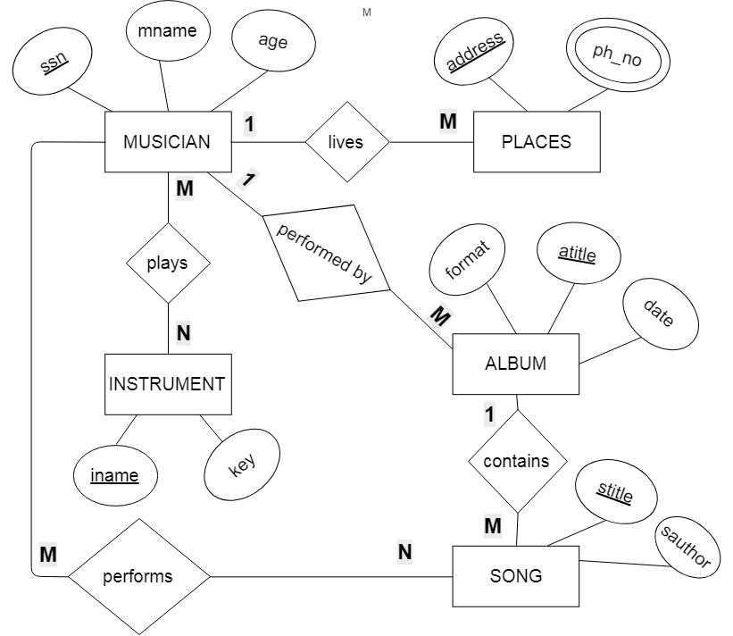

**TABLE CONVERSIONS FROM ER DIAGRAM:**

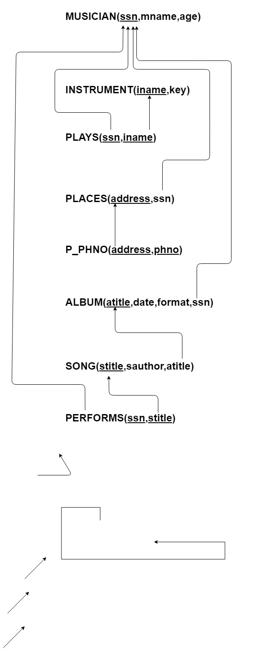

**CREATION OF TABLES IN THE DATABASE:**

create table musician

(ssn number(5) primary key,

mname varchar2(50),

age number(2));

create table instrument

(iname varchar2(30) primary key,

key number(10));

create table plays

(ssn number(5) references musician(ssn),

iname varchar2(30) references instrument(iname),

primary key(ssn,iname));

create table places

(address varchar2(50) primary key,

ssn number(5) references musician(ssn));

create table p_phno

(address varchar2(50) references places(address),

phno number(10),

primary key(address,phno));

create table album

(atitle varchar2(50) primary key,

rdate date,

format varchar2(50),

ssn number(5) references musician(ssn));

create table song

(stitle varchar2(50) primary key,

sauthor varchar2(50),

atitle varchar2(50) references album(atitle));

create table performs

(ssn number(5) references musician(ssn),

stitle varchar2(50) references song(stitle),

primary key(ssn,stitle));

**QUERIES:**

insert into musician(ssn,mname,age) values ('" + textBox1.Text + "','" + textBox2.Text + "','" + textBox3.Text + "')";

select * from musician

"delete from musician where SSN='" + textBox4.Text+"'"

select * from musician

"update musician set age='" + textBox5.Text+"' where ssn='"+textBox6.Text+"'";

select * from musician

"select count(ssn) from musician"

"select * from instrument"

"insert into instrument(iname,key) values ('" + textBox2.Text + "','" + textBox1.Text + "')";

"select * from instrument"

"delete from instrument where key='" + textBox4.Text + "'";

"select * from instrument";

"select m.mname,i.iname from musician m, instrument i, plays p where m.age = (select min(age) from musician) and m.ssn=p.ssn and i.iname=p.iname";

"select * from plays";

"select * from places"

"select * from p_phno";

"select * from album"

"insert into album(atitle,rdate,format,ssn) values ('" + textBox2.Text + "','" + textBox1.Text + "','" + textBox4.Text + "','" + textBox3.Text + "')";

"select * from album"

"delete from album where ssn='" + textBox5.Text + "'";

"select * from album"

"select * from song";

"insert into song(stitle,sauthor,atitle) values ('" + textBox1.Text + "','" + textBox2.Text + "','" + textBox3.Text + "')";

"select * from song"

"delete from song where stitle='" + textBox4.Text + "'";

"select * from song";

"select * from (album natural join song)"

"select * from performs";

**FORMS:**

1. **Form 1 is to log into the database application.** Only the correct username and password allows the user to enter into the application.

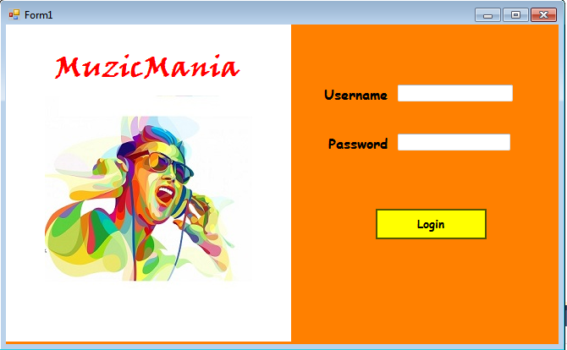

1. **Form 2 displays the names of all the tables of the application on buttons**, clicking on which, the user can access i.e. view as well as perform various operations such as insertion, deletion and updation and it also provides user with some information such as the number of musicians and the youngest musician and the instruments he plays on the aforementioned tables.

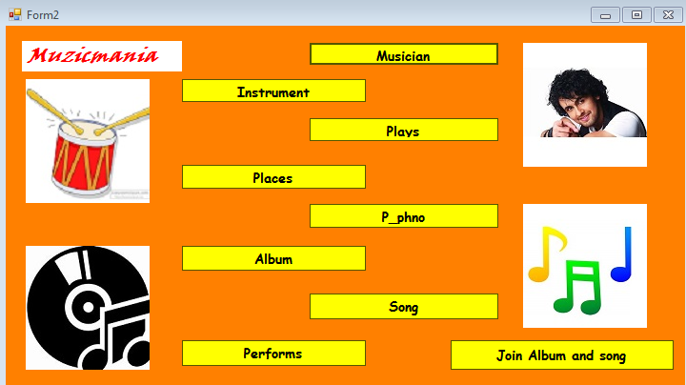

The forms below show what it looks like when clicked on each of the options (i.e. table names) on the previous form.

1. **When clicked on : ‘Musician’, form 3 opens.**

There is an option to view the ‘Musician’ table. The user can perform insertion of data of a new musician, deletion of an existing musician’s data and updation in a musician’s age.

It also provides an option to display the number of Musicians. The user can access the next table i.e. ‘Instrument’ just by clicking on ‘go to next form’.

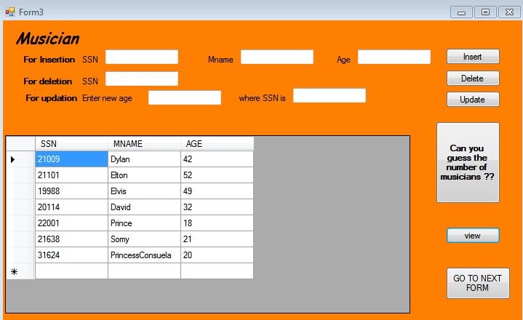

1. **When clicked on : ‘Instrument’, form 4 opens.**

There is an option to view the ‘Instrument’ table. One can perform insertion of a new instrument and deletion of an existing instrument. It also provides an option where the user can find out who is the youngest musician and what instrument he plays. The user can access the next table i.e. ’Plays’ just by clicking on ‘go to next form’.

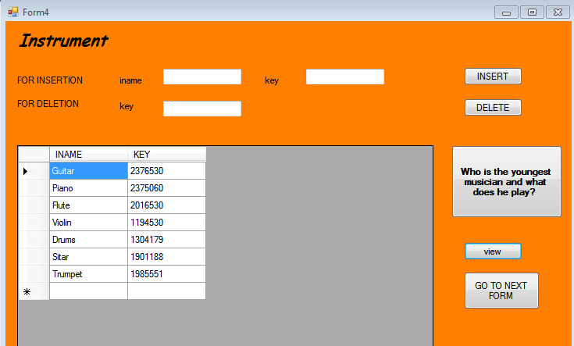

1. **When clicked on : ‘Plays’, form 5 opens.**

The ‘Plays’ table shows which instruments are played by which musicians by displaying the musician’s SSN and the name of the instrument. One can access the next table i.e. ’Places’ just by clicking on ‘go to next form’.

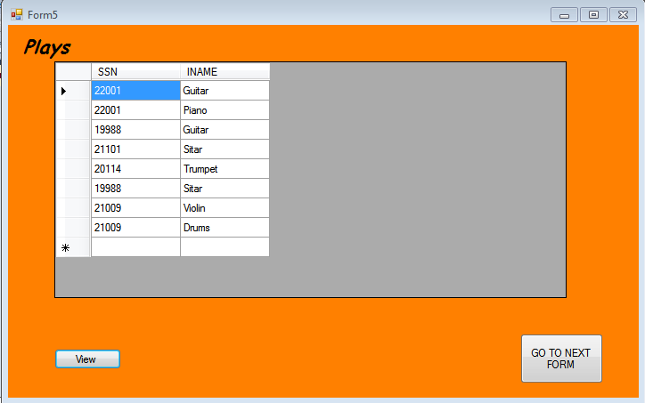

1. **When clicked on : ‘Places’, form 6 opens.**

The ‘Places’ table shows which musician has lived or currently lives at which place by displaying the name of the place and the SSN of the musicians. One can access the next table i.e. ’P_phno’ just by clicking on ‘go to next form’.

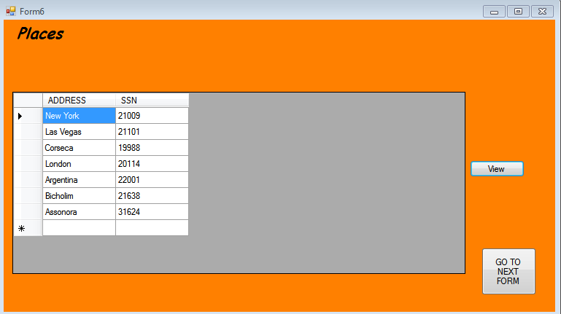

1. **When clicked on : ‘P_phno’, form 7 opens.**

The ‘P_phno’ table shows the contact details of each musician. It displays the name of the place where the musician has lived or currently lives and his/her phone number. One can access the next table i.e. ’P_phno’ just by clicking on ‘go to next form’.

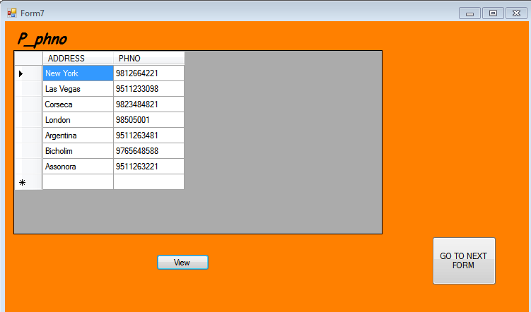

1. **When clicked on : ‘Album’, form 8 opens.**

There is an option to view the ‘Album’ table. One can perform insertion of a new album by entering all the necessary attributes such as album title, date, format and SSN of the musician and perform deletion of an existing album by entering only the SSN of the musician. The user can access the next table i.e. ’Songs’ just by clicking on ‘go to next form’.

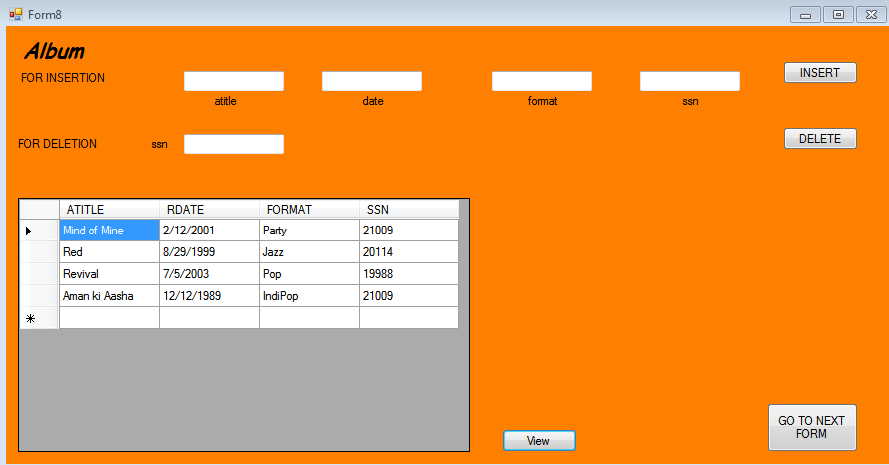

1. **When clicked on : ‘Songs’, form 9 opens.**

There is an option to view the ‘Songs’ table. One can perform insertion of a new song by entering all the necessary attributes such as song title, song author and title of the album to which it belongs and perform deletion of an existing song by entering only the title of the album to which the song belongs. The user can access the next table i.e. ’Performs’ just by clicking on ‘go to next form’.

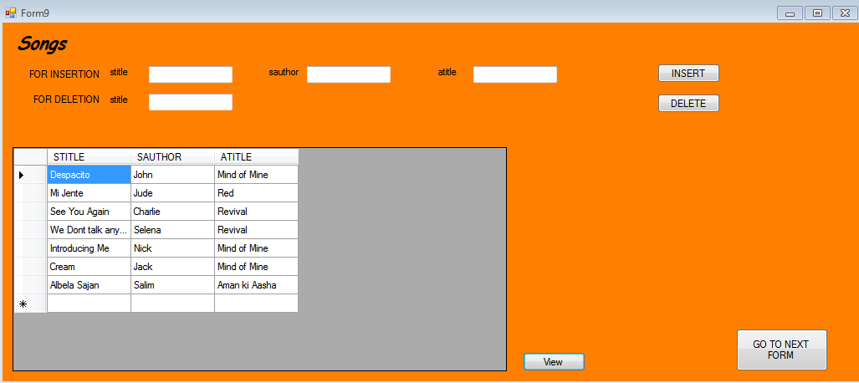

1. **When clicked on : ‘Performs’, form 10 opens.**

The ‘Performs’ table shows the SSN of the musicians and the title of the song performed by them. There is a ‘menu’ button, clicking on which, the user is taken back to the main menu i.e the form 2.

