**KERALA TOURISM**

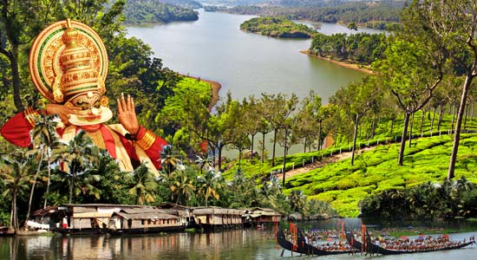

**BY: PRACHI MATHUR**

**LOGIN PAGE**

<html>

<body background="l.jpg">

<center>

<font size=10 color=lime>LOGIN</font>

<form action="mainpage.asp" method=post>

<font size=5 color=cyan>Enter user name <input type=text name=uname>

<BR><br>

Enter password&nbsp;<input type=password name=pswd>

<BR><br>

<input type=submit value=Login>

</form>

</center></body></html>

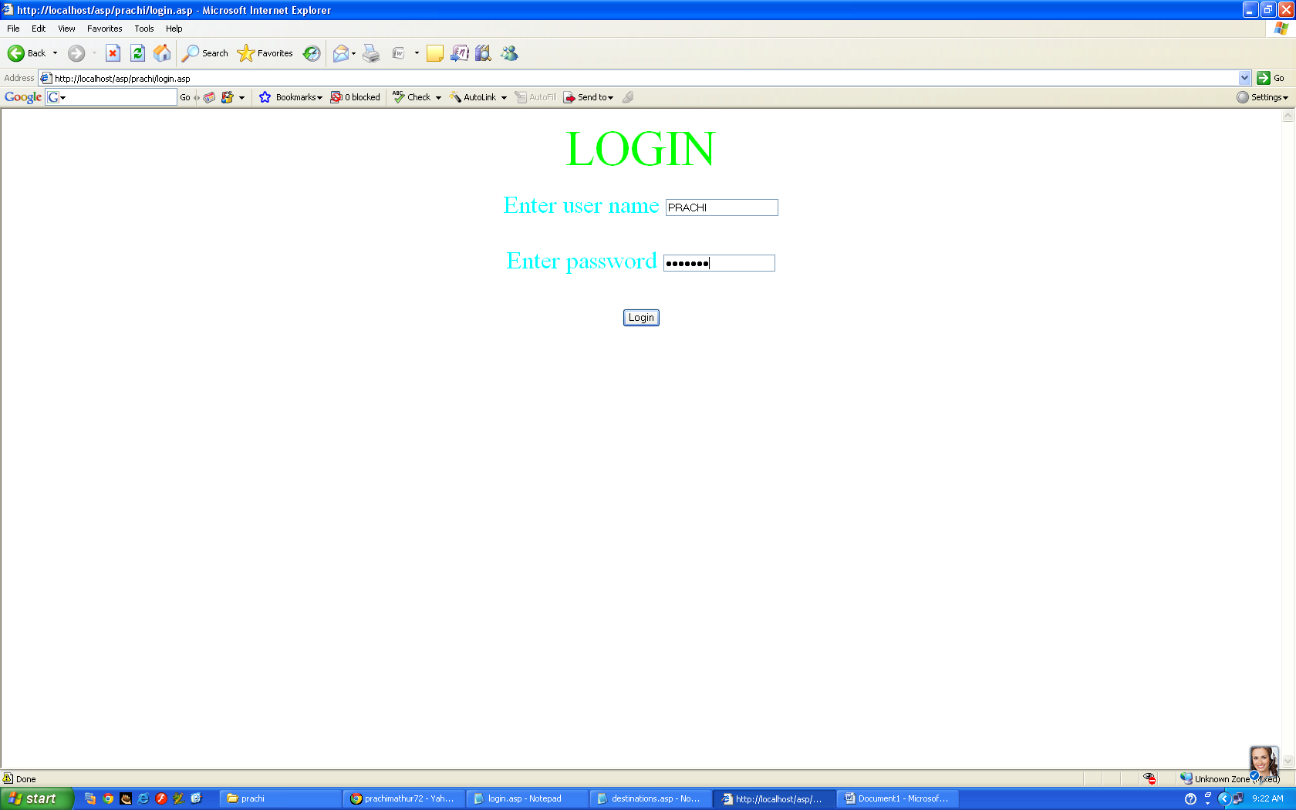

**MAINPAGE**

<html>

<frameset rows="26%,7%,67%">

<frame src="1.asp">

<frame src="2.1.asp" border="0">

<frame src="2.2.asp" name="1">

</frameset>

</frameset>

</html>

**FRAME1**

<html>

<head><title>1</title></head>

<body>

<center>

<img src="keralatourism-logo.jpg" height=162 width=1260>

</center>

<center>

<h3>Welcome to KERALA TOURISM on <%response.write(date)%></h3>

</center>

</body>

</html>

**FRAME 2**

<html>

<head><title>2.1</title></head>

<body bgcolor="green">

<table border=0 bgcolor="yellow" width=100% height=100%>

<tr>

<th><font face="Cooper Black"><a href="2.2.asp" vlink="white" alink="white" link="white" target="1">HOME</a></th>

<th><font face="Cooper Black" color="white"><A href="destinations.asp" vlink="white" alink="white" link="white" target="1">DESTINATIONS</font></th>

<th><font face="Cooper Black" color="white"><a href="climate.asp" vlink="white" alink="white" link="white" target="1">CLIMATE</font></th>

<th><font face="Cooper Black" color="white"><a href="food.asp" vlink="white" alink="white" link="white" target="1">FOOD</font></th>

<th><font face="Cooper Black" color="white"><a href="accomodations.asp" vlink="white" alink="white" link="white" target="1">ACCOMODATIONS</font></th>

<th><font face="Cooper Black" color="white"><a href="packages.asp" target="1">TOUR PACKAGES</font></th

<th><font face="Cooper Black" color="white"><a href="form.asp" target="1">TRAVEL ASSISTANCE</font></th>

</tr>

</table>

</body>

</html>

**FRAME 3**

<html>

<head><title>2.2</title></head>

<body bgcolor="pink">

<font face="Comic Sans MS" size=4 color="purple">

<embed src="Kabhi Jo Baadal Barse (Instrumental)-(MirchiFun.Mobi).mp3" hidden="true" autostart="true" loop="true">

<center><embed src="MOVIE2.SWF" width="400" height="400"></CENTER>

<center><H2>COME,EXPLORE AND EXPERIENCE</H2></CENTER>

<center><H2>THE MARVEL CALLED KERALA....</H2></CENTER>

<p>Wedged between the Western Ghats on the East and the Arabian Sea on the West, the narrow strip of land known as Kerala is a destination of a lifetime.<BR>

<marquee style="position: relative;" behavior="scroll" direction="left" scrollamount="6">

<img src="Picture1.png" height="150" width="300">

<img src="Picture2.png" height="150" width="300">

<img src="Picture4.png" height="150" width="300">

<img src="Picture5.png" height="150" width="300">

<img src="Picture6.png" height="150" width="300">

<img src="Picture7.png" height="150" width="300">

<img src="Picture3.png" height="150" width="300">

</marquee>

The timeless beauty of the palm fringed beaches of Kovalam and Varkala, the majesty of the undulating hills of Munnar and Vagamon, the serenity of the pristine backwaters of Kumarakom & Kuttanad and the enchantingwoods and forests of Thekkady and Silent Valley will have you bowled over.<BR>

That such a small terrain can hold diverse geographical features and cultures is a wonder in itself.</p>

</body>

</html>

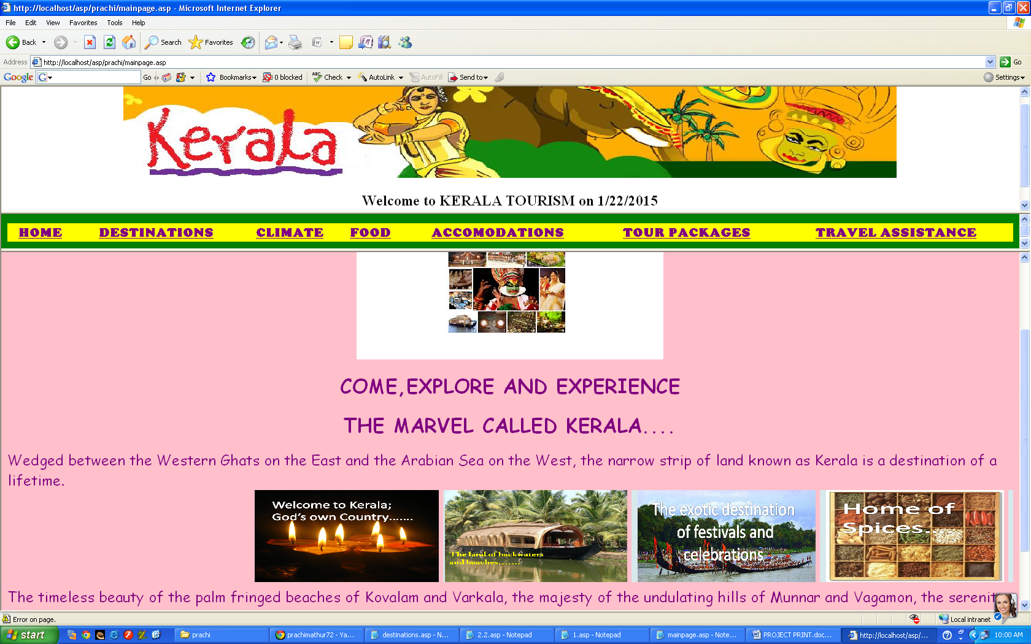

**DESTINATION**

<html>

<head><title>Destinations</title></head>

<body bgcolor="sky blue">

<center><%

set myad=server.createobject("mswc.adrotator")

RESPONSE.WRITE(myad.getadvertisement("adrotator1.txt"))

%></center>

<font size=5 color="white">

<p>Kerala tourist places are the most popular destinations in India. Kerala is well known for its Backwaters, Beaches, Wild life sanctuaries, Hill stations and Ayurvedic treatments. Kerala Beaches have become one of the main attraction in Kerala Tourism. SightSeeing in Kerala is very interesting.</p>

<img src="kerala tourism map.jpg" align="right" width="750" height="750">

<ul>

<li><a href="beaches.asp">Beaches</a>

<li><a href="temples.asp">Temples</a>

<li><a href="backwaters.asp">Backwaters</a>

<li><a href="wildlifesancturies.asp">Wildlife Sactuaries</a>

<li><a href="hillstations.asp">Hill Stations</a>

</ul></body><html>

**ADROTATOR.txt**

width 300

height 300

border 1

*

images.jpg

KERALA TOURISM

55

Kerala-Tourism.jpg

kerala tourism

45

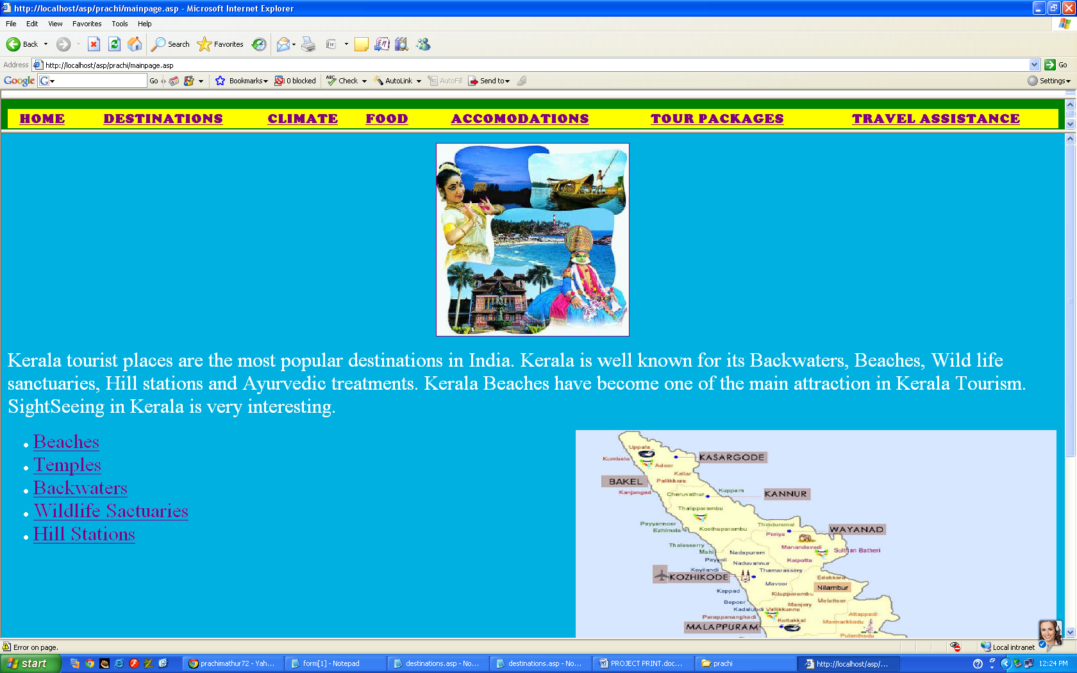

**BEACHES.ASP**

<html>

<head><title>Beaches</title></head>

<body bgcolor="orange">

<h1>Beaches</h1>

<ul></p>

<li><h3>Kovalam</h3><br>Situated 15 Km south of Trivandrum (Thiruvananthapuram) city. This internationaly renowned beach has been favourite haunt of tourists since long past and regarded as one of the finest beach resorts of the world.

<li><h3>Cherai</h3><br>This is a new-generation tourist hot-spot very near to North Paravur town with golden beaches, coconut groves and backwaters. This beautiful, very quiet beach bordering Vypeen island is ideal for swimming. The maritime friend of humans, the Dolphins can occasionally be sighted. Cherai is famous for sea food and coconut toddy. The sea on the western side and the backwaters on the east give a uniqueness here which can be found only in Kerala.

<li><h3>Fort Kochi</h3><br> The Fort Kochi Beach is located 12 Km far from Ernakulam city. It is originally a fishing village that became the first European township in India. The historic fort with its eventful colonial history, is the main attraction on this beach. There is a colourful Carnival on New Year eve.

<li><h3>Kappad</h3><br>Kappad, where the Portuguese explorer Vasco Da Gama landed on May 27, 1498, located 16 km away from the Calicut (Kozhikode) city. The main attraction in the beach is the sprawling rock that protrudes into the sea. The temple on the rock is about 800 years old.

</body>

</html>

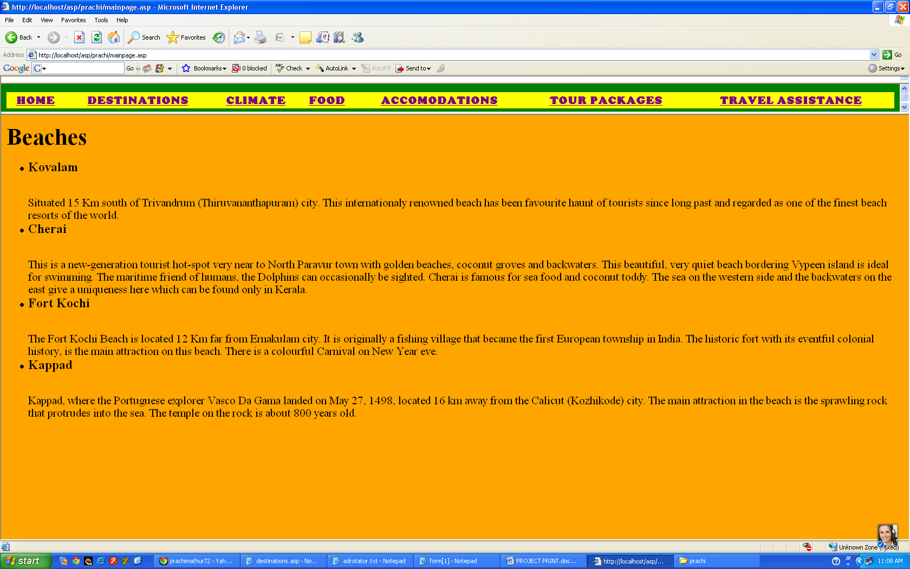

**TEMPLES**

<html>

<head><title>temples</title></head>

<body bgcolor="orange">

<h1>Temples</h1>

<p>Kerala Temples has got in one way or other, its own eminence and speciality. There is a legend or folk-story behind the origin, the presiding deity, the main offering and the festivals of each temple. Elephants are an integral part of festivals in most of the temples. Temple architecture in Kerala is different from that of other states in India. Kerala Temples are dedicated to various Gods and Goddesses from the Hindu mythology.

<ul tyle="disc"></p>

<li><h3>Sabarimala Temple</h3><br>

Sabarimala, one of the most visited piligrim centres in the world is situated at Pathanamthitta District, in the midst of 18 hills and surrounded by mountains and dense forests. The presiding deity of the temple is 'Lord Ayyappa'.

<li><h3>Sree Padmanabhaswamy Temple</h3><br>

The 16th century shrine of Lord Vishnu as Sri. Padmanabhaswamy is the most conspicuous landmark of theTiruvanandapuram city. This is one of the most important Vaishnava temples in India. This temple in its present form is built by Maharaja Marthanda Varma.

<li><h3>Guruvayoor Temple</h3><br>

This is a major Hindu pilgrim centre in south India. It is also known as the 'Dwaraka of south'. The belief says that this temple was created by the teacher of Gods Brahaspathi (Deva Guru) and Vayu (God of winds).

The major events are

<ul>

<li>Elephant-race

<li>Guruvayoor Ekadasi

<li>Chembai Sangeetholsavam

</ul>

<li><h3>Vadakkunnathan Temple</h3><br>

The temple is one of the oldest and largest among the Kerala Temples. This is a classical example of Kerala style of architecture with beautiful murals delineating graphically, various episodes from the Mahabharata and wood carvings and art pieces of immense historical value.This is one of Kerala's most ancient shrines. It preservesand respects an amazing Mahalingam concealed under a huge mound of ghee. Pouring of ghee on the idolis the main ritualistic offering in the sanctum sanctorum. Miraculously the ghee never melts even though it gets heat from the atmosphere and the burning wicks. Parts of ghee mound are said to be over thousand year old.

</body>

</html>

**BACKWATERS**

<html>

<head><title>BACKWATERS</title></head>

<body bgcolor="orange">

<h1>Backwaters</h1>

<p>Kerala Backwaters are the main attraction in Kerala tourism. The Kerala Backwaters are a network of interconnected brackish lagoons and lakes lying parallel to the Arabian Sea coast. The backwaters are unique to Kerala.</p><ul>

<li><h3>Alappuzha</h3><br>

Alappuzha (Alleppy) is famous for it's backwaters. Alappuzha 'The Venice of the East' is endowed with exceptional natural beauty and emerged as a major tourist destination of the Kerala. The entire district teems with an array of rivers, canals and lakes ideal for boat cruise. Alappuzha is also famous for boat races, houseboats, beaches, marine products and coir industry.Alappuzha Beach is a beautiful beach and the Vijaya Beach Park is an added attraction. The Seaview Park here has boating facilities and a swimming pool.

<li><h3>Kamarokom</h3><br>

Kumarakom, popular sub-tropical paradise on the banks of Vembanad Lake is interspersed with enchanting waterways and canals. The mangrove forests, lush paddy fields and coconut groves add to the beauty of this small water world.

<li><h3>Kollam</h3><br>

This town stands on the Ashtamudi Lake, with its belt of palm trees and picturesque promontories and making it the southern gateway to the magnificent backwaters of Kerala. The Quilon District Tourism Promotion Council arranges backwater cruises at the adventure park adjacent to the Government Guest House. The eight hour backwater cruise between Kollam and Alappuzha is the longest and most enchanting experience and it passes through canals, lakes, water bound villages and Chinese fishing nets.

</body>

</html>

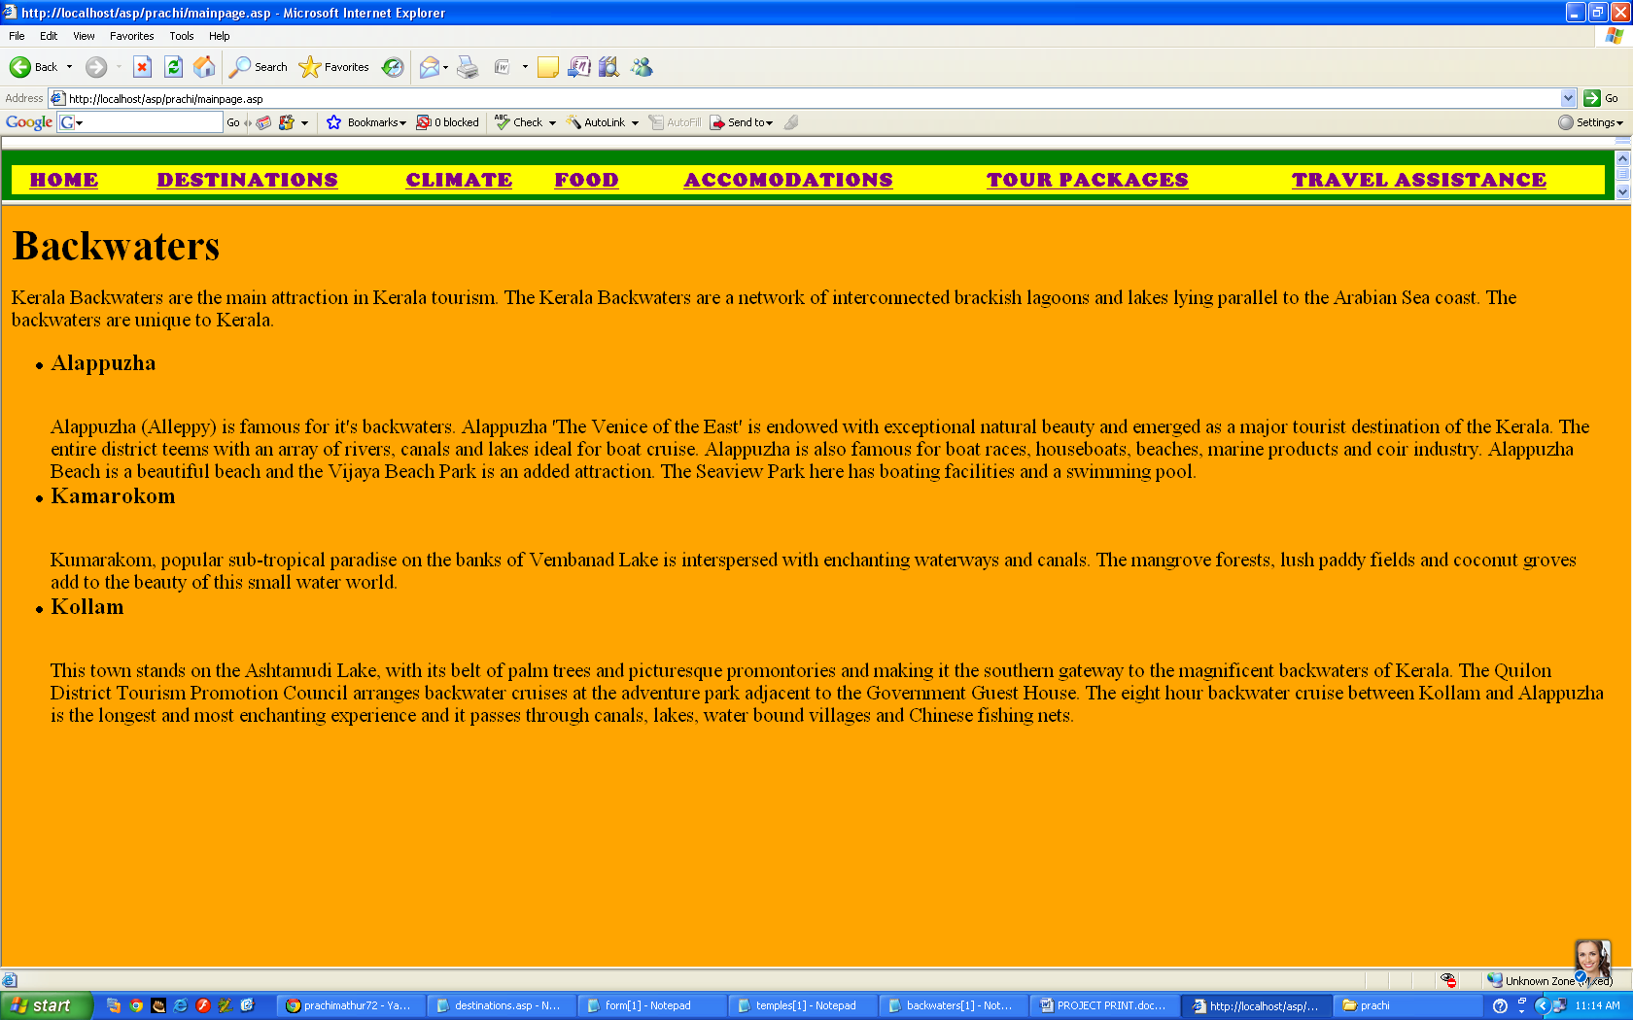

**WILDLIFE SANCTURIES**

<html>

<head><title>Wildlife Sancturies</title></head>

<body bgcolor="orange">

<h1>Wildlife Sancturies</h1>

<p>Kerala, also called God's Own Country, has national parks, bird sanctuaries, wildlife sanctuaries and tiger reserves. Kerala is famous for its rich and diverse flora and fauna, is also home to a innumerable species of rare wildlife found nowhere else on the world. The enchanting green and rain forest with elephants, nilgiri Tahr, tigers, leopards, lion-tailed macaque, deer, gaurs, monkeys, civet cats, squirrels including the Malabar giant squirrel and many indigenous and water birds gives the tourist a rare sight.Kerala is becoming a favorite hot spot among bird lovers and nature lovers from across the world. A visit to Kerala bird sanctuaries will give you the pleasure to meet a variety of migratory birds that cluster in thousands, some from the Himalayas, and some even from Siberia. You can also enjoy the priceless show of avian acrobats, pulsating on the beats of nature. During the rains, some of India's most spectacular avians gather in their finest haunts to court their mates and nest in huge colonies in the trees lining the paths of the sanctuaries.

<ul tyle="disc"></p>

<li><h3>Periyar Wildlife Sanctuary</h3><br>

Periyar, a nature reserve of Kerala is one of the most noted wildlife sanctuary in India. The park is famous by the name thekkady also. It has a picturesque lake at the heart of the sanctuary. This sanctuary formed with the building of mullaperiyar dam in 1895. Boat cruises on the lake are the best way of viewing animals at close and to explore the park.

<li><h3>Kumarakom Bird Sanctuary</h3><br>

It is situated on the banks of the Vembanad Lake, and is famous all over the world for its avian population. It is a favourite haunt of migratory birds like the egret, siberian stork, heron, darter and teal that come from Himalayas or far places like Siberia. We can see a large number of local birds like Waterfowls, kingfishers, Cuckoos and Owls. The bird sanctuary spreads over an area of 14 acres. The best way to watch the Kumarakom Bird Sanctuary is a boat trip round the islands.

<ul>

<li>Nearest Airport : Kochi Airport Nedumbassery, about 106 km.

<li>Nearest Rail : Kottayam Junction, about 15 km.

</ul>

<li><h3>Thattekkad Bird Sanctuary</h3><br>

Located 12 km. from Kothamangalam and about 58 km from Kochi city. It has dense tropical evergreen forest and a population of over 500 species of exotic birds. This world famous bird sanctuary owes much of its fame to Dr. Salim Ali, the internationally renowned ornithologist. The sanctuary covers an area of 25 sq. km. stretching between the branches of river Periyar. There is also a rich variety of butterflies here. This one of the famous Bird-Sanctuaries Kerala.

<ul>

<li>Nearest Airport :Nedumbassery, about 70km.

<li>Nearest Railway Station : Aluva, about 50km.

</ul>

<li><h3>Chinnar Wildlife Sanctuary</h3><br>

The Sanctuary is located in the rainshadow region of Western Ghats of Kerala and it causes thorny scrub forests. The sanctuary is home to a large variety of plants and animals. The Chinnar River and Pambar rivers are the main perennial water resources in the sanctuary. The enchanting Thoovanam water falls lie deep within the Sanctuary on the Pambar River. This breathtaking cascade is a major tourist attraction. During your journey from Karimuthi to Chinnar you get to watch wild animals such as spotted deer, monkeys, elephants and peacocks roaming freely on either side of the road. This sanctuary is a natural habitat for wild animals such as the elephants, grizzly giant squirrel, loris, gaur, sambhar, chital, munjtac, leopards, hanuman monkey, panthers, sloth bear, rabbits and star tortoise.

</body></html>

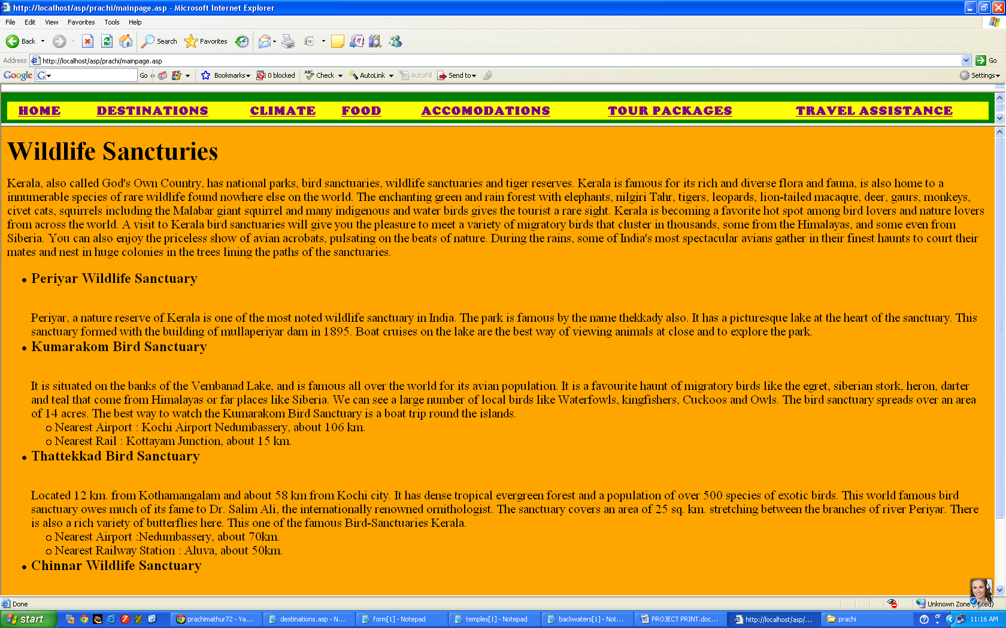

**HILL STATIONS**

<html>

<head><title>Hill Stations</title></head>

<body bgcolor="orange">

<h1>Hill Stations</h1>

<p>The high and rugged Western Ghats endow Kerala with a number of beautiful Hillstations. Expansive plantations of tea,coffee,rubber and fragrant cardamom, cinnamons, pepper and other spices for which Kerala is famous for, are cultivated on the slopes of these hill stations.</p>

<ul tyle="disc">

<li><h3>Munnar</h3><br>

The scent of fresh eucalyptus leaves, Verdant green hills and rolling tea gardens makes Munnar like a paradise. Munnar or the 'three rivers' nestles amidst Western Ghats at the confluence of three mountain streams(Mudrapuzha, Nallathani, and Kundala). It is one of the most popular tourist destinations of Kerala.

<li><h3>Kumarakom Bird Sanctuary</h3><br>

Ponmudi is 61 kms away from Thiruvananthapuram and is located in a rich forest area, this place may be of interest to those who are interested in tropical vegetation. The enchanting beauty of nature can be seen in the midst quiet surroundings. The climate is always pleasant and trekking and hiking are major attractions of the place.Ponmudi is also called the Golden Valley sneak peek. It is an access point to the river Kallar. Well-rounded pebbles, lush green trees, the cool water, fishes and the sheer wilderness of the park are the main attractions.

<ul>

<li>By Air: Nearest airport is Trivandrum International Airport.

<li>By Rail: Nearest railway station is Trivandrum.

</ul>

<li><h3>Wayanad Hillstations</h3><br>

Chembra PeakChembra Peak is the highest peak in Wayanad, at 2100m above sea level. The hills, rocks and valleys, which contribute to the very unique character of Wayanad. Nearest town is Meppady which is 12 km away from Kalpetta. Trekking to the top of the peak takes one full day. Tourists can stay at the top of the peak in temporary camps. District Tourism Promotion Council provides guides and necessary accessories on hire. You can enjoy the scenic beauty of Wayanad, which is visible from the top of Chembra, is very stimulating.

</body></html>

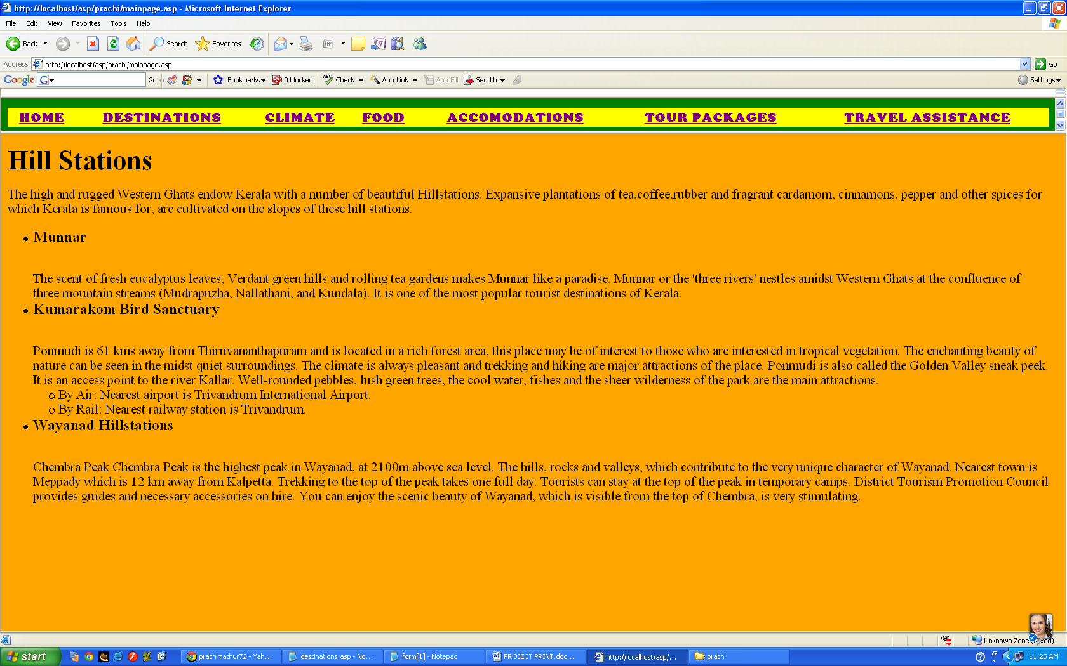

**CLIMATE**

<html>

<head><title>climate</title></head>

<body bgcolor="yellow">

<font color="blue"><h1>Climate of Kerala</h1></font>

Although Kerala lies closer to the equator than most Indian states, it is blessed with pleasant and equable climatethroughout the year. This is because of the land’s nearness to the sea and the presence of the natural fort likeWestern Ghats on the east that protect the state from dry and hot winds blowing from the north. Kerala receives copious rain (average 3000 mm) each year. The temperature normally ranges from 28’C to 32’ C(82’F to 90’ F) on the plains but drops to about 20’C (68’ F) in the highlands. The Highlands of Kerala, enjoys a cool and invigorating climate the year-round. Owing to its diversity in geographical features, the climatic condition in Kerala is diverse.<br>

It can be divided into 4 seasons - Winter, Summer, South-West Monsoon and North-East Monsoon.

<h4><font color="blue">The visitors must pack their bag in the season of winter to visit this beautiful land of dream and imagination. <br>

The rainy season has its own beauty, if you plan to take a break in the back waters of the Alleppey. <br>

The lush green picturesque view with wings of imagination will make you feel to be in Elysian.<br>

The mortal souls do not know what heaven is, you must not miss the golden opportunity to take a peep-a-boo in this country of coconut trees and "God of Small Things". <br>

Take your family and acquaintance to this place to be charmed by the beauty of Kerala.</h4><font color="blue"></p>

<table border=2 width="1000">

<tr bgcolor="blue"><th width="100"></th><th width="100">January</th><th width="100">February</th><th

width="100">March</th><th width="100">April</th><th width="100">May</th>

<th width="100">June</th><th width="100">July</th><th width="100">August</th><th width="100">September

</th><th width="100">October</th><th width="100">November</th><th width="100">December</th></tr>

<tr><th width="100">Maximum Temperature</th><td width="100">30</td><td width="100">31</td><td width="100">32</td>

<td width="100">34</td><td width="100">34</td><td width="100">30</td>

<td width="100">29</td><td width="100">29</td><td width="100">30</td><td width="100">30</td><td width="100">30</td>

<td width="100">31</td></tr>

<tr><th width="100">Minimum Temperature</th><td width="100">22</td><td width="100">23</td>

<td width="100">24</td><td width="100">25</td><td width="100">25</td><td width="100">24</td>

<td width="100">23</td><td width="100">23</td><td width="100">23</td><td width="100">23</td>

<td width="100">23</td><td width="100">22</td></tr>

</table></body></html>

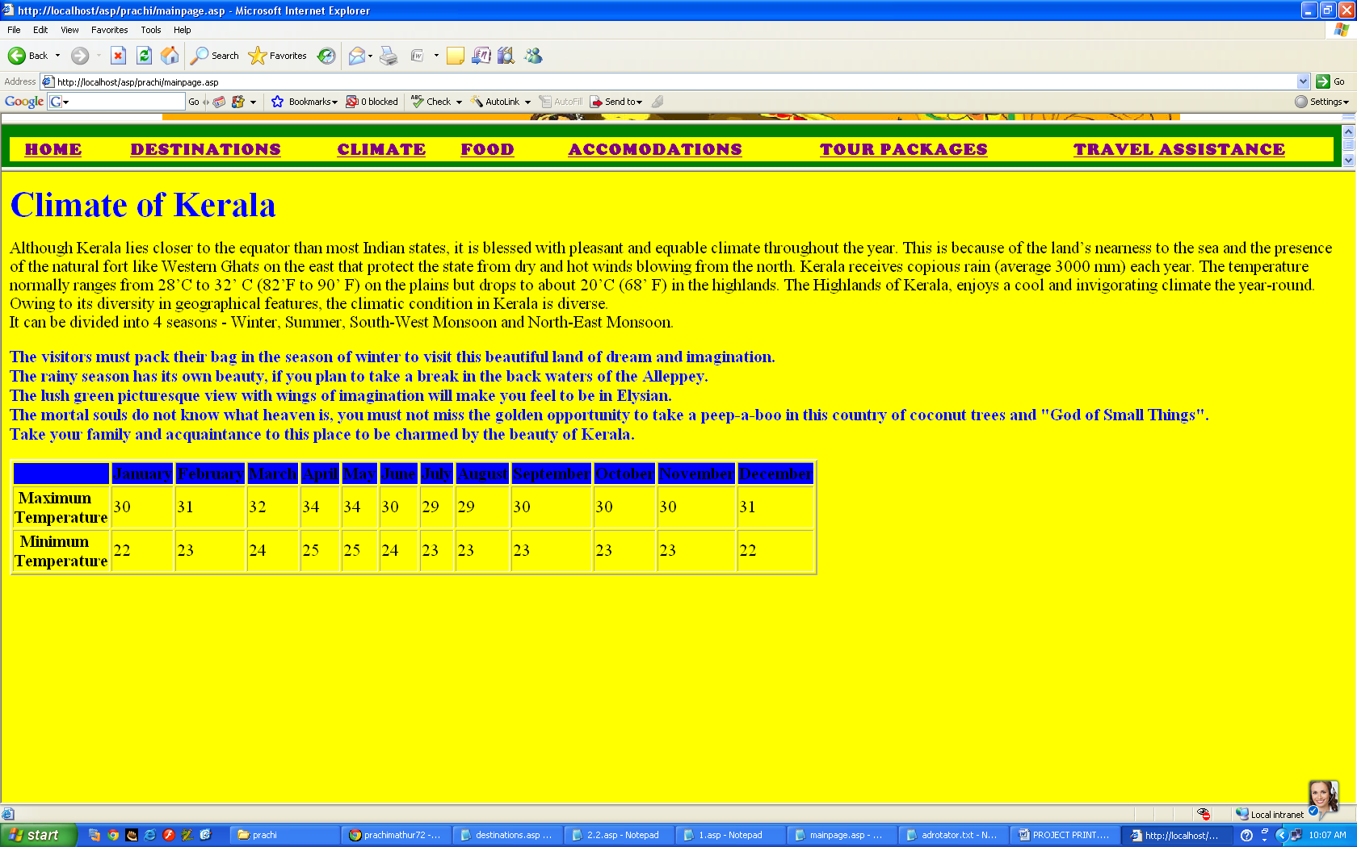

**FOOD**

<html>

<head><title>food</title></head>

<body bgcolor="green">

<h1>Kerala:"The land of Spices"</h1>

<font size=4 color="white">

<p>Traditionally, in Kerala food is served on a banana leaf. One has to take food with right hand. Almost every dish prepared in Kerala has coconut and spices to flavour the local cuisine giving it a sharp pungency that is heightened with the use of tamarind, while coconut gives it its richness, absorbing some of the tongue-teasing, pepper-hot flavours. The unusual cuisine of Kerala brings to the fore the culinary expertise of the people of Kerala. Producing some of the tastiest foods on earth, the people of Kerala are gourmets with a difference.<br></p>

The famous restraunts of Kerala are-

<ul type="square"><p><li><b>Leo Restaurant(Trivandrum)</b><br>

<center><img src="leo.jpg"></center>

Visiting Kerala for the first time and have landed up in Trivandrum, then you must check the Leo Restaurant in Kovalam.Apart from the evening snacks, this restaurant is a perfect place to enjoy and relish the South Indian dishes duringdinner.The price is reasonable.So don’t forget to stop at the lemon ginger soda on one hot afternoon!!

<ul>

<li>Address: Light House beach, Kovalam 695527, India

<li>Price: Below 10 USD

</ul></p>

<p><li><b>Harbour Restaurant</b><br>

<center><img src="Old-Harbour-Hotel.jpg" height="250" width="350"></center>

Alleppey is an exquisite place where you can spend your long holiday.Try the Harbor Restaurant and certainly you will love this one. Apart from the food, you would love the interiors and ethnic sitting of the place along the beach road which is simply perfect. With an impeccable blend of rural and urban décor, this restaurant is not far from being a preferred tourist destination. Mainly known to be a marvelous South indian Restaurant, one can also try out different sea food platters.

<ul>

<li>Address: Beach Road, Allapuzha, Kerala

<li>Ambience: Ethnic

<li>Price: Below 10 USD

</ul></p>

<p><li><b>Indian Coffee House(Trivandrum)</b><br>

<center><img src="photo-of-coffee-shop.jpg" height="250" width="400"></center>

For the ones who love coffee and wish having a real taste of coffee then visit to the Indian Coffee House is the best.It is acknowledged as the Hard Rock Café of Trivandrum and is believed to be very trendy. Spicy masala dosa together with a cup of coffee is a perfect joint to sit down, relax while chat. Apart from the southern dishes, toasts and eggs are also famous here. This coffee house is mainly the best place for the individuals to cherish the particular culture of Kerala and hear the local musicians. So treasure all this in Indian Coffee House.</p>

<p><li><b>Arca Nova Restaurant(Cochin)</b><br>

<center><img src="fort-house.jpg" height="250" width=400"></center>

This restaurant is one in which you can hop into all of a sudden whenever you are hungry.With contemporary amenities, impeccable services and notable interiors done by professional designers, this place is a perfect waterfront hotel located inside the Forthouse hotel which lies on the Calvathy road before the Fort Kochi in Cochin. The place is not just about food, however is well known for its interior and cool breeze which flows from the Arabian Sea together with the calm and soft sound of the waves which splash against the pier which further accelerates the entire experience.

Apart from all this, this hotel is multi cuisine and has everything from American, European to South Indian Veg and non veg dishes.

You will feel excellent, relish tempting dinner and experience the most unforgettable – a perfect value for money!

spent.

<ul>

<li>Address:2/6A Calvathi Road ,Cochin 682 001,Kerala, India

<li>E Mail: fort_hs@yahoo.com

</ul></p></font>

</body></html>

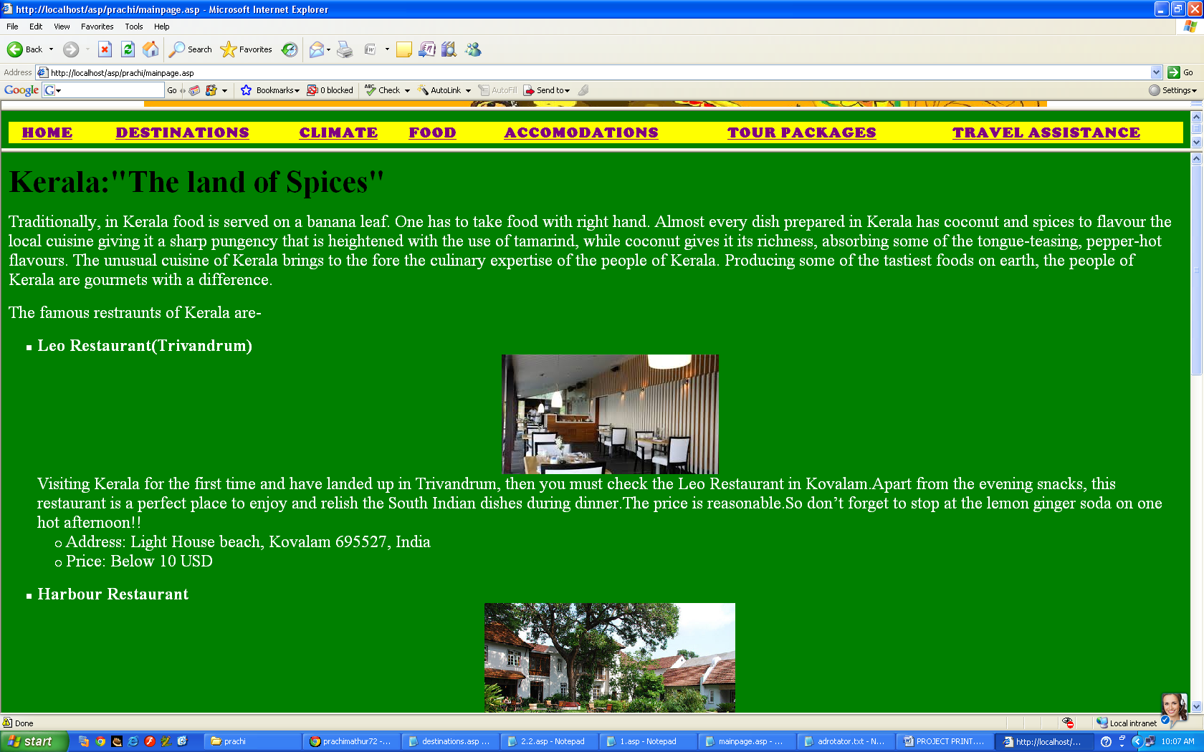

**ACCOMODATIONS**

<html>

<head><title>Accomodations</title></head>

<body bgcolor="olive green">

<h1>Hotels In Kerala</h1>

<img src="1369345106749.jpg" align="top" height="250" width="350"><h2>The Gateway Hotel Beach Road(Calicut)</h2>

The Gateway Hotel Beach Road is one of a kind hotel and the only five star hotel in the city of Calicut. The Gateway Hotel Beach Road belong to the famous chain of Taj Hotels. Hotel is nestled among five acres of lush greenery that plays a major role in the rejuvenation packages that are offered by the hotel group.

<h2>Le Meridien Cochin Resort & Convention Centre</h2>

<img src="hotel-le-meridien-cochin.jpg" align="top">

Le Meridien Hotel of Cochin is part of the world renownded chain of Le Meridien Group of Hotels. Hotel have won award for the best 5 star hotel of Kerala.

<h2>Taj Malabar Cochin</h2>

Hotel offers a unique combination of unparalleled luxury and combination of traditional Indian hospitality.

<h2>Trident Cochin</h2>

<img src="room-at-trident-cochin.jpg" align="top">

Hotel Trident is a true value for money hotel. Hotel Trident offers the relaxation and comfort that guests coming to this hotel are looking for. Hotel is situated at a drive of just 20 minutes from some major tourist attractions of the city.

<h2>Casino Hotel</h2>

Hotel Casino is truly a world class five star hotel. Located on the Willingdon Island hotel is an ideal get away from the tiresome life of Cochin.

<h2>Brunton Boatyard</h2>

<img src="brunton-boatyard-cochin.jpg" align="top">

The style and principles used for building Brunton Boatyard are those of Dutch and Portuguese architecture.

<h2>Kumarakom Lake Resort(Kumarakom)</h2>

Lake Resort is a true heritage resort as it provides guests with the taste of living in traditional Kerala style of cottages. Historical significance of these cottages are truly surprising as every detail have been kept by the hotel staff who are more than happy to tell you the tales behind these cottages.

<h2>The Malabar House Hotel(Cochin)</h2>

<img src="the-malabar-house-cochin.jpg" align="top">

The Malabar House Hotel, is situated in the middle of an heritage building and is facing the St. Francis church. An impressive collection of art is incorporated here in rooms and around the hotel but still Malabar House is able to Offer several luxuries.

<h2>Club Mahindra Lake View Resort(Munnar)</h2>

Club Mahindra Lake View Resort is surounded with green mountains. Resort Club Mahindra Lakeview Munnar provides a truly exotic view of the descending mountain slopes that are covered with verdant tea gardens.

<h2>The Muthoot Plaza(Trivandrum)</h2>

<img src="download.jpg" align="top">Hotel The Muthoot Plaza is part of the Indian hotels chain of Sarovar Park Plaza Hotels and Resorts. Hotel is considered one of the premiere business class hotels here in Trivandrum. Hotel The Muthoot Plaza interiors have been done tastefully and this reflects as soon as one enter the lobby of the hotel.

<h2>Kovalam Ashok Beach Resort</h2>

Hotel Kovalam Ashok Beach Resort is nestled at the southern most tip of the beautiful Malabar Coast, that is covered with the sand on beaches and is touched by the vast Arabian sea.

<h2>Taj Garden Retreat (Varkala)</h2>

<img src="download (1).jpg" align="top">

Taj Garden Retreat hotel is a low rise hotel and is one of its kind in the city of Varkala. Hotel offers stunning view of the sea from the windows of the rooms. Also, the location of the hotel atop a majestic red cliff Hotel Taj Garden Retreat offers very hospitable staff who have been trained and taught to provide comfortable stay at the hotel.

</body></html>

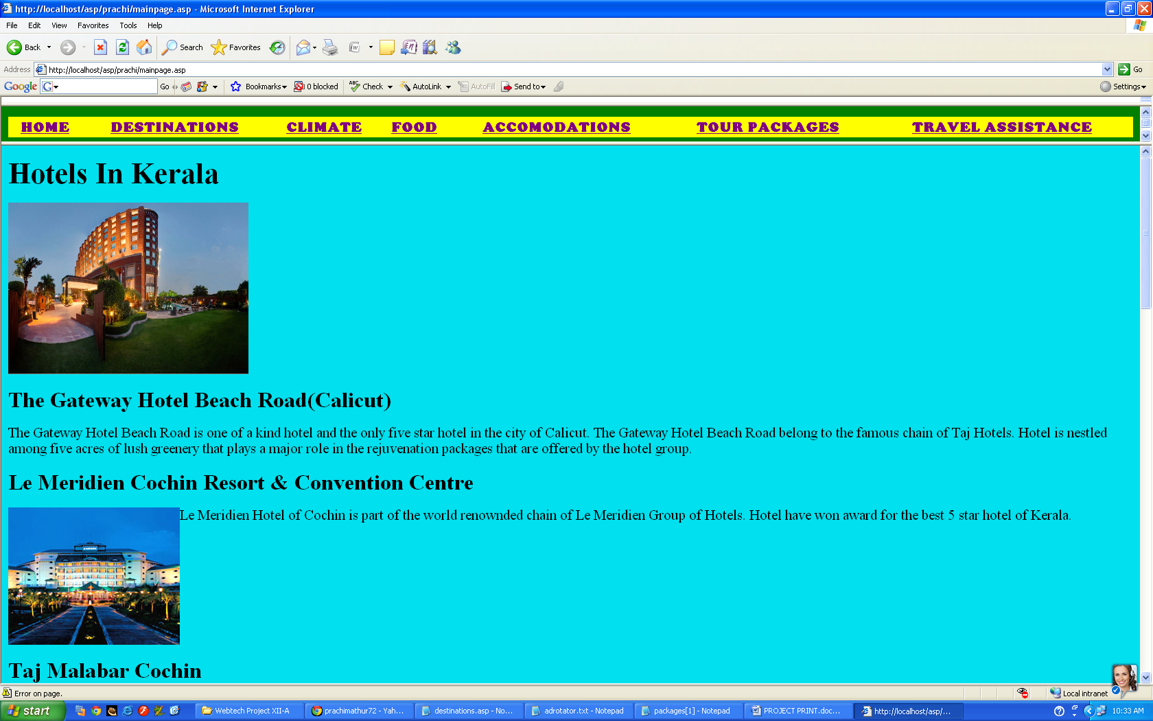

**PACKAGES**

<html>

<head><title>tour packages</title></head>

<body bgcolor="maroon">

<font color="white">

<h1>Tour Packages</h1>

<ol type="i">

<p><b><li>PACKAGE1-KERALA PACKAGE (9 N 10 D)</b>

<ul>

<li>Destination : Cochin, Munnar, Periyar, Alleppey ,Kovalam, Kanyakumari, Trivandrum

<li>Duration : 09 Nights / 10 Days

<li>Travel Pass – Indian Rupees:10000/-per person

<li>Travel Pass – Indian Rupees:8600/-per child

<li>Price Inclusion

<ul type="square">

<li>4-Star Hotel Accommodations for Four Nights

<li>Transportation by Air-Conditioned Coach

<li>Sightseeing Excursion

<li>Guide in 25 languages available

<li> Traditional State Food

</ul></ul></p>

<p>

<b><li>PACKAGE 2-Kerala Hop On Hop Off Flexi Stay Tour</b>

<ul>

<li>Destination : Cochin, Alleppy, Periyar, and Munnar

<li>Duration : 4 Nights

<li>Travel Pass – Indian Rupees.5500/-per person

<li>Travel Pass – Indian Rupees.3500/-per child

<li>Price Inclusion

<ul type="square">

<li>3-Star Hotel Accommodations for Four Nights

<li>Transportation by Air-Conditioned Coach

<li>Half-day Sightseeing Excursion in Munnar

<li>Guide

</ul></ul>

<b><li>PACKAGE 3-GLIMPSE of KERALA PACKAGE (6 N 7 D)</b>

<ul>

<li>Destination : Cochin, Munnar, Periyar ,Thekkady, Alapuzzha,Kovalam, ,

<li>Duration : 6 Night and 7 Days

<li>Travel Pass – Indian Rupees:8500/-per person

<li>Travel Pass – Indian Rupees.6500/-per child

<li>Price Inclusion

<ul type="square">

<li>3-Star Hotel Accommodations for Four Nights

<li>Transportation by Air-Conditioned Coach

<li>Guide

<li> Traditional State Food

</ul></ul></p>

<b><li>PACKAGE 4-Kerala Weekend Tour</b>

<ul>

<li>Destination Covered: Munnar – Alleppey - Kochi

<li>Duration: 03 nights and 04 days

<li>Travel Pass – Indian Rupees:7300/-per person

<li>Travel Pass – Indian Rupees.5800/-per child

<li>Price Inclusion

<ul type="square">

<li>Accommodation on double sharing basis

<li>Breakfast.

<li>A/C Indica car for all transfers and intercity travel (sightseeing).

<li>A/C deluxe houseboat in Alleppey with all meals with deluxe and luxury Hotels. (a/c working 9:00 PM to 6:00 AM)

<li>All Toll tax, parking, fuel charge, driver allowance etc.</ul></ul>

</body></html>

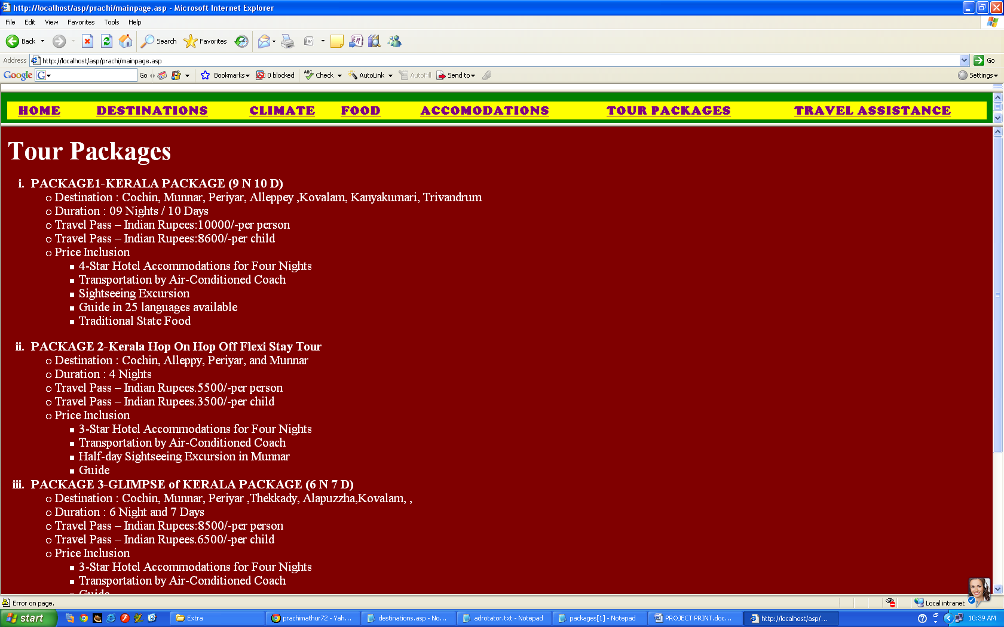

**FORM**

<html>

<head><title>feedback</title>

<%

dim strconn, objconn, objRS

set objconn=server.createobject("ADODB.Connection")

strconn=Provider="Microsoft.Jet.OLEDB.4.0; data source="&_"packages1.accdb"

set objRS="server.createobject("ADODB.Recordset")

objRS.open "Order" , objconn

objRs("Name")=request.form("t1")

objRs("Address")=request.form("t2")

objRs("Packages")=request.form("t3")

objRs("No of adults")=request.form("t4")

objRs("No of Kids")=request.form("t5")

objRS.close

objconn.close

set objRS=nothing

set objconn=nothing

%>

<script language="vbscript">

sub b1_onclick

dim a,b,c

document.form1.t4.value=a

document.form1.t5.value=b

document.form1.t6.value=c

if selected.value="0" then

c=(cint(a)*10000)+(cint(b)*8600)

else if selected.value="1" then

c=(cint(a)*5500)+(cint(b)*3500)

else if selected.value="2" then

c=(cint(a)*8500)+(cint(b)*6500)

else

c=(cint(a)*7300)+(cint(b)*5800)

end if

</head>

<body bgcolor="green">

<embed src="C:\Users\Owner\Desktop\html\ishq wala love instrumental - [Mp3Truck.Net].mp3"

hidden="true" autostart="true" loop="true">

<form name="form1">

<center><%

set mycontrot=server.createobject("mswc.contentrotator")

response.write(mycontrot.choosecontent("contentrotator.txt"))

%></center>

<b>Name:</b><input type="text" maxlength="40" name="t1"><br>

<b>Phone:</b><input type="text" maxlength="15" name="t2"><br>

<b>Address:</b><textarea cols="40" rows="5"></textarea><br>

<b>City:</b><input type="text"><br>

<b>Country:</b><input type="text"><br>

<b>E-mail:</b><input type="text" maxlength="60"></br>

<b>Sex:</b><br>

Male :<input type="radio" name=1 value="Male">

Female:<input type="radio" name=1 value="Female"><br>

<b>Please choose the package desired:</b><br><select name="t3">

<option selected>PACKAGE 1</option>

<option>PACKAGE 2</option>

<option>PACKAGE 3</option>

<option>PACKAGE 4</option>

</select><br>

<b>Number of adults:</b><input type="text" maxlength="3" name="t4"><br>

<b>Number of kids :</b><input type="text" maxlength="3" name="t5"><br>

<b>Any Special Requirements:</b><br><textarea cols="30" rows="5"></textarea><br>

<input type="submit" value="Submit" name="b1">

<input type="submit" value="Reset">

<br>

Calculated Amount:<input type="text" name="t6">

</form>

</body>

</html>

**DATABASE**

