Install Truenas

Set 6 Hard- disk

For windows

Create pool on TrueNas

Add Portal

Add Target

Add Intiator

Add Extends

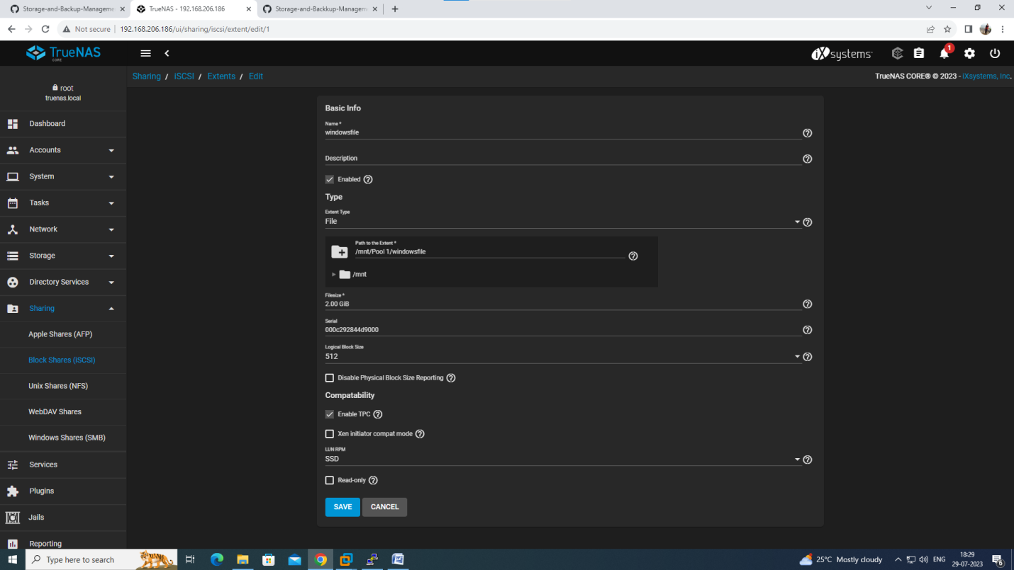

When you give name to extends, then

Choose Extend type = file

Then, provide path

/mnt/pool1/filename (file name is your extend name)

Filesize: 2 GB

Save

Search Iscsi Initiator in windows.

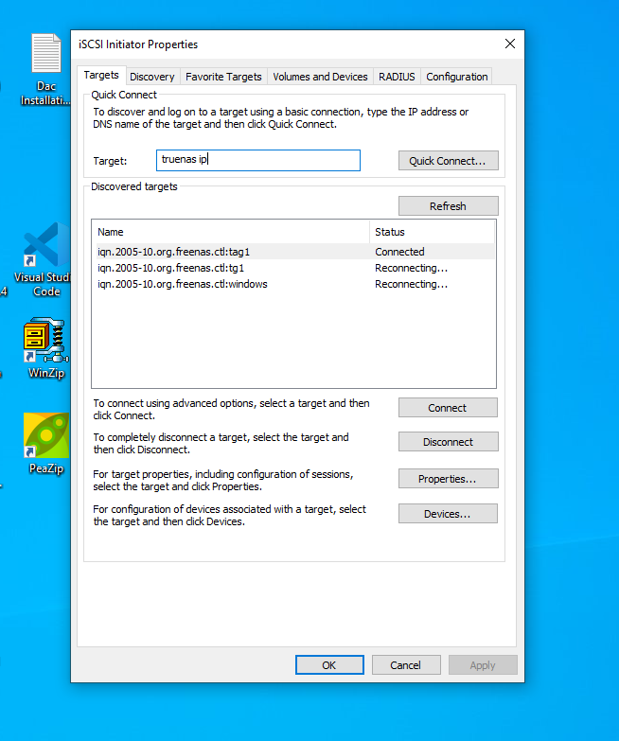

Provide your truenas ip address

Click Quick Connect

Search Computer Disk Management in windows.

Click on Disk Managetment

You will see Disks

Then right click on any disk

Select initialize disk

Again right click

Select Allocate

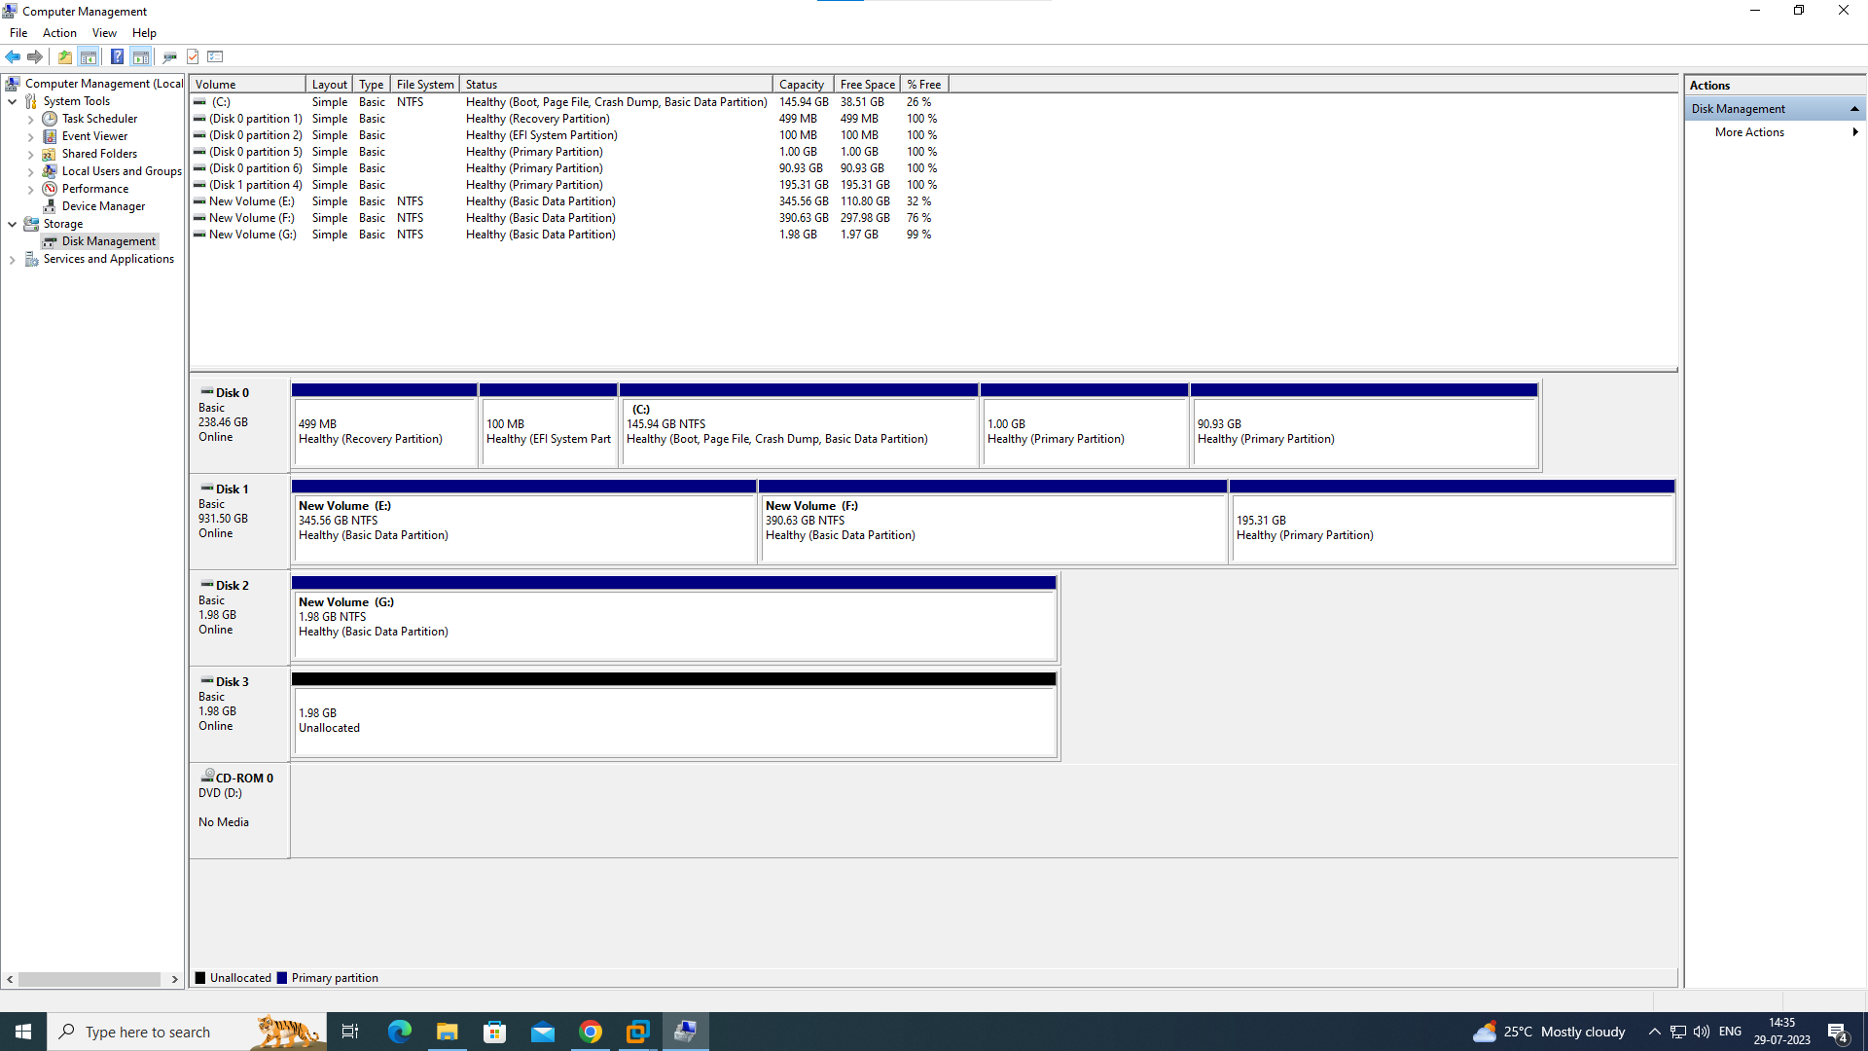

Go to This PC and right click on This Pc

Then Manage

Initilize

Allocate

Next next next

You will in This PC disk created

FOR LINUX

Create pool on TrueNas

Add Portal

Add Target

Add Intiator

Add Extends

[root@localhost ~]# yum install iscsi-initiator-utils

[root@localhost ~]# cd /etc/iscsi/

[root@localhost iscsi]# cat initiatorname.iscsi

InitiatorName=iqn.1994-05.com.redhat:602eee36c0c6

You have to add this iqn number in intiator

[root@localhost iscsi]# iscsiadm -m discovery -t st -p 192.168.206.186 (truenas ip)

192.168.206.186:3260,-1 iqn.2005-10.org.freenas.ctl:tag1

192.168.206.186:3260,-1 iqn.2005-10.org.freenas.ctl:tag2

[root@localhost iscsi]# fdisk -l

[root@localhost iscsi]# iscsiadm -m discovery -t st -p 192.168.206.186 --login

[root@localhost iscsi]# fdisk -l

[root@localhost iscsi]# lsblk

[root@localhost iscsi]# iscsiadm -m session

[root@localhost iscsi]# lsblk

[root@localhost iscsi]# fdisk /dev/sdb