Retail Sales Intelligence & Performance Analytics

1. Problem Statement
The objective of this project is to analyze the performance of a multi-branch retail network. Management needs actionable insights regarding branch profitability, product category performance, and customer loyalty behaviors to optimize inventory and marketing strategies.

2. Dataset Information
This project uses a self-generated synthetic dataset designed to mimic realistic retail transactions. It contains 1,000 records with attributes such as Transaction Date, Branch, Category, Product, Sales, Profit, and Customer Type.

3. Key Performance Indicators (KPIs)
• Total Sales
• Total Profit
• Average Transaction Value
• Profit Margin

4. Exploratory Data Analysis & Visualizations

4.1 Branch Performance
Analysis indicates distinct performance variances among branches. Branch A (New York) drives the highest volume.
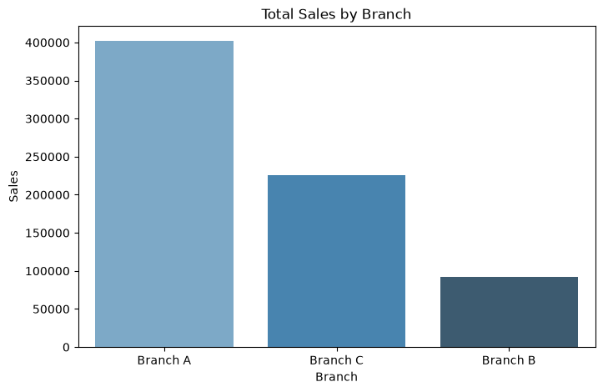

4.2 Profitability by Category
Electronics and Clothing contribute significantly to overall profit, although Electronics has tighter margins.
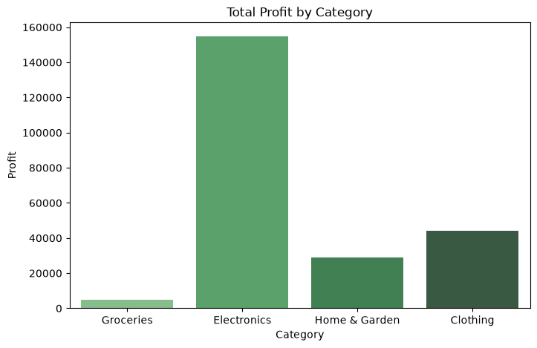

4.3 Time Series Trend
Sales trends show fluctuations over the months, indicating seasonal purchasing behaviors.
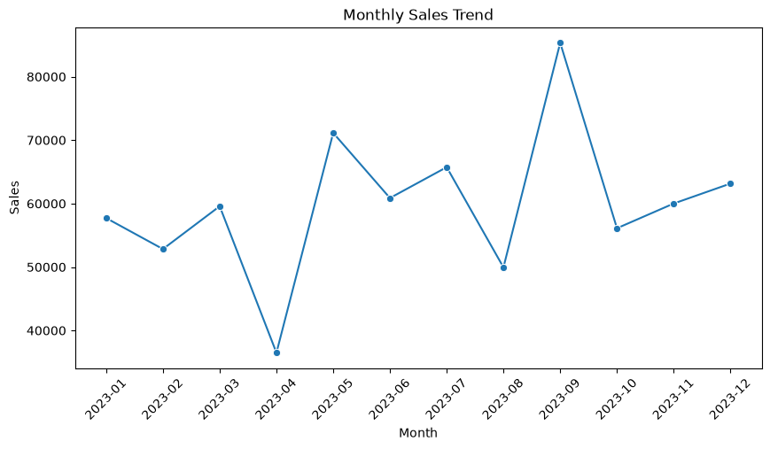

5. Key Insights & Opportunities
1. Branch A dominates total sales; inventory allocation should prioritize this hub.
2. Member customers show higher retention and ratings, indicating the loyalty program is effective.
3. Groceries drive footfall but have very low margins; they should be strategically placed to encourage cross-selling with higher-margin items like Home & Garden.

6. Business Decisions & Actions
• Action 1: Replicate Branch A's operational model in Branch B to improve satisfaction scores.
• Action 2: Introduce bundled discounts combining Electronics with high-margin Accessories to improve the profit margin per transaction.
• Action 3: Launch a targeted marketing campaign to convert 'Normal' customers into 'Members'.

