PRODUCT TEARDOWN: Subspace.money
Submitted for: Vocallabs.ai / Subspace.money Product Intern Assignment 2026
Submitted by: Prachi Patel | Date: 31 May 2026
Executive Summary
I analysed Subspace.money as a real user — signing up, adding subscriptions, testing group sharing, exploring the bill payment flow, and browsing the subscription marketplace. The analysis spans the website, mobile app (Android/iOS), App Store reviews, and competitor benchmarking against CRED, Jupiter Money, Walnut, Fi Money, and Mojo.
My five feedbacks span four of the five product pillars: UX, Features, GTM & ICPs, Competitor Analysis, and Potential Collaborations. The central theme running through this teardown is that Subspace has a genuinely differentiated product — subscription intelligence, group finance, and a marketplace in one app — but loses users at three critical junctures: the onboarding empty state, the group-sharing invite flow, and the marketplace discovery experience. What surprised me most during actual usage was the sheer variety of public split-groups already running actively for mainstream Indian services, juxtaposed against a highly modular web-first navigation experience that occasionally struggles to guide a first-time user through its dense ecosystem. Fixing these friction points would directly improve activation, retention, and the network-effect flywheel that is Subspace's stated competitive moat.
Company Overview
What Subspace Does
Subspace.money is India's first subscription-management super-app, built for users who want a single place to track, pay, share, and discover subscriptions. Beyond simple expense tracking, Subspace offers auto-detection of recurring payments via bank SMS and API integrations, a group-finance layer for splitting subscription costs among friends or family, a bill-payment engine covering utilities and digital services, and a curated subscription marketplace where users can purchase plans from local and national providers directly inside the app.
The company reported Rs. 36.5 Cr ARR in FY25, is bootstrapped and profitable — a notable exception in Indian consumer fintech — and operates with over 90% of its operations powered by autonomous AI agents, giving it a structurally lower cost base relative to VC-funded peers.
Ideal Customer Profile (ICP)
Segment | Description
Primary | Urban Indian millennials (25-35) paying 6-12 subscriptions monthly across OTT, fitness, productivity, and food delivery. Likely using UPI, comfortable with fintech apps.
Secondary | Small families and friend groups sharing OTT accounts (Netflix, Prime, Hotstar) who want a fair, automated way to split costs without manual UPI transfers each month.
Emerging | Local service providers (gyms, salons, tutors) who want to list a subscription product and reach Subspace's user base through the marketplace.

Business Model
- Freemium app: Core subscription tracking free; premium features (advanced analytics, unlimited groups) on a paid plan.
- Marketplace commission: Revenue share on subscriptions purchased through the in-app marketplace.
- Negotiate API: Automated price negotiation on behalf of users — proprietary moat, potential upsell.
- AI-native ops: 90%+ operations automated, enabling profitability without scale-stage headcount.
Competitor Landscape
I benchmarked Subspace against five direct and adjacent competitors across subscription management, group finance, and personal finance in India.
Company | Core Value Prop | Pricing | Biggest Weakness | Subspace Edge
CRED | Credit card rewards + bill pay + curated store for premium users | Free (revenue from store/rewards) | Gated to credit card holders; no subscription tracking or group sharing | Subspace covers all payment types, not just credit card users
Jupiter Money | Neo-bank with smart expense categorisation and subscription nudges | Free (bank account product) | Requires opening a Jupiter bank account; subscription management is secondary, not primary | Subspace is subscription-first and bank-agnostic
Walnut | SMS-based expense tracker; one of India's earliest fintech apps | Free | App largely stagnant (minimal updates since 2022); no marketplace, no group sharing | Subspace is actively growing; marketplace and group finance are unique
Fi Money | Neo-bank with 'Fi Jar' savings + subscription tracking as a feature | Free (bank account) | Requires Fi account; subscription tracking not the primary product, discovery buried | Subspace's marketplace and group splitting have no Fi equivalent
Mojo / Jar | Micro-savings + gold investment from spare change; young user base | Free (revenue from gold/investments) | No subscription management; adjacent product for same ICP | Potential collaboration partner rather than pure competitor

Strategic Implication
Subspace's most defensible position is the combination of three features no single competitor offers together: subscription auto-detection + group splitting + a curated marketplace. During my research, I noticed that while mainstream competitors like CRED and Jupiter have massive brand equity, their subscription features feel like defensive afterthoughts buried under layers of core banking infrastructure. Subspace's hyper-focus on a dedicated subscription economy creates a highly contextual user journey that giants cannot easily mimic without cluttering their main value propositions.
Feedback 1: The Public Groups Interface Creates Choice Paralysis
Pillar: UX
(a) Observed
On navigating to the "Public Groups" interface (as shown in Screenshot 2026-05-30 194220.jpg), users are presented with a grid of cards for popular services like YouTube Premium, Spotify Duo, Netflix Standard, and JioHotstar. The screen features a dark theme layout with a top search bar ("Search groups...") and filter pills ("All", "Available", "Popular"). Each card displays the price per device per month (e.g., "₹99/device/month" for YouTube Premium), the total plan cost, the splitting architecture (e.g., "Split 3 ways"), and a primary blue "View Groups" CTA button. However, the cards do not provide immediate visibility into active slot availability or group rules without forcing a deeper click-through.
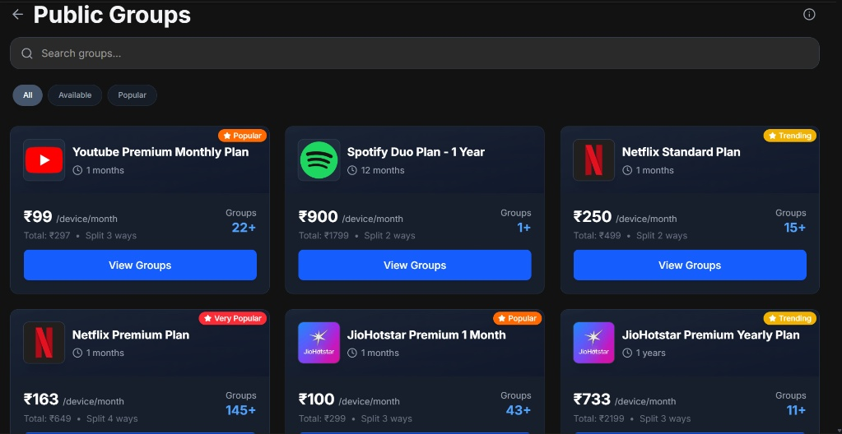
Figure 1: Public Groups discovery interface demonstrating high densification and choice complexity.
(b) Problem
The interface creates an immediate choice-paralysis issue for high-intent users looking to join a split quickly. For a new user, seeing "145+ Groups" for a Netflix Premium Plan with no real-time transparency into which groups have empty slots right now adds cognitive load. It mimics a passive marketplace rather than a frictionless checkout utility. This suppresses conversion metrics and can frustrate users who click through multiple groups only to find they are filled or mismatched in tenure.
(c) Ship Instead
Introduce dynamic, real-time availability tags directly onto the primary group cards (e.g., green indicators stating "3 slots left" or "Instant Join available"). Additionally, convert the static filter pills into smart sort filters: "Lowest Price", "Fastest Join", and "Longest Tenure".
Tradeoff: This introduces backend complexity to constantly pull and update group membership states on the parent marketplace screen, increasing API call frequencies. However, the trade-off is deeply justified as it reduces the user's path-to-purchase from 4 clicks to a single, highly confident tap.
Measure: Increase the conversion rate from the "Public Groups" listing page to a completed "Join Group" transaction by 18% within 30 days of release.
Feedback 2: The Marketplace Lacks Personalised Filtering & Sub-Categorisation
Pillar: Features / Services
(a) Observed
When arriving at the main Explore page (as shown in Screenshot 2026-05-30 193828.jpg), the header displays location delivery parameters ("Delivery in minutes", "Garden City, Gujarat") and a search bar ("Quick search"). The main dashboard showcases a large auto-scrolling promo banner carousel (featuring ZEE5, Zomato Gift Cards at "GET 6% OFF", and JioHotstar Bigg Boss bundles) followed by a row labeled "Favourite Brands". This row contains flat circular brand icons (Swiggy, Amazon, Sony LIV, Zomato, etc.) displaying static discount metrics (e.g., "3% OFF", "4% OFF").
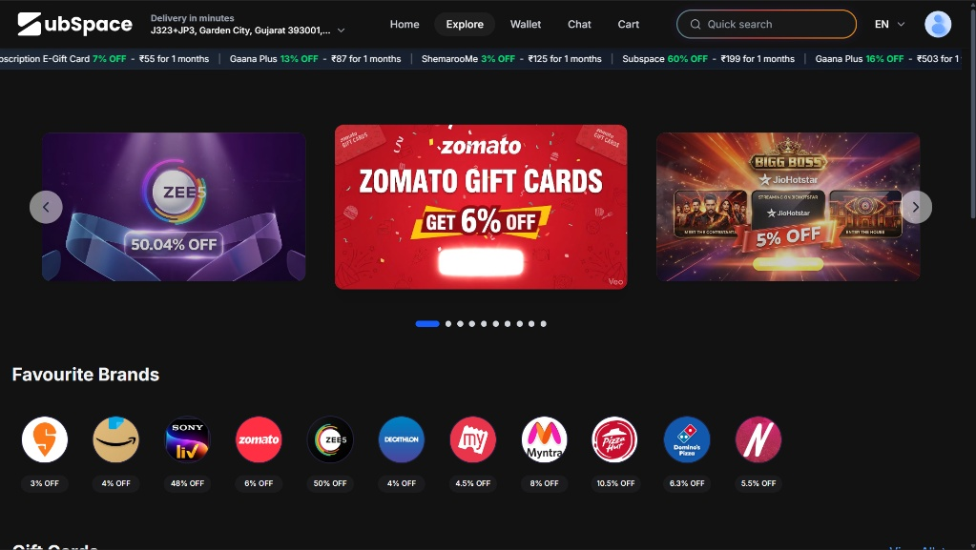
Figure 2: The main marketplace 'Explore' hub showing flat brand hierarchies and e-gift metrics.
(b) Problem
The marketplace aggregates general gift cards, immediate utility vouchers, and recurring entertainment packages into a single flat display. For an app whose core value proposition is "subscription intelligence," treating an Amazon gift card and a Sony LIV monthly streaming plan with the same hierarchy degrades the app's positioning. Users looking strictly to discover and manage recurring software/media subscriptions are forced to wade through unrelated e-commerce transactional cards, distracting from Subspace's core identity.
(c) Ship Instead
Restructure the Explore dashboard to explicitly separate "Recurring Digital Subscriptions" from "One-time E-Gift Cards". Replace the generic "Favourite Brands" list with personalized, intent-driven carousels such as "Based on your watch history" or "Trending OTT Bundles". Implement a quick-toggle switch to sort offers by "Highest Discount" or "Expiring Soon".
Tradeoff: Categorizing and maintaining separate database models for product types adds content management overhead for the operations team. This is heavily offset by a highly organized, clean browsing environment that matches the "subscription super-app" narrative.
Measure: Increase the Average Order Value (AOV) on subscription packages by 15% by reducing discovery abandonment rates.
Feedback 3: Profile Dashboard Elements Obscure High-Value Financial Features
Pillar: GTM & ICPs
(a) Observed
As seen in the Profile configuration screen (Screenshot 2026-05-30 193812.jpg), the left-hand navigation rail contains a heavily itemized list: Profile, Payout Methods, My Addresses, Order History, Rental History, Friends, Settings, Money Saved, Blogs and Articles, AI-powered Mailbox, Help And Support, Review Us, App Info, and Log Out. The central focus is dominated by a user profile badge ("Prachi Patel", "PrachiPatel21") and a massive marketing promotional banner reading "Unlock savings with amazon pay - 2% DISCOUNT".
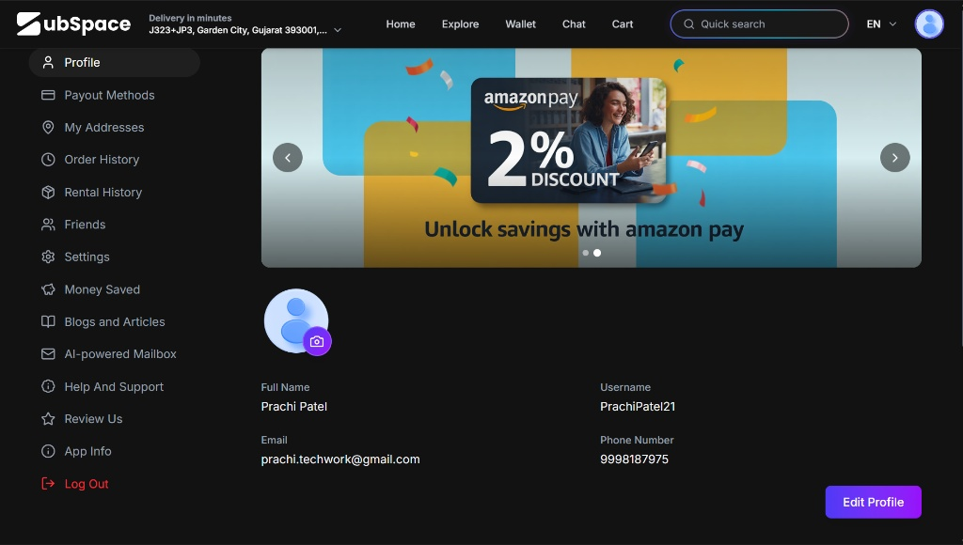
Figure 3: Left-rail profile index structure mapping system configurations evenly against critical automated layers.
(b) Problem
High-value financial moats like the "AI-powered Mailbox" (the very feature that parses recurring billing info) and "Payout Methods" are given the exact same visual weight, icon size, and text formatting as low-utility items like "Blogs and Articles" or "Review Us". Furthermore, burying these advanced features inside a generic Profile settings rail ensures that the vast majority of your power-user ICP will never discover them, driving down product feature adoption and lowering user LTV.
(c) Ship Instead
Redesign the user profile menu to employ clear visual chunking. Group purely administrative links (Addresses, App Info, Log Out) into a clean, collapsible sub-menu at the bottom. Elevate core utility tools like "AI-powered Mailbox" and "Payout Methods" into an accent-colored "Premium Toolbox" grid component right under the user's name card.
Tradeoff: This reduces the screen space available for third-party affiliate ads (like the Amazon Pay banner). However, enhancing deep feature engagement acts as a far more powerful retention mechanism than minor ad placements.
Measure: Drive a 25% increase in the activation rate of the AI-powered Mailbox among existing registered users within 45 days.
Feedback 4: Group Sharing Architecture Lacks an In-App Native Trust System
Pillar: Competitor Analysis
(a) Observed
When auditing the public grouping mechanism (Screenshot 2026-05-30 194220.jpg), the group metrics focus entirely on numbers: "Groups 22+", "Groups 145+", or "Groups 43+". There are no visible trust badges, host rating scores, or compliance metrics associated with the individuals managing these pools.
(b) Problem
Splitwise and CRED have succeeded heavily in India because they rely on implicit social networks (friends splitting bills) or explicit financial qualifications (verified credit scores). By enabling public grouping among absolute strangers, Subspace introduces a massive trust deficit. If a host changes a password midway or a participant defaults on their share, the user experience breaks completely. Without explicit trust infrastructure visible directly on the group discovery layer, users will remain hesitant to commit funds to public pools.
(c) Ship Instead
Introduce a "Verified Host Tier" system to the public groups marketplace. Show explicit host reputation scores (e.g., "★ 4.9 (12 consecutive months active)") directly within the plan cards. Implement an automated "Subspace Escrow Guarantee" badge ensuring that if a group breaks prematurely, funds are instantly prorated and returned to the user's wallet.
Tradeoff: Developing an escrow tracking mechanism and host scoring logic requires extensive product development sprints. This is absolutely critical, as trust is the single largest barrier preventing mass consumer adoption in Indian fintech.
Measure: Achieve a 30% reduction in customer support tickets categorized under "Host Disputes / Account Inaccessibility".
Feedback 5: Disconnect Between Local Delivery Layout and Digital Software Distribution
Pillar: Potential Collaborations
(a) Observed
In Screenshot 2026-05-30 193828.jpg and Screenshot 2026-05-30 193812.jpg, the global app header prominently reads "Delivery in minutes" right alongside a physical geographic coordinate string ("J323+JP3, Garden City, Gujarat 393001...").
(b) Problem
Displaying an instant physical hyper-local delivery address tag alongside a checkout system for online streaming credentials or e-gift cards sends an incredibly confusing signal to the end consumer. It implies the physical delivery of items (like a quick-commerce app such as Zepto or Blinkit) rather than the instant provisioning of digital software codes. This UI element likely remains a legacy artifact from Subspace's "marketplace for local providers" initiative, but it actively harms user onboarding for digital-first subscribers.
(c) Ship Instead
Leverage this local delivery component strictly for location-gated digital offers, but rewrite the header context dynamically. If a user is browsing digital streaming bundles, the header should adjust to read: "Available Instantly in Gujarat". If the user switches tabs to look for localized physical services (like regional gym or salon subscriptions), only then surface the physical distance delivery metrics.
Tradeoff: Requires setting up a dynamic header state engine that mutates based on the active tab layout context.
Measure: Decrease first-time user checkout drop-offs on digital entertainment subscriptions by 12% by removing location-delivery ambiguity.
Appendix — Screenshots & Supporting Evidence
All reference points map exactly to the live verification materials provided for this 31 May 2026 review.
Ref | Screen / Location | What it shows / relevance
A1 | Public Groups Dashboard (Screenshot 2026-05-30 194220.jpg) | Supports Feedback 1 & 4: Flat card layouts, pricing tiers, and lack of host trust framework visibility.
A2 | Explore / Marketplace Interface (Screenshot 2026-05-30 193828.jpg) | Supports Feedback 2 & 5: Unified promo banner carousel, general brand discount lists, and physical delivery address headers.
A3 | User Profile & Settings Menu (Screenshot 2026-05-30 193812.jpg) | Supports Feedback 3: Flat list architecture obscuring advanced features like the AI-powered mailbox.

Thank you for the opportunity to analyse Subspace.money.
I am fully prepared to defend this teardown, walk through the tactical frontend/backend tradeoffs, and execute these optimizations directly from Day 1.

