WEEK 3 TASK

Exploratory Data Analysis and Visualization Plan
Smart Supply Chain Analytics
An evidence-led plan for examining sales, product categories, profitability and delivery performance

Document Information | Details
Internship | Data Analytics Strategist Internship
Organization | InAmigos Foundation
Project title | Smart Supply Chain Analytics: Demand, Sales and Delivery Analysis
Dataset | DataCo Smart Supply Chain for Big Data Analysis
Deliverable | Week 3 EDA and visualization plan
Primary technology | Python in Jupyter Notebook
Libraries | pandas, NumPy, Matplotlib and Seaborn; Plotly optional
Planned effort | 33 hours (within the required 30–35 hour window)
Project stage | Exploratory analysis and visualization; advanced forecasting/dashboard work follows

Prepared as an actionable foundation for reproducible analysis and future dashboard development.

Contents
- 1. Executive Summary
- 2. Objectives and Scope
- 3. Dataset Overview and Data Grain
- 4. Business Questions
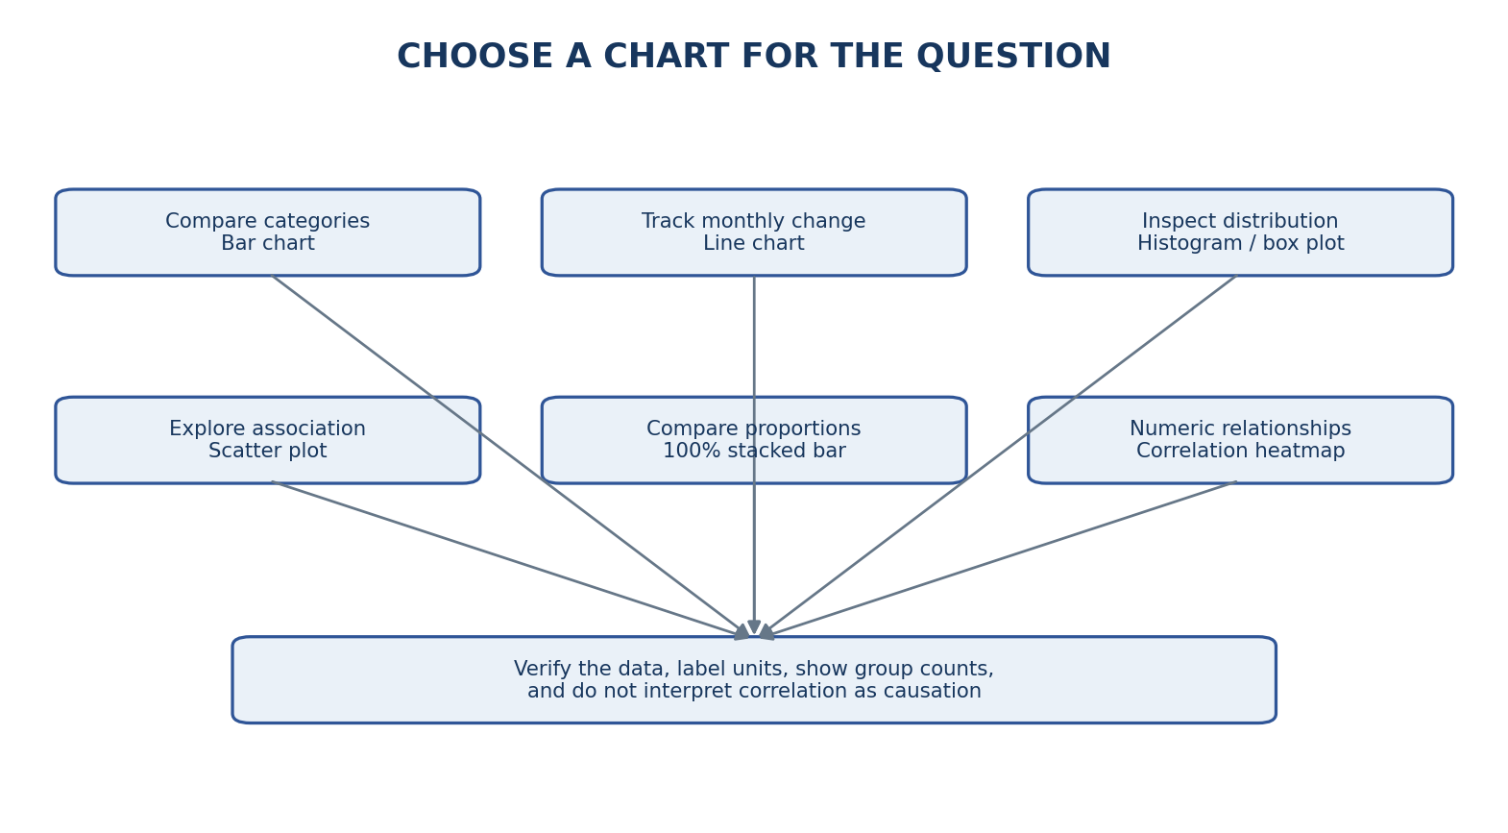
Figure 1. Chart selection aligned to the EDA business questions in the task.
- 5. Statistical Summarization Plan
- 6. Visualization Plan and Selection Rationale
- 7. Visualization Design and Interactivity
- 8. Python Tools and Notebook Structure
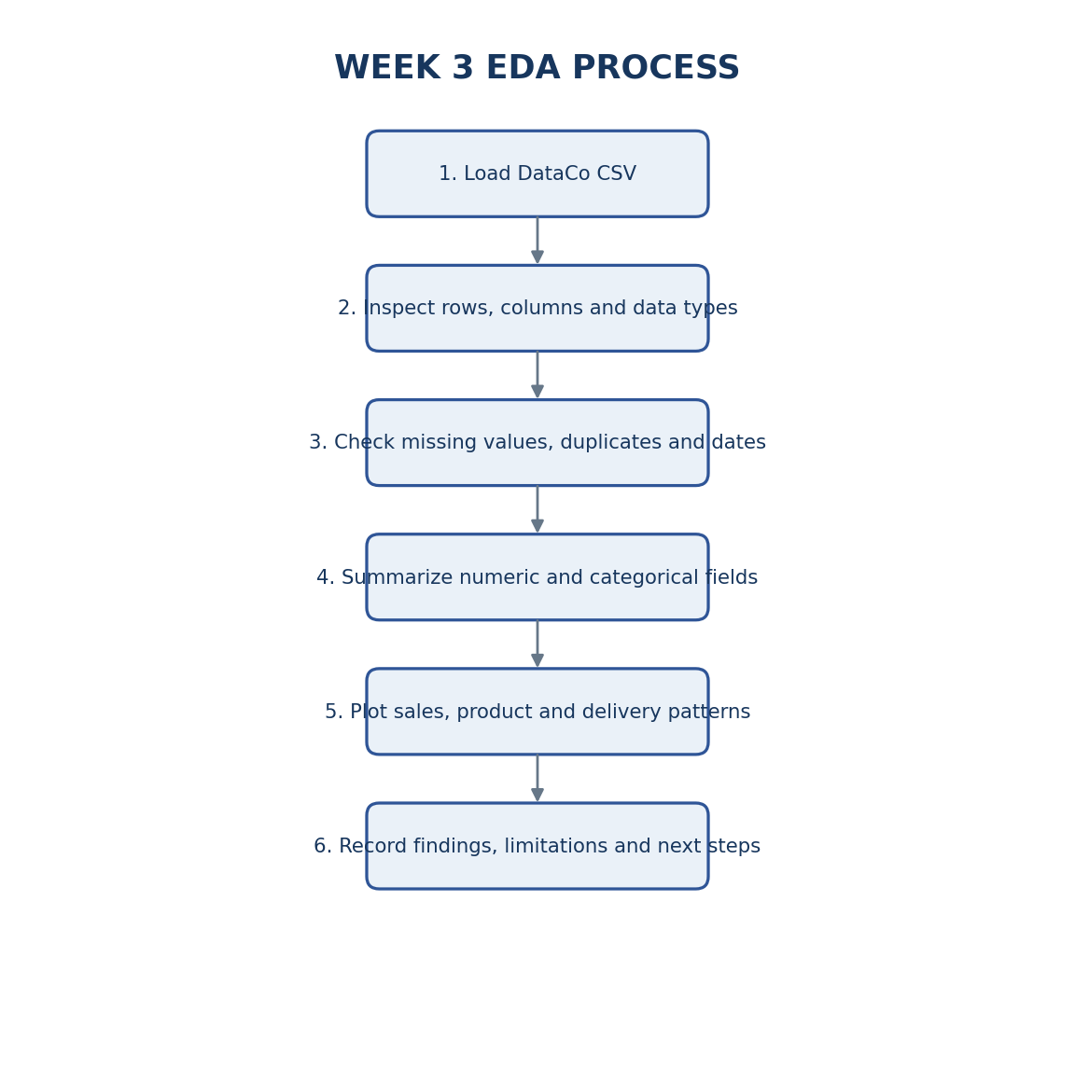
Figure 2. EDA workflow aligned with the supplied Week_3_EDA_Analysis.ipynb notebook.
- 9. Mock Analysis Plan: Hypotheses to Test
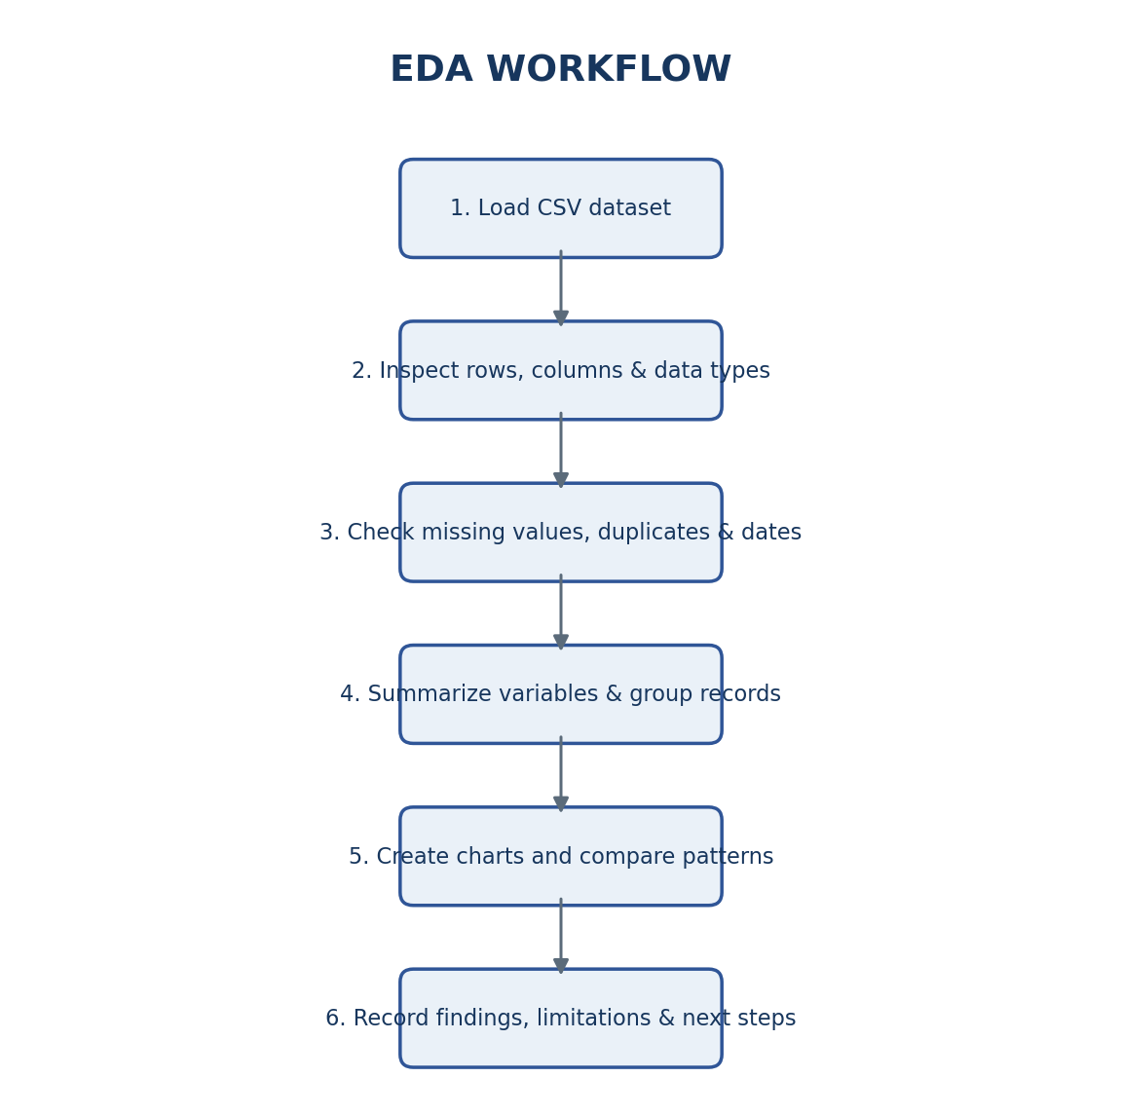
- 10. Data Quality, Limitations and Responsible Use
- 11. 33-Hour Timeline
- 12. Expected Deliverables and Success Criteria
- 13. Conclusion
- References

1. Executive Summary
Exploratory Data Analysis (EDA) is the structured process of profiling data, summarizing distributions, checking data quality and visualizing patterns before deeper statistical or predictive work. This Week 3 plan is aligned with the supplied Week_3_EDA_Analysis.ipynb notebook and the DataCo Smart Supply Chain dataset.
The notebook is designed to inspect dataset structure and data types; calculate descriptive statistics; assess missing values, exact duplicate rows and potential outliers; and visualize sales by month, product category, market/region and customer segment. It also examines shipping duration, actual versus scheduled shipping time, delivery status by shipping mode, order status, and selected numerical relationships such as discount and profit.
The notebook is a planned/reproducible analysis workflow. Unless the CSV has been loaded and the cells executed successfully, the report does not present chart rankings, correlations or business outcomes as verified findings. Possible patterns in this document are hypotheses to test, not conclusions.

2. Objectives and Scope
- Understand the dataset dimensions, columns, data types and level of detail.
- Produce numerical and categorical summaries, including counts, quartiles and missingness.
- Investigate data-quality concerns such as missing values, exact duplicates, invalid dates and implausible numeric values.
- Compare recorded sales across product categories, time periods, markets/regions and customer segments.
- Explore shipping duration, scheduled-versus-actual shipping time and delivery-status distributions.
- Explore associations between discounts, profit, quantity, sales and shipping-time variables without making causal claims.
- Create readable, labelled visualizations and export useful summary tables for later reporting.
Scope boundary: this EDA focuses on the fields available in the selected dataset. Complete inventory optimization, supplier scorecards and reliable future demand forecasting may require additional inventory, supplier, purchase-order, replenishment and future-period data not established as available in this dataset.

3. Dataset Overview and Data Grain
Dataset source: Kaggle — DataCo Smart Supply Chain for Big Data Analysis.
https://www.kaggle.com/datasets/shashwatwork/dataco-smart-supply-chain-for-big-data-analysis
The notebook expects a file named DataCoSupplyChainDataset.csv in the same folder as the notebook and reads it using pandas with latin1 encoding. The notebook prints the actual shape and column list at runtime. The supplied planning draft reported an initial profile of 180,519 rows and 53 columns, with Product Description fully missing, Order Zipcode substantially missing, and a small number of missing customer surname/zipcode values. These figures should be reconfirmed from the exact CSV used for submission.
Analysis group | Example fields in the notebook/report | Potential use
Sales and value | Sales, Order Profit Per Order, Order Item Discount | Compare recorded sales and explore profit/discount associations.
Order/item details | Order Id, Order Item Quantity, Order Status | Distinguish orders from item-level records and review status distribution.
Products | Category Name, Product Name, Department Name, Product Price | Compare category-level recorded sales and product mix.
Customers | Customer Segment, Customer City, Customer Country | Summarize sales by customer segment and explore geography.
Delivery/shipping | Delivery Status, Shipping Mode, Days for shipping (real), Days for shipment (scheduled), Late_delivery_risk | Compare shipping-time distributions and delivery outcomes.
Time/geography | order date (DateOrders), Market, Order Region, Order Country | Create monthly sales summaries and regional/market comparisons.

Data grain warning: the dataset contains order-item records. One order can appear on multiple rows. Repeated Order Id values are therefore not automatically duplicate records. Use exact full-row duplicate checks separately from unique-order counts and order-item record counts.

4. Business Questions

4.1 Sales and product mix
- Which product categories have the highest recorded sales?
- How do recorded sales vary by month?
- Which markets or regions contribute most to recorded sales?
- How do sales totals and row counts vary by customer segment?
- Are recorded sales concentrated in a limited number of categories or geographies?

4.2 Profitability and discounts
- How are Order Item Discount and Order Profit Per Order associated in the observed records?
- Are there categories with high recorded sales but comparatively lower recorded profit?
- Do unusual discount or profit values need data validation?

4.3 Shipping and delivery
- How does actual shipping duration vary by shipping mode?
- How does actual shipping time compare with scheduled shipping time?
- What is the distribution of Delivery Status within each shipping mode?
- Do shipping and delivery patterns differ by market or region?

4.4 Data quality
- Which columns contain missing values, and what percentage is missing?
- How many exact duplicate rows exist?
- Are dates parsed correctly and numeric values plausible?
- Which outliers need investigation rather than automatic removal?

5. Statistical Summarization Plan

5.1 Numerical variables
For relevant numeric fields such as Sales, Order Item Quantity, Order Item Discount, Order Profit Per Order and shipping duration, calculate non-null count, mean, median, standard deviation, minimum, maximum and 25th/50th/75th percentiles. The notebook uses df.describe() and adds missing counts and missing percentages for numerical columns.
The median and quartiles should be interpreted alongside the mean because skewed sales and profit distributions can make the mean less representative of a typical record. Inspect units and definitions before comparing variables.

5.2 Categorical variables
For Category Name, Customer Segment, Market, Shipping Mode, Delivery Status and Order Status, calculate frequency counts, percentage distribution, distinct category count and missing-value count. The notebook uses describe(include="all") and value_counts() for these summaries.

5.3 Grouped summaries and counting rules
Use groupby summaries to calculate total recorded sales by category and market/region, sales by customer segment, and count/mean/median/minimum/maximum shipping duration by shipping mode. Report the aggregation unit clearly: row count, order-item count and unique Order Id count are different measures. Totals should be checked for duplicated business meaning before being interpreted as distinct-order revenue.

6. Visualization Plan and Selection Rationale
Visualization | Fields / method | Why this chart fits | Interpretation to test
Missing-value horizontal bar chart | Missing percentage by column | Ranks columns by missingness and makes long labels readable. | Which fields need exclusion, recovery or an explicit missing-data policy?
Box plots for numeric fields | Sales, quantity, discount, profit and actual shipping days | Shows median, spread and potential outliers. | Are extreme values valid observations or possible data issues?
Line chart: monthly sales | Parsed order date grouped to month-start; sum Sales | Shows chronological changes and possible recurring patterns. | Are there peaks, declines or seasonality supported by the full time span?
Horizontal bar chart: sales by category | Category Name grouped by sum of Sales | Makes category rankings easy to compare. | Which categories lead recorded sales?
Horizontal bar chart: sales by market/region | Market, or Order Region if Market is unavailable; sum Sales | Supports ranking across geographic groups. | Where is recorded sales activity concentrated?
Histogram: sales distribution | Sales values; bins selected for readability | Shows skewness, concentration and long tails. | Are most records in lower value ranges with a smaller high-value tail?
Box plot: shipping duration by mode | Shipping Mode and Days for shipping (real) | Compares central tendency, spread and outliers across modes. | Do duration distributions differ by mode? Compare with scheduled expectations.
Histogram: actual minus scheduled days | Days for shipping (real) − Days for shipment (scheduled) | Shows how far records sit above or below the schedule. | How common are positive differences, zero differences and negative differences?
100% stacked bar chart: delivery status by mode | Shipping Mode × Delivery Status, normalized within mode | Compares proportions when group sizes differ. | Does delivery-status composition vary across modes?
Correlation heatmap | Sales, discount, quantity, profit and shipping-time fields | Compact view of pairwise linear associations. | Which numeric variables move together? Check mathematical dependencies.
Scatter plot: discount versus profit | Order Item Discount and Order Profit Per Order | Shows spread, clusters and unusual points between two numeric measures. | Is there an association, and does it vary across categories?
Bar chart: sales by customer segment | Customer Segment grouped by sales sum; also show row count | Compares recorded sales across segment groups. | Are sales totals different, and are group sizes also different?
Bar chart: order status distribution | Order Status value counts and percentages | Summarizes categorical status composition. | Which statuses are most frequent in the dataset?

Chart outputs must be generated from the actual CSV and checked before any ranking or pattern is reported as a finding. When groups have different numbers of records, use percentages or show counts alongside totals where appropriate.

7. Visualization Design and Interactivity

7.1 Design rules
- Use a consistent, professional palette; use contrasting colors only when they carry meaning.
- Keep delivery-status colors consistent across charts and use colorblind-friendly combinations where practical.
- Give every chart a descriptive title, labelled axes and units where relevant.
- Sort bar charts when ranking matters; use horizontal bars for long category labels.
- Use readable font sizes, sufficient spacing and consistent date formatting. Avoid 3D effects and decorative gradients.
- Use percentages for composition comparisons and totals for volume questions; do not confuse the two.
- Add a short interpretation that states what was observed, why it matters and what limitations remain.
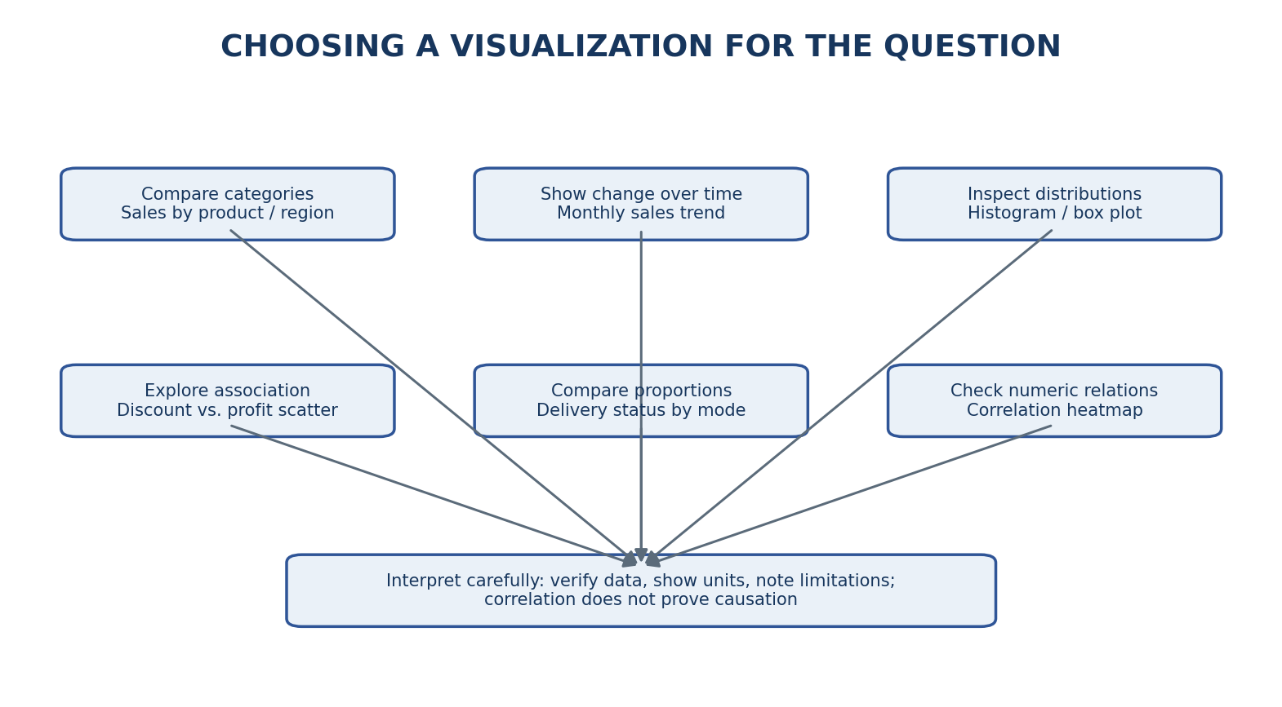

7.2 Interactivity (optional)
If time remains after the core EDA is complete, Plotly may be used to add interactive hover labels and filters for date, market, category and shipping mode. A Power BI dashboard is a possible later-stage extension, but it is not required to complete this Week 3 EDA plan. Any interactive view should use clearly defined metrics and should not expose personal identifiers.

8. Python Tools and Notebook Structure
Tool | Purpose in this project
Python / Jupyter Notebook | Keeps the analysis organized, executable and reproducible.
pandas | Loads the CSV; inspects columns; handles missingness, date parsing, grouping and summary tables.
NumPy | Supports numerical operations and data checks.
Matplotlib | Creates line charts, bar charts, histograms and other base plots.
Seaborn | Creates box plots, heatmaps and statistical visualizations.
Plotly (optional) | Adds interactivity only if time permits.

Notebook sequence aligned to the supplied Week_3_EDA_Analysis.ipynb:
- Import libraries and set plotting defaults.
- Load DataCoSupplyChainDataset.csv and print shape and sample rows.
- Inspect columns, data types and descriptive statistics.
- Calculate missing-value counts/percentages and visualize the columns with missing values.
- Check exact duplicate rows separately from repeated Order Id values.
- Review selected numeric columns with descriptive statistics and box plots.
- Parse order date and summarize monthly sales.
- Plot sales by product category and market/region.
- Plot sales distribution and summarize skewness, median and mean.
- Compare shipping duration by mode and actual versus scheduled days.
- Summarize delivery status by shipping mode as counts and percentages.
- Explore correlation, discount versus profit, customer segment and order status.
- Print an EDA summary and export summary tables to an eda_outputs folder.
Execution note: the notebook expects the CSV in the same folder and uses a specific filename. Confirm that the file is present, execute cells in order, and check for column-name mismatches before treating the outputs as final.

9. Mock Analysis Plan: Hypotheses to Test
Area | Hypothesis (not a result) | Business relevance | Validation / follow-up
Product categories | Recorded sales may be concentrated in a few categories. | Helps focus category reviews. | Rank category sales; compare with row counts and profit.
Monthly sales | Recorded sales may vary by month. | Can inform further trend analysis. | Check date coverage, missing dates and whether patterns repeat across years.
Shipping modes | Actual duration and delivery-status proportions may differ by mode. | Supports service-level review. | Compare scheduled duration, destination mix and group sizes before recommending changes.
Discount and profit | Discount levels may be associated with profit outcomes. | May inform discount-policy review. | Inspect scatter plot, correlation and category-level patterns; do not infer causality.
Geographic performance | Sales and delivery outcomes may differ by market or region. | Helps prioritize further investigation. | Compare both volume and proportions; investigate destination mix.
Missingness/outliers | Some columns may have high missingness or unusual values. | Prevents unreliable interpretation. | Check source definitions and investigate records before excluding or imputing.

For every chart/table, document four items: (1) Observation — what the computed output actually shows; (2) Interpretation — what it may mean; (3) Business relevance — why it matters; and (4) Next step — what additional validation is needed.

10. Data Quality, Limitations and Responsible Use
- Missing values: the initial planning profile flags Product Description as fully missing and Order Zipcode as substantially missing. Recalculate these statistics from the exact CSV; do not fill missing values without a reasoned rule.
- Duplicates and repeated IDs: exact duplicate rows and repeated Order Id values are different checks. Multiple item rows can legitimately belong to one order.
- Dates: parse order dates with errors handled explicitly, then count invalid/missing parsed dates before monthly resampling.
- Outliers: box-plot points are potential outliers, not automatic errors. Validate with field definitions and business context before removing records.
- Metric definitions: Sales, Order Item Total, Order Profit Per Order and Benefit per order may have different meanings. Confirm field definitions and aggregation level before comparing totals.
- Association versus causation: correlations and group differences do not establish that discounts or shipping mode cause an outcome.
- Scope limitations: the selected data may not contain inventory-on-hand, supplier identifiers/scorecards, reorder points or purchase-order lead times needed for complete inventory and supplier optimization.
- Privacy: avoid publishing names, customer-level identifiers, or other unnecessary personal information in charts and shared outputs.

11. EDA Timeline — 33 Hours
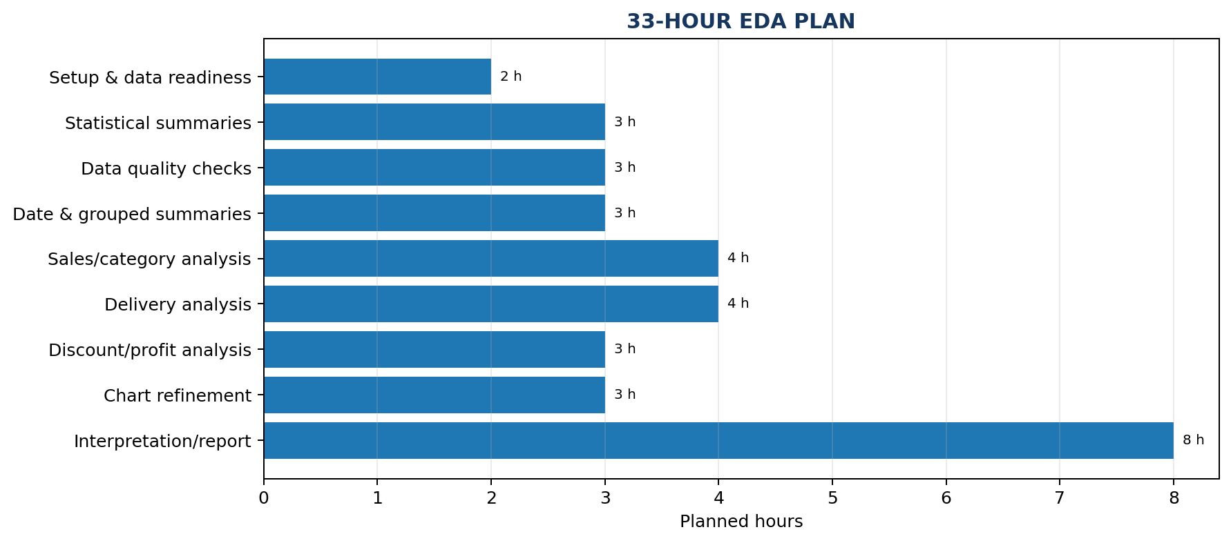

Activity | Hours | Planned output
Define business questions and EDA scope | 2 | Question list and metric definitions
Load dataset and inspect structure | 2 | Dataset profile, column/type review
Calculate descriptive statistics | 3 | Numerical and categorical summary tables
Investigate missingness, duplicates and data quality | 3 | Missing-value summary and quality notes
Prepare dates and grouped summaries | 3 | Parsed date field and grouped tables
Analyze sales and product categories | 4 | Category, market/region and monthly sales charts
Analyze delivery and shipping performance | 4 | Shipping-duration and delivery-status charts
Explore discounts, profit and numeric relationships | 3 | Scatter plot, correlation table/heatmap
Create and refine visualizations | 3 | Readable, labelled charts
Interpret results and document limitations | 3 | Evidence-led observations and caveats
Prepare final charts and EDA report | 3 | Report, notebook and exported tables
TOTAL | 33 | Within the required 30–35 hour window

The schedule can be adjusted if the CSV has data-quality problems or if notebook execution reveals missing fields. Core analysis and interpretation take priority over optional interactivity.

12. Expected Deliverables and Success Criteria

12.1 Expected deliverables
- A professional EDA and visualization report.
- A reproducible Jupyter Notebook or Python script.
- Dataset profile and descriptive-statistics summary.
- Missing-value and exact-duplicate checks.
- Charts for sales trends, category/geographic comparisons, distributions and shipping performance.
- A list of evidence-based observations, hypotheses and follow-up questions.
- Exported CSV summary tables in the eda_outputs folder.
- Documented limitations and data-handling decisions.

12.2 Success criteria
- Dataset structure, key columns and data grain are documented.
- Numerical and categorical summaries are generated successfully.
- Missing values, duplicate rows and potential outliers are investigated.
- Each key business question is linked to a suitable method or chart.
- Charts have readable titles, labels, appropriate scales and consistent formatting.
- Interpretations are supported by computed outputs and hypotheses are clearly labelled.
- Notebook code runs in sequence and exports the expected tables.
- The work is completed within the 30–35 hour schedule.

13. Conclusion
This EDA plan provides a structured foundation for analyzing the DataCo Smart Supply Chain dataset. It links statistical summaries and visualization choices to business questions about recorded sales, product mix, customer segments, geography and shipping performance. The accompanying notebook includes code for data profiling, quality checks, visual analysis and summary-table export.
The final report should present only results verified by executing the notebook against the selected CSV. Missing values, repeated order identifiers, unusual values and metric definitions must be reviewed before drawing conclusions. The analysis can guide later dashboard development and identify questions for deeper analysis; complete inventory optimization, supplier evaluation or predictive forecasting should only be attempted if the required data and validation are available.

References
- Kaggle. DataCo Smart Supply Chain for Big Data Analysis. https://www.kaggle.com/datasets/shashwatwork/dataco-smart-supply-chain-for-big-data-analysis
- pandas documentation. https://pandas.pydata.org/docs/
- Matplotlib documentation. https://matplotlib.org/stable/
- Seaborn documentation. https://seaborn.pydata.org/
- NumPy documentation. https://numpy.org/doc/

