WEEK 4 TASK
Predictive Analytics and Model Strategy
Smart Supply Chain Analytics
A step-by-step strategy for building, validating and refining forecasting and classification models in Python
Item | Details
Internship | Data Analytics Strategist Internship
Dataset | DataCo Smart Supply Chain for Big Data Analysis (Kaggle)
Tools | Python, pandas, NumPy, scikit-learn, statsmodels (optional), Matplotlib, Seaborn
Planned effort | 33 hours (plus a 2-hour buffer, within the 30–35 hour window)

1. Executive Summary
This document sets out a strategy for using predictive analytics on the DataCo Smart Supply Chain dataset. It explains which questions the models should answer, which algorithms are suitable and why, how the data will be split, trained, validated and evaluated in Python, and what could go wrong (limitations, assumptions and bias).
Three use cases are proposed. The main one is a classification model that predicts whether an order will be delivered late, using only information available when the order is placed. Two supporting use cases are a monthly sales forecast and a regression model for profit per order. Each model is compared with a simple baseline so that its real value can be measured.
To keep the plan realistic, a first pass was run on the actual dataset (172,765 order items after removing cancelled shipments). The results shaped the strategy: (1) four very different algorithms all reach almost the same ROC-AUC of about 0.745, so the signal comes mainly from the shipping mode and the plan focuses on data and features before complex tuning; (2) one column, Days for shipping (real), gives a perfect score because it is only known after delivery, so it must be excluded to avoid leakage; (3) the markets Africa and USCA stop in January 2017 while others continue, so the data must be split by time and not at random. These points are discussed in Sections 4, 7 and 11.

2. Background: Predictive Analytics and Its Relevance
Predictive analytics uses historical data and statistical or machine-learning methods to estimate what is likely to happen next. In a supply chain, descriptive analytics (Weeks 2 and 3) explains what already happened, while predictive analytics supports decisions before they are made: which orders need attention, how much demand to expect and where margins may fall.
- Classification predicts a category, for example late or on time.
- Regression predicts a number, for example sales next month or profit of an order.
- Time-series forecasting predicts a value over time and uses past values, trend and seasonality.
Relevance to the project: the project title promises demand forecasting, inventory optimization, supplier performance and delivery analytics. Late-delivery prediction supports delivery and supplier performance; sales forecasting supports demand planning and inventory; profit prediction supports pricing and discount decisions. The EDA from Week 3 provides the starting point: shipping mode is strongly related to lateness (First Class 100% late, Second Class 79.8%, Same Day 47.9%, Standard Class 39.8%, with cancelled shipments excluded), and discount rate has a weak negative link with profit.

3. Strategic Use Cases
Use case | Target variable | Model type | Business value | Priority
U1 Late-delivery risk | Late_delivery_risk (1 = late) | Binary classification | Flag risky orders early, choose shipping mode, set customer expectations | High (main)
U2 Monthly sales forecast | Total Sales per month | Time-series regression | Plan stock, staffing and budget | Medium
U3 Profit per order | Order Profit Per Order | Regression | Understand which discounts and products erode margin | Medium
U4 Order-fraud screening (optional) | Order Status = SUSPECTED_FRAUD (2.2%) | Imbalanced classification | Only if time remains; rare class needs special metrics | Low

U1 is chosen as the main model because the target is already in the dataset, the business question is clear, and a first pass shows that the problem is feasible. U4 is mentioned only as an extension and is not part of the 33-hour plan.

4. Data Context and Readiness

4.1 What the data allows
Fact (verified on the dataset) | Consequence for modelling
180,519 order items, 65,752 orders, Jan 2015 – Jan 2018 | Enough rows for tree and boosting models; rows of one order are related, so splits by time are safer than random splits
7,754 items have Delivery Status "Shipping canceled" | Removed for U1: a cancelled order is not a late order. Leaves 172,765 items
Late rate in the remaining data: 57.3% | Classes are fairly balanced; accuracy alone is still not enough, so AUC, recall and F1 are also used
From October 2017 orders are recorded differently (about 1 item per order instead of about 3) | Monthly totals before and after are not comparable; U2 uses data before October 2017
Africa and USCA appear only between Aug/Apr 2016 and Jan 2017; LATAM ends Jun 2017 | Later periods contain only some markets, so the test period is not representative of all markets (see Figure 2)
Customer e-mail, password, name and street columns are personal | Dropped; they carry no predictive value and create privacy risk

4.2 Allowed and forbidden features for U1
A model must use only information that is known when the prediction is needed, i.e. at the time the order is placed.
Group | Columns | Decision
Known at order time | Shipping Mode, Days for shipment (scheduled), Market, Order Region, Order Country, Customer Segment, Category Name, Department Name, Order Item Quantity, Order Item Discount Rate, Sales, Order Item Product Price, month and weekday of order | Use
Known only after shipping | Days for shipping (real), Delivery Status, shipping date | Exclude (leakage). Adding Days for shipping (real) raised the test AUC from 0.747 to 1.000
Result of the order | Order Profit Per Order, Benefit per order, Order Status | Exclude for U1; profit is the target of U3
Identifiers and personal data | Order Id, Customer Id, e-mail, password, names, street, zipcodes | Exclude

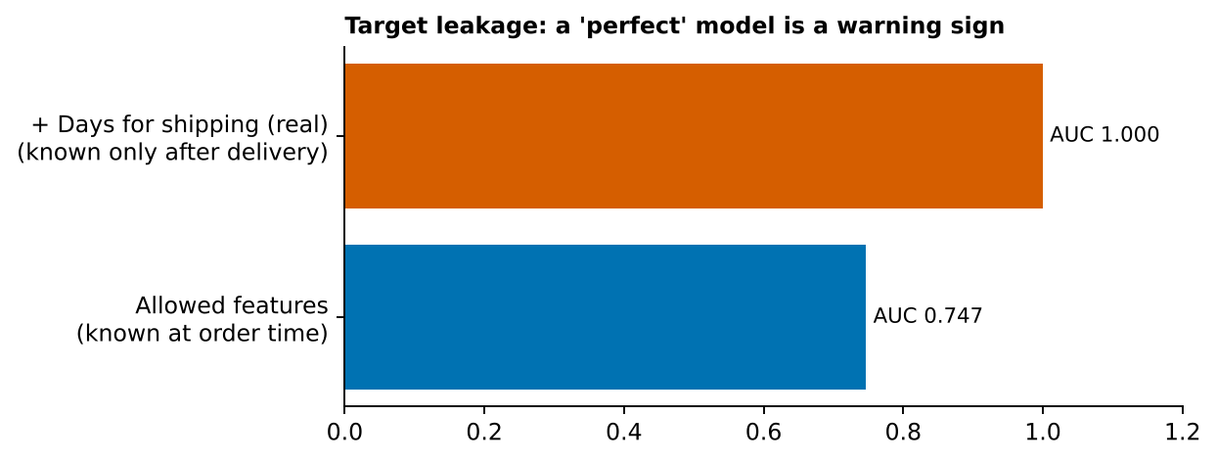
Figure 1: Target leakage test: the same model with and without a column that is only known after delivery

5. Model Types and Algorithm Selection

5.1 Candidate algorithms
Algorithm | Family | Why it is considered | Main weakness | Role
Majority-class / naive forecast | Baseline | Sets the minimum a real model must beat | No learning | Reference
Logistic Regression (U1); Ridge / Linear Regression (U2, U3) | Linear model | Fast, transparent; coefficients show direction of effects; good first model | Cannot capture interactions unless added by hand | Interpretable benchmark
Decision Tree (limited depth) | Tree | Rules can be read by managers, e.g. "Standard Class + low discount" | Unstable; overfits when deep | Explainable model
Random Forest | Ensemble (bagging) | Handles mixed data and interactions, robust to outliers | Slower; less transparent | Strong candidate
Gradient Boosting (HistGradientBoosting, optional XGBoost / LightGBM) | Ensemble (boosting) | Often the best accuracy on tabular data; handles missing values | Needs tuning; can overfit | Strong candidate
Seasonal naive, Exponential Smoothing / SARIMA (optional) | Time series | Standard methods for monthly data with seasonality | Needs long history; only about 33 usable months here | U2 only

5.2 Selection criteria
- Fit to the target. Classification for late/on time, regression for amounts, time-series methods for monthly totals.
- Data size and type. About 173,000 rows with a mix of categories and numbers suit trees and boosting; the small monthly series suits simple methods.
- Interpretability. Business users must understand why an order is flagged, so linear and tree models stay in the comparison even if ensembles score slightly higher.
- Performance versus baseline. A model is kept only if it clearly beats the baseline on validation data.
- Cost and time. All candidates train in minutes on a laptop; no deep learning is planned because it adds cost without clear benefit on tabular data.
- Stability. A model whose cross-validation scores vary little between folds is preferred.

5.3 Justification in the project context
For U1 all four main model families are trained, because the first pass showed that they are close, and the choice will then depend on interpretability and stability. If the scores stay equal, the simpler model (logistic regression or a shallow tree) is recommended. For U2 the plan starts with seasonal-naive and linear methods because only about 33 monthly points exist. For U3 gradient boosting is compared with a median baseline.

6. Model Building Workflow in Python
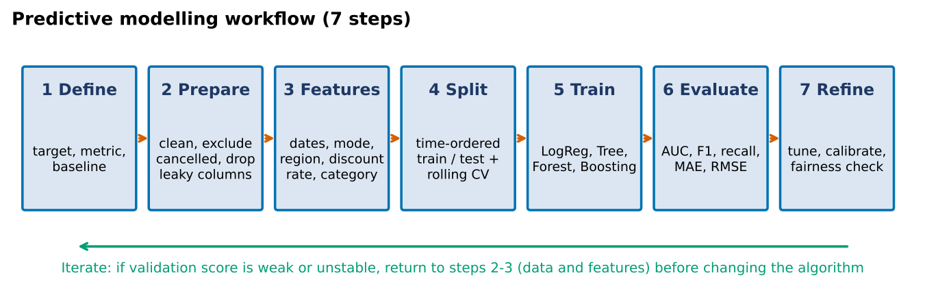
Figure 2: Seven-step modelling workflow with an iteration loop

6.1 Libraries
Library | Use in this project
pandas, NumPy | Loading, cleaning, feature creation, time-based splitting
scikit-learn | Pipeline, ColumnTransformer, OneHotEncoder, StandardScaler, models, TimeSeriesSplit, GridSearchCV / RandomizedSearchCV, metrics, calibration, permutation importance
statsmodels (optional) | Exponential smoothing, SARIMA and statistical tests for U2
Matplotlib, Seaborn | ROC curve, confusion matrix, residual plots, feature importance
joblib | Saving the final pipeline so results can be reproduced

6.2 Steps
- Define: fix target, prediction time, metric and baseline for each use case.
- Prepare: load the data, parse dates, remove cancelled shipments for U1, drop personal and leaking columns.
- Features: create month and weekday, keep discount rate (not discount amount, which mainly scales with price), group rare categories.
- Split: order the data by order date; the first 80% is training, the last 20% is the final test set.
- Train: build one scikit-learn Pipeline per model so that encoding and scaling are learned only from training data.
- Validate: use rolling (time-series) cross-validation inside the training data and tune hyperparameters.
- Evaluate: score the final test set once and compare with the baseline; analyse errors by shipping mode, market and period.
- Refine and document: apply the contingency plan (Section 13), save the final pipeline and record results.

6.3 Code skeleton
import pandas as pd, numpy as np
from sklearn.pipeline import Pipeline
from sklearn.compose import ColumnTransformer
from sklearn.preprocessing import OneHotEncoder, StandardScaler
from sklearn.ensemble import HistGradientBoostingClassifier
from sklearn.model_selection import TimeSeriesSplit, cross_val_score
from sklearn.metrics import roc_auc_score, f1_score, recall_score

df = pd.read_csv("DataCoSupplyChainDataset.csv", encoding="latin1")
df["od"] = pd.to_datetime(df["order date (DateOrders)"])
df = df[df["Delivery Status"] != "Shipping canceled"].sort_values("od")
df["month"], df["dow"] = df.od.dt.month, df.od.dt.dayofweek

cat = ["Shipping Mode","Market","Order Region","Customer Segment","Category Name","Department Name"]
num = ["Days for shipment (scheduled)","Order Item Quantity","Order Item Discount Rate",
"Sales","Order Item Product Price","month","dow"]
X, y = df[cat + num], df["Late_delivery_risk"]

cut = int(len(df) * 0.8) # time-ordered split
X_tr, X_te, y_tr, y_te = X.iloc[:cut], X.iloc[cut:], y.iloc[:cut], y.iloc[cut:]

pre = ColumnTransformer([
("c", OneHotEncoder(handle_unknown="ignore", min_frequency=50, sparse_output=False), cat),
("n", "passthrough", num)])
model = Pipeline([("prep", pre), ("clf", HistGradientBoostingClassifier(random_state=42))])

cv = TimeSeriesSplit(n_splits=5)
print(cross_val_score(model, X_tr, y_tr, cv=cv, scoring="roc_auc").round(3))
model.fit(X_tr, y_tr)
p = model.predict_proba(X_te)[:, 1]
print("AUC", roc_auc_score(y_te, p), "F1", f1_score(y_te, p >= 0.5))
The notebook file name and column names above follow the Kaggle file; the code is the same structure that was used for the first-pass results in Section 10.

7. Data Splitting Plan
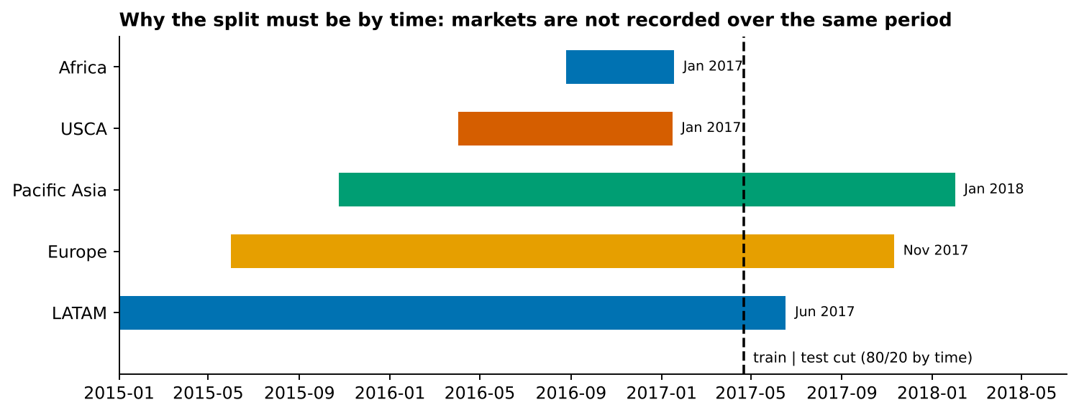
Figure 3: Order period of each market and the proposed train/test cut
Question | Decision | Reason
Random or time-based split? | Time-based (order date) | The model will predict future orders; a random split would let it see future patterns. Markets also cover different periods
Split ratio | 80% train, 20% test (test starts 22 April 2017) | Standard ratio; the test set holds about 34,500 items
Validation inside training | TimeSeriesSplit with 5 folds (expanding window) | Each fold validates on data that is later than its training part
Final test set | Used once, after the model and settings are chosen | Prevents optimistic results from repeated testing
Group leakage | Items of one order stay on the same side of the cut | The cut is made on order date, so almost all items of an order fall on the same side
U2 monthly forecast | Months before October 2017; last 6 months as test | Orders are recorded differently from October 2017
Preprocessing | Fitted on training data only, inside a Pipeline | Avoids information from the test data entering the model

8. Model Training and Validation Plan

8.1 Training
- Baselines first. Majority class for U1, last-month and seasonal-naive for U2, training median for U3.
- Default settings next. Train every candidate with defaults to see the spread between models.
- Tune the best two. Use RandomizedSearchCV with TimeSeriesSplit; limit the search to what fits in the planned 5 hours.
- Fixed random seed. random_state=42 everywhere so results can be repeated.
Model | Hyperparameters to tune (starting ranges)
Logistic Regression | C: 0.01 – 10; class_weight: none / balanced
Decision Tree | max_depth: 3 – 10; min_samples_leaf: 20 – 200
Random Forest | n_estimators: 100 – 400; max_depth: 6 – 20; min_samples_leaf: 10 – 50
Gradient Boosting | learning_rate: 0.03 – 0.2; max_depth: 3 – 8; max_iter: 100 – 400; l2_regularization: 0 – 1

8.2 Validation
- Rolling cross-validation gives a mean score and a spread; a model with a large spread between folds is treated as unstable.
- Learning curves show whether more data or a more complex model is likely to help.
- Probabilities are checked with a calibration curve, and the decision threshold (default 0.5) can be moved depending on whether missing a late order or raising a false alarm costs more.
- Results are also compared by shipping mode and by market to see where the model works poorly.

9. Performance Evaluation Plan
Use case | Metrics | Why
U1 classification | ROC-AUC (main), precision, recall, F1 for the late class, confusion matrix, PR-AUC | AUC does not depend on the threshold; recall shows how many late orders are caught; precision shows how many alerts are correct
U2 forecast | MAE, RMSE, MAPE (%) against seasonal-naive | MAE is easy to explain in currency; MAPE allows comparison across scales
U3 regression | MAE, RMSE, R² against median baseline | RMSE punishes large errors; R² shows how much variation is explained
All | Cross-validation mean and standard deviation; permutation importance; error by segment | Shows stability and which features matter

9.1 Acceptance criteria
- A model must beat its baseline on the test set and on cross-validation.
- U1 target: ROC-AUC clearly above 0.70 with a small gap between cross-validation and test scores (less than 0.03).
- Performance in each market and shipping mode that has enough data should not be much worse than the overall score.
- Results must be reproducible by running the notebook from top to bottom.

10. First-Pass Results on the Real Data
The pipeline in Section 6 was run once on the actual file to test feasibility. The test set is the last 20% by time (34,554 items). These are starting values, not final results.
Model (U1: late delivery) | ROC-AUC | Accuracy | Precision | Recall | F1
Majority class (baseline) | 0.500 | 0.573 | – | 0.000 | 0.000
Logistic Regression | 0.744 | 0.696 | 0.883 | 0.540 | 0.670
Decision Tree (depth 6) | 0.744 | 0.695 | 0.881 | 0.540 | 0.670
Random Forest | 0.745 | 0.695 | 0.860 | 0.560 | 0.678
Gradient Boosting (HistGB) | 0.747 | 0.695 | 0.863 | 0.555 | 0.676

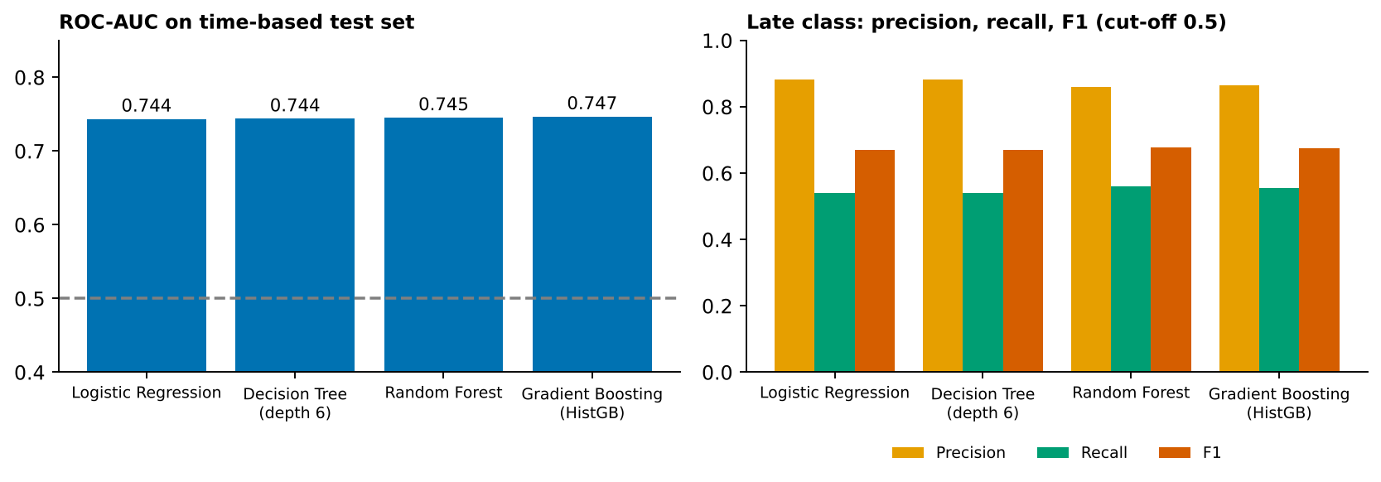
Figure 4: First-pass results for the late-delivery classifiers on the time-based test set

10.1 What these results tell us
- Models beat the baseline, but not by model choice. All four are within 0.003 AUC. Rolling cross-validation for Gradient Boosting gave 0.739 on average with a spread of 0.002, so the score is stable. The information in the allowed features is limited, mainly the shipping mode (late rate 39.8% to 100%).
- The next gains must come from data, not algorithms. The plan therefore spends time on feature work and error analysis (Section 13) before more tuning.
- Precision is high, recall is lower. About 86–88% of orders flagged late really are late, but only about 54–56% of late orders are caught at the 0.5 threshold. Lowering the threshold would raise recall at the cost of precision.
- Market scores are similar where data exists. Recall on the test period was 0.546 (Pacific Asia), 0.551 (LATAM) and 0.560 (Europe); AUC 0.734–0.746. Africa and USCA are not in the test period, so nothing can be said about them.
- U2 and U3 are harder. Forecasting the last 6 months before October 2017 (about 1.04 million sales per month) gave a mean error of about 39,300 (3.8%) for the "same as last month" baseline, and larger errors (about 57,000) for a linear model with last-month and last-year values. With only 21 usable monthly rows, simple baselines are hard to beat. For profit per order, gradient boosting reached a mean absolute error of 61.6 against 63.3 for the median baseline, a very small gain.

11. Limitations, Assumptions and Potential Biases

11.1 Assumptions
- The data represents real operations and the relationships found in the past continue in the future (the dataset is a public teaching dataset, so this cannot be confirmed).
- Late_delivery_risk (1 when actual shipping days exceed scheduled days) is an acceptable definition of "late".
- Cancelled shipments are excluded from U1 because a cancelled order has no delivery outcome.
- Only the information available at order time is used for predictions.

11.2 Limitations and biases
Issue | Why it matters | Handling
Coverage bias (market and time) | Africa and USCA exist only until January 2017; the test period contains only Europe, LATAM and Pacific Asia | Report scores per market; do not claim results for markets missing from the test period; re-check if more data is added
Change in recording (Oct 2017) | Items per order drop from about 3 to about 1; forecasts mix two different series | Train U2 on data before the break; flag later months in all charts
Target leakage | Days for shipping (real) gives AUC 1.000 | Strict allowed-feature list; leakage test in the notebook
Weak signal | Different algorithms give the same score, so extra features or data are needed | Feature engineering and error analysis before tuning
Proxy and geographic bias | Market, region and country may stand in for factors not in the data; the model could treat regions unfairly | Compare recall and error between markets; remove geography if it adds little
Imbalance and threshold choice | A single threshold may suit one group more than another | Choose the threshold on validation data and report results per group
Small monthly series (U2) | About 33 months; seasonality cannot be confirmed | Prefer simple methods; show uncertainty; do not over-promise
Data quality and synthetic patterns | Product Description is empty and Order Zipcode is 86% missing; some fields may be generated | Drop empty columns; avoid relying on such fields
Privacy | Customer names, e-mail and street are present | Removed before modelling and from all outputs
Concept drift | Delivery performance can change after process or carrier changes | Plan periodic retraining and monitoring if used in practice

12. Risk Mitigation for Model Bias
- Audit features before training and remove leaking, identifier and personal columns.
- Split by time and fit all preprocessing inside the pipeline.
- Report every metric overall and by market, shipping mode, customer segment and year.
- Use class weights or a tuned threshold if a group is under-detected; compare the effect on each group.
- Test whether removing geography columns changes the score; if not, leave them out.
- Run a simple sensitivity check: retrain on a different time window and compare the results.
- Document every limitation in the final report so users know where the model should not be trusted.

13. Contingency Plan and Iterative Improvement
If this happens | Then do this | Time
Model does not beat the baseline | Check the target and split; try new features (e.g. discount band, price band, past late rate per mode); simplify the model | 2–3 h
Scores are the same for all models (as in the first pass) | Stop tuning; add features and review errors by segment; recommend the simplest model | 2 h
Validation score is much higher than test score | Look for leakage or drift; shorten the training window; add regularization | 2 h
Large gap between markets | Add market-specific features or thresholds; if data is missing for a market, state that it is not covered | 1–2 h
Recall too low for the business need | Lower the threshold or use class weights; report the precision trade-off | 1 h
Training takes too long | Sample the data, use HistGradientBoosting, reduce the search grid | 1 h
Forecast is worse than naive (U2) | Keep the naive or seasonal-naive method and say so; treat the model as a benchmark | 0.5 h

13.1 Iteration rounds
Round | Focus | Exit condition
1 – Baselines | Baselines and default models | All models scored with the same split
2 – Features | Feature work and leakage audit | Validation AUC improves or the signal is shown to be limited
3 – Tuning | Tune the best two models | Cross-validation spread stays small
4 – Checks | Per-group errors, calibration, threshold | Acceptance criteria in Section 9.1 are met or the gaps are documented

14. Alignment with Project Goals
Project goal | Contribution of predictive analytics
Delivery analytics and supplier performance | U1 gives an early warning of late orders and shows which shipping modes carry the highest risk
Demand forecasting and inventory optimization | U2 gives a monthly forecast with an honest error range
Pricing and profitability | U3 and the discount analysis show how discounts and categories relate to margin
Reliable dashboards and decisions | Model outputs can feed the dashboards planned in later weeks; limitations are documented so that users know how far to trust them

15. Timeline Within the Project Schedule
The work fits within 30–35 hours. A 2-hour buffer is kept for unexpected issues.
# | Activity | Output | Hours
1 | Define use cases, targets and metrics | Use-case sheet | 2
2 | Data readiness and leakage audit | Allowed-feature list | 3
3 | Feature engineering | Modelling table | 4
4 | Splitting and baselines | Baseline scores | 3
5 | Train candidate models | Comparison table | 5
6 | Cross-validation and tuning | Tuned models | 5
7 | Evaluation and error analysis | Metrics and charts | 4
8 | Bias and fairness checks | Per-group report | 2
9 | Forecast (U2) and profit model (U3) | Secondary results | 2
10 | Documentation and final report | DOC and notebook | 3
 | Total (plus 2 h buffer) |  | 33

16. Expected Deliverables and Success Criteria
- This strategy document.
- A reproducible Python notebook with the pipeline, validation, metrics and charts.
- A model comparison table and a short list of recommendations.
- A limitations and bias statement.
The strategy is successful if the process can be followed step by step, the model is compared fairly with baselines, the evaluation uses suitable metrics, and the risks and biases are clearly documented.

17. Conclusion
Predictive analytics can add value to this project if it is applied carefully. The first-pass experiment shows that late deliveries can be predicted moderately well (ROC-AUC about 0.745 using only information known at order time), that the choice of algorithm matters less than the quality of the features, and that leakage and uneven market coverage can easily give misleading results. The plan therefore stresses a time-based split, a strict feature list, comparison with baselines, per-group evaluation and a clear contingency plan. Final model results will be reported only after the full workflow is run and checked.

