WEEK 5 TASK
Data Analytics Reporting and Strategic Impact Presentation
Smart Supply Chain Analytics
Final strategic report and presentation storyboard
Item | Details
Internship | Data Analytics Strategist Internship
Dataset | DataCo Smart Supply Chain for Big Data Analysis (Kaggle)
Tools | Python, pandas, scikit-learn, Plotly, Dash, Matplotlib
Planned effort | 32 hours (plus a 2-hour buffer, within the 30–35 hour window)

1. Executive Summary
Smart Supply Chain Analytics studied the DataCo order data (180,519 order items, 65,752 orders, January 2015 to January 2018) to answer a practical question: where is the supply chain losing money and customer trust, and what should be done about it? Over four weeks the project cleaned the data, explored it, and tested simple predictive models. This report brings those results together and turns them into recommendations and a plan for presenting them.
The business in numbers: sales of about 36.8 million, profit of about 3.97 million (a margin of 10.8%), and 57.3% of delivered order items arriving later than scheduled.
Four findings matter most:
- Late delivery depends on the shipping mode, not on the region. First Class is late 100% of the time, Second Class 79.8%, Same Day 47.9% and Standard Class 39.8%, while late rates are almost the same in every market (56.8% to 57.7%). The faster modes promise delivery windows (1 and 2 days) that actual operations do not meet (about 2 and 4 days).
- Discounts are linked to lower profit. Average profit per item falls from about 23.9 at a 0–5% discount to 18.4 at 20–25%. The link is weak in statistical terms but consistent, and 18.7% of items are sold at a loss.
- Sales are concentrated. The top 5 of 50 product categories bring 60.7% of sales and Fishing alone 18.8%. A few categories earn a margin below 5% (Strength Training 0.6%, As Seen on TV 3.5%, Men's Clothing 4.6%).
- The data has gaps that limit conclusions. Orders are recorded differently from October 2017, and Africa and USCA appear only until January 2017.
A first predictive model can flag late orders using only information known at order time (ROC-AUC about 0.745, about 55% of late orders caught). It is useful as decision support but not yet as an automatic decision-maker.
Recommended actions (Section 4): reset or meet the First Class and Second Class delivery promises; test limits on discounts above 15%; review low-margin categories; improve data capture; and pilot the late-risk flag. The report also provides a dashboard plan with Python code (Plotly and Dash) and a 12-slide presentation storyboard for a 15-minute talk.

2. Summary of the Analytics Process
Week | Work done | Main result
2 – Data acquisition and preprocessing | Loaded the dataset, checked quality, planned cleaning, removed personal columns | No duplicates; Product Description empty; Order Zipcode 86% missing; 7,754 cancelled shipments must not be counted as late
3 – EDA and visualization | Descriptive statistics, outliers (IQR), 19 charts on sales, profit, discounts, delivery, customers and regions | Late rate depends on shipping mode; discounts weakly reduce profit; top categories dominate; recording change in October 2017
4 – Predictive strategy | Compared logistic regression, tree, random forest and boosting on late-delivery risk; tested forecasting and profit models | ROC-AUC about 0.745 for all models; leakage found; forecasting and profit models barely beat simple baselines
5 – Reporting (this document) | Combine results into a story, recommendations, dashboard plan and presentation plan | Sections 3 to 9

Every number in this report was recalculated from the actual dataset. Findings are described as associations in the data; they show where to look and what to test, not proven causes.

3. Key Findings

3.1 Delivery performance is a promise problem
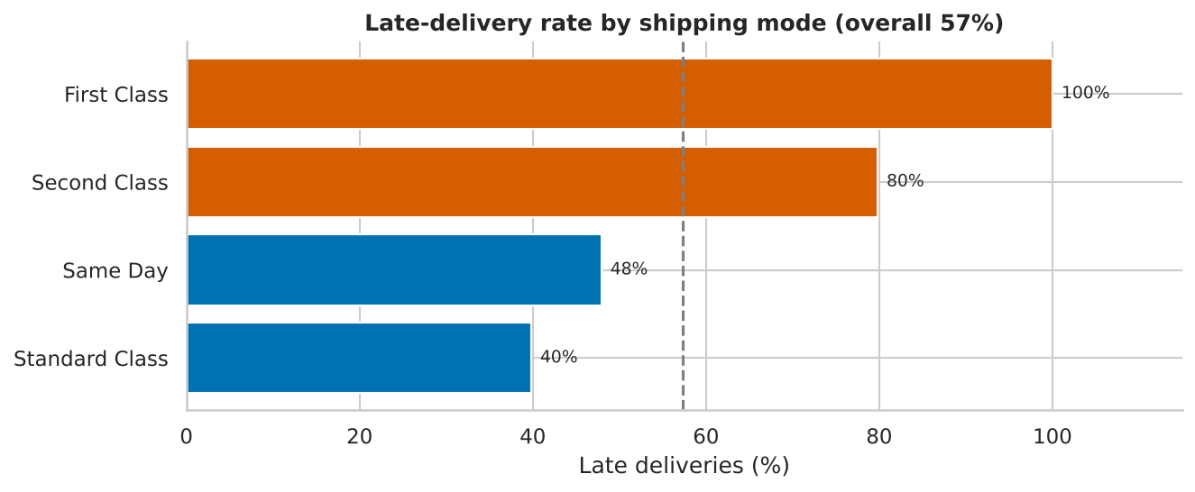
Figure 1: Late-delivery rate by shipping mode (cancelled shipments excluded)
- First Class is scheduled for 1 day but takes about 2 days on average; every item is late.
- Second Class is scheduled for 2 days and takes about 4 days; 79.8% are late.
- Standard Class (4 days scheduled, about 4 actual) is late 39.8% of the time, even though it is the slowest mode.
- A chi-square test confirms that late rate and shipping mode are strongly related; late rates by market and by customer segment are almost identical.
So what: The problem is not a weak region but the way delivery times are promised for the fast modes. Fixing promises or processes for First Class and Second Class addresses the largest share of late orders.

3.2 Sales are stable and concentrated
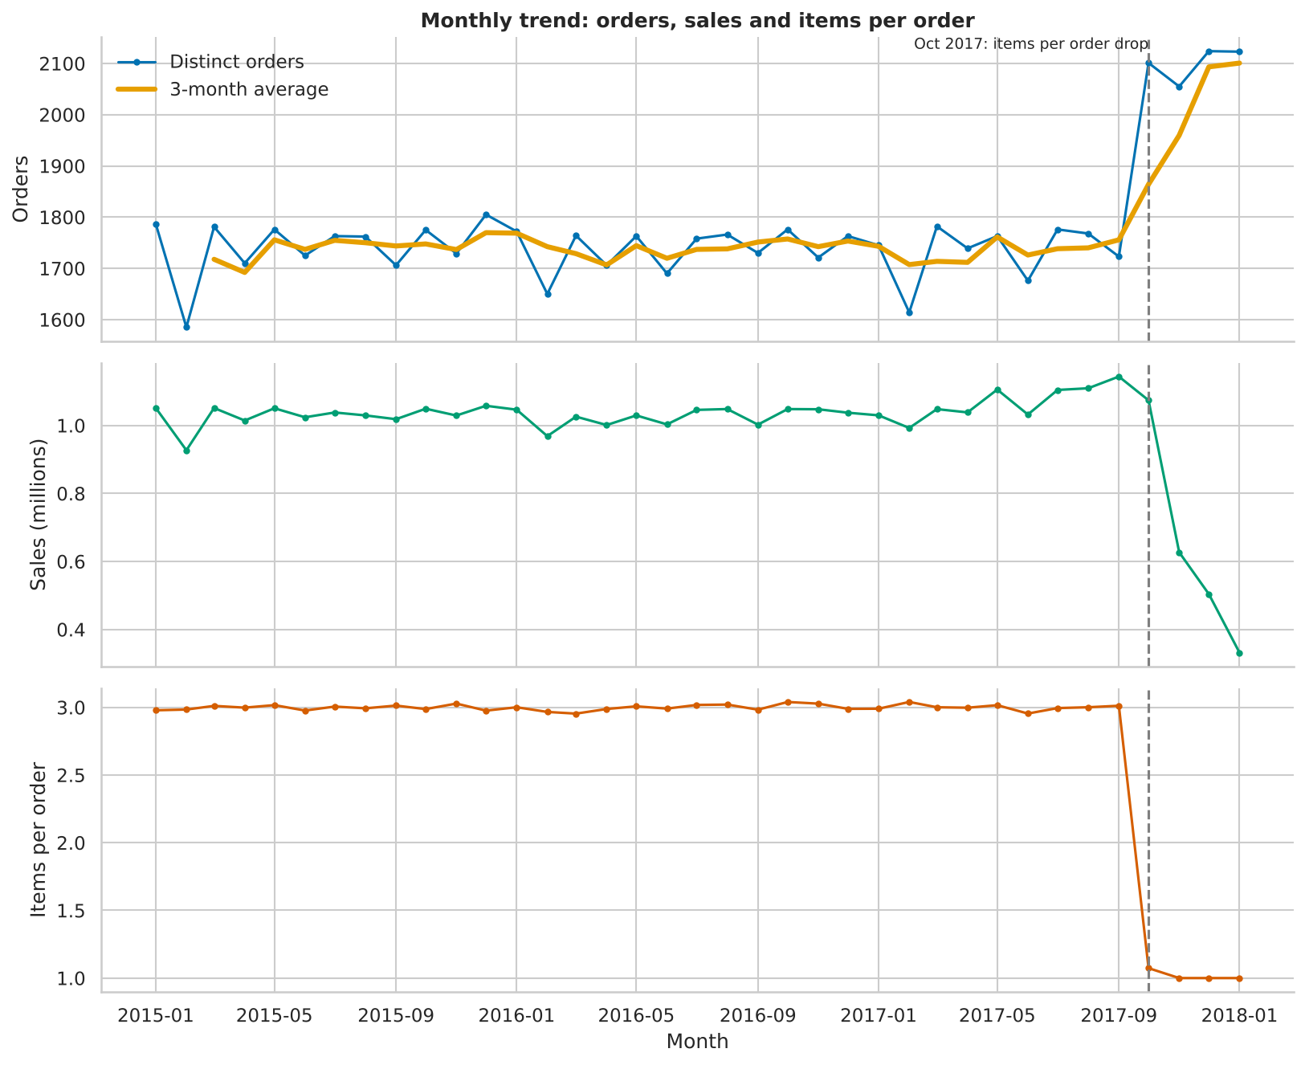
Figure 2: Orders, items and sales per month, with the October 2017 recording change
- Yearly sales were about 12.3 million in 2015 and 2016 and 11.8 million in 2017: stable, not growing.
- From October 2017 the data shows about 1 item per order instead of about 3, and monthly sales drop. This is a change in how orders are recorded, not a real collapse or growth.
- Market shares of sales are Europe 29.6%, LATAM 27.9%, Pacific Asia 22.5%, USCA 13.8% and Africa 6.2%. USCA and Africa are recorded for only about 9 and 5 months, so their shares are not comparable with the others.
- Customer segments: Consumer 51.9%, Corporate 30.4%, Home Office 17.7% of sales.
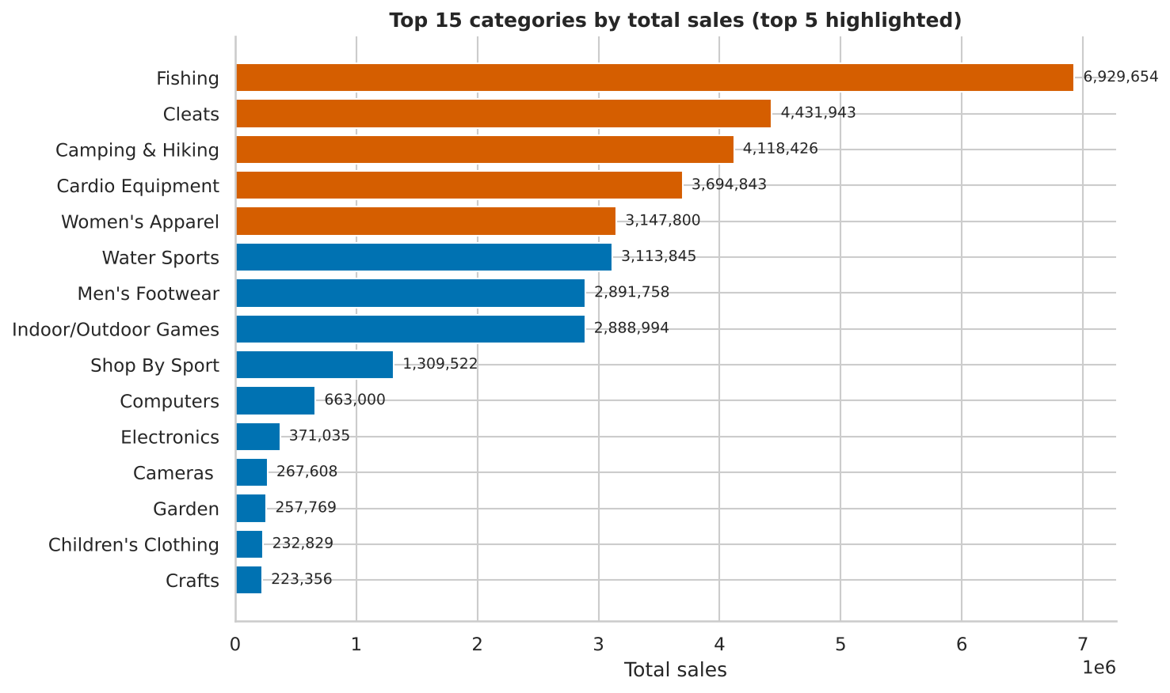
Figure 3: Sales by product category (top categories highlighted)
So what: Planning (stock, promotions) should focus on the few categories that carry most of the sales, and market comparisons need the coverage caveat.

3.3 Discounts and profit
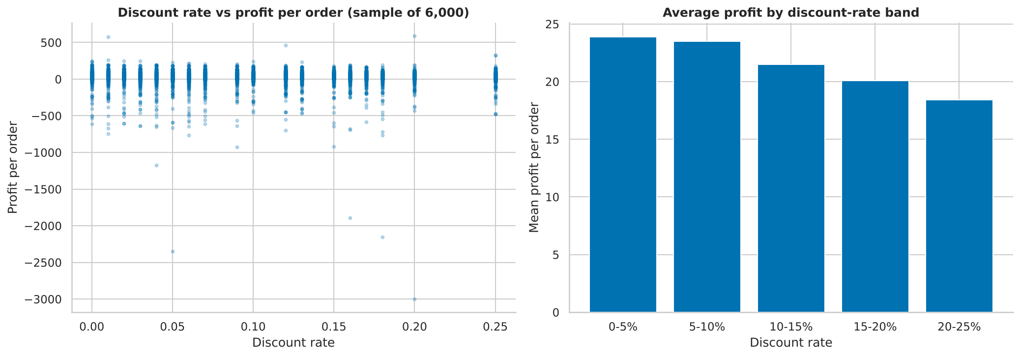
Figure 4: Discounts and profit: scatter and average profit per item by discount-rate band
- Average profit per item: about 23.9 (0–5% discount), 23.5 (5–10%), 21.5 (10–15%), 20.1 (15–20%) and 18.4 (20–25%).
- The overall correlation is weak (Spearman −0.054). Product and price differences explain far more of the profit spread than the discount does.
- 18.7% of items have negative profit; most top categories earn about 10–11% margin.
So what: Discounts are not the main driver of profit, but deeper discounts consistently go with lower profit. A controlled test is needed before changing policy.

3.4 What prediction can add
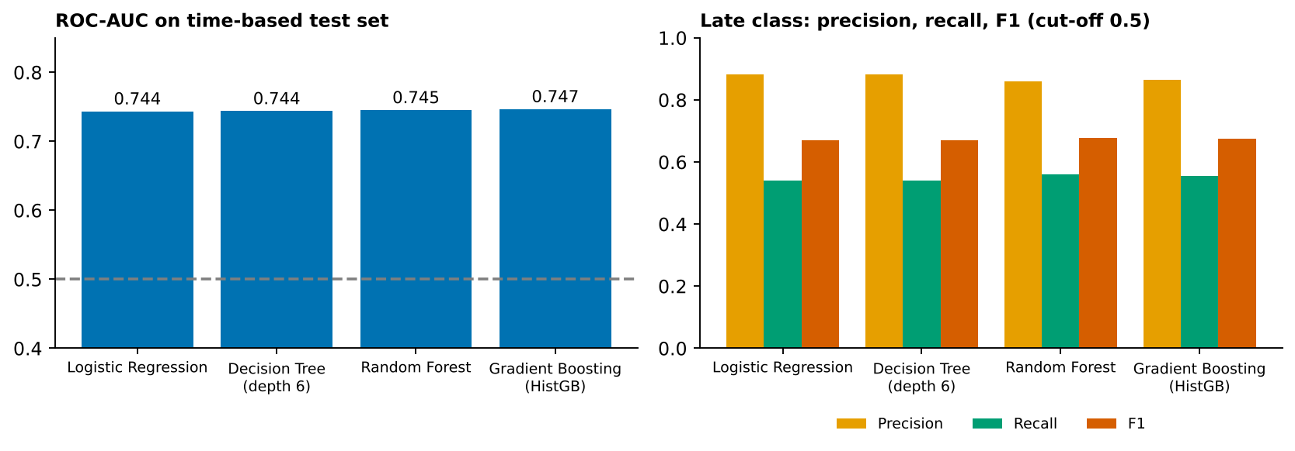
Figure 5: Late-delivery models on a time-based test set (last 20% of orders)
- Four different models reach the same ROC-AUC (0.744 to 0.747), so the information in the order-time features is limited.
- About 86–88% of orders flagged late really are late; about 54–56% of all late orders are caught at the default threshold.
- The column Days for shipping (real) must be excluded: it is known only after delivery and gives a false perfect score of 1.0.
- Monthly sales forecasting and profit-per-order models barely improve on simple baselines (profit MAE 61.6 vs 63.3).
So what: Use the model as an early-warning list for staff to check, not as an automatic rule, and invest first in better input data.

4. Strategic Recommendations
Recommendation | Evidence | Expected impact | How to measure
R1. Make First Class and Second Class promises realistic, or fix the process behind them | First Class: 1 day promised, about 2 actual, 100% late. Second Class: 2 promised, about 4 actual, 79.8% late | Fewer late orders on paper and fewer customer complaints; clarity about real delivery times | Late rate by mode; promised vs actual days (monthly)
R2. Pilot limits on discounts above 15% | Profit per item falls from 23.9 to 18.4 across discount bands; effect is weak but consistent | Protect margin where discounts add little | A/B test: profit per order and order volume in test vs control
R3. Review low-margin categories and loss-making items | Strength Training 0.6%, As Seen on TV 3.5%, Men's Clothing 4.6% margin; 18.7% of items lose money | Better pricing and product mix | Category margin; share of items with negative profit
R4. Improve data capture and monitoring | Recording change in Oct 2017; Africa and USCA stop in Jan 2017; empty or sparse fields | More reliable dashboards and models | Data-quality checks run on every refresh
R5. Pilot the late-risk flag as decision support | ROC-AUC about 0.745; precision 86–88%, recall 54–56% | Earlier attention to risky orders | Share of flagged orders that are late; staff time saved

Priority: R1 and R4 first (low cost, high clarity), then R3, then the pilots R2 and R5. R1 is expected to give the largest visible change because it affects the two largest late-delivery groups.

5. Step-by-Step Approach to Report Generation
- Define the audience and the decision. Write one sentence: "After this report, the reader should decide ..."
- Collect results. Gather the verified tables and charts from Weeks 2–4 into one folder, with the code that produced them.
- Re-check the numbers. Recalculate every figure used from the data file and note any caveat (for example, cancelled shipments, October 2017).
- Select the key points. Keep a finding only if it passes the filter in the table below.
- Build the story. Order the findings from context to evidence to action; write the headline message of each section first.
- Write and visualize. One chart per message, labelled with the conclusion as the title.
- Add recommendations and measures. Each action gets evidence, expected impact and a way to measure it.
- Review. Check consistency of numbers, plain language, and whether an outsider can follow the logic without help.

5.1 Filter for key insights
Question | Keep the finding if ...
Is it important? | It affects sales, profit, delivery or customers in a measurable way
Is it reliable? | It holds after cleaning (for example, cancelled shipments excluded) and is not caused by a data change
Is it actionable? | Someone can do something about it
Is it surprising or clear? | It changes what the audience believes or gives a simple message
Is it honest? | Its limits and uncertainty are stated

6. Visualization Techniques for Data Storytelling
Story point | Chart type | Storytelling technique | Interactive element
Delivery promise vs reality | Sorted horizontal bars | Highlight the worst bars in orange-red, grey for the rest; title states the conclusion | Hover for item counts; filter by market and date
Sales trend | Line chart with annotation | Mark October 2017 with a dashed line and a short note | Date-range slider; toggle orders / items / sales
Sales concentration | Sorted bar (Pareto style) | Show the cumulative share, label the top 5 | Hover for category share; click to see products
Discounts and profit | Bar by discount band plus scatter | Use bands, not raw amounts, to avoid misleading price effects | Switch between bands and scatter
Market comparison | Bar and heatmap | Use one colour scale, mask cells with fewer than 30 items | Dropdown for market; hover for details
Model results | Bars of metrics vs baseline | Always show the baseline next to the model | Threshold slider showing precision and recall change

6.1 Design rules
- Use one colour-blind-safe palette (blue, orange, green, red-orange, grey) and the same colour for the same meaning in every chart.
- Write chart titles as messages ("Fast shipping modes are almost always late"), not labels ("Late rate by mode").
- Remove clutter: no 3-D, few gridlines, direct labels instead of legends where possible.
- Always label units and the period; annotate data breaks.
- Show uncertainty and limits on the chart or directly under it.

6.2 Examples of interactive elements
Element | What the viewer can do | Plotly / Dash feature
Filters | Choose market, shipping mode and dates; all charts update | dcc.Dropdown, dcc.DatePickerRange, callbacks
Hover details | See exact value, count and share | Plotly hover templates
KPI tiles | See sales, margin, orders and late rate for the current selection | html.Div updated by a callback
Zoom and range selection | Zoom into a period on the trend chart | Plotly range slider
What-if threshold (optional) | Move a cut-off and see precision and recall | dcc.Slider + callback

7. Dashboard Plan with Python
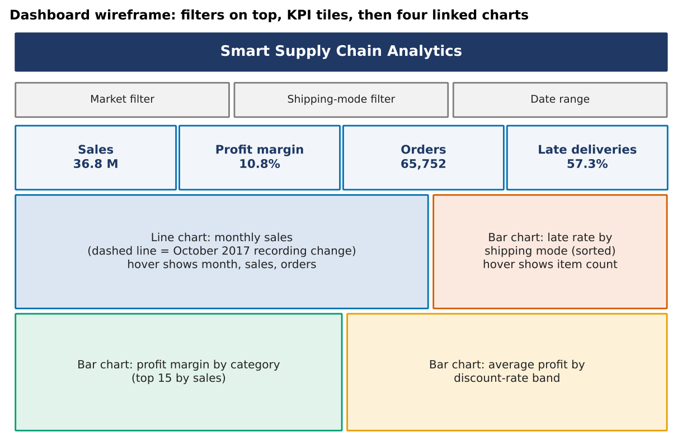
Figure 6: Dashboard wireframe

7.1 Design
- Layout. Filters at the top, four KPI tiles, then a trend chart and late-rate chart, and a margin chart and discount chart.
- Libraries. pandas for data, Plotly Express for charts, Dash for the web app and filters.
- Structure. dash_data.py holds all data functions (testable without Dash); app.py holds the layout and one callback that updates all charts. The full code is in Appendix A and B.
- Privacy. Only the needed columns are loaded; names, e-mail, password and street are never read.
- Correct definitions. Cancelled shipments are excluded from the late rate; the October 2017 change is marked on the trend chart.

7.2 How to run
pip install pandas plotly dash
# put DataCoSupplyChainDataset.csv (or the .csv.gz file) next to app.py
python app.py
# open http://127.0.0.1:8050 in the browser

7.3 Testing status
The data functions in dash_data.py were run on the real file and gave the figures used in this report (sales 36.78 million, margin 10.8%, 65,752 orders, late rate 57.3%, late rate by mode, profit by discount band). The Dash layout in app.py was syntax-checked but not started in the preparation environment, because Plotly and Dash could not be installed there. It should be run once locally; if a library version differs, only small changes to the layout code are expected.

7.4 Sharing options
- Run locally during the presentation (live demo).
- Export charts to standalone HTML with fig.write_html("late_rate.html") to share without a server.
- Deploy on a free hosting service if the audience needs a link.

8. Proposed Structure of the Final Presentation
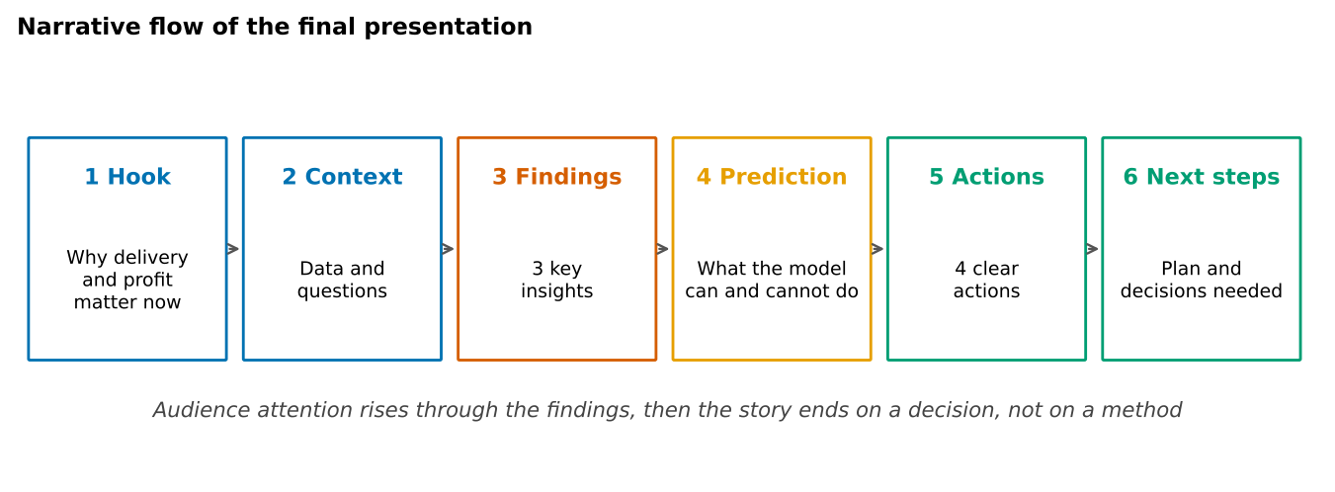
Figure 7: Narrative flow: hook, context, findings, prediction, actions, next steps
Total time: 15 minutes plus 5 minutes of questions. Each slide carries one message, written as its title.
# | Slide title (message) | Visual | Key talking point | Min
1 | Smart Supply Chain Analytics: what the data tells us to do | Title and KPI strip | State the purpose in one sentence | 0.5
2 | Late delivery and thin margins are our two levers | Simple icon diagram | Why these two topics | 1
3 | We analysed 180,519 order items over 3 years | Data facts and 4-week flow | Source, size, period, privacy handling | 1
4 | The business at a glance | KPI tiles | Sales 36.8 M, margin 10.8%, 57.3% late | 1
5 | Fast shipping modes are almost always late | Sorted bar chart, promise vs actual | Promise problem, not a regional problem | 2
6 | Five categories bring 60% of sales | Category bars and market share | Concentration and coverage caveat | 1.5
7 | Deeper discounts go with lower profit | Bar by discount band | Weak but consistent link; test before acting | 1.5
8 | Two data issues limit what we can conclude | Timeline of markets, trend with break | October 2017 change; USCA and Africa stop | 1
9 | A model can flag late orders, with limits | AUC and recall chart | Useful as an early-warning list; caution | 1.5
10 | Five actions, each with a measure | Recommendation table | Priority order and expected effect | 2
11 | Live dashboard demonstration | Dashboard | Filter by market and mode; show hover | 1.5
12 | Decisions needed and next steps | Short list | What approval is needed this month | 0.5

8.1 Delivery tips
- Open with the conclusion, then show the evidence.
- Keep the backup slides (methods, definitions, model details) after the final slide for questions.
- Rehearse the live demo and keep a screenshot version in case the demo fails.

9. Communicating to Diverse Audiences
Audience | What they care about | What to show | Style
Executives | Impact, cost, decisions | KPI tiles, 3 findings, recommendations | Short, answer first, numbers rounded, no method detail
Operations and logistics managers | Where delays happen and why | Delivery charts by mode, promise vs actual | Concrete examples, practical actions
Sales, finance and pricing teams | Margin, discounts, categories | Discount and category charts | Tables with clear definitions, caveats about causes
Data and IT team | Data quality, method, reproducibility | Data issues, model metrics, code | Technical detail, notebook and code shared
Academic mentors / evaluators | Rigour and learning | Process, validation, limitations | Full structure, references, honest limits

9.1 Making technical insights clear for non-technical stakeholders
Technical term | Plain wording
ROC-AUC of 0.745 | If we pick one late and one on-time order at random, the model ranks the late one as riskier about 75% of the time
Recall 55% | The model catches about 55 of every 100 late orders
Precision 87% | When the model says "late", it is right about 87 times out of 100
Spearman correlation −0.054 | Higher discounts go with slightly lower profit, but the link is weak
Outlier (IQR) | An unusually large order, such as the Dell laptop, that can distort averages
Data leakage | Using information that would not be known when the decision is made

- Lead with the answer. State the conclusion first, then why.
- One message per slide. The title is the message.
- Use comparisons. "About 4 of 10" is easier than "39.8%"; keep exact numbers in the notes.
- Tell the truth about uncertainty. Say what the data cannot show.
- Use analogies. A late-risk flag is like a weather warning: it does not decide, it prepares.
- Invite questions. Prepare answers to likely challenges (Section 10).

10. Anticipated Questions
Question | Prepared answer
Are the late deliveries real, or an artefact of scheduling? | The late flag compares actual and scheduled days. That is why Recommendation R1 asks to review the promises as well as the operations.
Why not just remove discounts? | The link to profit is weak, and discounts may drive volume that the data cannot show. A controlled test is proposed.
Why is the model not more accurate? | Order-time information is limited; all four models reach the same score. Better data (carrier, weather, stock) is the next step.
Can we trust the sales drop after October 2017? | No. Orders are recorded differently from that month; it is not comparable.
Why are USCA and Africa small? | Their orders appear only for about 9 and 5 months in the data.

11. Limitations
- The dataset is a public teaching dataset; patterns may not match a real company.
- Findings are associations; recommendations R2 and R5 are designed as tests.
- The late definition depends on the scheduled days in the data.
- Market comparisons are affected by different coverage periods and the October 2017 recording change.
- The Dash app was not started in the preparation environment (see Section 7.3).
- Forecasting results rest on about 21 usable months and should not be over-interpreted.

12. Timeline
# | Activity | Output | Hours
1 | Consolidate findings from Weeks 2–4 | Findings list | 4
2 | Re-verify all numbers | Checked fact sheet | 3
3 | Write the report | This document | 6
4 | Build dashboard data layer and charts | dash_data.py, charts | 6
5 | Build and test dashboard app | app.py | 5
6 | Design storyboard and slides | 12-slide deck | 4
7 | Audience versions and rehearsal | Notes and Q&A sheet | 2
8 | Final review | Final files | 2
 | Total (plus 2 h buffer) |  | 32

13. Deliverables and Success Criteria
- This report and storyboard (DOC).
- Dashboard code: dash_data.py and app.py (Appendix A and B).
- A slide deck built from Section 8.
The work is successful if a non-technical reader can understand the findings and the actions, every claim can be traced to the data, and the presentation can be delivered in 15 minutes.

14. Conclusion
The analysis shows where the supply chain loses time and margin: fast shipping modes promise more than they deliver, deeper discounts go with lower profit, a small set of categories carries most sales, and data gaps limit what can be said. The most valuable next step is to reset the delivery promises and measure the result, with a controlled discount test and better data capture alongside. The dashboard and storyboard in this document turn the findings into a story that executives, managers and technical colleagues can each follow and act on.

Appendix A: dash_data.py
"""Data layer for the Smart Supply Chain dashboard (pandas only, so it can be tested without Plotly/Dash)."""

import glob
import numpy as np
import pandas as pd

USE = [
"Order Id",
"Order Item Id",
"order date (DateOrders)",
"Shipping Mode",
"Market",
"Order Region",
"Customer Segment",
"Category Name",
"Delivery Status",
"Late_delivery_risk",
"Sales",
"Order Profit Per Order",
"Order Item Discount Rate",
"Days for shipment (scheduled)",
"Days for shipping (real)",
]

def load_data(path=None):
path = path or glob.glob("*.csv*")[0]
df = pd.read_csv(path, usecols=USE, encoding="utf-8") # personal columns are never loaded
df["order_date"] = pd.to_datetime(df["order date (DateOrders)"])
df["month"] = df["order_date"].dt.to_period("M").dt.to_timestamp()
df["cancelled"] = df["Delivery Status"].eq("Shipping canceled")
df["is_late"] = np.where(df["cancelled"], np.nan, df["Late_delivery_risk"].astype(float))
df["discount_band"] = pd.cut(
df["Order Item Discount Rate"],
[-0.001, 0.05, 0.10, 0.15, 0.20, 0.25],
labels=["0-5%", "5-10%", "10-15%", "15-20%", "20-25%"],
)
return df

def filter_data(df, markets=None, modes=None, start=None, end=None):
m = pd.Series(True, index=df.index)
if markets:
m &= df["Market"].isin(markets)
if modes:
m &= df["Shipping Mode"].isin(modes)
if start:
m &= df["order_date"] >= pd.Timestamp(start)
if end:
m &= df["order_date"] <= pd.Timestamp(end)
return df[m]

def kpis(d):
sales, profit = d["Sales"].sum(), d["Order Profit Per Order"].sum()
return {
"sales": sales,
"profit": profit,
"margin": profit / sales if sales else np.nan,
"orders": d["Order Id"].nunique(),
"late_rate": d["is_late"].mean(),
"cancelled": int(d["cancelled"].sum()),
}

def monthly(d):
return (
d.groupby("month")
.agg(
orders=("Order Id", "nunique"), items=("Order Item Id", "count"), sales=("Sales", "sum")
)
.reset_index()
)

def late_by_mode(d):
x = d[~d["cancelled"]].groupby("Shipping Mode")["is_late"].agg(["mean", "count"]).reset_index()
return x.rename(columns={"mean": "late_rate", "count": "items"}).sort_values("late_rate")

def margin_by_category(d, top=15):
g = (
d.groupby("Category Name")
.agg(sales=("Sales", "sum"), profit=("Order Profit Per Order", "sum"))
.reset_index()
)
g["margin"] = g["profit"] / g["sales"]
return g.sort_values("sales", ascending=False).head(top)

def profit_by_discount(d):
return d.groupby("discount_band", observed=True)["Order Profit Per Order"].mean().reset_index()

Appendix B: app.py
"""Interactive dashboard: Smart Supply Chain Analytics. Run: python app.py then open http://127.0.0.1:8050
Needs: pip install dash plotly pandas"""

from dash import Dash, dcc, html, Input, Output
import plotly.express as px
import dash_data as dd

PALETTE = ["#0072B2", "#E69F00", "#009E73", "#D55E00", "#7F7F7F"]
df = dd.load_data("DataCoSupplyChainDataset.csv") # change the path if needed

app = Dash(__name__)
app.title = "Smart Supply Chain Analytics"

def tile(title, comp_id):
return html.Div(
[
html.Div(title, style={"fontSize": 12, "color": "#555"}),
html.Div(id=comp_id, style={"fontSize": 26, "fontWeight": 700, "color": "#1F3864"}),
],
style={"flex": 1, "padding": 12, "background": "#F2F6FA", "borderRadius": 8},
)

app.layout = html.Div(
style={"fontFamily": "Calibri, Arial", "maxWidth": 1200, "margin": "auto", "padding": 16},
children=[
html.H2("Smart Supply Chain Analytics"),
html.Div(
[
dcc.Dropdown(
sorted(df["Market"].unique()),
multi=True,
placeholder="Market (all)",
id="f-market",
style={"flex": 1},
),
dcc.Dropdown(
sorted(df["Shipping Mode"].unique()),
multi=True,
placeholder="Shipping mode (all)",
id="f-mode",
style={"flex": 1},
),
dcc.DatePickerRange(
id="f-dates",
min_date_allowed=df["order_date"].min().date(),
max_date_allowed=df["order_date"].max().date(),
start_date=df["order_date"].min().date(),
end_date=df["order_date"].max().date(),
),
],
style={"display": "flex", "gap": 12, "marginBottom": 12},
),
html.Div(
[
tile("Sales", "k-sales"),
tile("Profit margin", "k-margin"),
tile("Orders", "k-orders"),
tile("Late deliveries (cancelled excluded)", "k-late"),
],
style={"display": "flex", "gap": 12},
),
html.Div(
[dcc.Graph(id="g-trend", style={"flex": 2}), dcc.Graph(id="g-late", style={"flex": 1})],
style={"display": "flex"},
),
html.Div(
[
dcc.Graph(id="g-margin", style={"flex": 1}),
dcc.Graph(id="g-discount", style={"flex": 1}),
],
style={"display": "flex"},
),
html.P(
"Note: from October 2017 orders are recorded with about one item per order, so monthly totals before and after "
"that date are not directly comparable.",
style={"fontSize": 12, "color": "#555"},
),
],
)

@app.callback(
Output("k-sales", "children"),
Output("k-margin", "children"),
Output("k-orders", "children"),
Output("k-late", "children"),
Output("g-trend", "figure"),
Output("g-late", "figure"),
Output("g-margin", "figure"),
Output("g-discount", "figure"),
Input("f-market", "value"),
Input("f-mode", "value"),
Input("f-dates", "start_date"),
Input("f-dates", "end_date"),
)
def update(markets, modes, start, end):
d = dd.filter_data(df, markets, modes, start, end)
k = dd.kpis(d)
trend = px.line(
dd.monthly(d), x="month", y="sales", title="Monthly sales", color_discrete_sequence=PALETTE
)
trend.add_vline(x="2017-10-01", line_dash="dash", annotation_text="recording change")
late = px.bar(
dd.late_by_mode(d),
x="late_rate",
y="Shipping Mode",
orientation="h",
title="Late rate by shipping mode",
color_discrete_sequence=[PALETTE[3]],
)
late.update_xaxes(tickformat=".0%", range=[0, 1])
margin = px.bar(
dd.margin_by_category(d),
x="margin",
y="Category Name",
orientation="h",
title="Profit margin, top 15 categories by sales",
color_discrete_sequence=[PALETTE[0]],
)
margin.update_xaxes(tickformat=".0%")
margin.update_yaxes(autorange="reversed")
disc = px.bar(
dd.profit_by_discount(d),
x="discount_band",
y="Order Profit Per Order",
title="Average profit per item by discount rate",
color_discrete_sequence=[PALETTE[2]],
)
return (
f"{k['sales']/1e6:,.2f} M",
f"{k['margin']:.1%}",
f"{k['orders']:,}",
f"{k['late_rate']:.1%}",
trend,
late,
margin,
disc,
)

if __name__ == "__main__":
app.run(debug=False)

References
- Kaggle. DataCo Smart Supply Chain for Big Data Analysis. https://www.kaggle.com/datasets/shashwatwork/dataco-smart-supply-chain-for-big-data-analysis
- Plotly Python Documentation. https://plotly.com/python/
- Dash Documentation. https://dash.plotly.com/
- pandas Documentation. https://pandas.pydata.org/docs/
- scikit-learn User Guide. https://scikit-learn.org/stable/user_guide.html
- Knaflic, C. N. Storytelling with Data. Wiley, 2015.

