Data:

<https://www.kaggle.com/datasets/kanakbaghel/hospital-management-dataset>

Data import

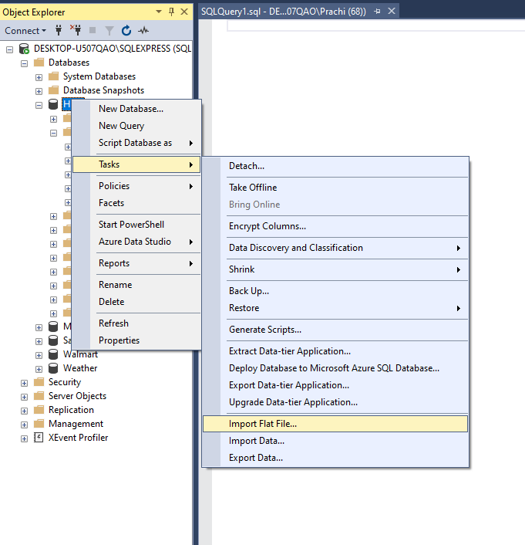

--Checking for null Values

--Identify missing values that could break joins or cause inaccurate KPIs.

SELECT *

FROM patients

WHERE patient_id is null

OR first_name is null

OR last_name is null

OR date_of_birth is null

OR contact_number is null

or insurance_provider is null

or insurance_number is null

or email is null

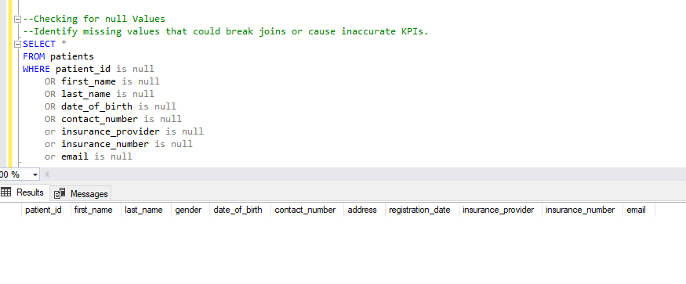

SELECT *

FROM doctors

WHERE doctor_id is null

OR first_name is null

OR last_name is null

OR specialization is null

or phone_number is null

or years_experience is null

or hospital_branch is null

or email is null

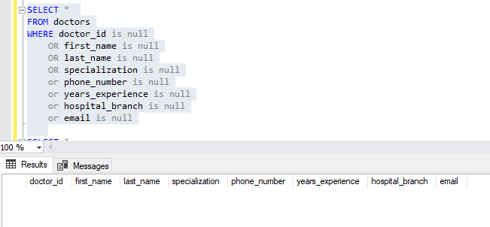

SELECT *

FROM appointments

WHERE appointment_id is null

or patient_id is null

or doctor_id is null

or appointment_date is null

or reason_for_visit is null

or [status] is null

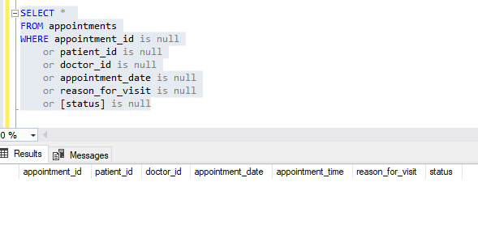

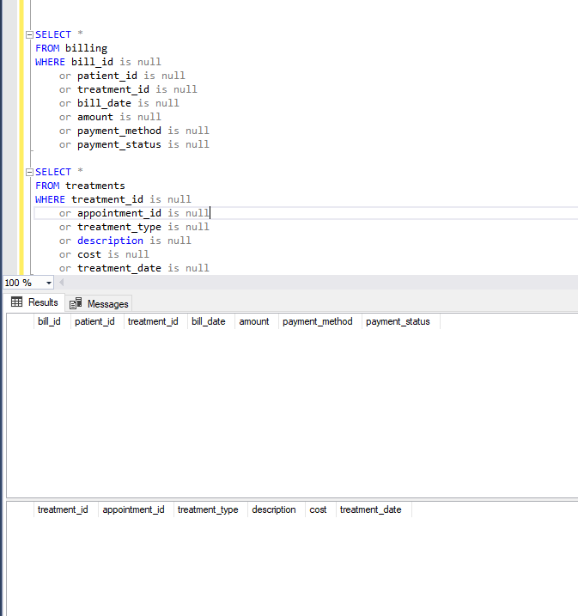

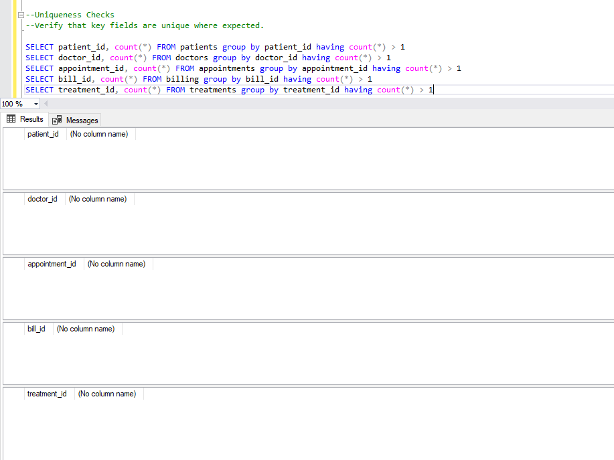

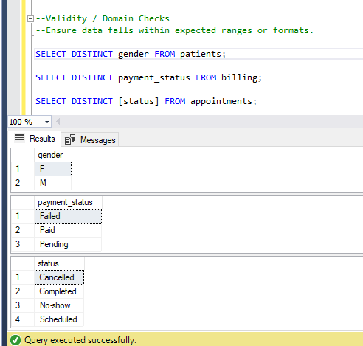

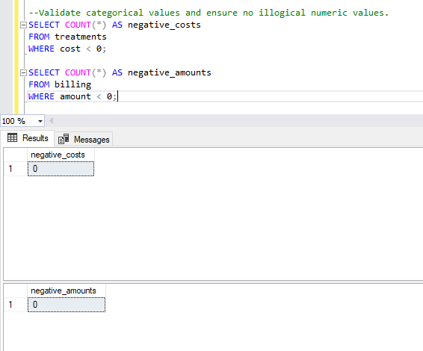

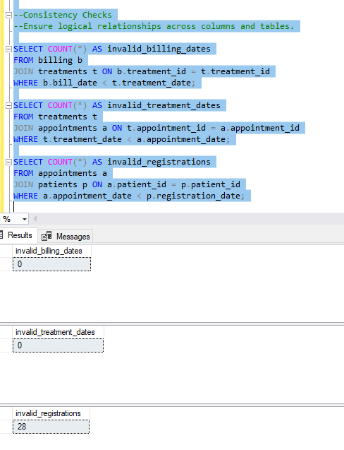

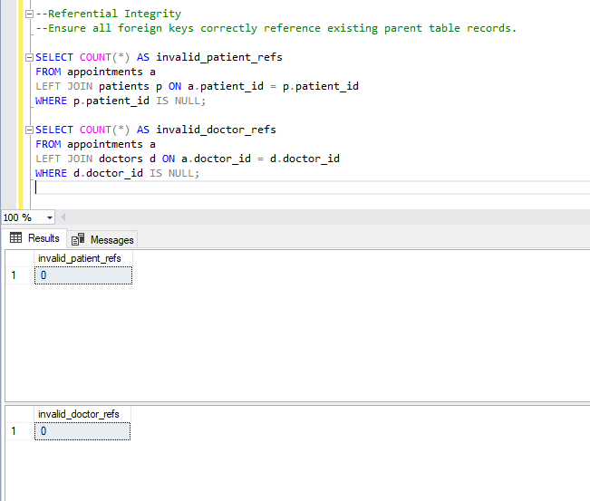

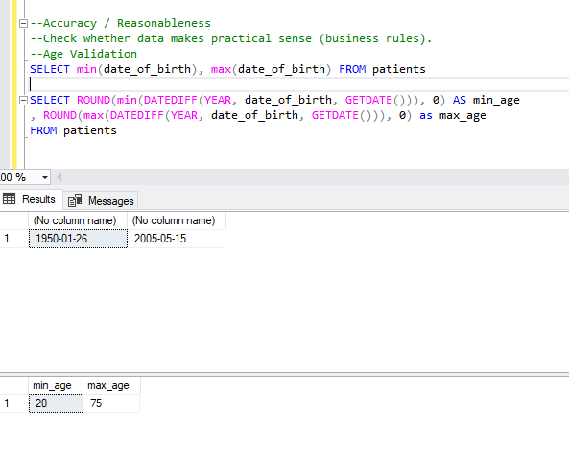

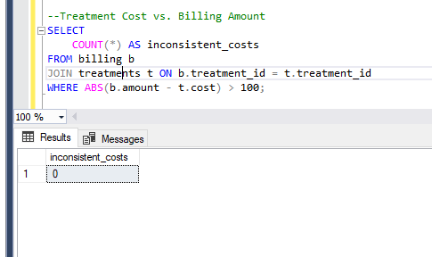

EDA

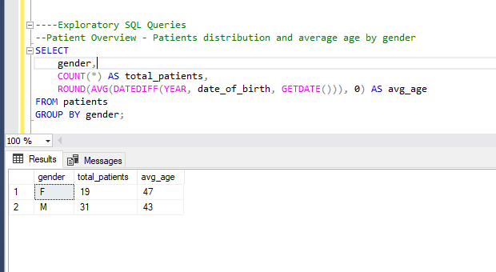

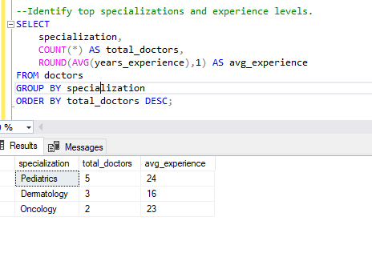

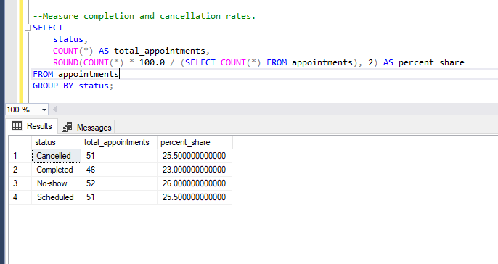

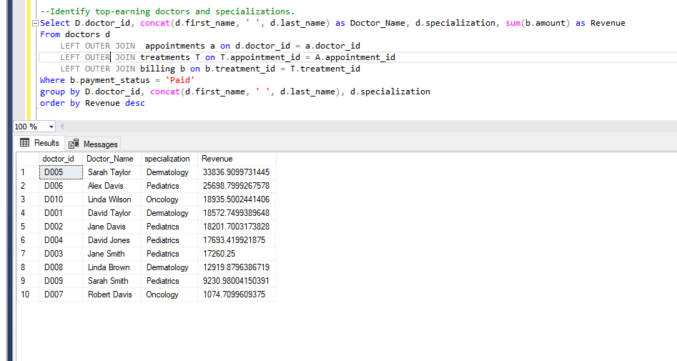

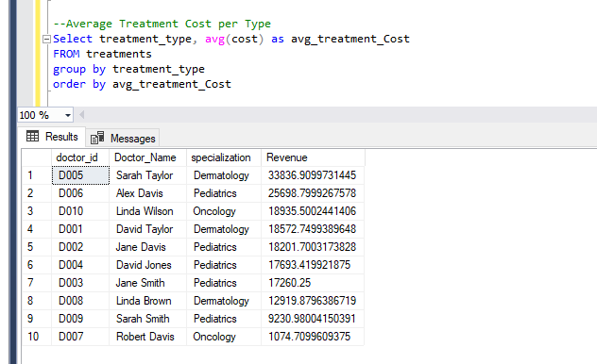

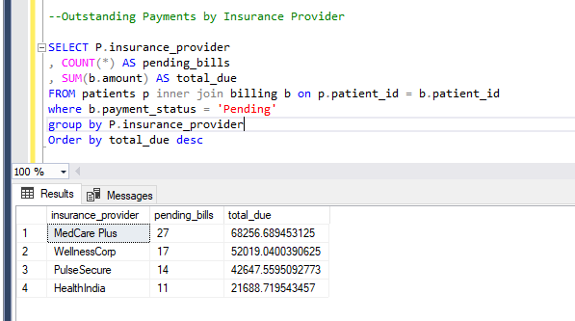

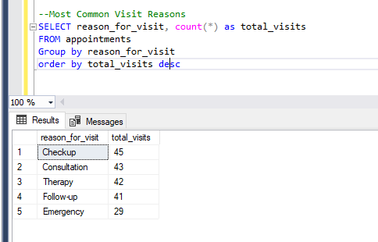

--Patient Lifetime Value (LTV)

SELECT

p.patient_id,

concat(p.first_name ,' ', p.last_name) AS patient_name,

SUM(b.amount) AS lifetime_value

FROM billing b

JOIN patients p ON b.patient_id = p.patient_id

WHERE b.payment_status = 'Paid'

GROUP BY p.patient_id, concat(p.first_name ,' ', p.last_name)

ORDER BY lifetime_value DESC;

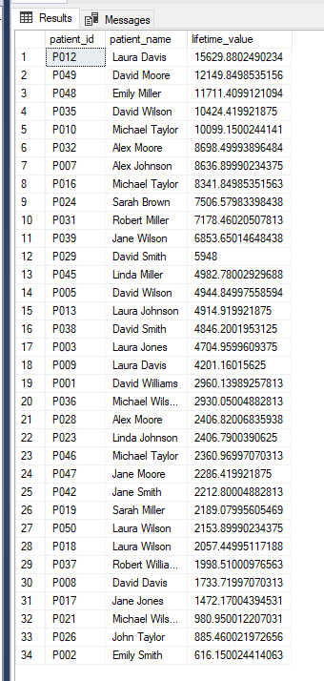

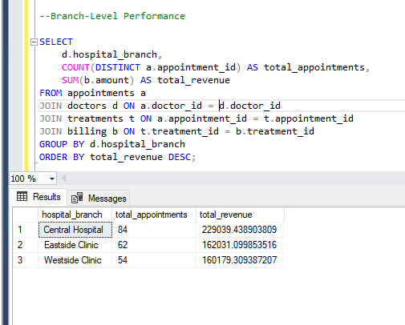

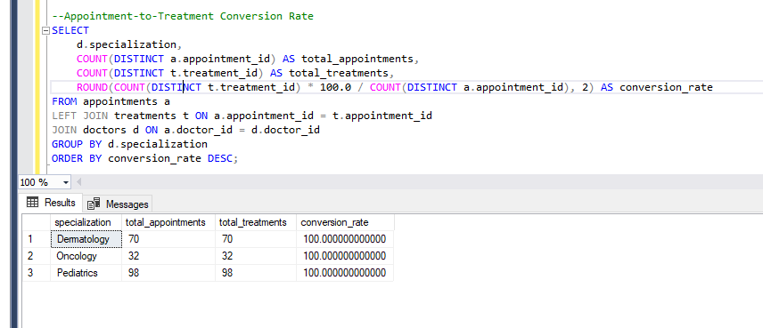

--Doctor Performance Insights --➤ Ranking & Trends - Rank doctors by monthly revenue contribution

--Shows top-performing doctors month over month, using window functions.

WITH MonthlyRevenue AS (

SELECT

d.doctor_id,

CONCAT(d.first_name, ' ', d.last_name) AS doctor_name,

FORMAT(b.bill_date, 'yyyy-MM') AS month_year,

SUM(b.amount) AS total_revenue

FROM doctors d

JOIN appointments a ON d.doctor_id = a.doctor_id

JOIN treatments t ON a.appointment_id = t.appointment_id

JOIN billing b ON t.treatment_id = b.treatment_id

WHERE b.payment_status = 'Paid'

GROUP BY d.doctor_id, d.first_name, d.last_name, FORMAT(b.bill_date, 'yyyy-MM')

)

SELECT *,

RANK() OVER (PARTITION BY month_year ORDER BY total_revenue DESC) AS revenue_rank

FROM MonthlyRevenue

ORDER BY month_year DESC, revenue_rank ASC;

|  |  |  |  |  |
| --- | --- | --- | --- | --- |
| doctor_id | doctor_name | month_year | total_revenue | revenue_rank |
| D002 | Jane Davis | 2023-12 | 5311.54 | 1 |
| D005 | Sarah Taylor | 2023-12 | 3288.15 | 2 |
| D001 | David Taylor | 2023-12 | 1958.69 | 3 |
| D003 | Jane Smith | 2023-12 | 1526.36 | 4 |
| D010 | Linda Wilson | 2023-12 | 1113.98 | 5 |
| D007 | Robert Davis | 2023-12 | 1074.71 | 6 |
| D003 | Jane Smith | 2023-11 | 5496.74 | 1 |
| D005 | Sarah Taylor | 2023-11 | 3690.71 | 2 |
| D002 | Jane Davis | 2023-11 | 2120.61 | 3 |
| D005 | Sarah Taylor | 2023-10 | 6807.82 | 1 |
| D003 | Jane Smith | 2023-10 | 4201.16 | 2 |
| D002 | Jane Davis | 2023-10 | 3384.37 | 3 |
| D006 | Alex Davis | 2023-10 | 1315.17 | 4 |
| D006 | Alex Davis | 2023-09 | 8665.28 | 1 |
| D008 | Linda Brown | 2023-09 | 3628.15 | 2 |
| D001 | David Taylor | 2023-09 | 2930.05 | 3 |
| D005 | Sarah Taylor | 2023-09 | 980.95 | 4 |
| D005 | Sarah Taylor | 2023-08 | 4846.2 | 1 |
| D002 | Jane Davis | 2023-08 | 4704.96 | 2 |
| D003 | Jane Smith | 2023-08 | 2286.42 | 3 |
| D009 | Sarah Smith | 2023-07 | 4109.42 | 1 |
| D008 | Linda Brown | 2023-07 | 2090.4 | 2 |
| D010 | Linda Wilson | 2023-07 | 1438.3 | 3 |
| D004 | David Jones | 2023-06 | 7889.99 | 1 |
| D006 | Alex Davis | 2023-06 | 4523.86 | 2 |
| D005 | Sarah Taylor | 2023-06 | 4178.52 | 3 |
| D009 | Sarah Smith | 2023-06 | 4025.2 | 4 |
| D001 | David Taylor | 2023-06 | 3605.02 | 5 |
| D010 | Linda Wilson | 2023-06 | 3565.03 | 6 |
| D008 | Linda Brown | 2023-06 | 2686.42 | 7 |
| D010 | Linda Wilson | 2023-05 | 5870.23 | 1 |
| D006 | Alex Davis | 2023-05 | 3815.93 | 2 |
| D005 | Sarah Taylor | 2023-05 | 1733.72 | 3 |
| D001 | David Taylor | 2023-05 | 1472.17 | 4 |
| D005 | Sarah Taylor | 2023-04 | 4973.63 | 1 |
| D010 | Linda Wilson | 2023-04 | 2406.82 | 2 |
| D008 | Linda Brown | 2023-04 | 1286.77 | 3 |
| D009 | Sarah Smith | 2023-04 | 1096.36 | 4 |
| D002 | Jane Davis | 2023-04 | 616.15 | 5 |
| D010 | Linda Wilson | 2023-03 | 4541.14 | 1 |
| D006 | Alex Davis | 2023-03 | 4418.42 | 2 |
| D001 | David Taylor | 2023-03 | 4289.15 | 3 |
| D004 | David Jones | 2023-03 | 3388.87 | 4 |
| D003 | Jane Smith | 2023-03 | 2153.9 | 5 |
| D005 | Sarah Taylor | 2023-03 | 804.26 | 6 |
| D002 | Jane Davis | 2023-02 | 2064.07 | 1 |
| D001 | David Taylor | 2023-02 | 968.49 | 2 |
| D004 | David Jones | 2023-01 | 6414.56 | 1 |
| D001 | David Taylor | 2023-01 | 3349.18 | 2 |
| D008 | Linda Brown | 2023-01 | 3228.14 | 3 |
| D006 | Alex Davis | 2023-01 | 2960.14 | 4 |
| D005 | Sarah Taylor | 2023-01 | 2532.95 | 5 |
| D003 | Jane Smith | 2023-01 | 1595.67 | 6 |

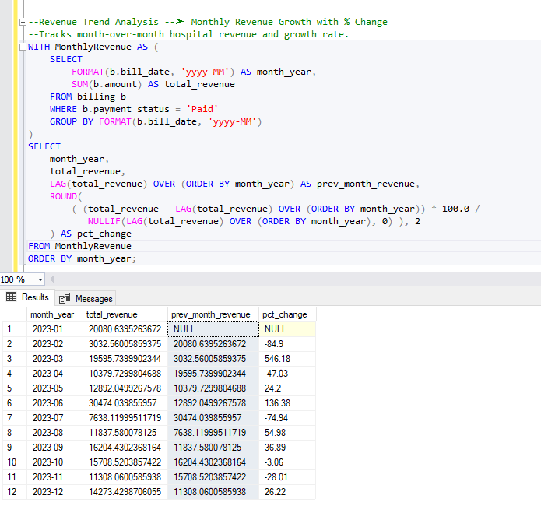

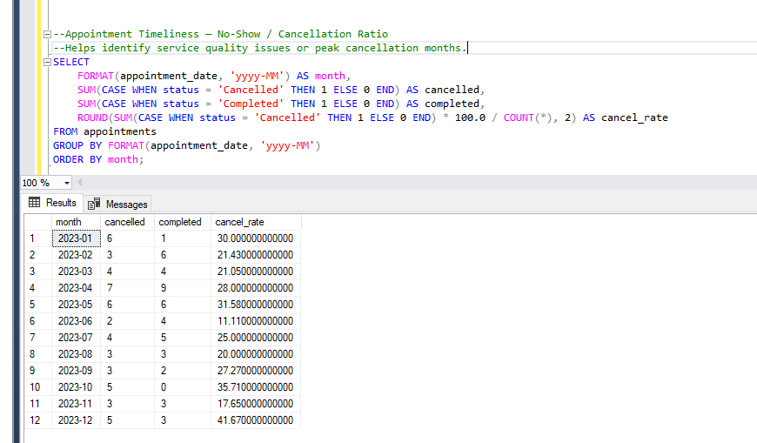

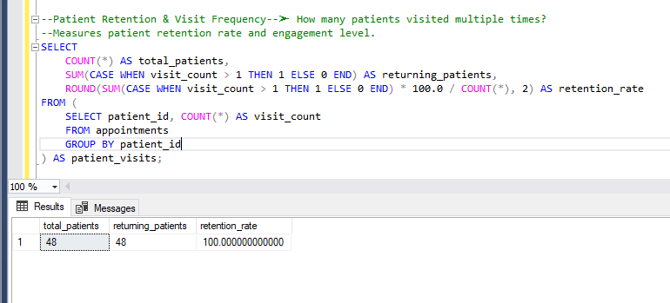

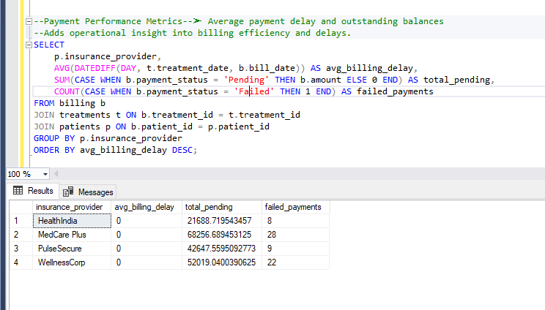

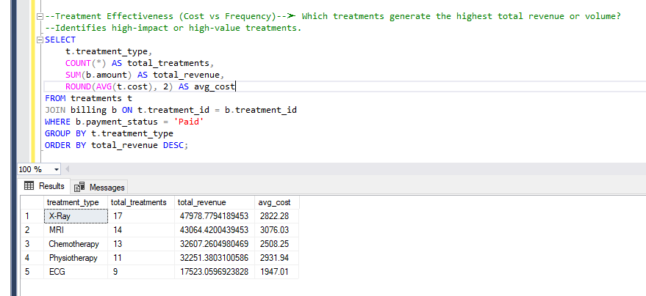

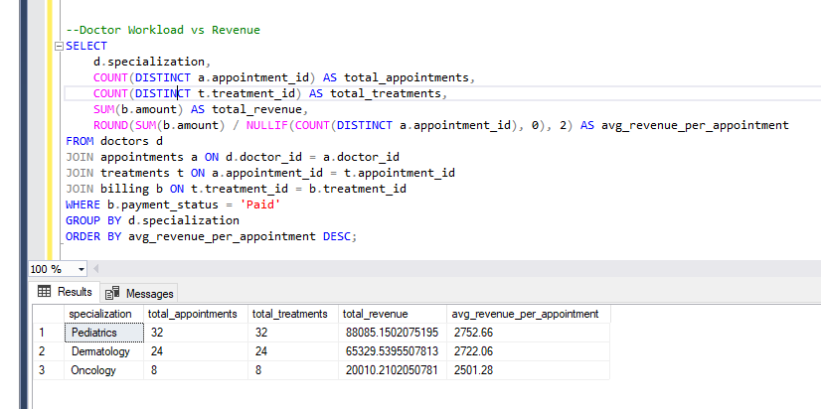

--Peak Time & Day Analysis --➤ Find the busiest appointment hours and weekdays

--Useful for resource planning and scheduling optimization.

SELECT

DATENAME(WEEKDAY, appointment_date) AS weekday,

DATEPART(HOUR, appointment_time) AS hour_slot,

COUNT(*) AS total_appointments

FROM appointments

GROUP BY DATENAME(WEEKDAY, appointment_date), DATEPART(HOUR, appointment_time)

ORDER BY total_appointments DESC;

|  |  |  |
| --- | --- | --- |
| weekday | hour_slot | total_appointments |
| Wednesday | 8 | 9 |
| Wednesday | 12 | 7 |
| Tuesday | 15 | 7 |
| Tuesday | 11 | 6 |
| Monday | 12 | 5 |
| Sunday | 13 | 5 |
| Tuesday | 13 | 5 |
| Friday | 15 | 5 |
| Sunday | 17 | 5 |
| Thursday | 17 | 5 |
| Saturday | 17 | 4 |
| Monday | 15 | 4 |
| Sunday | 15 | 4 |
| Thursday | 15 | 4 |
| Saturday | 14 | 4 |
| Wednesday | 15 | 4 |
| Tuesday | 14 | 4 |
| Thursday | 12 | 4 |
| Friday | 9 | 4 |
| Monday | 8 | 4 |
| Thursday | 9 | 4 |
| Wednesday | 9 | 4 |
| Tuesday | 10 | 4 |
| Wednesday | 10 | 4 |
| Friday | 11 | 3 |
| Saturday | 11 | 3 |
| Sunday | 11 | 3 |
| Tuesday | 9 | 3 |
| Tuesday | 8 | 3 |
| Saturday | 10 | 3 |
| Sunday | 10 | 3 |
| Thursday | 13 | 3 |
| Monday | 13 | 3 |
| Monday | 16 | 3 |
| Saturday | 16 | 3 |
| Sunday | 14 | 3 |
| Thursday | 14 | 3 |
| Monday | 17 | 3 |
| Wednesday | 16 | 3 |
| Friday | 17 | 2 |
| Friday | 14 | 2 |
| Monday | 14 | 2 |
| Thursday | 16 | 2 |
| Tuesday | 16 | 2 |
| Wednesday | 14 | 2 |
| Friday | 13 | 2 |
| Wednesday | 11 | 2 |
| Tuesday | 12 | 2 |
| Saturday | 12 | 2 |
| Friday | 8 | 2 |
| Saturday | 8 | 2 |
| Friday | 10 | 2 |
| Monday | 10 | 2 |
| Thursday | 11 | 1 |
| Thursday | 8 | 1 |
| Saturday | 9 | 1 |
| Sunday | 9 | 1 |
| Sunday | 12 | 1 |
| Thursday | 10 | 1 |
| Saturday | 13 | 1 |
| Wednesday | 13 | 1 |
| Friday | 16 | 1 |
| Sunday | 16 | 1 |
| Tuesday | 17 | 1 |
| Wednesday | 17 | 1 |

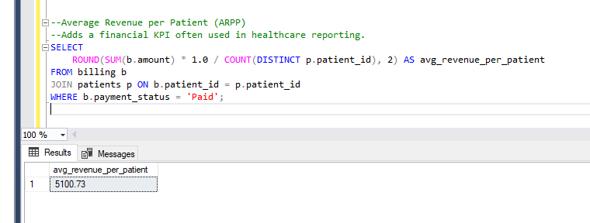

--Top Returning Patients

--Great for patient loyalty analysis.

SELECT

p.patient_id,

CONCAT(p.first_name, ' ', p.last_name) AS patient_name,

COUNT(a.appointment_id) AS total_appointments,

SUM(b.amount) AS total_spent

FROM patients p

JOIN appointments a ON p.patient_id = a.patient_id

JOIN treatments t ON a.appointment_id = t.appointment_id

JOIN billing b ON t.treatment_id = b.treatment_id

GROUP BY p.patient_id, p.first_name, p.last_name

HAVING COUNT(a.appointment_id) > 2

ORDER BY total_spent DESC;

|  |  |  |  |
| --- | --- | --- | --- |
| patient_id | patient_name | total_appointments | total_spent |
| P012 | Laura Davis | 10 | 30053.08 |
| P049 | David Moore | 7 | 23554.06 |
| P016 | Michael Taylor | 7 | 22967.94 |
| P036 | Michael Wilson | 7 | 21583.56 |
| P025 | Robert Wilson | 5 | 19513.17 |
| P005 | David Wilson | 8 | 18609.91 |
| P035 | David Wilson | 7 | 18407.42 |
| P048 | Emily Miller | 5 | 17082.48 |
| P010 | Michael Taylor | 6 | 15929.15 |
| P017 | Jane Jones | 4 | 14850.28 |
| P039 | Jane Wilson | 5 | 14357.43 |
| P037 | Robert Williams | 6 | 13886.89 |
| P031 | Robert Miller | 4 | 13732.02 |
| P032 | Alex Moore | 5 | 13656.67 |
| P029 | David Smith | 7 | 13324.5 |
| P023 | Linda Johnson | 6 | 13237.69 |
| P014 | Alex Taylor | 3 | 13236.19 |
| P022 | John Brown | 4 | 13143.45 |
| P045 | Linda Miller | 5 | 13120.96 |
| P033 | Michael Wilson | 4 | 12234.85 |
| P050 | Laura Wilson | 4 | 11206.38 |
| P007 | Alex Johnson | 4 | 10734.38 |
| P009 | Laura Davis | 4 | 10556.54 |
| P026 | John Taylor | 6 | 10487.7 |
| P024 | Sarah Brown | 4 | 10476.7 |
| P047 | Jane Moore | 3 | 10423.17 |
| P019 | Sarah Miller | 5 | 10408.9 |
| P046 | Michael Taylor | 3 | 10031.8 |
| P021 | Michael Wilson | 3 | 9374.61 |
| P013 | Laura Johnson | 4 | 9308.08 |
| P034 | Alex Smith | 3 | 9104.39 |
| P001 | David Williams | 4 | 7719.07 |
| P041 | Robert Williams | 3 | 7506.22 |
| P028 | Alex Moore | 3 | 6227.44 |
| P002 | Emily Smith | 3 | 5968.74 |
| P040 | Emily Williams | 3 | 5602.68 |
| P030 | Emily Moore | 3 | 5588.64 |
| P043 | Linda Brown | 3 | 4947.03 |