ITIS 6177 SYSTEM INTEGRATION

PRACHI SHENDE : 801306878

FINAL PROJECT

MICROSOFT AZURE COGNITIVE SERVICES : TRANSLATOR API

Release version : 1.0.0

Document Status : Final Draft

University of North Carolina, Charlotte

2022

Text Translator API

Abstract

Translator, part of [Azure Cognitive Services](https://azure.microsoft.com/services/cognitive-services/translator-text-api/), is a cloud-based [machine translation](https://www.microsoft.com/en-us/translator/business/machine-translation/) service that can be used to build applications, websites, tools, or any solution requiring multi-language support.

Built for business, Translator is a proven, customizable, and scalable technology for machine translation. Translator technology powers translation features across Microsoft products includes [Microsoft Translator app](https://www.microsoft.com/translator/apps/) for Android and iOS, Microsoft [Office](https://www.microsoft.com/en-us/translator/business/office/), [Edge](https://support.microsoft.com/topic/use-microsoft-translator-in-microsoft-edge-browser-4ad1c6cb-01a4-4227-be9d-a81e127fcb0b), [SharePoint](https://www.microsoft.com/en-us/translator/business/sharepoint/), [Yammer](https://www.microsoft.com/en-us/translator/business/yammer/), [Visual Studio](https://www.microsoft.com/en-us/translator/business/visual-studio/), [Bing](https://www.bing.com/translator?ref=MsftMT), and [Skype](http://www.skype.com/translator). Simply integrate translation into web, desktop, or mobile applications, using industry standard REST technology, Translator provides a rich functionality set for any developer.

**Value of Translator for Business**

**Secure**

As an Azure service, Translator meets strict security requirements. Customer data submitted for translation by Translator are not written to persistent storage. There will be no record of the submitted text in any Microsoft data center. Translator has also received compliance certifications such as HIPAA, ISO, SOC, and FedRAMP. Learn more about Translator [security and confidentiality](https://www.microsoft.com/en-us/translator/business/notrace/).

**Scalable**

Translator is an Azure service used globally by thousands of organizations as part of their existing workflows, for both internal-facing and external-facing content and applications. Getting started using the Translator service is a snap to scale to your needs. Sign up for a free subscription for volumes up to 2 million characters per month, purchase a monthly subscription for higher volumes from the [Azure portal](https://azure.microsoft.com/en-us/?b=17.05). Review pricing options on our Translator [pricing page](https://azure.microsoft.com/en-us/pricing/details/cognitive-services/translator-text-api/) within Cognitive Services on the Azure portal. Volume licensing is available for Enterprise customers. [Get started today](https://www.microsoft.com/en-us/translator/business/trial/#get-started).s

If you are in China, you can sign up for a **[free 2 million character per month subscription](https://www.azure.cn/home/features/cognitive-services/translator-text-api/)** on Azure.cn.

**Customizable**

Translator’s open cloud API can be integrated into any platform. Translator works across devices and operating systems, in client and web applications. The service adapts to enterprise workflows and products, and is included in [Microsoft Office](https://www.microsoft.com/en-us/translator/business/office/) products. For high-security scenarios, an [on premises](https://www.microsoft.com/en-us/translator/business/on-premises/) version is also available.

Translator also supports industry-specific translation [customization](https://www.microsoft.com/en-us/translator/business/customization/) using Custom Translator.

**Key API Features**

**Natively Neural –** Use modern neural machine translation (NMT) as default for all [supported languages](https://www.microsoft.com/en-us/translator/business/languages/). NMT technology has transformed machine translation, providing major advances in translation quality over the existing industry-standard statistical machine translation (SMT) technology. NMT better captures the context of full sentences before translating them, providing much higher quality translation and more human-sounding output. Learn more about [how NMT works](https://www.microsoft.com/en-us/translator/business/machine-translation/#nmt).

**Translate into multiple languages at once –** Translate into multiple languages with a single request to the Translator cloud service. The translate feature automatically detects the language of the source content.

**Detect –** Automatically detect the language of the text sent to the API to help decide which content should be sent for translation or not.

**Transliteration –** Convert words and sentences from one script into another script. For instance, you can present Chinese characters in the Latin alphabet (PinYin) so they can be read by non-Chinese audiences.

Bilingual dictionary – Display alternative translations from or to English, examples of words in context to help you choose the perfect translation, and even examples of translated sentences using this word.

API OPERATIONS

ENDPOINT URL :

“[http://137.184.25.239:3000/api/translate](https://137.184.25.239:3000/api/translate)"

LocalHostURL :

“<http://localhost:3000/docs/#/default/post_api_translate>"

SWAGGER DOCUMENTATION :

“https://137.184.25.239/docs/#/

| Sr. no | OPERATION | METHOD | DESCRIPTION | PAYLOAD |
| --- | --- | --- | --- | --- |
| **1** | /api/translate | POST | Post method is used to pass the input “text” that is to be translated to the target language code mentioned in “to” input parameter of the request body | POST : /api/translate  [{“text” : “String”,  “to” : “String”}] |

SAMPLE PAYLOAD :

[

{

“text” : “Life is Beautiful”,

“to” : “fr”

}

]

|  |
| --- |
| **Response body**  **Download**  [  {  "detectedLanguage": {  "language": "en",  "score": 1  },  "translations": [  {  "text": "La vie est belle",  "to": "fr"  }  ]  }  ] |

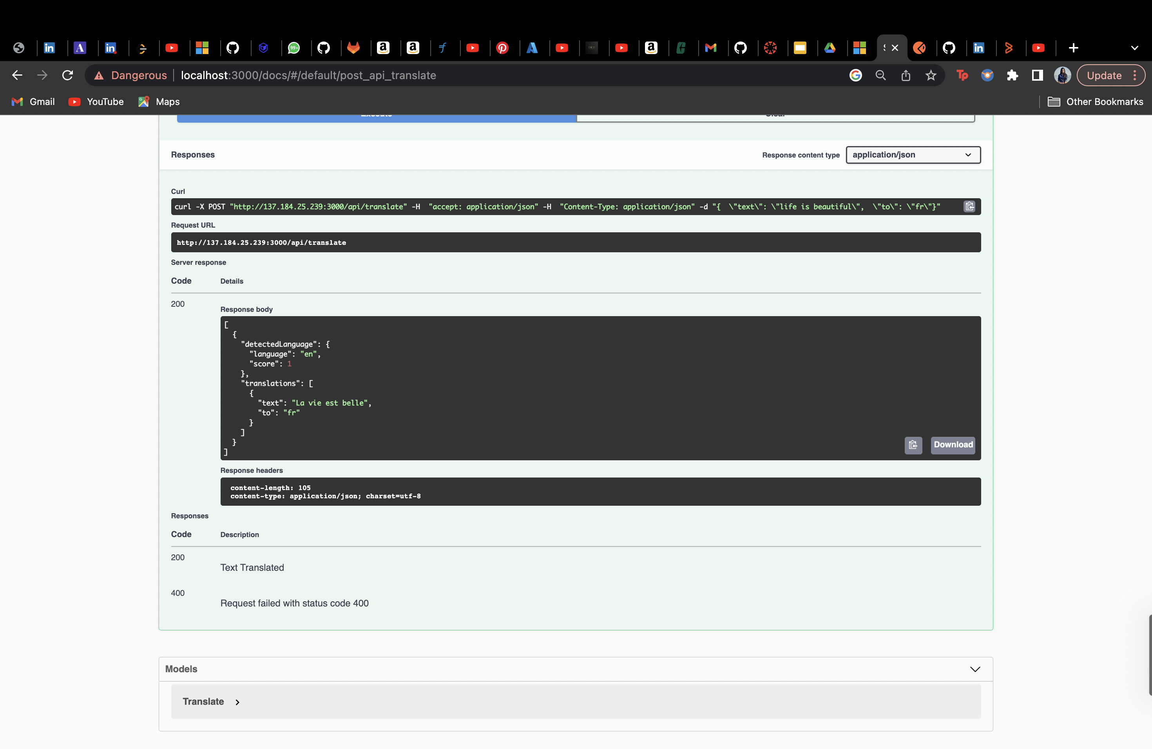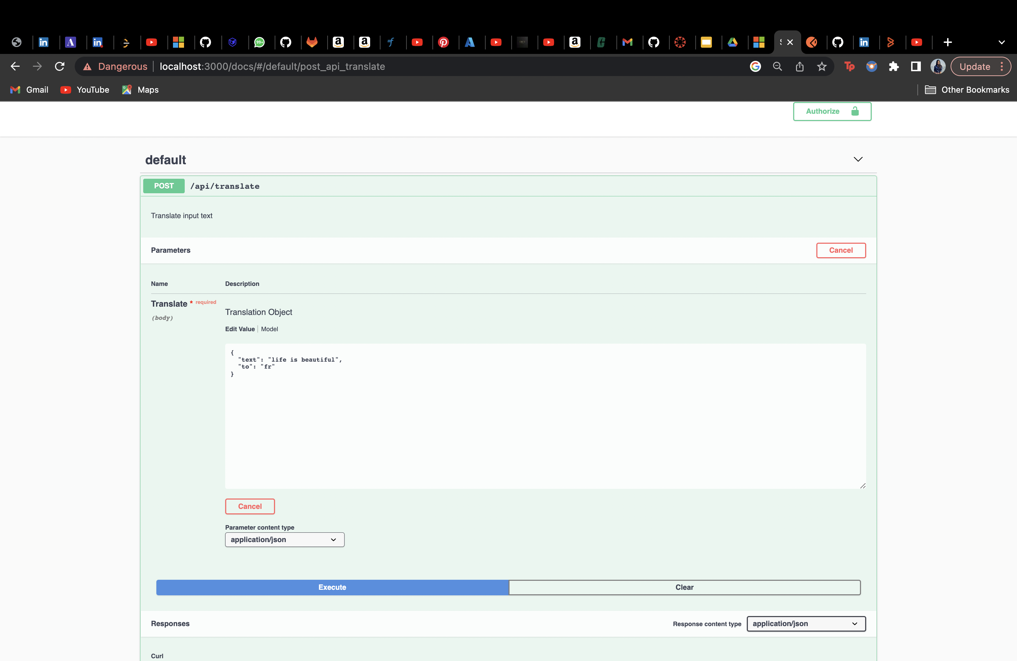

References

1. <https://www.microsoft.com/en-us/translator/business/translator-api/>
2. <https://learn.microsoft.com/en-us/azure/cognitive-services/translator/>