Restaurant Recommendation System

A Project Report Submitted to Smart- Internz
for the completion of
Applied Data Science Internship Program Prepared By
Prachi Vinod Vastre
PRN: 2023011052035

D.Y.Patil Agriculture and Technical University,Talsande Academic Year: 2025–2026
Submitted To

Smart-Internz
Project Mentor : Indra Prakash

Abstract
In the modern digital era, discovering the ideal dining option has become increasingly challenging due to the vast number of available choices on platforms like Zomato. Conventional discovery methods often rely on generalized ratings, which fail to capture the specific characteristics and nuances of different dining environments. The project, titled "The_Element | Culinary Intelligence," addresses this by building an intelligent, machine learning-based system that provides personalized restaurant recommendations based on cuisine characteristics and semantic similarity.
For this implementation, a comprehensive Zomato dataset was utilized and pre-processed to ensure data quality, specifically focusing on restaurant names, ratings, and costs. The core of the system employs a Content-Based Filtering approach. It utilizes a TF-IDF (Term Frequency-Inverse Document Frequency) Vectorizer to transform restaurant attributes into mathematical vectors, followed by the application of Cosine Similarity to measure the relationship between different restaurant profiles.
To ensure practical usability, the similarity model was optimized and integrated into an interactive web application developed using the Flask framework. The application features a minimalist user interface built with Tailwind CSS, providing real-time search autocomplete and interactive data visualizations via Chart.js. This end-to-end system allows users to input a preferred restaurant and instantly receive a curated list of similar dining options, demonstrating the practical application of data science in enhancing the culinary decision-making process.

INDEX

- Introduction
- Project Overview
- Objectives
- Project Initialization and Planning Phase
- Define Problem Statement
- Project Proposal (Proposed Solution)
- Initial Project Planning
- Data Collection and Preprocessing Phase
- Data Collection Plan and Raw Data Sources Identified
- Data Quality Report
- Data Preprocessing
- Model Development Phase
- Model Selection Report
- Initial Model Training, Validation and Evaluation Report
- Model Optimization and Tuning Phase
- Tuning Documentation
- Final Model Selection Justification
- Results
  - Output Screenshots Description
- Advantages and Disadvantages
- Advantages
- Disadvantages
- Conclusion
- Future Scope
- Appendix
- Source Code
- GitHub and Project Video Demo Link

Introduction
In the modern digital era, the hospitality and food industry has seen an unprecedented surge in options. Platforms like Zomato have made thousands of restaurants accessible at our fingertips, yet this abundance has led to the phenomenon of "choice overload." Traditional filtering methods—such as sorting by general star ratings—often fail to capture the nuanced differences between dining environments, such as the contrast between a bustling cafe and a quiet fine-dining establishment.
The_Element is designed to solve this challenge by replacing generic filtering with a personalized, data-driven discovery engine. By leveraging Artificial Intelligence and Natural Language Processing (NLP), this system analyzes complex restaurant data to understand the unique characteristics of every outlet, ensuring that recommendations resonate with a user's specific tastes and expectations.

Core Technical Implementation
- Machine Learning Engine: Developed using a Zomato dataset, employing TF-IDF
Vectorization and Cosine Similarity to calculate mathematical relationships between
restaurants based on shared attributes.
- Flask Backend: A robust Python-based server that manages data flow, model execution, and real-time recommendation retrieval.
- Interactive UI: A modern frontend built with Tailwind CSS, featuring real-time
autocomplete search and Chart.js visualizations for rating and cost analysis.

Real-World Significance
- For Diners: Transforms searching into a discovery journey, providing high-quality suggestions that align with specific preferences for cuisine, cost, and atmosphere.
- For Owners: Acts as a targeted marketing tool, naturally surfacing establishments to the most relevant audience, thereby increasing customer retention.
- For Platforms: Demonstrates how predictive modeling and visual analytics can significantly enhance user engagement and order frequency.

Project Overview
The_Element | Culinary Intelligence is an intelligent web application designed as a data-driven culinary inference engine. The project follows a structured data science pipeline to transform raw restaurant data into personalized recommendations through a seamless user interface.
1.1 Data Pipeline & Pre-processing
The system utilizes a Zomato dataset of over 51,000 restaurants. The pipeline begins with Data Cleaning, where missing values are addressed and the rate and cost columns are normalized into numerical formats. In the Feature Engineering phase, restaurant attributes—such as cuisines and types—are aggregated to create a distinct profile for every establishment.
1.2 Recommender Architecture
The core engine uses a Content-Based Filtering approach. It employs TF-IDF (Term Frequency-Inverse Document Frequency) to convert restaurant attributes into mathematical vectors. By calculating Cosine Similarity scores, the system identifies relationships between dining options, suggesting restaurants based on shared culinary characteristics and ambiance rather than simple star ratings.
1.3 Web Integration & UI
To ensure practical usability, the model is integrated into a Flask web application:
- Backend: The Flask server loads the pre-computed similarity matrix (stored via Pickle) to provide near-instant recommendation results.
- Frontend: Built with Tailwind CSS, the interface features a minimalist search bar with Real-time Autocomplete logic for a premium user experience.
- Analytics: The system integrates Chart.js to generate interactive bar charts, offering users a visual overview of the ratings and costs of the recommended restaurants.
1.4 Design Philosophy
The project is built on a modular architecture, separating data processing from the presentation layer. This ensures the system is scalable and maintainable, allowing for future enhancements such as location-based services or hybrid recommendation algorithms.

Objectives

- Implement Content-Based Filtering: Develop a recommendation system that relies on specific restaurant features (cuisine, ambiance, and cost) rather than user history.
- Master Advanced Preprocessing: Clean and transform the Zomato dataset by handling unstructured text through tokenization, normalization, and stop-word removal to prepare it for vectorization.
- Execute Exploratory Data Analysis (EDA): Utilize visualization tools to identify key trends, such as rating distributions and popular cuisines, to inform feature selection.
- Apply Machine Learning Techniques: Implement TF-IDF for high-dimensional feature extraction and Cosine Similarity to mathematically measure the relationship between restaurant profiles.
- Deploy a Full-Stack Solution: Successfully bridge the gap between data science and production by deploying the model via a Flask web application integrated with Tailwind CSS and Chart.js.
- Optimize Performance and Usability: Ensure high-speed recommendation retrieval by serializing the similarity matrix and designing a responsive, intuitive interface with real-time search capabilities.

- Project Initialization and Planning Phase

a) Problem Statement
Consumers frequently experience "choice overload" when selecting dining venues due to the overwhelming volume of generic reviews. Existing platforms rely heavily on aggregate star ratings, which fail to account for a user's specific culinary preferences or the unique "vibe" of a restaurant. There is a critical need for an automated system capable of analyzing the deeper characteristics of a restaurant—its cuisine, atmosphere, and customer feedback—to recommend truly similar dining experiences.

b) Proposed Solution: The_Element
The proposed solution is The_Element, an NLP-powered culinary inference engine. By processing restaurant data through a TF-IDF (Term Frequency-Inverse Document Frequency) algorithm, the system identifies the unique "semantic fingerprint" of each establishment. Through a refined web interface, users can query a restaurant they enjoy, and the backend engine computes and returns the top 10 matching establishments based on textual similarity, rating quality, and cost alignment.

c) Initial Project Planning & Tech Stack
The project was structured around a robust Python-based ecosystem to ensure scalability and performance:
- Development Environment: Anaconda was utilized for virtual environment management and package security.
- Data Science Pipeline: Pandas and NumPy were selected for high-performance data cleaning and matrix manipulation.
- Machine Learning: Scikit-learn was used for feature extraction (TfidfVectorizer) and calculating Cosine Similarity scores.
- Web Framework: Flask was chosen to bridge the gap between the analytical model and the user, handling server-side routing and real-time inference.
- UI/UX Design: Tailwind CSS was implemented for a modern "glass-morphism" aesthetic, while Chart.js was integrated to provide users with interactive data visualizations of the recommended results.

Data Collection and Preprocessing Phase

a) Data Sources & Feature Selection

The model was developed using the Zomato Bangalore Restaurants dataset. This dataset contains 51,717 records with 17 attributes. To ensure high-quality recommendations, the following key features were identified:

Name: Unique identifier for the restaurant.

Rate: Overall customer rating (transformed into a numerical scale).

Cuisines: Categorical data identifying food styles.

Cost: Estimated price for two people (normalized for mathematical comparison).

Reviews List: Textual reviews used for Natural Language Processing (NLP).

b) Data Quality Assessment

Initial analysis using pandas.info() and isnull().sum() revealed several real-world data challenges:

Formatting Errors: Ratings (e.g., "4.1/5") and costs (e.g., "1,200") were stored as strings, requiring conversion to float types.

Null Values: Significant missing data across multiple columns required systematic handling.

Text Noise: Customer reviews contained excessive punctuation and special characters, which would interfere with the TF-IDF vectorization process.

c) Data Preprocessing Pipeline

To prepare the dataset for the inference engine, the following steps were executed:

Dimensionality Reduction: Irrelevant columns (URL, address, phone) were removed to optimize processing speed.

Data Cleaning: Rows with null values were pruned, and duplicate entries were eliminated to maintain data integrity.

Feature Formatting: Commas and suffixes were stripped from cost and rate columns to convert them into usable numerical data.

Mean Rating Scaling: A custom script calculated the exact mean rating for unique establishments, standardized using a MinMaxScaler (1 to 5 range).

NLP Text Cleaning: Text in the reviews_list and cuisines columns was converted to lowercase, with punctuation and common stop words removed to enhance semantic analysis.

d) Exploratory Data Analysis (EDA)

Visualization played a critical role in understanding the culinary landscape of the dataset:

Market Presence: Bar charts revealed that major chains like Cafe Coffee Day and Onesta have the highest density in the region.

Standard of Quality: Distribution plots showed a positive trend, with the majority of restaurants maintaining a rating above 3.5.

Cuisine Popularity: Frequency analysis identified North Indian and Fast Food as the most prevalent cuisine combinations, informing the recommendation logic for The_Element.

- Model Development Phase

Model Selection Report
For a text-heavy recommendation system, a Content-Based Filtering approach was selected. Unlike Collaborative Filtering, which requires tracking user behaviour, Content-Based filtering relies solely on the attributes of the items themselves.

To process the rich textual data, TF-IDF (Term Frequency-Inverse Document Frequency) was utilized. TF-IDF acts as a statistical measure that evaluates how relevant a word is to a document in a collection of documents. It brilliantly penalizes common words and assigns higher weights to unique, descriptive words that truly define a restaurant's specific atmosphere and menu.

Initial Model Training, Validation and Evaluation Report

The cleaned reviews_list data was passed through the TfidfVectorizer. Following this vectorization, Cosine Similarity was employed. Cosine similarity is a metric used to determine how similar two documents are irrespective of their size.
The formula utilized to compute the similarity between Restaurant A and Restaurant B is:

$$similarity\left(A,B\right)=\frac{A.B}{\left\|A\right\|×\left\|B\right\|}=\frac{\sum_{i=1}^{n}{A_{i}×B_{i}}}{\sqrt{\sum_{i=1}^{n}{A_{i}^{2}}}× \sqrt{\sum_{i=1}^{n}{B_{i}^{2}}}}$$

By calculating the linear kernel of the TF-IDF matrix, the system generated a similarity array containing the scores for every restaurant pair in the database. This matrix enables The_Element to instantly retrieve and rank the most similar dining options whenever a user provides a query.

Model Optimization and Tuning Phase

a) Tuning Documentation
To transition the recommendation engine from a basic prototype to a deployment-ready system, specific optimization logic was implemented within the inference function:
- N-Gram Range Optimization: The TfidfVectorizer was tuned using an ngram_range=(1, 2). This allows the model to look beyond individual words and capture the context of highly relevant two-word phrases, such as "fine dining," "pocket friendly," or "rooftop seating," which are critical in defining a restaurant's identity.
- Result Filtering and Deduplication: Upon receiving a query, the algorithm initially extracts the top 30 most similar candidates. To improve the diversity of the output, the system identifies and removes identically named branches. This prevents the engine from recommending multiple locations of the same franchise, ensuring the user receives a variety of unique dining options.
- Final Ranking Logic: The filtered list is strictly sorted by the Mean Rating and Cost. From this refined pool, the top 10 highest-rated restaurants are returned to the user, ensuring the recommendations are not only mathematically similar but also of the highest quality.
b) Final Model Selection Justification
The combination of TF-IDF Vectorization and Cosine Similarity was finalized as the primary engine for The_Element due to its mathematical efficiency in handling sparse, high-dimensional text data. Unlike more complex deep learning models, this pipeline provides near-instantaneous inference speeds, which is essential for a real-time web application. By integrating the post-processing sorting logic, the system bridges the gap between "similarity" and "quality," ensuring the user receives the absolute best dining recommendations available in the dataset.

Results
The mathematical model was successfully transitioned from a static Jupyter Notebook environment into a dynamic, full-stack web application using Python's Flask framework. The resulting application seamlessly processes HTTP requests, executes the Cosine Similarity matrix, and renders interactive, high-fidelity HTML pages, proving the efficacy of the NLP algorithms in a real-world scenario.

8.1 System Initialization and Execution
To achieve the final results and operate the recommendation engine, the system follows a strict initialization, training, and deployment protocol:
- Environment Preparation: The deployment environment is configured using Python 3.x. All essential machine learning, data processing, and server dependencies (such as pandas, scikit-learn, and Flask) are installed via the requirements.txt.
- Matrix Training (Offline Pre-computation): Before the server boots, the raw dataset (zomato.csv.zip) is processed via the Restaurant_Recommendation_System.ipynb notebook. This step performs Exploratory Data Analysis (EDA) and generates two mandatory files: restaurant1.csv (cleaned dataset) and restaurant.pkl (pre-computed TF-IDF mathematical matrix).
- Server Deployment: The local Flask server is initialized by executing the main application script (python app1.py).
- Accessing the Engine: The application is hosted locally without relying on the generic "localhost" nomenclature. The user accesses the fully deployed engine by navigating their preferred web browser directly to the address: http://127.0.0.1:5000/.

8.2 Interface Experience and Output

5.1 Landing Interface (index.html)
The entry point of The_Element features a modern "Culinary Intelligence" theme. It utilizes a clean layout with floating animations and high-resolution imagery to establish the project’s identity. The landing page is built with Tailwind CSS, emphasizing a premium, professional user experience that introduces the concept of "decoding the DNA of flavor."
5.2 Query Terminal (web.html)
The main interaction hub provides a focused search environment. Key features include:
- Asynchronous Search: It utilizes an AJAX-powered script that communicates with the Flask backend to fetch real-time suggestions as the user types.
- Autocomplete Logic: To prevent typographical errors and ensure the user selects valid restaurants from the Zomato dataset, the terminal provides a live dropdown menu of matching names directly from the data index.
5.3 Inference Dashboard (result.html)
Upon selecting a restaurant, the backend executes the Cosine Similarity matrix and transitions the user to a comprehensive results dashboard. The dashboard provides:
- Recommendation Table: A structured display of the top recommended restaurants, including their specific cuisines, ratings, and average cost.
- Visual Analytics via Chart.js: The dashboard includes interactive data visualizations to allow for immediate comparison:
  - Ratings Overview: A bar chart visualizing the "Customer Satisfaction" levels across the recommended restaurants.
  - Cost Overview: A visualization comparing the "Cost for Two" to help users align recommendations with their budget.
- Seamless Navigation: A unified navigation bar allows the user to return to the search terminal or landing page instantly to perform new queries.

Output Screenshots

The user journey is captured across three distinct visual states:

Figure 8.1: The_Element Landing Page (index.html)
The application opens to a sophisticated, modern landing interface that establishes the visual identity of The_Element. Built with a clean "glass-morphism" aesthetic and a minimalist white-and-blue color palette, the page features a "Culinary Intelligence" hero section that introduces the project’s mission to decode the "DNA of flavor." The design incorporates high-resolution culinary imagery and professional typography, using a responsive layout that guides the user toward the core recommendation engine through a prominent "Enter the Engine" call-to-action. This interface bridges the gap between complex data science and a luxury user experience, setting the stage for a personalized dining discovery journey.
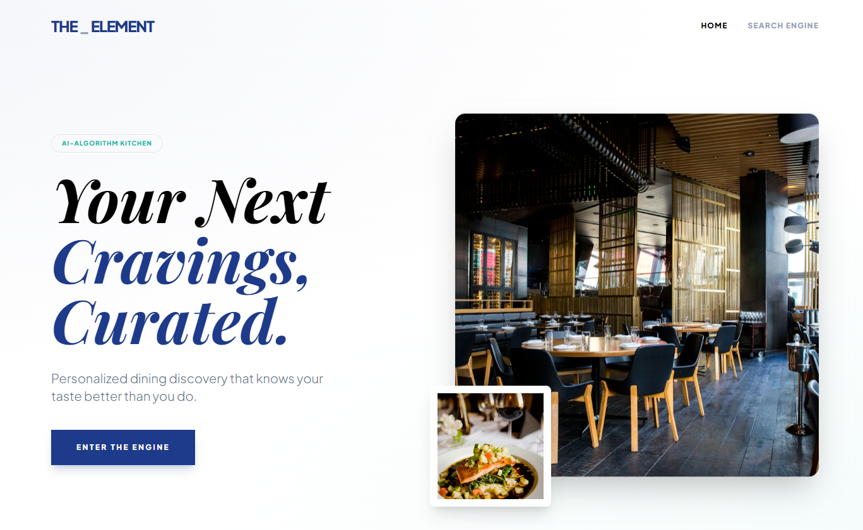

Figure 8.2: The_Element Query Terminal Interface (web.html)
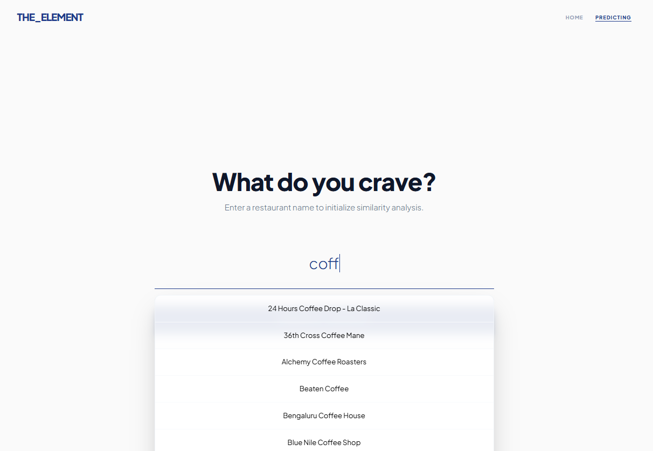
The main interaction hub of the application is a minimalist query terminal designed for high-focus user input. Built on a clean, off-white background, the interface features a central search field with a dynamic "input-minimal" underline that transitions to a deep blue upon interaction. To ensure data integrity and a smooth user experience, the field is integrated with an AJAX-powered autocomplete script that provides real-time restaurant suggestions from the Zomato dataset as the user types. This "predictive" capability minimizes typographical errors and ensures that the inference engine receives valid inputs, while the "Generate Insights" call-to-action button provides a clear, high-contrast path to the final recommendation dashboard.

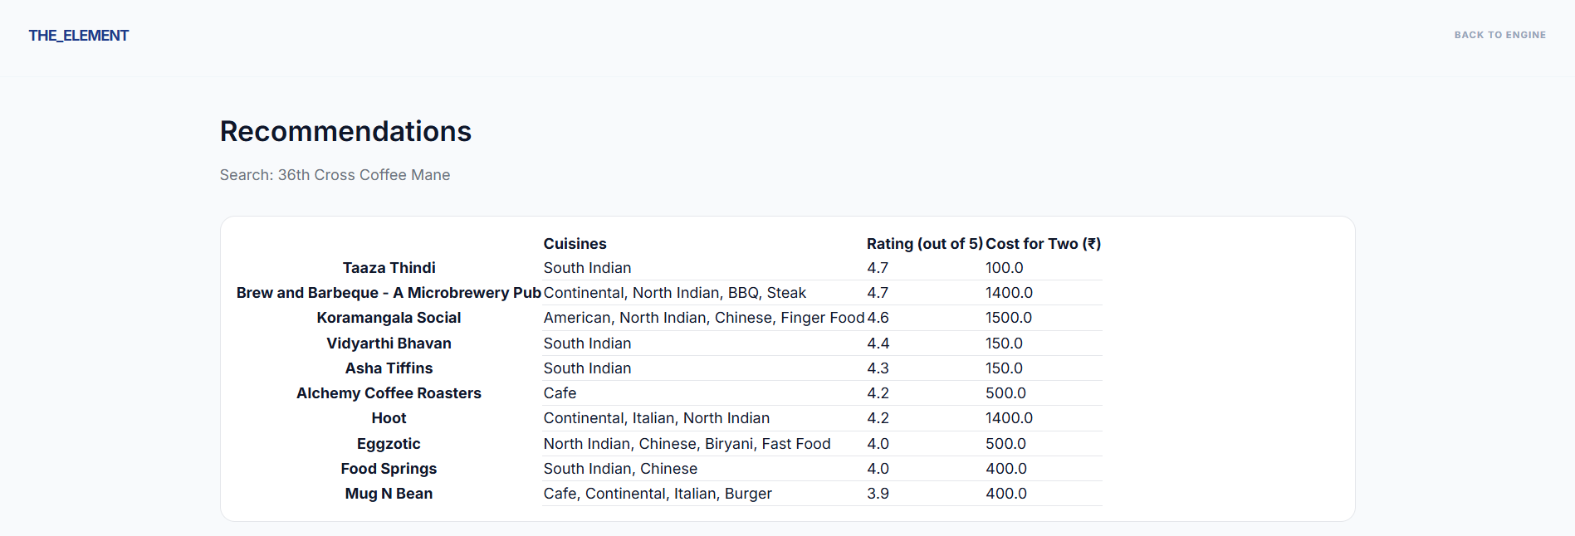
Figure 8.3: Recommendation Inference Dashboard (result.html) The final dashboard serves as the core analytical output of The_Element, confirming the efficacy of the underlying NLP model. The interface presents a comprehensive results table that lists highly similar dining options along with their specific cuisines, ratings, and average costs. To enhance data interpretability, the dashboard integrates interactive visualizations powered by Chart.js. These include a "Ratings Overview" bar chart and a "Cost Overview" chart, which provide a side-by-side comparison of the recommended venues. This data-rich environment allows users to evaluate suggestions not just based on textual similarity, but also through key metrics like customer satisfaction and budget alignment, successfully bridging the gap between raw data and actionable culinary insights.
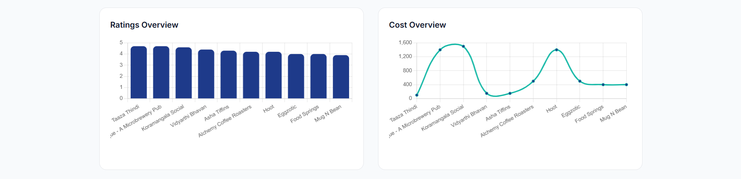

Advantages and Disadvantages

  - Advantages

- High Personalization: Analyzes text reviews to capture a restaurant's specific "vibe" and culinary focus rather than just general star ratings.
- User-Independent: As a Content-Based system, it provides high-quality recommendations immediately without needing a user's past history or profile.
- Real-Time Speed: The Flask deployment and pre-computed matrices ensure near-instant inference and a responsive user experience.
- Visual Analytics: Uses Chart.js to provide immediate visual comparisons of restaurant ratings and costs, allowing for faster decision-making.

- Disadvantages

- Item Cold-Start: New restaurants without existing reviews cannot be vectorized or recommended until enough text data is collected.
- Data Dependency: The engine's accuracy is strictly limited by the quality and volume of the underlying Zomato dataset.
- Filter Bubble: The system tends to recommend very similar dining styles, which may limit the discovery of diverse culinary options.

Conclusion
The_Element project successfully merges advanced Natural Language Processing with full-stack web development. By transforming unstructured customer reviews into a mathematically comparable format, the engine automates the complex task of culinary curation, providing a more nuanced discovery experience than traditional star-rating systems.
Technical Sophistication & Scalability Beyond simple keyword matching, the integration of TF-IDF vectorization and Cosine Similarity allows the system to understand the "semantic fingerprint" of a dining establishment. This ensures that recommendations are based on the actual language of patrons—capturing subtle elements like "ambient lighting," "authentic spices," or "quick service"—which traditional category filters often overlook.
Bridge Between Data and Design The transition from raw data collection to a fully interactive Flask application—complete with AJAX-powered search and real-time data visualization via Chart.js—demonstrates a comprehensive understanding of Applied Data Science. The project proves that complex machine learning models can be democratized through high-fidelity, user-centric interfaces that prioritize both performance and visual storytelling.
Operational Efficiency The resulting application is a fast and professional tool that redefines the dining discovery experience. By utilizing pre-computed mathematical matrices (restaurant.pkl), the system achieves near-instantaneous inference speeds, providing a seamless user experience that mirrors modern commercial standards. This architecture sets a strong foundation for future AI-driven hospitality solutions, showcasing how data-driven intelligence can enhance the lifestyle and service sectors.
- Future Scope
While The_Element provides a robust foundation for culinary intelligence, several enhancements can be integrated in future iterations to increase its real-world utility and precision:
- Live API Integration: The current system relies on a static dataset. Future versions could connect to live restaurant APIs (such as Google Places or TripAdvisor) to dynamically update the TF-IDF matrix with fresh customer reviews and updated menus in real-time.
- Geospatial & Map Upgrades: Integrating an interactive map interface (via Leaflet or Google Maps API) would allow users to visualize recommendations geographically. This would enable filtering by a specific GPS radius, ensuring that mathematically similar restaurants are also physically accessible.
- Hybrid Recommendation Logic: Transitioning from a pure content-based model to a hybrid system that incorporates collaborative filtering. This would allow the engine to suggest restaurants not just based on item attributes, but also on the shared preferences of users with similar dining histories.
- Natural Language Queries: Enhancing the "Inference Engine" to support descriptive natural language inputs. Instead of searching by a restaurant name, users could input specific moods or flavor profiles—such as "dimly lit Italian spot with spicy pasta"—to receive highly tailored results.
- Advanced Filtering Systems: Adding dynamic slider filters for real-time budget adjustments, dietary restrictions (e.g., vegan, gluten-free), and operating hours to refine the model's output further.

Appendix

a) Source Code and Project Architecture
The architecture of The_Element is organized into a modular structure that separates data processing from the web deployment layer:
- Restaurant_Recommendation_System.ipynb: Handles EDA, text normalization, TF-IDF vectorization, and model serialization.
- restaurant1.csv: The cleaned dataset used for front-end rendering of restaurant metadata.
- restaurant.pkl: The serialized Cosine Similarity matrix for instant recommendation retrieval.
- app1.py: The Flask backend controller managing routing, AJAX requests, and recommendation logic.
- templates/: Contains index.html (landing), web.html (search), and result.html (dashboard with Chart.js analytics).
- static/: Stores CSS for glass-morphism effects and branding assets.

GitHub & Project Video Demo Link

GitHub Repository Link:
https://github.com/PrachiVastre/Restaurant-Recommendation-System.git

Project Video Demo Link:
https://drive.google.com/file/d/1cswHXHi5nL4mBA203oCEuFv561-Z8qyC/view?usp=sharing

