**System Design Study**

1. What is **Client-Server architecture**?

* Client-server architecture is a fundamental concept in system design where a network involves multiple clients and a server.
* Clients are devices or programs that request services or resources, while the server is a powerful machine providing these resources or services.

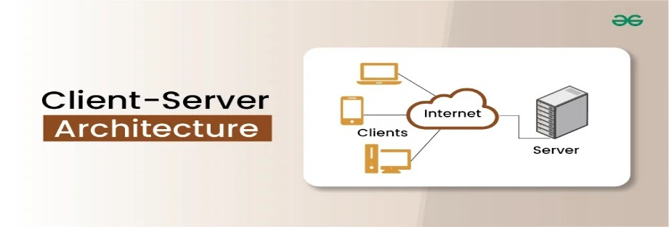

1. What is the difference between **Frontend, Backend, and Database**?

* Frontend (Client-side):
* Purpose: The user interface (UI) and user experience (UX) that users directly see and interact with in their web browser or mobile application.
* Functionality: Handles visual presentation, user input, and displaying information retrieved from the backend.
* Backend (Server-side):
* Purpose: The "brains" of the application, responsible for processing requests, managing data, and implementing business logic.
* Functionality: Receives requests from the frontend, interacts with the database, performs calculations, handles authentication and authorization, and sends responses back to the frontend.
* Database:
* Purpose: Stores and organizes the application's data in a structured manner.
* Functionality: Provides mechanisms for storing, retrieving, updating, and deleting data, ensuring data integrity and consistency.

1. Read about **REST API basics** (what is an API, GET/POST/PUT/DELETE).

* An Application Programming Interface (API) is a set of defined rules and protocols that allows different software applications to communicate with each other. It acts as an intermediary, enabling one application to request services or data from another.
* REST (REpresentational State Transfer) API is an architectural style for designing networked applications, particularly web services. It utilizes standard HTTP methods to perform operations on resources, often represented by URLs. These operations align with CRUD (Create, Read, Update, Delete) actions.
* GET: Used to retrieve data from the server.
* POST: Used to create a new resource on the server.
* PUT: Used to update an existing resource on the server, or create it if it doesn't exist.
* DELETE: Used to remove a resource from the server.