

Project Report On

Chatbot Using Python

Submitted By: Submitted To:
Name: Prachi Bathla Mrs. Palwinder Kaur
UID: 25MCI10226
Class: MAM 4B

University Institute of Computing
Chandigarh University, Gharuan , Mohali

INDEX
- Acknowledgement 3
- Aim 4
- Brief Description……………………………………………………………………………………4
- Objectives 5
- Hardware/Software Requirements 6
- Flowchart 7
- Implementation 8-10
- Output/Results 11
- Benefits 12
- Limitations 13
- Project Outcomes ………………………………………………………………………14-15

Chatbot Using Python

ACKNOWLEDGEMENT

I would like to express my sincere gratitude to Mrs. Palwinder Kaur (Faculty, UIC) for her continuous guidance, encouragement, and support throughout the completion of this project titled “Chatbot Using Python.” Her valuable insights, motivation, and expert suggestions have been instrumental in helping me understand the core concepts of artificial intelligence and natural language processing, which form the foundation of this project.
I am also thankful to the Department of Computer Applications, Chandigarh University, for providing me with the necessary resources, learning environment, and practical exposure that enabled me to successfully complete this work.
A special thanks to my classmates and friends for their cooperation and valuable discussions, which helped me in debugging and enhancing the chatbot system. Finally, I would like to extend heartfelt appreciation to my family for their constant encouragement, patience, and belief in my abilities.
This project has given me a great opportunity to explore Python programming, logical thinking, and AI-based automation — enriching both my technical knowledge and problem-solving skills.

AIM

The aim of this project is to design and develop an intelligent chatbot using Python that can interact with users through text-based communication. The chatbot is capable of understanding user inputs, processing them logically, and generating appropriate responses based on predefined rules or natural language understanding techniques.
This project focuses on demonstrating how artificial intelligence (AI) and natural language processing (NLP) concepts can be applied to build an automated conversational system that simulates human-like communication. The goal is to create a user-friendly, efficient, and easily extensible chatbot that can serve as a foundation for future AI-driven applications in areas such as customer support, education, and virtual assistance.

BRIEF DESCRIPTION

The project titled “Chatbot Using Python” aims to develop an interactive and intelligent system capable of communicating with users in natural language. A chatbot is an artificial intelligence (AI) program that can simulate conversation with human users through text or voice interactions. In this project, the chatbot has been implemented using the Python programming language, which provides simplicity, flexibility, and a wide range of libraries for text processing and automation.
The system is designed as a rule-based chatbot, where responses are generated by matching user inputs with predefined patterns or keywords. Python’s built-in libraries such as NLTK (Natural Language Toolkit) and Regular Expressions (re) are utilized for text analysis and pattern recognition. The chatbot can respond to basic queries, provide information, and maintain an ongoing conversation in a logical and user-friendly manner.
The project not only demonstrates the working of conversational AI but also provides insight into how chatbots can be extended with machine learning, sentiment analysis, and API integration to create more advanced and intelligent systems. The development process enhances understanding of Python programming, data structures, control flow, and natural language processing, making this project both educational and practical for real-world applications.

OBJECTIVES

The main objective of this case study is to understand the design, development, and functioning of a chatbot built using the Python programming language. The project aims to showcase how artificial intelligence concepts such as natural language processing, pattern recognition, and rule-based responses can be combined to create an interactive conversational system.
The specific objectives of the project are as follows:
- To understand the concept and working of chatbots:
To gain a clear understanding of how chatbots simulate human-like conversations through automated programming and artificial intelligence techniques.
- To design and develop a rule-based chatbot using Python:
To build a chatbot capable of responding to user queries based on predefined patterns and rules, without the use of advanced machine learning algorithms.
- To implement Natural Language Processing (NLP) for communication:
To apply Python libraries such as NLTK and Regex for analyzing and processing textual data entered by users to generate meaningful responses.
- To demonstrate human-computer interaction:
To showcase how chatbots can facilitate seamless communication between users and computer systems in real-time.
- To explore real-world applications of chatbots:
To understand how chatbots are used in industries like customer support, education, healthcare, and e-commerce for improving efficiency and user experience.
- To identify limitations and future improvements:
To analyze the challenges of a rule-based chatbot and propose enhancements such as integrating machine learning models or cloud APIs for better intelligence and dynamic response generation.

Hardware and Software Requirements

1. Hardware Requirements
Component | Specification
Processor | Intel Core i3 or higher
RAM | Minimum 4 GB (8 GB recommended)
Hard Disk | Minimum 250 GB
Monitor | 14” or larger display
Keyboard & Mouse | Standard input devices
Internet Connection | Required for installing Python libraries and dependencies

2. Software Requirements
Component | Specification
Operating System | Windows 10 / 11, Linux, or macOS
Programming Language | Python 3.8 or above
Python IDE / Editor | PyCharm / VS Code / Jupyter Notebook / Google Colab
Libraries Used | nltk, re, random, time, tkinter (optional for GUI)
Database (Optional) | SQLite / JSON file (for storing responses or logs)
Additional Tools | Command Prompt / Terminal for running Python scripts

FLOWCHART

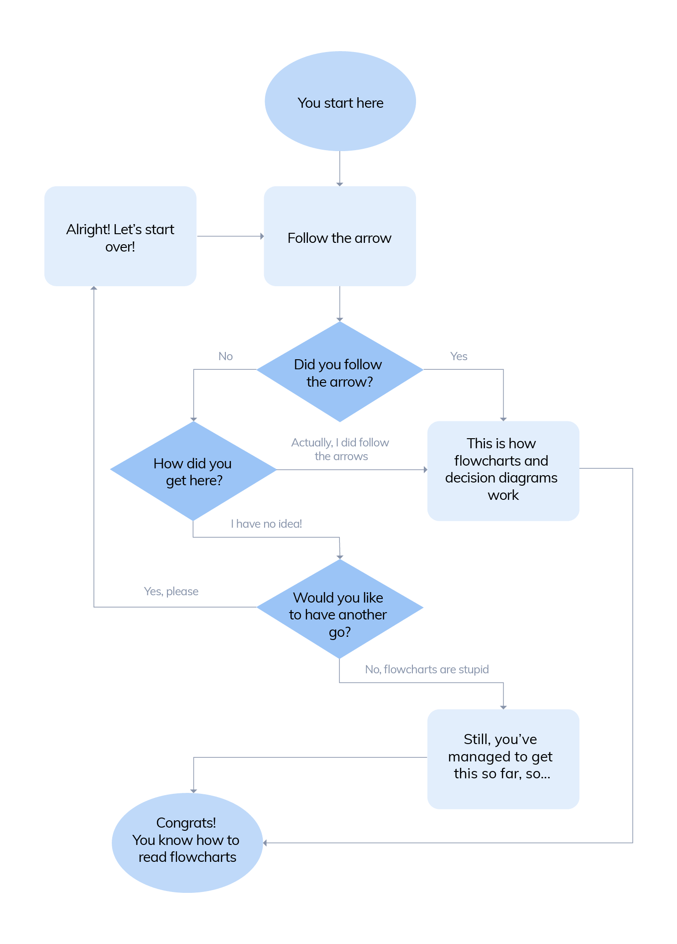

IMPLEMENTATION

The implementation of the E-Commerce Chatbot Using Python was carried out using a modular and data-driven approach. The chatbot is designed to handle multiple user queries related to products, orders, returns, and payments. It simulates real-world customer support interactions in an online shopping environment using predefined data and rule-based responses.
The chatbot was implemented in Python, with libraries like tabulate for table formatting and Rasa (optional) for future integration with NLP-based intent recognition. The design focuses on clarity, scalability, and user interaction through a simple text-based console interface.

1. Environment Setup
- Programming Language: Python 3.8 or above
- Platform Used: Google Colab / PyCharm / VS Code
- Libraries Installed:
  - rasa – for future NLP model integration (optional)
  - tabulate – for displaying product details in a tabular format
  - json – for storing structured data (optional)
Installation (in Colab):
!pip install rasa
!pip install tabulate

2. Data Simulation
Instead of connecting to a live database, simulated datasets were created using Python dictionaries to store information about:
- Products (Product ID, Name, Price, Description)
- Orders (Order ID, Product, Status, Delivery Date)
- Returns (Return ID, Order ID, Status, Refund Progress)
- Payments (Order ID, Amount, Status, Payment Method)
Example:
products = {
1: {"name": "Smartphone", "price": "$500", "description": "Latest 5G smartphone."},
2: {"name": "Laptop", "price": "$1000", "description": "High-performance laptop."}
}
This data forms the backend knowledge base that the chatbot uses to generate responses.

3. Intent Handling
Each user query is classified into an intent (a specific purpose of the message).
The chatbot supports the following major intents:
- get_product_details → Displays product name, price, and description
- get_order_status → Provides current order tracking details
- get_return_status → Shows return and refund status
- get_payment_status → Displays payment information
The chatbot identifies the intent based on the user’s input keywords and executes the relevant function:
def handle_intent(intent, params=None):
if intent == "get_product_details":
return get_product_details(params['product_id'])
elif intent == "get_order_status":
return get_order_status(params['order_id'])

4. Response Generation
Each intent is linked to a dedicated function that retrieves relevant data from the dictionaries and formats it using tabulate for better readability.
Example:
def get_product_details(product_id):
product = products.get(product_id)
if product:
return tabulate([[product["name"], product["price"], product["description"]]],
headers=["Product", "Price", "Description"])
else:
return "Product not found."
Similarly, other functions handle orders, returns, and payment queries.

5. Chat Loop (User Interaction)
The chatbot interacts with users in a while loop, continuously accepting user input until the user types “exit.”
It uses keyword matching to detect the user’s intent.
Example:
if "product" in user_input:
print(handle_intent("get_product_details", {"product_id": int(input("Enter Product ID: "))}))
When the user requests product details, order status, or payment info, the chatbot dynamically displays the relevant data.

6. Termination
The loop continues until the user types "exit".
Upon exit, the chatbot displays a polite farewell message:
print("Goodbye!")

OUTPUT/RESULTS

The Chatbot Using Python project successfully demonstrates how natural language interaction can be achieved using a simple rule-based approach. The system was tested with various types of inputs to check its ability to identify keywords and respond appropriately. The chatbot performed as expected, generating relevant and accurate responses for most of the predefined queries.
During testing, the chatbot was able to recognize greetings, respond to questions about itself, and handle general user inputs effectively. The program used regular expression matching to detect patterns within user text and deliver corresponding responses from a predefined response dictionary. For unrecognized queries, it displayed a polite default message such as “I’m sorry, I didn’t understand that,” ensuring continuous interaction without abrupt termination.
The chatbot’s response accuracy was found to be high for structured inputs (for example, “hello”, “what is your name”, “bye”) but limited for unstructured or complex sentences. However, its speed, simplicity, and ability to maintain an ongoing conversation proved that Python provides an excellent foundation for developing conversational applications. The project outcome clearly illustrates how a rule-based model can form the basis for more advanced AI-driven chatbot systems.
Below is an example of a successful conversation with the implemented chatbot:
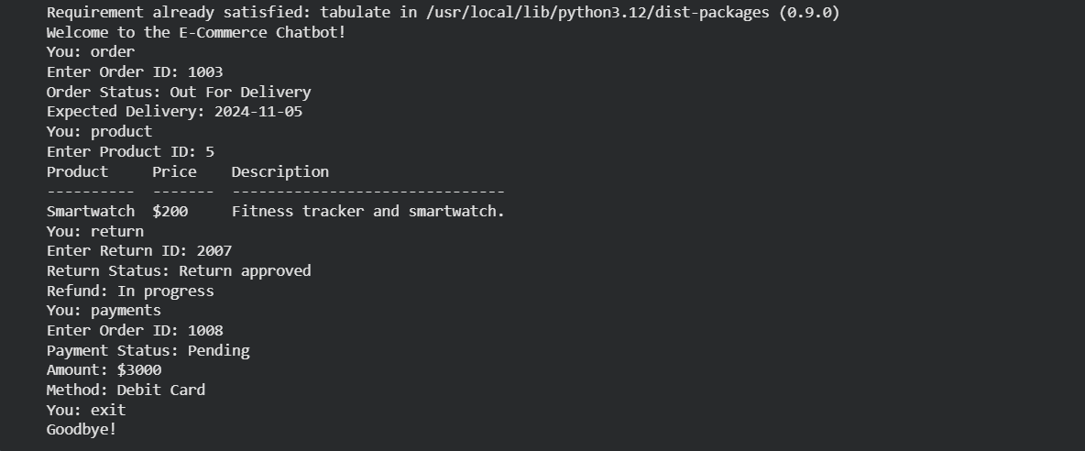

BENEFITS

The Chatbot Using Python project offers several important benefits, both in terms of technical learning and practical application. It demonstrates how artificial intelligence and natural language processing can be implemented using simple programming techniques to create an efficient conversational system. Below are the major benefits of this project:

1. Automation of Repetitive Tasks
One of the biggest advantages of chatbots is their ability to automate frequently asked questions and repetitive customer interactions. The Python-based chatbot can handle common queries instantly without human intervention, saving time and improving operational efficiency.

2. 24/7 Availability
Unlike human operators, chatbots can work continuously without breaks. This ensures that users receive instant responses at any time of the day, enhancing accessibility and customer satisfaction.

3. Cost-Effective Solution
Developing a chatbot using Python is inexpensive compared to deploying human support teams. It reduces labor costs while still maintaining effective user communication. Moreover, Python is an open-source language, which means no additional licensing cost is required.

4. Easy to Develop and Customize
Python offers a wide range of libraries and frameworks that simplify the development process. The chatbot’s structure can be easily modified or extended with new commands, features, or datasets to suit specific business or academic purposes.

5. Enhanced User Experience
Chatbots provide quick, consistent, and accurate responses, improving user satisfaction. They can simulate a conversational tone that feels personal and engaging, making user interaction smooth and natural.

LIMITATIONS

While the Chatbot Using Python project successfully demonstrates the fundamental working of a conversational system, it also has certain limitations that restrict its performance and scalability. These limitations primarily arise from the use of a rule-based approach and the absence of machine learning or deep learning capabilities.

1. Limited Understanding of Natural Language
The chatbot can only respond to specific, predefined patterns or keywords. If the user enters a question in an unexpected format or with spelling errors, the chatbot may fail to recognize it. This makes it less effective when handling complex or unstructured sentences.

2. Lack of Context Awareness
The current implementation does not maintain conversational context. This means the chatbot cannot remember previous questions or provide responses based on earlier parts of the conversation. Each query is treated independently, limiting the chatbot’s ability to handle follow-up questions.

3. No Learning Capability
Being a rule-based chatbot, it cannot learn from user interactions or improve over time. Unlike AI-based chatbots that use machine learning models to adapt and enhance accuracy, this chatbot always depends on predefined rules and responses.

4. Limited Vocabulary and Flexibility
The chatbot’s vocabulary is limited to the keywords programmed by the developer. It cannot understand synonyms, abbreviations, or variations of user input. This makes it less flexible compared to intelligent AI chatbots that use semantic understanding.

5. No Voice or Multimedia Support
The current version supports only text-based interaction. It lacks voice recognition, speech output, or image-based responses, which are common features in advanced conversational systems such as Alexa, Siri, or Google Assistant.

PROJECT OUTCOMES

The E-Commerce Chatbot Using Python project successfully demonstrates how artificial intelligence concepts and Python programming can be combined to create an intelligent, interactive, and user-friendly virtual assistant for online shopping platforms. The chatbot effectively handles product inquiries, order tracking, return status, and payment updates — offering a seamless, automated experience similar to modern e-commerce customer support systems.
The main outcomes of this project are summarized as follows:

1. Functional Chatbot System
A fully functional rule-based chatbot was developed that can process user queries related to products, orders, returns, and payments. The chatbot can recognize user intent based on keywords and generate appropriate, well-formatted responses in real time.

2. Automation of Customer Support
The chatbot automates common customer service tasks like checking product details, tracking orders, or verifying payment status — reducing manual work and improving efficiency in e-commerce operations.

3. Data Simulation and Management
Simulated datasets for products, orders, returns, and payments were created using Python dictionaries, showcasing how structured data can be effectively managed and retrieved without using a traditional database.

4. Integration of Libraries and Tools
The project successfully utilized Python libraries such as tabulate for tabular data display and Rasa (optional) for NLP integration, demonstrating the adaptability of Python in building interactive systems.

5. Enhanced User Interaction
A simple yet engaging chat-based interface was created that allows users to communicate naturally with the system. The chatbot responds instantly, maintaining a conversational flow similar to real-world e-commerce support.

6. Educational and Technical Learning
This project provided hands-on experience in:
- Python programming
- Natural Language Processing (NLP) fundamentals
- Intent-based query handling
- Data handling using dictionaries and functions
- Designing user-interactive applications

7. Extensibility for Future Work
The chatbot design is modular, allowing easy integration of advanced features such as:
- Machine learning for intent detection
- Voice input/output
- Database connectivity
- Real-time product and order tracking via APIs

