Comprehensive Handbook on Vector Databases, Including Storage, Retrieval, & What the Future Holds for LLMs
The Backbone Of AI Applications
The era of AI — The backbone of AI applications: AI is transforming our digital horizon, but a very important, though often neglected, piece of underlying technology making our AI reality is vector databases. In a very recent detailed overview, scientists from top research organizations have given a very detailed perspective on a very rapidly emerging branch of technology, proving the inevitability of vector databases in AI, starting from large language models.
What Is a Vector Database, And Why Is It Relevant?
In fact, conventional relational database systems are very effective for storing structured data in a well-organized, row-column form. But can they be very helpful in storing image, text, audio, and video data based on meaning instead of a search string? Vector database systems are excellent at this.
Essentially, a vector database houses data in the form of high-dimensional vectors. The vectors are mathematical models in which the grasping of the semantic value of data is possible. In a certain context, it can be observed that a vector has coordinates in a high-dimensional space, at which convergent data points are analogous. It can be observed that a vector database is able to grasp the meaning associated with a search result named "a sunny beach."
The dimensions of such vectors can range from dozens to thousands, depending on the complexity of the data. Thus, vector databases have the ability to process unstructured data, which cannot be done in a traditional database.
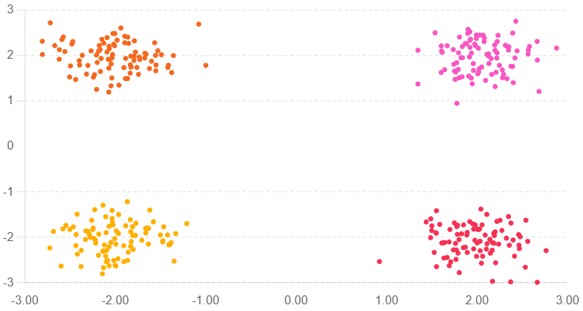
Figure 1 — Conceptual representation of embedding space, where conceptually equivalent items cluster together.
Three Game-Changing Benefits
Vector databases have some advantages over traditional database systems, which include:
1. Semantic Capabilities of Search
Unlike traditional vector search, where results rely on the exact match of keywords, vector search databases facilitate information retrieval based on similarity. The reason is, vector search enables the development of applications such as natural language processing, computer visions, as well as recommendations.
2. Unstructured Data Complex Management
Data ranging from text, image, audio, to video can be processed very well in vector databases compared to relational databases, as vector databases can easily cope with the complexity of data.
3. Scalability & Real-time processing
By utilizing technology like sharding, partitioning, caching, and replication, vector databases can distribute their workload across multiple machines, processing a vast number of vectors in real-time without running into the bottleneck problems that a traditional system would entail.
The Storage Layer: Dealing with Huge Vectors
Data management is a consideration in vector database performance. Based on the findings, the four categories of data storage include:
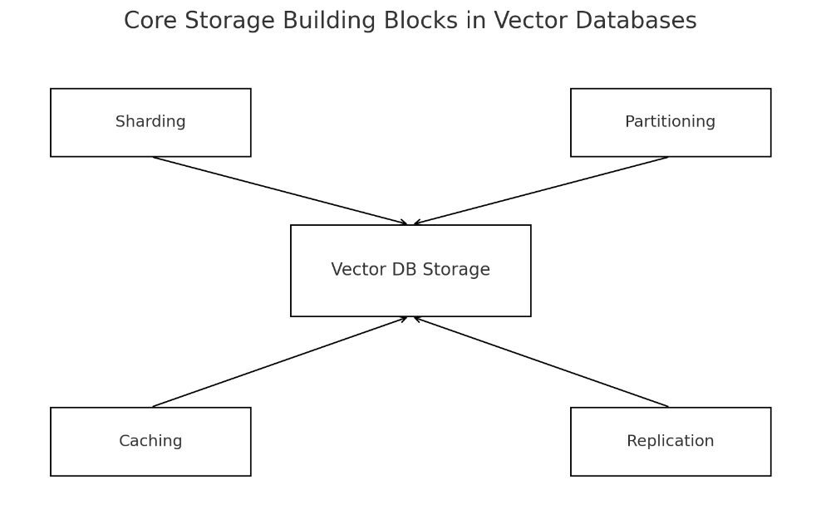
Figure 2 — Storage primitives in a vector DB: sharding, partitioning, caching, replication.
Sharding: Splitting Data Across Machines
The database can be fragmented on different servers using different techniques including:
- Range-based sharding: Data is fragmented based on a range of keys.
- Hash-based sharding: Using hash functions for well-rounded distribution, thereby having fewer changes as nodes join/exchange from the network.
- Geographic Sharding: This involves placing data in regions to reduce region-specific latencies.
Partitioning: Organizing within nodes
Even while distributing the data on multiple machines within a shard, distributing the data within a node can be accomplished using techniques such as:
- Range partitioning: Scales well for time series/range-type queries
- List partitioning: Categorizing based on categorical values
- K-means partitioning: It involves clustering vectors based
- Hash partitioning: Distribution within the partitions.
Caching: Speeding Up
In vector databases, sophisticated caching systems are used. The following:
- FIFO (First-In First-Out): The simplest form
- LRU (Least Recently Used): It keeps a record of recently accessed data.
- MRU (Most Recently Used): It is apt for onetime use.
- LFU (Least Frequently Used): This approach favors the frequently accessed items.
- Partitioned caching: Different cache policies for different data partitions.
Replication: Providing Availability
There are three ways of replication. It's fault tolerant.
- Leader-follower: Leader COPYs writes, followers REPLICATE.
- Multi-leader: More than one node can do writes.
- Leaderless: The node can both accept reads as well as writes.
The Search Engine: Finding Needles in Billion-Vector Haystacks
It's in search functionality where the true power of vector databases lies. Based on search functionality, it's identified that two prominent manners of implementation of search functionality are:
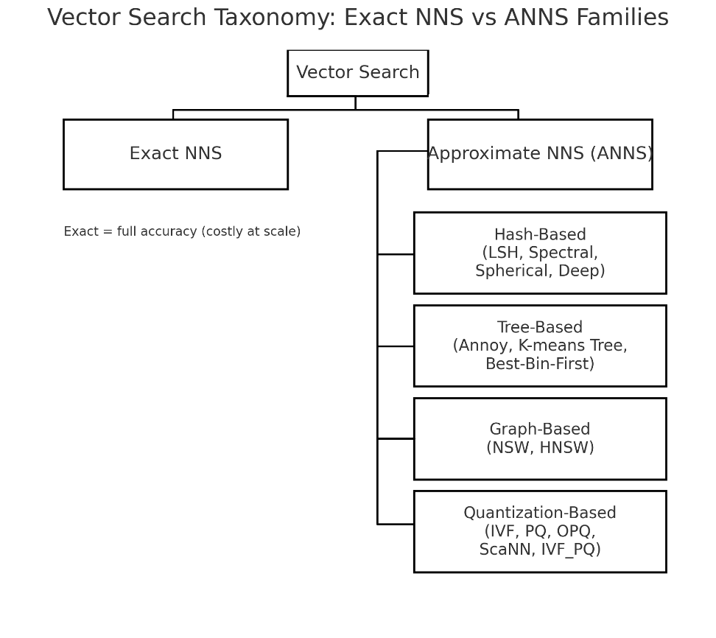
Figure 3 — Taxonomy of vector search algorithms, narrowing down to the families of exact versus approximation algorithms in nearest neighbor search.
Nearest Neighbor Search (NNS)
NNS finds the exact closest vectors, but it can be computationally expensive. It contains:
- Brute Force approach: which has O(n) complexity. It always guarantees accuracy
- Tree structure based algorithms: KD-Tree, Ball-Tree, R-Tree, M-Tree
Approximate Nearest Neighbor Search (ANNS)
ANNS sacrifices some accuracy for a huge advantage in speed, which is a very attractive feature. Four important techniques have been developed:
1. Hash-Based Methods
This enables the transformation of high-dimensional vectors into binary codes. The main methods include:
- Locality Sensitive Hashing (LSH): Similar vectors are given high probability of mapping to the same hash value.
- Spectral Hashing: The approach aims to reduce the quantization error, which is achieved based on using a spectral graph theory
- Spherical Hashing: It uses hyperspheres instead of hyperplanes to partition the space.
- Deep Hashing: It employs neural networks to acquire the best hashing functions.
2. Tree-Based Techniques
- Annoy (Approximate Nearest Neighbors Oh Yeah): Annoy makes a random projection tree forest.
- Best Bin First: The search process focuses on probable branches as indicated.
- K-means Tree: Hierarchical clustering based on k-means
3. Graph-Based Algorithms
Motivated from "six degrees of separation," these algorithms trace small-world networks:
- NSW (Navigable Small World): Couples vectors to nearest-intraspecific & random inter-specific long-range connectors
- HNSW (Hierarchical NSW): A hierarchical structure on the graph leads to very efficient search, state-of-the-art
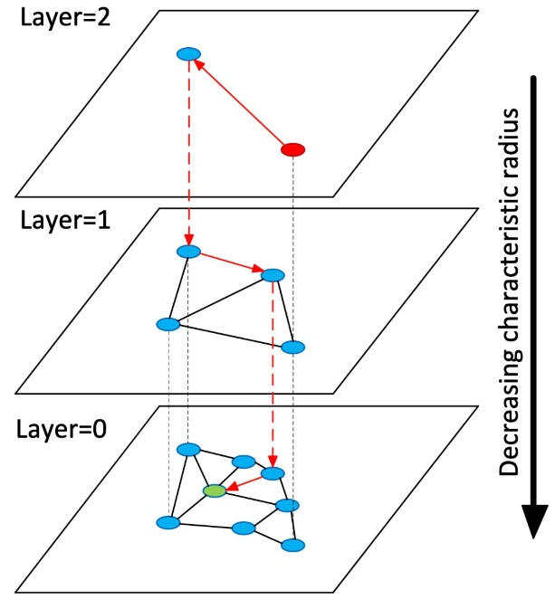
Figure 4 — Concept of HNSW, the sparse top layers help guide the entry points, while the bottom layer provides the dense layer for refining the neighborhood.
4. Quantization-Based Methods
It is necessary to compress these vectors to be able to store as well as compare them. The comparison has been implemented:
- IVF (Inverted File Index): Vectors are grouped, relevant clusters are searched
- Product Quantization (PQ): Vectors are divided into sub-vectors
- Optimized PQ (OPQ): The rotation takes place prior to PQ.
- ScaNN: In maximization of inner product search, it employs anisotropic quantization.
- IVF_PQ: It's a blend of clustering along with product quantization.
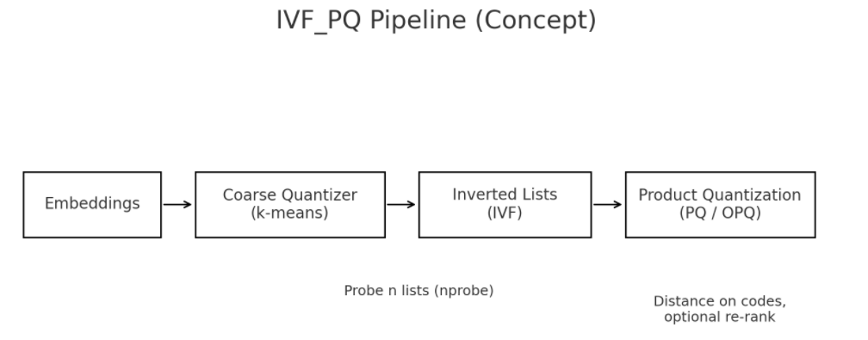Figure 5 — IVF_PQ pipeline. The coarse quantizer, IVF, filters the search space, while PQ/OPQ performs the refinement
Comparing Real-World Vector Databases
The comparison examined the most common vector search engines, namely Milvus, Pinecone, Weaviate, Qdrant, PgVector, Zilliz Cloud, and Elastic. The results include:
Performance Leaders:
- Milvus scored first place based on 380 QPS, 12.4ms latency
- ZillizCloud has the lowest latency, which is 6ms
- ElasticCloud trailed, recording 11.29 QPS and 361ms latency
Indexing Support:
The indexing supports for all databases, except Pinecone, rely on graph indexes, particularly on HNSW, as it's very common. Most of the indexing supports have more than one metric, such as Cosine Similarity, Euclidean Distance, and dot products.
Scalability:
- PgVector, QdrantCloud, as well as Pinecone, support horizontal scaling as well as vertical scaling
- WeaviateCloud, Milvus, & ElasticCloud primarily serve horizontal scaling
- Magnitude values in vectors range from 16,000 to 65,535.
Critical Features:
Almost all DBMSs support, as a minimum, replication, sharding, and partitioning, which are absolutely required for high availability and fault tolerance.
Recent Challenges & Future Prospects
Despite the advancements, vector databases have some challenges, some of which include:
1. High Dimensional Indexing
The task of indexing, searching, and processing vectors measuring in billions, while having dimensions ranging from hundreds to thousands, requires intensive computation, making it a challenge in need of special handling to cope with the "curse of dimensionality."
2. Heterogeneous Data Types
The support for dense vectors, sparse vectors, binary vectors, among many other formats, requires flexible indexing systems.
3. Distributed Processing
Large systems require sophisticated handling techniques, such as data partitioning, load balancing, fault tolerance, and maintaining consistency.
4. Integration with ML Frameworks
Integrating the systems with TensorFlow, PyTorch, and Scikit-learn requires easy-to-use APIs as well as dealing with a wide array of data formats.
5. Rising Applications
The novel applications include progressive k-NN search, as well as hybrid search, which involves both keyword search as well as vector search.
6. Security & Privacy
High-dimensional data, as vector database data is, requires a high level of security, whether it is related to matters like encryption, accessibility, or emerging trends such as blockchain.
The Synergy Effect of Large Language Models
The most interesting development, as it appears to me, is the coupling of vector databases with large language models. Both ways of this coupling are interesting:
Vector Database Enabling LLMs
Retrieval-Augmented Generation (RAG)
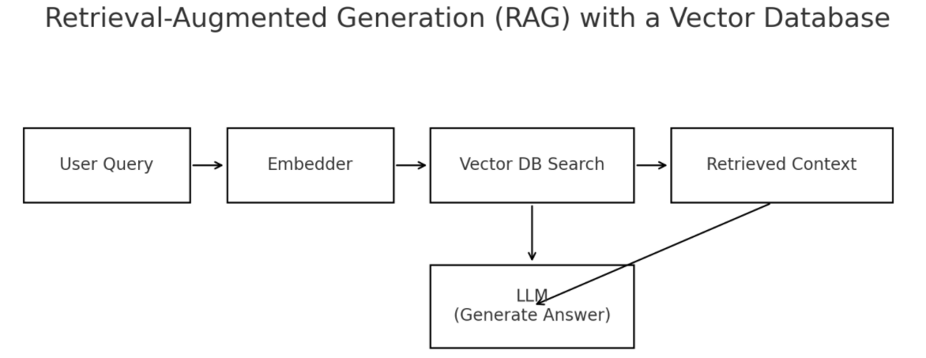Figure 6 — The RAG workflow, include a question → vector search → get context → generate via LLM.
The vector database can be looked at as an external knowledge database. It allows LLMs to search for knowledge relevant to a question before answering it. It addresses challenges associated with hallucinations as well as knowledge gaps in the following ways:
• Query representation as embeddings
• Search for semantically related documents
• Adding context from retrieval to prompts
• Carrying out informed, correct responses
Semantic Caching
As it retains the vectors of past questions and answers, vector databases significantly reduce API calls as well as the time it takes to answer questions without impacting accuracy.
Long-Term Memory
The vector database allows LLMs to have memory, which contains past experiences as well as knowledge, thereby making it feasible for the model to be dynamically updateable.
LLMs Improving Vector Databases
The relationship is not one-way, as LLMs are also impacting database management systems.
Data Base Administration System Handbook
The LLMs analyze the peculiar metrics, diagnose, and prescribe a solution, making the optimization of a database highly automatic.
Natural Language Interfaces
The search functionality in natural English is available to the user, while the LLM translates the commands so that they can be implemented.
Data Management Deck
LLMs can also be used to generate targeted content based on vector inputs, improve sparse vectors based on context, handling translation between cross-language, as well as processing varying data based on semantic analysis.
System Optimization
Based on the performance data, LLMs make recommendations on configuration parameters, indicate performance bottlenecks, as well as generate performance optimization reports.
A Unified Framework
The four proposed levels of integrating LLM-VDB are:
- User level — Language questions; thoughtful questioning.
- System Level — The LLM examines searches, extracting valuable information from it.
- AI Database Level — The vector database performs a similarity search using NNS/ANNS.
- Data level — Different kinds of data (PDF, Image, Data).
It enables the development of complex applications, such as voice assistants to specialized expert systems, because of the vector database, which has a vital connectivity function between data and AI knowledge.
Conclusion
Vector databases represent a paradigm shift in how we have been accessing data in the AI age. It has been noted from the findings of this research study that vector databases include sophisticated algorithms used for data storage, indexing, retrieval, scaling, processing, or connectivity.
The coupling between the large language models has generated a kind of transformation in both of these technologies, as vector databases form a memory infrastructure on which the large language models rely for utilization. The large language models enhance vector databases to be smarter.
For a researcher/developer, it has become a requirement to have knowledge of vector databases. Whether it is a personal project on a topic of recommend systems, research on a topic of semantic search, or a team project on next-generation AI applications, vector databases are the foundation on which future intelligent systems are built.
And because this technology also continues to evolve, it becomes apparent how it will not only be more integrated within AI systems, but it will also advance in processing power thanks to innovative indexing. It's vector-tasted, and this future of data management is here.

Based on the paper, "A Comprehensive Survey on Vector Database: Storage and Retrieval Technique, Challenge," written by Le Ma, Ran Zhang, Yikun Han, & numerous researchers from renowned research establishments.

