**Story**

Venkatesh Iyer is an undergraduate student and this is a day in his life. He wakes up 10 minutes prior to the lecture and realizes he is late for the class. The ambiguity of the lecture links worries him as there are sometimes multiple lecture links for the same lecture. So he wishes that there was some platform through which he could easily get the relevant lecture links easily. After he is done with the lecture he realizes that he has an assignment due in 12 hours and also he is having an examination this evening. Although he is well prepared, he still needs to re-check the exam and assignment submission platform. Due to the zillion different exam platforms, he gets quite bewildered and thus is afraid of missing the deadline.

**Sequence of steps he uses to complete the task**

1. He logs into his user account in infollege and checks for the course schedule for today.
2. He immediately receives a prompt that his first class starts in 10 minutes and also receives the relevant lecture link which had been parsed by infollege beforehand.
3. After he is done with today's lectures he receives another notification that he has one assignment due in 12 hours and also an exam this evening.
4. He finds difficulty in finding the submission portal for the assignment and exam but infollege had already parsed the information regarding his due submissions and provided him with the correct submission links.

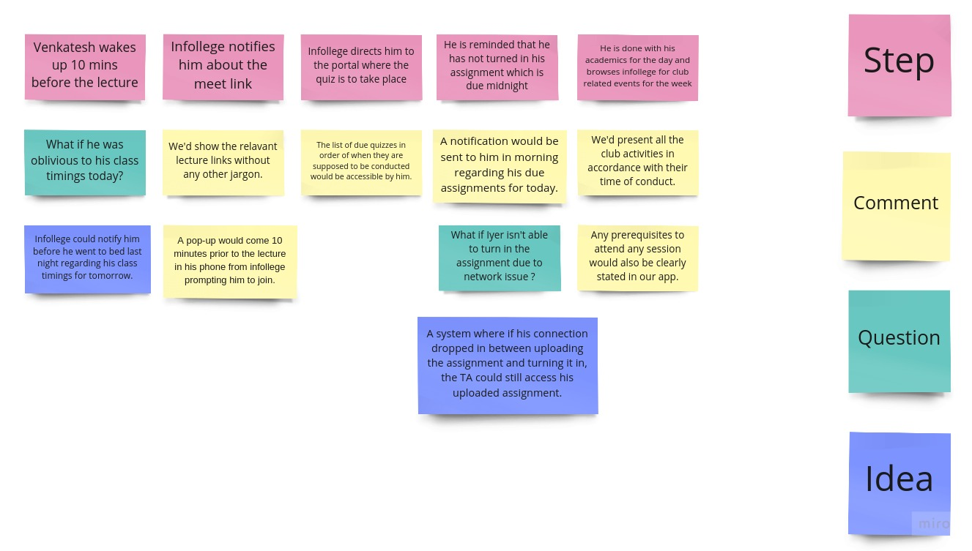[1]

**Objectives**

1. Our app will support the ability to sort assignment deadlines in increasing order of their submission time.
2. An automatic parser of lecture links is a requirement that will be supported by infollege.
3. An inbuilt calendar application will enable students to know about various club activities and sessions happening this week.
4. An auto-save feature will be present whenever students upload their assignments but weren’t able to submit them due to connectivity issues. This feature will help TAs to know whether a student has even attempted his/her assignment or not.

**GROUP 19-**

**Aaryaansh Agarwal -** [**aaryaansh20003@iiitd.ac.in**](mailto:aaryaansh20003@iiitd.ac.in)

**Deepam Sarmah -** [**deepam20050@iiitd.ac.in**](mailto:deepam20050@iiitd.ac.in)

**Ishmeet Singh Saluja -** [**ishmeet20511@iiitd.ac.in**](mailto:ishmeet20511@iiitd.ac.in)

**Prachi -** [**prachi20098@iiitd.ac.in**](mailto:prachi20098@iiitd.ac.in)

**Utkarsh Pal -** [**utkarsh20144@iiitd.ac.in**](mailto:utkarsh20144@iiitd.ac.in)

1. Learned from <https://kurzy.kpi.fei.tuke.sk/guis-en/student/resources/scenario-example.png>