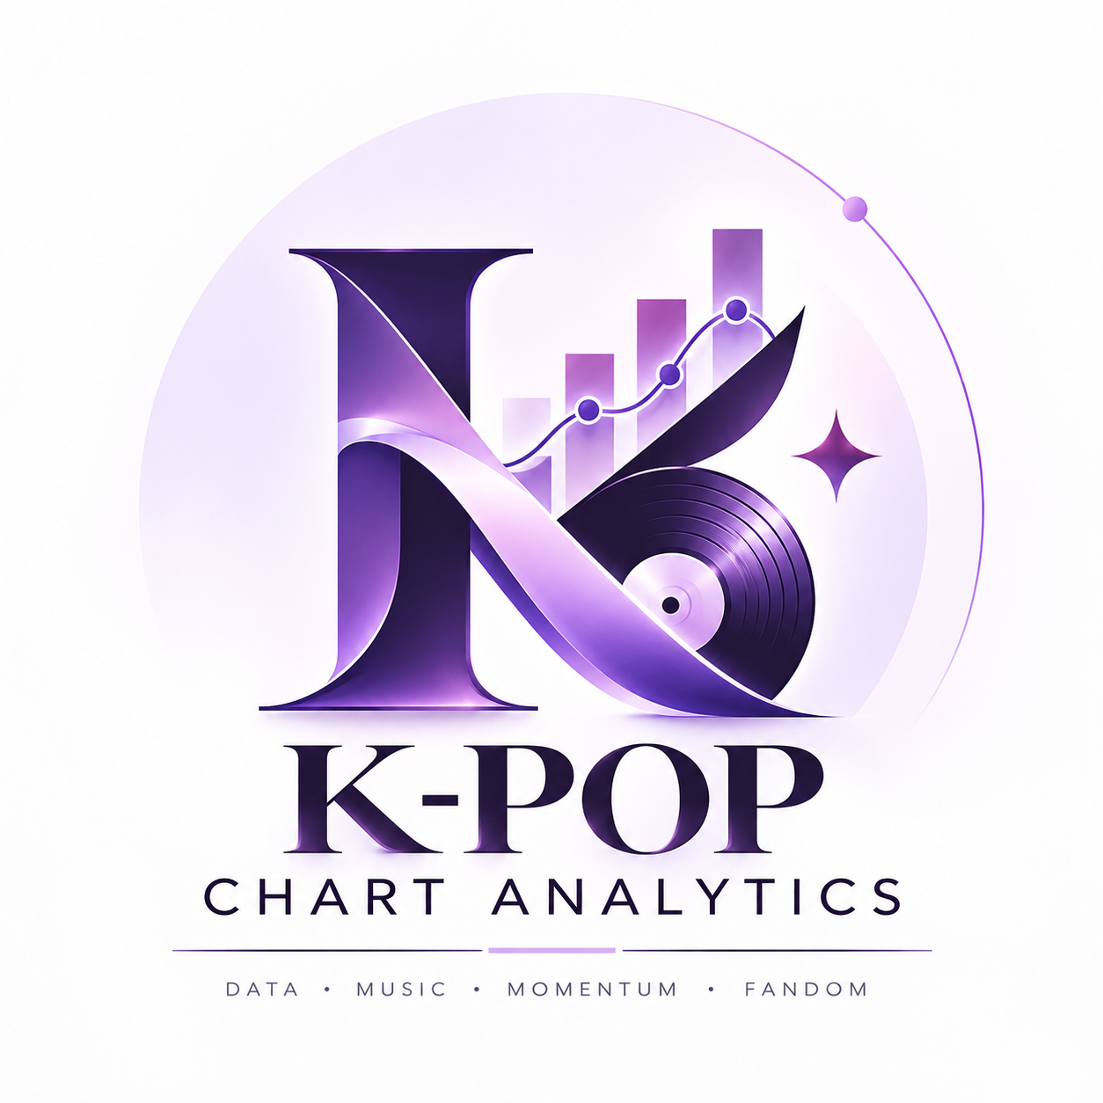
K-POP CHART ANALYTICS
Comeback Momentum, Chart Re-entry,
Fandom Intensity and Sustainability
A Data Science Research Study of the South Korea Top 50 Chart
Prepared by
Prachi Panchal
B.Sc. Data Science & Analytics
Research focus
A reproducible study of chart re-entry and repeated chart behaviour using project-specific indices for comeback momentum, fandom intensity, sustainability and integrated performance.

1. Abstract & Introduction
Abstract. This research presents a data-driven analysis of the South Korea Top 50 music chart. The study focuses on what happens after a song leaves the tracked chart and later returns. Using a cleaned and validated chart dataset, the project identifies re-entry events and derives comparative measures for comeback momentum, fandom intensity and chart sustainability. These measures are normalized and combined into an integrated performance score. The final analysis reports 1,067 re-entry events, an average comeback gap of 8.68 days, and 194 unique artists in the integrated output. An interactive Streamlit dashboard communicates the results through rankings, album artwork, charts, filters and song-level exploration.

1.1 Background
Music charts are dynamic systems in which songs can rise, fall, disappear and reappear. A single chart position captures only one point in time; repeated appearances provide an additional way to study persistence and return behaviour. This project therefore shifts attention from one-time ranking toward longitudinal chart behaviour.

1.2 Problem Statement
Traditional chart summaries can identify songs with strong positions, but they do not necessarily explain how songs behave after leaving a chart. This project asks which songs return, how long they are absent, how strong their returns are, and which songs show repeated and sustained chart presence.

1.3 Objectives
- Clean and validate the supplied South Korea Top 50 chart data.
- Detect songs that leave and later re-enter the tracked Top 50.
- Quantify comeback momentum using absence duration and re-entry position.
- Construct a project-specific fandom-intensity index from repeated chart behaviour.
- Measure chart sustainability using repeated presence, chart strength, momentum and fandom intensity.
- Combine the analytical dimensions into an integrated performance score.
- Present the results through an interactive dashboard.
Scope note
Fandom intensity is a project-specific analytical proxy, not a direct measurement of real-world fandom size. Integrated scores are intended for comparative analysis within the dataset.

2. Data & Methodology

2.1 Dataset Preparation
The supplied dataset contained 27,800 raw records. Project documentation identifies 16 exact duplicate rows and one chart date (2025-03-01) with 100 records instead of the expected 50. The cleaning workflow removes exact duplicates first, resolves duplicate date-position records by keeping the first source record, and then validates that every chart date contains exactly 50 records.

2.2 Analytical Workflow
Stage | Purpose
Data preparation | Load, inspect, clean and validate the chart data.
Chart re-entry | Identify a song's return after it previously left the tracked Top 50.
Comeback momentum | Combine the pre-return gap and re-entry position into a comparative score.
Fandom intensity | Combine re-entry frequency, chart strength and average momentum.
Sustainability | Combine frequency, chart strength, momentum and fandom intensity.
Integrated performance | Normalize sustainability, fandom intensity and momentum, then combine them.
Dashboard | Present the analytical outputs through interactive visual exploration.

2.3 Comeback Momentum
For each re-entry event, the project records the previous chart date, re-entry date, gap in days and re-entry position. The momentum calculation scales the gap and re-entry strength to create a comparable event-level score. Song-level summaries include total re-entries, average gap, longest gap, best re-entry position and momentum measures.

2.4 Fandom Intensity
Fandom intensity combines normalized re-entry frequency, chart strength and average momentum. The notebook assigns 40% to normalized frequency, 30% to chart strength and 30% to average momentum. The resulting index is categorized into project-specific intensity bands.

3. Sustainability, Integration & Results

3.1 Chart Sustainability
Sustainability extends the analysis beyond a single comeback. The project combines normalized re-entry frequency, chart strength, average momentum and fandom intensity with equal weighting. The resulting score is used for song- and artist-level comparison.

3.2 Integrated Performance
The final integrated score combines normalized sustainability, fandom intensity and average momentum. The notebook assigns 35% to normalized sustainability, 35% to normalized fandom intensity and 30% to normalized average momentum.

3.3 Core Results
Metric | Result
Raw dataset records | 27,800
Exact duplicate rows | 16
Total re-entry events | 1,067
Average comeback gap | 8.68 days
Unique artists | 194
Top overall song | Our Blues, Our Life — Lim Young Woong
Momentum–fandom correlation | 0.0682

3.4 Selected Top-Ranked Songs
Song | Artist | Re-entries | Overall score
Our Blues, Our Life | Lim Young Woong | 31 | 0.7015
Ditto | NewJeans | 27 | —
Seven (feat. Latto) (Explicit Ver.) | Jung Kook | — | —
Lost and Found | KingLee & Lil’ Flip | — | —
That's What I Like | Bruno Mars | — | —
Interpretation
The reported momentum–fandom correlation of 0.0682 is weak in magnitude, indicating that the two project indices capture different aspects of chart behaviour rather than representing the same pattern.

4. Discussion & Dashboard

4.1 Discussion
The project demonstrates the value of moving from static chart rankings toward longitudinal event analysis. A song that returns after an absence creates an observable event with a duration, a re-entry position and a subsequent record of repeated appearances. Aggregating these events makes it possible to compare songs by how they behave across the tracked period.

4.2 Momentum and Fandom Together
The notebook reports a momentum–fandom correlation of 0.0682. This weak relationship suggests that comeback momentum and repeated-appearance intensity should be interpreted as separate analytical dimensions. A song can therefore show strong repeated presence without having the highest average comeback momentum, and vice versa.

4.3 Interactive Dashboard
The Streamlit dashboard translates the notebook's analytical outputs into a user-facing interface. Its sections include Home, Top Songs, Comeback Momentum, Fandom Intensity, Sustainability, Artist Analysis, Song Explorer and About Project. Album artwork, KPI cards, rankings, interactive charts and filters support exploration.
Dashboard component | Purpose
Top Songs | Visual ranking with album artwork and integrated performance scores.
Comeback Momentum | Event-level momentum rankings and gap-versus-position analysis.
Fandom Intensity | Song rankings, intensity categories and momentum comparison.
Sustainability | Comparative ranking of sustained chart performance.
Artist Analysis | Artist-level sustainability and performance comparisons.
Song Explorer | Filter and inspect individual songs and analytical measures.

4.4 Practical Contribution
The final system combines reproducible notebook analysis with an interactive dashboard, demonstrating data cleaning, feature engineering, quantitative scoring, visualization and application development in one project workflow.
Reproducibility
The final notebook is intended to be executed from a fresh kernel using Restart Kernel and Run All. The analysis exports dashboard-ready CSV files consumed by the Streamlit application.

5. Conclusion, Limitations & Future Scope

5.1 Conclusion
K-POP Chart Analytics provides a structured framework for studying repeated chart behaviour in the South Korea Top 50. The project begins with data cleaning and validation, identifies chart re-entry events, and transforms those events into comparative measures of comeback momentum, fandom intensity and sustainability. The integrated performance score combines these dimensions while preserving the underlying analytical components.
The final notebook reports 1,067 re-entry events and an average comeback gap of 8.68 days. The overall ranking places Our Blues, Our Life by Lim Young Woong at the top of the integrated analysis. The reported momentum–fandom correlation is 0.0682, reinforcing the value of treating the analytical dimensions separately.

5.2 Limitations
- The analysis is based on chart observations and does not directly measure streaming, sales, social-media engagement or fan population size.
- Fandom intensity is a project-specific proxy derived from chart behaviour.
- The integrated score depends on the selected normalization and weighting scheme.
- Album artwork is used for dashboard presentation and does not form part of the analytical scoring.
- Results are intended for comparative analysis within the supplied dataset and tracked chart period.

5.3 Future Scope
- Time-series forecasting for future chart re-entry.
- Integration of streaming and social-media engagement metrics.
- Artist clustering based on chart behaviour.
- Sentiment analysis of fan and public responses.
- Cross-country chart comparison.
- Automated or real-time chart data ingestion.
- Predictive modelling for future chart re-entry.

5.4 Final Statement
The project demonstrates how a music chart can be transformed into a reproducible Data Science workflow. Rather than treating chart position as a single static number, the study models return events, repeated appearances and sustained presence as measurable patterns. The resulting notebook and dashboard provide a coherent analytical and visual framework for exploring K-pop chart behaviour.
K-POP CHART ANALYTICS
Data • Music • Momentum • Fandom

