Motor mounting bracket - static and modal check
Example study / L-bracket, Al 6061-T6, 6 mm plate
Analyst: Claude via Ansys connector Date: 2026-10-25 Rev: A Units: mm, N, MPa, s
Verdict: REVIEW
The bracket carries the 500 N shock load with a safety factor of about 2.0 on yield and 0.81 mm deflection. With a realistic motor rotary inertia, mode 2 sits at 131 Hz, 9.5 % above twice running speed (120 Hz), inside the 20 % resonance band. Stiffening or a bump test is recommended before release.

1. Scope
Linear static check under a 500 N shock load plus gravity, and modal check against 3600 rpm.

2. Model
L-bracket: 80 mm base with two 8.5 mm bolt holes at X = 20 and 60 mm, 60 mm upright, 40 mm wide, 6 mm thick.

Material
Property | Value | Unit | Note
Young's modulus | 68900 | MPa
Poisson's ratio | 0.33
Density | 2.70e-9 | t/mm^3
Yield strength | 276 | MPa

Mesh
Item | Value | Unit | Note
Element | SOLID187 (10-node tet)
Global / local size | 2 / 1 | mm
Nodes | 84k

Supports
- Both bolt bores fully fixed; base underside free

Loads
- 500 N in +X on the motor (RBE3 to 20x20 mm patch)
- Gravity -Y on bracket and 1.2 kg motor

3. Results
Quantity | Value | Unit | Location | Limit | Margin | Status
Max von Mises (outside singular zones) | 135 | MPa | Base top, between corner and bolt 1 | 276 MPa yield | SF 2.0 | PASS
Max deflection | 0.81 | mm | Top of upright
Mode 1 | 76.5 | Hz |  | outside 48-72 / 96-144 Hz | +6 % above 1x band | WARN
Mode 2 | 131.4 | Hz |  | outside 96-144 Hz | +9.5 % from 2x | FAIL

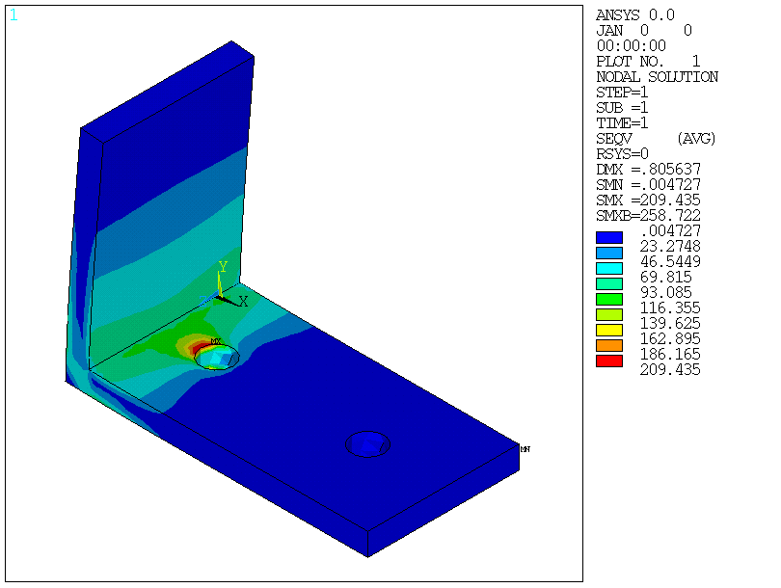
Von Mises stress, 500 N + gravity
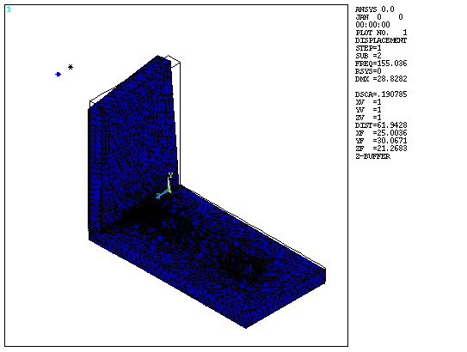
Mode 2 (point-mass run)

4. Verification
Check | Expected | Actual | Status | Note
Equilibrium, X | 500 N | 500.0 N | PASS
Equilibrium, Y (weight) | 12.6 N | 12.6 N | PASS
Hand calc, upright root bending | ~85 MPa | 78 MPa | PASS
Bolt-bore peak | converged | 203 -> 300 MPa, rising | WARN | Singularity at fixed bore; excluded

Mesh convergence: max von Mises outside singular zones
Mesh | Nodes | Value | Change
coarse | 15k | 131.5 MPa
1 mm local | 87k | 135.5 MPa | 3.0 %
0.75 mm local | 84k | 136.2 MPa | 0.5 %

5. Assumptions
- Motor rotary inertia 1 t*mm^2 (80 mm diameter motor)
- Bolt bores fully fixed

6. Limitations
- Stresses at the bolt holes are not meaningful with fixed bores
- Shock treated as static; pulses shorter than ~11 ms may amplify up to 2x

7. Conclusions
- Static strength adequate (SF 2.0)
- Mode 2 too close to 2x running speed

8. Recommendations
- Add a corner gusset or thicken the upright, then re-check mode 2
- Bump-test the prototype

9. Files
File | Path
APDL model | examples/motor-bracket/bracket.mac

Prepared: Claude via Ansys connector
Checked by: ____________________ Date: ________
Approved by: ___________________ Date: ________
Generated with the Ansys connector for Claude (unofficial). Results depend on the model, inputs and assumptions above and must be reviewed by a qualified engineer before use.

