**LAB 1**

**1.Write a Java program to print "Hello, World!" to the console.**

**CODE:-**

package demo;

public class hello {

public static void main(String[] args) {

System.***out***.println("Hello World...");

// **TODO** Auto-generated method stub

}

}

**OUTPUT:-**

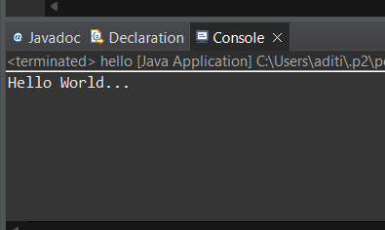

**2.Write a program to find the sum of two numbers entered by the user.**

**CODE:-**

package demo;

import java.util.Scanner;

public class userno {

public static void main(String[] args) {

int a, b, c;

Scanner s = new Scanner(System.***in***);

System.***out***.println("Enter 1st number:");

a =s.nextInt();

System.***out***.println("Enter 2nd number:");

b = s.nextInt();

c = a + b;

System.***out***.println("Sum is: "+ c);

s.close();

// **TODO** Auto-generated method stub

}

}

**OUTPUT:-**

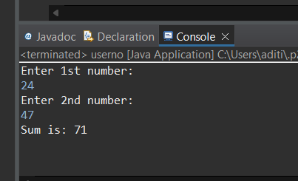

**3.Write a Java program to check whether a given number is even or odd.**

**CODE:-**

package demo;

import java.util.Scanner;

public class Evenodd {

public static void main(String[] args) {

// **TODO** Auto-generated method stub

Scanner sc = new Scanner(System.***in***);

System.***out***.println("Enter a number : ");

int num = sc.nextInt();

if(num % 2 == 0)

System.***out***.println("Entered number is Even. ");

else

System.***out***.println("Entered number is Odd. ");

sc.close();

}

}

**OUTPUT:-**

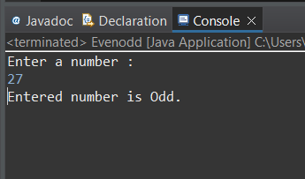

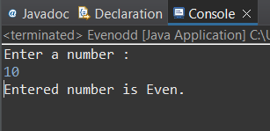

**4.Write a java program to find greatest of 2 numbers.**

**CODE:-**

package demo;

import java.util.Scanner;

public class greatnumber {

public static void main(String[] args) {

Scanner sc = new Scanner(System.***in***);

System.***out***.println("Enter 1st number : ");

int num1 = sc.nextInt();

System.***out***.println("Enter 2nd number : ");

int num2 = sc.nextInt();

int greatest = (num1 > num2) ? num1 :num2;

System.***out***.println("The Greatest number is : " + greatest);

sc.close()

// **TODO** Auto-generated method stub

}

}

**OUTPUT :-**

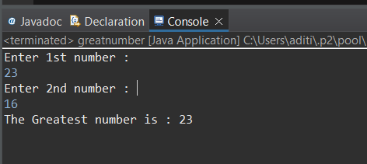

**5.Write a program to implement a basic calculator that takes input as a string expression and** **evaluates it.**

**CODE:-**

package demo;

import java.util.Scanner;

public class BasicCalculator {

public static void main(String[] args) {

Scanner sc = new Scanner(System.***in***);

System.***out***.print("Enter an expression: ");

String expression = sc.nextLine();

double result = *evaluateExpression*(expression);

System.***out***.println("Result: " + result);

}

public static double evaluateExpression(String expression) {

// Implement your expression evaluation logic here

// For simplicity, let's assume the expression is in the form of "operand1 operator operand2"

String[] parts = expression.split(" ");

double operand1 = Double.*parseDouble*(parts[0]);

String operator = parts[1];

double operand2 = Double.*parseDouble*(parts[2]);

double result = 0;

switch(operator) {

case "+":

result = operand1 + operand2;

break;

case "-":

result = operand1 - operand2;

break;

case "*":

result = operand1 * operand2;

break;

case "/":

result = operand1 / operand2;

break;

default:

System.***out***.println("Invalid operator");

}

return result;

}

}

**OUTPUT:-**

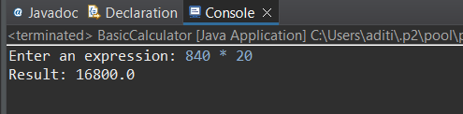

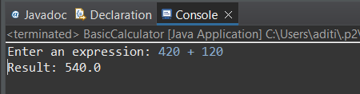

**6.Write a Java program to check if a given number is even or odd.**

**CODE:-**

package demo;

import java.util.Scanner;

public class Evenodd {

public static void main(String[] args) {

// **TODO** Auto-generated method stub

Scanner sc = new Scanner(System.***in***);

System.***out***.println("Enter a number : ");

int num = sc.nextInt();

if(num % 2 == 0)

System.***out***.println("Entered number is Even. ");

else

System.***out***.println("Entered number is Odd. ");

sc.close();

}

}

**OUTPUT:-**





**7.Create a Java program that compares two numbers and prints the larger one.**

**CODE:-**

package demo;

import java.util.Scanner;

public class Largerone {

public static void main (String args[]) {

Scanner s = new Scanner(System.***in***);

System.***out***.println("Enter 1st number : ");

int num1 = s.nextInt();

System.***out***.println("Enter 2nd number : ");

int num2 = s.nextInt();

if(num1 > num2) {

System.***out***.println("The larger number is : " +num1);

}

if(num2 > num1) {

System.***out***.println("The larger number is : " +num2);

}

else {

System.***out***.println("Both numbers are equal");

}

s.close();

}

}

**OUTPUT:-**

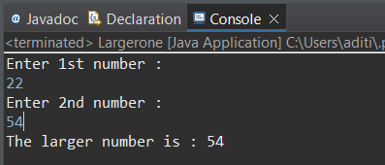

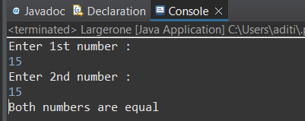

**8.Write a Java program that takes an age input from the user and determines if they are eligible to vote (considering the legal voting age).**

**CODE:-**

package demo;

import java.util.Scanner;

public class AgetoVote {

public static void main(String[] args) {

Scanner s = new Scanner(System.***in***);

System.***out***.println("Enter your age : ");

int age = s.nextInt();

if (age >= 18) {

System.***out***.println("You are eligible to vote.");

}

else {

System.***out***.println("You are not eligible to vote.");

}

s.close();

// **TODO** Auto-generated method stub

}

}

**OUTPUT:-**

