**LAB 2**

**1.     Write a program that takes a student's score as input and outputs the corresponding grade based on the following scale:**

**A: 90-100**

**B: 80-89**

**C: 70-79**

**D: 60-69**

**F: 0-59**

**CODE:-**

package demo;

import java.util.Scanner;

public class StudentGrade {

public static void main(String[] args) {

// **TODO** Auto-generated method stub

Scanner s = new Scanner(System.***in***);

System.***out***.println("Enter Student Score :");

int score = s.nextInt();

s.close();

// Calculate the grade

char grade = *calculateGrade*(score);

// Display the grade

System.***out***.println("The grade is: " + grade);

}

public static char calculateGrade(int score) {

if (score >= 90) {

return 'A';

} else if (score >= 80) {

return 'B';

} else if (score >= 70) {

return 'C';

} else if (score >= 60) {

return 'D';

} else {

return 'F';

}

}

}

**OUTPUT:-**

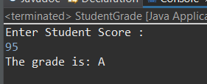

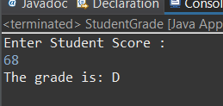

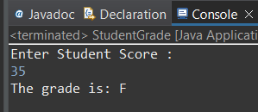

**2.     Write a program to check if a given year is a leap year. (A year is a leap year if it is divisible by 4 but not by 100, or it is divisible by 400.)**

**CODE:-**

package demo;

import java.util.Scanner;

public class Leapyear {

public static void main(String[] args) {

// TODO Auto-generated method stub

Scanner s = new Scanner(System.in);

System.out.println("Enter a Year: ");

int num = s.nextInt();

if (num % 4 == 0)

System.out.println("This is a Leap Year. ");

else

System.out.println("This is not a Leap Year. ");

s.close();

}

}

**OUTPUT:-**

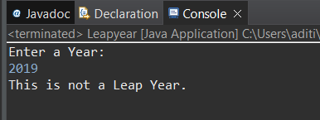

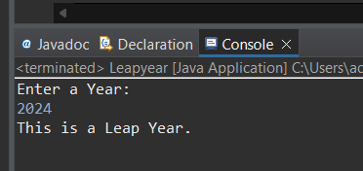

**3.     Write a program that takes an integer as input and checks if it is positive, negative, or zero.**

**CODE:-**

package demo;

import java.util.Scanner;

public class PositiveNegavtive {

public static void main(String[] args) {

// **TODO** Auto-generated method stub

Scanner s = new Scanner(System.***in***);

System.***out***.println("Enter a digit");

int num = s.nextInt();

if(num > 0)

System.***out***.println("Entered digit is Positive");

else if (num < 0)

System.***out***.println("Entered digit is Negative");

else

System.***out***.println("Entered digit is Zero");

}

}

**OUTPUT:-**

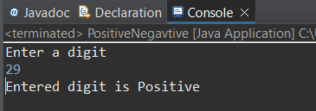

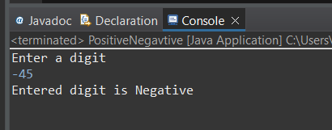

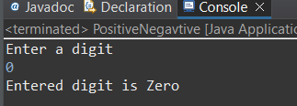

**4.     Write a program that prints numbers from 1 to 10 using a loop.**

CODE:-

package demo;

public class forloop {

public static void main(String[] args) {

int i;

for (i=0; i<=10; i++) {

System.***out***.println("Value is:" +i);

}

// **TODO** Auto-generated method stub

}

}

**OUTPUT:-**

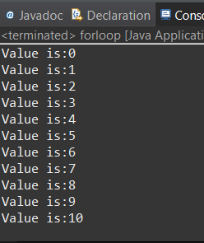

**5.     Write a program that takes an integer N as input and calculates the sum of entered numbers.**

CODE:-

package demo;

import java.util.Scanner;

public class SumOfNumbers {

public static void main(String[] args) {

Scanner s = new Scanner(System.***in***);

System.***out***.print("Enter the number of integers to sum : ");

int N = s.nextInt();

// Initialize sum variable

int sum = 0;

// Loop to read and add N integers

for (int i = 1; i <= N; i++) {

System.***out***.print("Enter integer " + i + ": ");

int number = s.nextInt();

sum += number;

}

// Display the sum

System.***out***.println("The sum of " + N + " integers is: " + sum);

s.close();

}

}

**OUTPUT:-**

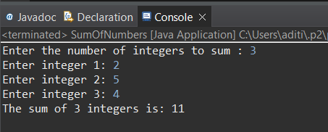

**6.     Write a program that takes an integer as input and prints its multiplication table up to 10.**

CODE:-

package demo;

import java.util.Scanner;

public class Multiplication {

public static void main(String[] args) {

// **TODO** Auto-generated method stub

Scanner s = new Scanner(System.***in***);

System.***out***.println("Multiplication of Number");

int num = s.nextInt();

for (int i = 1; i<=10; i++) {

System.***out***.println( + num + " = " +num*i);

s.close();

}

}

}

**OUTPUT:-**

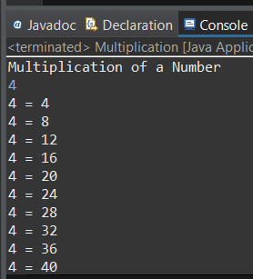

**7.     Write a program that takes a positive integer as input and prints its digits in reverse order.**

**CODE:-**

package demo;

import java.util.Scanner;

public class ReverseDigits {

public static void main(String[] args) {

// **TODO** Auto-generated method stub

Scanner s = new Scanner(System.***in***);

System.***out***.println("Enter digits ");

int num = s.nextInt();

if ( num > 0) {

System.***out***.println("Digits are Positive");

}

else

System.***out***.println("Digit is Negative");

System.***out***.print("Digits in reverse order: ");

while (num > 0) {

int digit = num % 10;

System.***out***.print(digit);

num /= 10;

}

System.***out***.println();

}

}

**OUTPUT:-**

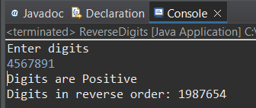

**8.     Create a class Animal with a method makeSound() that prints "Some generic animal sound". Create another class Dog that extends Animal and overrides the makeSound() method to print "Bark". Write a main method to demonstrate calling the makeSound() method on an Animal reference holding a Dog object.**

**CODE:-**

package demo;

class Animal {

public void makeSound() {

System.***out***.println("Some generic animal sound");

}

}

class Dog extends Animal {

*@Override*

public void makeSound() {

System.***out***.println("Bark");

}

}

public class AnimalSound {

public static void main(String[] args) {

// Create an Animal reference holding a Dog object

Animal animalRef = new Dog();

// Call the makeSound() method on the animalRef

animalRef.makeSound();

}

}

**OUTPUT:-**

