**LAB 5**

**1. Write a Java program that reads a string from the user and uses StringTokenizer to split the string into individual words. Print each word on a new line.**

**CODE:-**

package lab5;

import java.util.Scanner;

import java.util.StringTokenizer;

public class StringSplitter {

public static void main(String[] args) {

// Create a Scanner object for reading input from the user

Scanner s = new Scanner(System.*in*);

System.*out*.println("Enter a string:");

// Read the entire line of input

String input = s.nextLine();

// Create a StringTokenizer to split the string into words

StringTokenizer tokenizer = new StringTokenizer(input);

while (tokenizer.hasMoreTokens()) {

System.*out*.println(tokenizer.nextToken());

}

}

}

**OUTPUT:-**

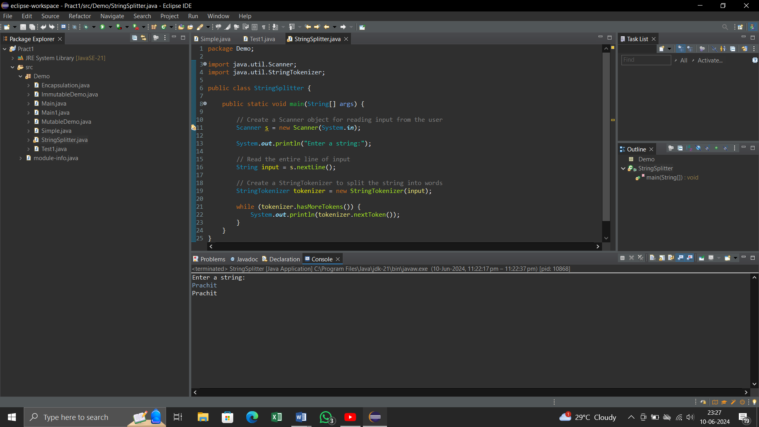

**2. Write a Java program that reads a string from the user and uses StringTokenizer to count the number of words in the string.**

**CODE:-**

package Lab5;

import java.util.Scanner;

import java.util.StringTokenizer;

public class WordCounter {

public static void main(String args[]) {

Scanner s = new Scanner(System.in);

System.out.println("Enter a String : ");

// Read the input string

String input = s.nextLine();

StringTokenizer t = new StringTokenizer(input);

// Count the number of tokens (words)

int wordCount = t.countTokens();

// Print the number of words

System.out.println("Number of words in the string: " + wordCount);

}

}

**OUTPUT:-**

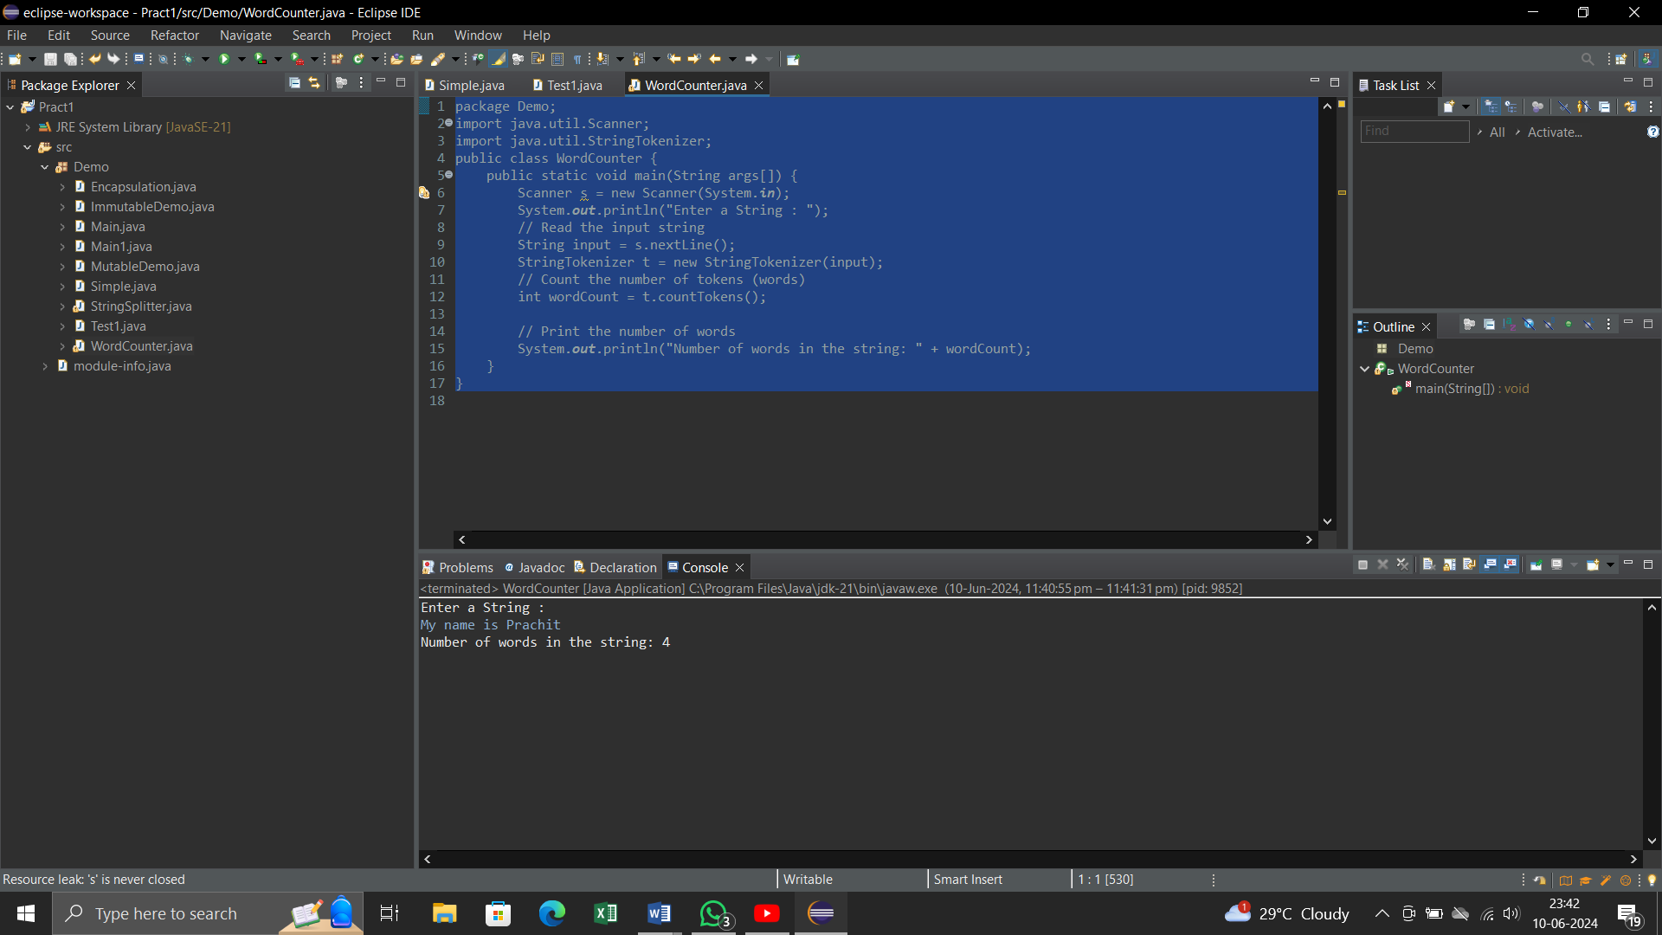

**3. Write a Java program to create a LinkedList of strings, add elements at specific positions (beginning, middle, end), and print the list.**

**CODE:-**

package Lab5;

import java.util.LinkedList;

public class LinkedListExample {

public static void main(String[] args) {

// Create a LinkedList of strings

LinkedList<String> list = new LinkedList<>();

list.add("End");// add to the end

list.addFirst("Beginning");// add to the beginning

// Add an element to the middle

// Assuming "middle" is index 1 for a 3-element list

list.add(1, "Middle");

// Print the LinkedList

System.out.println("LinkedList elements : ");

for (String element : list) {

System.out.println(element);

}

}

}

**OUTPUT:-**

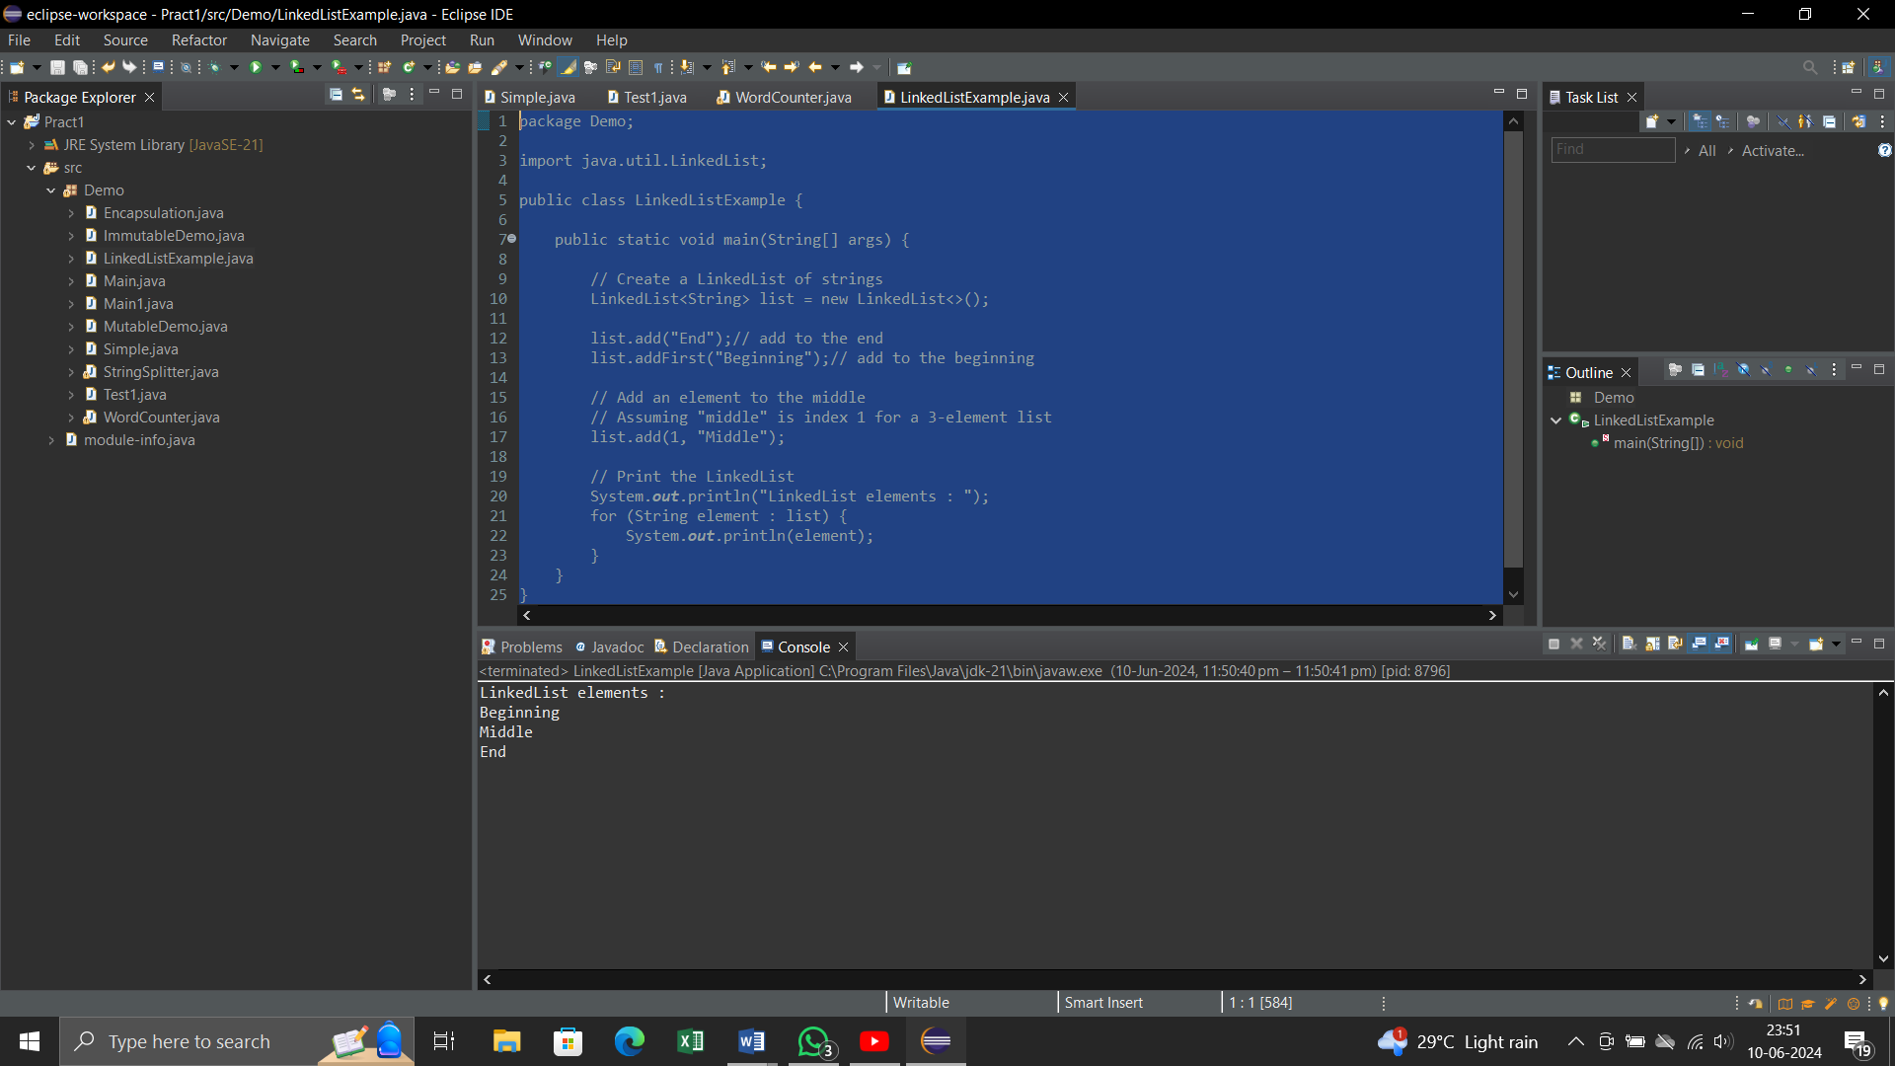

**4. Write a Java program to sort a given array list.**

**CODE:-**

package Lab5;

import java.util.ArrayList;

import java.util.Collections;

public class SortArrayList {

public static void main(String[] args) {

ArrayList<String> list=new ArrayList<>();

// Add elements to the ArrayList

list.add("Banana");

list.add("Apple");

list.add("Mango");

list.add("Cherry");

list.add("Date");

// Print the ArrayList before sorting

System.out.println("ArrayList before Sorting : ");

for(String element :list )

{

System.out.println(element);

}

// Sort the ArrayList

Collections.sort(list);

// Print the ArrayList after sorting

System.out.println("\nArrayList after sorting:");

for (String element : list) {

System.out.println(element);

}

}

}

**OUTPUT:-**

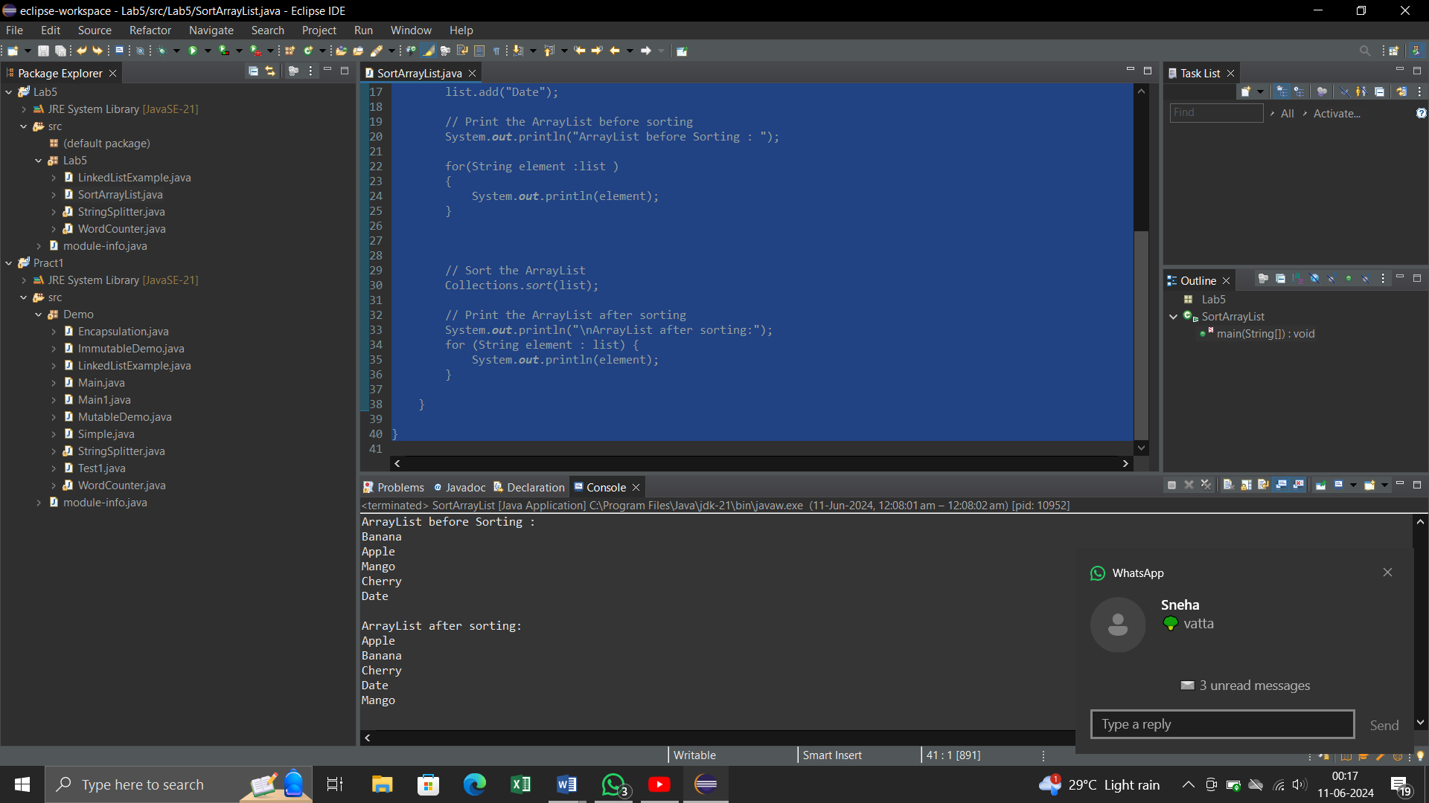

**5. Write a Java program to replace the second element of an ArrayList with the specified element.**

**CODE:-**

package Lab5;

import java.util.ArrayList;

import java.util.Iterator;

public class ReplaceElement {

public static void main(String[] args) {

ArrayList<String> list = new ArrayList<>();

// Add elements to the ArrayList

list.add("ONE");

list.add("TWO");

list.add("THREE");

list.add("FOUR");

list.add("FIVE");

System.out.println("ArrayList before replacement : ");

for (String element : list) {

System.out.println(element);

}

// Replace the second element (index 1) with the specified element

String newElement = "New Second";

list.set(1, newElement);

// Print the ArrayList after replacement

System.out.println("\nArrayList after replacement:");

for (String element : list) {

System.out.println(element);

}

}

}

**OUTPUT:-**

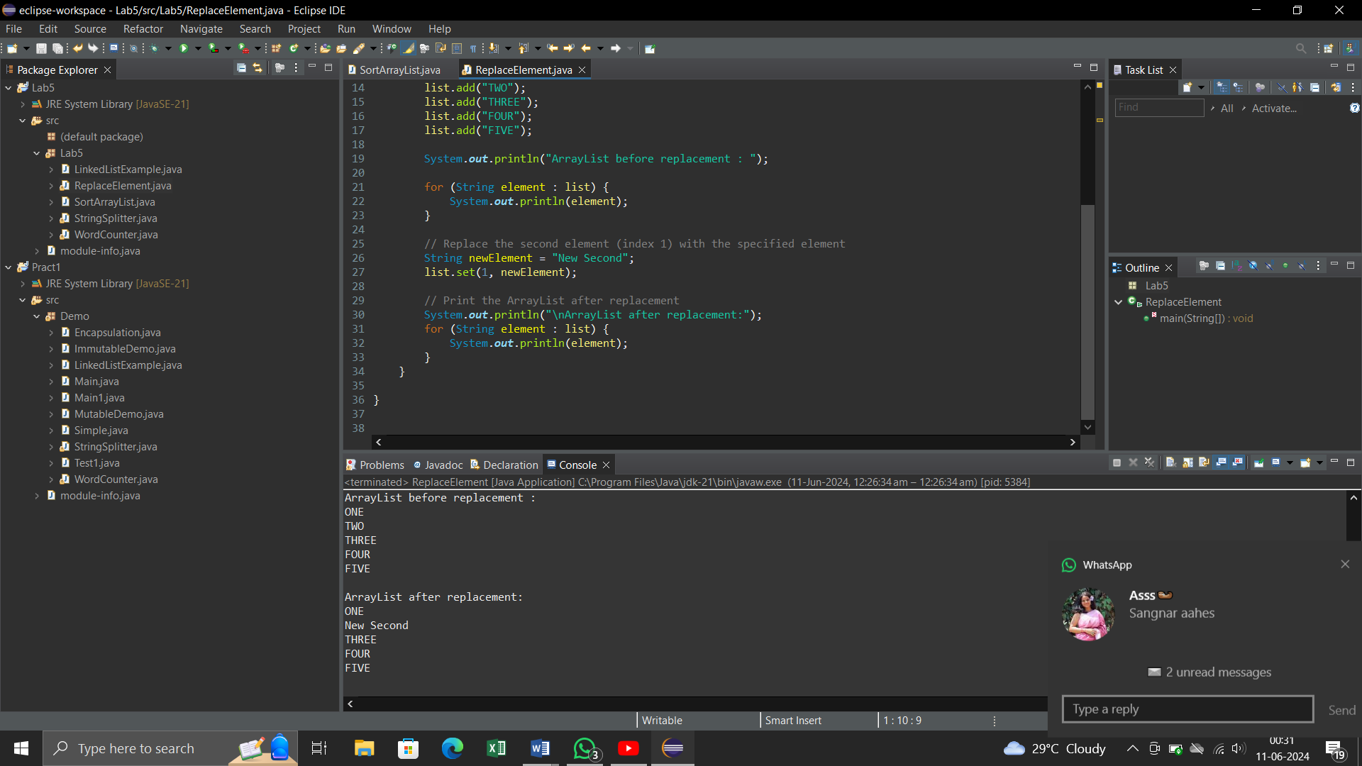

**6. Write a Java program to iterate a linked list in reverse order.**

**CODE:-**

package Lab5;

import java.util.LinkedList;

import java.util.ListIterator;

public class ReverseLinkedList {

public static void main(String[] args) {

LinkedList<String> list = new LinkedList<>();

// Add elements to the LinkedList

list.add("ONE");

list.add("TWO");

list.add("THREE");

list.add("FOUR");

list.add("FIVE");

System.out.println("LinkedList element :");

for (String element : list) {

System.out.println(element);

}

// Iterate the LinkedList in reverse order

System.out.println("\nLinkedList elements in reverse order:");

ListIterator<String> iterator = list.listIterator(list.size());

while (iterator.hasPrevious()) {

System.out.println(iterator.previous());

}

}

}

**OUTPUT:-**

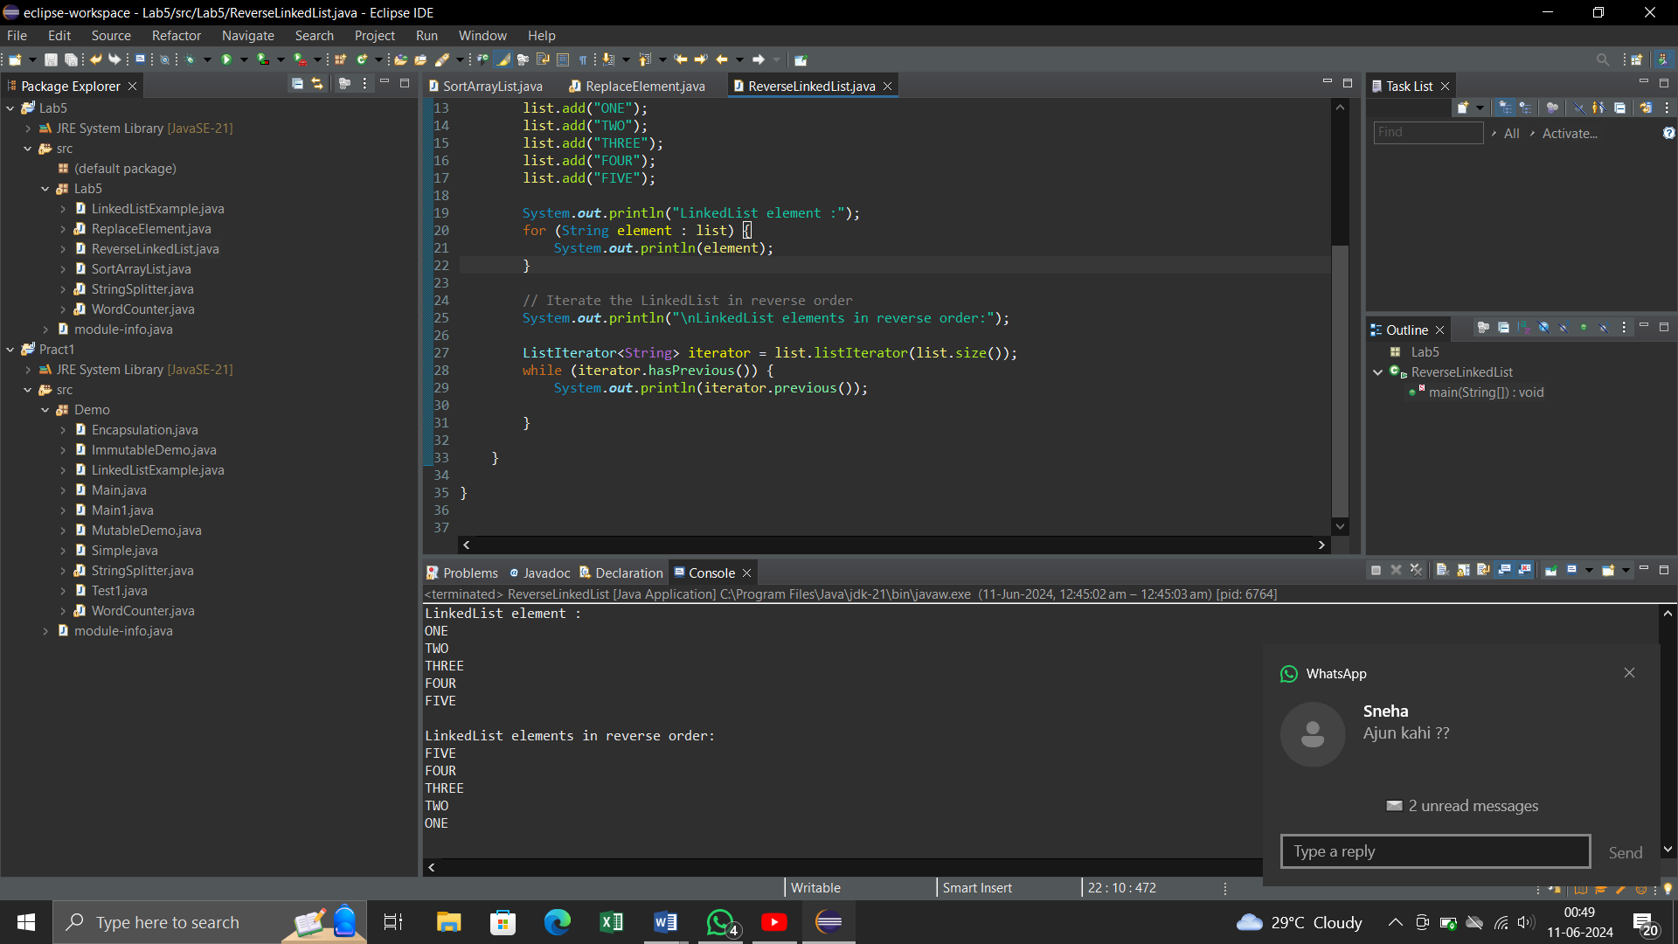

**7. Write a Java program to retrieve, but not remove, the last element of a linked list.**

**CODE:-**

package Lab5;

import java.util.LinkedList;

public class RetrieveLastElement {

public static void main(String[] args) {

// Create a LinkedList of strings

LinkedList<String> list = new LinkedList<>();

// Add elements to the LinkedList

list.add("Dog");

list.add("Rat");

list.add("Cat");

list.add("Bat");

// Retrieve, but do not remove, the last element

String lastElement = list.peekLast();

// Print the last element

System.out.println("The last element is: " + lastElement);

// Print the LinkedList to show it has not been modified

System.out.println("LinkedList elements:");

for (String element : list) {

System.out.println(element);

}

}

}

**OUTPUT:-**

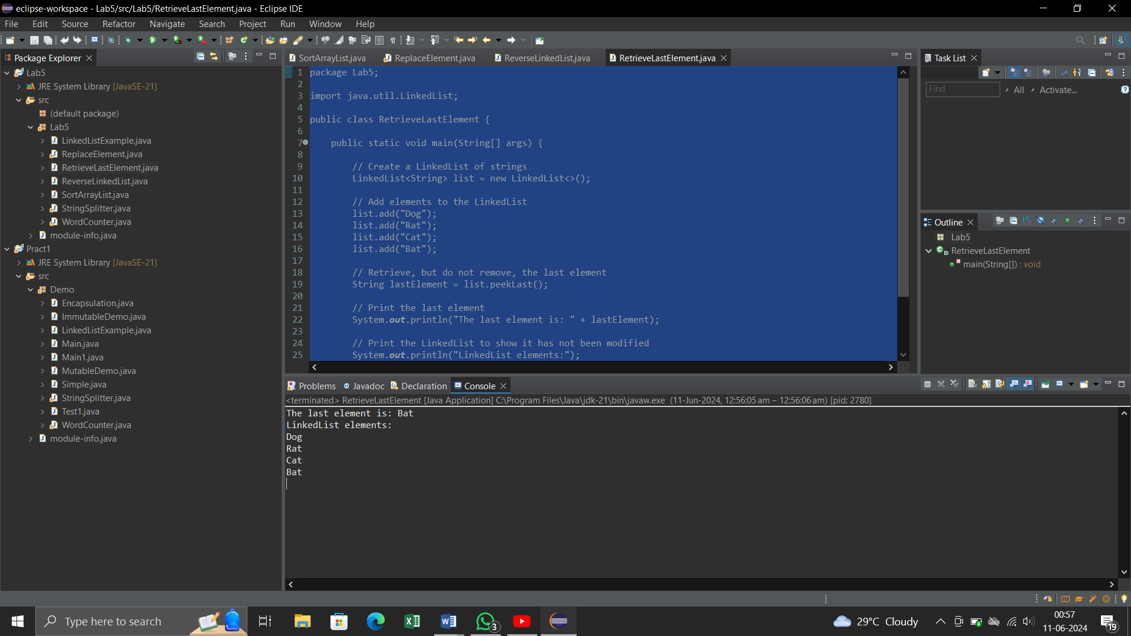

**8. Write a Java program to create a LinkedList of integers and print all the elements.**

**CODE:-**

package Lab5;

import java.util.LinkedList;

public class LinkedListOfIntegers {

public static void main(String[] args) {

LinkedList<Integer> list = new LinkedList<>();

// Add elements to the LinkedList

list.add(10);

list.add(20);

list.add(30);

list.add(40);

list.add(50);

// Print the LinkedList elements

System.out.println("LinkedList elements : ");

for (Integer element : list) {

System.out.println(element);

}

}

}

**OUTPUT:-**

