**Lab 8**

1. **Write a program that tries to access an element outside the bounds of an array and handles the ArrayIndexOutOfBoundsException by printing a user-friendly message.**

**Code:**

package lab8;

public class ArrayOutOfBoundsDemo {

public static void main(String[] args) {

int[] array = { 1, 2, 3, 4, 5 }; // Define an array with 5 elements

try {

// Attempt to access an element outside the bounds of the array

int element = array[10];

System.*out*.println("Element at index 10: " + element);

} catch (ArrayIndexOutOfBoundsException e) {

// Handle the exception by printing a user-friendly message

System.*out*.println("Error: Attempted to access an index that is out of bounds.");

}

System.*out*.println("Program continues after handling the exception.");

}

}

**Output:**

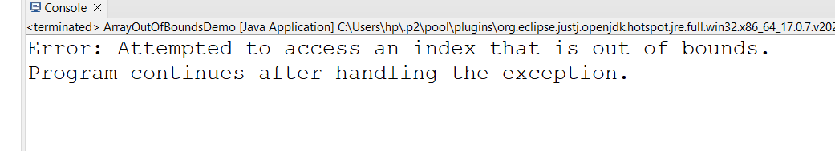

**2. Write a program that attempts to divide a number by zero and handles the ArithmeticException by printing a message that division by zero is not allowed.**

**Code:**

package lab8;

public class DivideByZeroDemo {

public static void main(String[] args) {

int num = 10;

int deno = 0;

try {

int result = num / deno;

System.*out*.println("Result: " + result);

} catch (ArithmeticException e) {

System.*out*.println("Error : Division by zero is not allowed.");

}

System.*out*.println("Porgrams continues after handling the exception.");

}

}

**OutPut:**

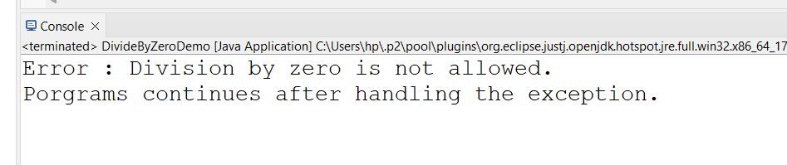

**3. Write a Java program that reads an integer input from the user and throws an IllegalArgumentException if the input is negative. Display an appropriate message when the exception is caught.**

**Code:**

package lab8;

import java.util.Scanner;

public class NegativeInputCheck {

public static void main(String[] args) {

Scanner s = new Scanner(System.*in*);

System.*out*.println("Please enter on integer :");

int userInput = s.nextInt();

try {

// Check if the input is negative

if (userInput < 0) {

throw new IllegalArgumentException("Negative input is not allowed.");

}

System.*out*.println("You entered: " + userInput);

} catch (IllegalArgumentException e) {

// Handle the exception by printing a user-friendly message

System.*out*.println("Error: " + e.getMessage());

}

System.*out*.println("Program continues after handling the exception.");

}

}

**OutPut:**

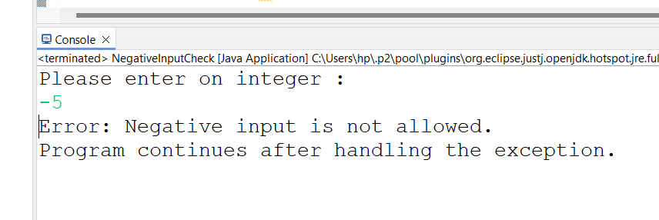

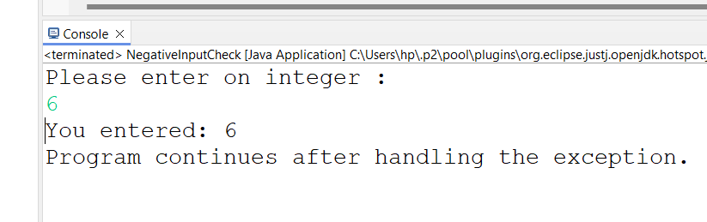

**4. Define a custom exception called InvalidAgeException. Write a Java program that throws this exception if the age provided is less than 18. Handle the exception and display an appropriate message.**

**Code:**

package lab8;

import java.security.InvalidAlgorithmParameterException;

import java.util.Scanner;

public class AgeVerification {

public static void main(String[] args) {

Scanner scanner = new Scanner(System.*in*);

System.*out*.print("Please enter your age: ");

int age = scanner.nextInt();

try {

*checkAge*(age);

System.*out*.println("Your age is valid.");

} catch (InvalidAlgorithmParameterException e) {

// Handle the custom exception by printing a user-friendly message

System.*out*.println("Error: " + e.getMessage());

}

// Continue with the rest of the program

System.*out*.println("Program continues after handling the exception.");

}

// Method to check the age

public static void checkAge(int age) throws InvalidAlgorithmParameterException {

if (age < 18) {

throw new InvalidAlgorithmParameterException("Age must be 18 or older.");

}

}

}

**OutPut:**

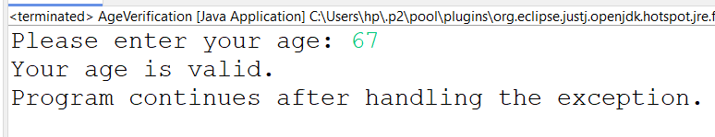

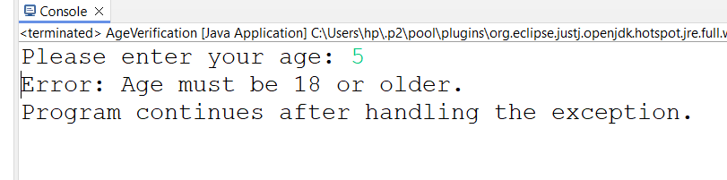

**5. Write a Java program that has a method to validate a user's email address. The method should throw a custom exception InvalidEmailException if the email does not contain @ and .. Handle the exception in the main method.**

**Code:**

package lab8;

import java.util.Scanner;

public class EmailValidation {

public static void main(String[] args) {

Scanner scanner = new Scanner(System.*in*);

System.*out*.print("Please enter your email address: ");

String email = scanner.nextLine();

try {

*validateEmail*(email);

System.*out*.println("Your email address is valid.");

} catch (Exception e) {

System.*out*.println("Error: " + e.getMessage());

}

System.*out*.println("Program continues after handling the exception.");

}

// Method to validate the email address

public static void validateEmail(String email) throws Exception {

if (!email.contains("@") || !email.contains(".")) {

throw new Exception("Email address must contain '@' and '.'");

}

}

}

**OutPut:**

