**Lab9**

**1. Perform the following tasks:**

**a. Create Student table with following attributes (STUDENT_ID , FIRST_NAME, LAST_NAME, PHONE_NUMBER, MARKS, COURSE_ID).**

**Code-**

CREATE TABLE Course (

COURSE_ID INT PRIMARY KEY,

COURSE_NAME VARCHAR(100)

);

CREATE TABLE Student (

STUDENT_ID INT PRIMARY KEY,

FIRST_NAME VARCHAR(100),

LAST_NAME VARCHAR(100),

PHONE_NUMBER VARCHAR(15),

MARKS DECIMAL(5, 2),

COURSE_ID INT,

FOREIGN KEY (COURSE_ID) REFERENCES Course(COURSE_ID)

);

**Output-**

**Course table**



**Student table**

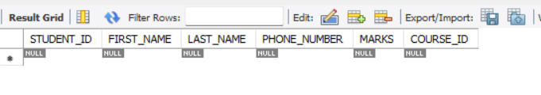

**b. Create Course table with following attributes (COURSE_ID, COURSE_NAME).**

**CODE-**

INSERT INTO Course (COURSE_ID, COURSE_NAME) VALUES

(1, 'Java Programming'),

(2, 'Database Systems'),

(3, 'Web Development'),

(4, 'Data Structures'),

(5, 'Algorithms');

INSERT INTO Student (STUDENT_ID, FIRST_NAME, LAST_NAME, PHONE_NUMBER, MARKS, COURSE_ID) VALUES

(1, 'PRATHAM', 'JAGDHANE', '1234567890', 85.5, 1),

(2, 'ATHARVA', 'CHAVAN', '2345678901', 78.0, 2),

(3, 'PRACHIT', 'GAWAND', '3456789012', 92.5, 1),

(4, 'DEEPAK', 'CHAMOLA', '4567890123', 87.0, 3),

(5, 'TANU', 'SHINDE', '5678901234', 88.0, 2);

**OUTPUT-**

**Course table-**

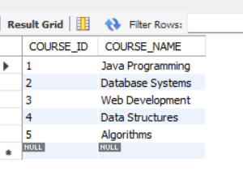

**Student table-**

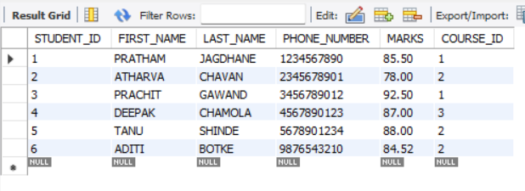

**c. Write a SQL statement to insert 8 records with your own value into the tables.**

**CODE-**

SELECT COURSE_ID, COUNT(*) AS student_count

FROM Student

GROUP BY COURSE_ID;

**OUTPUT-**

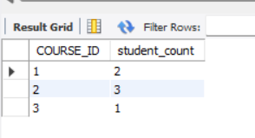

**d. Write a query to get the number of students with the same course.**

**CODE-**

SELECT s.FIRST_NAME, s.LAST_NAME, c.COURSE_NAME, s.MARKS

FROM Student s

JOIN Course c ON s.COURSE_ID = c.COURSE_ID;

**OUTPUT-**

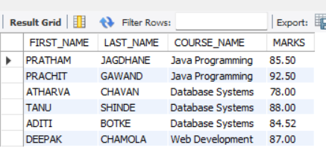

**g. Write a query to get the Average marks of students course wise.**

**Code-**

SELECT c.COURSE_NAME, AVG(s.MARKS) AS average_marks

FROM Student s

JOIN Course c ON s.COURSE_ID = c.COURSE_ID

GROUP BY c.COURSE_NAME;

**OUTPUT-**

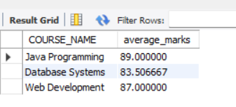

**2.  Create database for hospital management system & Perform the following tasks:**

1. **Create HEALTH CARE WORKERS table with following attributes (EMPLOYEE_ID , FIRST_NAME, LAST_NAME,EMAIL, PHONE_NUMBER, HIRE_DATE, SALARY, DESIGNATION).**

**CODE-**

CREATE TABLE HEALTH_CARE_WORKERS (

EMPLOYEE_ID INT PRIMARY KEY,

FIRST_NAME VARCHAR(100),

LAST_NAME VARCHAR(100),

EMAIL VARCHAR(100),

PHONE_NUMBER VARCHAR(15),

HIRE_DATE DATE,

SALARY DECIMAL(10, 2),

DESIGNATION VARCHAR(100)

);

CREATE TABLE PATIENT (

PATIENT_ID INT PRIMARY KEY,

NAME VARCHAR(100),

PHONE_NUMBER VARCHAR(15)

);

**OUTPUT-**

**HEALTH CARE TABLE-**



**PATIENT TABLE-**

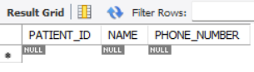

1. **Write a SQL statement to insert 10 records with your own value into the tables.**

**CODE-**

INSERT INTO HEALTH_CARE_WORKERS (EMPLOYEE_ID, FIRST_NAME, LAST_NAME, EMAIL, PHONE_NUMBER, HIRE_DATE, SALARY, DESIGNATION) VALUES

(1, 'Alice', 'Johnson', 'alice.johnson@example.com', '1234567890', '2020-01-15', 30000.00, 'Doctor'),

(2, 'Bob', 'Smith', 'bob.smith@example.com', '2345678901', '2019-07-22', 25000.00, 'Nurse'),

(3, 'Carol', 'Williams', 'carol.williams@example.com', '3456789012', '2018-09-30', 27000.00, 'Technician'),

(4, 'David', 'Jones', 'david.jones@example.com', '4567890123', '2021-03-10', 32000.00, 'Doctor'),

(5, 'Eve', 'Brown', 'eve.brown@example.com', '5678901234', '2017-11-25', 28000.00, 'Nurse'),

(6, 'Frank', 'Davis', 'frank.davis@example.com', '6789012345', '2022-01-12', 26000.00, 'Technician'),

(7, 'Grace', 'Miller', 'grace.miller@example.com', '7890123456', '2016-05-18', 30000.00, 'Doctor'),

(8, 'Henry', 'Wilson', 'henry.wilson@example.com', '8901234567', '2015-08-25', 23000.00, 'Nurse'),

(9, 'Ivy', 'Moore', 'ivy.moore@example.com', '9012345678', '2014-02-14', 24000.00, 'Technician'),

(10, 'Jack', 'Taylor', 'jack.taylor@example.com', '0123456789', '2013-10-10', 22000.00, 'Technician');

**OUTPUT-**

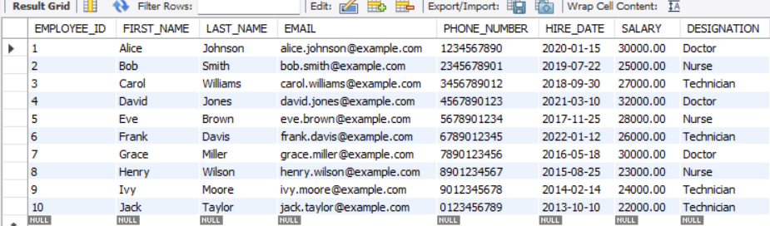

1. **Write a query to get the names (first_name, last_name),Designation, salary.**

**CODE-**

SELECT FIRST_NAME, LAST_NAME, DESIGNATION, SALARY

FROM HEALTH_CARE_WORKERS;

**Output-**

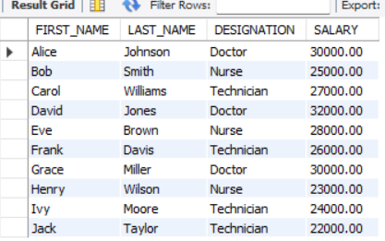

1. **Write a query to get the number of employees with the same Designation**

**Code-**

SELECT DESIGNATION, COUNT(*) AS number_of_employees

FROM HEALTH_CARE_WORKERS

GROUP BY DESIGNATION;

**Output-**

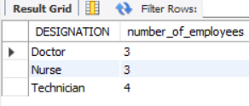

1. **Write a query to get employee name who are getting salary more than 25000.**

**Code-**

SELECT FIRST_NAME, LAST_NAME

FROM HEALTH_CARE_WORKERS

WHERE SALARY > 25000;

**Output-**

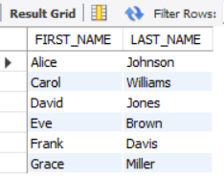

1. **Fetch HEALTH CARE WORKERS name using their employee id.**

**Code-**

SELECT FIRST_NAME, LAST_NAME

FROM HEALTH_CARE_WORKERS

WHERE EMPLOYEE_ID = employee_id;

**Output-**

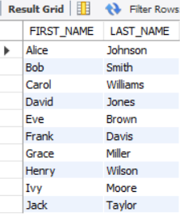

**3. Consider two tables, customers and orders, with the following structures:**

**a. Customers Table: customer_id (Primary Key) first_name Last_name**

**code-**

-- Customers Table

CREATE TABLE Customers (

customer_id INT PRIMARY KEY,

first_name VARCHAR(100),

last_name VARCHAR(100)

);

-- Orders Table

CREATE TABLE Orders (

order_id INT PRIMARY KEY,

customer_id INT,

order_date DATE,

total_amount DECIMAL(10, 2),

FOREIGN KEY (customer_id) REFERENCES Customers(customer_id)

);

**Output-**

**Customer table-**

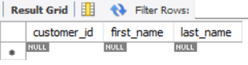

**Order table-**

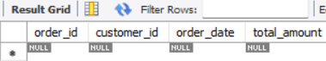

**b. Orders Table: order_id (Primary Key) customer_id (Foreign Key) order_date Total_amount**

**code-**

SELECT c.first_name, c.last_name, o.order_date, o.total_amount

FROM Customers c

INNER JOIN Orders o ON c.customer_id = o.customer_id;

**Output-**

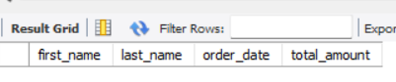

**4.Consider two tables, departments and employees, with the following structures:**

**Departments Table: department_id (Primary Key) department_name**

**Employees Table: employee_id (Primary Key) first_name last_name department_id (Foreign Key)**

**Write an SQL query to retrieve a list of all departments and the names of employees who belong to each department. Use a LEFT JOIN to include departments that have no employees.**

**Code-**

-- Departments Table

CREATE TABLE Departments (

department_id INT PRIMARY KEY,

department_name VARCHAR(100)

);

-- Employees Table

CREATE TABLE Employees (

employee_id INT PRIMARY KEY,

first_name VARCHAR(100),

last_name VARCHAR(100),

department_id INT,

FOREIGN KEY (department_id) REFERENCES Departments(department_id)

);

**Output-**

**Department table**

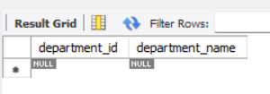

**Employees table**

