SOFTWARE ENGINEERING

PROJECT REPORT
NYAYADEEP

TITLE
NyayaDeep: An AI-Powered Constitutional Literacy and Civic Awareness Platform
Subtitle: A Web-Based Interactive Learning System to Simplify the Indian Constitution through Gamification, AI Chatbots, and Progressive Web Technology
NyayaDeep is an innovative web-based educational platform developed to simplify and popularize the understanding of the Indian Constitution among citizens. The platform bridges the gap between complex legal language and everyday understanding by presenting key constitutional concepts—such as the Preamble, Fundamental Rights, Duties, and important Articles—in a simplified and interactive format.
Through the integration of interactive games, quizzes, blogs, and AI-powered chatbots, NyayaDeep transforms traditional learning into an engaging and dynamic experience. The inclusion of multilingual support ensures that users from diverse linguistic backgrounds can access content in their preferred language, promoting inclusivity and national reach.
Technically, the system is built using the MERN stack (MongoDB, Express.js, React.js, Node.js) to deliver fast, scalable, and modular performance. It also incorporates Progressive Web App (PWA) capabilities, allowing users to learn even without continuous internet connectivity. By blending technology, education, and gamification, NyayaDeep aims to foster greater constitutional literacy, civic awareness, and digital empowerment across India.

AIM
The primary aim of NyayaDeep is to promote constitutional literacy and civic awareness among Indian citizens by transforming complex legal concepts into simple, interactive, and engaging digital learning experiences. The project seeks to make the Indian Constitution accessible to everyone — from students to general citizens — through the use of modern web technologies, gamification, and AI-driven assistance.
NyayaDeep strives to build an inclusive learning environment where users can understand their rights, duties, and democratic values in an enjoyable and meaningful way, thereby encouraging informed citizenship and active participation in democracy.

OBJECTIVES
- Simplify Constitutional Concepts
NyayaDeep aims to make the Indian Constitution more approachable by breaking down complex legal language into simple explanations. Articles, rights, and duties are presented through concise summaries, infographics, and visual learning modules so that users of all ages can easily grasp the essence of each concept.
- Enhance Engagement through Gamification
To make learning more interactive, the platform integrates educational games such as quizzes, puzzles, and role-play scenarios. These gamified modules reward users with XP points and badges, motivating them to explore more topics while transforming a serious subject into an enjoyable experience.
- Leverage AI for Smart Learning
NyayaDeep includes an AI-powered chatbot — Samvidhan Saathi — designed to answer users’ constitutional queries in real time. This feature uses natural language processing (NLP) to provide accurate, context-aware responses and makes legal knowledge easily accessible even for non-experts.
- Enable Multilingual and Inclusive Access
Recognizing India’s linguistic diversity, the platform supports multiple languages to ensure inclusivity. Features like text-to-speech, voice assistance, and region-specific translations make NyayaDeep accessible to users across different age groups, literacy levels, and regions.
- Ensure Offline Learning Support
To reach users in areas with limited internet connectivity, NyayaDeep functions as a Progressive Web App (PWA). This allows learners to download lessons, games, and materials for offline access, ensuring continuous learning without dependence on active internet availability.
- Encourage Continuous Learning and Motivation
The platform tracks individual progress through XP points, streaks, and achievement badges. This progress-tracking system helps maintain motivation, promotes consistency, and provides a sense of accomplishment as users advance through learning levels.
- Provide Reliable and Verified Content
All information presented on the platform is validated by legal experts and verified through credible sources. This ensures the accuracy, reliability, and trustworthiness of constitutional knowledge being shared with the public.
- Promote Civic Responsibility and Awareness
Beyond education, NyayaDeep encourages users to internalize constitutional values such as justice, equality, liberty, and fraternity. The platform’s real-world case studies and discussions aim to foster a sense of civic responsibility and inspire informed, active participation in India’s democracy.

FUNCTIONAL REQUIREMENTS
The functional requirements describe the key operations, behaviors, and interactions that the NyayaDeep system must support to fulfill its objectives. These requirements ensure that all modules — from user authentication to gamified learning and chatbot integration — function cohesively to deliver a smooth, engaging user experience.

User Management & Verification
- The system shall allow users to securely sign up using email, username, and password.
- The system shall hash and store passwords to prevent unauthorized access.
- The system shall generate and store One-Time Passwords (OTP) in hashed form for email verification.
- The system shall verify user accounts through email-based OTP validation before activation.
- The system shall allow Telegram account linking for extended engagement.
- The system shall support login and logout functionality for authenticated access.
- The system shall differentiate between normal users and admin users, each with specific privileges.
- The system shall allow users to update profile information, such as name, language preference, and avatar image.

This module ensures secure onboarding and user verification using industry-standard encryption techniques. Admins have extended privileges for managing content, quizzes, and user progress. Telegram integration bridges real-time engagement with the web platform.

Learning Roadmap
- The system shall organize lessons under sections.
- The system shall track lesson completion.
- The system shall update progress upon lesson completion.
- The system shall show where the user left earlier.
This module defines the learning flow, enabling users to progress through Constitution topics at their own pace. It supports personalization and encourages consistent learning habits through continuous tracking.

Quiz and Games
- The system shall support multiple quiz formats including MCQs, multi-select, and True/False.
- The system shall validate answers and mark correctness instantly.
- The system shall award XP points for correct answers to encourage learning.
- The system shall store attempts, scores, and history for performance tracking.
- The system shall include interactive games like:
- Crossword
- Word Search
- Quiz
- Spin the Wheel (randomized reward system)
- The system shall allow multiplayer gameplay for real-time engagement.
Gamification converts learning into an enjoyable experience, improving user retention. The XP and badge systems create healthy competition through leaderboards and multiplayer features.

Daily Facts
- The system shall display one unique constitutional fact daily per user.
- The system shall ensure the same fact is not repeated within a day, even on refresh.
This promotes daily engagement while improving civic awareness. Facts are pulled dynamically from curated datasets for reliability.

Gamification
- The system shall track total XP earned by each user.
- The system shall maintain streak counts (current and longest).
- The system shall grant bonus XP for maintaining learning streaks.
- The system shall maintain leaderboards at global and monthly levels.
- The system shall assign badges for milestones and specific achievements.
- The system shall maintain XP and streak history logs for analysis and transparency.
Gamification enhances user motivation by providing measurable progress and visual rewards, creating a sense of accomplishment and long-term engagement.

Chatbot Integration
- The system shall allow users to chat with NyayaBot for Constitution-related queries.
- The system shall display chatbot responses in a clean conversational interface.
- The chatbot shall maintain chat history (queries and responses) for each user.
- The chatbot shall be accessible via the main web platform.
The AI chatbot, Samvidhan Saathi, is powered by Google Gemini API. It simplifies legal concepts through natural, conversational explanations, ensuring instant and accurate assistance.

Telegram Bot Integration
- The system shall allow linking/unlinking of Telegram accounts.
- The Telegram bot shall send daily facts, XP updates, and streak notifications.
- The bot shall broadcast leaderboard updates and game results.
The Telegram bot enhances engagement by delivering personalized updates and reminders outside the web platform, ensuring continuous user interaction.

Accessibility Features
- The system shall provide text-to-speech functionality for lessons, quizzes, and facts.
- The system shall support multilingual interaction (Hindi, Marathi, English).
- The system shall allow dynamic language switching.
- The system shall offer audio-based navigation for visually impaired users.
Accessibility ensures inclusivity for diverse linguistic and ability groups, aligning with the constitutional principle of equality and promoting digital literacy across all demographics.

External Interface Functional Requirements

User Interfaces :
- The system shall display a personalized dashboard with greetings, learning level, motivational tips, and a progress tracker.
- The system shall provide visual progress tracking and a "Continue Learning" option.
- The system shall provide quick access to last activity metadata (lesson, quiz, blog).
- The system shall provide a lightweight daily quiz with submit, skip, and feedback mechanisms.
- The system shall display a daily Constitution fact.
- The system shall support interactive games (Snake & Ladder, Spin the Wheel, Matching Pairs, Quiz Challenges) integrated with XP, leaderboards, badges, streaks, and levels.
- The system shall provide a chat interface for NyayaBot.
- The system shall integrate a Telegram bot for delivering facts and reminders.
- The system shall allow language change and profile update via settings.
- The system shall provide standard navigation and controls consistently across screens.
- The system shall provide clear, actionable, and accessible error messages.
- The system shall ensure responsive design across desktop and mobile screens.

Software Interfaces :
- The system shall store user data in MongoDB with userID, lastViewed, progress, quizResults, XP, badges, and streaks.
- The system shall use external datasets (eGazette, Kaggle) for facts and articles.
- The system shall integrate Google Gemini API for NyayaBot.
- The system shall integrate Telegram API for bot functionality.
- The system shall support real-time updates for games and leaderboards.
- The system shall securely share user progress between dashboard, games, quizzes, and bot instances.
- The system shall not share sensitive information with external bots unless user-approved.

NON-FUNCTIONAL REQUIREMENTS
NyayaDeep is a new, self-contained web-based educational platform designed to simplify constitutional literacy for Indian citizens. NyayaDeep is not intended to replace existing platforms; rather, it serves as a complementary system that enhances the accessibility and engagement of constitutional literacy through the following features:
- Interactive Learning: Gamified modules and quizzes for engaging understanding.
- AI-powered Assistance: Chatbots for general queries and case analysis.
- Offline Access: Progressive Web App and downloadable learning packages.
- Expert Content: Blogs, legal analyses, and curated constitutional facts.

NyayaDeep is modular, consisting of multiple subsystems:
- User Management Subsystem – handles registration, login, and user profiles.
- Learning & Games Subsystem – delivers quizzes, games, and interactive lessons.
- Chatbot Subsystem – Samvidhan Saathi (Q&A).
- Content Management Subsystem – Blogs, facts, and legal resources.
- Progress Tracking Subsystem – tracks user learning, XP, and achievements.

External Interfaces:
- MongoDB / AWS DocumentDB for data storage
- Third-party NLP services (Gemini API, AWS Comprehend)
- Optional Telegram bot for notifications and daily facts

Product Functions
The platform provides the following high-level functions:

- User registration, login, and personalized dashboard
- Language selection and knowledge-level assessment
- Interactive games (Snake & Ladder, Spin the Wheel, Matching Pairs, Quiz Challenges, Role-play)
- Daily constitutional facts and quizzes
- AI Chatbots for question answering and case analysis
- Progress tracking (XP, levels, streaks, badges)
- Blog content access (articles, case analyses, legal discussions)
- Settings customization (language change, profile updates)
- Offline access via PWA and downloadable resources

User Classes and Characteristics
- General Citizens
  - Age: 14+ (above 8th standard)
  - Use the platform to understand rights, duties, and constitutional provisions
  - Moderate technical skills (can navigate web apps and mobile apps)
- Students/Learners
  - School and college students
  - Motivated by gamified learning, quizzes, and role-play scenarios
  - Moderate technical literacy
- Legal Enthusiasts/Proffesionals
  - Access blogs, case analyses, and AI chatbot for deeper knowledge
  - Familiar with legal terminology
  - May need advanced features (case comparison, document analysis)
- Administrators/Content Managers
  - Upload blogs, quizzes, and manage learning content
  - Require backend access and content management tools

Operating Environment
Hardware: Desktop, Laptop, Tablets, Mobile devices
OS: Windows, macOS, Linux, Android, iOS (via PWA)
Web Browser: Chrome, Firefox, Safari, Edge (latest versions)
Software Components:
- Frontend: React.js
- Backend: Node.js, Express.js
- Database: MongoDB / AWS DocumentDB
- NLP APIs: Gemini API, AWS Comprehend
Offline Support: Local Storage, IndexedDB (for PWA)

Design and Implementation Constraints
- Must support multilingual content
- Progressive Web App for offline usage
- APIs and backend services must be secure (HTTPS, token-based authentication)
- Data privacy: user data stored securely, following applicable regulations
- Chatbots require external NLP APIs (Gemini, AWS Comprehend)
- Compatible with modern browsers and mobile devices

User Documentation
- User Manual (PDF / downloadable)
- Online Help (FAQ section and chatbot support)
- Interactive Tutorials for games and quizzes

Assumptions and Dependencies
- Users have basic internet access initially for registration and content download
- NLP APIs (Gemini, AWS Comprehend) are available and functional
- MongoDB / AWS DocumentDB services are operational and scalable
- Users have devices that support modern web browsers
- Gamification elements rely on accurate user progress tracking

DESIGN
- Architectural diagram
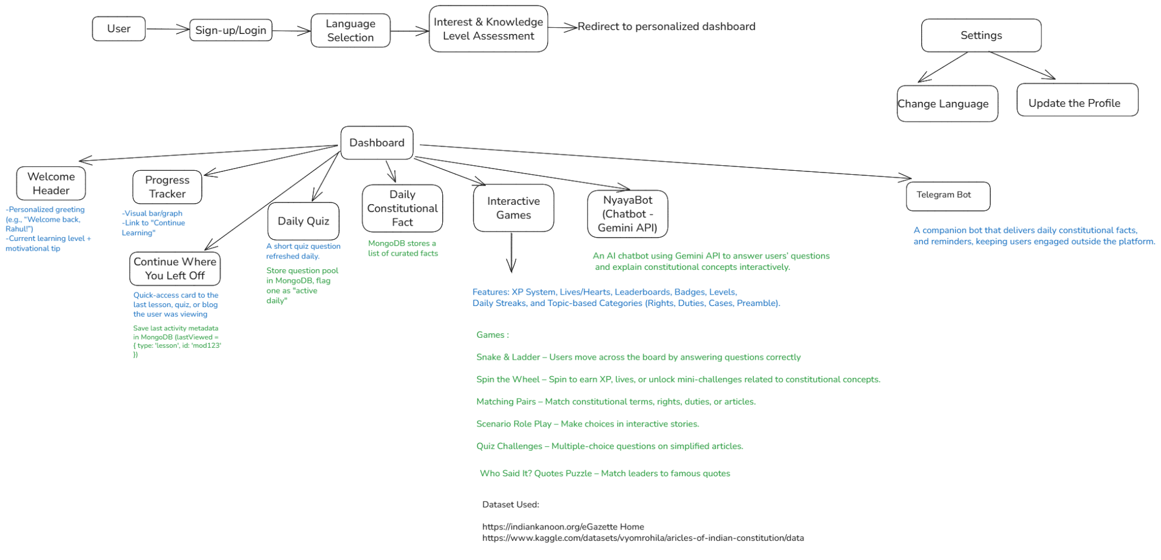
- ER Diagram
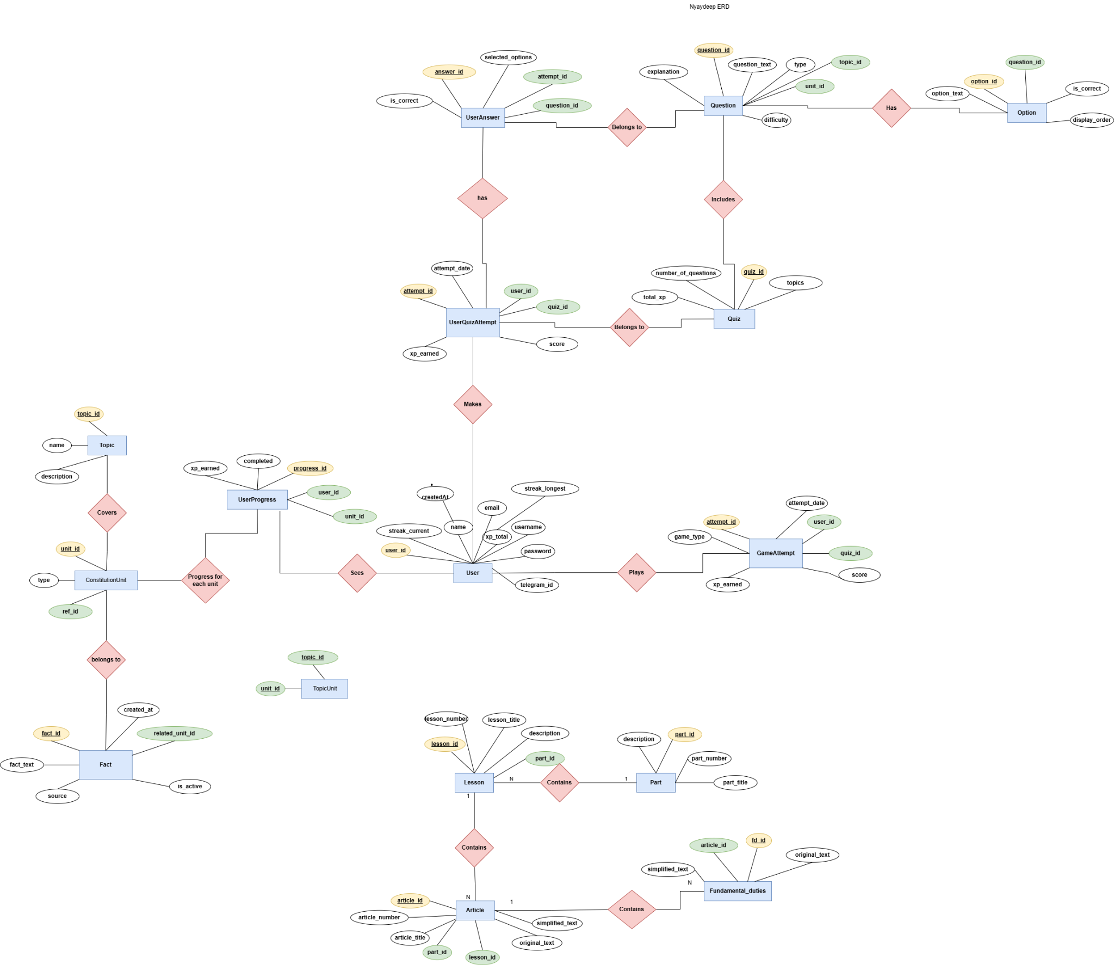

- DFD till system becomes atomic
LEVEL-0 DFD :
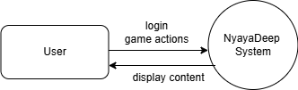
LEVEL-1 DFD :
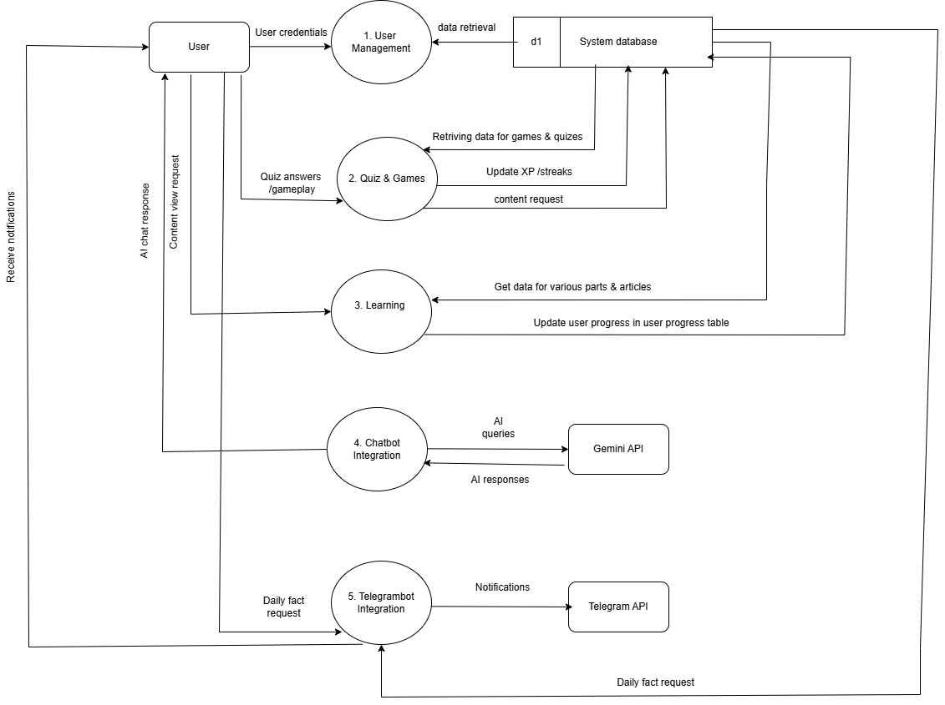

LEVEL-2 DFD :
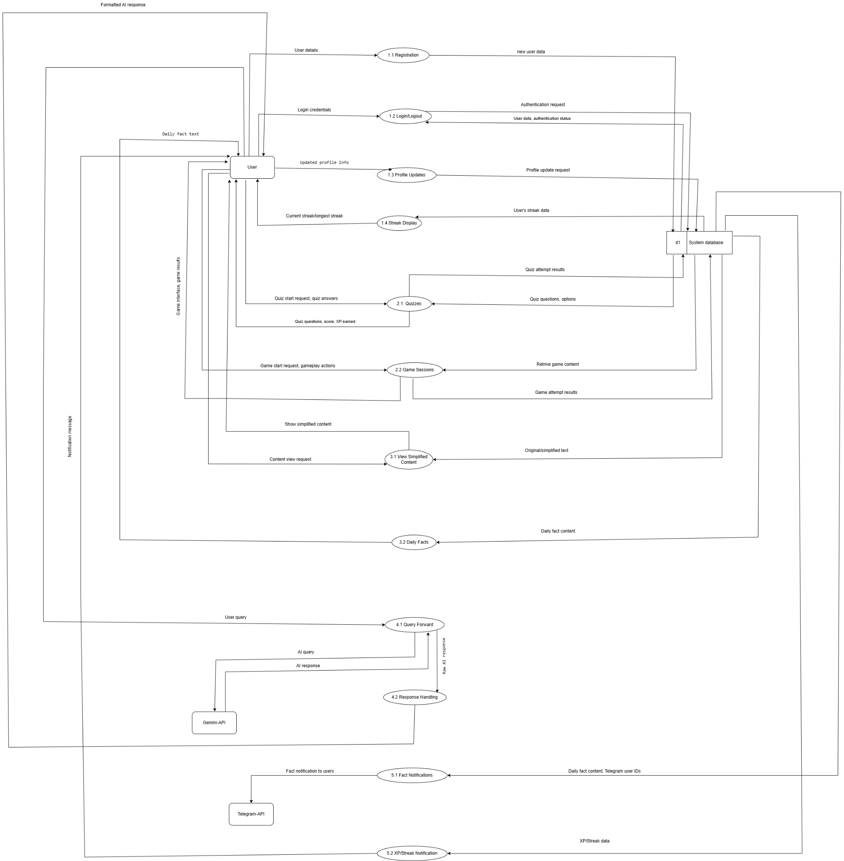

- UML Diagrams
Use-Case Diagram — Actors and high-level interactions: Student, Teacher, PolicyMaker, Admin, RAG Engine, Blockchain Node, Wallet.
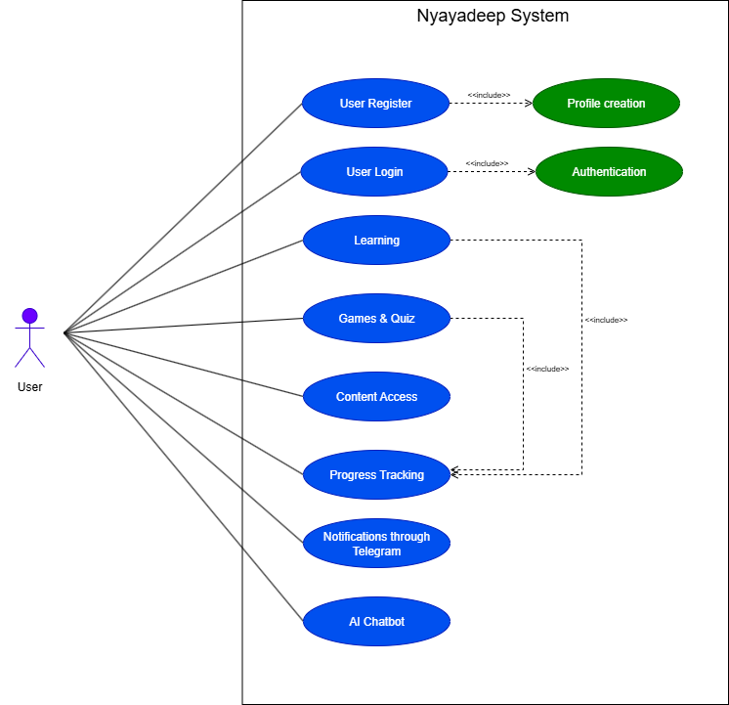

Class Diagram — Core domain objects: UserProfile, Lesson, Question, ArticleReference, TokenRecord, Wallet, ProgressRecord, EmbeddingIndex, RAGDocument, SyncQueue.

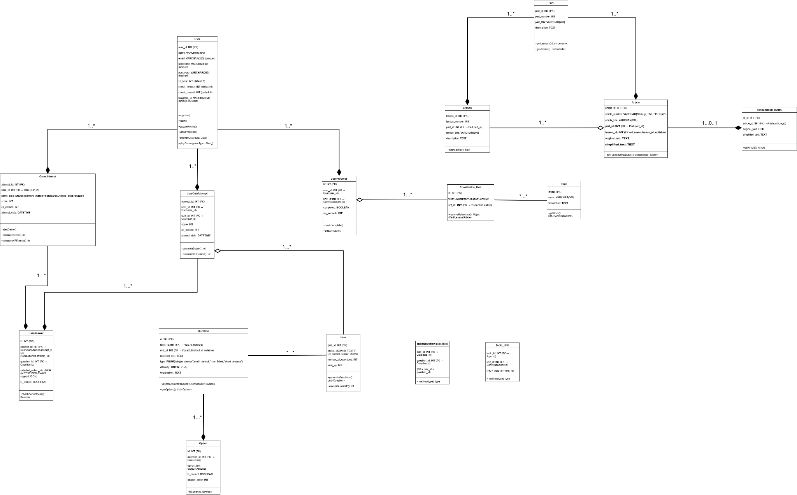

Activity Diagram — Offline sync and lesson consumption workflow
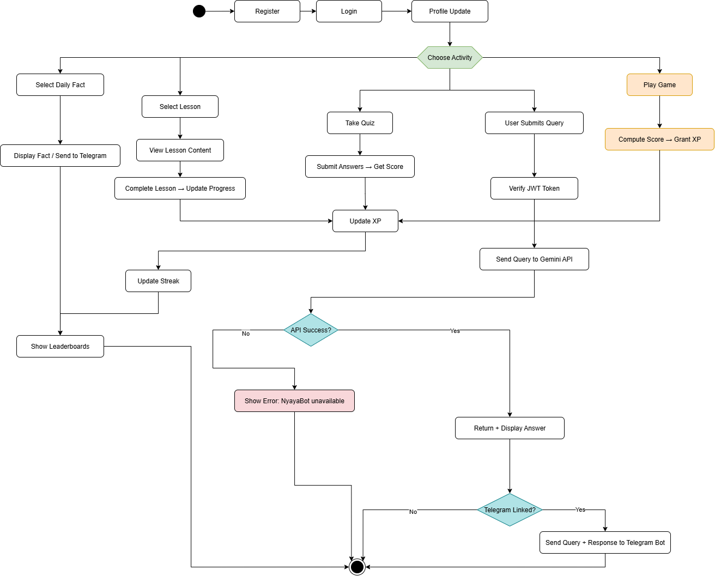

Swimlane Diagram :
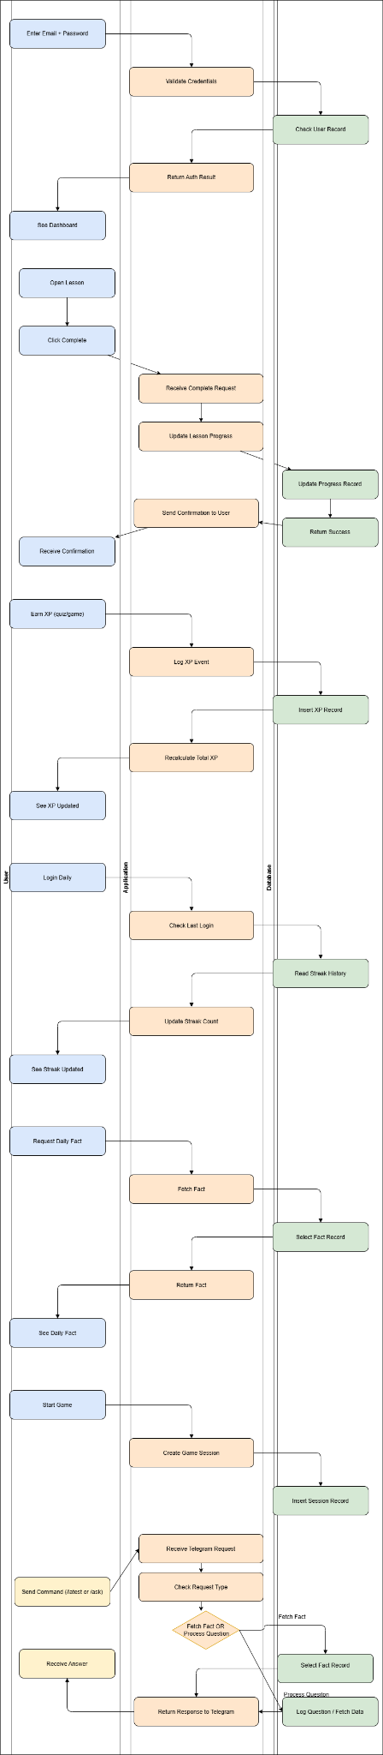
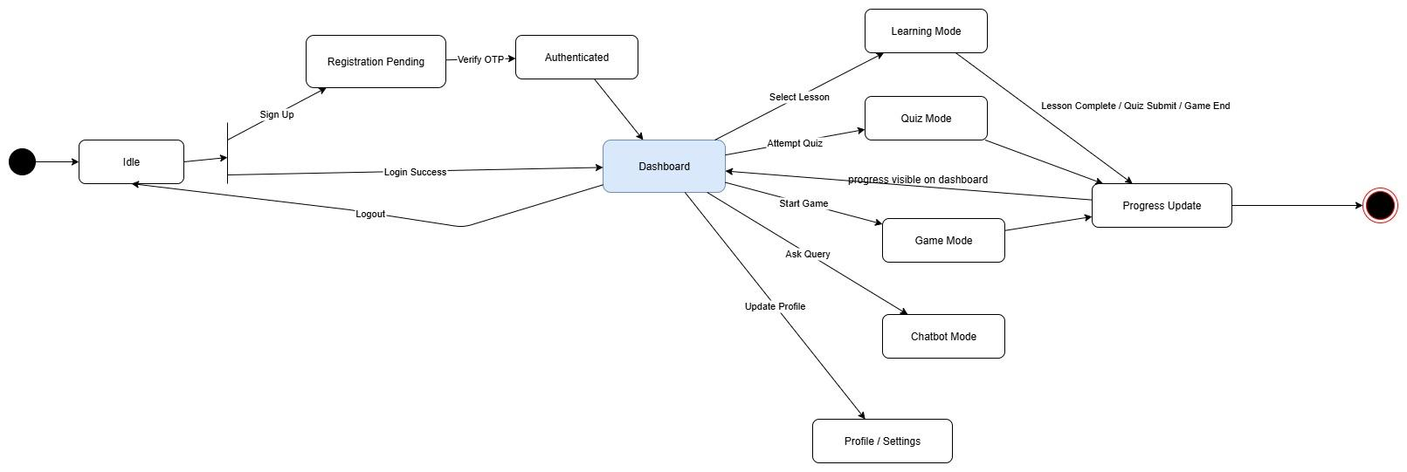
State Diagram:

IMPLEMENTATION DETAILS AND CODING
Landing page
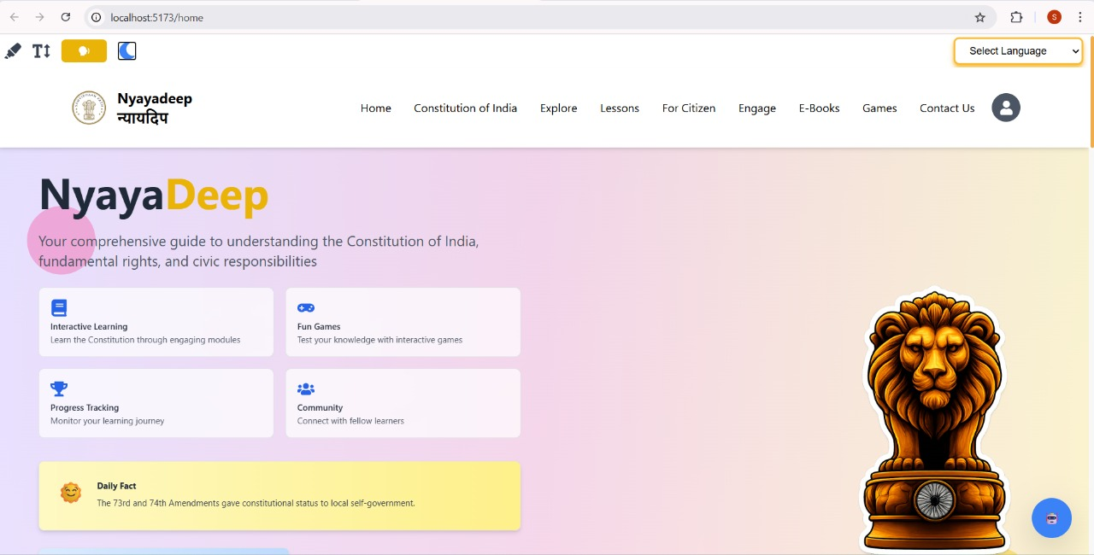
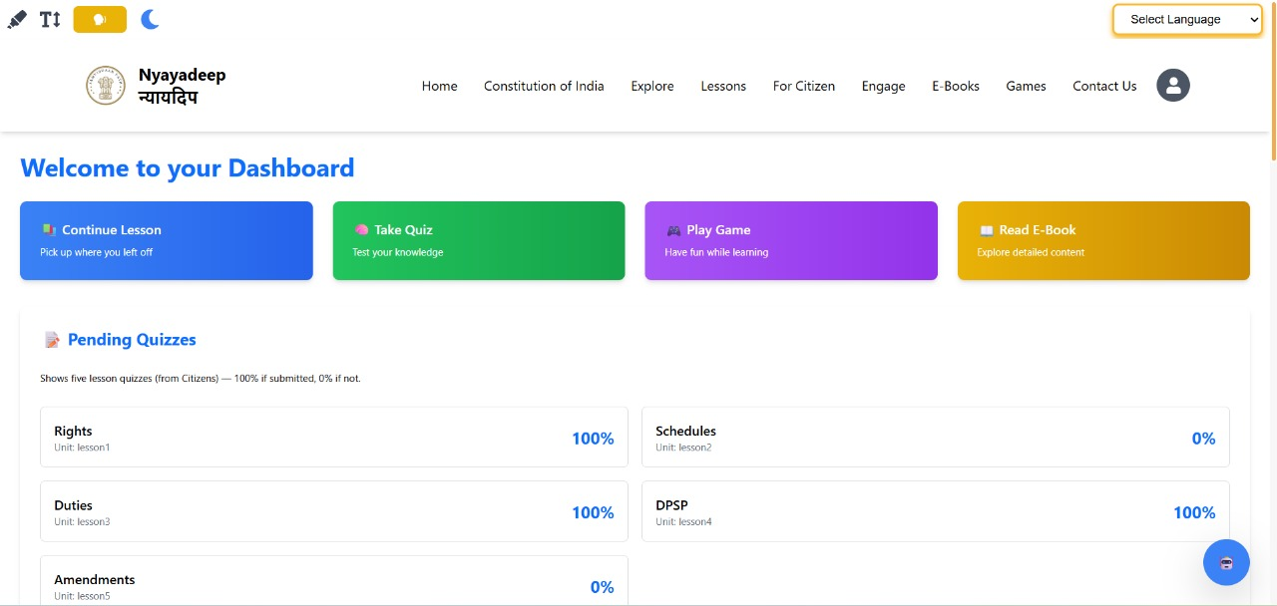
Learning Dashboard
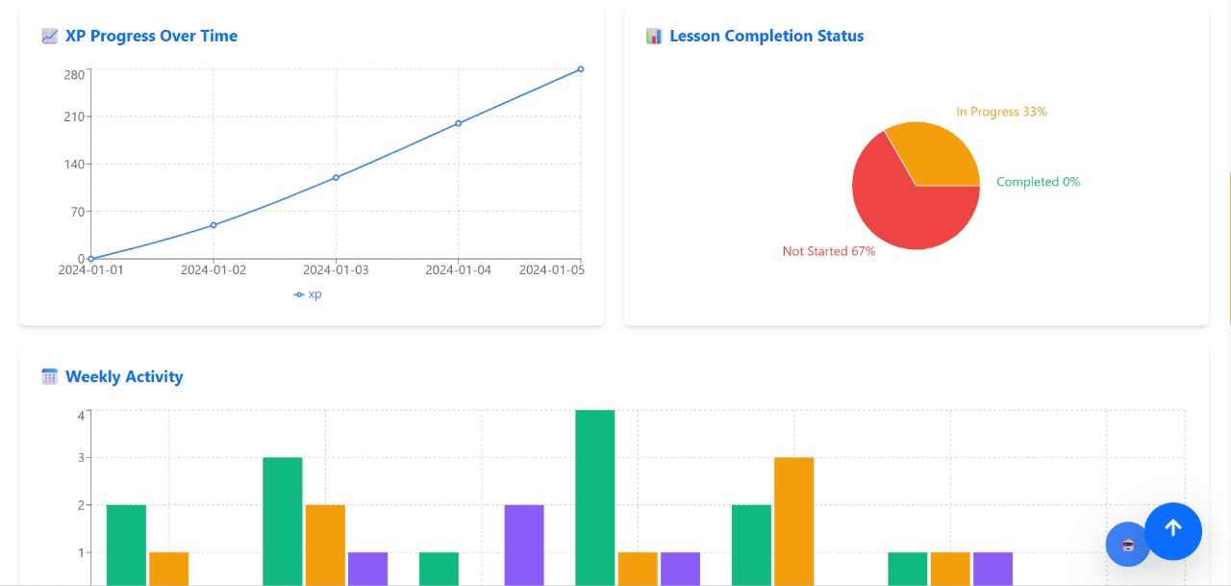
Progress Tracking Dashboard

Chatbot
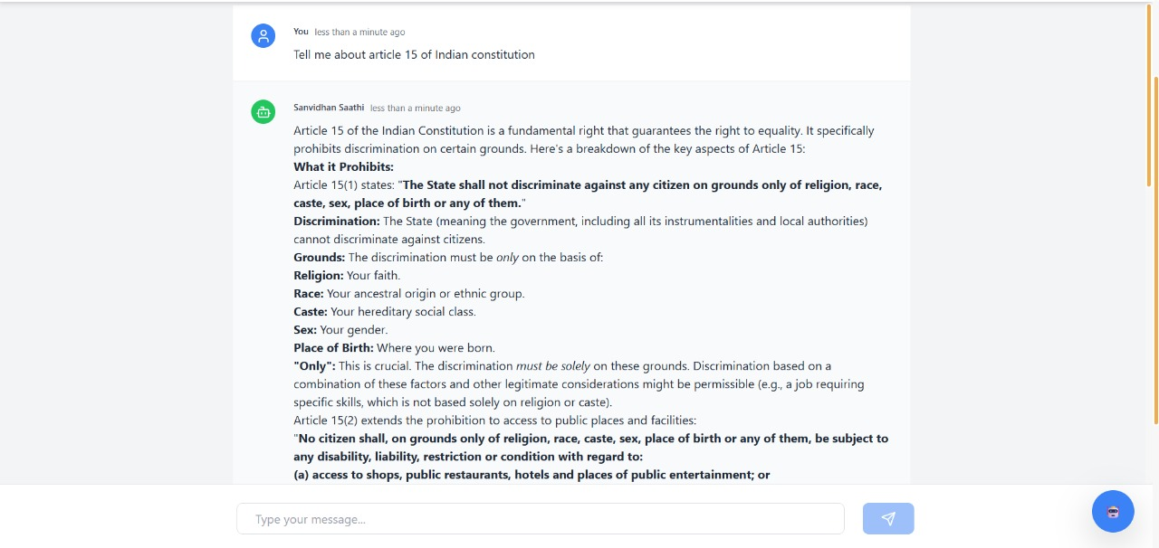
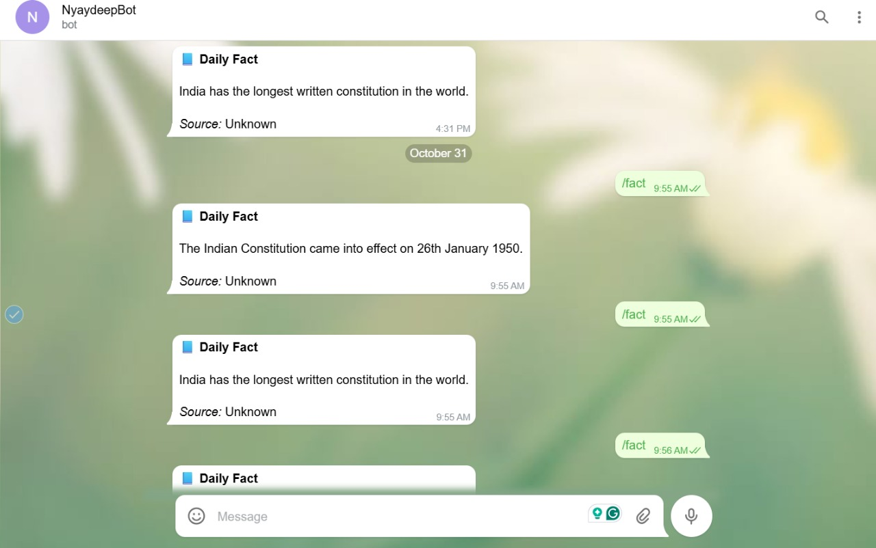
Telegram Bot

TESTING

Login Functionality Test Plan – NyayDeep
This test verifies that the login mechanism in NyayDeep functions as expected for different combinations of user credentials. It ensures that users can log in using valid credentials and are granted access to their account with a valid authentication token.
The test also validates the system’s behavior for invalid or missing credentials, ensuring proper error handling and feedback messages (e.g., “Invalid email or password”) are returned by the API.
The login() function takes 2 parameters:
- Email
- Password
Since there are two input fields and each can be correct or incorrect, there are a total of 2² = 4 possibilities:
Sr No | Email | Password | Expected Behavior
1 | Wrong | Wrong | Login fails with status 401 Unauthorized
2 | Right | Wrong | Login fails with status 401 Unauthorized
3 | Wrong | Right | Login fails with status 401 Unauthorized
4 | Right | Right | Login succeeds with status 200 OK, returns a JWT token and user data

Exhaustive Testing : Login Function
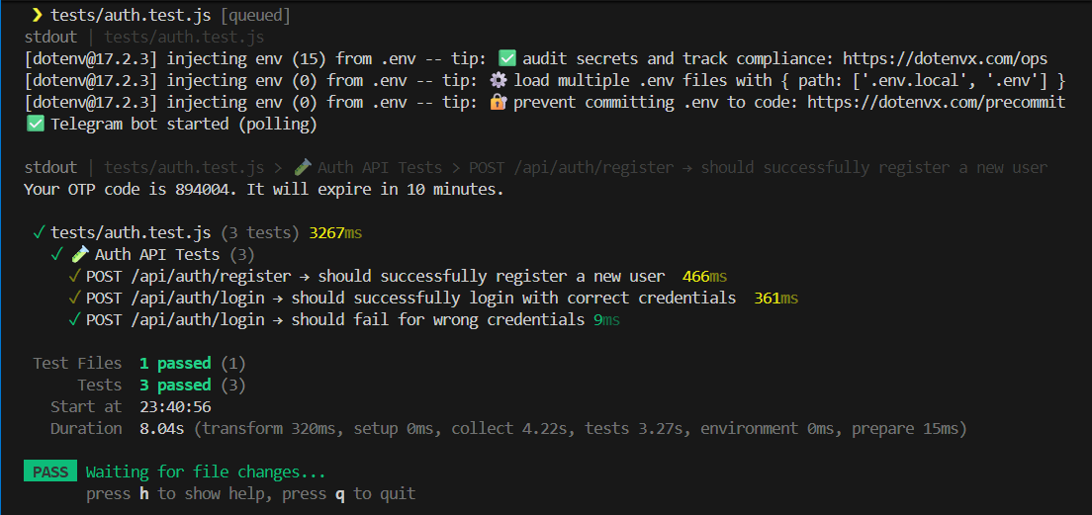

Black Box Testing – Nyaydeep

The system interacts with a backend database that stores user profiles, lesson progress, quiz scores, XP, streaks, and game history. The only external integrations are email for daily facts and OTP verification, Telegram bot, and chatbot.

Sr. No | Function | Test Scenario | Expected Output | Conformance to Expectation
1 | Signup | User fills all mandatory fields and submits signup form. | Account created successfully; OTP sent to email for verification. | System behaves as expected.
2 | Signup | User enters invalid or already registered email. | Validation error shown: “Email already in use” or “Invalid email.” | Proper error message displayed.
3 | Login | User enters correct email/username and password. | User successfully logged in and redirected to dashboard. | Login works correctly.
4 | Login | User enters incorrect password or non-existent email. | System shows “Invalid credentials” error. | Proper error response given.
5 | Lesson Access | User selects a lesson from lesson plans. | Lesson content (articles, parts, images, videos) displayed correctly. | Lesson content loads as expected.
6 | Quiz | User attempts a quiz after lesson completion. | Questions displayed; answers recorded; score updated on completion. | Quiz scoring and tracking works correctly.
7 | Quiz | User tries to submit without answering all mandatory questions. | System shows validation error: “Please answer all questions.” | Validation works as expected.
8 | Games – Spin the Wheel / Word Search / Crossword | User plays a game. | XP points added to user account; game result shown. | Game mechanics and XP system function correctly.
9 | Daily Facts | User gets to daily facts on email. | Daily email sent to registered email with fact of the day. | Email delivery and content correct.
10 | OTP Verification | User enters OTP during signup or login. | System verifies OTP; user account activated or login allowed. | OTP verification works correctly.
11 | Telegram Bot | User interacts with Telegram bot for lesson or quiz. | Bot responds with requested content, quizzes, or feedback correctly. | Bot integration works as expected.
12 | Chatbot | User asks questions via web chatbot. | Chatbot responds with relevant answers, suggestions, or lesson links. | Chatbot responds accurately.
13 | Case Studies | User accesses case studies section. | Full case study content displayed; users can comment or rate if applicable. | Case study content loads and functions correctly.
14 | XP & Streak | User completes activities (lessons, quizzes, games). | XP points added; streak counter updates; progress reflected on dashboard. | XP & streak system functions correctly.
15 | Error Handling | User tries invalid actions (e.g., invalid lesson ID, quiz attempt without login). | System shows proper error messages and prevents unauthorized actions. | Error handling is robust.

For Nyaydeep, the database fields of interest include the user’s name, email, signup date, and OTP status. For lessons, the relevant fields are lesson ID, title, parts, articles, and completion status. Quiz-related fields include quiz ID, questions, answers, scores, and timestamps. For games, the database tracks game type, result, XP awarded, and streak updates. Daily facts require storing email sent status and date. For the chatbot and Telegram bot, the fields include user interactions, queries, and responses. Finally, for case studies, the database maintains case study ID, content, comments, and ratings.

Gray Box Testing – Nyaydeep
Grey Box Testing was carried out to evaluate Nyaydeep’s functionality by combining perspectives of both users and developers. Testers had access to database structures, Django view logic, and internal state transitions. This enabled testing of data flow between frontend forms and backend models, verification of permissions (like teacher/admin-only actions), and cross-checking system outputs with actual database states. It helped uncover defects related to integration, session handling, XP/streak updates, and input validation.
Sr. No | Test Scenario | Test Method | Expected Outcome | Backend Verification
1 | User signup with valid data | Submit signup form via web UI | OTP sent; account created successfully | Verify User model entry created with correct OTP status and role
2 | Signup with invalid or duplicate email | Submit signup form | Validation error displayed | No new User entry created in DB
3 | User login with correct credentials | Enter credentials on login page | User successfully logged in | Verify session created and last_login timestamp updated in User model
4 | Access lesson content | Click on lesson from dashboard | Lesson parts, articles, media displayed correctly | Lesson completion status unchanged or updated on progress
5 | Complete a quiz | Submit quiz answers | Score calculated; user notified; XP added | Quiz model updated with answers, score, and timestamp; XP added to User profile
6 | Play game (Spin the Wheel / Crossword / Word Search) | Play game via web UI | Game result displayed; XP added; streak updated | Game model logs result; User XP and streak fields updated correctly
7 | Receive daily fact email | Trigger daily email feature | Email delivered to user inbox | DailyFacts model updated with email sent status and date
8 | OTP verification | Enter OTP received via email | Account activated or login allowed | OTP status in User model updated to “verified”
9 | Chatbot query | Enter question in chatbot | Bot responds with appropriate answer or suggestion | Chatbot interactions stored in DB for logging and analytics
10 | Telegram bot interaction | Interact with bot for lessons/quizzes | Bot responds correctly | TelegramBot model logs query and response correctly
11 | Case study access and comment | Open case study; add comment | Content displayed; comment saved | CaseStudy model updated with new comment and rating if applicable
12 | Unauthorized access to teacher/admin feature | Enter teacher/admin URL directly | Access denied or redirected | No unauthorized DB changes triggered
13 | Invalid quiz or lesson ID | Navigate to invalid URL | Proper error message displayed | No data created/modified for invalid IDs
14 | Session timeout / concurrent login | Use session after timeout or multiple devices | User redirected to login | Session model reflects expiration; last activity updated correctly

White Box Testing – Nyaydeep
White Box Testing was carried out to evaluate the internal logic and structure of Nyaydeep. Testers analyzed Django models, views, and utility functions to verify correct implementation of algorithms, data flow, and condition handling. This type of testing helped detect defects related to conditional logic, loop execution, exception handling, database queries, and integration between modules.
Sr. No | Test Scenario | Test Method | Expected Outcome | Code / Logic Verification
1 | User signup validation | Test signup function with various inputs | Correct account creation or validation errors | Check if all field validations and OTP generation logic executed correctly
2 | Login authentication | Test login function with valid/invalid credentials | Successful login or “invalid credentials” response | Verify authentication logic and session creation code
3 | Lesson progress update | Mark lesson as completed | Completion status updated accurately in DB | Check LessonCompletion model update and related signals or methods
4 | Quiz scoring algorithm | Submit answers with different correct/incorrect combinations | Score calculated correctly; XP awarded | Verify calculate_score() function, edge cases, and XP logic
5 | Game XP & streak logic | Play game multiple times, including boundary cases | XP and streak updated correctly | Test update_xp() and update_streak() functions, including consecutive day streak logic
6 | Daily fact email generation | Generate daily email | Email content created correctly, sent successfully | Verify email template rendering, scheduling function, and database updates for DailyFacts
7 | OTP verification | Enter correct/incorrect OTP | Account activated or error shown | Test OTP validation function, expiration handling, and DB field update
8 | Chatbot response logic | Send queries covering all types | Responses match expected logic | Check chatbot intent matching, response selection, and logging functions
9 | Telegram bot command handling | Send bot commands for lessons/quizzes | Correct response returned | Test command parsing functions, API calls, and DB updates
10 | Case study comment submission | Submit comments with valid/invalid inputs | Comment saved or validation error shown | Verify input sanitization, save logic, and rating calculation
11 | Admin-only access | Call admin functions directly via code | Access denied for unauthorized users | Test decorators or permission functions in views for role validation
12 | Exception handling | Trigger edge cases (invalid IDs, empty inputs, DB errors) | Proper exception handling, no crash | Verify try-except blocks, error logging, and fallback logic
13 | Session handling | Expire sessions or simulate multiple logins | User redirected or session updated | Test session management code, last activity timestamp, and concurrency logic
14 | Database queries optimization | Execute queries for lessons/quizzes/games | Queries return correct data efficiently | Check queryset filters, joins, prefetch/select related usage

SUMMARY AND CONCLUSION
NyayaDeep is an innovative AI-powered educational platform designed to make the Indian Constitution simple, engaging, and accessible to all citizens. By integrating modern web technologies, artificial intelligence, and gamification, it transforms constitutional learning from a static subject into an interactive experience that promotes civic awareness and digital inclusion.
Built using the MERN stack with Progressive Web App (PWA) capabilities, NyayaDeep ensures speed, scalability, and offline accessibility. The system combines several core modules — user management, gamified learning, AI chatbot assistance, multilingual support, and progress tracking — to create a holistic learning ecosystem.
The platform’s AI chatbot (Samvidhan Saathi) uses natural language processing to provide instant, context-aware responses to users’ constitutional queries, while games, quizzes, and XP-based rewards sustain motivation and continuous learning. Multilingual features, accessibility tools, and Telegram integration extend the platform’s reach across diverse linguistic and demographic groups.
From a software engineering perspective, NyayaDeep fulfills both functional and non-functional requirements, ensuring security, inclusivity, usability, and scalability. It empowers citizens—especially students and general learners—to understand their rights, duties, and constitutional values in an enjoyable and meaningful way.
Ultimately, NyayaDeep stands as a digital bridge between legal knowledge and public understanding, fostering constitutional literacy, civic responsibility, and informed democratic participation through the power of technology and AI.

