Image-Based 3D Reconstruction of a Thai Libation Brass Vessel Using Learned Feature Matching and Multi-View Stereo

Eaint Myat Thu  Vincent Mary School of Engineering,  Science and Technology  Assumption University of Thailand  Samut Prakan, Thailand  u6726101@au.edu | Sithu Win San  Vincent Mary School of Engineering,  Science and Technology  Assumption University of Thailand  Samut Prakan, Thailand  u6726077@au.edu | Gulizara Benjapalaporn  Vincent Mary School of Engineering,  Science and Technology  Assumption University of Thailand  Samut Prakan, Thailand  u6612233@au.edu

Abstract—This paper presents the completed image-based reconstruction of a brass vessel used in kruat nam (กรวดน้ำ), a Thai Buddhist water-pouring practice associated with merit dedication, from a controlled smartphone capture. The polished surface was temporarily matted and marked for geometry acquisition, while separate uncoated photographs preserved appearance information. The dataset contains 688 photographs, of which 372 geometry views were selected for reconstruction. Grounding DINO-T and SAM 2.1 isolated the vessel; ALIKED-N16Rot and LightGlue established local correspondences; COLMAP recovered camera poses, sparse structure, dense depth, and a fused point cloud. Poisson reconstruction produced the initial scan surface, which was then refined in Blender under a scan-preserving policy that prohibited replacement modeling. The selected sparse model registered all 372 views with a mean reprojection error of 1.20 pixels. Dense fusion produced 1.93 million points, and the final V139 model contains 451,312 vertices and 902,838 triangles. A fresh GLB re-import reproduced the same topology and material assignment. The completed asset documents a difficult reflective object while preserving the form of a vessel associated with a continuing Thai ritual practice.
Keywords—3D reconstruction, cultural heritage, Structure-from-Motion, multi-view stereo, reflective object, ALIKED, LightGlue, COLMAP
I. INTRODUCTION
Image-based 3D reconstruction is widely used to document cultural objects because it can recover shape from ordinary photographs without placing a physical sensor on the object. The method is less reliable when the subject is polished metal. View-dependent highlights move across the surface as the camera changes position, broad brass regions may contain little stable texture, and narrow structures can occupy only a small part of each frame. These effects interfere with the correspondence assumptions used by Structure-from-Motion (SfM) and multi-view stereo (MVS). Recent work on reflective and low-texture reconstruction continues to treat these materials as a difficult case for multi-view vision [8]-[11].
A. Importance to Thai Arts and Culture
The vessel is relevant to Thai Arts and Culture because it is used in kruat nam (กรวดน้ำ), a Buddhist water-pouring practice associated with merit dedication in Thailand. The Department of Cultural Promotion describes kruat nam as a ritual performed after merit-making, particularly when merit is dedicated to deceased relatives, and notes that clean water may be poured from a small ewer or another suitable vessel [12]. Contemporary Buddhist scholarship likewise discusses water pouring as an established practice of merit dedication [13]. The cultural importance of this project comes from documenting a physical object together with the ritual use that gives it meaning. The report does not treat the exact silhouette of this individual vessel as a universal or canonical Thai form.
The vessel was selected because it links a physical object to a continuing Thai Buddhist practice. A 3D record documents the photographed object's specific proportions, openings, visible surface condition, and brass appearance. It can be used for study or digital display and for later comparison without repeated handling of the original. This made the vessel a suitable Thai Arts and Culture subject: the aim was to document this particular ritual object faithfully rather than replace it with a generalized or idealized ceremonial model.
B. Object selection and reconstruction scope
The vessel is also a demanding reconstruction target. Polished brass produces view-dependent reflections, smooth regions provide little stable texture, the body contains strong rotational repetition, and the narrow upper features occupy few pixels in many views. These properties motivated controlled matting, marker texture, multi-elevation capture, learned feature matching, masking, dense reconstruction, and scan-preserving cleanup.
The reconstruction uses consumer hardware and an image-derived workflow. A fixed smartphone photographed the rotating vessel at several elevations. Grounding DINO-T and SAM 2.1 isolated the object; ALIKED-N16Rot and LightGlue established local correspondences; COLMAP recovered sparse and dense geometry; Poisson reconstruction generated the initial surface; and Blender was used for bounded scan cleanup and export. A separate uncoated sequence supplied brass appearance information. The final Blender and GLB assets remain tied to the photographed reconstruction rather than a manually rebuilt vessel.
II. RELATED WORK
COLMAP provides the geometric basis for the reconstruction. Incremental SfM estimates camera poses and sparse 3D structure from verified image correspondences [1]. Its MVS formulation estimates depth and surface normals with view selection and geometric consistency before fusing those estimates into a dense model [2]. These methods work best when the same surface region produces repeatable appearance across views.
Learned local features can improve the correspondence stage when classical texture is weak or viewpoint change is large. ALIKED extracts sparse keypoints and deformable descriptors and was designed for image matching, visual measurement, and 3D reconstruction [3]. LightGlue then matches local descriptors with an adaptive transformer architecture that reduces unnecessary computation on easy image pairs while retaining stronger reasoning for difficult pairs [4]. In this project, the two methods are used together before COLMAP geometric verification.
Object isolation is also important in turntable capture. Grounding DINO accepts language-guided object queries for open-set localization [5], while SAM 2 provides promptable segmentation for images and video [6]. Their combination allows the vessel to be separated from the stationary background and the rotating support. This prevents strong but irrelevant background texture from dominating feature extraction and dense fusion.
Reflective-object research often uses polarization, neural fields, or dedicated datasets because specular appearance violates photometric consistency [8], [9], [11]. This project instead changes the capture condition temporarily so that a conventional multi-view pipeline can operate on the same physical object. Poisson surface reconstruction is then used to convert the fused oriented points into a continuous surface [7].
III. IMAGE ACQUISITION AND DATASET
A. Object preparation and capture setup
The vessel was photographed with the rear camera of an OPPO Reno12 F at 3072 x 4080 pixels. The phone remained fixed on a stand during each turntable pass. The vessel was placed on a wide rotating board in front of a white backdrop and illuminated from both sides with diffuse light. A fixed camera simplified the motion pattern: instead of walking the camera around the object, the object rotated through the camera view while the camera height and viewing angle were changed between passes.
Before geometry capture, the brass surface received a removable matte coating. The coating reduced sharp view-dependent highlights that would otherwise move between frames. Irregular dark marker dots were then added to create local appearance changes across the otherwise smooth metal. The preparation was intended to improve correspondence, not to modify the object shape. Separate uncoated photographs were captured before or after the geometry sequence so that the final material could be estimated from the natural brass surface rather than from the temporary coating.
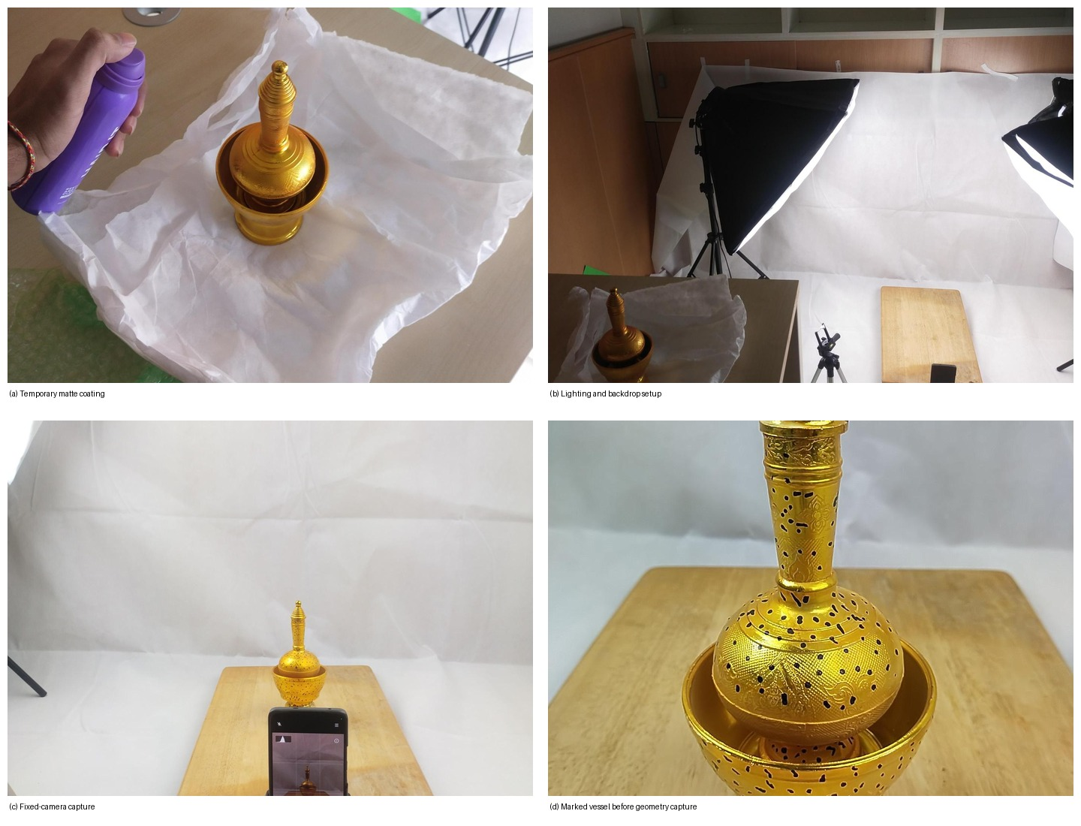
Fig. 1. Actual project setup. The photographs show surface preparation, the diffuse-light white-background arrangement, the fixed-phone position, the rotating board, and the marked vessel used for geometry capture.
B. Multi-elevation capture plan
A single horizontal ring is insufficient for a tall vessel because the bowl can hide the pedestal from upper views, while the neck and terminal become poorly observed from lower views. The geometry capture therefore used several elevation passes. The selected set includes a lower-horizontal ring followed by lower-mid, mid, mid-high, high, and steep-high coverage. Within each pass the object was rotated in small increments so adjacent frames retained substantial overlap. Cross-elevation overlap was also preserved so that the rings could be connected into one reconstruction.
The final capture contains 688 JPEG photographs. Of these, 423 show the coated and marked vessel for geometry, 158 show the uncoated vessel for appearance, and 107 show the empty board or background. The media audit confirmed a consistent 3072 x 4080 geometry image size and no exact duplicate groups. Sequence analysis retained 372 geometry frames for reconstruction. The remaining geometry frames were not needed to increase viewpoint coverage after the selected rings had been defined.
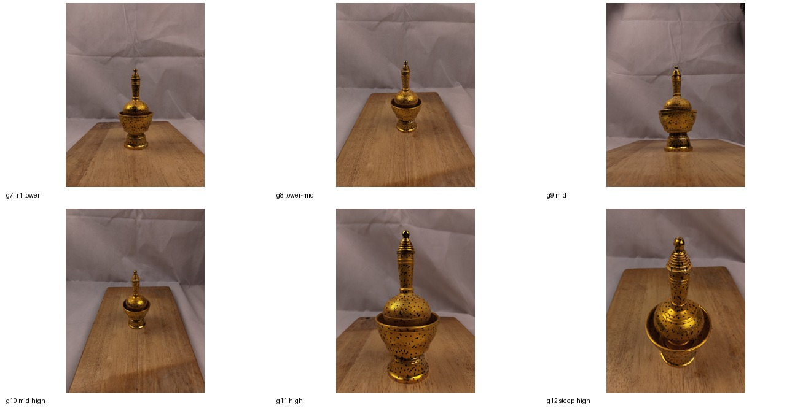
Fig. 2. Representative photographs from the six selected geometry rings. The sequence moves from lower views to steep-high coverage so the pedestal, body, neck, upper rings, and terminal are observed from different elevations.
C. Dataset roles and audit
The dataset was separated by role before reconstruction. Geometry images supplied the multi-view measurements. Uncoated images were reserved for brass appearance statistics. Empty-board images provided evidence about the support and background. This separation matters because the geometry sequence intentionally changes the visible surface with coating and markers. Using those coated colors as a final texture would mix acquisition aids with the object appearance.
Raw photographs were treated as immutable input. Derived MVS images, vessel masks, and feature masks were generated separately, with 372 files in each derived set. The capture manifest records image roles, sequence membership, dimensions, and selection status. This gave the reconstruction a fixed source set and avoided changes in image membership between the sparse and dense stages.
IV. RECONSTRUCTION METHOD
A. Vessel localization and segmentation
Each selected geometry image was isolated before local feature extraction. Grounding DINO-T localized the vessel using the prompt "a brass libation vessel." The detector used a box threshold of 0.25 and a text threshold of 0.20 in the recorded run. SAM 2.1 Hiera-small then produced the vessel mask at the source image resolution. The same 372 selected images were processed through this isolation stage.
The segmentation output served two related purposes. The vessel mask defined the object region for dense reconstruction, while a feature-support mask restricted local feature extraction to areas likely to belong to the vessel. Background cloth and board texture can be visually strong, so leaving them unrestricted would allow correct but irrelevant matches to dominate the correspondence graph. Masking therefore improved the semantic focus of both sparse and dense reconstruction without altering the source image geometry.
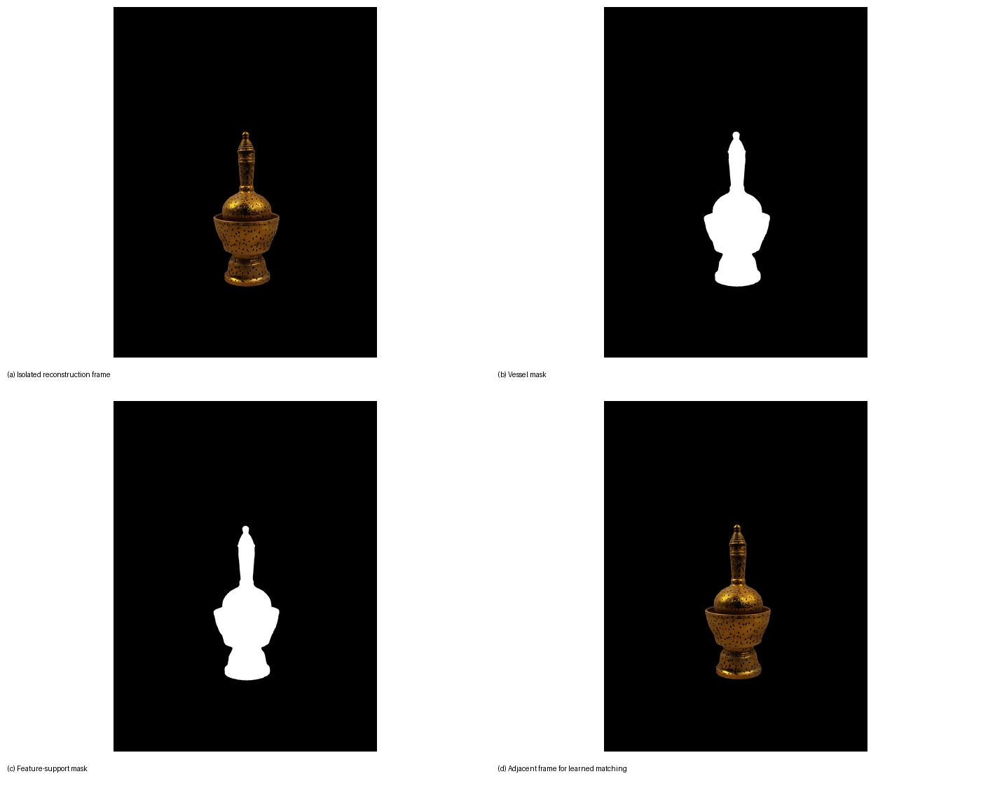
Fig. 3. Real reconstruction inputs after isolation. The figure shows the masked vessel, the feature-support region, and neighboring geometry frames used for learned local matching.
B. Learned feature extraction and matching
ALIKED-N16Rot was used to detect and describe local image features. The recorded configuration allowed up to 4096 keypoints per image at a maximum feature-extraction image size of 2048 pixels. Across 372 images, the feature database contains 562,404 keypoint rows. The masked input concentrates these keypoints on the vessel, including the marker pattern and stable boundaries around the pedestal, bowl, shoulder, neck, and upper structure.
Candidate image pairs were scheduled from capture locality and cross-ring overlap. LightGlue matched the ALIKED descriptors for 2,121 scheduled pairs. The database records 1,394,499 raw match rows. COLMAP two-view verification then checked those correspondences against epipolar geometry with robust estimation. It retained 1,237,912 verified inlier rows across 2,118 verified pairs, which corresponds to about 88.8% of the raw matched rows. This verified graph, rather than the descriptor matches alone, was passed to sparse reconstruction.
C. Sparse Structure-from-Motion
The verified match graph was reconstructed with pyCOLMAP and COLMAP. The selected sparse model registered all 372 reconstruction views in one connected camera graph. It contains 87,964 sparse 3D points and 461,983 image observations. Mean track length is 5.25 observations per point, so a typical reconstructed point is supported by more than two images. The mean reprojection error is 1.20 pixels.
The recovered camera centers follow the six intended acquisition rings around the object. Because the estimated camera geometry matches the capture design, the selected sparse model became the fixed source for image undistortion and dense stereo.
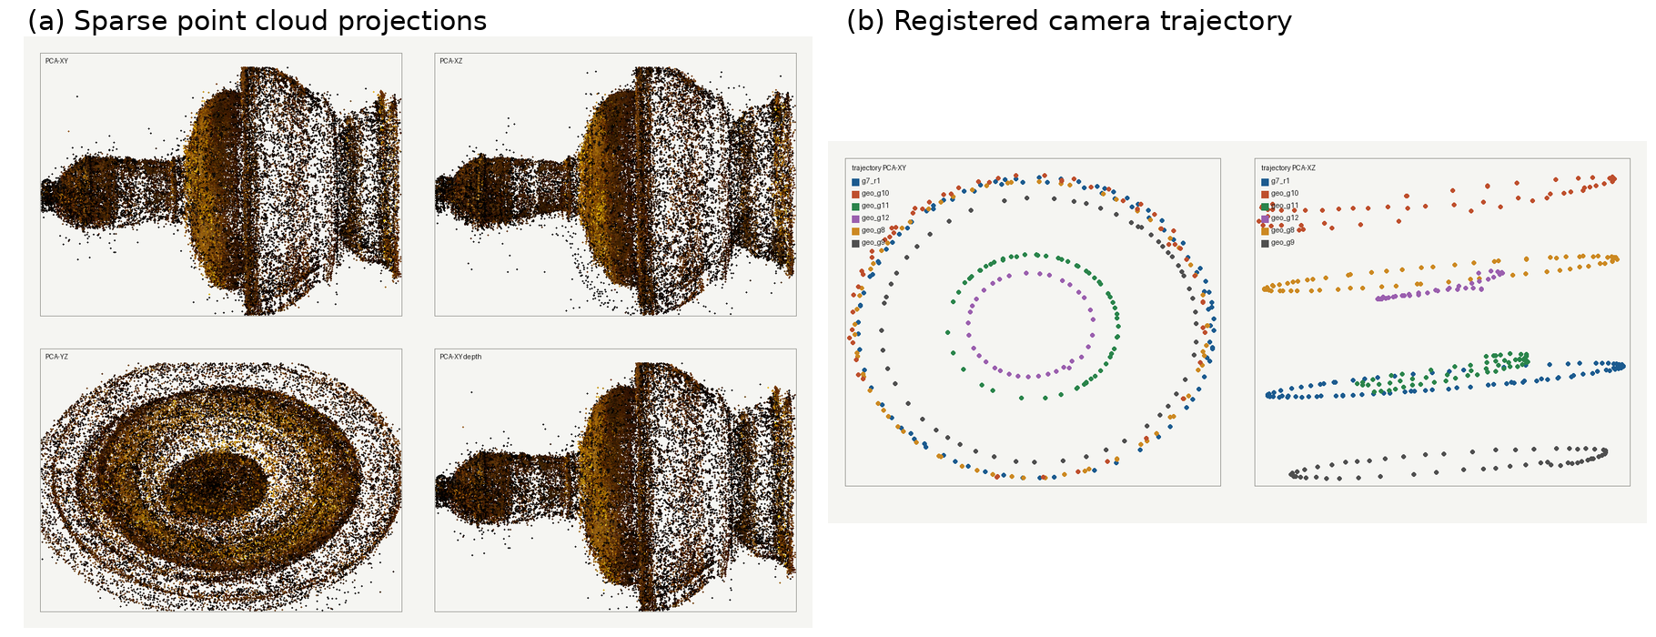
Fig. 4. Selected sparse reconstruction and registered camera trajectories. All 372 selected geometry views are represented in the connected model.
D. Dense multi-view stereo and fusion
COLMAP undistorted the registered images into a dense workspace using the selected sparse camera model. The vessel masks were transformed with the images so mask alignment was preserved after undistortion. CUDA PatchMatch Stereo then estimated dense depth and surface-normal maps for every registered reference view. The selected full run used all 372 registered views with photometric and geometric consistency phases.
Stereo Fusion combined mutually consistent depth estimates into a colored point cloud while retaining the vessel mask as an object constraint. The selected fused cloud contains approximately 1.93 million points. The cloud preserves the main continuous regions of the vessel, including the pedestal, bowl, shoulder, neck, upper tower, and interior rim. Point density is lower on narrow or weakly observed structures, which later becomes visible as higher surface uncertainty in the mesh.
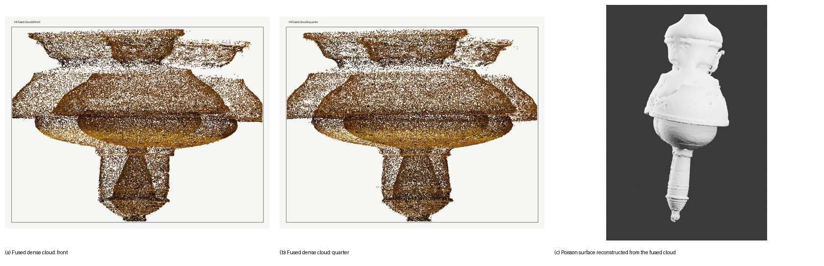
Fig. 5. Dense reconstruction and surface generation. Left and center: fused dense point cloud from different views. Right: the Poisson surface reconstructed from the same scan.
E. Poisson surface reconstruction
The fused oriented point cloud was converted into a continuous triangle mesh with the COLMAP Poisson mesher, following the global surface formulation introduced by Kazhdan et al. [7]. The selected mesh contains 4,952,940 vertices and 9,899,268 faces before production cleanup. More than 99% of the faces belong to the dominant connected component, so the output is primarily one vessel surface rather than a collection of similarly sized fragments.
Poisson reconstruction closes gaps by solving for a continuous implicit surface, which is useful for a noisy fused scan but can also create unwanted bridges or caps where evidence is weak. The raw mesh was therefore treated as a reconstruction result that still required inspection. It was not accepted as a finished asset simply because it was continuous. The Blender stage preserved the scan lineage while removing only geometry that could be identified as reconstruction residue or locally inconsistent surface noise.
F. Scan-preserving Blender refinement and appearance
Blender 5.2 was used after the image-derived geometry had been fixed. The cleanup policy prohibited a lathed replacement, primitive-based rebuilding, generic ornament, or reference-assisted redesign of the vessel. The raw Poisson mesh and preserved scan versions remained available as rollback evidence. Cleanup operated on reconstructed vertices and, where needed, same-object scan evidence from intact regions of the vessel.
The final V139 pass removed a synthetic planar bottom cap while preserving the physical bottom opening observed in the scan. Seventy cap faces were removed. The centerline was corrected from about 6.85 degrees of tilt to about 0.67 degrees, and the bottom boundary was leveled. Local fairing focused on the holder-to-middle transition, tower, upper ring, and terminal. The terminal was repaired from existing reconstructed vertices using bounded same-scan profile correction and local fitting rather than a new sphere or rebuilt finial.
The completed mesh contains 451,312 vertices and 902,838 triangles in one connected component. It has one intentional 72-edge boundary loop at the physical bottom opening and no other non-manifold edges. Surface irregularities supported by the scan were retained when removing them would have required fabrication. This choice keeps the final object closer to a repaired reconstruction than to a CAD interpretation.
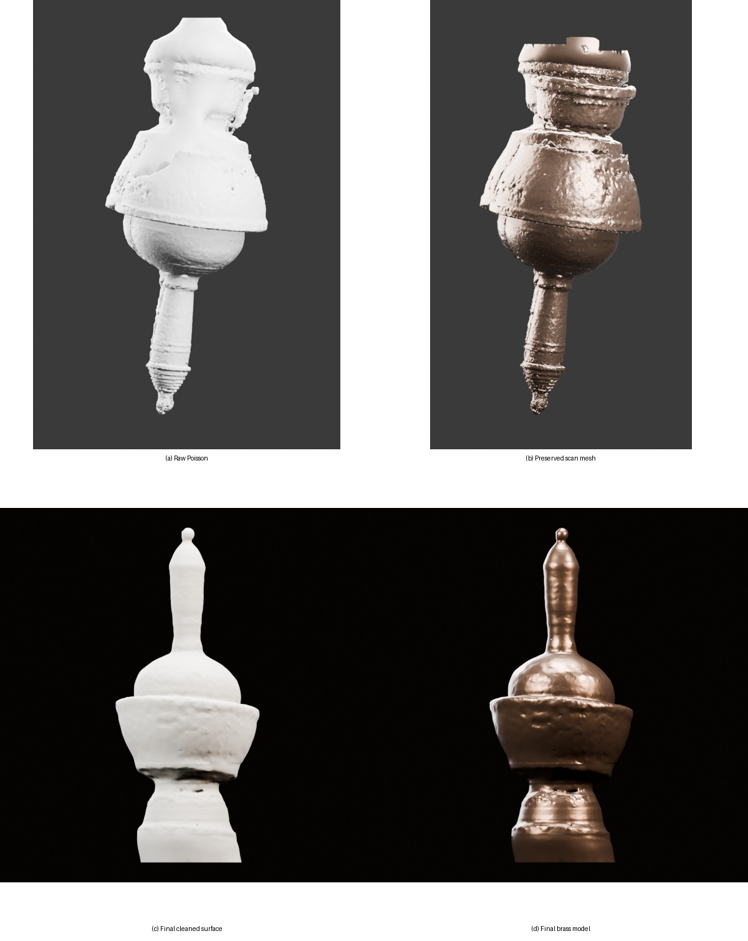
Fig. 6. Scan-preserving refinement from the raw Poisson surface to the completed V139 geometry. Each stage remains tied to reconstructed evidence rather than a manually rebuilt vessel.
G. Appearance reconstruction
Appearance was reconstructed from the separate 158-image uncoated set because the geometry photographs contain temporary coating and marker dots. These uncoated views show the natural brass color and the variation caused by the surrounding illumination. They were used to derive project-wide appearance statistics rather than a camera-specific texture from the coated geometry sequence. This separation keeps the geometry and appearance stages traceable to the image sets that were designed for them.
The final V139 asset uses one statistics-only brass material, MAT_V4_V115_BrassStatsOnly. The exported GLB records a metallic factor of 0.85 and roughness of about 0.308, with the base color derived from the uncoated capture statistics. Surface relief comes from the scan geometry itself. The project does not claim a verified photographic UV projection on V139, and topology-specific AO or normal maps from earlier meshes were not reused after the final geometry changed.
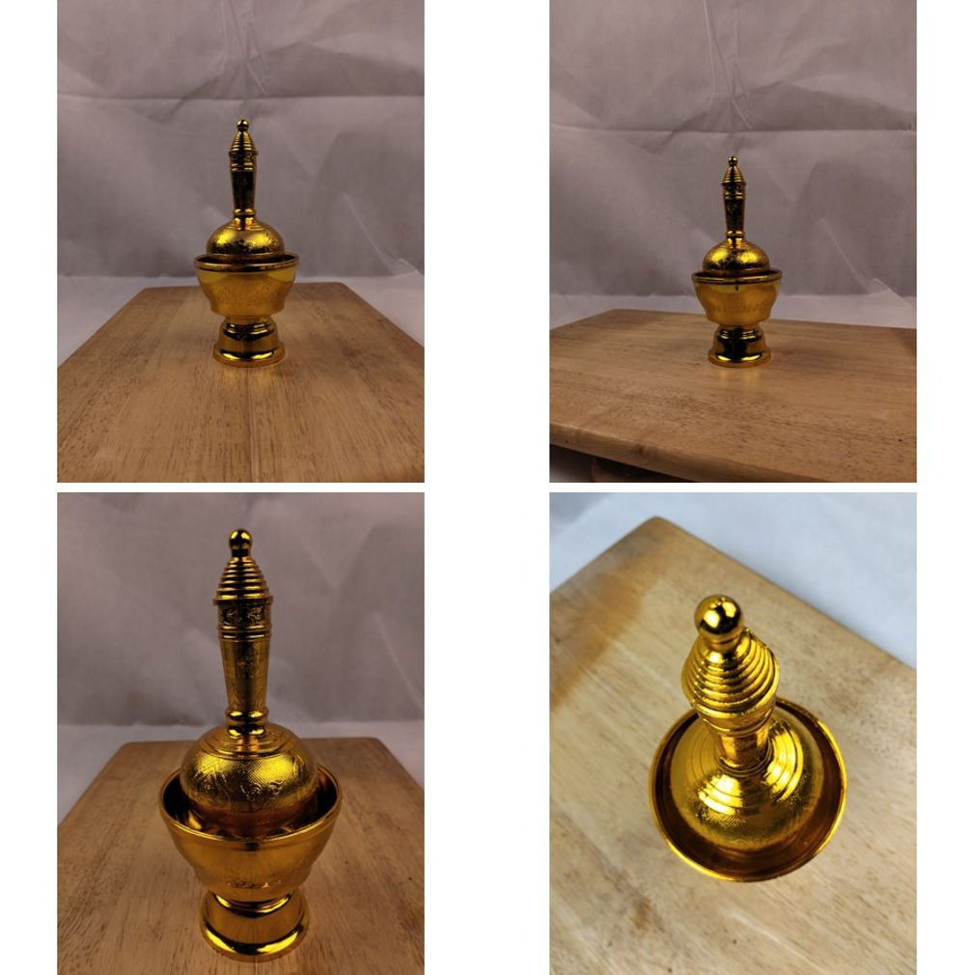
Fig. 7. Representative uncoated appearance photographs used to derive the final brass material statistics. These images were kept separate from the coated geometry sequence.
H. Final geometry QA and portable export
The completed geometry was inspected from a fixed set of views before export. Quality-control renders included eight full turntable angles, four top-oblique views, two underside views, and segmented checks of the holder ring, holder-to-middle transition, lower bowl, bowl rim, globe shoulders, lower and middle tower, upper tower ring, and terminal. This review was used to check silhouette continuity, local surface noise, the preserved bottom opening, and whether cleanup had introduced visible shape discontinuities.
After the final QA pass, the selected V139 object was promoted to the canonical Blender file and exported as GLB. Export verification was performed in a fresh Blender 5.2 factory-startup scene rather than in the authoring session. The fresh import produced one mesh, one brass material, identity transforms, and the same final topology. This separate re-import step was used to confirm that the portable deliverable matched the selected authoring object and did not carry hidden rollback meshes, cameras, lights, or debug objects.
V. RESULTS AND EVALUATION
A. Reconstruction measurements
Table I summarizes the selected reconstruction. The sparse result uses every retained geometry view and keeps reprojection error close to one pixel. Dense fusion increases the representation from tens of thousands of sparse points to roughly two million fused points. Poisson meshing produces a high-resolution surface, while the final Blender model reduces the working geometry to about 451 thousand vertices without replacing the scan-derived form.

TABLE I. RECONSTRUCTION SUMMARY
Measurement | Result
Source photographs | 688
Selected geometry views | 372
Verified image pairs | 2,118
Sparse 3D points | 87,964
Dense fused points | 1.93 M
Poisson mesh | 4.95 M vertices
Final V139 mesh | 451,312 vertices
B. Visual geometry assessment
The larger continuous surfaces are the strongest parts of the reconstruction. The pedestal profile, bowl volume, shoulder, neck, and major upper-ring transitions remain readable from multiple views. The six-ring capture contributes directly to this result because each height region is observed from more than one elevation. The final surface also preserves the bowl opening and the physical bottom opening instead of closing them solely to produce a watertight mesh.
Fine relief and very narrow structures are less certain. They occupy fewer pixels, receive fewer favorable viewing angles, and remain sensitive to masking and dense-depth uncertainty. The final cleanup therefore favors continuity and removal of scan noise over speculative sharpening. The terminal was made coherent from the existing reconstruction, but the model does not claim recovery of ornament or surface detail that was not clearly supported by the photographs.
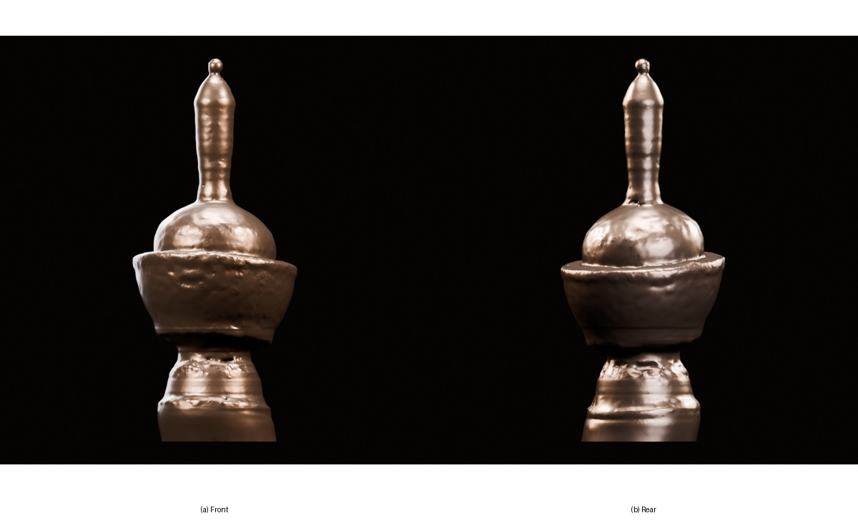
Fig. 8. Completed brass model from front and rear views after the final scan-preserving cleanup and material assignment.
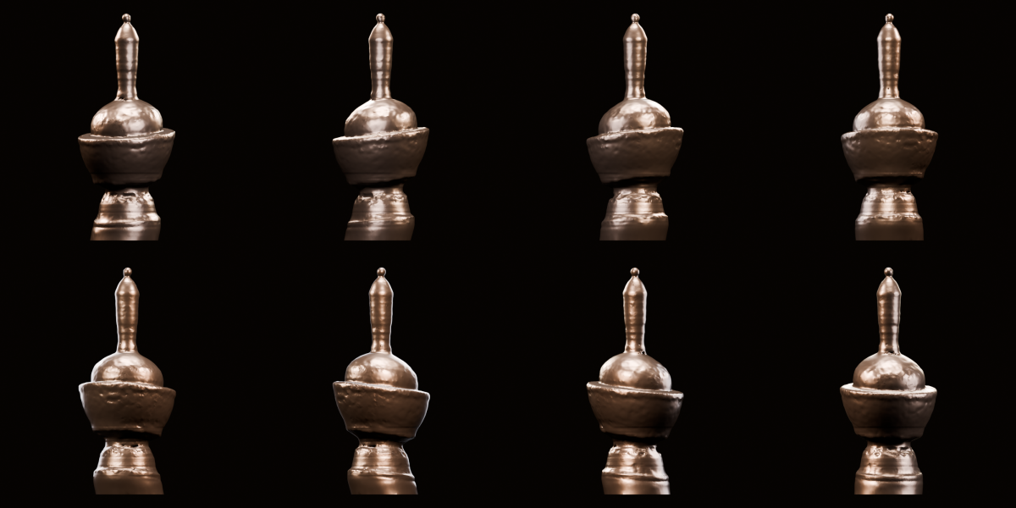
Fig. 9. Eight-angle turntable verification of the completed V139 brass model. The same final mesh is shown around a full rotation to check silhouette continuity and surface behavior.
C. Export and re-import validation
The final authoring object was promoted to the canonical Blender file and exported to GLB. The GLB was then loaded into a fresh Blender 5.2 factory-startup scene. The re-import produced exactly one mesh object with 451,312 vertices and 902,838 triangles, the expected brass material, identity transforms, and the same scene-space dimensions as the authoring object. Cameras, lights, rollback meshes, and debug objects were absent from the portable export.
The GLB structure was also inspected directly. It contains one scene, one node, one mesh, and one material. The mesh accessor reports 451,312 positions and 2,708,514 triangle indices, which is exactly 902,838 triangles. The exported material retains the V139 brass factors. These checks confirm that the delivered GLB matches the selected final topology rather than an earlier reconstruction state.
VI. DISCUSSION
A. Effect of acquisition design
The capture procedure had a direct effect on reconstruction quality. A polished brass vessel photographed without preparation would provide unstable highlights and weak surface texture, both of which reduce repeatable local correspondence. Temporary matting changed that condition. Marker dots then added spatially irregular texture that the feature extractor could follow around the rotation. The result is still a photogrammetric reconstruction, but the scene was prepared so the assumptions behind local matching were more nearly satisfied.
The fixed-camera turntable arrangement also simplified viewpoint control. Adjacent frames changed mainly because of object rotation, and separate elevation passes added vertical coverage in a structured way. This made it possible to schedule many useful within-ring pairs while still connecting neighboring rings. The 372-view camera trajectory recovered by SfM follows the intended acquisition layout, which supports the decision to use that model for dense reconstruction.
B. Role of learned matching
The learned correspondence stage supplied a dense enough verified graph for full registration. ALIKED produced more than half a million keypoint rows, and LightGlue generated over 1.39 million raw match rows across the scheduled pairs. Geometric verification retained about 88.8% of those rows as inliers. These counts do not by themselves prove surface accuracy, but they show that the prepared imagery produced a large connected set of geometrically usable correspondences.
Using masks during feature extraction was equally important. A fixed turntable scene contains repeatable background texture that can be easier to match than the object itself. Those matches are valid in image space but useless for reconstructing a rotating object. Restricting features to the vessel region keeps the correspondence graph tied to the target geometry and reduces the chance that a stationary background becomes the dominant structure.
C. Scan preservation and limitations
The final Blender stage deliberately stops short of complete geometric regularization. The vessel is rotationally structured, so it would be easy to replace damaged regions with idealized profiles, lathed surfaces, or smooth primitives. Doing so would produce a cleaner model but would weaken the link between the final asset and the reconstructed evidence. V139 instead keeps one connected scan-derived mesh and uses bounded smoothing, same-object evidence, and local correction where the reconstruction is defective.
The study has three limitations. First, there is no independent laser scan or measured CAD model, so absolute surface error cannot be reported. Evaluation therefore relies on reprojection, track support, dense coverage, topology checks, and multi-view visual inspection. Second, the reconstruction does not establish an independently calibrated physical scale; the Blender dimensions are scene coordinates and should not be interpreted as measured vessel dimensions. Third, the final material is based on appearance statistics rather than a verified photographic texture projection, so it represents the observed brass response without claiming pixel-level color registration.
The result should therefore be interpreted as a traceable image-derived cultural-object asset made with consumer equipment, not as a metrology-grade model. A metrology study would require a calibrated scale reference, independent ground-truth geometry, and controlled reflectance capture. Here, evaluation is limited to the reconstruction evidence and export checks described above.
D. Reproducibility and evidence traceability
The reconstruction was organized so that the selected result can be traced back to a fixed image set. The 688 source photographs were preserved separately from derived files, and the 372 reconstruction images have corresponding vessel masks and feature masks. Capture manifests record image roles and sequence membership. Sparse, dense, and mesh outputs are stored with reports that identify the selected lineage. The manifests and fixed image roles allow later inspection without relying on memory of which images or intermediate files were active during earlier runs.
Visual evidence was kept for the major stages rather than for every diagnostic experiment. The retained evidence includes setup photographs, representative acquisition rings, masks, sparse point clouds and camera trajectories, dense point-cloud views, the Poisson surface, and final multi-angle Blender renders. This gives a reader a direct way to compare the geometry seen in the photographs with the structure produced by the reconstruction stages. It also reduces the chance that a final model is evaluated only from a single favorable render.
The canonical GLB was also imported into a clean Blender process and checked independently of the authoring scene. Matching topology, material assignment, transforms, and scene structure confirm that the portable file contains the selected final mesh. The editable authoring file supports continued work, while the compact portable asset is easier to archive, inspect, and reuse in other software. Keeping both files provides a practical record of the completed reconstruction without changing the geometry after verification.
VII. CONCLUSION
This project reconstructed the selected Thai libation brass vessel from a controlled smartphone capture and carried the result through to a completed Blender and GLB asset. The geometry sequence used temporary matting, marker texture, a fixed camera, and six elevation ranges. Grounding DINO-T and SAM 2.1 isolated the object. ALIKED and LightGlue produced local correspondences, COLMAP recovered all 372 selected camera views, PatchMatch Stereo and fusion generated the dense point cloud, and Poisson reconstruction produced the initial surface.
The final stage refined the scan without substituting a manually rebuilt vessel. The completed V139 model contains 451,312 vertices and 902,838 triangles, one connected component, and the intended bottom opening. Fresh re-import confirmed the same topology and material in the exported GLB. Because the vessel is used in kruat nam, the result also records a physical object connected to a continuing Thai Buddhist merit-dedication practice. The final 3D file is accompanied by a documented path from photographs to a scan-preserving cultural-object reconstruction whose major stages can be inspected and reproduced from the project evidence.
REFERENCES
[1] J. L. Schönberger and J.-M. Frahm, "Structure-from-Motion revisited," in Proc. IEEE Conf. Comput. Vis. Pattern Recognit. (CVPR), 2016, pp. 4104-4113.
[2] J. L. Schönberger, E. Zheng, J.-M. Frahm, and M. Pollefeys, "Pixelwise view selection for unstructured multi-view stereo," in Computer Vision - ECCV 2016, 2016, pp. 501-518.
[3] X. Zhao, X. Wu, W. Chen, P. C. Y. Chen, Q. Xu, and Z. Li, "ALIKED: A lighter keypoint and descriptor extraction network via deformable transformation," IEEE Trans. Instrum. Meas., vol. 72, pp. 1-16, 2023, doi: 10.1109/TIM.2023.3271000.
[4] P. Lindenberger, P.-E. Sarlin, and M. Pollefeys, "LightGlue: Local feature matching at light speed," in Proc. IEEE/CVF Int. Conf. Comput. Vis. (ICCV), 2023, pp. 17627-17638.
[5] S. Liu et al., "Grounding DINO: Marrying DINO with grounded pre-training for open-set object detection," in Proc. Eur. Conf. Comput. Vis. (ECCV), 2024.
[6] N. Ravi et al., "SAM 2: Segment anything in images and videos," arXiv:2408.00714, 2024.
[7] M. Kazhdan, M. Bolitho, and H. Hoppe, "Poisson surface reconstruction," in Proc. Eurographics Symp. Geometry Processing, 2006, pp. 61-70.
[8] Z. Cui, J. Gu, B. Shi, P. Tan, and J. Kautz, "Polarimetric multi-view stereo," in Proc. IEEE Conf. Comput. Vis. Pattern Recognit. (CVPR), 2017, pp. 1558-1567.
[9] Y. Han et al., "NeRSP: Neural 3D reconstruction for reflective objects with sparse polarized images," in Proc. IEEE/CVF Conf. Comput. Vis. Pattern Recognit. (CVPR), 2024, pp. 11821-11830.
[10] H. Jung et al., "On the importance of accurate geometry data for dense 3D vision tasks," in Proc. IEEE/CVF Conf. Comput. Vis. Pattern Recognit. (CVPR), 2023, pp. 780-791.
[11] Z. Liang et al., "3DReflecNet: A large-scale dataset for 3D reconstruction of reflective, transparent, and low-texture objects," in Proc. IEEE/CVF Conf. Comput. Vis. Pattern Recognit. (CVPR), 2026, pp. 7244-7255.
[12] Department of Cultural Promotion, Ministry of Culture, Thailand, "เล่าสู่กันฟัง...เรื่อง “กรวดน้ำ” อย่างเข้าใจและรู้ความหมาย" ["Understanding kruat nam (water-pouring) and its meaning"], Mar. 30, 2020. [Online]. Available: https://www.culture.go.th/culture_th/ewt_news.php?filename=i&nid=4846. Accessed: Sep. 19, 2026. [in Thai].
[13] Phrakru Kittipipat (Doung Kittipanno), T. Donkamonkan, and Phrakhrubhavanapatthanabanthita, "Water pouring: correct beliefs and practices," Journal of Graduate Saket Review, vol. 9, no. 1, pp. 16-26, 2024.

