CSX4213 Computer Vision Project

Thai Libation Brass Vessel
3D Reconstruction
  - Verified Image QA and Preprocessing Progress Walkthrough
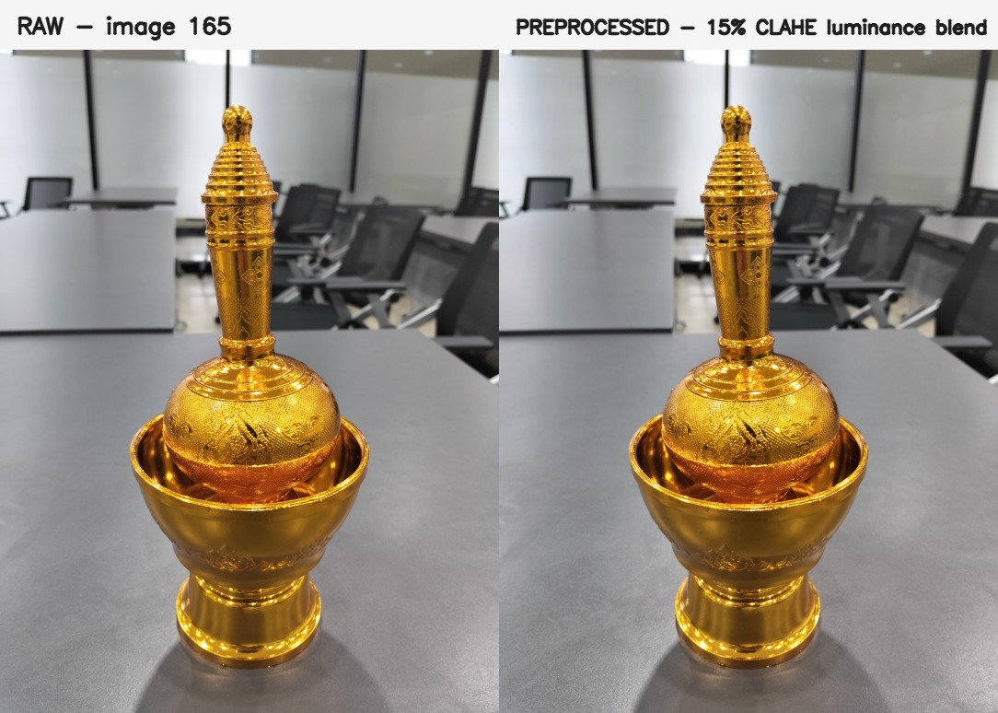
Representative capture and the selected mild preprocessing variant.
Prepared by: Sithu Win San, Eaint Myat Thu, and Gulizara Benjapalaporn
Assumption University | CSX4213 Computer Vision
Verified 27 August 2026

Executive Summary
PREPROCESSING COMPLETE: 288 evidence-selected, geometry-preserving images are ready for pyCOLMAP; all 297 originals still match their baseline hashes.
The project audited 297 OPPO Reno12 F photographs of a Thai brass libation vessel, calibrated quality warnings from the real capture distribution, retained useful coverage, compared RAW and PREPROCESSED neighboring-frame correspondences, and exported an unambiguous next-stage image set. The phase stops before pyCOLMAP reconstruction.
Evidence item | Verified result
Raw captures | 297 readable JPEGs, 3072 x 4080
Final decisions | 207 ACCEPT | 81 WARN | 9 REJECT
Selected dataset | 288 PREPROCESSED images
SIFT/RANSAC evidence | 2,483 PREPROCESSED vs 2,376 RAW inliers
Pair consistency | PREPROCESSED non-worse on 9 of 10 pairs
Final integrity | 0 raw mismatches | 0 output duplicates
Hard boundary | pyCOLMAP has not started

1. Project Objective
Reconstruct a real Thai brass libation vessel from smartphone images through an explainable computer vision workflow: image QA and preprocessing, pyCOLMAP Structure from Motion, later dense reconstruction, meshing/texturing, and Blender cleanup. This report covers only the completed preprocessing boundary.

2. Capture Methodology
The 297 portrait photographs were captured at 3072 x 4080 with an OPPO Reno12 F. The main fixed-object sequence provides dense middle, low, elevated, top-down, and detail coverage with neighboring overlap. Images 289-297 form a later hand-held/flipped sequence where object pose and background relation change and hands occlude the vessel.
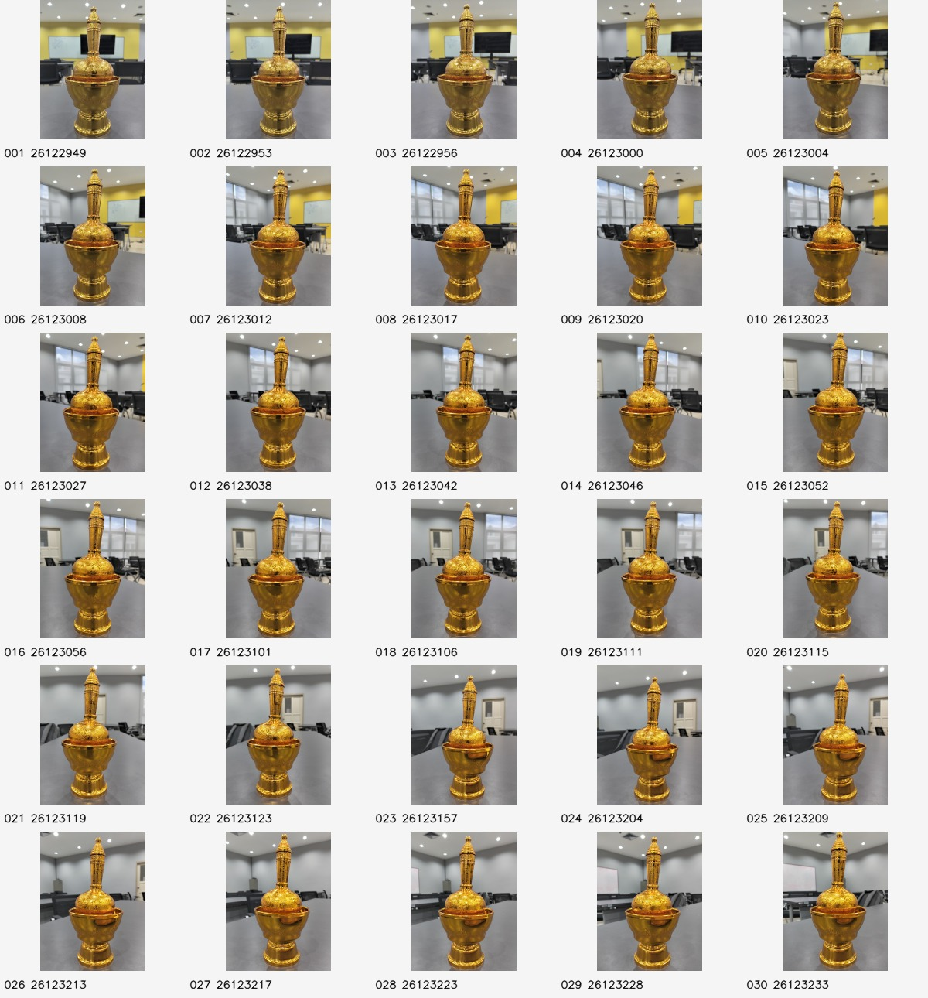
Example contact sheet from the full ten-sheet sequence review.

3. Why the Originals Are Preserved
The raw directory IMG20260826122949/ is immutable source evidence. Processing reads from it and writes only to preprocessing/. raw_manifest_before.json records the expected filename, byte count, and SHA-256 digest of every original, making accidental mutation observable.

4. The 297-Image Audit
- 297 of 297 JPEGs readable; consistent 3072 x 4080 dimensions, OPPO Reno12 F metadata, and EXIF orientation 1.
- No exact SHA-256 duplicates and no conservative adjacent dHash near-duplicate candidates.
- All ten original contact sheets visually reviewed across the entire acquisition sequence.
- Existing audit reports were reused; obsolete exploratory scripts were not recreated.

5. Image-Quality Metrics and Real-Data Thresholds
quality_check.py measures an 800-pixel-wide in-memory analysis copy: luminance mean, contrast, Laplacian-variance sharpness, dark/bright clipping, and SIFT feature count. Thresholds are the eligible dataset's 5th/95th percentiles plus conservative severe components.
Threshold | Final value | Purpose
Sharpness warning | 178.1662 | Review low-detail frames
Severe sharpness component | 131.3283 | Reject only with severe low features
Brightness low / high | 120.7684 / 139.3575 | Dataset-relative exposure review
Contrast warning | 31.1619 | Review low-separation views
Dark / bright clip (%) | 0.1017 / 0.8486 | Review tonal extremes
Feature count warning | 1,320 | Review weak local texture
Severe feature component | 528 | Reject only with severe blur

6. Visual and Contact-Sheet Inspection
After the final run, four decision sheets containing every WARN and REJECT case were opened. Warning frames remained useful views with expected brass highlights, angular continuity, and overlap. All ten before/after figures were also opened to check that the transform remained mild and geometry-preserving.

7. ACCEPT, WARN, and REJECT Reasoning
Decision | Count | Meaning | Included for pyCOLMAP?
ACCEPT | 207 | No dataset-relative review signal | Yes
WARN | 81 | Review signal; still useful coverage | Yes
REJECT | 9 | Fixed-object geometry break (289-297) | No

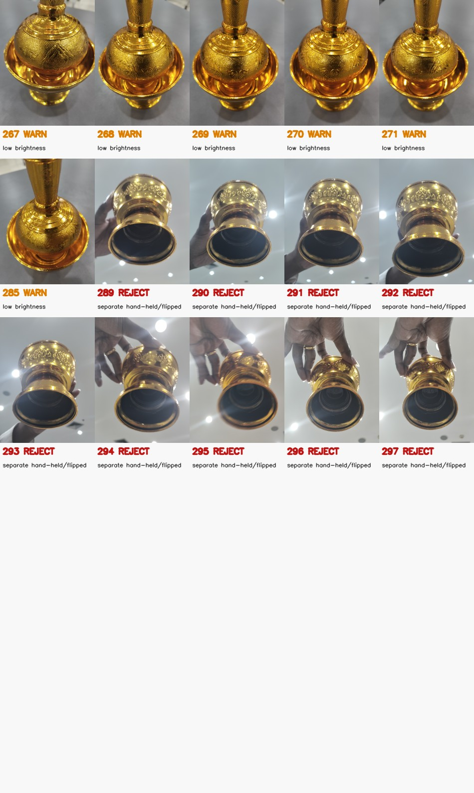
The nine red REJECT frames are the separate hand-held/flipped and hand-occluded sequence.

8. Conservative Preprocessing
preprocess_images.py converts BGR to LAB, applies CLAHE to luminance, blends 15% of the enhanced luminance into the original, and converts back to BGR. It never crops, rotates, resizes, warps, perspective-corrects, synthesizes detail, or removes reflections. Outputs are deterministic uint8 BGR images at 3072 x 4080.
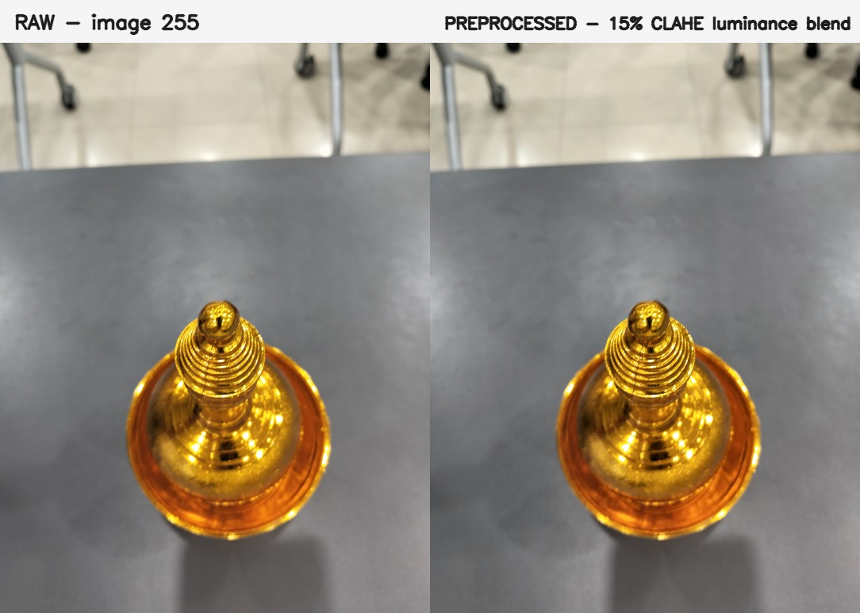
Low-feature top-down case: subtle photometric change, identical geometry.

9. RAW vs PREPROCESSED SIFT Experiment
Ten neighboring pairs sample early, middle, elevated, top-down, low-feature, and late sequence regions. Both variants use OpenCV SIFT (up to 8,000 features at maximum width 1,200), BFMatcher with L2 distance, two neighbors, Lowe ratio 0.75, and fundamental-matrix RANSAC (1.5 px, 0.99 confidence). PREPROCESSED matching decodes the exact deterministic quality-95 JPEG bytes used by final export.
Pair indices | RAW good / inliers | PREPROCESSED good / inliers
15-16 | 905 / 722 | 958 / 704
45-46 | 478 / 328 | 505 / 335
75-76 | 365 / 210 | 362 / 211
105-106 | 466 / 342 | 497 / 350
135-136 | 468 / 270 | 483 / 297
165-166 | 451 / 254 | 478 / 300
195-196 | 272 / 143 | 290 / 158
225-226 | 228 / 76 | 238 / 93
255-256 | 49 / 17 | 57 / 18
280-281 | 61 / 14 | 67 / 17
TOTAL INLIERS | 2,376 | 2,483

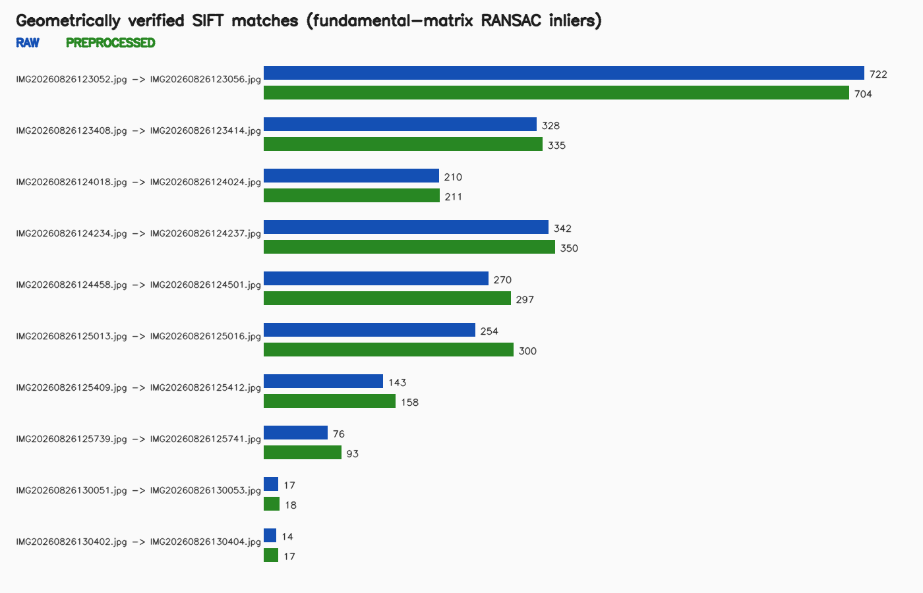
PREPROCESSED produced at least as many verified inliers on nine of ten tested pairs.

10. Evidence Used to Choose the Input
The selection rule was fixed before reading the outcome: choose PREPROCESSED only when total verified inliers are greater and it is non-worse on at least half the pairs; otherwise preserve RAW. PREPROCESSED produced 107 additional inliers (4.50% more) and was non-worse on 9 of 10 pairs, so it became the reconstruction input.

11. Final pyCOLMAP-Ready Dataset
- Exact directory: preprocessing/pycolmap_input/images/
- 288 JPEGs using deterministic original capture filenames.
- Every output reopened successfully at 3072 x 4080.
- Every output hash matches selection_manifest.csv; zero duplicates found.
- All ACCEPT and WARN images included; all nine REJECT images absent.

12. Hash-Based Proof of Raw Immutability
The workflow verifies the baseline before processing and again afterward. A separate final integrity audit then re-hashed every raw file and reopened every selected output.
Verification | Scope | Outcome
Python compile | 3 preprocessing scripts | PASS
Focused tests | 15 behavior/integration tests | 15 PASS, 0 FAIL
Real pipeline | 297 raw images | Exit 0
Selected outputs | 288 images | 288 readable, all 3072 x 4080
Selection hashes | 288 manifest entries | 0 mismatches, 0 duplicates
Raw re-hash | 297 baseline entries | 0 size/SHA-256 mismatches
Visual review | 10 before/after + 4 decision sheets | Opened and inspected

13. What Comes Next in pyCOLMAP
In a separate phase, verify the installed pyCOLMAP API and environment, point it only at the final 288-image directory, extract features, match views, run incremental mapping, and evaluate registered-image count, reprojection error, track length, and coverage before dense reconstruction.
STOPPING BOUNDARY: no pyCOLMAP, sparse/dense reconstruction, meshing, texturing, or Blender reconstruction work has run yet.

Professor Demonstration: Step-by-Step Speaking Guide
- Open README.md and explain the full smartphone-capture to 3D-model pipeline.
- Show IMG20260826122949/ and raw_manifest_before.json as immutable source evidence.
- Open early and late contact sheets to demonstrate angular coverage and overlap.
- Open quality_decisions.csv and explain the measured columns and three decisions.
- Show the real-data threshold table and explain why warnings are not automatic rejects.
- Open the four decisions_*.jpg sheets and point out that useful warning frames remain included.
- Use decisions_076_090.jpg to explain the fixed-object geometry break in images 289-297.
- Open two before_after_*.jpg figures and explain the 15% luminance-only CLAHE blend.
- Open sift_inliers.png and explain SIFT, the 0.75 ratio test, and RANSAC inliers.
- Explain the predeclared selection rule and the 2,483 versus 2,376 result.
- Show preprocessing/pycolmap_input/README.md and the 288-image images/ directory.
- Open raw_verification_after.json and state that all 297 baseline hashes still match.
- Finish clearly: preprocessing is verified; pyCOLMAP reconstruction is the next stage, not a completed claim.

Limitations and Honest Claims
- The ten-pair experiment is representative evidence, not an all-pairs benchmark.
- SIFT/RANSAC improvement does not prove that every selected image will register in Structure from Motion.
- All 81 WARN frames are deliberately retained; pyCOLMAP diagnostics may justify later targeted removal.
- No sparse model, dense model, mesh, texture, or final 3D reconstruction exists yet.

