

**FPT UNIVERSITY**

**--o0o---**

**Project Report:**

**Festivals**

Member: 1. Nhu Hoang Minh Duc

2. Do Thi Chan Hoa

3. Nguyen Nhu Sang

4. Pham Thanh Tung

Faculty: Dang Kim Thi

**Table of Contents**

1. **Problem Definition**
2. Introduction
3. Implementation Environment
4. **UI\UX**
5. Home
6. Theme
7. …
8. …
9. …
10. About
11. Accout
12. Book
13. Buy Book
14. **Summary**

**I. Problem Definition**

**1.** **Introduction**

With the need for entertaining the festival is 1 part indispensable in humans. To get the correct information as well as the closest to the festival taking place in and out of the country we theme has made a most friendly website vs customers. Here you don't just get the information about the festival that you can Consult or find the best books about life, music, flower,....

The website is to be developed for the Windows Platform using HTML5,

JavaScript and Geolocation. The site should work well in all leading browsers

including Chrome, IE, Firefox etc.

The Web site is to be created based on the following requirements:

1. The Home Page should be created making use of Sections with a suitable logo
2. The site should display a menu which will contain the options for brief introduction about the various categories or link, and about is feedback and so on.
3. Links of the all the religion can be added and each religion link must open the list of the festivals coming under them.
4. The images of each festival must be added.
5. Navigation of the project must be made smooth and uniformity must be expected.
6. Various books based on the festivals must be added in the webpage, which user can see and purchase (for purchasing section the dummy procedure must be used).
7. Site map, Gallery, About us, Queries link, Contact us link must be added. Address of the Company should be displayed using GeoLocation API (eg. GoogleMaps).
8. The complete historic reason and its description must be allowed to get download as pdf or doc file.

**2.Implementation Environment**

* + HTML5/ CSS/ JavaScript
  + Boostrap / Jquery/ Boostrap Hover
  + Amazing Slider
  + Dreamweaver
  + Google Chrome/ Mozilla FireFox/ Internet Explorer
  + Ajax

**II.UI\UX**

1.Home

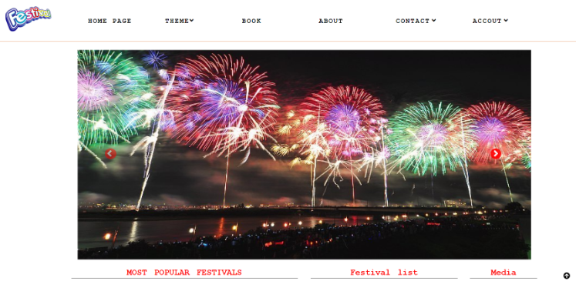

2.Theme

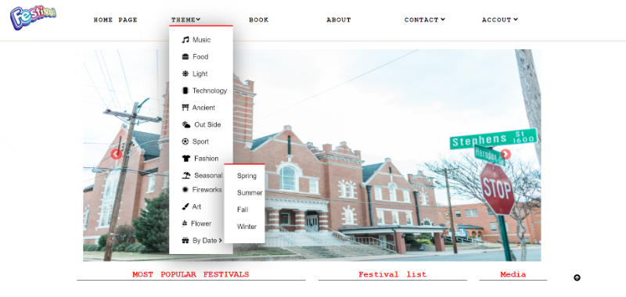

3.Festivals

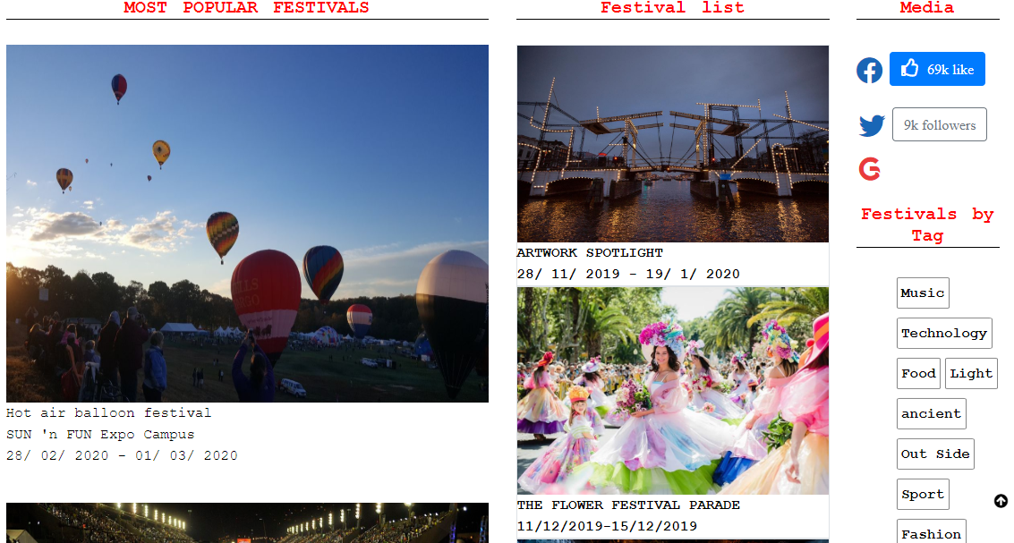

3.Footer

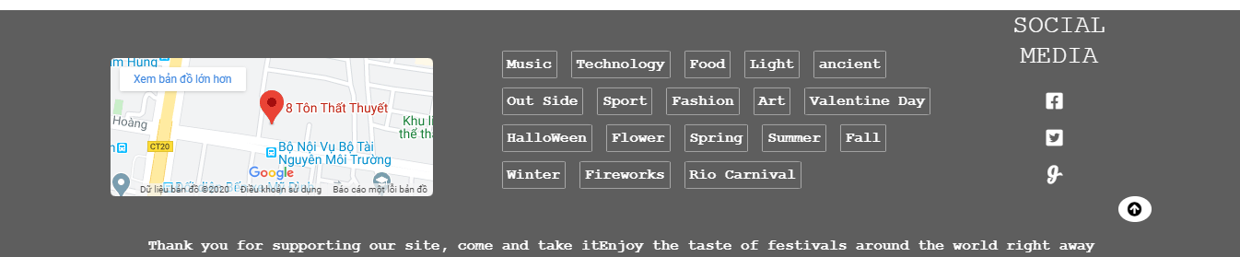

4.Book

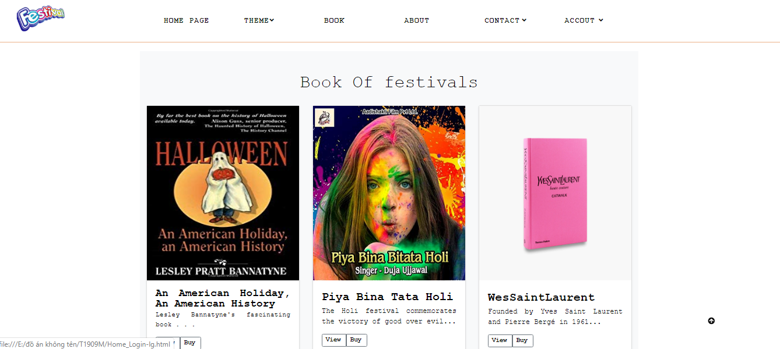

5. About

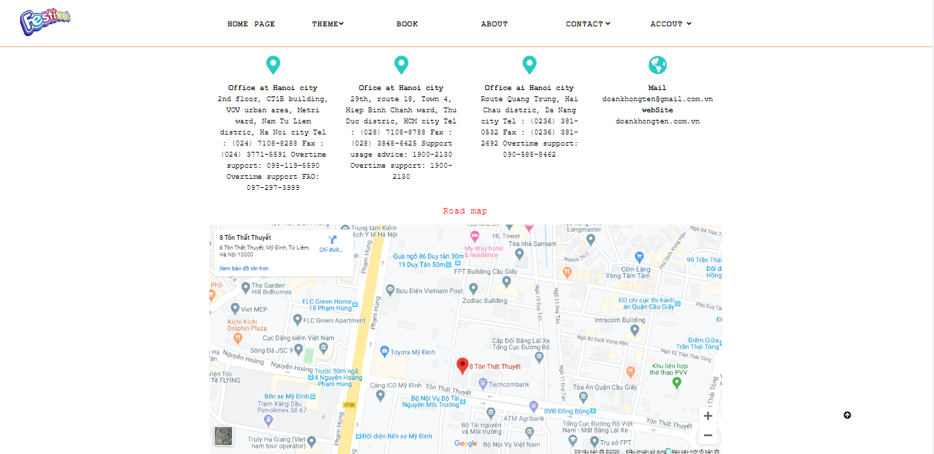

6.Contact



7.Accout



8.Accout – Login

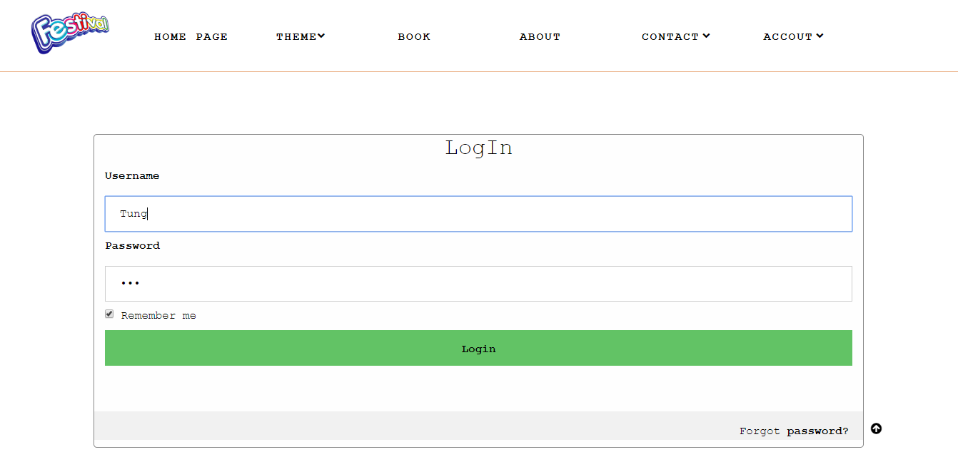

9. Accout –Login –My profile

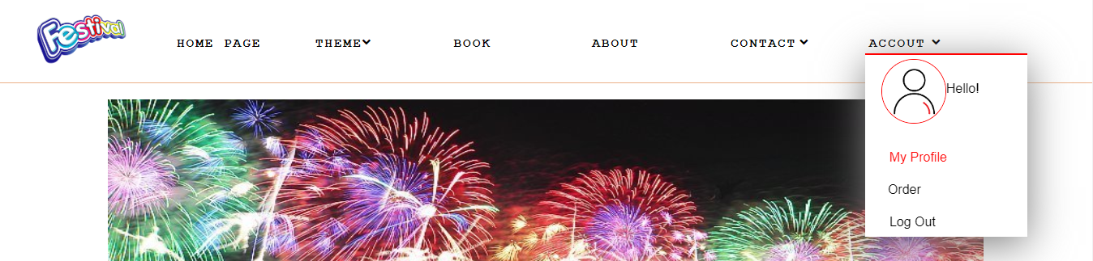

10.My profile

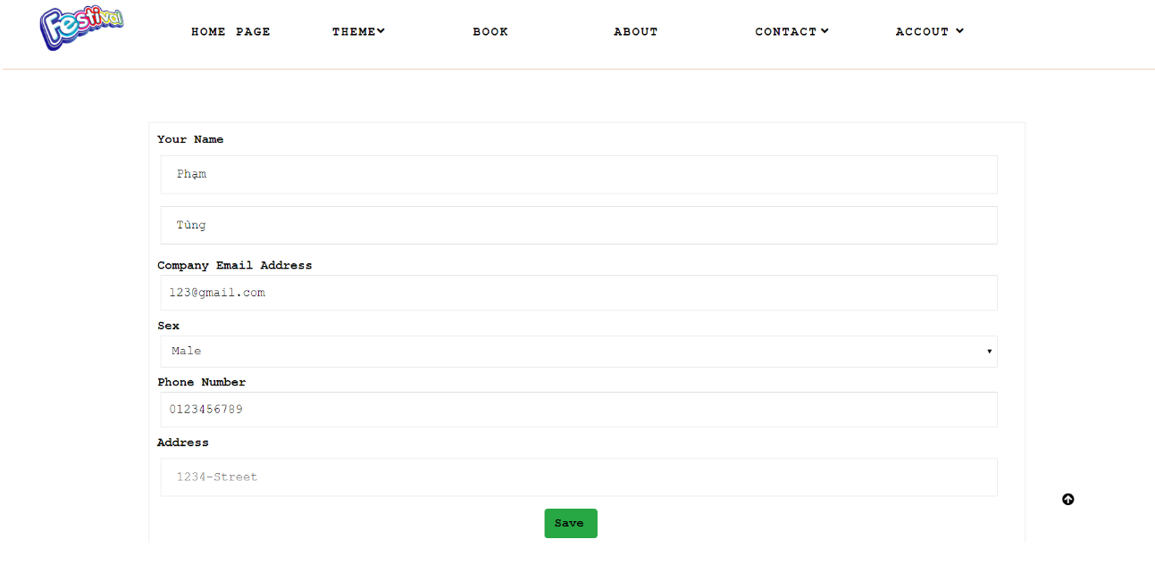

11. Buy Book

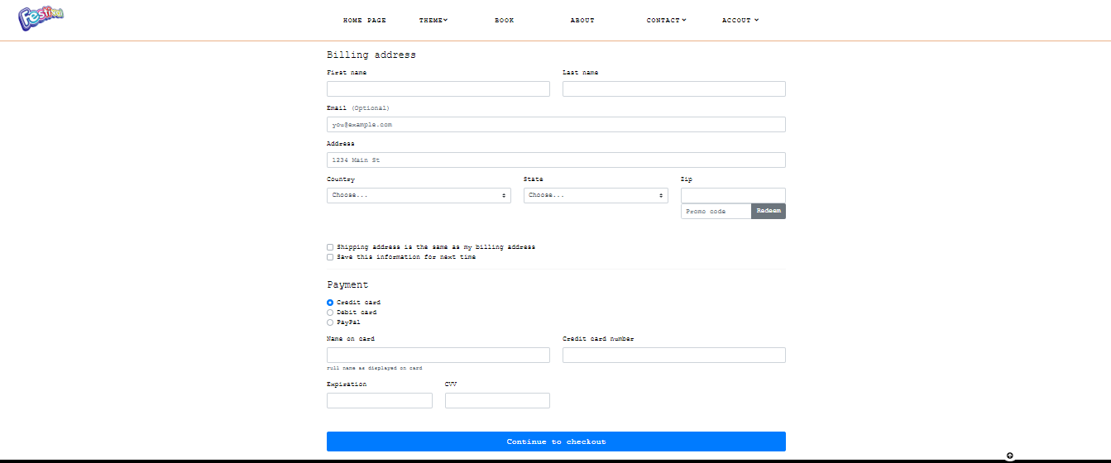

13. Buy Suc…

III. Summary

|  |  |
| --- | --- |
| responsible | Task |
| Nhu Hoang Minh Duc | Home Page, Many articles, signup, Book, Theme |
| Do Thi Chan Hoa | Many articles, Books, Buy Book |
| Pham Thanh Tung | Design mockup, Home Page, login, logout |
| Nguyen Nhu Sang | About, Many articles, tester |