Presentations

01_systems

1. Which of the following is not a type of AI learning system?

* Semi-unsupervised Learning
* Unsupervised Learning
* Supervised Learning
* Reinforcement Learning

1. All data is labeled, and the algorithms learn to predict the output from the input data:

* Dataset
* unsupervised learning
* supervised learning
* Classifiers

1. If the computer is trained to recognize cars, bikes, and trucks with human supervision.

* supervised learning
* unsupervised learning

1. The following picture shows the result of ...

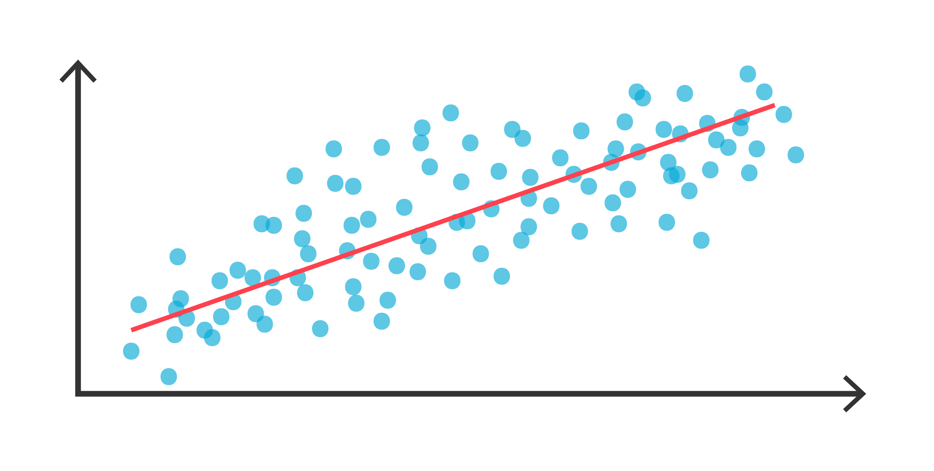

* Supervised Learning: Classification
* Unsupervised Learning: Regression
* Unsupervised Learning: Prediction
* Supervised Learning: Regression

1. The machine will group objects with similar features but will not be able to identify what this group labels.

* supervised learning
* unsupervised learning

1. The goal of clustering a set of data is to.

* choose the best data from the set
* divide them into groups of data that are near each other
* determine the nearest neighbors of each of the data
* predict the class of data

1. Reinforcement learning is _____.

* an action and reward process governed by the expert system's algorithm which lacks corresponding output information forcing the computer to learn by experience and mistakes
* a type of supervised machine language that forces the computer to do relatable tasks
* a type of unsupervised machine learning in which the computer groups similar data characteristics together to form new relationships
* machine learning that employs double algorithms

1. What are the applications of supervised learning: classification?

* Fraud Detection
* Forecasting
* Customer Retention
* Diagnostics

1. Targeted marketing, Recommended Systems, and Customer Segmentation are applications in ...

* Unsupervised Learning: Clustering
* Supervised Learning: Classification
* Reinforcement Learning
* Unsupervised Learning: Regression

1. What are the applications of Reinforcement Learning?

* Real-Time decisions
* Game AI
* Structure Discovery
* Learning Tasks
* Skill Acquisition
* Big Data Visualization

02.1_ai_intro

1. What is AI?

* Intelligence demonstrated by machines
* Smart robots
* Artificial Instructions
* Augmented Intelligence

1. Artificial Intelligence is _____

* a branch of computer science that constitutes underlying technology that enables computers to simulate human intelligence
* a branch of computer algorithms that facilitates an expert machine to make accurate predictions
* is a branch of computer science that renders supervision to expert machines
* is a branch of computer science constituting underlying technology that governs expert machines

1. Machine learning is defined as _____.

* the only branch of artificial intelligence
* training algorithms and data implemented into an expert system enabling it to learn and perform tasks without being explicitly programmed
* expert systems implemented into algorithmic systems enabling the computer to perform human-like decisions
* the processing of outputs is partially done by an expert machine and partially done manually

1. Select statements about deep learning that are true.

* Deep learning is a tool for achieving intelligent machines
* Deep learning was invented in the 1950s
* Deep learning uses layered neuron-like architecture inspired by the human brain
* Artificial intelligence is a superset of Machine learning, while deep learning is a completely different field

1. What is the difference between machine learning and deep learning?

* Deep learning is the same as machine learning
* Deep learning utilizes statistical data and machine learning does not
* Machine learning uses neural networks and deep learning does not
* None of the above

[**The Key Differences between Machine Learning and Deep Learning**](https://www.softwaretestinghelp.com/deep-learning-vs-machine-learning/)

|  | **Deep Learning** | **Machine Learning** |
| --- | --- | --- |
| **Data** | Deep learning requires a more significant amount of data. | Machine learning requires fewer data to train the model. |
| **Accuracy** | Deep learning provides higher accuracy. | Machine Learning gives less accuracy in comparison to deep learning. |
| **Hardware Requirement** | Deep learning demands machines with GPU to train adequately. | On the other hand, machine learning works well with low-end machines like CPUs. |
| **Engineering Anomalies** | For deep learning, you need to understand the basic functionality of the data. | For machine learning, you need to understand the features and represent the information. |
| **Training Time** | Deep learning models usually take a longer time to train. | In contrast, machine learning algorithms take less time to train. |
| **Hyperparameter Tuning** | Deep learning can be tuned in numerous ways. | Machine learning has limited tuning capabilities. |
| **Processing Time** | Deep learning takes a few hours or weeks for preprocessing. | Machine learning takes a few seconds or hours to preprocess. |
| **Number Of Algorithms** | Deep learning has fewer algorithms and formulas. | Machine learning has many algorithms. |
| **Data Interpretation** | Data interpretation in deep learning models is difficult. | In machine learning, some ML algorithms are easy to interpret, whereas, at the same time, some are extremely hard to decode and understand. |

1. During which decade did AI suffer a major setback known as AI winter?

* 2010s
* 2000s
* 1990s
* 1970s

1. Who coined the term Artificial Intelligence?

* Marvin Minsky
* Arthur Samuel
* Alan Turing
* John McCarthy

1. In 1950, a computer pioneer first theorized the concept of artificial intelligence. He suggested that humans use available information as well as the reason to solve problems and make decisions, so why can’t machines do the same thing? This formed the framework of his paper, “Computing Machinery and Intelligence,” in which he discussed building intelligent machines and testing their intelligence. Who was this scientist?

* Stuart Russell
* John McCarthy
* Alan Turing
* Peter Norvig

1. What does the Turing Test do?

* It tests the ability of a machine to demonstrate or exhibit human intelligence
* It tests the Turing abilities of machines
* It tests the ability of a machine to crack the Enigma code
* It tests the ability of machines to demonstrate mathematical calculating abilities

1. What was the name of the first program claimed to have passed the Turing test?

* Cleverbot
* Eliza
* Katie

02.2_learning_machine

1. What are the two main computational approaches?

* inside-out and outside-in
* left-right and right-left
* top-down and bottom-up
* front-back and back-front

1. Which of the following characteristics belong to bottom-up approaches?

* Focus on knowledge, problem decomposition, symbolic (abstract) reasoning, and problem-solving algorithms
* Focus on inputs (e.g., data, environment) and low-level methods of processing
* AI is achieved by learning, self-organization, or optimization
* AI is achieved by direct engineering

1. In top-down or symbolic AI systems, knowledge was typically represented as rules of thumb, which are known as _____ programming languages.

* Machine Logic
* Predicate Logic
* Propositional Logic
* and ii)

1. What is true about Machine Learning?

* Machine Learning (ML) is the field of computer science
* ML is a type of artificial intelligence that extract patterns out of raw data by using an algorithm or method
* The focus of ML is to allow computer systems to learn from experience without being explicitly programmed or human intervention.
* All the above

1. Select the true statements:

* Machine learning takes input data and static rules to predict the output value
* Traditional programming uses static rules to process input data to produce output
* Traditional programming analyzes input data and comes up with rules and output data
* Machine learning uses knowledge about input data and expected output to learn the rules for modeling data relationships

04_ethics

1. Ethics in artificial intelligence is:

* Something that we need to apply today.
* Something that is not an issue.
* Something that somebody else is going to do in the future.
* Something that is entirely solved in current AI systems.

1. Which ethical framework places the utmost emphasis on the consequences of one's actions?

* consequentialism
* deontology
* virtue ethics
* metaethics

1. Deontological Frameworks focus on:

* whether the results are favorable or not
* the duty or obligation in determining whether the actions are wrong or right
* how individual beliefs must be reconciled with social beliefs
* the benefit of the ends compared with the method needed to get to the ends

1. What are the principles to guide ethical deliberations by researchers?

* Respect for Persons
* Beneficence
* Informed consent
* Justice
* Respect for Law and Public Interest
* Integrity

1. One approach that helps developers avoid unintentionally creating bias in AI systems is:

* Using a wide variety of appropriately diverse data for training
* Using highly specific training data from a narrow range
* Not using any training data
* None of the above

1. Bias could occur through the data itself or the programming of the AI algorithm.

* Yes
* No

1. What is a key method that those who create AI models can prevent bias from being introduced?

* Using only examples from their own environment as training data.
* Using government-approved algorithms.
* Providing effective training data and performing the critical evaluation of AI models
* Using less varied AI systems and datasets.