# **Guide to ECAM Checklists, Failures, and Flight Control Laws in the Airbus A320 Family**

# **A318, A319 (A319ceo, A319neo), A320 (A320ceo, A320neo), A321 (A321ceo, A321neo, A321XLR), A320F (Freighter), A320neoLRS (Long Range), A321LR (Long Range)**

Ojas Girish

## **Table of Contents**

1. **Introduction**
   * Overview of the Airbus A320 ECAM System
   * Importance of ECAM in Flight Operations
2. **Section 1: ECAM and Takeoff Configuration**
   * Explanation of the ECAM System
   * Components of ECAM (E/WD & SD)
   * Takeoff Configuration (TO CONFIG)
   * ECAM Message Prioritization
   * Normal, Abnormal, and Advisory Messages
   * Crew Response to ECAM Alerts
3. **Section 2: Possible ECAM Failures**
   * Classification of Failures (Single, Multiple, Catastrophic)
   * Electrical Failures
   * Hydraulic Failures
   * Engine-Related Failures
   * Fuel System Failures
   * Flight Control and Autopilot Failures
   * Pressurization and Air Conditioning Failures
   * Avionics and Communication Failures
   * Landing Gear and Brake System Failures
   * ECAM Degraded Modes
4. **Section 3: Failures Leading to Alternate/Direct Law**
   * Understanding Flight Control Laws
   * Normal Law Degradation
   * Transition to Alternate Law
   * Direct Law Activation and Handling
   * Situations Triggering ALTN/Direct Law
   * Recovery Procedures
5. **Section 4: ECAM Checklists**
   * Types of ECAM Checklists (Normal, Abnormal, Emergency)
   * ECAM Actions and Crew Coordination
   * Automatic vs. Manual ECAM Handling
   * Key Checklists for Major Failures (Hydraulics, Engines, Flight Controls)
   * Memory Items and Pilot Response Procedures
6. **Final Conclusion**
   * Summary of Key Takeaways
   * Importance of ECAM Proficiency in A320 Operations
7. **References**
   * Cited Sources for Further Learning

**Section 1: ECAM/TO Config**

The **Electronic Centralized Aircraft Monitoring (ECAM)** system is one of the most essential and innovative features of the Airbus A320 family’s flight deck design. It acts as the central interface between the aircraft’s onboard systems and the flight crew, continuously monitoring the operational status of critical components and systems. ECAM not only provides real-time data, but also assists in troubleshooting, presenting detailed checklists, and providing the flight crew with step-by-step corrective actions when abnormalities or system failures occur.

One of the most important safety functions ECAM performs is the **Takeoff Configuration Check (TO Config)**. This automatic check is designed to ensure the aircraft is correctly configured for takeoff, preventing common errors that could compromise performance, controllability, or structural integrity during departure.

### **What is ECAM and Why is it Important?**

The **Electronic Centralized Aircraft Monitoring** system is an advanced avionics system that consolidates data from nearly every onboard system — including the engines, hydraulics, flight controls, electrical systems, and pressurization systems — into two primary displays in the cockpit:

* **Upper ECAM Display:** Shows real-time aircraft system status, engine parameters, and immediate warnings requiring crew attention.
* **Lower ECAM Display:** Displays system synoptic pages (schematic diagrams), checklists for normal and abnormal procedures, and secondary alerts.

Together, these displays create a streamlined and centralized method for the flight crew to monitor aircraft health, respond to faults, and ensure all systems are properly configured for safe operation.

### **What is the Takeoff Configuration Check (TO Config)?**

The **Takeoff Configuration Check** is a fully automated ECAM process that occurs whenever the flight crew advances the thrust levers into the takeoff thrust detent (either FLEX or TOGA power). At that moment, ECAM scans key aircraft systems to confirm they are properly configured for takeoff based on data entered into the Flight Management System (FMS).

If any monitored system is misconfigured or out of alignment with required takeoff parameters, ECAM generates a **TO CONFIG** warning, clearly specifying which item needs correction. The flight crew must immediately halt the takeoff roll, diagnose the discrepancy, and correct the issue before attempting departure again.

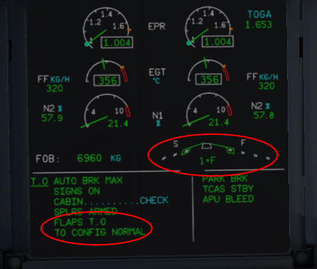

### **Why Takeoff Configuration is Critical**

The takeoff phase is one of the most unforgiving parts of flight. Unlike cruise flight, where the aircraft has time and altitude to handle system errors, problems during takeoff develop rapidly and leave little room for error or recovery. Even relatively small configuration mistakes, like failing to set the correct flap position, could prevent the aircraft from generating sufficient lift or could cause severe directional instability.

#### **Case Study: Northwest Airlines Flight 255**

In 1987, Northwest Airlines Flight 255, operating an MD-82, attempted takeoff from Detroit without extending the flaps or slats. The aircraft failed to gain enough lift and crashed just beyond the runway, killing all but one passenger. This tragedy highlighted the critical importance of proper configuration verification, which Airbus addressed with ECAM’s automated Takeoff Configuration Check.

### **Systems Monitored by TO Config and Crew Responses**

#### **1. Flaps and Slats**

**Purpose:** Flaps and slats are high-lift devices essential for takeoff. By increasing wing camber and surface area, they allow the aircraft to generate more lift at lower speeds, reducing the runway length needed for liftoff.

**ECAM Check:**ECAM verifies that the flaps and slats are extended to the specific setting entered into the Flight Management System (FMS) during takeoff performance planning. Typical settings range from Config 1+F to Config 2 depending on aircraft weight, runway length, and environmental conditions.

**Warning Message:  
TO CONFIG FLAPS**

**Required Crew Action:**

* Immediately reject the takeoff if the warning appears during the takeoff roll.
* Reconfirm the planned flap/slat setting in the FMS.
* Visually check the flap/slat lever position.
* Re-extend flaps/slats to the correct position.
* Re-run the ECAM takeoff configuration test before re-attempting takeoff.

**Real Example:**In 2018, an A320 departing from Amsterdam received a **TO CONFIG FLAPS** warning during the initial thrust application. The crew halted the takeoff, confirmed a mis-set flap lever, corrected it, and safely departed on a later clearance.

#### **2. Horizontal Stabilizer Trim**

**Purpose:** The horizontal stabilizer trim adjusts the angle of the horizontal stabilizer, helping maintain proper pitch attitude during rotation and climb. Proper trim prevents excessive nose-up or nose-down tendencies that could lead to over-rotation or shallow climbs.

**ECAM Check:**ECAM verifies that the stabilizer trim is set according to the calculated center of gravity (CG) and takeoff weight.

**Warning Message:  
TO CONFIG TRIM**

**Required Crew Action:**

* Reject the takeoff.
* Review the takeoff trim setting calculated on the load sheet.
* Adjust the stabilizer trim using the trim wheel.
* Cross-check the FMS-provided trim with the manual setting.
* Re-run the TO Config check before attempting another takeoff.

**Real Example:**In 2015, a private flight from Teterboro nearly experienced a pitch upset after takeoff due to incorrect trim settings. On Airbus aircraft, ECAM’s automatic trim verification would have detected and prevented this error.

#### **3. Parking Brake**

**Purpose:** The parking brake holds the aircraft stationary when parked or during certain ground operations. Attempting takeoff with the parking brake engaged can cause severe tire damage, brake overheating, or runway overrun.

**ECAM Check:**ECAM detects whether the parking brake is released before the takeoff roll begins.

**Warning Message:  
TO CONFIG PARK BRK**

**Required Crew Action:**

* Reject the takeoff.
* Disengage the parking brake.
* Confirm brake pressure returns to normal.
* Re-run the takeoff configuration check.

#### **4. Engine Thrust Levers**

**Purpose:** Proper thrust lever positioning ensures the engines are delivering the correct power for the takeoff profile, either **TOGA (maximum thrust)** or **FLEX (reduced thrust based on conditions).**

**ECAM Check:**ECAM confirms the thrust levers are correctly set in the appropriate detent.

**Warning Message:  
TO CONFIG THRUST**

**Required Crew Action:**

* Reject the takeoff.
* Reposition the thrust levers to the proper detent.
* Confirm correct FLEX temperature entry (if using reduced thrust).
* Re-attempt the takeoff after verifying the proper thrust lever position.

#### **5. Cabin and Cargo Doors**

**Purpose:** All doors must be properly closed and locked to ensure fuselage integrity and proper cabin pressurization during the climb.

**ECAM Check:**ECAM checks sensors at each door for proper closure and locking.

**Warning Message:  
TO CONFIG DOORS**

**Required Crew Action:**

* Reject the takeoff.
* Confirm which door is improperly closed.
* Have ground personnel verify and re-secure the door.
* Re-run the TO Config check before retrying takeoff.

#### **6. Autothrust System**

**Purpose:** The auto thrust system automatically manages thrust levels during climb and cruise. If the system is not armed before takeoff, it cannot engage properly.

**ECAM Check:**ECAM verifies autothrustt arming status.

**Warning Message:  
TO CONFIG AUTO THRUST**

**Required Crew Action:**

* Reject the takeoff.
* Verify auto thrust arming via the FCU (Flight Control Unit).
* Reconfirm correct thrust and flight mode settings.
* Perform another configuration check.

### **Conclusion**

The **ECAM Takeoff Configuration Check** serves as the Airbus A320’s last line of defense against configuration errors during takeoff. By continuously monitoring critical systems and comparing their real-time status to the expected configuration derived from flight planning data, ECAM significantly reduces the risk of takeoff incidents caused by human error or oversight.

In a highly automated modern cockpit, ECAM does not replace the crew’s responsibility for pre-departure checks, but it enhances and complements their oversight by acting as a smart, reliable backup system. When combined with proper crew training and disciplined checklist adherence, ECAM’s **TO Config** ensures Airbus A320 family aircraft are in optimal condition before every departure.

**Section 2: Possible Failures in the A320 ECAM System**

The **ECAM (Electronic Centralized Aircraft Monitoring)** system in the Airbus A320 is designed to manage, monitor, and alert the flight crew about the status of all aircraft systems. It plays a pivotal role in detecting failures and presenting the necessary actions to mitigate them. Understanding possible **system failures** and their corresponding ECAM alerts is crucial for a safe and efficient flight operation.

In this section, we will look at the **common failures** that can occur within the ECAM system, focusing on various **aircraft systems**, and their associated **ECAM messages** and **remedial actions**.

### **General Overview of ECAM Failure Responses**

ECAM messages for failures in the A320 come in various categories. These categories can be broadly classified as follows:

1. **Warning (W)**: A critical failure that requires immediate action.
2. **Caution (C)**: A less severe issue that requires attention but is not immediately critical.
3. **Advisory (A)**: Minor system issues that have a lower operational impact and may be acknowledged later.

The system is designed to identify failures and display clear messages to alert the crew. **ECAM messages** appear on the **Upper ECAM Display** (for system status) and the **Lower ECAM Display** (for checklists and actions).

### **1. Engine Failures and ECAM Responses**

Engine failures are among the most serious threats to the aircraft’s performance and safety, especially during critical flight phases like takeoff and climb. ECAM provides real-time identification, prioritization, and procedural guidance for engine-related failures.

#### **a. Engine Fire**

**Failure Type:** Engine fire during takeoff, climb-out, cruise, or landing.  
**ECAM Message:** "ENG 1 FIRE" or "ENG 2 FIRE"  
**Warning Level:** Warning (W)

**Explanation:**Engine fires are considered catastrophic events. ECAM immediately triggers a red warning, accompanied by a continuous chime and a master warning light. The fire detection loop senses excessive heat in the engine nacelle, activating fire handles and prompting the crew to initiate immediate fire suppression procedures. ECAM displays a dedicated fire checklist to ensure the crew follows every required step, including confirming fire handle activation, discharging extinguishing agents, and monitoring for residual fire indications.

**ECAM Actions:**

* Pull the affected engine’s fire handle to isolate fuel, hydraulics, and bleed air.
* Discharge fire extinguishing agent 1.
* Monitor for fire warning persistence; if necessary, discharge bottle 2.
* Secure engine systems following ECAM checklist guidance.
* Plan diversion if fire indication does not cease.

#### **b. Engine Stall**

**Failure Type:** Loss of engine thrust due to disrupted airflow within the compressor stages.  
**ECAM Message:** "ENG 1 STALL" or "ENG 2 STALL"  
**Warning Level:** Warning (W)

**Explanation:**Engine stalls occur when compressor blades lose stable airflow, resulting in erratic thrust and potentially damaging compressor components. This can be caused by ingestion of debris, incorrect engine power settings, or abrupt airflow disturbances.

**ECAM Actions:**

* Retard the thrust lever for the affected engine to idle.
* Monitor engine parameters (N1, N2, EGT) for stabilization.
* If parameters stabilize, cautiously increase thrust as required.
* If the stall persists, secure the engine following the ECAM checklist.
* Assess the need for single-engine diversion.

#### **c. Engine Surge**

**Failure Type:** Inconsistent airflow through the engine resulting in loud bangs, vibrations, and transient power loss.  
**ECAM Message:** "ENG 1 SURGE" or "ENG 2 SURGE"  
**Warning Level:** Caution (C)

**Explanation:**Surges can occur during rapid thrust changes, especially in high-power settings. These events temporarily disrupt combustion stability but may be recoverable if handled promptly.

**ECAM Actions:**

* Gradually retard thrust to reduce compressor load.
* Monitor all engine parameters for recovery.
* Avoid rapid thrust adjustments.
* If surging persists, prepare to shut down the engine.
* Follow ECAM guidance for further steps.

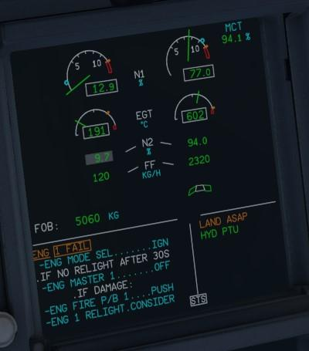

### **2. Hydraulic System Failures and ECAM Responses**

The A320 has three independent hydraulic systems: Green, Yellow, and Blue. These systems power flight controls, landing gear, brakes, slats, and other critical components. Failure in any of these systems can significantly degrade aircraft controllability.

#### **a. Green System Low Pressure**

**Failure Type:** Hydraulic pressure loss in the Green system.  
**ECAM Message:** "HYD G LO PR"  
**Warning Level:** Caution (C)

**Explanation:**The Green system powers primary flight controls, landing gear, and slats. Loss of pressure reduces control redundancy and may require manual gear extension.

**ECAM Actions:**

* Monitor system pressure and fluid quantity.
* Review affected components (slats, gear, etc.).
* Prepare for manual landing gear extension.
* Cross-reference with the ECAM checklist for further isolation and mitigation.

#### **b. Dual Hydraulic System Loss (Green and Yellow)**

**Failure Type:** Combined failure of two independent hydraulic systems.  
**ECAM Message:** "HYD G + Y LO PR"  
**Warning Level:** Warning (W)

**Explanation:**With only the Blue system remaining, the aircraft loses most flight control redundancy, requiring increased pilot workload and modified flight techniques.

**ECAM Actions:**

* Assess available flight control functionality.
* Manually extend the landing gear.
* Review the ECAM checklist for system isolation and workload sharing.
* Prepare for an abnormal landing.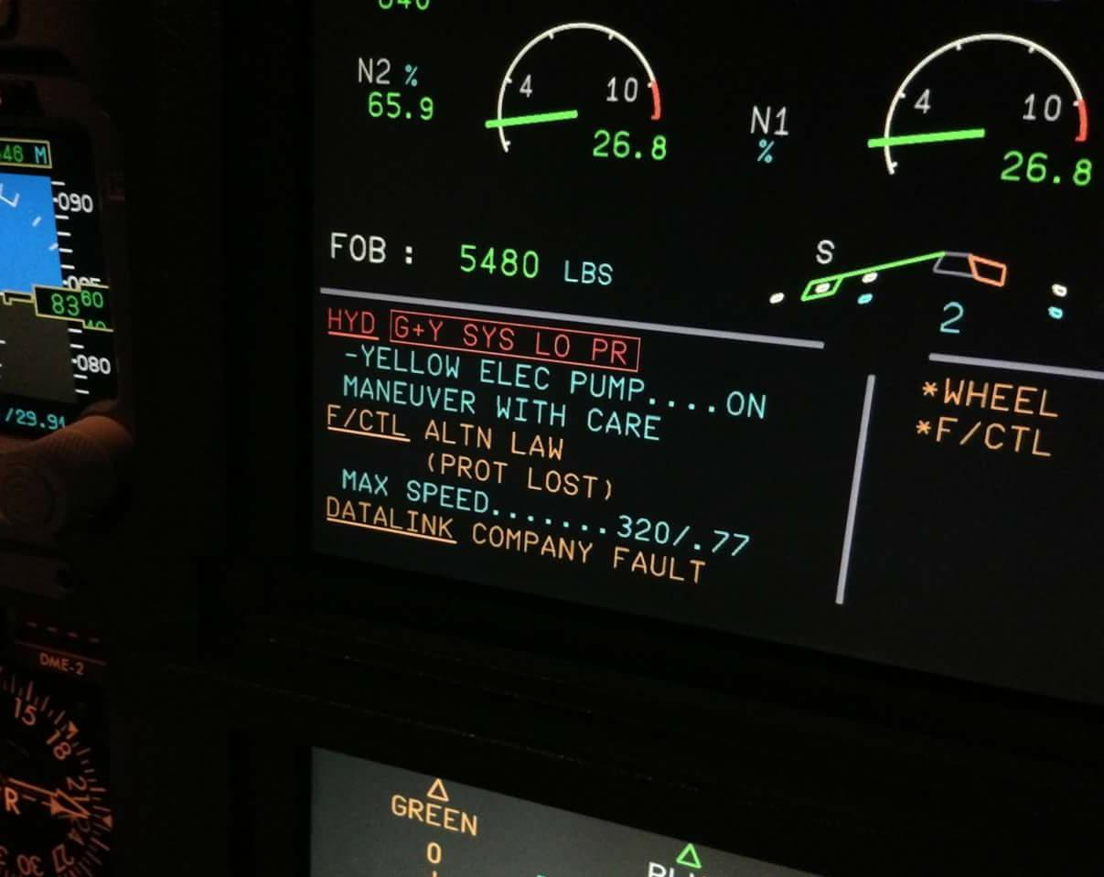

### **3. Electrical System Failures and ECAM Responses**

The A320 electrical system distributes power across AC and DC buses supplied by engine-driven generators, the APU, and batteries.

#### **a. Generator Failure**

**Failure Type:** Loss of one engine-driven generator.  
**ECAM Message:** "ELEC GEN 1 FAULT"  
**Warning Level:** Caution (C)

**Explanation:**Single generator loss is manageable, but reduces system redundancy and increases dependence on the remaining power sources.

**ECAM Actions:**

* Attempt to reset the generator.
* If the reset fails, activate the APU generator.
* Monitor affected buses and systems.
* Review the ECAM checklist for load-shedding.

#### **b. Dual Generator Failure**

**Failure Type:** Loss of both engine-driven generators.  
**ECAM Message:** "ELEC EMER CONFIG"  
**Warning Level:** Warning (W)

**Explanation:**Complete generator failure forces the aircraft into Emergency Electrical Configuration, relying solely on the **RAT (Ram Air Turbine)** and batteries.

**ECAM Actions:**

* Deploy RAT automatically.
* Follow the ECAM procedure for preserving battery power.
* Monitor critical systems powered by essential buses.
* Land at the nearest suitable airport.

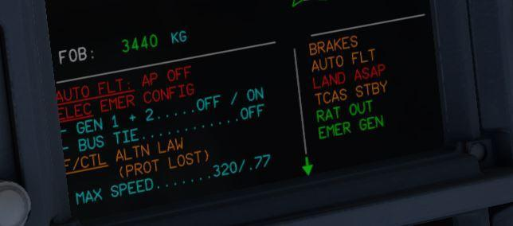

### **4. Flight Control Failures and ECAM Responses**

The A320's flight controls are electronically managed via the **Fly-by-Wire (FBW)** system. Failures here directly impact handling and protections.

#### **a. Flight Control Law Reversion**

**Failure Type:** Reversion to Alternate or Direct Law.  
**ECAM Message:** "F/CTL ALTN LAW"  
**Warning Level:** Caution (C)

**Explanation:**Flight control laws provide automatic protections for angle-of-attack, bank, and load factors. Reversion to degraded laws removes protections, increasing pilot workload.

**ECAM Actions:**

* Assess available flight control authority.
* Review control response changes.
* Follow the ECAM checklist for reversion handling.
* Land at the nearest suitable airport.

### **5. Fuel System Failures and ECAM Responses**

The A320 fuel system manages distribution between tanks, fuel pumps, and engines.

#### **a. Fuel Imbalance**

**Failure Type:** Unequal fuel distribution between wings.  
**ECAM Message:** "FUEL WING TK IMBAL"  
**Warning Level:** Caution (C)

**Explanation:**Significant imbalances can lead to lateral instability.

**ECAM Actions:**

* Transfer fuel between tanks using crossfeed.
* Monitor imbalance reduction.
* Follow the ECAM checklist for further monitoring and action.

### **Summary**

The A320 ECAM system is one of the most critical innovations in modern commercial aviation, acting as the central hub for monitoring, diagnosing, and responding to system failures across the aircraft. From engine malfunctions to hydraulic loss, electrical faults, and flight control degradation, ECAM is designed to alert the crew with clear warnings, cautions, and advisories, ensuring that no critical system issue goes unnoticed. Each alert is accompanied by a step-by-step checklist specifically tailored to the situation, enabling the crew to follow a structured, standardized process to contain, troubleshoot, and mitigate the failure while keeping the aircraft within safe operational limits.

One of ECAM’s greatest strengths is its ability to connect individual system failures to the broader operational picture, automatically identifying secondary and cascading failures caused by the initial malfunction. For example, a hydraulic system failure doesn’t just affect the hydraulic pumps—it impacts the flight controls, landing gear operation, and even brake system performance. ECAM doesn’t just present isolated warnings—it paints a complete, real-time picture of how the failure impacts the aircraft, ensuring the flight crew understands the full extent of the situation and can plan appropriately.

The procedural guidance provided by ECAM checklists is more than just a set of instructions—it is context-sensitive and tailored to the phase of flight. A fuel imbalance detected during cruise will have different steps and urgency than one detected shortly before landing. ECAM’s ability to prioritize the most time-critical actions and eliminate unnecessary steps based on current conditions helps the flight crew focus on what matters most, especially in high-stress, high-workload environments.

In addition to its technical functionality, ECAM also serves as a powerful Crew Resource Management (CRM) tool. By displaying the same alerts, system synoptics, and checklists to both pilots, ECAM acts as a shared point of reference, ensuring that both the captain and first officer are always working off the same data set. This promotes clear communication, effective task sharing, and efficient problem-solving, even when failures involve multiple systems or require complex troubleshooting.

A compelling real-life example of ECAM’s effectiveness occurred in 2005 on Air Transat Flight 961, an Airbus A310 (which uses a system very similar to the A320’s ECAM). While cruising over the Caribbean, the aircraft experienced a severe structural failure when a portion of the rudder detached. ECAM instantly alerted the crew to the flight control degradation and provided immediate checklists and system synoptics, allowing the pilots to quickly assess which flight controls were available and how the aircraft’s handling had been affected. Thanks to ECAM’s clear procedural guidance, the crew successfully stabilized the aircraft and diverted to Varadero, Cuba, for a safe landing. This incident highlighted how rapid access to accurate data and structured response procedures can mean the difference between a manageable emergency and a catastrophic loss of control.

Ultimately, the ECAM system reflects Airbus’ philosophy of combining cutting-edge automation with human oversight, creating an environment where technology enhances the crew’s situational awareness, reduces cognitive overload, and supports safe decision-making under pressure. Whether the failure is a minor sensor issue or a major system-wide emergency, ECAM ensures the crew has the right information, at the right time, in the right format—helping maintain the Airbus A320 family’s reputation as one of the safest and most reliable aircraft types in the world.

# 

# 

# 

# 

# 

# 

# 

# 

# **Section 3: Failures Leading to ALTN/Direct Law**

The Airbus A320’s **Fly-by-Wire (FBW)** system revolutionized modern airliner design by replacing traditional mechanical flight control linkages with an **electronic interface**, where the pilots' sidestick inputs are processed by flight control computers before being transmitted to the control surfaces. This system not only improves handling and reduces weight but also introduces several layers of **flight envelope protection**, ensuring that the aircraft cannot exceed safe limits for speed, angle of attack (AOA), or bank angle. However, these protections are only available in **Normal Law**, the highest level of flight control law.

The A320’s **flight control architecture** relies on seven key computers:

* **2 ELACs (Elevator and Aileron Computers)** – Responsible for **pitch control through the elevators and stabilizer** and **roll control through the ailerons**.
* **3 SECs (Spoiler and Elevator Computers)** – Primarily manage **spoilers** but also serve as **backup pitch computers**.
* **2 FACs (Flight Augmentation Computers)** – Provide **yaw damping**, **turn coordination**, **rudder trim**, and manage some of the **flight envelope protections**.

The aircraft’s ability to maintain Normal Law depends heavily on these computers functioning correctly, receiving reliable sensor data (especially from the **Air Data Reference Units - ADRs**), and maintaining stable electrical and hydraulic power. When specific failures occur, the system automatically **downgrades to Alternate Law or Direct Law**, depending on the severity of the failure and the redundancy still available.

## **Normal Law Overview**

Normal Law is the intended operational mode for all phases of flight under normal conditions. In this mode:

* **Sidestick inputs = Flight Path Commands**
* The pilot commands a desired pitch rate or bank angle, not direct surface deflection.
* Flight control computers blend elevator, stabilizer, aileron, and rudder inputs for **smooth, augmented flight**.

### **Protections in Normal Law:**

* **Load Factor Limiting:** +2.5g clean / +2.0g with slats or flaps extended.
* **Stall Protection:** Automatic nose-down commands if AOA approaches critical levels.
* **High-Speed Protection:** Automatic nose-up input and thrust reduction if overspeed is detected.
* **Bank Angle Limiting:** The Bank angle is limited to 67°, auto-return to 33° when the stick is released.

Normal Law provides a high level of **automation and envelope protection**, meaning that the aircraft automatically prevents the pilots from exceeding critical limits.

## **Alternate Law Overview**

Alternate Law is a **degraded control law** that provides basic flight control capability when some—but not all—critical systems are lost. In Alternate Law:

* **Sidestick inputs = Control Surface Rate Commands** (less augmentation than in Normal Law).
* **Protections are reduced or eliminated:**
  + **Load Factor Protection:** Still available.
  + **Stall Protection:** This may still exist (depending on remaining ADR data), but no Alpha Floor protection.
  + **High-Speed Protection:** Lost.
  + **Bank Angle Limiting:** Lost—pilots can roll the aircraft through 360° if desired.
  + **Yaw Damping:** May be degraded.
* **Autotrim:** Still works.

ECAM displays:  
**F/CTL ALTN LAW: PROT LOST**

**​​**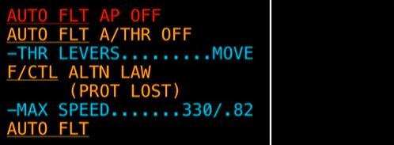

## **Direct Law Overview**

Direct Law is the **lowest level of control law**, used when the system can no longer augment pilot inputs. It is essentially **manual control with no protections**. In Direct Law:

* **Sidestick inputs = Direct Surface Deflection Commands** (full mechanical-like control).
* **Protections:** None—no stall protection, no overspeed protection, no bank angle limiting.
* **Autotrim:** Lost—pilots must manually trim the stabilizer.
* **Yaw Damping:** Lost—manual rudder inputs required.

ECAM displays:  
**F/CTL DIRECT LAW: USE MAN PITCH TRIM**

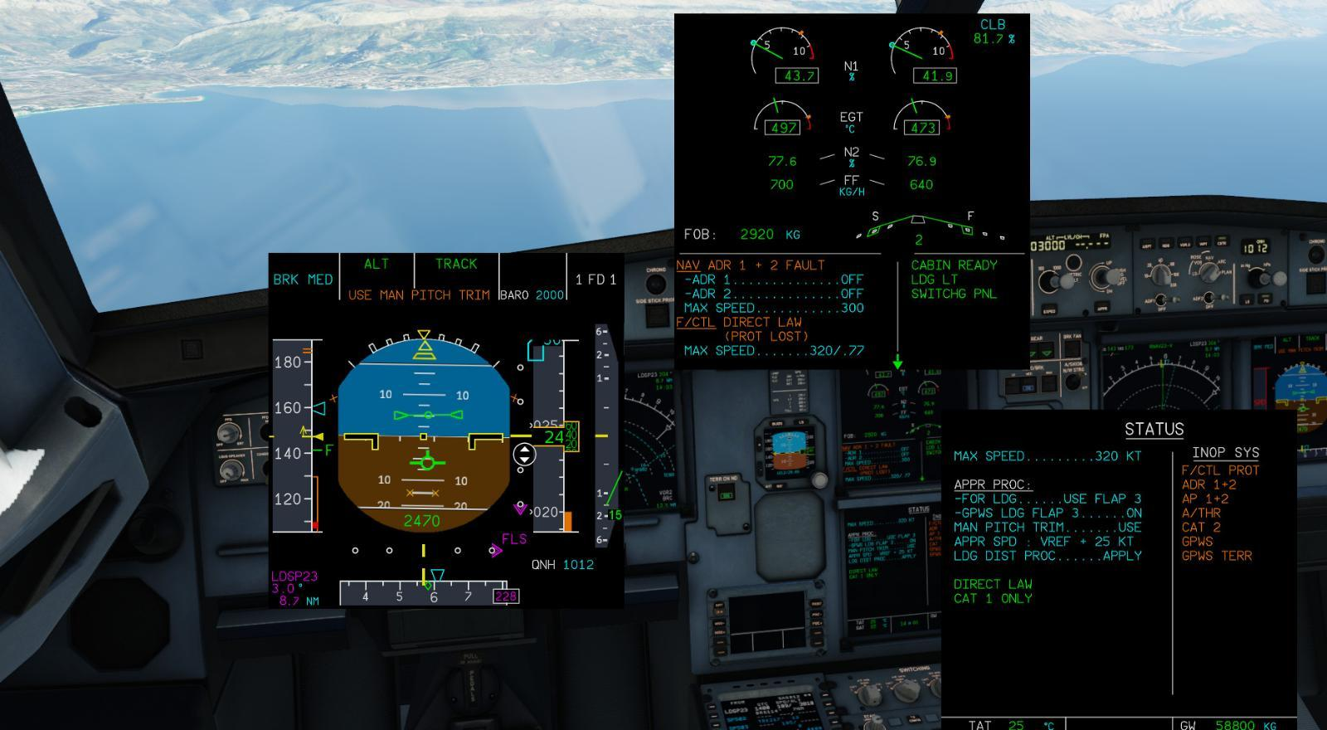

## **Failures Leading to ALTN or Direct Law**

### **1. Dual ELAC Failure (Complete Loss of Both Primary Flight Control Computers)**

**ECAM Message:  
F/CTL ELAC 1+2 FAULT**

**What Happens:**The ELACs provide the **primary pitch and roll control functions**. If both fail, the A320 immediately **reverts to Direct Law**, as no system remains to augment or blend pilot inputs.

**System Impacts:**

* Pitch and roll control become **fully manual**.
* **Protections are completely lost**.
* **Manual pitch trim is required**, which must be continually adjusted by the pilot.
* **Rudder coordination is lost**—pilots must manually apply the rudder during turns.

**Real Example:**In 2002, an A320 en route to Lyon experienced overheating in the avionics bay, causing both ELACs to fail. ECAM displayed **F/CTL ELAC 1+2 FAULT**, and the aircraft immediately downgraded to **Direct Law**. The crew hand-flew the approach and landing, constantly adjusting pitch trim while dealing with **direct surface response and no protections**.

### **2. Loss of One ELAC and One SEC (Critical Redundancy Loss)**

**ECAM Messages:  
F/CTL ELAC 1 FAULT  
F/CTL SEC 2 FAULT**

**What Happens:**The loss of one ELAC and one SEC leaves the aircraft with **only one channel for pitch control and reduced spoiler control**, which degrades the system to **Alternate Law**.

**System Impacts:**

* Flight envelope protections are **reduced or lost**.
* Bank angle limiting disappears—pilots must manually monitor roll limits.
* Stall and high-speed protections are either reduced or lost.
* Autotrim is retained.

**Real Example:**In 2015, a Lufthansa A320 suffered combined ELAC 1 and SEC 2 failures over Germany. The system downgraded to **Alternate Law**, requiring the pilots to actively monitor airspeed, bank angle, and stall margins manually.

### **3. Multiple ADR Sensor Failures (Loss of Reliable Air Data)**

**ECAM Message:  
NAV ADR DISAGREE**

**What Happens:**The flight control computers rely on **air data from the ADRs** for speed, altitude, and angle of attack (AOA). When ADR inputs disagree or are lost, Normal Law protections are **compromised**, triggering a downgrade to **Alternate Law**.

**System Impacts:**

* Stall and high-speed protections are reduced or lost.
* Airspeed management becomes **manual**.
* Flight crews must rely on **pitch-and-power techniques**.
* Autotrim may be retained.

**Real Example:**In 2013, an A320 flying over Europe encountered severe icing, which blocked two pitot tubes. ECAM triggered **NAV ADR DISAGREE**, and the system was downgraded to **Alternate Law**. The crew flew using **memorized pitch and power values** until the pitot tubes cleared.

### **4. Dual Hydraulic System Loss (Green and Yellow)**

**ECAM Message:  
HYD G + Y LO PR**

**What Happens:**The A320 relies on three hydraulic systems. The loss of two systems (leaving only Blue) reduces flight control redundancy so severely that the system reverts to **Direct Law**.

**System Impacts:**

* All protections are lost.
* Manual pitch trim is required.
* Roll authority may be reduced if spoilers are affected.
* Rudder coordination becomes manual.

**Real Example:**In 2010, an A320 departing Warsaw suffered **hydraulic contamination**, leading to the loss of Green and Yellow systems. The aircraft was downgraded to **Direct Law**, and the crew manually flew and trimmed the aircraft to a safe landing.

### **5. Complete Electrical Failure (Dual Generator Loss)**

**ECAM Message:  
ELEC EMER CONFIG**

**What Happens:**When both IDGs fail, the Ram Air Turbine (RAT) deploys to power only **essential systems**, including one flight control computer. This forces a downgrade to **Alternate Law** (potentially further degrading to Direct Law if computer power is lost).

**System Impacts:**

* No protections beyond load factor limiting.
* Autotrim depends on which computer stays powered.
* Navigation, autopilot, and auto thrust lost.

**Real Example:**In 2001, Air Transat Flight 236 (A330, similar system) lost all fuel and power, relying on RAT power in **Alternate Law** for 75 minutes, before a successful emergency landing.

## **Conclusion**

The A320’s transition from **Normal to Alternate to Direct Law** protects the aircraft’s core flyability even after catastrophic system failures. These layers of redundancy give the flight crew **time and options**, ensuring that manual flying is always possible—though requiring vastly increased pilot workload and precise handling.

### **Section 4: ECAM Checklists in the Airbus A320: A Comprehensive Overview**

The **ECAM (Electronic Centralized Aircraft Monitoring)** system is one of the defining features of the Airbus A320 family, blending **automated system monitoring, real-time fault detection, and procedural guidance** into a single, integrated platform. ECAM plays a pivotal role in ensuring safe and efficient operations, particularly in the **highly automated fly-by-wire environment** of the A320. More than just a status display, **ECAM actively assists pilots by presenting system pages, real-time data, and dynamically generated checklists in response to faults or failures.** These checklists guide the flight crew through immediate actions, troubleshooting, and system management, ensuring that nothing is overlooked — even under high-stress conditions. This section provides a comprehensive look at the **structure, categories, and best practices** for using ECAM checklists, along with detailed examples of how they are used in real-world situations.

## **1. ECAM Overview**

The ECAM system is the A320’s **central nerve center for system monitoring and fault management**, continuously gathering data from nearly every aircraft system — including **engines, hydraulics, electrical systems, flight controls, pressurization, fuel, and more**. When all systems are healthy, ECAM displays **normal system synoptic pages** showing the status and configuration of key systems. However, when a malfunction occurs, ECAM does much more than simply display a fault. It:

* **Generates alerts** (warnings, cautions, or advisories) categorized by severity.
* **Displays interactive, step-by-step checklists** customized to the specific fault detected.
* **Automatically tracks which items have been completed** and adapts the list based on system responses.
* **Prioritizes multiple faults, ensuring the crew handles the most critical failures first.**

### **Key Features of ECAM**

* **Real-Time Monitoring:** Continuous monitoring of systems with live data displayed on the upper and lower ECAM screens.
* **Alerting System:** Immediate visual and auditory alerts, color-coded based on urgency.
* **System Synoptic Pages:** Graphical schematics of major systems (hydraulics, fuel, electrical, etc.), updated in real-time.
* **Dynamic Checklists:** Automatically tailored to match the exact nature of the failure.

### **ECAM Message Priorities**

* **Red (Warnings):** Immediate action required — safety is at risk.
* **Amber (Cautions):** Attention required, but not immediately life-threatening.
* **Blue (Information):** Advisory items or procedural reminders.

## **2. Types of ECAM Checklists**

ECAM checklists are classified into distinct categories based on the type of procedure they guide. Each type serves a unique operational purpose.

### **A. Normal Checklists**

Normal checklists are procedural guides for routine flight phases. These **non-emergency checklists** ensure the aircraft is properly configured at every stage.

* **Examples:**
  + Pre-Start Checklist — Verifies basic system readiness.
  + Before Takeoff Checklist — Ensures flaps, trim, and takeoff data are correctly set.
  + Descent Checklist — Ensures correct altimeter settings, approach briefing, and system readiness.

These checklists are usually completed without ECAM prompts, but ECAM provides reminders (e.g., the **TO CONFIG TEST**).

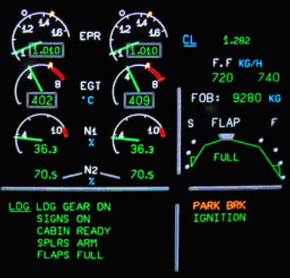

### **B. Abnormal Checklists**

Abnormal checklists respond to system faults or malfunctions that do not present an immediate danger but still **require action**. ECAM automatically generates these checklists in response to detected faults.

* **Examples:**
  + **HYD Y LO PR (Hydraulic System Low Pressure)** — Guides pilots through hydraulic isolation and alternate system management.
  + **ELEC GEN 1 FAULT** — Assists with generator isolation and reconfiguration.
  + **AIR PACK 1 FAULT** — Provides steps to isolate a malfunctioning air conditioning pack.

Abnormal checklists may end with a **Status Page**, summarizing all deferred actions and inoperative systems.

### **C. Emergency Checklists**

These checklists address **immediate and potentially catastrophic failures**, demanding urgent action to preserve aircraft and passenger safety. They often involve **memory actions**, which must be performed **before referencing the checklist**.

* **Examples:**
  + **ENGINE FIRE** — Immediate engine shutdown and fire suppression.
  + **CABIN PRESSURE LOSS** — Emergency descent and oxygen mask deployment.
  + **SMOKE/FUMES** — Immediate smoke isolation and ventilation procedures.

### **D. Memory Checklists**

Certain high-risk situations require crews to **act immediately from memory** without waiting for ECAM guidance. These memory actions are trained intensively.

* **Examples:**
  + **Unreliable Airspeed** — Set specific pitch and power settings.
  + **Engine Severe Damage or Fire on Takeoff** — Immediate engine shutdown and fire handle action.

## **3. Detailed ECAM Checklist Procedures**

### **Example 1: Engine Fire Checklist (Emergency)**

An **Engine Fire** is among the most serious emergencies on the A320, and ECAM’s structured checklist helps manage this high-stakes situation.

* **Initial Alert:**
  + ECAM displays **ENGINE FIRE** in red.
  + Master Warning light flashes, and a loud continuous chime sounds.
* **Memory Actions (Performed Immediately):**
  + **Affected Engine Master Switch – OFF.**
  + **Engine Fire Handle – PULL (to cut fuel and hydraulics).**
* **ECAM-Guided Actions:**
  + Discharge fire extinguishers if the fire persists.
  + Monitor ECAM for fire indication clearance.
  + Assess system status (hydraulic and electrical impact).
  + Plan for possible emergency diversion or landing.

### **Example 2: Hydraulic Failure Checklist (Abnormal)**

A hydraulic system loss can affect **flight controls, landing gear, brakes, and spoilers**, requiring close coordination with ECAM.

* **Initial Alert:**
  + ECAM displays **HYD G LO PR** (for Green system loss).
* **ECAM-Guided Actions:**
  + Identify which systems are lost.
  + Assess if manual gear extension is required.
  + Reconfigure flight controls and brakes based on available hydraulics.
  + Adjust approach speed and stopping distance for reduced braking.

### **Example 3: Fuel Contamination Checklist (Abnormal)**

ECAM also assists in complex, evolving situations like **fuel contamination**, where both monitoring and isolation are critical.

* **Initial Alert:**
  + ECAM displays **FUEL CONTAMINATED**.
* **ECAM-Guided Actions:**
  + Crossfeed to balance usable fuel.
  + Monitor engine parameters for signs of abnormal combustion.
  + Consider alternate airports if engine performance degrades.
  + Assess inoperative systems if fuel system isolation is required.

## **4. Using the ECAM System Efficiently**

### **Best Practices**

* **Follow ECAM Flow Exactly:**
  + Complete each checklist step in order.
  + Avoid skipping items, even if the cause seems obvious.
* **Memory Item Mastery:**
  + Memorize critical actions for engine fires, pressurization loss, and unreliable airspeed.
  + Practice recalling them in simulator training.
* **Crew Coordination:**
  + One pilot handles flying, while the other manages ECAM and checklists.
  + Maintain clear communication and verbalize each completed step.
* **Cross-Check ECAM Status Pages:**
  + After completing a checklist, review the **ECAM Status Page** for deferred actions and inoperative systems.

## **Conclusion**

The Electronic Centralized Aircraft Monitoring (ECAM) system in the Airbus A320 family stands as one of the most revolutionary advancements in modern aircraft design, embodying Airbus’ philosophy of blending cutting-edge automation with pilot-centered control and decision-making tools. More than just a system status monitor, ECAM serves as an interactive hub for system health, failure detection, and procedural guidance, all in real time. Its layered design, combining live system synoptics, prioritized alerts, and dynamic checklists, ensures that pilots have constant situational awareness, whether the aircraft is operating normally or facing complex, cascading system failures.

At its core, ECAM transforms the way pilots interact with the aircraft's systems, ensuring that no matter the flight phase — from pre-flight setup to cruise, approach, or emergency descent — critical information is presented clearly and logically. Traditional aircraft designs required flight crews to reference physical checklists, multiple system displays, and fault lights scattered across the cockpit, creating a fragmented workflow that increased the risk of errors or missed steps under pressure. ECAM consolidates this process, ensuring the crew receives not just a description of the fault but a real-time roadmap to resolving it, complete with automatic status updates as each corrective action is performed.

The ECAM Takeoff Configuration (TO Config) checks a core part of the system and plays a particularly vital safety role by ensuring the aircraft is correctly configured for departure, a flight phase where even small configuration errors can have catastrophic results. By cross-checking inputs from the flight control computers, hydraulics, flight management system (FMS), and air data systems, ECAM proactively warns the crew of issues like incorrect flap settings, trim misconfiguration, active parking brakes, or door warnings — all before the aircraft ever leaves the ground. This feature alone has prevented numerous accidents, highlighting ECAM’s role as a safety net against human error.

While ECAM is invaluable during normal operations, its true value is most apparent when abnormalities or emergencies arise. When a system malfunction or failure occurs, ECAM’s prioritized alerting system immediately draws the crew’s attention to the most critical issues, while lower-priority faults are deferred until the immediate threat is addressed. This hierarchical structure prevents information overload, ensuring that the crew focuses their attention where it’s needed most. By presenting step-by-step checklists directly on the lower ECAM screen, tailored to the specific failure detected, ECAM eliminates the need for the crew to manually locate the correct page in a physical manual, further reducing response time in time-critical situations.

The color-coded nature of ECAM messages — red for immediate, life-threatening emergencies, amber for serious but non-immediate faults, and blue for informational notices — allows pilots to instantly assess the urgency of each alert. Combined with system synoptic pages that graphically depict system health (showing pressure, valve positions, pump status, etc.), ECAM ensures that the crew understands both the symptoms and the root causes of a problem. This real-time situational awareness allows for better decision-making, ensuring that no corrective action is taken in isolation and that all interconnected systems are considered before executing a procedure.

One of the most unique aspects of ECAM is its ability to adapt dynamically as failures evolve. Many checklist systems, both in older aircraft and some modern designs, rely on static procedures that do not change based on system responses. ECAM checklists, by contrast, actively track which steps have been completed and update automatically if the system responds positively to an action. For example, if a pilot isolates a hydraulic leak and pressure stabilizes, ECAM may remove or modify subsequent checklist items, reflecting the improved system status. This dynamic capability makes ECAM responsive, flexible, and tailored to each unique failure scenario, which is essential when multiple, overlapping failures occur — a phenomenon known as cascading failures.

This adaptability extends to flight control law transitions as well. In the Airbus A320’s fly-by-wire environment, ECAM is fully aware of changes from Normal Law to Alternate or Direct Law when failures impact critical flight control computers or sensors. Rather than simply alerting the crew to the change, ECAM also provides tailored guidance specific to the degraded flight law, helping the pilots adapt to the reduced protections, increased manual workload, and altered handling characteristics that come with degraded flight laws. This ensures that the crew is never left guessing about what capabilities have been lost — a key part of Airbus’ philosophy of keeping the pilots fully informed, even when the aircraft’s automation capabilities are diminished.

Another fundamental strength of the ECAM system lies in its seamless integration with crew resource management (CRM) practices. ECAM procedures are designed to encourage the division of responsibilities between the pilot flying (PF) and the pilot monitoring (PM). While one pilot flies the aircraft and maintains external situational awareness, the other focuses on executing ECAM checklists, communicating with air traffic control, and monitoring system health. This division of labor helps ensure that no critical task is overlooked, particularly when operating in high-stress, high-workload scenarios.

Real-world incidents highlight the profound impact ECAM has had on flight safety and accident prevention. Numerous flight crews have safely recovered from engine fires, hydraulic system failures, pressurization loss, and complex electrical faults thanks in part to ECAM’s structured, step-by-step guidance. Even in extreme cases, such as dual hydraulic loss or unreliable airspeed events, ECAM has proven itself to be an indispensable tool in preserving situational awareness, managing crew workload, and ensuring proper adherence to emergency procedures.

However, it’s important to note that ECAM is a support tool, not a substitute for airmanship and critical thinking. ECAM provides procedural solutions, but it is up to the flight crew to assess whether those solutions fit the operational context. There are cases where following an ECAM checklist exactly might need to be delayed or modified based on factors like terrain clearance, weather conditions, or fuel status. This balance between automation and pilot discretion reflects Airbus’ underlying design philosophy — technology should enhance the pilot’s abilities, not replace them.

In summary, the ECAM system is a cornerstone of Airbus’ approach to operational safety, combining real-time system monitoring, prioritized alerting, and dynamically updating procedural checklists into a single integrated platform. By ensuring that the flight crew is always aware of the aircraft’s status, and by providing immediate, clear, and prioritized steps for managing any irregularity, ECAM significantly reduces the risk of human error while preserving pilot authority and control. Whether guiding routine pre-flight checks, managing minor system irregularities, or supporting the crew through major in-flight emergencies, ECAM is more than a system — it is an essential partner in the safe operation of every Airbus A320 flight.

### **References**

The Airline Pilots. (n.d.). *A320 normal procedures.* Retrieved from https://www.theairlinepilots.com/forumarchive/a320/a320-normal-procedures.pdf

The Airline Pilots. (n.d.). *A320 flight control laws protection.* Retrieved from https://www.theairlinepilots.com/forumarchive/a320/a320-flight-control-laws.pdf

Boeing 737NG Reference. (n.d.). *A320/321 flight crew training manual.* Retrieved from https://www.737ng.co.uk/A320%20321%20FCTM%20Flight%20Crew%20Training%20Manual.pdf

Peking University. (n.d.). *Airbus A320/A330/A340 electrical flight controls.* Retrieved from https://www2.coe.pku.edu.cn/tpic/20119110210756.pdf

Federal Aviation Administration. (n.d.). *A320 final special condition.* Retrieved from https://www.faa.gov/sites/faa.gov/files/A320%20Final%20Special%20Condition.pdf

Airbus. (2024). *A320 aircraft characteristics airport and maintenance planning.* Retrieved from https://aircraft.airbus.com/sites/g/files/jlcbta126/files/2025-01/AC_A320_0624.pdf

Scribd. (n.d.). *Airbus A320 flight control laws.* Retrieved from https://es.scribd.com/presentation/370191671/64148571-Airbus-A320-Flight-Controls-Laws

Scribd. (n.d.). *Airbus A320/A321 systems guide.* Retrieved from https://www.scribd.com/document/495711225/Vol4-Systems-En

Heller, C. (n.d.). *Electrical flight controls: From Airbus A320/330/340 to future designs.* In The Avionics Handbook. Retrieved from https://helitavia.com/avionics/TheAvionicsHandbook_Cap_12.pdf