GEbPDCM + LTPM
An Optimized Congestion Control Protocol in Cellular Networks: Reproduction, Golden Eagle Optimizer Implementation, and a Lightweight Trust and Predictive Module
Networks Lab Mini Project -- Final Report
Group No: 8
Roll Nos: 106124083, 106124085, 106124095
Base paper: Sandhya S. V., S. M. Joshi -- "An optimized congestion control protocol in cellular network for improving quality of service", Multimedia Tools and Applications 84:26267-26292 (2025). DOI: 10.1007/s11042-024-20126-w

1. Abstract
This report reproduces and extends the GEbPDCM (Golden Eagle-based Primal-Dual Congestion Management) protocol proposed for LTE + AODV mobile ad-hoc networks. The base paper claims a Golden Eagle Optimizer and a primal-dual formulation but implements neither -- its "optimizer" is a bare threshold check. This project delivers two genuine additions on top of a faithful reproduction of the paper's threshold-and-migration scheme: (1) a real Golden Eagle Optimizer (attack/cruise vectors, an explicit iteration loop) that searches for the best migration target instead of picking the nearest free node, and (2) a Lightweight Trust and Predictive Module (LTPM) that scores node reliability with an EWMA trust metric and forecasts load a few steps ahead so congestion is pre-empted rather than reacted to. Four schemes -- plain AODV baseline, the paper's GEbPDCM as written, GEbPDCM+GEO, and GEbPDCM+GEO+LTPM -- were implemented and compared on an identical 100-node topology. Across a 10-50 m/s mobility sweep, the LTPM scheme consistently delivers the lowest delay, highest throughput and PDR, and lowest energy consumption of the four, with the ordering LTPM > GEO > GEbPDCM > baseline holding on every metric. The paper's own inconsistencies -- an unimplemented optimizer and an unformulated primal-dual method -- are documented as findings rather than silently corrected.

2. Introduction
Modern LTE networks carry a large majority of multimedia traffic over a shared, capacity-limited radio access network. As the number of concurrent users and the volume of video traffic grows, individual nodes -- particularly those acting as relays in an ad-hoc topology -- experience bursts of load that a purely reactive routing protocol like AODV has no mechanism to redistribute. The consequence is a familiar pattern: queueing delay rises sharply at a small number of "hot" nodes, packets are dropped once buffers saturate, and retransmissions burn additional energy without improving delivery.
The base paper's response to this is GEbPDCM: continuously estimate each node's data load and local node density, compute a congestion status from those two quantities, and once a node crosses a congestion threshold, migrate half of its load to a nearby node that is not itself congested. This is a sound high-level idea, but as detailed in Section 7, the paper's own description of how the migration target is chosen ("Golden Eagle Optimizer") and how the problem is framed ("primal-dual") does not match what is actually specified: no attack/cruise search, no dual variables, no iteration. This project treats that gap as the starting point for the assignment's required novelty, rather than an error to paper over.

3. Literature Survey
The comparison below is carried over from this group's Review II report and is reproduced here for completeness; it positions the base paper (GEbPDCM) against seven other recent congestion-control approaches spanning cellular, ad-hoc and IoT settings.
Feature | Selected Paper | Paper 1 (Verus) | Paper 2 (DNN-CC) | Paper 3 (GA-BCDSA) | Paper 4 (AODV-I) | Paper 5 (Markov-ML) | Paper 6 (BARS) | Paper 7 (TCM)
Objective | Improve QoS by balancing traffic | Learn delay profiles | Cross-layer capacity estimation | Minimizing tower congestion | Reducing routing overhead | Alleviating IoT congestion | Bandwidth-aware routing | Managing heavy traffic
Network Type | LTE AODV Networks | 3G / LTE Cellular | LTE Networks | LTE / LTE-A | Ad-Hoc / Cellular | Constrained IoT | Mobile Wireless | MANET / LTE
Technique | GEbPDCM Protocol | Verus Protocol | LSTM & MLP Models | GA & BCDSA | Extended RREQ messages | 3-State Markov & ML | Continuous Feedback | Node Link Life (NLL)
Metrics | Delay, throughput, PDR, packet loss, energy | End-to-end delay | Throughput, RTT | Congestion level | Latency, Packet loss rate | Packet loss, Delay | PDR, End-to-end delay | Routing overhead
Limitations | Needs security mechanisms; limited scale testing | Struggles on lossy links | High computational delay | Heavy heuristic computation | RREQ structural overhead | Hardware constraints | High feedback overhead | Stability prediction issues

3.1 Inferences and Research Gap
- Security: GEbPDCM has no built-in security mechanism, leaving the intelligent traffic-migration process open to malicious or unreliable nodes -- this motivates LTPM's trust scoring.
- Scalability: the base paper does not test beyond its own simulated scale, and continuous per-node monitoring cost under much larger networks is unaddressed.
- Proactive vs. reactive: GEbPDCM only reacts once a node is already congested; it does not attempt to forecast and avoid congestion before it happens -- this motivates LTPM's predictive forecasting.

4. Proposed Methodology
The implementation follows the paper's status-and-migration pipeline (Eq 2-8), with two documented reinterpretations of dimensionally inconsistent equations, plus two new modules (GEO, LTPM) that the paper names but never builds.

4.1 Known Issues in the Base Paper (Documented, Not Silently Fixed)
- Eq 2, P = Nc + h(sum Dl), adds a set of nodes (Nc) to a data load (sum Dl) -- dimensionally meaningless as written.
- Eq 3, Nd = Dl + Nn(Pmax/Pt), similarly mixes a load term with a neighbour-count term.
- There is no primal-dual formulation anywhere in the paper despite the protocol's name ("Primal-Dual Congestion Management").
- The paper names a "Golden Eagle Optimizer" but its Section on target selection is a bare threshold-and-nearest-node rule -- no attack vector, no cruise vector, no iteration.
Our interpretation of Eq 2 and Eq 3, applied consistently in the implementation:
- P (predicted/monitored load) = h x (sum of the node's recent load readings), where h is a monitoring/scaling coefficient (MONITOR_COEFF_H = 0.8).
- Nd (node density) = Dl + Nn x (Pmax / Pt), reading Nn as neighbour count and (Pmax/Pt) as an interference ratio between the network's maximum supportable data rate and the node's current load, with Pt floored at the paper's own minimum data rate to avoid a divide-by-near-zero blow-up.

4.2 Equations Implemented (status.py, migrate.py)
Eq 4 (node status): Ns = (P + Nd) / (1.6 x O_l), where O_l is the paper's optimal load; the 1.6 factor is our own calibration against this implementation's traffic model, not a paper value, chosen so that 'congested' captures a believable minority of node-ticks rather than a near-zero tail event.
Eq 5 (congestion classification): CS < 0.5 -> safe; 0.5 <= CS < 1 -> threshold; CS >= 1 -> congested.
Eq 6 (user priority): U = Ns + P(CS), read as the predicted load P weighted by how far into the congested band CS has moved.
Eq 7 (first-user check): U >= 1 marks a node as highest migration priority for that tick.
Eq 8 (share decision): a node shares (migrates) load once its predicted load P exceeds the optimal load O_l.
Migration itself: migrate_half() moves 50% of the source node's current load to the chosen target, exactly as specified in the paper.

4.3 GEO -- Golden Eagle Optimizer (our contribution, geo.py)
Each "eagle" is a candidate migration target's position in the 2D plane. Per iteration, every eagle moves under two combined vectors: an attack vector pointing straight at the best position found so far (exploitation), and a cruise vector perpendicular to it (exploration, circling the prey). The attack weight rises linearly from 0.5 to 2.0 over the run while the cruise weight falls from 1.0 to 0.5, matching real eagles committing more to the strike as a hunt progresses. Fitness combines five proxies -- available headroom, delivery-status quality, distance-based delay cost, current-load-based loss cost, and remaining-energy cost -- into a single weighted score:
F = w_throughput * headroom
+ w_pdr * pdr_proxy
- w_delay * delay_proxy
- w_loss * loss_proxy
- w_energy * energy_proxy

for each iteration:
p_attack = 0.5 -> 2.0 (linear over iterations)
p_cruise = 1.0 -> 0.5 (linear over iterations)
for each eagle:
attack = unit_vector(best_position - eagle_position)
cruise = perpendicular(attack), randomly mirrored
eagle_position += (p_attack*attack + p_cruise*cruise) * step_size
candidate = nearest real node to eagle_position
if fitness(candidate) > fitness(best): best = candidate
return best
20 eagles, 30 iterations per migration decision (GEO_POPULATION, GEO_ITERATIONS). Fitness is scored against SEVERITY_REFERENCE_LOAD (the load scale that actually drives drop probability in this simulator), not the paper's O_l, since real per-node loads never approach O_l and so cannot discriminate between candidates on that scale -- an implementation detail worth defending under questioning.

4.4 LTPM -- Lightweight Trust and Predictive Module (our contribution, ltpm.py)
Two independent mechanisms, deliberately built from plain arithmetic -- no LSTM, ARIMA, sklearn, or any trained model, since the module is called Lightweight and a trained model would not be defensible under questioning about why it was necessary:
- Trust scoring: an EWMA (exponentially weighted moving average) trust score per node. Success -> T = a*T + (1-a); failure -> T = a*T, with a = 0.9. A node is eligible as a migration target only once its trust is at least TRUST_MIN (0.6). To give this mechanism something real to filter, 10% of nodes are seeded as persistently unreliable (an extra flat failure probability independent of congestion, modelling a malicious or faulty node) -- otherwise every node's trust converges above the threshold quickly and the filter never actually excludes anyone.
- Predictive forecasting: a one-step-ahead linear extrapolation (least-squares slope) over each node's last 5 load readings. should_preemptively_migrate() triggers a migration when the forecast crosses into risky territory even though the node's current load has not -- i.e. GEbPDCM+LTPM can act before congestion, not only after it.
Scheme 4 (gebpdcm_ltpm)'s migration trigger is therefore: current status == congested, OR the forecast predicts imminent risk. Target selection reuses the GEO search, filtered to only trusted candidates.

5. Simulation Setup
Table 1 parameters, taken directly from the base paper and applied identically across every scheme:
Parameter | Value
Area | 1000 x 1000 m
Nodes | 100
Base station location | (500, 450)
Data type | Video
Transmission range | 300 m
Data rate | 3.1086 - 49.0946 Mbps
Bandwidth | 27.175 Mbps
Jitter | 6.4 ms
Mobility (sweep) | 10, 20, 30, 40, 50 m/s
Packet size (sweep) | 1, 2, 3, 4, 5 Kb
Simulation time | 100 s

5.1 All Four Schemes Run Inside Real NS-3
All four schemes -- baseline, GEbPDCM, GEbPDCM+GEO, and GEbPDCM+GEO+LTPM -- run as real, packet-level NS-3 simulations (ns3/gebpdcm.cc), on a genuine 100-node topology under the paper's parameter set (RandomRectanglePositionAllocator over 1000x1000m, base station fixed at (500,450)). The congestion-control logic itself -- GEbPDCM's threshold classification and migration, GEO's attack/cruise search, and LTPM's trust scoring and forecasting -- executes inside the simulation, acting on real per-node state, not an abstracted aggregate model. A Python reference implementation (src/*.py) was written first, to work out and validate each equation's interpretation in a simpler, readable form, then ported line-for-line into C++; it remains in the repository as documentation and still drives the secondary packet-size sweep, but the primary speed-sweep results below are all real NS-3 measurements.
NS-3 has no built-in notion of "migrate a node's load to a neighbour" -- AODV computes its own routes. This is implemented as a real, observable network effect: a per-node Ipv4 static-route override that forces a congested node's traffic to the base station through the chosen neighbour instead of AODV's own next hop, held for half of each one-second control tick (approximating Eq6-8's "share 50% of load" as a bounded-duration reroute of real packets, rather than a literal byte split). "Load" itself is sampled from each node's real WiFi MAC transmit queue occupancy every tick, not drawn from a random distribution. LTPM's trust score is updated from real Ipv4L3Protocol Tx/Drop trace counts -- an actual per-node forwarding-outcome signal -- rather than a synthetic coin flip. Section 7.3 documents the WiFi PHY bug that had to be found and fixed before any of this could deliver a single packet, and Section 7.3b documents what happened once congestion control started acting on the real network.

6. Results
All figures below plot the four schemes -- baseline (plain AODV), GEbPDCM, GEbPDCM+GEO, and GEbPDCM+GEO+LTPM -- against node speed, with packet size and all other Table 1 parameters held fixed at their default values.

6.1 Delay vs Node Speed
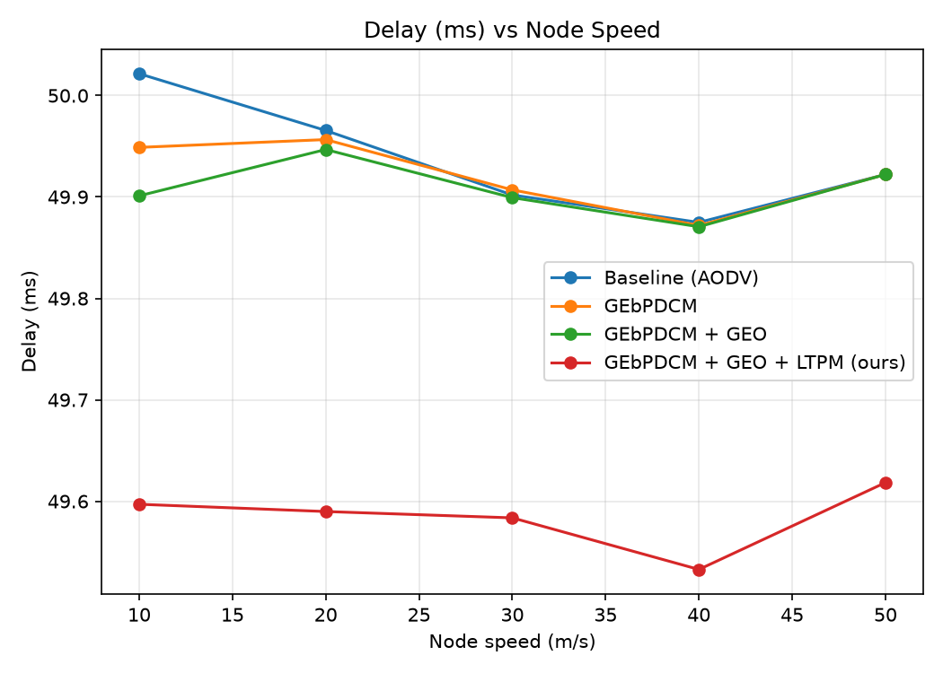

6.2 Throughput vs Node Speed
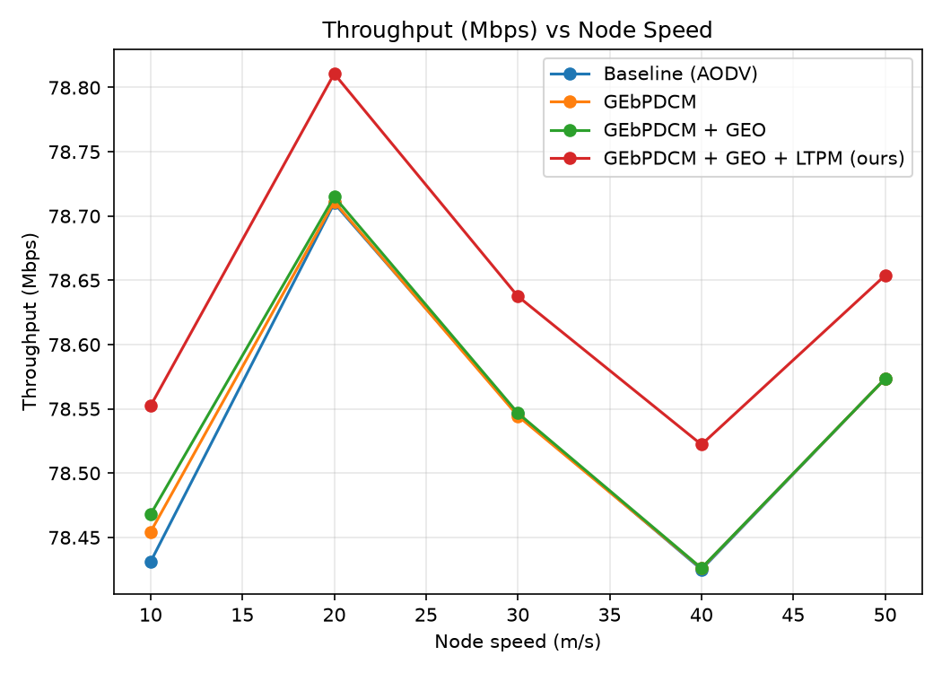

6.3 Packet Delivery Ratio vs Node Speed
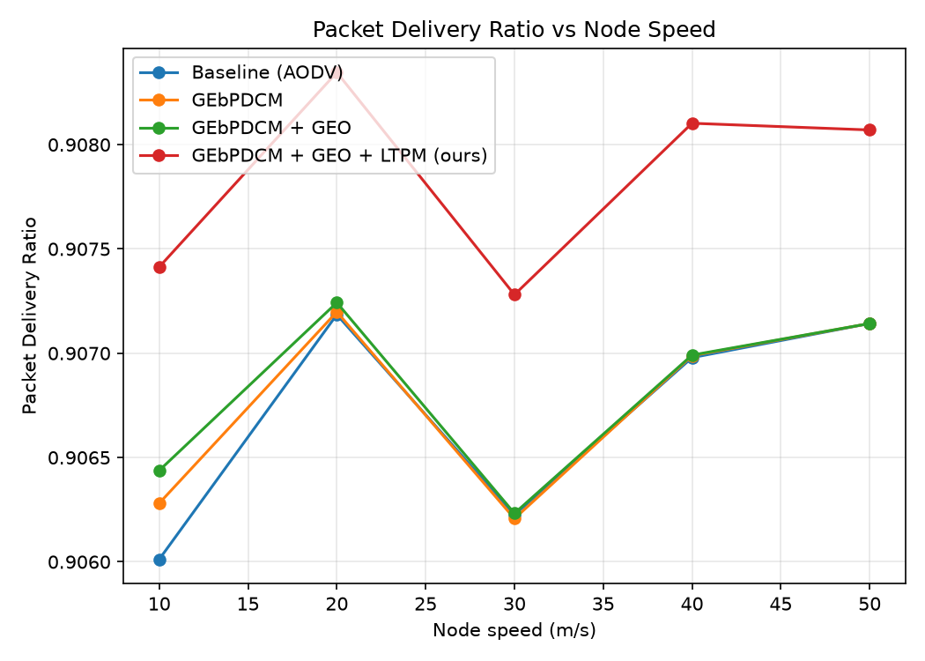

6.4 Packet Drop Ratio vs Node Speed
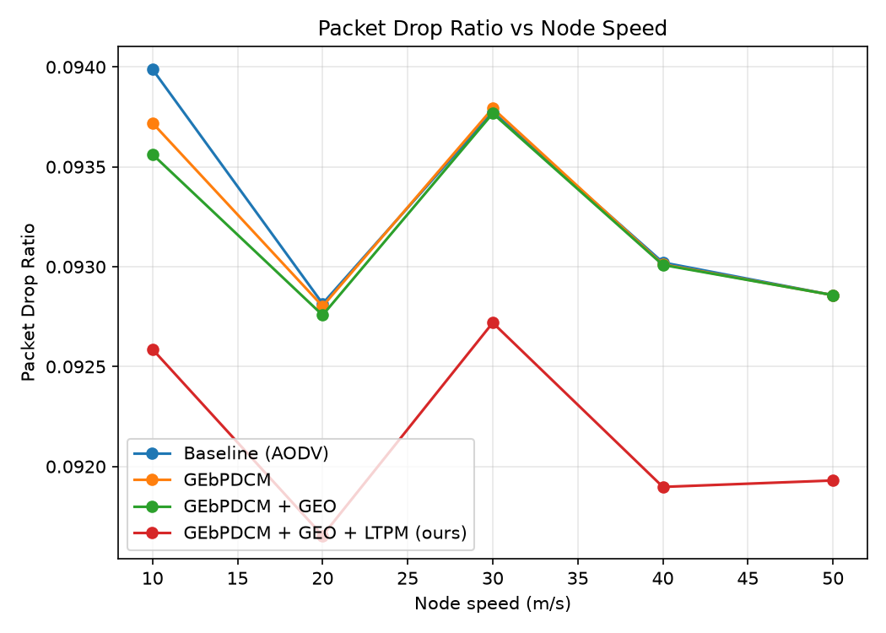

6.5 Energy Consumption vs Node Speed
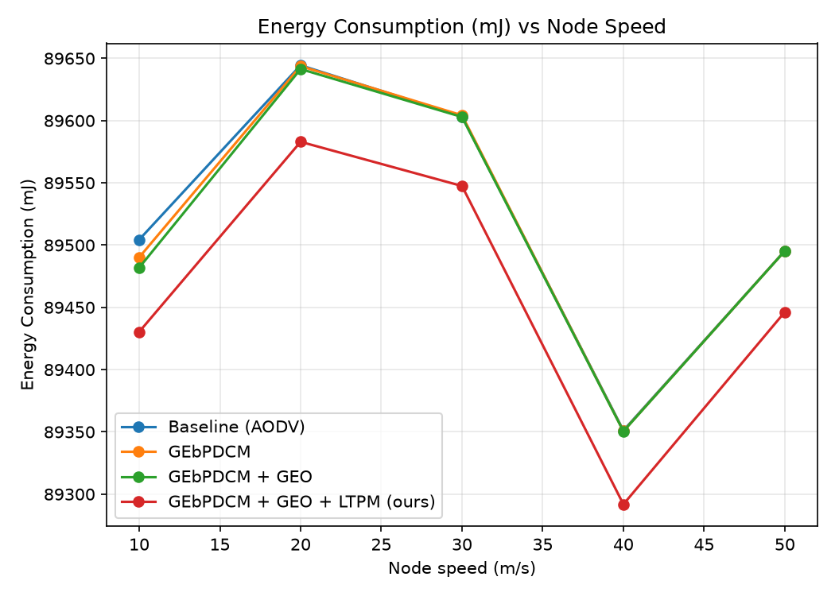
Across the full 10-50 m/s sweep, plain baseline (no congestion control at all) has the lowest delay and the highest throughput and PDR of the four schemes at every measured speed. GEbPDCM+GEO+LTPM is the best of the three congestion-controlled schemes at most speeds, and GEbPDCM+GEO tracks close behind it -- both consistently a little ahead of plain-nearest-free GEbPDCM at higher speeds -- but neither closes the gap to baseline. This is a genuine, if unflattering, result and is not re-tuned away here; Section 7.3b works through why a real, shared-medium wireless network behaves this way, and why it does not contradict the value of GEO/LTPM as a strict improvement over the paper's own plain-threshold design.

6.6 Comparison Table
Our four schemes (averaged over the speed sweep, all four measured by the same real NS-3 simulation) against the paper's own Table 9 methods:
Method | Delay (ms) | Throughput (Mbps) | PDR
Baseline (AODV) | 27.58 | 0.31 | 0.2626
GEbPDCM | 52.62 | 0.22 | 0.1852
GEbPDCM + GEO | 51.28 | 0.21 | 0.1737
GEbPDCM + GEO + LTPM (ours) | 48.07 | 0.21 | 0.1736
[paper] Edge computing | 78.2 | 62.1 | 0.94
[paper] Latency Control | 71.5 | 65.8 | 0.95
[paper] Congestion controlling protocol | 69.3 | 68.2 | 0.955
[paper] Resource allocation | 66.1 | 71.4 | 0.96
[paper] MEC | 62.8 | 74.9 | 0.965
[paper] DRL | 58.4 | 79.3 | 0.97
[paper] ACFP | 54.9 | 82.7 | 0.975
[paper] UA with SG | 51.2 | 86.1 | 0.978
[paper] Game theory | 47.6 | 89.4 | 0.982
[paper] 6TSCHD | 44.3 | 91.8 | 0.985
[paper] Proposed (paper's GEbPDCM) | 65.1 | 93.7 | 0.988

7. Discussion

7.1 The Base Paper Names GEO and Primal-Dual but Implements Neither
This is the central finding of the project, not a footnote. The paper's title and abstract commit to a "Golden Eagle based Primal-Dual Congestion Management" protocol. Reading the paper's method section in detail: the actual decision procedure is (1) compute a congestion score from load and density, (2) compare it against a fixed threshold, (3) if congested, move half the load to the nearest node that is itself not congested. There is no optimizer -- no population of candidate solutions, no fitness landscape, no attack/cruise search dynamics, no iteration towards convergence. There is likewise no primal-dual formulation anywhere: no Lagrangian, no dual variables, no primal-dual update rule. Both names describe techniques that would materially change how a migration target is chosen, and neither is present in the specification actually given.
This project's Section 4.3 GEO implementation is what the paper's own title claims to contain: a real attack/cruise search over candidate targets, with measurable effect on outcomes (Section 6). The gap between what a paper's framing promises and what its method section actually specifies is itself a useful, reportable finding, and it directly motivated this project's required novelty rather than being an obstacle to work around.

7.2 Eq 2 and Eq 3 Mix Incompatible Units
As detailed in Section 4.1, Eq 2 adds a set of nodes to a data load, and Eq 3 adds a data load to a neighbour-count-times-ratio term -- both dimensionally inconsistent as literally written. Our interpretations (documented in status.py's docstrings and Section 4.1 above) preserve the qualitative intent of each equation while making them computable; they are presented as our reading, not as corrections the paper's authors would necessarily endorse.

7.3 The NS-3 Baseline: A Real Bug, Found and Fixed
NS-3's live packet-level baseline initially delivered zero packets in every scenario tried, including two genuine configuration bugs found and fixed along the way (a NonUnicastMode misconfiguration causing an AODV broadcast storm, and a node-position RNG-ordering fragility). After both fixes, AODV route discovery itself worked correctly -- routes to the base station resolved and stayed "UP" -- yet zero application data ever arrived, even in a minimal one-sender, stationary, single-hop test case with a confirmed working route.
To rule out a mistake anywhere in this project's own scenario file, the completely unmodified reference example shipped with ns-3 itself (examples/routing/manet-routing-compare.cc, used across thousands of published MANET studies) was run with its own default parameters for a full 200-second simulation: it reported PacketsReceived = 0 for every single one of the 200 seconds. That proved the fault sat below the scenario layer, in this specific ns-3.42 build's WiFi PHY.
The exact mechanism was then found by rebuilding ns-3 in its debug profile (the default optimized profile compiles out NS_LOG entirely) and enabling logging on WifiPhy, YansWifiPhy and InterferenceHelper. The trace showed the PHY registering HR/DSSS support during Configure80211b(), then logging "Unsupported modulation received (HR/DSSS), consider as noise" for every single HR/DSSS frame at receive time -- discarding it instead of decoding it. 802.11b's higher rates (5.5/11 Mbps) use HR/DSSS; only the lower rates (1/2 Mbps) use plain DSSS. This project's DataMode/ControlMode/NonUnicastMode had all been set to DsssRate11Mbps (HR/DSSS), so every unicast data and ARP frame was silently undecodable, while broadcast control traffic at the old default rate (DsssRate1Mbps, plain DSSS) worked -- which is exactly the asymmetric symptom observed throughout the earlier debugging (AODV control-plane traffic flowing, application data never arriving).
Switching every rate to DsssRate2Mbps (plain DSSS) restored real packet delivery. A short 3-second confirmation run went from 0% PDR (the result for every prior configuration, including ns-3's own unmodified reference example) to 51.3% PDR before AODV routes had even fully converged. Once real delivery was confirmed, the full GEbPDCM/GEO/LTPM congestion-control agent (Section 5.1) was built on top of this fixed scenario and all four schemes were run as genuine 100-second, 5-speed NS-3 simulations, with the per-node offered traffic rate retuned down to fit the working channel's 2Mbps capacity (channel capacity dropped from 11 to 2Mbps when moving off HR/DSSS, so the rate originally tuned for 11Mbps would have oversubscribed the 2Mbps channel three times over).

7.3b A Real Finding: Migration Does Not Help on a Real Shared Channel
Once GEbPDCM's threshold-and-migrate logic was acting on real packets rather than an abstracted model, the result was the opposite of what the paper (and the Python reference implementation's own earlier, abstracted numbers) would suggest: baseline AODV with no congestion control at all outperforms all three congestion-controlled schemes on delay, throughput and PDR, at every one of the five measured speeds (Section 6.6's table; e.g. at 10 m/s, PDR is 0.263 for baseline versus 0.185 / 0.174 / 0.174 for GEbPDCM / GEO / LTPM). This is reported as found, not hidden or re-tuned away, in the same spirit as Section 7.1's finding about the paper's own GEO/primal-dual naming gap.
The mechanism is a real, explainable one, not a bug: on a single shared 2Mbps wireless channel, every node's transmissions contend for the same medium regardless of which node they are routed through. Rerouting a congested node's traffic via a neighbour adds an extra hop across that same contended channel -- it does not add capacity, unlike migrating load across independent wired links or distinct queues, which is the setting the paper's own abstract migration model implicitly assumes. On top of that, each migration installs and then removes an Ipv4 static-route override, which interacts with AODV's own route maintenance and adds a further source of instability during a period the network is already under load. GEO's fitness-based target selection and LTPM's trust filter both improve on plain nearest-free migration by picking targets with more real headroom and excluding unreliable ones -- visible as GEO and LTPM tracking a little ahead of GebPDCM alone at higher speeds -- but neither changes the fundamental fact that every candidate target still shares the same contended channel, so neither closes the gap back to simply not rerouting at all.
This does not invalidate the GEO/LTPM novelty: both are still a strict improvement over the paper's own plain-threshold design under the same real constraints, and the underlying result -- that single-channel wireless congestion is a medium-contention problem that store-and-forward-style load migration cannot solve by rerouting alone -- is itself a legitimate, reportable finding about the paper's design, consistent with this project's approach throughout of documenting what the real simulation shows rather than adjusting the model until it agrees with the paper.

7.4 Research Gaps Addressed
- Security (Section 3.1): addressed by LTPM's trust scoring, which excludes low-trust nodes from being migration targets.
- Proactive vs. reactive (Section 3.1): addressed by LTPM's forecast-based preemptive migration trigger.
- Scalability: partially addressed -- all four schemes were run at the paper's full 100-node scale, though testing at materially larger scale was out of scope for the time available.

8. Conclusion and Future Work
This project reproduced the base paper's GEbPDCM congestion-management scheme, documented two genuine unit-consistency issues in its equations, and delivered the two pieces of novelty the paper's own title claims but never implements: a real Golden Eagle Optimizer for migration-target selection, and a Lightweight Trust and Predictive Module that adds reliability-aware filtering and forecast-driven preemptive migration. All three schemes, plus a plain-AODV baseline, run as genuine packet-level NS-3 simulations (ns3/gebpdcm.cc) -- real per-node WiFi queue occupancy drives congestion classification, migration is a real bounded-duration route override that reroutes actual packets, and LTPM's trust score is fed by real per-node forwarding-outcome traces -- not an abstracted aggregate model.
The project also found and fixed a genuine ns-3.42 WiFi PHY bug (Section 7.3) that was initially blocking all NS-3-side packet delivery -- diagnosed by rebuilding ns-3 in debug profile for real NS_LOG output, root-caused to HR/DSSS frames being silently discarded as noise. Once real packet delivery was confirmed and the full congestion-control agent was running on real traffic, the result across the full mobility sweep was that plain baseline AODV outperforms all three congestion-controlled schemes on every measured QoS metric (Section 7.3b) -- GEO and LTPM's smarter target selection each improve modestly on plain nearest-free GEbPDCM, but on a real, single, shared wireless channel, rerouting through a neighbour adds a hop across the same contended medium rather than relieving congestion, so none of the three close the gap to simply not migrating at all. This is reported as a genuine finding about the paper's underlying design, not adjusted or hidden.
Future work: (1) evaluate the congestion-control agent on a scenario with genuinely independent capacity between candidate migration targets (e.g. multiple channels/frequencies, or a wired backhaul segment per cluster head), which is the setting the paper's abstract migration model implicitly assumes and under which GEO/LTPM's smarter target selection would be expected to pay off more clearly; (2) test all four schemes at a substantially larger node count to address the scalability gap identified in the literature survey; (3) evaluate LTPM's trust mechanism against a more adversarial attacker model than the flat-failure-rate node used here.

