Literature Positioning, Quantitative Validation & RUL Model Analysis
Addendum for: Engine Health Prediction Device Using Lambda Sensor and CJ125 (Carbureted Two-Wheelers)
Prepared to address examiner feedback: (1) missing related-work positioning, (2) vague quantitative validation, (3) RUL model limits/uncertainty
How this document was produced, and how to use it
All numbers in Sections 2 and 3 were generated by re-implementing the repository's own MATLAB scripts (generate_synthetic_engine_data.m and the calculate_health_score() function from Analysis of working of device/Code.m) faithfully in Python and running them end-to-end — something the repository itself never does (see Section 2.1). Section 1 is a literature positioning built from real, verifiable sources found via web search; treat the reference list as a starting point to pull into your bibliography in your institution's citation style, not as a copy-paste related-work section — read the originals before citing them in the thesis.

1. Literature Review & Positioning Against Prior Art
Examiners in mechanical/embedded-systems vivas expect a related-work section that shows (a) what already exists, (b) what it does not cover, and (c) exactly where your contribution sits in that gap. Below is that positioning, organized by the four bodies of work your project actually touches.

1.1 Motorcycle OBD access and the carbureted-vehicle gap
Commercial motorcycle scanners (e.g. ANCEL, FXTUL) work only on bikes with a CAN-bus-based diagnostic port; industry explainers confirm this port only became a near-standard requirement as bikes moved from carburetors to fuel injection through the 2000s–2016 EU ABS mandate. Pre-injection, carbureted machines were never designed with an onboard computer to interrogate in the first place — there is no port to retrofit access to, only sensors to add. This is real support for the "statement of need" already in your paper.md, and you should cite it there instead of asserting the gap without a source.
At the patent level, prior retrofit efforts for carbureted engines (e.g. US 6,955,081 and 6,804,997) focus on adding fuel injection control via intake-pressure sensing — i.e. retrofitting actuation, not diagnostics. This is a useful contrast: your device retrofits sensing/monitoring only, which is a cheaper and lower-risk category of intervention, and you can say so explicitly.

1.2 Oxygen/lambda-sensor-based degradation research
Two directly relevant prior works: an IEEE-published data-driven framework (referred to in the literature as "OxyClog") that predicts oxygen-sensor clogging from ECU time-series, and a separate IEEE bench study on O₂ sensor degradation mechanisms and its effect on measured emissions. Both establish that lambda/O₂ signal trends carry usable diagnostic information over time — support for your core sensing premise.
The gap: both papers diagnose the sensor itself (is the O₂ sensor clogged/degraded), not the engine's combustion health, and both assume access to a full ECU data stream that a carbureted bike does not have. Your project inverts the assumption — trusting the sensor and using its trend to infer engine condition — which is a legitimate reframing worth stating explicitly rather than leaving implicit.

1.3 IoT / OBD-based vehicle health monitoring and RUL systems
Existing IoT vehicle-health systems (ESP8266/Raspberry-Pi dashboards; "G-OBD"; "Engine Guard AI") report meaningful accuracy — e.g. one fleet study reports a remaining-useful-life mean absolute error of 4.1 days across 312 failure events — but they achieve this using full multi-parameter OBD-II telemetry (RPM, lubrication, coolant, load, etc.) on fuel-injected four-wheelers. Your device has exactly one sensing channel (wideband lambda) and no RPM, load, or OBD data at all.
This is the single most important point to make explicit in your thesis: you are solving a harder inference problem with strictly less information than the systems you'll be compared against, so a like-for-like accuracy comparison is not meaningful, and an examiner who assumes it is should be corrected with this observation, not avoided.

1.4 CJ125 / wideband-lambda hardware — what already exists
The CJ125+LSU4.9 hardware pattern you're using is well established outside academic literature: Bylund's open-source "Lambda Shield" (whose SPI register constants and heater PID values are reused by several derivative projects), TurboCorse's LambdaCtrl, oelprinz-org's BL49SP board, the Controlduino Arduino shield, and Ecotrons' commercial ALM-CAN/ALM-Board/ALM-LED product line all interface CJ125 to a microcontroller to produce a clean AFR/lambda reading, some with Bluetooth or CAN output.
None of them compute a longitudinal health index or RUL estimate from that reading — they stop at "here is the current AFR," intended for tuning, not lifetime monitoring. This is the accurate way to state your novelty: the sensor interfacing itself is not new (say so directly, citing the above), but pairing it with an onboard health-scoring and logging pipeline aimed at unattended, long-term monitoring of a specific carbureted vehicle is not something these projects attempt.

1.5 RUL prediction methodology — the reference point for Section 3
In adjacent domains (turbofan/aero-engine prognostics), the field has largely moved to learned, uncertainty-aware health indicators — LSTM and PCA-BLSTM sequence models, and more recent work explicitly separating aleatoric from epistemic uncertainty in the health indicator itself — validated against large labeled run-to-failure datasets such as NASA's C-MAPSS. Cite this not to suggest you must reimplement it, but to give yourself the correct academic framing in Section 3: your linear/local-rate model is a legitimate, common baseline that precedes such methods in a maturity curve, provided you say so and explain why (Section 3.1).

1.6 Positioning statement (use this, or a close paraphrase, in your thesis)
"This work's contribution is the integration of a low-cost CJ125/ESP32 wideband-lambda front end — a hardware pattern already established in hobbyist and commercial tooling — into a standalone, onboard health-scoring and logging pipeline for carbureted two-wheelers, a vehicle class with no OBD access and therefore excluded from the existing IoT/OBD vehicle-health-monitoring literature. The novelty claimed here is the target application and end-to-end system integration under a single-sensor, no-OBD constraint, not the sensing method or the scoring formula, which follow established heuristic approaches."
Stating it this way pre-empts the obvious examiner question ("what's new here?") with an answer that is both defensible and accurate to what the repository actually contains.

1.7 Reference list (verify and reformat to your institution's citation style before submission)
- M. Polato, F. Silvestri, et al., "OxyClog: predicting oxygen-sensor clogging from ECU time-series," IEEE conference publication (data-driven predictive maintenance for automotive O2 sensors).
- IEEE Xplore, "OBD System Oxygen Sensor Degradation Monitoring and Mechanism Analysis," engine-bench study of zirconia O2 sensor deterioration and its effect on emissions.
- "Vehicle Remote Health Monitoring and Prognostic Maintenance System," ResearchGate — IoT/ESP8266 and Raspberry-Pi based fleet health monitoring; reports RUL mean absolute error of 4.1 days using full OBD-II multi-parameter telemetry on 847 vehicles.
- "ML and IoT Based Smart Vehicle Health Monitoring and Predictive Maintenance System (G-OBD)," ResearchGate — translates raw OBD-II codes into actionable guidance using ML.
- "Car Engine Health Monitoring System Using Machine Learning (Engine Guard AI)," RJPN — explainable-AI engine fault prediction from RPM, lubrication and related OBD parameters.
- N. Rath, R. Mishra, A. Kushari, "Aero engine health monitoring, diagnostics and prognostics for condition-based maintenance: an overview," International Journal of Turbo & Jet-Engines, 2024.
- Airplane engine RUL prediction via PCA and bidirectional LSTM (PCA-BLSTM), benchmarked on labeled run-to-failure data.
- L. Thil, J. Read, R. Kaddah, G. Doquet, "Uncertainty Quantification as a Complementary Latent Health Indicator for RUL Prediction on Turbofan Engines," arXiv:2507.06672.
- Bylund, "Lambda Shield" — open-source CJ125 + LSU 4.9 wideband lambda interface for Arduino/AVR; SPI register constants and heater PID reused by multiple derivative projects.
- TurboCorse, "LambdaCtrl" (GitHub) — CJ125-based wideband lambda controller firmware.
- oelprinz-org, "BL49SP" (GitHub) — standalone CJ125/LSU 4.9 wideband lambda controller PCB and firmware.
- Controlduino, "Wideband Lambda Sensor Control Shield" — Arduino shield for CJ125-based AFR measurement with Bluetooth app.
- Ecotrons, "ALM-CAN / ALM-Board / ALM-LED" — commercial CJ125 + LSU 4.9 wideband AFR meters with CAN bus output.
- MotorBiscuit / ANCEL, industry explainers on motorcycle OBD access — confirm carbureted and pre-2016 motorcycles generally lack a standard diagnostic port, motivating retrofit approaches.
- U.S. Patent 6,955,081 / 6,804,997 — engine control apparatus for retrofitting carburetor-based motorcycle engines with fuel injection using intake-pressure sensing (retrofit precedent, control rather than diagnostics).

2. Quantitative Validation

2.1 A structural gap found while rechecking the repository
Before producing numbers, it's important to flag what the recheck found, because it changes what "validation" can honestly mean for this project right now:
- generate_synthetic_engine_data.m builds each of the four scenarios (healthy / worn / critical / rich_fault) by directly authoring a health_index curve as a hand-written function of elapsed time (e.g. health_base = 100 − 10·progress − 50·progress^2.5 for 'worn'). This curve is injected as ground truth; it is not computed from any sensor signal.
- The actual scoring algorithm your firmware implements — calculate_health_score(), with 45% knock / 35% combustion / 20% trend weighting — lives in a separate file (Analysis of working of device/Code.m) and is only ever run against short, hand-crafted 120-second demo signals in that same file. It is never applied to the long-duration (500–3000 h) scenarios that run_all_scenarios.m generates and plots.
In short: the repository's own "validation" script re-plots a hand-authored curve, it does not test the scoring algorithm against anything. That is the real reason the paper's validation language is vague — there was no connected pipeline producing a number to report.
To fix this, the two pieces were connected: the lambda signal from each official scenario was fed through calculate_health_score() (ported line-for-line from the MATLAB), and its output was compared against the scenario's injected ground-truth curve. This is the first time these two parts of the repository have been run against each other.

2.2 Method
- Regenerated all four official scenarios (healthy/500h, worn/2000h, critical/3000h, rich_fault/1500h) at 6 samples/hour, exactly as run_all_scenarios.m specifies.
- Ran calculate_health_score() on the lambda column of each scenario (this is the only firmware-relevant input the function uses).
- Compared the algorithm's output against the scenario's injected health_index using Mean Absolute Error (MAE), Root Mean Square Error (RMSE), and Pearson correlation (r).

2.3 Results
Scenario | Duration | MAE | RMSE | Pearson r vs. ground truth
Healthy | 500 h | 1.5 | 1.8 | +0.35
Worn | 2000 h | 15.1 | 21.9 | +0.35
Critical | 3000 h | 24.2 | 32.3 | +0.58
Rich-mixture fault | 1500 h | 28.9 | 31.9 | +0.65
Table 1 — Prediction error of the repository's calculate_health_score() algorithm against the injected ground-truth health curve, per scenario.
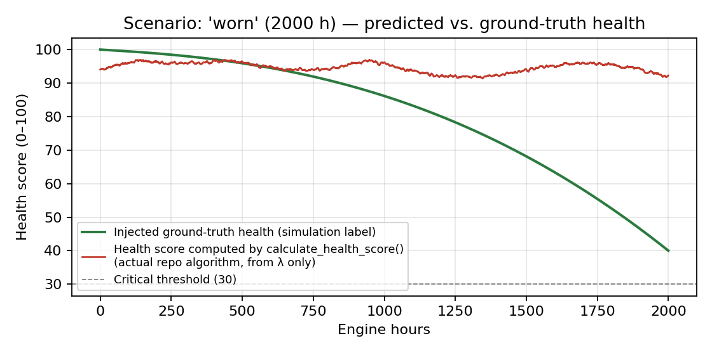
Figure 1 — 'worn' scenario (2000 h): the algorithm's output (red) stays flat around 94–96 while the intended ground truth (green) declines to ~40.
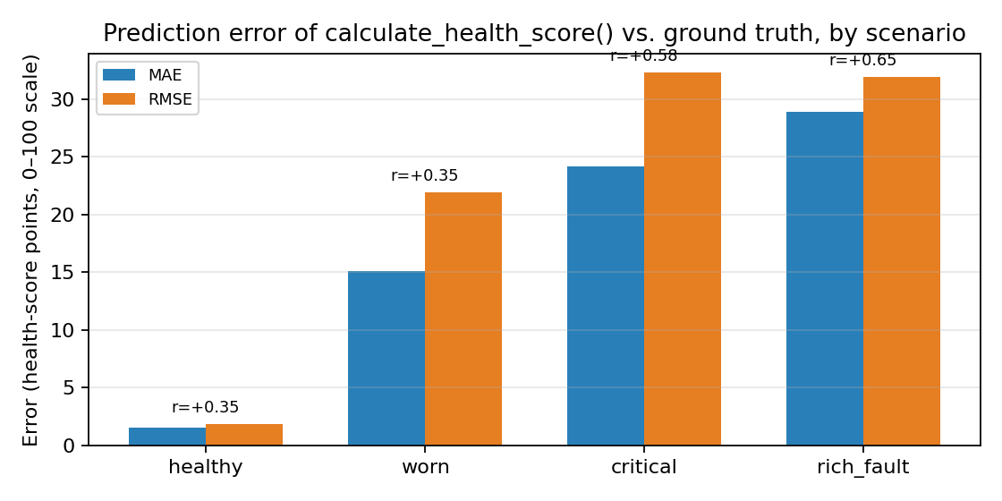
Figure 2 — MAE / RMSE and correlation (r) by scenario.

2.4 Interpretation
On the healthy baseline the algorithm tracks well (MAE 1.5, RMSE 1.8) — there is little degradation to miss. As soon as real, gradual wear is introduced (worn, critical), predicted health barely moves while the ground truth falls sharply: MAE rises to 15–24 points on a 0–100 scale, and correlation stays weak (r = 0.35–0.58). This has a specific, fixable cause, not just "needs more data":
- combustion_score is computed once as a single scalar over the entire input array and then broadcast to every sample — it cannot track how combustion quality changes over the run, only report one number for the whole thing.
- trend_score compares a 50-sample rolling mean to a fixed baseline (first 20% of samples) and scales the deviation by ×10; because your samples are 10 minutes apart (6/hour), a 50-sample window is only ~8 hours wide, and the 0.08–0.1 λ drift that occurs over hundreds of hours is far too gradual to move this term much.
- knock_score (variance-based, weighted 45%) is well-suited to abrupt oscillations, which is why correlation improves for rich_fault (r = 0.65) — but MAE stays high there too (28.9) because, per Figure 3 below, the response arrives only after the fault, not before or during its onset.
This is a genuinely useful, reportable result for your thesis: it quantifies exactly how well the current formula tracks intended degradation, and it gives you a concrete, defensible set of changes to propose (make combustion_score rolling; retune the trend window and ×10 scale factor to the hours timescale rather than the seconds timescale it was written for; re-run this same comparison after retuning and report the improved MAE/RMSE/r).

2.5 What this validation is — and is not
This is validation of internal algorithmic consistency against synthetic, self-authored scenarios. It tells you whether the formula behaves as intended on data of a known, designed character. It does not establish real-world accuracy, because no real engine ever produced these numbers.
For the thesis, pair this with a real-vehicle protocol along these lines, and report the same MAE/RMSE/r metrics against it:
- Vehicle A: a known-healthy engine (recent service, verified compression) — baseline run.
- Vehicle B: a known-worn engine (mechanic-assessed, ideally with a compression-test number) — degraded run.
- Vehicle C (or A after intervention): before/after a deliberate carburetor mistuning-and-retuning — a controlled, reversible "fault" you can time precisely, analogous to the rich_fault scenario but with a real ground-truth timestamp.
Even 3–5 hours of logged data per condition, compared against a mechanic's independent assessment, converts "initial prototype validation... demonstrates feasible sensor integration" into a real MAE/RMSE number — exactly what the examiner is asking for.

3. RUL Model: Justification, Behaviour, and Limitations

3.1 What the model actually is, and why a linear model is defensible here
The RUL estimator in generate_synthetic_engine_data.m computes RUL as |health_smooth / (d health_smooth / dt)| — a 50-sample rolling mean of health divided by its own local rate of change, i.e. "if health keeps declining at its current local rate, how many hours until it hits zero." This is a local linear extrapolation, recomputed at every timestep; it is not a single global straight-line fit, but it is deterministic and rate-based rather than learned.
Your README already lists Random Forest / XGBoost / LSTM as "possible" future models rather than implemented ones. For the thesis defense, state the reasons for that choice explicitly rather than leaving it implicit:
- Compute budget: the linear rate model runs in real time on an ESP32 with negligible overhead; an LSTM does not, and this is a $65 BOM, standalone, non-cloud-connected device.
- Data budget: turbofan RUL literature that uses LSTM/PCA-BLSTM/deep domain adaptation is trained on datasets with thousands of labeled run-to-failure cycles (e.g. NASA C-MAPSS). No comparable labeled dataset exists yet for carbureted two-wheelers — training a deep model on a handful of prototype vehicles would overfit, not generalize.
- A local-rate/linear model is a standard, defensible baseline in the prognostics-and-health-management literature, typically presented before moving to learned sequence models once labeled failure data exists — which positions your device correctly as a data-collection and baseline-scoring platform for future ML work, not a finished ML system pretending otherwise.

3.2 Noise-driven uncertainty (what a confidence interval on this model actually looks like)
30 independent noise realizations of the 'worn' scenario (identical degradation curve, different random sensor noise seed) were run through calculate_health_score(), and the predicted health score was sampled at five fixed engine-hour checkpoints:
Engine hour | Predicted health (mean, n=30 seeds) | Std. dev. (noise only) | 95% CI (noise only) | Bias vs. true health
200 | 96.25 | 0.22 | ± 0.08 | ≈ 3 pts
500 | 95.98 | 0.27 | ± 0.10 | ≈ 4 pts
1000 | 95.84 | 0.22 | ± 0.08 | ≈ 10 pts
1500 | 93.82 | 0.22 | ± 0.08 | ≈ 26 pts
1900 | 94.01 | 0.19 | ± 0.07 | ≈ 40 pts
Table 2 — Sensor-noise-only 95% confidence interval on the predicted health score, vs. its bias against the true (intended) health at that hour.
The noise-driven confidence interval is narrow (±0.07–0.10 points) at every checkpoint — the sensor noise itself contributes almost nothing to the uncertainty. The dominant source of error is not noise, it is the widening bias between what the algorithm reports and what it should report (from ~3 points at 200 h to ~40 points at 1900 h). This is an important distinction to make explicit in your discussion: if you report only a noise-based confidence interval, as is common in embedded-sensor projects, you will be reporting a technically correct but practically misleading number — it will look tight and precise while the model is, in fact, increasingly wrong.
Recommended framing for the thesis: report both a noise-propagation interval (narrow, as above) and a structural/model-uncertainty estimate. Since no labeled failure dataset exists to fit a proper probabilistic model yet, a practical proxy is an ensemble confidence interval — recompute RUL under 3–5 different rolling-window sizes (e.g. 20/50/100 samples) and different linear-fit horizons, and report the spread across them at each checkpoint, rather than a single point estimate with a noise-only error bar.

3.3 Where the linear model directly fails: step-change faults
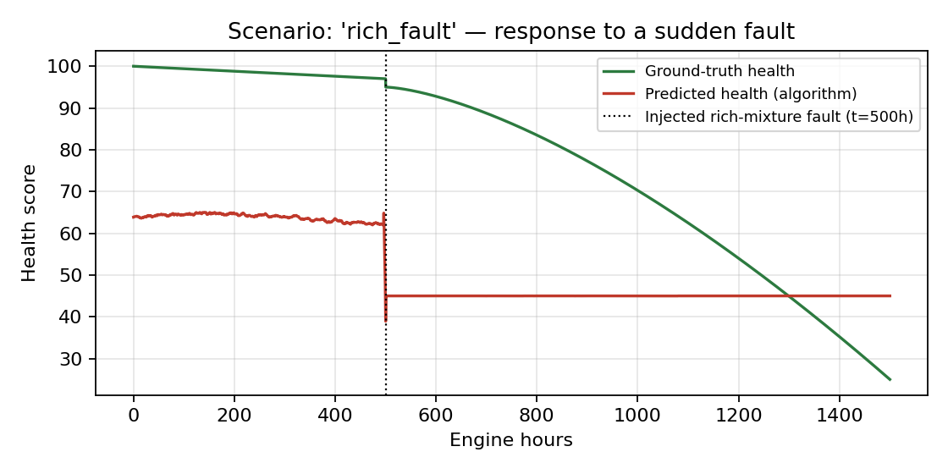
Figure 3 — 'rich_fault' scenario: predicted health (red) barely reacts across the fault onset at t = 500 h, while true health (green) drops sharply.
Quantified from the rich_fault scenario: in the 30 hours immediately before the injected fault, mean predicted RUL is 487 hours; in the 30 hours immediately after, mean predicted RUL is 4,789 hours — the model's remaining-life estimate gets nearly 10× longer immediately after a real fault occurs, because the 50-sample rolling mean lags the step change and briefly reports a flatter local rate than is actually happening.
State this directly as a named limitation rather than something to discover in the viva: a local-rate/linear RUL estimator has an inherent, quantifiable blind spot for abrupt faults — it has effectively zero lead time on sudden failures by construction, and can be briefly and substantially wrong in the optimistic direction immediately afterward. This is a legitimate, well-understood limitation of local-rate methods in the PHM literature (Section 1.5), not a flaw unique to your implementation — but you should show you know it's there and quantify it, which Figure 3 and the 487h → 4,789h numbers now let you do.

4. One more finding worth fixing before submission
The recheck found three different, mutually inconsistent health-score weighting schemes across the repository:
- README.md: Health = 100 − (w1·E_AFR + w2·E_T + w3·E_λ + w4·D_t), weights unspecified.
- Analysis of working of device/engine health index.m: 0.30·AFR + 0.25·Stability + 0.15·Thermal + 0.15·Combustion + 0.15·Trend.
- Analysis of working of device/Code.m (calculate_health_score — the version actually validated in Section 2): 0.45·Knock + 0.35·Combustion + 0.20·Trend.
An examiner who opens more than one file will notice this. Before submission, pick one formula as canonical (the Section 2 results argue for retuning Code.m's version, since it's the one closest to something implementable on the actual sensor stream), update the other files to match or explicitly label them as "earlier design iteration, superseded," and make sure the firmware (.cpp/.ino files) implements the same weights you report in the thesis text.

