1. Given numbers = [1, 2, 3, 4, 5], use a for loop to print each number.

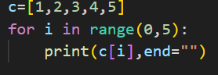

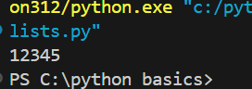

2. Given fruits = ["apple", "banana", "cherry"], use a for loop to print:

css

Copy

Edit

I like apple

I like banana

I like cherry

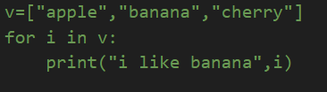

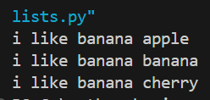

3.Sum of List Elements:Given nums = [10, 20, 30, 40], use a for loop to calculate and print the total sum.

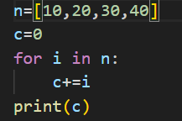



4.Count Even Numbers:Given numbers = [1, 2, 3, 4, 5, 6], use a for loop to count how many numbers are even.

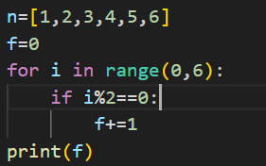



5. Find the Largest Number:Given nums = [3, 7, 2, 8, 5], use a for loop to find and print the largest number.

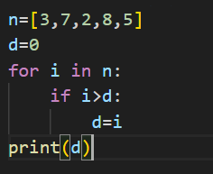



6.Multiply Each Element by 2:Given nums = [1, 2, 3, 4], use a for loop to create a new list where each number is doubled.

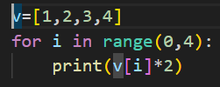

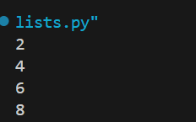

7. Reverse a List (Using Loop):Given words = ["hello", "world", "python"], use a for loop to print the elements in reverse order.

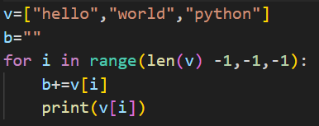

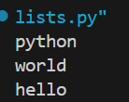

8. Find Words Starting with 'A':Given words = ["apple", "banana", "avocado", "grape"], use a for loop to print only the words that start with "a".

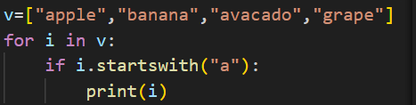

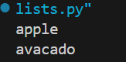

9. Create a New List with Only Positive Numbers:Given numbers = [-5, 10, -3, 7, -2, 8], use a for loop to create a new list containing only the positive numbers.

