**Java Plug-in**

**Scenario’s Document**

**Scenario 1:**Once the user clicks on the navigation panel in the Appian system, there will be an option as JSON to Excel in that list, once I select the option a new window will be opened, in that there will be a field as Select report with a dropdown, once I click on that dropdown there will be 4 options which are mentioned below. Non - Template report will be default shown in the field.

1. **Non - Template Report**
2. Template Report
3. Template with Multiple Sheets
4. Template with Single Sheet

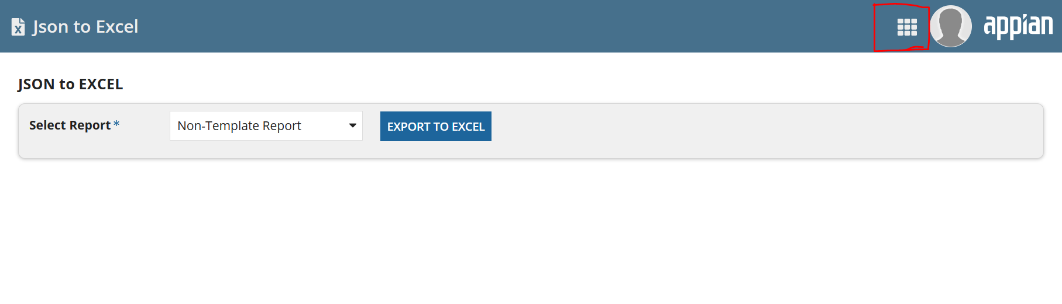

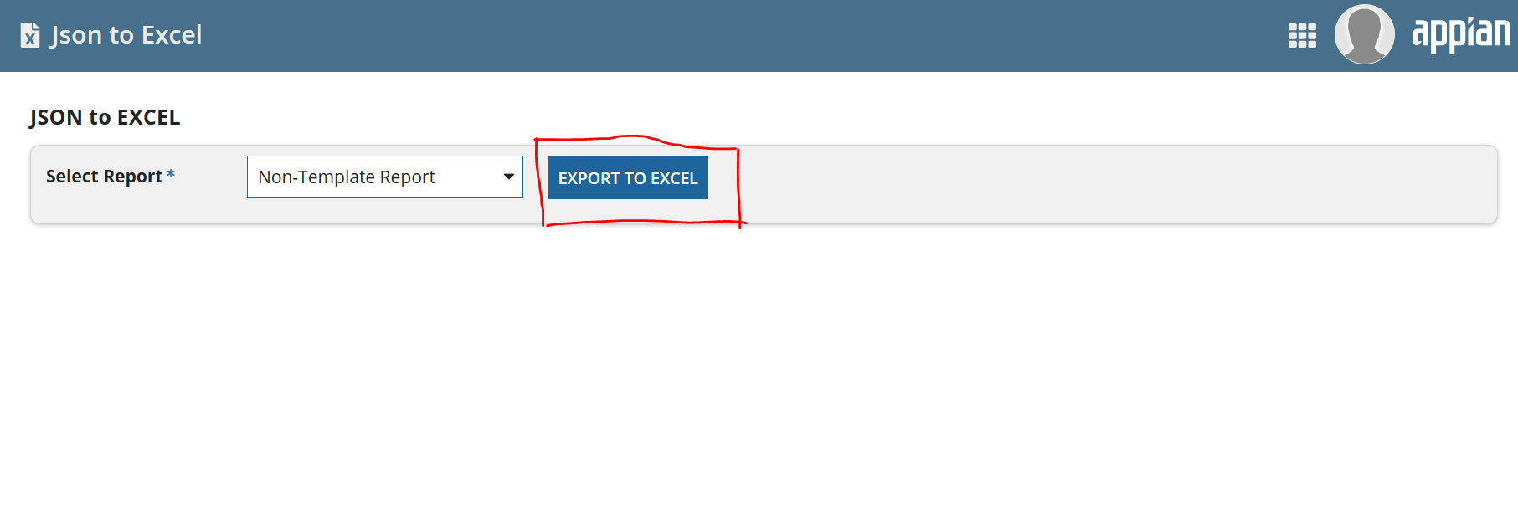

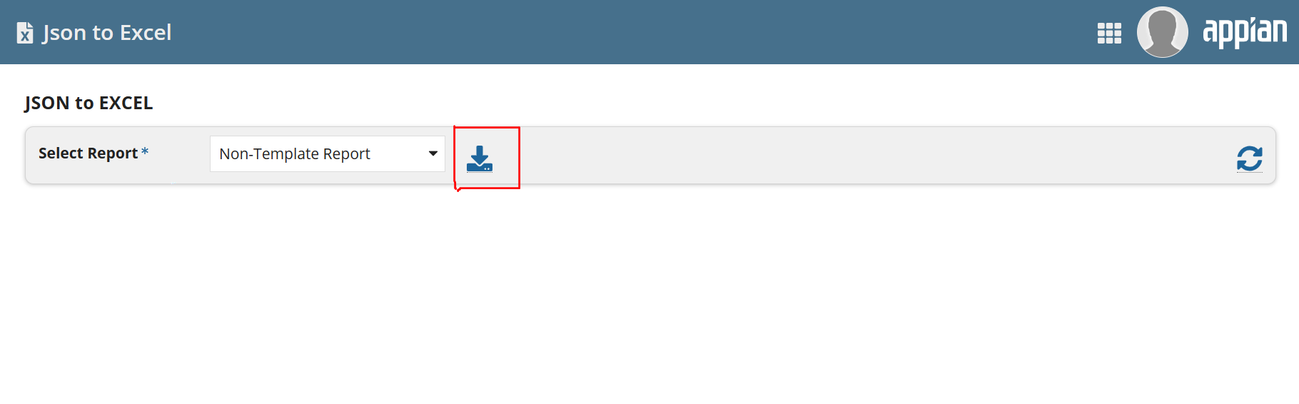

Post clicking on the Export to Excel option, the system will take the data from the Appian stored procedure in a string format (JSON) and java plug-in will be called which convert the data from Json to Excel. Once the data is convert to Excel will see a option as Download (Icon).

Post clicking on that option the Excel sheet will be downloaded into the system.

**Note:** By selecting this Non – Template report option the system will generate the default file name and auto selects the row (Default row) and converts the data into that Excel sheet.

**Scenario 2:**Once the user clicks on the navigation panel in the Appian system, there will a option as JSON to Excel in that list, once I select the option, a new window will be opened in that there will be a field as select report with a dropdown, once I click on that dropdown there will be 4 options which are mentioned below.

1. Non - Template Report
2. **Template Report**
3. Template with Multiple Sheets
4. Template with Single Sheet

Now when the user clicks on the 2nd option from the drop down list, that template name will be displayed in the field and the system will show the below mentioned options which user has to fill before Exporting.

* Row Number (Mandatory)
* Out Put Excel Document Name (Mandatory)
* Sheet Number (Mandatory)

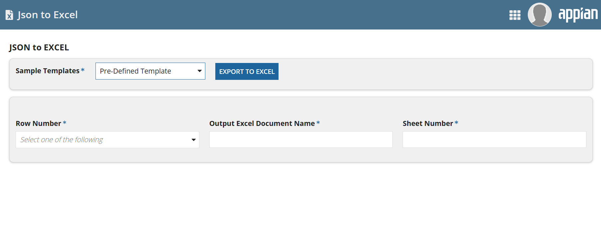

Once the user fills all the above information, clicking on the Export to Excel option, the system will take the data from the Appian stored procedure in a string format (JSON) and java plug-in will be called which convert the data from Json to Excel. Once the data is convert to Excel, will see an option as Download (Icon).

Post clicking on that option the Excel sheet will be downloaded into the system.

**Note:** In this Template Reportoption by filling the above-mentioned details the system will start filling the data from the specified row number, in specified sheet and with a given document name.

**Scenario 3:**Once the user clicks on the navigation panel in the Appian system, there will a option as JSON to Excel in that list, once I select the option, a new window will be opened in that there will be a field select report with a dropdown, once I click on that dropdown there will be 4 options which are mentioned below.

1. Non - Template Report
2. Template Report
3. **Template with Multiple Sheets**
4. Template with Single Sheet

Now when the user clicks on the 3rd option from the drop down list, Export to Excel option will be populated and the system will show the below mentioned options which user has to fill before exporting.

* Pre-defined Template (Yes/No) (Mandatory)
* Header (True/False) (Mandatory)
* Row Number (Mandatory)
* Out Put Excel Document Name (Mandatory)
* Number of Sheets (Mandatory)

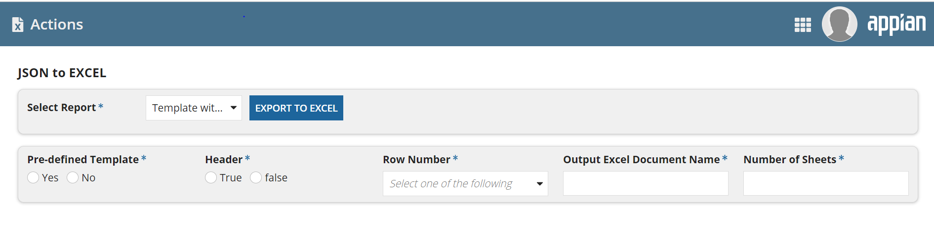

Once the user fills all the above information, clicking on the Export to Excel option, the system will take the data from the Appian stored procedure in a string format (JSON) and java plug-in will be called which convert the data from Json to Excel. Once the data is convert to Excel, will see a option as Download (Icon).

Post clicking on that option the Excel sheet will be downloaded into the system.

**Note:** In this Template with Multiple Sheets option by filling the above mentioned details the system will fill the data from the specified row number, with a given document name and Number of sheets selected with the given template.

**Scenario 4:**

Once the user clicks on the navigation panel in the Appian system, there will an option as JSON to Excel in that list, once I select the option, a new window will be opened in that there will be a field select report with a dropdown, once I click on that dropdown there will be 4 options which are mentioned below.

1. Non - Template Report
2. Template Report
3. Template with Multiple Sheets
4. **Template with Single Sheet**

Now when the user clicks on the 4th option from the drop down list, Export to Excel option will be populated and the system will show the below mentioned options which user has to fill before exporting.

* Pre-defined Template (Yes/No) (Mandatory)
* Header (True/False) (Mandatory)
* Row Number (Mandatory)
* Out Put Excel Document Name (Mandatory)
* Number of Rows in sheet (Mandatory)

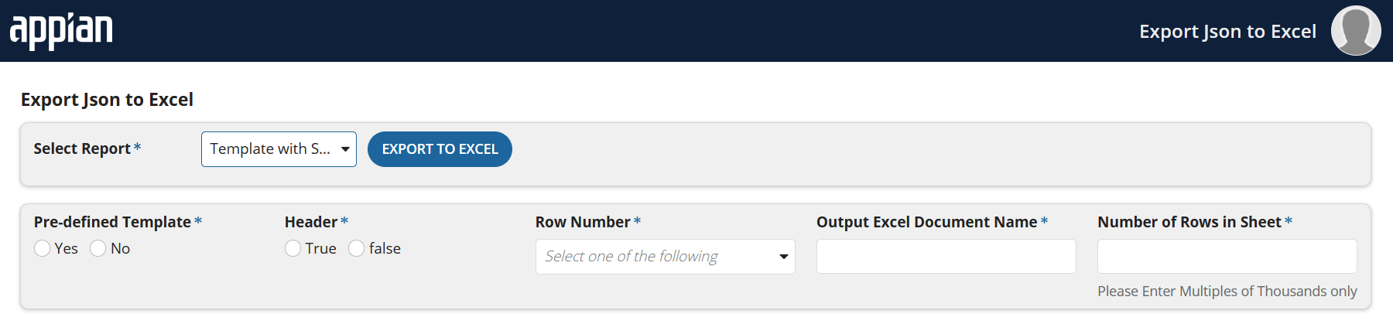

Once the user fills all the above information, clicking on the Export to Excel option, the system will take the data from the Appian stored procedure in a string format (JSON) and java plug-in will be called which convert the data from Json to Excel. Once the data is converted to Excel, will see an option as Download (Icon).

Post clicking on that option the Excel sheet will be downloaded into the system.

**Note:** In this Template with Single Sheet option by filling the above mentioned details the system will fill the data from the specified row number, with a given document name and data will entered in a single sheet with the given template.

**Flow Chart:**

