

Program Name: (BCS )hons

Course Code:  2423

Course Name: Distributed and Parallel Computing

**Individual project**

Date of Submission: 10th   September 2021

**Submitted By: Submitted To:**

Student Name: Pradip Dhakal Faculty Name: Manoj Gautam

IUKL ID: 042902900047 Department: LMS

Semester: 4th

Intake: September 2019

**Introduction**

Web log analysis software (also known as a web log analyzer) is a type of web analytics software that parses a server log file from a web server and extracts information about when, how, and by whom a web server is accessed based on the values included in the log file. Reports are normally created right away, but data retrieved from log files can also be kept in a database, allowing for further analysis. This web application is made by using HTML/CSS/bootstrap/ C++. I have also implemented C++ thread in this program. The log file will break into 4 different parts using 4 threads and parse.

**Technologies**

* HTML/CSS (for frontend webapp)
* C++ (for parsing log file)
* Json ( for creating server)

**Feature of the Web Application (Weblogalanyzer)**

* It will show country wise data
* It will show operating system wise data
* It will show user access time wise data
* It will show browser wise data
* Graphical representation
* Easy to understand
* Many more

**Testing**

**index page**

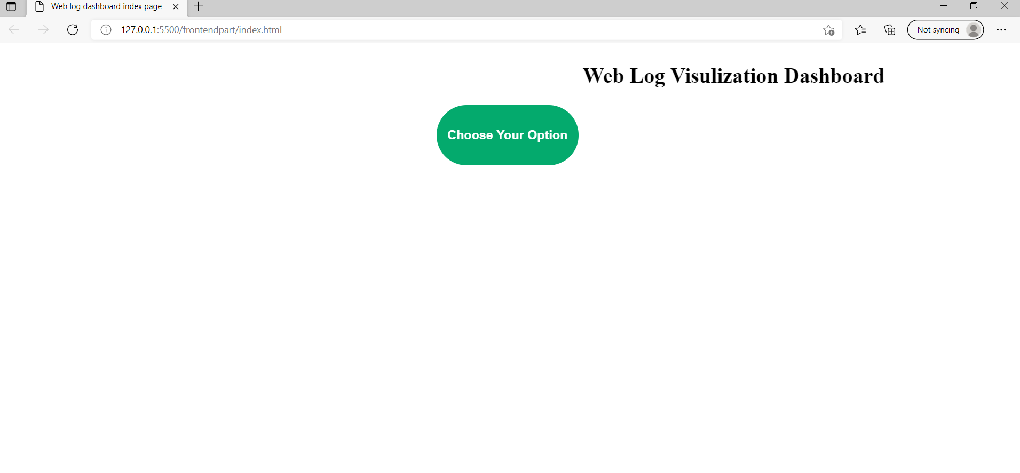

**Country Wise data**

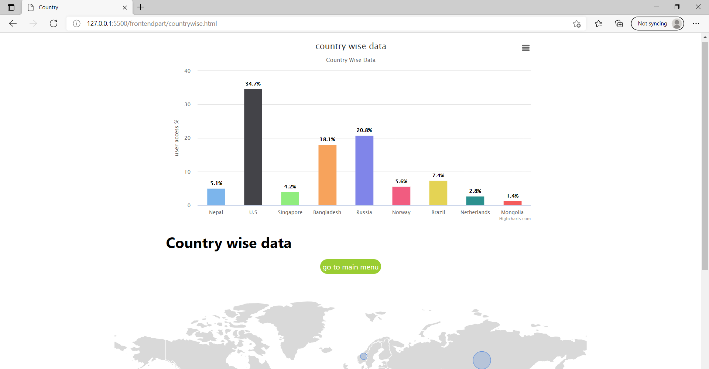

**Operating System wise data**

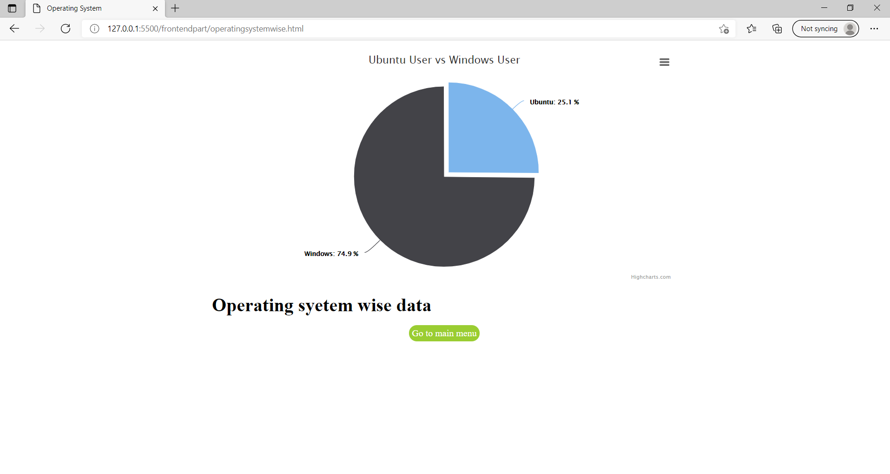

**Browser wise data**

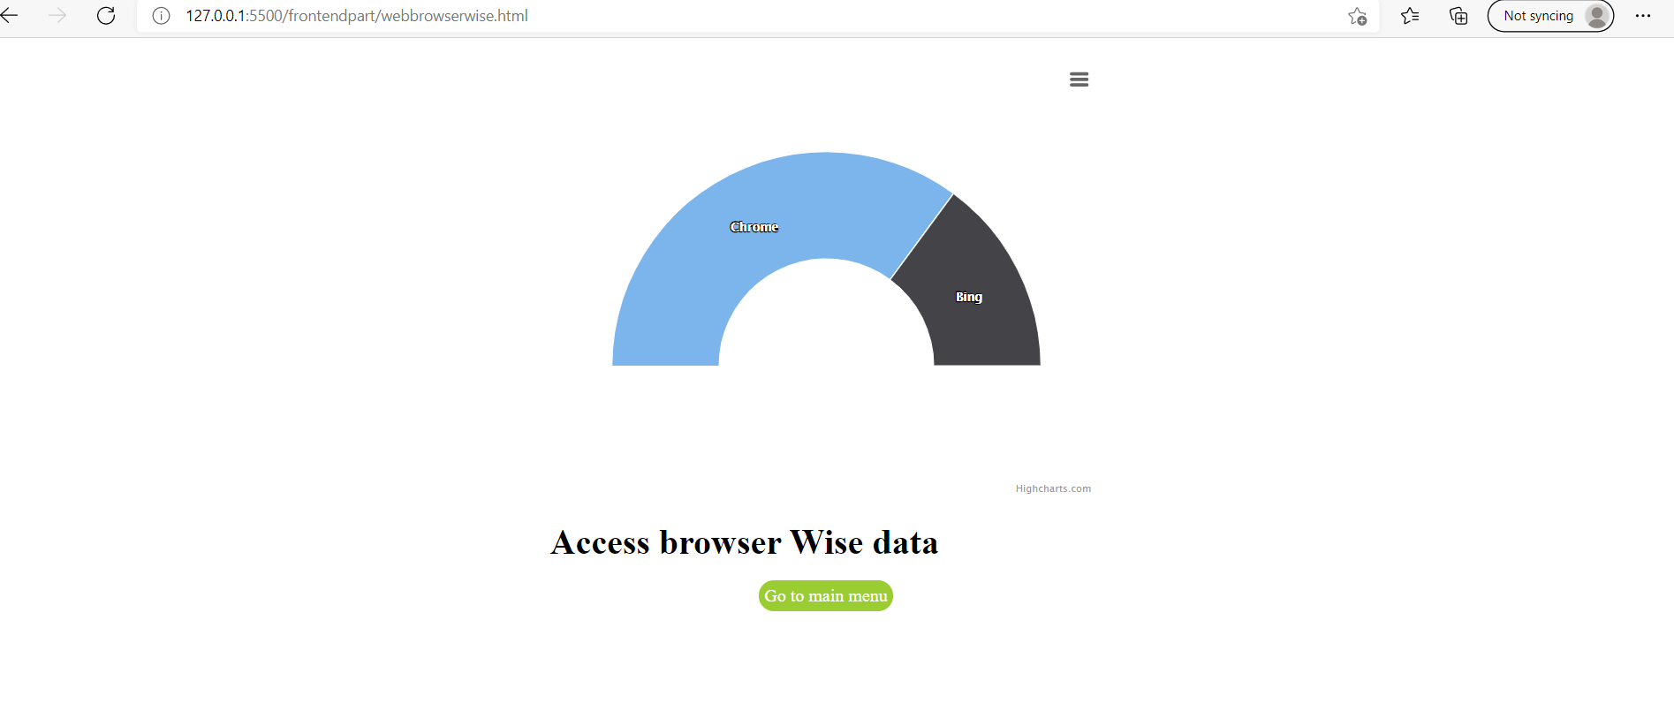

**User access time wise data**

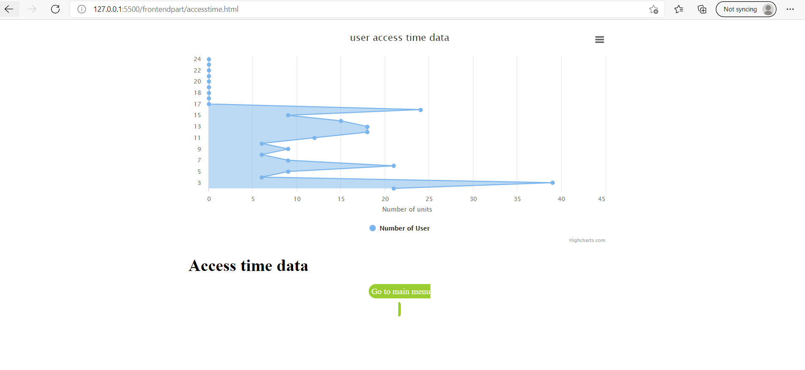

**Appendix**

**Github** [**link**](https://github.com/Pradeep-Dhakal/Apache_logfile_visulization)**:** [**https://github.com/Pradeep-Dhakal/Apache_logfile_visulization**](https://github.com/Pradeep-Dhakal/Apache_logfile_visulization)

**To start this web app**

**Step1:** npm install -g json-server

**Step2:** json-server –watch loginfo.json

**Index.html**

<!DOCTYPE html>

<html>

<head>

<meta name="viewport" content="width=device-width, initial-scale=1">

<title>Web log dashboard index page </title>

<style>

.dropbtn {

  background-color: #04AA6D;

  color: white;

  padding: 16px;

  font-size: 16px;

  border: none;

  border-radius: 5em;

}

.dropdown {

  position: relative;

  display: inline-block;

}

.dropdown-content {

  display: none;

  position: absolute;

  background-color: #f1f1f1;

  min-width: 160px;

  box-shadow: 0px 8px 16px 0px rgba(0,0,0,0.2);

  z-index: 1;

}

.dropdown-content a {

  color: black;

  padding: 12px 16px;

  text-decoration: none;

  display: block;

  border-radius: 4em;

}

.dropdown-content a:hover {background-color: #ddd;}

.dropdown:hover .dropdown-content {display: block;}

.dropdown:hover .dropbtn {background-color: #3e8e41;}

</style>

</head>

<body>

<marquee behavior="" direction=""><h1>Web Log Visulization Dashboard</h1></marquee>

<center>

<div class="dropdown">

  <button class="dropbtn"><h3> Choose Your  Option</h3>  </button>

  <div class="dropdown-content">

    <a href="countrywise.html">View Country wise</a>

    <a href="operatingsystemwise.html">View OS wise</a>

    <a href="accesstime.html">view access time wise</a>

    <a href="webbrowserwise.html"> view Access browser wise</a>

  </div>

</div>

</center>

</body>

</html>

**Accesstime.html**

<!DOCTYPE html>

<html lang="en">

<head>

    <meta charset="UTF-8">

    <meta http-equiv="X-UA-Compatible" content="IE=edge">

    <meta name="viewport" content="width=device-width, initial-scale=1.0">

    <title>Time</title>

    <style>

#container {

  height: 410px;

}

.highcharts-figure, .highcharts-data-table table {

  min-width: 320px;

  max-width: 800px;

  margin: 1em auto;

}

.highcharts-data-table table {

  font-family: Verdana, sans-serif;

  border-collapse: collapse;

  border: 1px solid #EBEBEB;

  margin: 10px auto;

  text-align: center;

  width: 100%;

  max-width: 500px;

}

.highcharts-data-table caption {

  padding: 1em 0;

  font-size: 1.2em;

  color: #555;

}

.highcharts-data-table th {

  font-weight: 600;

  padding: 0.5em;

}

.highcharts-data-table td, .highcharts-data-table th, .highcharts-data-table caption {

  padding: 0.5em;

}

.highcharts-data-table thead tr, .highcharts-data-table tr:nth-child(even) {

  background: #f8f8f8;

}

.highcharts-data-table tr:hover {

  background: #f1f7ff;

}

a{

    background-color:yellowgreen;

    text-decoration: none;

    width: 20px;

    padding: 5px 5px;

    color: rgb(255, 255, 255);

    border-radius: 4em;

}

a:hover{

    background-color: rgb(129, 65, 36);

    text-decoration: none;

    width: 20px;

    padding: 7px 7px;

    color: black;

    border-radius: 4em;

}

    </style>

</head>

<body>

    <script src="https://code.highcharts.com/highcharts.js"></script>

    <script src="https://code.highcharts.com/modules/exporting.js"></script>

    <script src="https://code.highcharts.com/modules/export-data.js"></script>

    <script src="https://code.highcharts.com/modules/accessibility.js"></script>

    <figure class="highcharts-figure">

      <div id="container"></div>

      <p style="text-align: center;">

       <h1>Access time data</h1>

      </p>

    </figure>

    <center>

        <a href="index.html">Go to main menu <menu></menu></a>

    </center>

</body>

<script>

      const api = 'http://localhost:3000/Timeuser';

        async function getdata() {

            const repsond = await fetch(api);

            const data = await repsond.json();

            console.log(data);

    Highcharts.chart('container', {

  chart: {

    type: 'area',

    inverted: true

  },

  title: {

    text: 'user access time data'

  },

  accessibility: {

    keyboardNavigation: {

      seriesNavigation: {

        mode: 'serialize'

      }

    }

  },

  xAxis: {

    categories: [

      '24',

      '23',

      '22',

      '21',

      '20',

      '19',

      '18',

      '18',

      '17',

      '16',

      '15',

      '14',

      '13',

      '12',

      '11',

      '10',

      '9',

      '8',

      '7',

      '6',

      '5',

      '4',

      '3',

      '2',

      '1',

    ]

  },

  yAxis: {

    title: {

      text: 'Number of units'

    },

    allowDecimals: false,

    min: 0

  },

  plotOptions: {

    area: {

      fillOpacity: 0.5

    }

  },

  series: [{

    name: 'Number of User',

    data: [data[23].time23,data[22].time22,data[21].time21,data[20].time20,data[19].time19,data[18].time18,data[17].time17,data[16].time16,data[15].time15,data[14].time14,data[13].time13,data[12].time12,data[11].time11,data[10].time10,data[9].time09,data[8].time08,data[7].time07,data[6].time06,data[5].time05,data[4].time04,data[3].time03,data[2].time02,data[1].time01,data[0].time00]

  }]

});

}

getdata();

</script>

</html>

**Countrywise.html**

<!DOCTYPE html>

<html lang="en">

<head>

    <meta charset="UTF-8">

    <meta http-equiv="X-UA-Compatible" content="IE=edge">

    <meta name="viewport" content="width=device-width, initial-scale=1.0">

    <title>Country</title>

    <style>

        .highcharts-figure, .highcharts-data-table table {

  min-width: 310px;

  max-width: 800px;

  margin: 1em auto;

}

#container {

  height: 400px;

}

.highcharts-data-table table {

  font-family: Verdana, sans-serif;

  border-collapse: collapse;

  border: 1px solid #EBEBEB;

  margin: 10px auto;

  text-align: center;

  width: 100%;

  max-width: 500px;

}

.highcharts-data-table caption {

  padding: 1em 0;

  font-size: 1.2em;

  color: #555;

}

a{

    background-color: yellowgreen;

    text-decoration: initial;

    width: 20px;

    padding: 5px 5px;

    color: rgb(255, 255, 255);

    border: none;

    border-radius: 4em;

}

a:hover{

    background-color: rgb(129, 65, 36);

    text-decoration: none;

    width: 20px;

    padding: 7px 7px;

    color: black;

    border-radius: 4em;

}

.highcharts-data-table th {

  font-weight: 600;

  padding: 0.5em;

}

.highcharts-data-table td, .highcharts-data-table th, .highcharts-data-table caption {

  padding: 0.5em;

}

.highcharts-data-table thead tr, .highcharts-data-table tr:nth-child(even) {

  background: #f8f8f8;

}

.highcharts-data-table tr:hover {

  background: #f1f7ff;

}

body {

  font-family: -apple-system, BlinkMacSystemFont, "Segoe UI", Roboto, Helvetica, Arial, sans-serif, "Apple Color Emoji", "Segoe UI Emoji", "Segoe UI Symbol";

}

#chartdiv {

  width: 100%;

  height: 500px

}

    </style>

</head>

<body>

    <script src="https://code.highcharts.com/highcharts.js"></script>

    <script src="https://code.highcharts.com/modules/data.js"></script>

    <script src="https://code.highcharts.com/modules/drilldown.js"></script>

    <script src="https://code.highcharts.com/modules/exporting.js"></script>

    <script src="https://code.highcharts.com/modules/export-data.js"></script>

    <script src="https://code.highcharts.com/modules/accessibility.js"></script>

    <figure class="highcharts-figure">

      <div id="container"></div>

      <p style="text-align: center;">

   <H1>Country wise data </H1>

      </p>

    </figure>

    <center>

        <a href="index.html">go to main menu</a>

    </center><br><br><br>

    <script src="https://www.amcharts.com/lib/4/core.js"></script>

<script src="https://www.amcharts.com/lib/4/maps.js"></script>

<script src="https://www.amcharts.com/lib/4/geodata/worldLow.js"></script>

<script src="https://www.amcharts.com/lib/4/themes/animated.js"></script>

<div id="chartdiv"></div>

    <script>

         const api = 'http://localhost:3000/country';

        async function getdata() {

            const repsond = await fetch(api);

            const data = await repsond.json();

            console.log(data);

            var Mongolia,Bangladesh,Singapore,UnitedStates,Russia,Brazil,Netherlands,Norway,Nepal;

            datMongolia = data[0].Mongolia;

            datBangladesh = data[1].Bangladesh;

            datSingapore = data[2].Singapore;

            datUnitedStates = data[3].UnitedStates;

            datRussia = data[4].Russia;

            datBrazil = data[5].Brazil;

            datNetherlands = data[6].Netherlands;

            datNorway = data[7].Norway;

            datNepal = data[8].Nepal;

            var alltotal = datMongolia+datBangladesh+datSingapore+datUnitedStates+datRussia+datBrazil+datNetherlands+datNorway+datNepal;

            console.log("Total country log : "+alltotal);

            Mongolia = (datMongolia/alltotal)*100;

            Bangladesh = (datBangladesh/alltotal)*100;

            Singapore = (datSingapore/alltotal)*100;

            UnitedStates = (datUnitedStates/alltotal)*100;

            Russia = (datRussia/alltotal)*100;

            Brazil = (datBrazil/alltotal)*100;

            Netherlands = (datNetherlands/alltotal)*100;

            Norway = (datNorway/alltotal)*100;

            Nepal = (datNepal/alltotal)*100;

        // Create the chart

Highcharts.chart('container', {

  chart: {

    type: 'column'

  },

  title: {

    text: 'country wise data '

  },

  subtitle: {

    text: 'Country Wise Data'

  },

  accessibility: {

    announceNewData: {

      enabled: true

    }

  },

  xAxis: {

    type: 'category'

  },

  yAxis: {

    title: {

      text: 'user access % '

    }

  },

  legend: {

    enabled: false

  },

  plotOptions: {

    series: {

      borderWidth: 0,

      dataLabels: {

        enabled: true,

        format: '{point.y:.1f}%'

      }

    }

  },

  tooltip: {

    headerFormat: '<span style="font-size:11px">{series.name}</span><br>',

    pointFormat: '<span style="color:{point.color}">{point.name}</span>: <b>{point.y:.2f}%</b> of total<br/>'

  },

  series: [

    {

      name: "Country",

      colorByPoint: true,

      data: [

        {

          name: "Nepal",

          y: Nepal,

        },

        {

          name: "U.S",

          y: UnitedStates,

        },

        {

          name: "Singapore",

          y: Singapore,

        },

        {

          name: "Bangladesh",

          y: Bangladesh,

        },

        {

          name: "Russia",

          y: Russia,

        },

        {

          name: "Norway",

          y: Norway,

        },

        {

          name: "Brazil",

          y: Brazil,

        },

        {

          name: "Netherlands",

          y: Netherlands,

        },

        {

          name: "Mongolia",

          y: Mongolia,

        }

      ]

    }

  ],

});

am4core.useTheme(am4themes_animated);

// Themes end

// Create map instance

var chart = am4core.create("chartdiv", am4maps.MapChart);

var title = chart.titles.create();

title.textAlign = "middle";

var latlong = {

  "AD": {"latitude":42.5, "longitude":1.5},

  "AE": {"latitude":24, "longitude":54},

  "AF": {"latitude":33, "longitude":65},

  "AG": {"latitude":17.05, "longitude":-61.8},

  "AI": {"latitude":18.25, "longitude":-63.1667},

  "AL": {"latitude":41, "longitude":20},

  "AM": {"latitude":40, "longitude":45},

  "AN": {"latitude":12.25, "longitude":-68.75},

  "AO": {"latitude":-12.5, "longitude":18.5},

  "AP": {"latitude":35, "longitude":105},

  "AQ": {"latitude":-90, "longitude":0},

  "AR": {"latitude":-34, "longitude":-64},

  "AS": {"latitude":-14.3333, "longitude":-170},

  "AT": {"latitude":47.3333, "longitude":13.3333},

  "AU": {"latitude":-27, "longitude":133},

  "AW": {"latitude":12.5, "longitude":-69.9667},

  "AZ": {"latitude":40.5, "longitude":47.5},

  "BA": {"latitude":44, "longitude":18},

  "BB": {"latitude":13.1667, "longitude":-59.5333},

  "BD": {"latitude":24, "longitude":90},

  "BE": {"latitude":50.8333, "longitude":4},

  "BF": {"latitude":13, "longitude":-2},

  "BG": {"latitude":43, "longitude":25},

  "BH": {"latitude":26, "longitude":50.55},

  "BI": {"latitude":-3.5, "longitude":30},

  "BJ": {"latitude":9.5, "longitude":2.25},

  "BM": {"latitude":32.3333, "longitude":-64.75},

  "BN": {"latitude":4.5, "longitude":114.6667},

  "BO": {"latitude":-17, "longitude":-65},

  "BR": {"latitude":-10, "longitude":-55},

  "BS": {"latitude":24.25, "longitude":-76},

  "BT": {"latitude":27.5, "longitude":90.5},

  "BV": {"latitude":-54.4333, "longitude":3.4},

  "BW": {"latitude":-22, "longitude":24},

  "BY": {"latitude":53, "longitude":28},

  "BZ": {"latitude":17.25, "longitude":-88.75},

  "CA": {"latitude":54, "longitude":-100},

  "CC": {"latitude":-12.5, "longitude":96.8333},

  "CD": {"latitude":0, "longitude":25},

  "CF": {"latitude":7, "longitude":21},

  "CG": {"latitude":-1, "longitude":15},

  "CH": {"latitude":47, "longitude":8},

  "CI": {"latitude":8, "longitude":-5},

  "CK": {"latitude":-21.2333, "longitude":-159.7667},

  "CL": {"latitude":-30, "longitude":-71},

  "CM": {"latitude":6, "longitude":12},

  "CN": {"latitude":35, "longitude":105},

  "CO": {"latitude":4, "longitude":-72},

  "CR": {"latitude":10, "longitude":-84},

  "CU": {"latitude":21.5, "longitude":-80},

  "CV": {"latitude":16, "longitude":-24},

  "CX": {"latitude":-10.5, "longitude":105.6667},

  "CY": {"latitude":35, "longitude":33},

  "CZ": {"latitude":49.75, "longitude":15.5},

  "DE": {"latitude":51, "longitude":9},

  "DJ": {"latitude":11.5, "longitude":43},

  "DK": {"latitude":56, "longitude":10},

  "DM": {"latitude":15.4167, "longitude":-61.3333},

  "DO": {"latitude":19, "longitude":-70.6667},

  "DZ": {"latitude":28, "longitude":3},

  "EC": {"latitude":-2, "longitude":-77.5},

  "EE": {"latitude":59, "longitude":26},

  "EG": {"latitude":27, "longitude":30},

  "EH": {"latitude":24.5, "longitude":-13},

  "ER": {"latitude":15, "longitude":39},

  "ES": {"latitude":40, "longitude":-4},

  "ET": {"latitude":8, "longitude":38},

  "EU": {"latitude":47, "longitude":8},

  "FI": {"latitude":62, "longitude":26},

  "FJ": {"latitude":-18, "longitude":175},

  "FK": {"latitude":-51.75, "longitude":-59},

  "FM": {"latitude":6.9167, "longitude":158.25},

  "FO": {"latitude":62, "longitude":-7},

  "FR": {"latitude":46, "longitude":2},

  "GA": {"latitude":-1, "longitude":11.75},

  "GB": {"latitude":54, "longitude":-2},

  "GD": {"latitude":12.1167, "longitude":-61.6667},

  "GE": {"latitude":42, "longitude":43.5},

  "GF": {"latitude":4, "longitude":-53},

  "GH": {"latitude":8, "longitude":-2},

  "GI": {"latitude":36.1833, "longitude":-5.3667},

  "GL": {"latitude":72, "longitude":-40},

  "GM": {"latitude":13.4667, "longitude":-16.5667},

  "GN": {"latitude":11, "longitude":-10},

  "GP": {"latitude":16.25, "longitude":-61.5833},

  "GQ": {"latitude":2, "longitude":10},

  "GR": {"latitude":39, "longitude":22},

  "GS": {"latitude":-54.5, "longitude":-37},

  "GT": {"latitude":15.5, "longitude":-90.25},

  "GU": {"latitude":13.4667, "longitude":144.7833},

  "GW": {"latitude":12, "longitude":-15},

  "GY": {"latitude":5, "longitude":-59},

  "HK": {"latitude":22.25, "longitude":114.1667},

  "HM": {"latitude":-53.1, "longitude":72.5167},

  "HN": {"latitude":15, "longitude":-86.5},

  "HR": {"latitude":45.1667, "longitude":15.5},

  "HT": {"latitude":19, "longitude":-72.4167},

  "HU": {"latitude":47, "longitude":20},

  "ID": {"latitude":-5, "longitude":120},

  "IE": {"latitude":53, "longitude":-8},

  "IL": {"latitude":31.5, "longitude":34.75},

  "IN": {"latitude":20, "longitude":77},

  "IO": {"latitude":-6, "longitude":71.5},

  "IQ": {"latitude":33, "longitude":44},

  "IR": {"latitude":32, "longitude":53},

  "IS": {"latitude":65, "longitude":-18},

  "IT": {"latitude":42.8333, "longitude":12.8333},

  "JM": {"latitude":18.25, "longitude":-77.5},

  "JO": {"latitude":31, "longitude":36},

  "JP": {"latitude":36, "longitude":138},

  "KE": {"latitude":1, "longitude":38},

  "KG": {"latitude":41, "longitude":75},

  "KH": {"latitude":13, "longitude":105},

  "KI": {"latitude":1.4167, "longitude":173},

  "KM": {"latitude":-12.1667, "longitude":44.25},

  "KN": {"latitude":17.3333, "longitude":-62.75},

  "KP": {"latitude":40, "longitude":127},

  "KR": {"latitude":37, "longitude":127.5},

  "KW": {"latitude":29.3375, "longitude":47.6581},

  "KY": {"latitude":19.5, "longitude":-80.5},

  "KZ": {"latitude":48, "longitude":68},

  "LA": {"latitude":18, "longitude":105},

  "LB": {"latitude":33.8333, "longitude":35.8333},

  "LC": {"latitude":13.8833, "longitude":-61.1333},

  "LI": {"latitude":47.1667, "longitude":9.5333},

  "LK": {"latitude":7, "longitude":81},

  "LR": {"latitude":6.5, "longitude":-9.5},

  "LS": {"latitude":-29.5, "longitude":28.5},

  "LT": {"latitude":55, "longitude":24},

  "LU": {"latitude":49.75, "longitude":6},

  "LV": {"latitude":57, "longitude":25},

  "LY": {"latitude":25, "longitude":17},

  "MA": {"latitude":32, "longitude":-5},

  "MC": {"latitude":43.7333, "longitude":7.4},

  "MD": {"latitude":47, "longitude":29},

  "ME": {"latitude":42.5, "longitude":19.4},

  "MG": {"latitude":-20, "longitude":47},

  "MH": {"latitude":9, "longitude":168},

  "MK": {"latitude":41.8333, "longitude":22},

  "ML": {"latitude":17, "longitude":-4},

  "MM": {"latitude":22, "longitude":98},

  "MN": {"latitude":46, "longitude":105},

  "MO": {"latitude":22.1667, "longitude":113.55},

  "MP": {"latitude":15.2, "longitude":145.75},

  "MQ": {"latitude":14.6667, "longitude":-61},

  "MR": {"latitude":20, "longitude":-12},

  "MS": {"latitude":16.75, "longitude":-62.2},

  "MT": {"latitude":35.8333, "longitude":14.5833},

  "MU": {"latitude":-20.2833, "longitude":57.55},

  "MV": {"latitude":3.25, "longitude":73},

  "MW": {"latitude":-13.5, "longitude":34},

  "MX": {"latitude":23, "longitude":-102},

  "MY": {"latitude":2.5, "longitude":112.5},

  "MZ": {"latitude":-18.25, "longitude":35},

  "NA": {"latitude":-22, "longitude":17},

  "NC": {"latitude":-21.5, "longitude":165.5},

  "NE": {"latitude":16, "longitude":8},

  "NF": {"latitude":-29.0333, "longitude":167.95},

  "NG": {"latitude":10, "longitude":8},

  "NI": {"latitude":13, "longitude":-85},

  "NL": {"latitude":52.5, "longitude":5.75},

  "NO": {"latitude":62, "longitude":10},

  "NP": {"latitude":28, "longitude":84},

  "NR": {"latitude":-0.5333, "longitude":166.9167},

  "NU": {"latitude":-19.0333, "longitude":-169.8667},

  "NZ": {"latitude":-41, "longitude":174},

  "OM": {"latitude":21, "longitude":57},

  "PA": {"latitude":9, "longitude":-80},

  "PE": {"latitude":-10, "longitude":-76},

  "PF": {"latitude":-15, "longitude":-140},

  "PG": {"latitude":-6, "longitude":147},

  "PH": {"latitude":13, "longitude":122},

  "PK": {"latitude":30, "longitude":70},

  "PL": {"latitude":52, "longitude":20},

  "PM": {"latitude":46.8333, "longitude":-56.3333},

  "PR": {"latitude":18.25, "longitude":-66.5},

  "PS": {"latitude":32, "longitude":35.25},

  "PT": {"latitude":39.5, "longitude":-8},

  "PW": {"latitude":7.5, "longitude":134.5},

  "PY": {"latitude":-23, "longitude":-58},

  "QA": {"latitude":25.5, "longitude":51.25},

  "RE": {"latitude":-21.1, "longitude":55.6},

  "RO": {"latitude":46, "longitude":25},

  "RS": {"latitude":44, "longitude":21},

  "RU": {"latitude":60, "longitude":100},

  "RW": {"latitude":-2, "longitude":30},

  "SA": {"latitude":25, "longitude":45},

  "SB": {"latitude":-8, "longitude":159},

  "SC": {"latitude":-4.5833, "longitude":55.6667},

  "SD": {"latitude":15, "longitude":30},

  "SE": {"latitude":62, "longitude":15},

  "SG": {"latitude":1.3667, "longitude":103.8},

  "SH": {"latitude":-15.9333, "longitude":-5.7},

  "SI": {"latitude":46, "longitude":15},

  "SJ": {"latitude":78, "longitude":20},

  "SK": {"latitude":48.6667, "longitude":19.5},

  "SL": {"latitude":8.5, "longitude":-11.5},

  "SM": {"latitude":43.7667, "longitude":12.4167},

  "SN": {"latitude":14, "longitude":-14},

  "SO": {"latitude":10, "longitude":49},

  "SR": {"latitude":4, "longitude":-56},

  "ST": {"latitude":1, "longitude":7},

  "SV": {"latitude":13.8333, "longitude":-88.9167},

  "SY": {"latitude":35, "longitude":38},

  "SZ": {"latitude":-26.5, "longitude":31.5},

  "TC": {"latitude":21.75, "longitude":-71.5833},

  "TD": {"latitude":15, "longitude":19},

  "TF": {"latitude":-43, "longitude":67},

  "TG": {"latitude":8, "longitude":1.1667},

  "TH": {"latitude":15, "longitude":100},

  "TJ": {"latitude":39, "longitude":71},

  "TK": {"latitude":-9, "longitude":-172},

  "TM": {"latitude":40, "longitude":60},

  "TN": {"latitude":34, "longitude":9},

  "TO": {"latitude":-20, "longitude":-175},

  "TR": {"latitude":39, "longitude":35},

  "TT": {"latitude":11, "longitude":-61},

  "TV": {"latitude":-8, "longitude":178},

  "TW": {"latitude":23.5, "longitude":121},

  "TZ": {"latitude":-6, "longitude":35},

  "UA": {"latitude":49, "longitude":32},

  "UG": {"latitude":1, "longitude":32},

  "UM": {"latitude":19.2833, "longitude":166.6},

  "US": {"latitude":38, "longitude":-97},

  "UY": {"latitude":-33, "longitude":-56},

  "UZ": {"latitude":41, "longitude":64},

  "VA": {"latitude":41.9, "longitude":12.45},

  "VC": {"latitude":13.25, "longitude":-61.2},

  "VE": {"latitude":8, "longitude":-66},

  "VG": {"latitude":18.5, "longitude":-64.5},

  "VI": {"latitude":18.3333, "longitude":-64.8333},

  "VN": {"latitude":16, "longitude":106},

  "VU": {"latitude":-16, "longitude":167},

  "WF": {"latitude":-13.3, "longitude":-176.2},

  "WS": {"latitude":-13.5833, "longitude":-172.3333},

  "YE": {"latitude":15, "longitude":48},

  "YT": {"latitude":-12.8333, "longitude":45.1667},

  "ZA": {"latitude":-29, "longitude":24},

  "ZM": {"latitude":-15, "longitude":30},

  "ZW": {"latitude":-20, "longitude":30}

};

var mapData = [

{ "id":"BD", "name":"Bangladesh", "value":datBangladesh, "color": chart.colors.getIndex(0) },

{ "id":"MN", "name":"Mongolia", "value":datMongolia, "color": chart.colors.getIndex(0) },

{ "id":"SG", "name":"Singapore", "value":datSingapore, "color": chart.colors.getIndex(0) },

{ "id":"US", "name":"United States", "value":datUnitedStates, "color":chart.colors.getIndex(4) },

{ "id":"RU", "name":"Russia", "value":datRussia, "color":chart.colors.getIndex(1) },

{ "id":"BR", "name":"Brazil", "value":datBrazil, "color":chart.colors.getIndex(3) },

{ "id":"NL", "name":"Netherlands", "value":datNetherlands, "color":chart.colors.getIndex(1) },

{ "id":"NO", "name":"Norway", "value":datNorway, "color":chart.colors.getIndex(1) },

{ "id":"NP", "name":"Nepal", "value":datNepal, "color": chart.colors.getIndex(0) }

];

// Add lat/long information to data

for(var i = 0; i < mapData.length; i++) {

  mapData[i].latitude = latlong[mapData[i].id].latitude;

  mapData[i].longitude = latlong[mapData[i].id].longitude;

}

// Set map definition

chart.geodata = am4geodata_worldLow;

// Set projection

chart.projection = new am4maps.projections.Miller();

// Create map polygon series

var polygonSeries = chart.series.push(new am4maps.MapPolygonSeries());

polygonSeries.exclude = ["AQ"];

polygonSeries.useGeodata = true;

var imageSeries = chart.series.push(new am4maps.MapImageSeries());

imageSeries.data = mapData;

imageSeries.dataFields.value = "value";

var imageTemplate = imageSeries.mapImages.template;

imageTemplate.propertyFields.latitude = "latitude";

imageTemplate.propertyFields.longitude = "longitude";

imageTemplate.nonScaling = true

var circle = imageTemplate.createChild(am4core.Circle);

circle.fillOpacity = 0.3;

circle.propertyFields.fill = "color";

circle.propertyFields.stroke = "color";

circle.propertyFields.strokeWidth = 30;

circle.tooltipText = "{name}: [bold]{value}[/]";

imageSeries.heatRules.push({

  "target": circle,

  "property": "radius",

  "min": 4,

  "max": 30,

  "dataField": "value"

})

}

        getdata();

    </script>

</body>

</html>

**Operatingsystemwise.html**

<!DOCTYPE html>

<html lang="en">

<head>

    <meta charset="UTF-8">

    <meta http-equiv="X-UA-Compatible" content="IE=edge">

    <meta name="viewport" content="width=device-width, initial-scale=1.0">

    <title>Operating System</title>

    <style>

        .highcharts-figure, .highcharts-data-table table {

  min-width: 320px;

  max-width: 800px;

  margin: 1em auto;

}

.highcharts-data-table table {

  font-family: Verdana, sans-serif;

  border-collapse: collapse;

  border: 1px solid #EBEBEB;

  margin: 10px auto;

  text-align: center;

  width: 100%;

  max-width: 500px;

}

.highcharts-data-table caption {

  padding: 1em 0;

  font-size: 1.2em;

  color: #555;

}

.highcharts-data-table th {

  font-weight: 600;

  padding: 0.5em;

}

.highcharts-data-table td, .highcharts-data-table th, .highcharts-data-table caption {

  padding: 0.5em;

}

.highcharts-data-table thead tr, .highcharts-data-table tr:nth-child(even) {

  background: #f8f8f8;

}

.highcharts-data-table tr:hover {

  background: #f1f7ff;

}

a{

    background-color:yellowgreen;

    text-decoration: none;

    width: 20px;

    padding: 5px 5px;

    color: rgb(255, 255, 255);

    border-radius: 4em;

}

a:hover{

    background-color: rgb(129, 65, 36);

    text-decoration: none;

    width: 20px;

    padding: 7px 7px;

    color: black;

    border-radius: 4em;

}

input[type="number"] {

  min-width: 50px;

}

    </style>

</head>

<body>

    <script src="https://code.highcharts.com/highcharts.js"></script>

<script src="https://code.highcharts.com/modules/exporting.js"></script>

<script src="https://code.highcharts.com/modules/export-data.js"></script>

<script src="https://code.highcharts.com/modules/accessibility.js"></script>

<figure class="highcharts-figure">

  <div id="container"></div>

  <p style="text-align: center;">

    <h1>Operating syetem wise data</h1></p>

</figure>

<center>

    <a href="index.html">Go to main menu </a>

</center><br><br><br>

    <script>

         const api = 'http://localhost:3000/operatingSys';

        async function getdata() {

            const repsond = await fetch(api);

            const data = await repsond.json();

            console.log(data);

            var datUbuntu = data[0].Ubuntu;

            var datWindows = data[1].Windows;

            var total = datUbuntu+datWindows;

            var Ubuntu, Windows;

            Ubuntu = (datUbuntu/total)*100;

            Windows = (datWindows/total)*100;

Highcharts.chart('container', {

  chart: {

    plotBackgroundColor: null,

    plotBorderWidth: null,

    plotShadow: false,

    type: 'pie'

  },

  title: {

    text: 'Ubuntu User vs Windows User'

  },

  tooltip: {

    pointFormat: '{series.name}: <b>{point.percentage:.1f}%</b>'

  },

  accessibility: {

    point: {

      valueSuffix: '%'

    }

  },

  plotOptions: {

    pie: {

      allowPointSelect: true,

      cursor: 'pointer',

      dataLabels: {

        enabled: true,

        format: '<b>{point.name}</b>: {point.percentage:.1f} %'

      }

    }

  },

  series: [{

    name: 'Brands',

    colorByPoint: true,

    data: [{

      name: 'Ubuntu',

      y: datUbuntu,

      sliced: true,

      selected: true

    }, {

      name: 'Windows',

      y: Windows

    }]

  }]

});}

        getdata();

    </script>

</body>

</html>

**Webbrowserwise.html**

<!DOCTYPE html>

<html lang="en">

<head>

  <meta charset="UTF-8">

  <meta http-equiv="X-UA-Compatible" content="IE=edge">

  <meta name="viewport" content="width=device-width, initial-scale=1.0">

  <title>Browser Wise</title>

  <style>

    .highcharts-figure,

    .highcharts-data-table table {

      min-width: 320px;

      max-width: 500px;

      margin: 1em auto;

    }

    #container {

      height: 400px;

    }

    .highcharts-data-table table {

      font-family: Verdana, sans-serif;

      border-collapse: collapse;

      border: 1px solid #EBEBEB;

      margin: 10px auto;

      text-align: center;

      width: 100%;

      max-width: 500px;

    }

    .highcharts-data-table caption {

      padding: 1em 0;

      font-size: 1.2em;

      color: #555;

    }

    .highcharts-data-table th {

      font-weight: 600;

      padding: 0.5em;

    }

    .highcharts-data-table td,

    .highcharts-data-table th,

    .highcharts-data-table caption {

      padding: 0.5em;

    }

    .highcharts-data-table thead tr,

    .highcharts-data-table tr:nth-child(even) {

      background: #f8f8f8;

    }

    .highcharts-data-table tr:hover {

      background: #f1f7ff;

    }

    a {

      background-color: yellowgreen;

      text-decoration: none;

      width: 20px;

      padding: 5px 5px;

      color: rgb(255, 255, 255);

      border-radius: 4em;

    }

    a:hover {

      background-color: rgb(129, 65, 36);

      text-decoration: none;

      width: 20px;

      padding: 7px 7px;

      color: black;

      border-radius: 4em;

    }

  </style>

</head>

<body>

  <script src="https://code.highcharts.com/highcharts.js"></script>

  <script src="https://code.highcharts.com/modules/exporting.js"></script>

  <script src="https://code.highcharts.com/modules/accessibility.js"></script>

  <figure class="highcharts-figure">

    <div id="container"></div>

    <p class="highcharts-description">

    <h1>Access browser Wise data</h1>

    </p>

  </figure>

  <center>

    <a href="index.html">Go to main menu</a>

  </center><br><br><br>

</body>

<script>

  const api = 'http://localhost:3000/WebBrowser';

  async function getdata() {

    const repsond = await fetch(api);

    const data = await repsond.json();

    console.log(data);

    var datfirefox, datchrome;

    datfirefox = data[1].Firefox;

    datchrome = data[0].Chrome;

    var total = datchrome + datfirefox;

    var firefox, chrome;

    firefox = (datfirefox / total) * 100;

    chrome = (datchrome / total) * 100;

    console.log(firefox);

    console.log(chrome);

    Highcharts.chart('container', {

      chart: {

        plotBackgroundColor: null,

        plotBorderWidth: 0,

        plotShadow: false

      },

      title: {

        text: '',

        align: 'center',

        verticalAlign: 'middle',

        y: 60

      },

      tooltip: {

        pointFormat: '{series.name}: <b>{point.percentage:.1f}%</b>'

      },

      accessibility: {

        point: {

          valueSuffix: '%'

        }

      },

      plotOptions: {

        pie: {

          dataLabels: {

            enabled: true,

            distance: -50,

            style: {

              fontWeight: 'bold',

              color: 'white'

            }

          },

          startAngle: -90,

          endAngle: 90,

          center: ['50%', '75%'],

          size: '110%'

        }

      },

      series: [{

        type: 'pie',

        name: 'Browser share',

        innerSize: '50%',

        data: [

          ['Chrome', chrome],

          ['Bing', firefox],

          {

            name: 'Other',

            y: 0,

            dataLabels: {

              enabled: false

            }

          }

        ]

      }]

    });

  }

  getdata();

</script>

</html>

**Style.css**

*{

    font-family: Arial, Helvetica, sans-serif;

    margin: 0px 0px;

}

body{

    background-color: rgb(0, 0, 0);

}

.header{

    color: white;

    font-size: 40px;

    text-align: center;

    height: 60px;

    background-color: rgb(32, 32, 32);

}

.textbold{

    color: white;

    text-align: center;

    margin-top: 20px;

    font-weight: bold;

}

a{

    background-color: white;

    text-decoration: none;

    width: 20px;

    padding: 5px 5px;

    color: black;

    border-radius: 10%;

}

a:hover{

    background-color: rgb(36, 129, 78);

    text-decoration: none;

    width: 20px;

    padding: 7px 7px;

    color: black;

    border-radius: 10%;

}

footer{

    color: white;

    text-align: center;

    height: 60px;

    opacity: 75%;

    background-color: rgb(32, 32, 32);

}

.dropbtn {

    background-color: #3498DB;

    color: white;

    padding: 16px;

    font-size: 16px;

    border: none;

    cursor: pointer;

  }

  .dropbtn:hover, .dropbtn:focus {

    background-color: #2980B9;

  }

  .dropdown {

    position: relative;

    display: inline-block;

  }

  .dropdown-content {

    display: none;

    position: absolute;

    background-color: #f1f1f1;

    min-width: auto;

    overflow: auto;

    box-shadow: 0px 8px 16px 0px rgba(0,0,0,0.2);

    z-index: 1;

  }

  .dropdown-content a {

    color: black;

    padding: 12px 16px;

    text-decoration:none;

    display: block;

  }

  .dropdown a:hover {background-color: #ddd;}

  .show {display: block;

}

.abc{

  height: inherit;

  width: fit-content;

}

**Backend.CPP**

#include <iostream>

#include <fstream>

#include <thread>

#include <map>

using namespace std;

int Mongolia=0,Bangladesh=0,Singapore=0,Usa=0,Russia=0,Brazil=0,Norway=0,Netherlands=0,Nepal=0,Windows=0,Ubuntu=0,Chrome=0, Firefox=0;

int fortime0 = 0,fortime1 = 0, fortime2 = 0,fortime3 = 0,fortime4 = 0,fortime5 = 0,fortime6 = 0,fortime7 = 0,fortime8 = 0,fortime9 = 0,fortime10 = 0,fortime11 = 0,fortime12 = 0,fortime13 = 0,fortime14 = 0,fortime15 = 0,fortime16 = 0,fortime17 = 0,fortime18 = 0,fortime19 = 0,fortime20 = 0,fortime21 = 0,fortime22 = 0,fortime23 = 0,fortime24 = 0;

void checkfiledata(string data){

    std::map<string, string> Iplocation = {

    { "180.149.125.175", "Mongolia" },

    { "43.251.85.96", "Bangladesh" },

    { "195.123.237.209", "Singapore" },

    { "205.185.126.200", "UnitedStates" },

    { "209.141.32.217", "UnitedStates" },

    { "45.146.164.110", "Russia" },

    { "178.238.8.65", "Netherlands" },

    { "209.141.48.78", "UnitedStates" },

    { "144.126.133.142", "UnitedStates" },

    { "189.60.107.182", "Brazil" },

    { "193.242.145.12", "Russia" },

    { "84.209.139.0", "Norway" },

    { "34.106.29.52", "UnitedStates" },

    { "192.241.198.203", "UnitedStates" },

    { "205.185.126.200", "UnitedStates" },

    { "134.66.77.89", "Nepal" },};

    for (auto& x: Iplocation) {

    if(data == x.first){

        if(x.second == "Mongolia"){

            Mongolia++;

        }

        else if (x.second == "Bangladesh")

        {

            Bangladesh++;

        }

        else if (x.second == "Singapore")

        {

            Singapore++;

        }

        else if (x.second == "UnitedStates")

        {

            Usa++;

        }

        else if (x.second == "Russia")

        {

            Russia++;

        }

        else if (x.second == "Brazil")

        {

           Brazil++;

        }

        else if (x.second == "Netherlands")

        {

            Netherlands++;

        }

        else if (x.second == "Norway")

        {

            Norway++;

        }

           else if (x.second == "Nepal")

        {

            Nepal++;

        }

    }

    }

    if(data == "Ubuntu"){

        Ubuntu++;

    }

    else if(data == "Windows"){

        Windows++;

    }

    else if(data == "Chrome"){

        Chrome++;

    }

     else if(data == "Firefox"){

        Firefox++;

    }

}

void checkfiledatatime(string data){

    if(data == "2021:00"){

        fortime0 ++;

    }

    else if (data == "2021:01")

    {

        fortime1++;

    }

     else if (data == "2021:02")

    {

        fortime2++;

    }

     else if (data == "2021:03")

    {

        fortime3++;

    }

     else if (data == "2021:04")

    {

        fortime4++;

    }

     else if (data == "2021:05")

    {

        fortime5++;

    }

     else if (data == "2021:06")

    {

        fortime6++;

    }

     else if (data == "2021:07")

    {

        fortime7++;

    }

     else if (data == "2021:08")

    {

        fortime8++;

    }

     else if (data == "2021:09")

    {

        fortime9++;

    }

     else if (data == "2021:10")

    {

        fortime10++;

    }

     else if (data == "2021:11")

    {

        fortime11++;

    }

     else if (data == "2021:12")

    {

        fortime12++;

    }

     else if (data == "2021:13")

    {

        fortime13++;

    }

     else if (data == "2021:14")

    {

        fortime14++;

    }

     else if (data == "2021:15")

    {

        fortime15++;

    }

     else if (data == "2021:16")

    {

        fortime16++;

    }

     else if (data == "2021:17")

    {

        fortime17++;

    }

     else if (data == "2021:18")

    {

        fortime18++;

    }

     else if (data == "2021:19")

    {

        fortime19++;

    }

     else if (data == "2021:20")

    {

        fortime20++;

    }

     else if (data == "2021:21")

    {

        fortime21++;

    }

     else if (data == "2021:22")

    {

        fortime22++;

    }

     else if (data == "2021:23")

    {

        fortime23++;

    }

}

int main(){

string myText;

ifstream MyReadFile("logfile.log");

while (getline (MyReadFile, myText)) {

    string temp = "";

    for(int i = 0;i<myText.size();i++){

        int num = 0;

        if(!isspace(myText[i])){

            temp += myText[i];

        }

        else{

            std::thread t1(checkfiledata,temp);

            std::thread t2(checkfiledatatime,temp);

            std::thread t3(checkfiledatatime,temp);

            std::thread t4(checkfiledatatime,temp);

            t1.join();

            t2.join();

            t3.join();

            t4.join();

            temp = "";

        }

    }

}

MyReadFile.close();

ofstream MyFile("loginfo.json");

  MyFile <<"{"<<"\n";

  MyFile <<"\"country\" : [{\"Mongolia\":"<<Mongolia<<"},{\"Bangladesh\":"<<Bangladesh<<"},{\"Singapore\":"<<Singapore<<"},{\"UnitedStates\":"<<Usa<<"},{\"Russia\":"<<Russia<<"},{\"Brazil\":"<<Brazil<<"},{\"Netherlands\":"<<Netherlands<<"},{\"Norway\":"<<Norway<<"},{\"Nepal\":"<<Nepal<<"}],"<<'\n';

  MyFile <<"\"operatingSys\" : [{\"Ubuntu\":"<<Ubuntu<<"},{\"Windows\":"<<Windows<<"}],"<<'\n';

  MyFile <<"\"WebBrowser\" : [{\"Chrome\":"<<Chrome<<"},{\"Firefox\":"<<Firefox<<"}],"<<'\n';

  MyFile <<"\"Timeuser\" : [{\"time00\":"<<fortime0<<"},{\"time01\":"<<fortime1<<"},{\"time02\":"<<fortime2<<"},{\"time03\":"<<fortime3<<"},{\"time04\":"<<fortime4<<"},{\"time05\":"<<fortime5<<"},{\"time06\":"<<fortime6<<"},{\"time07\":"<<fortime7<<"},{\"time08\":"<<fortime8<<"},{\"time09\":"<<fortime9<<"},{\"time10\":"<<fortime10<<"},{\"time11\":"<<fortime11<<"},"<<'\n';

  MyFile <<"{\"time12\":"<<fortime12<<"},{\"time13\":"<<fortime13<<"},{\"time14\":"<<fortime14<<"},{\"time15\":"<<fortime15<<"},{\"time16\":"<<fortime16<<"},{\"time17\":"<<fortime17<<"},{\"time18\":"<<fortime18<<"},{\"time19\":"<<fortime19<<"},{\"time20\":"<<fortime20<<"},{\"time21\":"<<fortime21<<"},{\"time22\":"<<fortime22<<"},{\"time23\":"<<fortime23<<"}]"<<'\n';

  MyFile <<"}"<<"\n";

  // Close the file

  MyFile.close();

return 0;

}

**Loginfo.json**

{

"country" : [{"Mongolia":3},{"Bangladesh":39},{"Singapore":9},{"UnitedStates":75},{"Russia":45},{"Brazil":16},{"Netherlands":6},{"Norway":12},{"Nepal":11}],

"operatingSys" : [{"Ubuntu":24},{"Windows":60}],

"WebBrowser" : [{"Chrome":99},{"Firefox":42}],

"Timeuser" : [{"time00":21},{"time01":39},{"time02":6},{"time03":9},{"time04":21},{"time05":9},{"time06":6},{"time07":9},{"time08":6},{"time09":12},{"time10":18},{"time11":18},

{"time12":15},{"time13":9},{"time14":24},{"time15":0},{"time16":0},{"time17":0},{"time18":0},{"time19":0},{"time20":0},{"time21":0},{"time22":0},{"time23":0}]

}

**Thank you**