ERROR LOGGING
Error Logging is the process of capturing and recording information about errors that occur inside an application, like when something goes wrong, we examine the recorded information to understand what happened to understand failures.
Types of logs:
DEBUG ---> detailed debugging information (Example : variable values)
INFO --- > Normal application activity (Example : user looged in )
WARN --- > Something unusual happened (Example : API is slow)
ERROR ----> An operation failed ( Example : database query failed)
FATAL ---- > Critical failure (Example : application cannot start )
An example how the error log looks :
{
"timestamp": "2026-11-03 09:30:15",
"level": "ERROR",
"service": "Login API",
"endpoint": "/api/login",
"method": "POST",
"status_code": 500,
"error": "Database connection failed",
"file": "authController.js",
"line": 45,
"request_id": "REQ-10245"
}

Field | What it tells us
Timestamp | When did it happen?
Level | How serious is it?
Service | Which service failed?
Endpoint | Which API failed?
Status code | What response was returned?
Error | What went wrong?
File and line | Where did it happen?
Request ID | Which particular request was affected?

• Logging: Recording what happened.
• Monitoring: Continuously checking whether the application is healthy.
• Debugging: Investigating the problem to find and fix its cause.
There are three different things:
- Error handling: What should the application do when something goes wrong?
- Error logging: What information should we record about the failure?
- Error monitoring: How do we continuously detect failures and alert developers?
They work together, but they aren't the same thing.
We can use the normal console.log() and console.error() for logging but its become difficult when we need to organize, filter, search and investigate those messages, which is y we use the help of the looging libraries. Such has WINSTON or PINO

Winston and Pino
Winston
A popular Node.js logging library. Supports multiple transports, such as console output and files.
Pino
A fast Node.js logger designed around structured logging, commonly producing JSON logs.
A structured logger can produce something like:
{
"level": "error",
"time": "2026-11-03T10:30:00.000Z",
"service": "BookingService",
"message": "Database connection failed"
}
The logs can be stored in this common destinations :
- Console/terminal — during development.
- Log files — in the server storage.
- Centralized platforms — for the search and monitor logs across servers.
Examples of centralized platforms include Grafana Loki and the Elastic Stack.
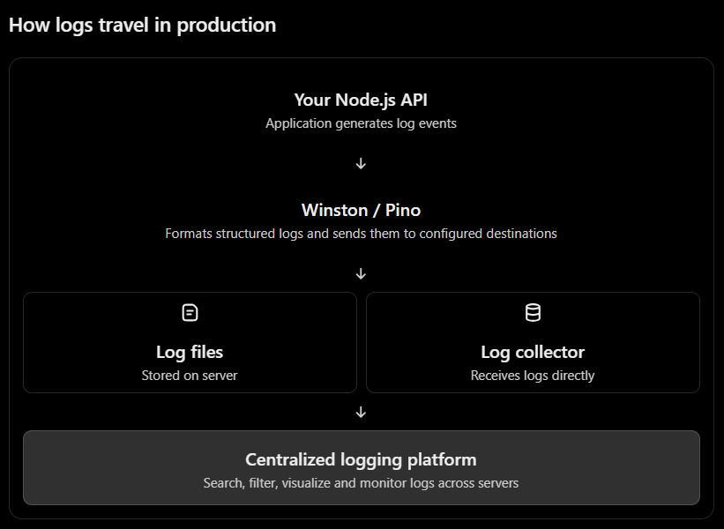
Real-world example
Suppose you have three API servers:
- Server 1 — Booking API
- Server 2 — Payment API
- Server 3 — Authentication API
All three send logs to a centralized platform.
If payment starts failing, you can search for level = ERROR and filter by service = PaymentService without manually accessing all three servers.
Log rotation and Retention
Log rotaion : It means creating the new log file periodicaly instead of writing everything into one file
Example :
logs/
app-2026-11-01.log
app-2026-11-02.log
app-2026-11-03.log
Log retention : It means how long to keep those logs
Example:
• Keep recent logs for 30 days.
• Archive important logs.
• Delete expired logs according to your retention policy.
Note : we use the request Id to indentify the which logs belongs to the particular request. Every log associated with that request carries the same ID, whixh helps in trace the request through different parts of the applications
How we can investigate a real API failure
Like take a scenario where an api starts returning the errors
Step 1 : we need to detect the problem which can be done by monitoring helps to alerts that an API error rate has incrased.
Step 2 : check which api end point is failing
Step 3 : go through the logs and search it by filtering with timestamp,ERROR, endpoint and the request ID
Step 4 : read the error message and the stack trace
Step 5 : resolve the issue
Step 6 : verify recovery

Common API errors and where to investigate
Error | What to investigate
400 | Request validation
401 | Authentication
403 | Authorization
404 | Resource or route not found
409 | Duplicate/conflicting data
500 | Unexpected application error
502 / 503 / 504 | Upstream service, availability or timeout
Remember: an HTTP status code gives you a clue, not necessarily the root cause.

