LLM’s
It’s a large language model , its work is to for a given input predict the next set of output (probability distributions of outputs) the inputs can be different types may be or may not text,NLP etc
The LLM is trained on the internet data which has its own dictionary which helps in marking the set of inputs in the form of token
Langchain
It is a framework to build the applications using the LLM’s which helps to coonect the LLM’s model to work with extra abilities using the external data scources,tools and etc .
We use it to builds agents
Agent = model + harness
The model is the LLM’s models Openai, anthropic etc
Harness is nothing but we can control the agent that is built by the model by the prompt , tools and the middileware to shape its behavior.
Tools
tool is just a function that gives an AI agent the ability to do something
create a tool example
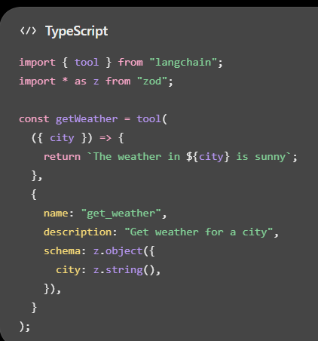 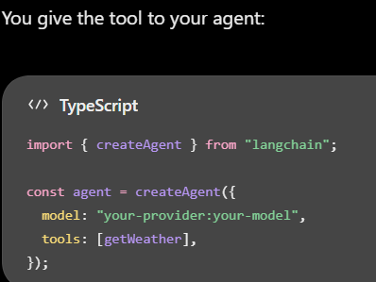
Structured Output
It means making an AI return data in a fixed format instead of giving a normal text answer.

LangChain Custom Middleware: State Updates
middleware can change or update an agent's state while the agent is running.
Method 1: Node-style hooks
Simpler
Return an object containing the fields you want to update.
Examples:
- beforeAgent
- beforeModel
- afterModel
- afterAgent
Method 2: Wrap-style hooks
Use Command to update state while wrapping a model or tool call.
Examples:
- wrapModelCall
- wrapToolCall
LangChain: Customizing Agent Memory
to add your own custom information to an AI agent's memory. To add custom fields, define a state schema on the middleware using stateSchema with a StateSchema or Zod object:
LangChain Agent Invocation
We can use this Invocation like how to send messages to an agent, keep conversation history, and pass extra information such as a user ID.
LangChain Streaming
This section explains how to see what your AI agent is doing while it is working, instead of waiting for the final answer. Using streaming, you can see intermediate updates while the agent is working.

