Redis -> In memory data store . it keeps the data in the ram ,read and write operations will be very fast , cache,rate limiter,message broker ,temp fast layer in front of our normal/main databse . it is used for the data for the short-lived or frequent acess data
Databse store data for long term on disk but redis store data for short term in memory
Redis is an in-memory data store used to store and retrieve data quickly.
Think of a backend API:
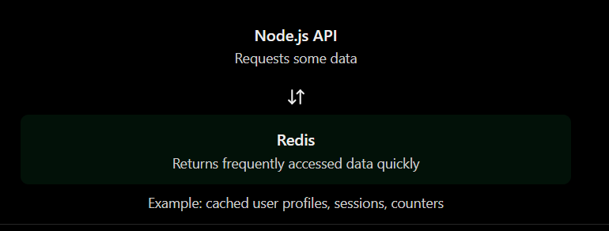
How is Redis different from PostgreSQL?
- PostgreSQL: commonly stores permanent application data on disk.
- Redis: primarily keeps data in memory for fast access; persistence options are available.
They often work together, rather than replacing one another.
Real-world example
API fetches a user's profile from PostgreSQL. It stores a copy in Redis. The next request can read that copy instead of querying PostgreSQL again.
This is called caching.

Redis Architecture
Redis uses a client-server architecture.
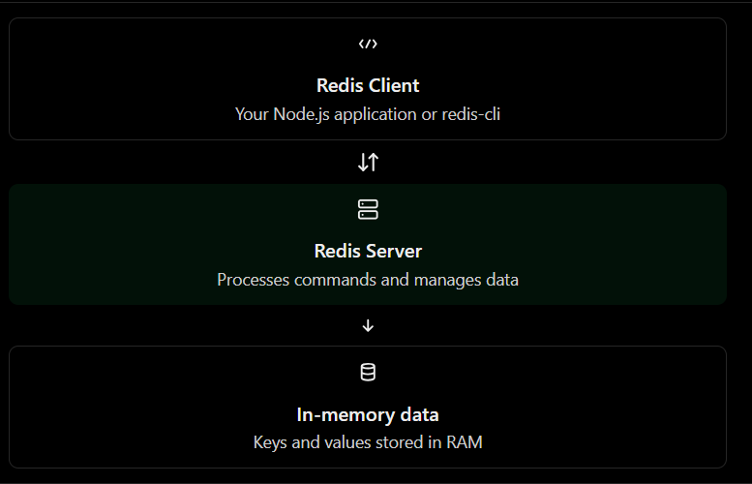
How does it work?
- Your application connects to the Redis server.
- It sends a command, such as SET user:1 "Alex".
- Redis executes the command and stores the value.
- The client receives a response.
Redis communicates using a protocol called RESP (Redis Serialization Protocol).
Try to understand this command
SET user:1 "Alex"
GET user:1
Expected response:
OK
"Alex"
- SET stores a value.
- GET retrieves a value.
- user:1 is the key.

Redis CLI Basics
redis-cli is a command-line tool used to communicate with a Redis server.

basic commands
Command | Purpose
SET name "Alex" | Store a value
GET name | Retrieve a value
EXISTS name | Check whether a key exists
DEL name | Delete a key
TTL name | Check remaining expiration time

Redis Keys and Values
Redis stores data as key-value pairs.
- Key: The name used to identify data.
- Value: The data stored under that key.
1. Example
SET user:101 "Alex"
GET user:101
Output:
OK
"Alex"
Here, user:101 is the key and Alex is the value.
2. Key naming conventions
Use meaningful names with a consistent structure.
Key | Purpose
user:101 | User data
product:205 | Product data
session:abc123 | Session data
order:5001:status | Order status
The colon (:) is a common naming convention, not a special Redis requirement.
3. Useful key commands
EXISTS user:101
TYPE user:101
DEL user:101
- EXISTS checks whether a key exists.
- TYPE tells you the value's data type.
- DEL deletes the key.
Important: Redis keys are strings, but their values can use different data types, such as strings, hashes, lists and sets.
Redis vs PostgreSQL
Both store data, but they are designed for different strengths.
1. Key differences
Feature | Redis | PostgreSQL
Primary storage | In-memory data store | Relational database
Data model | Key-value and data structures | Tables and relations
Querying | Commands by data type/key | SQL queries
Typical strength | Fast access, caching, counters | Durable application data, complex queries
Persistence | Configurable | Durable storage by default
Relationships and joins | Not its primary strength | Built-in support
2. Real-world backend example
Imagine an e-commerce application.
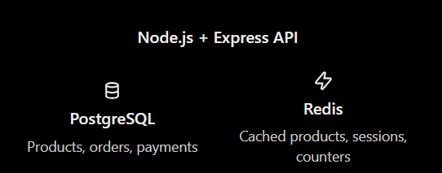
When a user requests a product:
- The API checks Redis for a cached copy.
- If found, it returns the cached data.
- If not found, it fetches the product from PostgreSQL and may cache it in Redis.
This reduces repeated database queries.
Important: Redis and PostgreSQL can complement each other. Redis is not automatically a replacement for PostgreSQL, and Redis can also be configured for persistence.

Redis Use Cases and Limitations
Redis is powerful, but it's important to know when to use it and when not to use it.
1. Common use cases
Caching
Store frequently accessed product or user data to reduce database queries.
Sessions and rate limiting
Manage login sessions and limit API requests across multiple servers.
Leaderboards and counters
Use sorted sets for rankings and atomic commands for counters.
Messaging
Use Pub/Sub for live messages or Streams for persistent event processing.
2. Limitations to understand
- Memory costs: Keeping data in RAM can be expensive at scale.
- Data loss risks: Persistence and replication need proper configuration; neither automatically guarantees zero data loss.
- Cache consistency: Cached values can become stale.
- Not ideal for every query: Complex joins and relational queries are usually better suited to PostgreSQL.
- Operational complexity: Production deployments require security, monitoring, backups and capacity planning.
3. Engineering rule
Use Redis when its data structures, speed or coordination features solve a specific problem. Choose it based on requirements—not simply because it's fast.

DataTypes and DataModel

Redis Strings
Redis strings are the simplest Redis data type. They can store text, numbers, serialized JSON, or binary data.
1. Basic commands
SET user:101 "Alex"
GET user:101
Output: "Alex"
Update the value:
SET user:101 "Sam"
GET user:101
Output: "Sam"
Remember: SET replaces the existing value for that key.
2. Store numbers and increment
SET views 10
INCR views
INCRBY views 5
GET views
Output: "16"
- INCR adds 1.
- INCRBY adds the specified integer.
- These increments are atomic.
3. Set an expiration time
SET otp:101 "482913" EX 60
TTL otp:101
EX 60 means the key expires after 60 seconds. This is useful for temporary OTPs and short-lived cache entries.
4. Avoid overwriting existing keys
SET user:101 "Alex" NX
NX means only set the key if it doesn't already exist. If the key exists, Redis won't overwrite it.
Example 1: Without NX
SET user:101 "Sam"
SET user:101 "Alex"
GET user:101
Output:
OK
OK
"Alex"
Why? The second SET replaces "Sam" with "Alex" because Redis allows overwriting by default.

Example 2: With NX
Start with the same key:
SET user:101 "Sam"
SET user:101 "Alex" NX
GET user:101
Output:
OK
(nil)
"Sam"
Why?
- First command stores "Sam".
- Second command uses NX — set only if the key does not exist. Since user:101 already exists, Redis doesn't change it and returns a nil response.
- GET still returns "Sam".
Real-world use case
Imagine generating a unique username or creating a key only if it doesn't exist. NX helps prevent accidentally overwriting existing data.
Remember:
- SET key value → create or overwrite.
- SET key value NX → create only if the key doesn't exist.

Redis Hashes
A Redis hash stores multiple field-value pairs under one key. It's useful for representing objects, such as user profiles.
1. Store a user
HSET user:101 name "Alex" age 22 city "Chennai"
Here:
- user:101 is the Redis key.
- name, age, and city are fields.
- "Alex", 22, and "Chennai" are values.
2. Read the data
Get one field:
HGET user:101 name
Output:
"Alex"
Get all fields:
HGETALL user:101
Output:
1) "name"
2) "Alex"
3) "age"
4) "22"
5) "city"
6) "Chennai"
3. Update one field
HSET user:101 city "Hyderabad"
HGET user:101 city
Output: "Hyderabad"
Only the city field changes; the other fields remain intact.
4. Delete one field
HDEL user:101 age
This removes age, not the entire user:101 hash.
String vs Hash
- SET user:101 "Alex" stores one string value.
- HSET user:101 name "Alex" age 22 stores multiple fields in a hash.
Real-world use: User profile data, product attributes, and configuration settings.

Redis Lists
A Redis list is an ordered collection of strings. You can add items to either end, making lists useful for queues and task processing.
1. Add items
LPUSH tasks "task3"
LPUSH tasks "task2"
RPUSH tasks "task4"
The list is now ordered as:
task2 → task3 → task4
- LPUSH adds items to the left.
- RPUSH adds items to the right.
2. Read items
LRANGE tasks 0 -1
Output:
1) "task2"
2) "task3"
3) "task4"
0 -1 means retrieve all items, from the first to the last.
3. Remove items
LPOP tasks
RPOP tasks
- LPOP removes and returns the leftmost item (task2).
- RPOP removes and returns the rightmost item (task4).
Update an item by index — LSET
Suppose your list is:
RPUSH tasks "task1" "task2" "task3"
Update the second item:
LSET tasks 1 "updated_task2"
Check the list:
LRANGE tasks 0 -1
Output:
1) "task1"
2) "updated_task2"
3) "task3"
Remember: Redis list indexes start at 0, so index 1 is the second item.

RPUSH tasks "task4"
This appends a new item; it doesn't update an existing one.
Key difference
- LSET → update an existing item at an index.
- LPUSH → add to the left.
- RPUSH → add to the right.
- LREM → remove matching items.
Example
1. Create the list
RPUSH fruits apple mango banana guava orange
The list indexes are:
Index | Fruit
0 | apple
1 | mango
2 | banana
3 | guava
4 | orange
2. Print banana and guava using LRANGE
LRANGE fruits 2 3
Output:
1) "banana"
2) "guava"
Why 2 3? Redis list indexes start at 0, and LRANGE includes both the start and end indexes.
3. Update guava to grapes
Guava is at index 3, so use LSET:
LSET fruits 3 grapes
Output:
OK
4. Verify the update
LRANGE fruits 2 3
Output:
1) "banana"
2) "grapes"
That's it! LRANGE reads a range of items, while LSET updates an item at a specific index.

LREM — Remove items from a list
Using our fruits list 🍎
RPUSH fruits apple mango banana guava orange
Syntax
LREM key count value
- key — list name
- count — how many matches to remove and search direction
- value — item to remove
1. Remove guava
LREM fruits 1 guava
Removes the first matching guava, searching from left to right.
2. What does count mean?
Count | Behavior
1 | Remove first match from the left
-1 | Remove first match from the right
0 | Remove all matching items
3. Example with duplicates
Suppose the list is:
RPUSH fruits apple guava mango guava orange
Remove all occurrences of guava:
LREM fruits 0 guava
LRANGE fruits 0 -1
Output:
1) "apple"
2) "mango"
3) "orange"
Remember: LREM removes items by value, whereas LSET updates an item by index.

Real-world use
A backend might use a Redis list to hold pending tasks that a worker processes. For reliable job processing, Redis Streams or a dedicated queue system may be more suitable.
Remember: Lists preserve order and allow duplicates.

Redis Sets
A Redis Set is an unordered collection of unique strings. Duplicate values are automatically ignored.

Example
1. Add fruits
SADD fruits apple mango banana guava
SADD fruits apple
The second command doesn't add another apple, because sets allow only unique members.
2. Get all members
SMEMBERS fruits
Returns all four fruits, but the order is not guaranteed.
3. Check whether an item exists
SISMEMBER fruits mango
Output: (integer) 1
1 means the fruit exists; 0 means it doesn't.
4. Remove a fruit
SREM fruits guava
SMEMBERS fruits
guava is removed from the set.

5. Real-world example: Common interests
Suppose two users have these interests:
SADD user:1:interests music cricket coding
SADD user:2:interests cricket movies coding
Find common interests:
SINTER user:1:interests user:2:interests
Result: cricket and coding (order may vary).
Remember:
- List → ordered, duplicates allowed.
- Set → unordered, duplicates not allowed.

Redis Sorted Sets
A Sorted Set stores unique members, each associated with a score. Redis orders members by score, from lowest to highest by default.
1. Add students with scores
ZADD leaderboard 85 "Alex" 95 "Sam" 70 "John"
- leaderboard is the key.
- 85, 95, 70 are scores.
- Names are members.
2. Get members in score order
ZRANGE leaderboard 0 -1 WITHSCORES
Output:
1) "John"
2) "70"
3) "Alex"
4) "85"
5) "Sam"
6) "95"
3. Get highest scores first
ZREVRANGE leaderboard 0 -1 WITHSCORES
Now Sam appears first, followed by Alex and John.
4. Update a score
ZADD leaderboard 99 "Alex"
Alex's score changes to 99; Redis doesn't create a duplicate Alex.

5. Real-world use
Sorted sets are useful for:
- Game leaderboards
- Ranking products by popularity
- Scheduling tasks by priority
- Tracking items by score or timestamp
Remember: Sets store unique members without ordering; sorted sets store unique members ordered by score.

Bitmaps, HyperLogLog and Geospatial Data
Redis has specialized data features for specific problems. Let's understand three briefly.

1. Bitmaps — track true/false states
A bitmap uses bits to represent states such as whether a user visited today.
SETBIT attendance:today 101 1
GETBIT attendance:today 101
Output: (integer) 1
- SETBIT sets a bit at an offset.
- GETBIT reads it.
- 1 could mean visited; 0 could mean not visited.
Use case: Daily attendance or activity tracking.

2. HyperLogLog — estimate unique counts
HyperLogLog estimates the number of unique items using very little memory, but it does not store the complete list of items.
PFADD visitors user1 user2 user3
PFADD visitors user2 user4
PFCOUNT visitors
The estimated unique visitor count is 4.
Use case: Estimating unique website visitors. Results are approximate.

3. Geospatial data — work with locations
Redis can store coordinates and search locations by distance.
GEOADD stores Chennai 80.2707 13.0827
Correction: GEOADD requires arguments in this order: key, longitude, latitude, member. Use the valid command below:
GEOADD stores 80.2707 13.0827 Chennai
GEOADD stores 77.5946 12.9716 Bangalore
GEOSEARCH stores FROMLONLAT 80.2707 13.0827 BYRADIUS 350 km
This searches for stored locations within 350 km of the specified coordinates.
Use case: Nearby stores, delivery services and location-based discovery.

Quick comparison
Feature | Best for
Bitmap | Compact binary states
HyperLogLog | Approximate unique counts
Geospatial | Location and distance searches

TTL
TTL (Time To Live) tells you how many seconds remain before a key expires.
SET otp:101 "482913" EX 60
TTL otp:101
The key expires after 60 seconds.
Common expiration commands:
Command | Purpose
EXPIRE key 60 | Expire after 60 seconds
PEXPIRE key 5000 | Expire after 5000 milliseconds
TTL key | Remaining lifetime in seconds
PERSIST key | Remove expiration
EXISTS key | Check whether key exists
3. Example: Change expiration
SET session:abc "active"
EXPIRE session:abc 300
TTL session:abc
The session expires after five minutes unless its expiration is changed.
Important: A normal SET overwrites the value and removes an existing TTL unless you specify an expiration or preserve it using supported options such as KEEPTTL.
4 TTL returns
- Positive number → seconds remaining.
- -1 → key exists but has no expiration.
- -2 → key doesn't exist.

change expiration (TTL)
TTL means Time To Live — how long a key remains before Redis automatically deletes it.
Set expiration when creating a key
SET session:abc123 "active" EX 300
The session expires after 300 seconds (5 minutes).
- EX = seconds
- PX = milliseconds
SET session:abc123 "active" EX 60
SET session:abc123 "active" PX 5000

Change expiration on an existing key
EXPIRE session:abc123 600
This makes the key expire 600 seconds (10 minutes) from now.
PEXPIRE session:abc123 5000
This makes it expire in 5,000 milliseconds (5 seconds).

Check or remove expiration
TTL session:abc123
Shows the remaining seconds.
PERSIST session:abc123
Removes the expiration, so the key no longer expires automatically.
Important: If you run SET on an existing key, Redis normally removes its previous expiration unless you set a new one or use KEEPTTL.

Example:
SET session:abc123 "active" EX 300
SET session:abc123 "logged-in" KEEPTTL
The value changes to "logged-in", but the existing expiration is preserved.

Choosing the right data type
Use case | Redis type
Simple value or counter | String
User fields | Hash
Unique tags or IDs | Set
Leaderboard | Sorted Set
Queue-like list | List
Choosing the Right Redis Data Type
Requirement | Redis command/type
Store a user's name | STRING — SET
Store user profile fields | HASH — HSET
Track unique visitors | SET — SADD
Maintain a leaderboard | SORTED SET — ZADD
Store recent activity | LIST — LPUSH
Count page views | STRING — INCR

Redis keys are independent. user:101:name and user:101 are separate keys, even though their names are related.

Redis in node and the express project
Packages
npm install redis express
npm install -D typescript tsx @types/node @types/express

redis-config
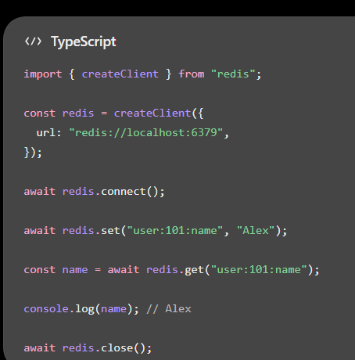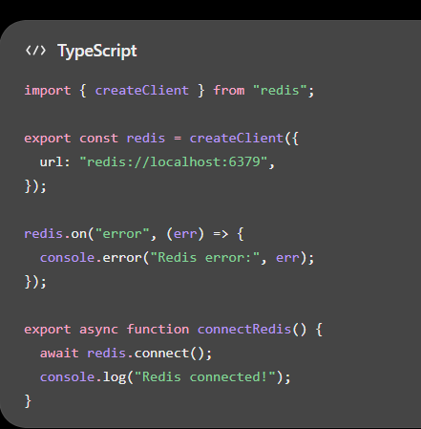
• createClient() creates the Redis client.
• connect() connects to the server.
• set() stores data.
• get() retrieves data.
• close() closes the connection.
import express from "express";
import { redis, connectRedis } from "./redis";

const app = express();
app.use(express.json());

app.post("/users/:id", async (req, res) => {
try {
await redis.set(
`user:${req.params.id}:name`,
req.body.name
);

res.json({ message: "User saved" });
} catch {
res.status(500).json({ error: "Redis operation failed" });
}
});

app.get("/users/:id", async (req, res) => {
try {
const name = await redis.get(
`user:${req.params.id}:name`
);

if (name === null) {
res.status(404).json({ error: "User not found" });
return;
}

res.json({ id: req.params.id, name });
} catch {
res.status(500).json({ error: "Redis operation failed" });
}
});

async function main() {
await connectRedis();

app.listen(3000, () => {
console.log("Server running on http://localhost:3000");
});
}

main().catch(console.error);

Redis CRUD Operations

1. Create — Store a user
await redis.set("user:101:name", "Alex");

2. Read — Retrieve the user
const name = await redis.get("user:101:name");
console.log(name); // Alex

3. Update — Change the user's name
await redis.set("user:101:name", "Sam");

SET overwrites the existing value.

4. Delete — Remove the user
await redis.del("user:101:name");
The key is now deleted.

Important: Check before updating or deleting
const exists = await redis.exists("user:101:name");

if (exists) {
await redis.set("user:101:name", "Sam");
}
EXISTS returns 1 if the key exists and 0 otherwise. For simple updates, checking first isn't always necessary; SET can create a missing key too.

Store Objects with Redis Hashes
We use it when need to store user details such as name, email, and age.

1. Store user details
Use HSET to store multiple fields in a Redis Hash.
await redis.hSet("user:101", {
name: "Alex",
email: "alex@example.com",
age: "22",
});
Redis stores these fields under the key user:101.

2. Retrieve user details
Get one field:
const name = await redis.hGet("user:101", "name");
console.log(name); // Alex
Get all fields:
const user = await redis.hGetAll("user:101");
console.log(user);
Result:
{
"name": "Alex",
"email": "alex@example.com",
"age": "22"
}
Note: Redis Hash field values are strings. Convert values such as age to numbers in your application when needed.

3. Update or delete a field
// Update age
await redis.hSet("user:101", "age", "23");

// Delete email field
await redis.hDel("user:101", "email");

When should you use a Hash?
Use a Hash when you need to store and update individual fields of an object without replacing the entire object.
For example, user profiles, product attributes, and simple configuration records.

Expiration and TTL in Node.js

This concept is useful for sessions, OTPs, temporary tokens, and cached data.

1. Set a key with expiration
await redis.set("otp:user:101", "482931", {
EX: 300,
});

The OTP expires after 300 seconds (5 minutes).

2. Change expiration on an existing key
await redis.expire("otp:user:101", 120);

The key will now expire in 120 seconds from this command.

3. Check remaining TTL
const ttl = await redis.ttl("otp:user:101");
console.log(ttl);
the output results can be in any :
- Positive number: remaining seconds.
- -1: key exists without expiration.
- -2: key doesn't exist.

4. Remove expiration
await redis.persist("otp:user:101");

The key remains until deleted or otherwise removed.

Security tip: For OTPs and session tokens, choose short expiration periods and never log sensitive token values.

Example of all the above concepts
import express from "express";
import { redis } from "./redis";

const app = express();
app.use(express.json());

// Save a product in Redis for 10 minutes
app.post("/products/:id", async (req, res) => {
try {
const { name, price } = req.body;
const product = { name, price };

await redis.set(
`product:${req.params.id}`,
JSON.stringify(product),
{ EX: 600 }
);

res.json({ message: "Product saved", product });
} catch {
res.status(500).json({ error: "Failed to save product" });
}
});

// Retrieve a product
app.get("/products/:id", async (req, res) => {
try {
const data = await redis.get(`product:${req.params.id}`);

if (data === null) {
res.status(404).json({ error: "Product not found" });
return;
}

res.json(JSON.parse(data));
} catch {
res.status(500).json({ error: "Failed to retrieve product" });
}
});

• JSON.stringify() converts a JavaScript object into a string for Redis.
• JSON.parse() converts the stored string back into an object.
• EX: 600 automatically expires the product after 10 minutes.
• 404 means the product key doesn't exist or has expired.
Redis Cache-Aside Pattern

API checks Redis first; if the data isn't cached, it fetches it from the database and caches the result.
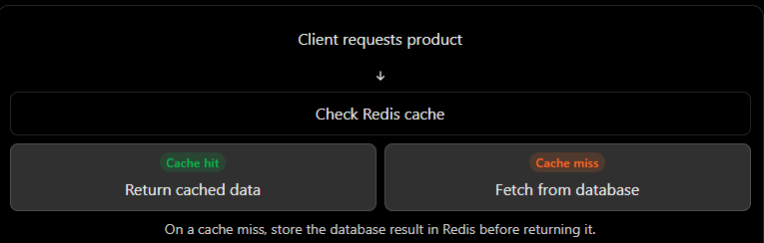

Example
import { redis } from "./redis";
async function getProduct(id: string) {
// 1. Check Redis first
const cached = await redis.get(`product:${id}`);

if (cached !== null) {
console.log("Cache hit");
return JSON.parse(cached);
}

// 2. Simulate fetching from a database
console.log("Cache miss");

const product = {
id,
name: "Keyboard",
price: 1500,
};

// 3. Cache the result for 10 minutes
await redis.set(
`product:${id}`,
JSON.stringify(product),
{ EX: 600 }
);

return product;
}

- First request: Redis misses, so the function fetches the product and caches it.
- Second request: Redis hits, so the function returns the cached product without fetching it again.
- After expiration: Redis misses again, and the product is fetched again.
Production tip: In a real application, replace the simulated database function with an actual database query. Also decide how your application should behave if Redis is unavailable

Drawback:
When the details is changed in the database, the database contains the old value not new value.
To sove this problem we have this concept of the cache inavalidation

Update and Invalidate Cache

One important problem: what happens when a changes made in the database but Redis still contains the old value?

That's called stale cache data.

1. The problem
Suppose Redis stores:
{
"id": "205",
"name": "Keyboard",
"price": 1500
}
The database price changes to 1800, but Redis still returns 1500.

2. Solution: Delete the cached value after updating the database
async function updateProduct(
id: string,
newPrice: number
) {
// 1. Update the database first
await database.updateProductPrice(id, newPrice);

// 2. Invalidate the old cache
await redis.del(`product:${id}`);
}
database.updateProductPrice() is a placeholder for your actual database function.
On the next request, the cache misses and the application fetches the updated product from the database.

3. Alternative: Update the cache directly
await database.updateProductPrice(id, 1800);

await redis.set(
"product:205",
JSON.stringify({
id: "205",
name: "Keyboard",
price: 1800,
}),
{ EX: 600 }
);

This keeps the cache warm, but you must ensure the cached object matches the database.

Practical rule: Cache invalidation with DEL is often simpler. Use a TTL as a safety net, because invalidation and database updates can still fail independently.

Example :
Redis in project use it has a middleware
1. Create the cache middleware
import { Request, Response, NextFunction } from "express";
import { redis } from "./redis";

export async function cacheMiddleware(
req: Request,
res: Response,
next: NextFunction
) {
try {
const cached = await redis.get(`cache:${req.originalUrl}`);

if (cached !== null) {
res.setHeader("X-Cache", "HIT");
res.json(JSON.parse(cached));
return;
}

res.setHeader("X-Cache", "MISS");
next();
} catch {
// If Redis fails, continue without the cache
next();
}
}
2. Use it in a route
import express from "express";
import { redis } from "./redis";
import { cacheMiddleware } from "./cacheMiddleware";

const app = express();

app.get("/products", cacheMiddleware, async (_req, res) => {
const products = [
{ id: 1, name: "Keyboard", price: 1500 },
{ id: 2, name: "Mouse", price: 500 },
];

await redis.set(
"cache:/products",
JSON.stringify(products),
{ EX: 60 }
);

res.json(products);
});
3. How it works
- First request: X-Cache: MISS — the route returns the data and caches it.
- Second request: X-Cache: HIT — middleware returns cached data without running the route.
- After 60 seconds: the cache expires, and the route runs again.

Note : This is a not a real example. In production, cache only successful responses, use consistent cache keys, and avoid caching personalized or sensitive responses under shared keys. Also ensure your cache key matches the URL used by the middleware.

Redis Transactions with Node.js

Redis transactions let you group commands so they execute together without other clients' commands interrupting the group.

1. Use MULTI and EXEC
import { redis } from "./redis";

const result = await redis
.multi()
.set("user:101:name", "Alex")
.set("user:101:status", "active")
.incr("stats:users")
.exec();

console.log(result);

What happens?
- MULTI starts a transaction.
- Commands are queued.
- EXEC executes the queued commands together.

* but they do not provide SQL-style rollback if an individual command fails during execution.
For simple atomic operations, a single command such as INCR is usually enough.

* Use them when several Redis commands need to execute together without another client's commands running between them.

Redis Pub/Sub in Node.js

Pub/Sub means Publish/Subscribe. It lets one part of your application send messages to other parts without directly calling them.
Common uses:
- Real-time notifications
- Chat messages
- Live updates across servers

1. Publisher — send a message
import { createClient } from "redis";

const publisher = createClient({
url: "redis://localhost:6379"
});

await publisher.connect();

await publisher.publish(
"notifications",
"Hello, users!"
);

await publisher.close();

2. Subscriber — receive messages
import { createClient } from "redis";

const subscriber = createClient({
url: "redis://localhost:6379"
});

await subscriber.connect();

await subscriber.subscribe(
"notifications",
(message) => {
console.log("Received:", message);
}
);

Run the subscriber first, then run the publisher in a separate terminal.
Output in the subscriber terminal:

Received: Hello, users!
Creating a Reusable Redis Service
Instead of writing Redis commands throughout your application, put them in one reusable file.
1. Create redisService.ts
import { createClient } from "redis";

const redis = createClient({
url: "redis://localhost:6379"
});

redis.on("error", (err) => {
console.error("Redis error:", err);
});

export async function connectRedis() {
if (!redis.isOpen) {
await redis.connect();
}
}

export async function saveValue(
key: string,
value: string
) {
await redis.set(key, value);
}

export async function getValue(
key: string
): Promise<string | null> {
return redis.get(key);
}

export async function deleteValue(key: string) {
return redis.del(key);
}

export { redis };

2. Use it in app
import {
connectRedis,
saveValue,
getValue
} from "./redisService";

await connectRedis();

await saveValue("user:101:name", "Alex");

const name = await getValue("user:101:name");

console.log(name); // Alex

Why is this useful?
- You keep Redis code in one place.
- Multiple routes can reuse the same functions.
- If you change how Redis connects, you update one file.
- Your application becomes easier to maintain.
Important: Connect once when your application starts, not on every API request.

Some extra concepts:
Caching stratergies :
• Cache-aside: Check Redis first, then fetch from the database on a miss. Cache-aside is a caching strategy where your application checks Redis first before querying the database.

• TTL: Controls how long cached data remains available. TTL (Time To Live) determines how long a cached key remains available before Redis expires it.

• Cache invalidation: Remove outdated cached data after database updates. Cache invalidation means removing or updating cached data when the underlying data changes. The solution: update the database, then delete the cache

• Cache stampede prevention: Reduce duplicate database queries. A cache stampede happens when a popular cache entry expires and many requests simultaneously try to fetch the same data from the database.
Imagine product:205 is requested by 1,000 users per second.
the problem is that many requests independently fetch the same missing data.

Solution: Single-flight request deduplication
For a Node.js application, a simple starting point is to let requests for the same key share one in-flight database query.
Instead of 100 concurrent requests running 100 database queries, they can share one query.

• TTL jitter: Spread expiration times.
TTL jitter means adding a small random amount of time to a cache entry's expiration.
Imagine caching 10,000 products, all with a TTL of 300 seconds. If they are created at roughly the same time, many may expire together, causing a burst of database requests.
Instead of giving every key exactly 300 seconds, we can vary the TTL slightly.

• Negative caching: Temporarily cache missing records. caching the fact that something was not found, instead of repeatedly querying the database for something that doesn't exist.()
One important limitation
Suppose user 99999 is created five seconds after we cache the absence. Redis may still say that the user doesn't exist for another 25 seconds.
To reduce this risk, use a short negative-cache TTL and invalidate the key when creating a user.
Also, don't treat database errors as “not found.” A database outage is not proof that a user doesn't exist.

• Cache warming: Preload frequently accessed data without evern the user is requesting for it . Cache warming means loading frequently requested data into Redis before users request it.

cache eviction polocies
Redis stores data in memory (RAM). If your cache grows too large, Redis can run out of available memory.
Eviction is the process of removing keys from Redis when memory limits require it.
For example, imagine your application caches one million products. Eventually, Redis may need to remove some keys to make room for new data.
Redis uses a configured eviction policy to decide which keys to remove.

2. Common Redis eviction policies
Policy | What it does
noeviction | Rejects new writes when the memory limit is reached.
allkeys-lru | Evicts keys that haven't been used recently.
allkeys-lfu | Evicts keys that are accessed least frequently.
volatile-lru | Evicts least recently used keys that have an expiration set.
volatile-ttl | Prefers keys with the shortest remaining TTL.
allkeys-random | Evicts randomly selected keys.
A useful starting point: For a general-purpose cache where any key can be removed and recomputed, allkeys-lru is a common choice.
- LRU = Least Recently Used.
- LFU = Least Frequently Used.
LRU focuses on recency; LFU focuses on frequency.

Write-through vs. Write-behind Caching

1. Write-through caching
Write-through means the application updates the database and cache as part of the same write operation.
Advantage: The cache is updated immediately after a successful database write.
Limitation: The database and Redis are separate systems. If the database succeeds but Redis fails, their contents can temporarily differ. This code does not provide an atomic transaction across both systems.

2. Write-behind caching
Write-behind (write-back) means writing to the cache first and persisting the change to the database asynchronously or later.
For example:
- The application writes Sam to Redis.
- The application acknowledges the change.
- A background worker eventually writes Sam to the database
This approach can reduce write latency and combine multiple writes, but it introduces a serious risk: if a change exists only in volatile Redis memory and Redis loses it before persistence, the database may never receive that change.

GRAPHQL

