Q 1.) How to create project_id in bigquery UI?

Step 1:- Select a Project

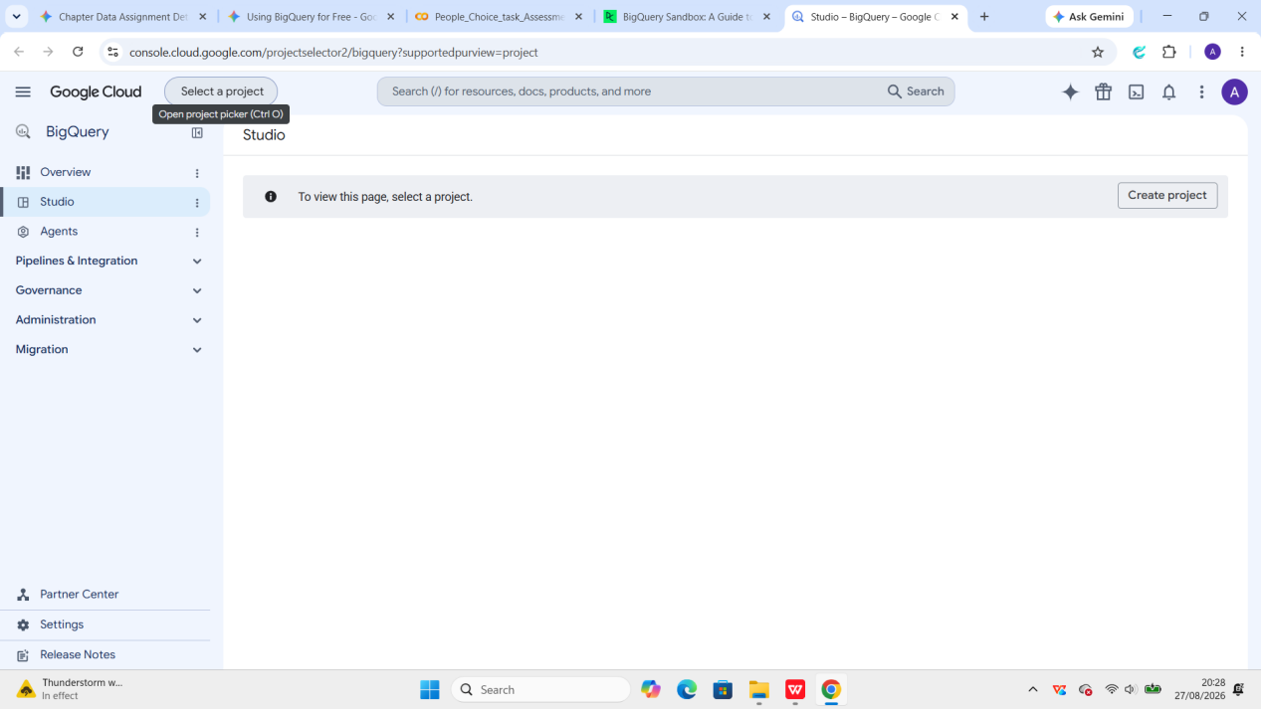

Step 2:- Click on New Project and give name (dp-dev-data-pipeline)

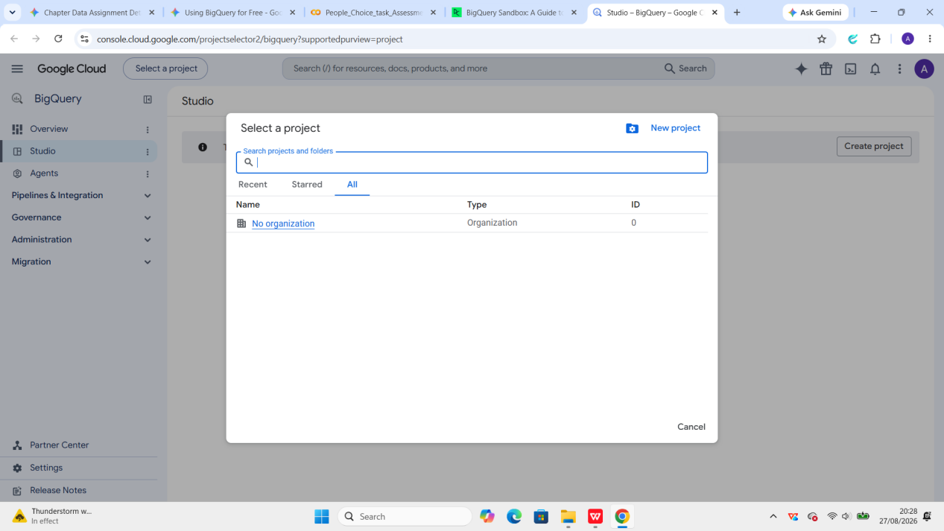

Step 3:- Do not create on any billing

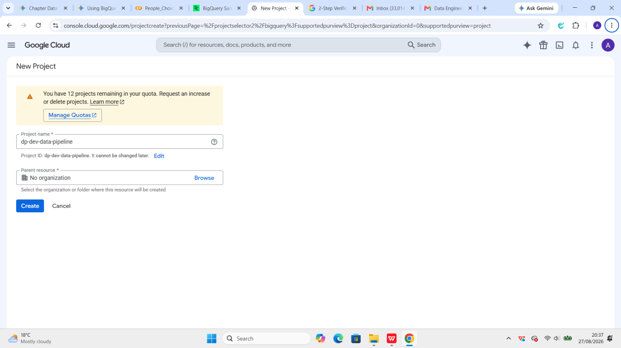

Step 4:- Once project is create open bigquery from left menu or direct search

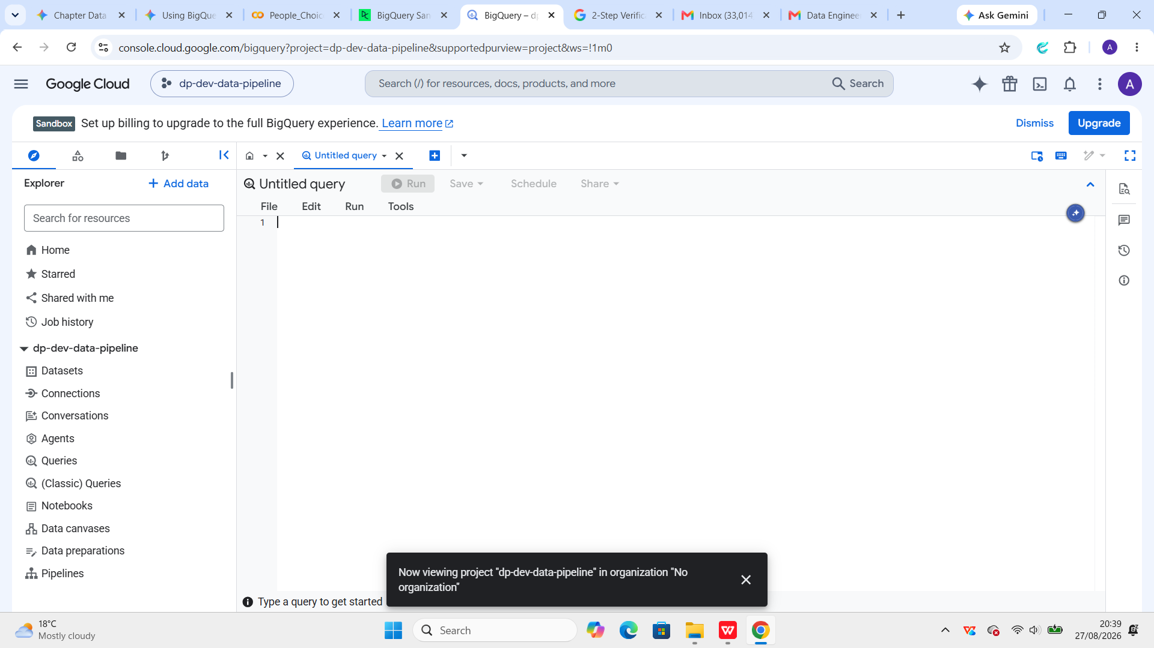

Step 5:- Click on Add data



Step 6:- Click on Public Datasets

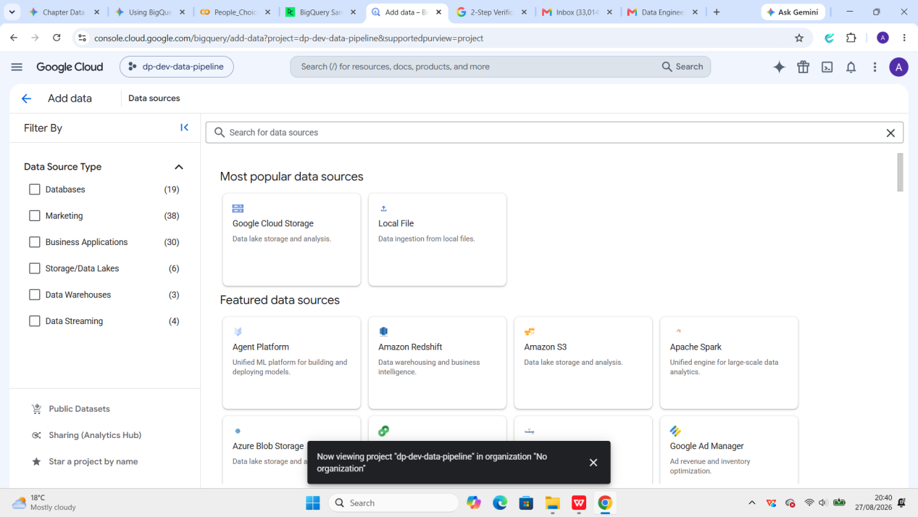

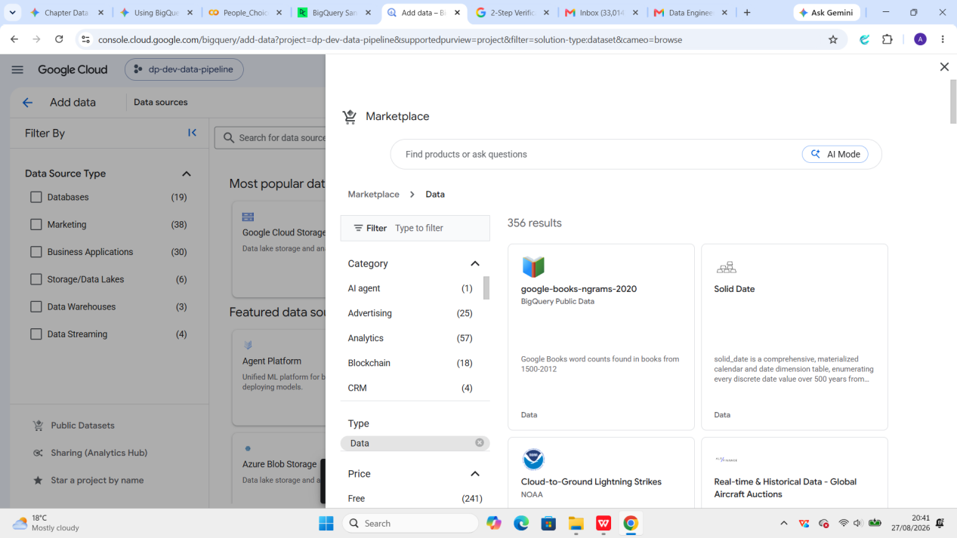

Step 7:- Type GitHub in space bar

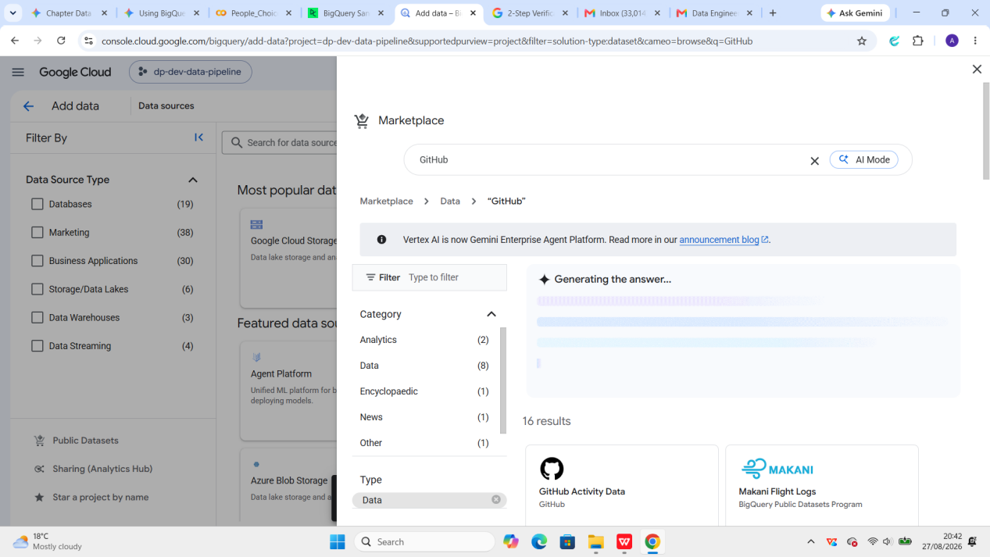

Step 8:- Click on View Dataset

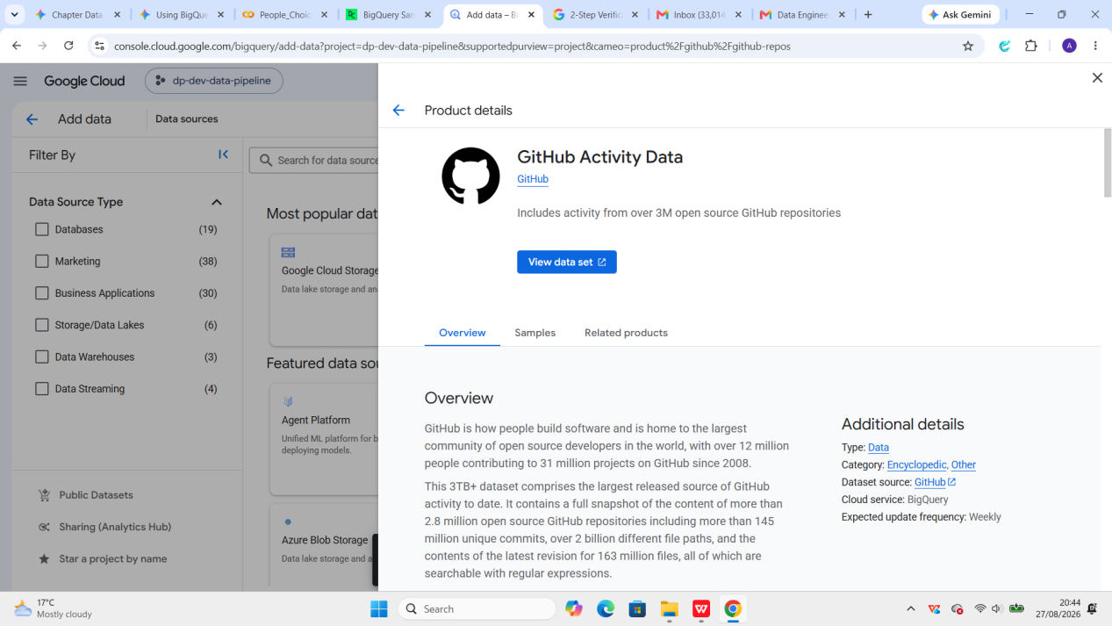

Step 9:- Click on the STAR button

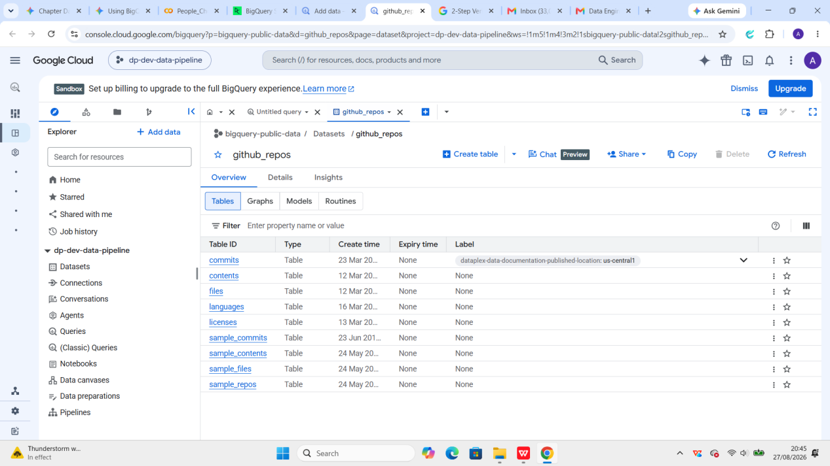

Q 2.) How to create dataset_id in BigQuery UI?

Step 1:- Click on Add data at left side of the bigquery UI.

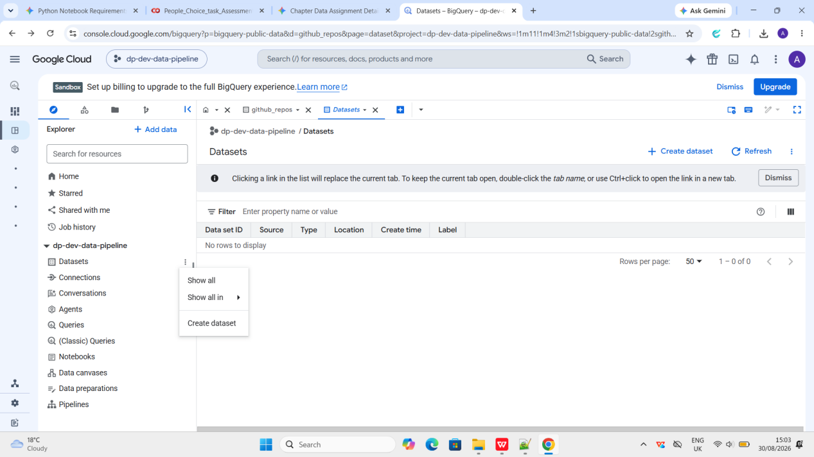

Step 2:- Give the name of dataset id: etl_pipeline

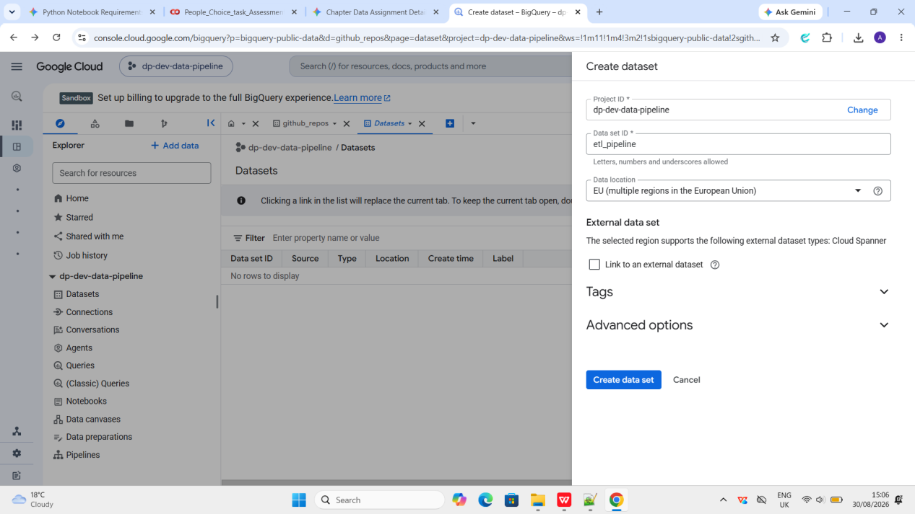

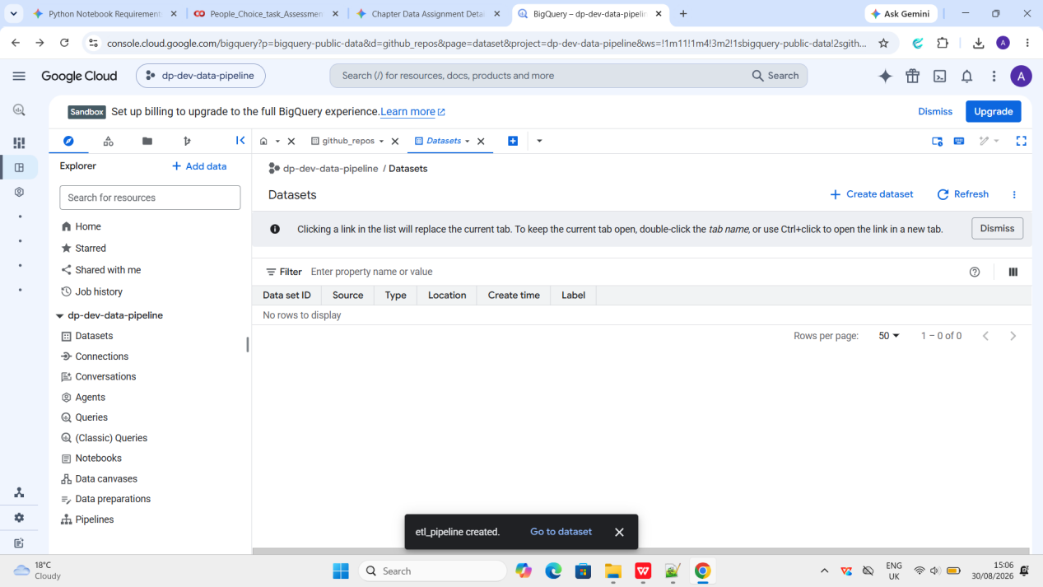

Step 3:- Now below is the UI of the dataset (etl_pipeline) inside project_id (dp-dev-data-pipeline)

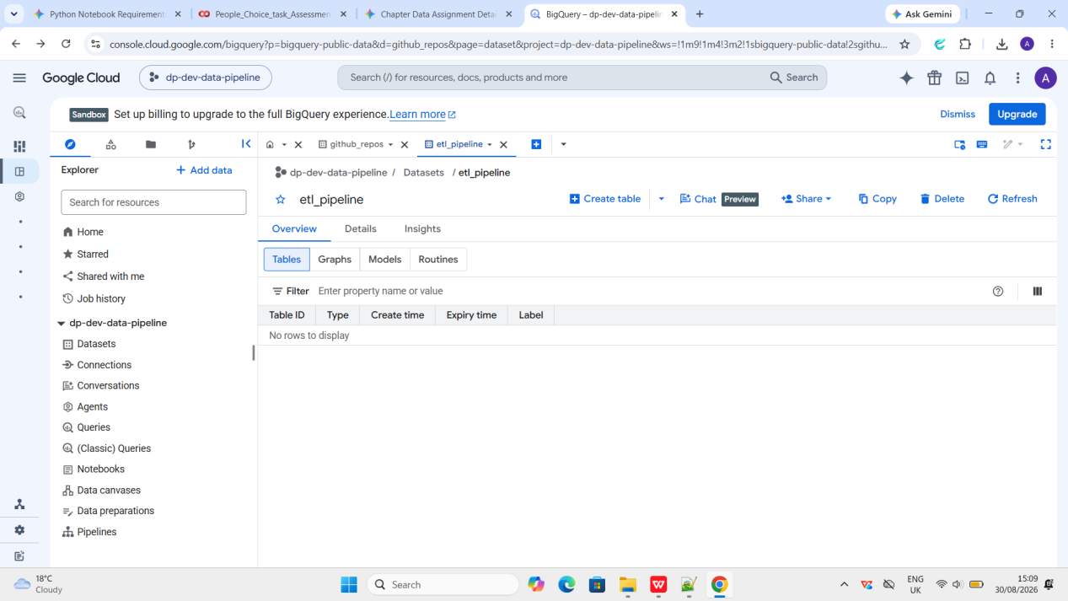

Step 4:- Reload the BigQuery UI console I see the table (university_chapters) got created.

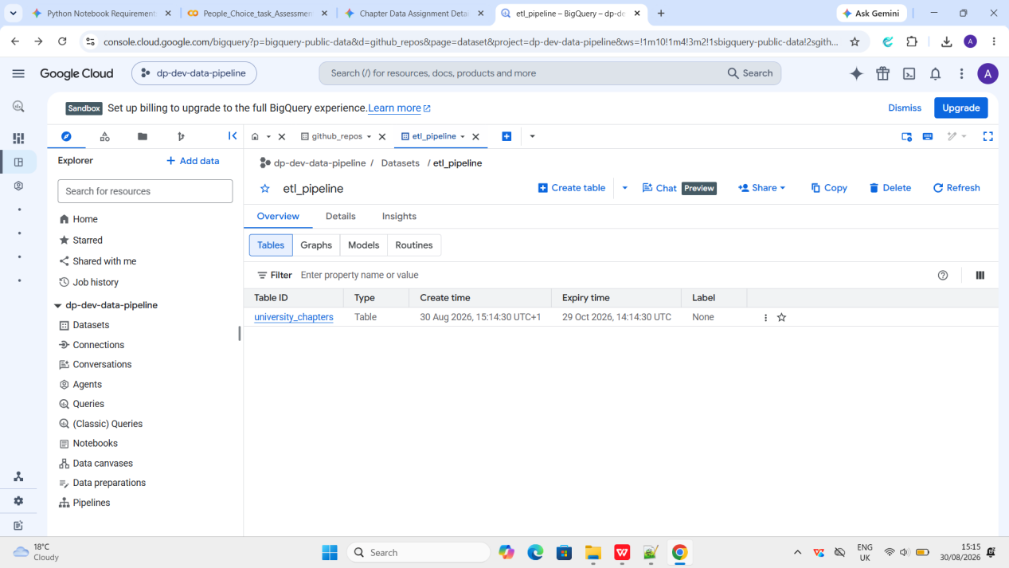

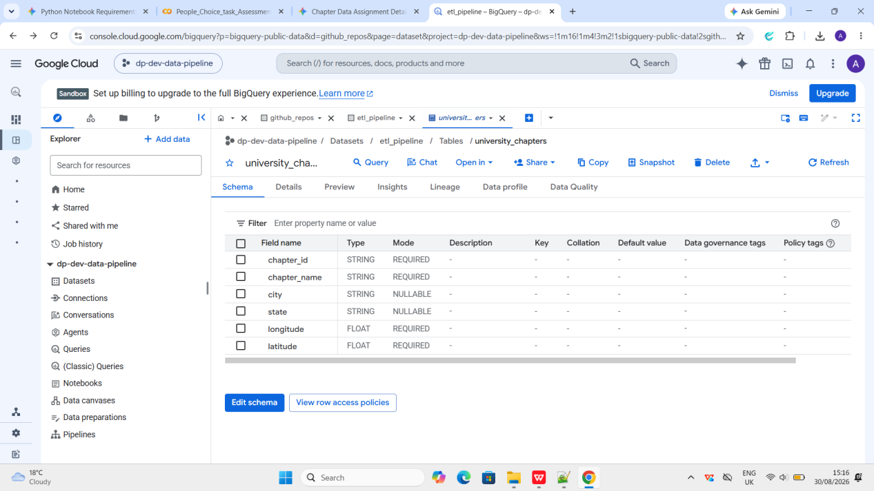

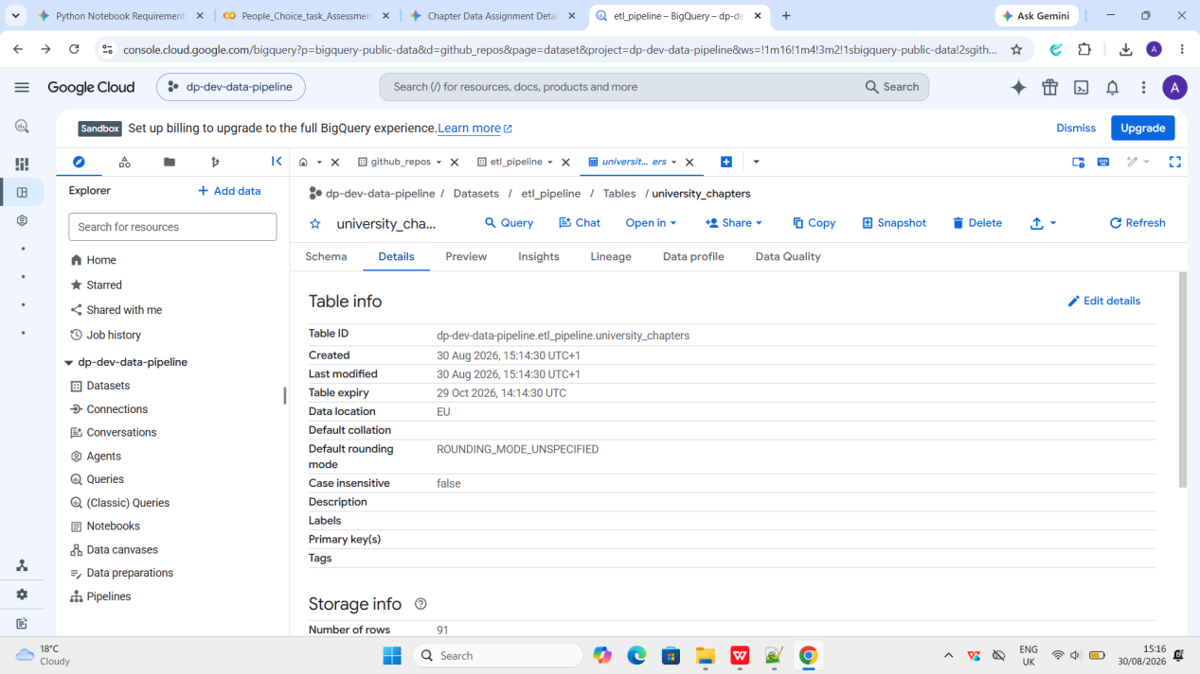

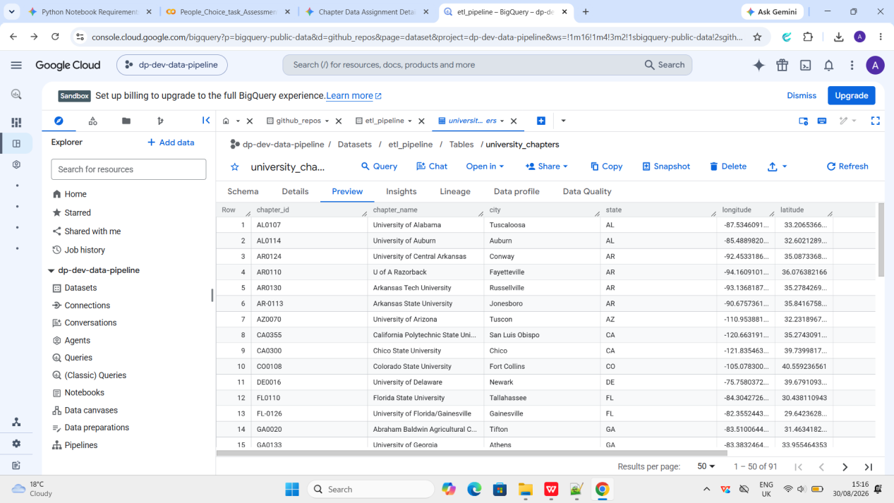

Q 3.) How to create and set up a Google Cloud service account key file?

Step 1:- Navigate to Service Accounts in the left hand navigation menu

Go to IAM & Admin > Service Accounts

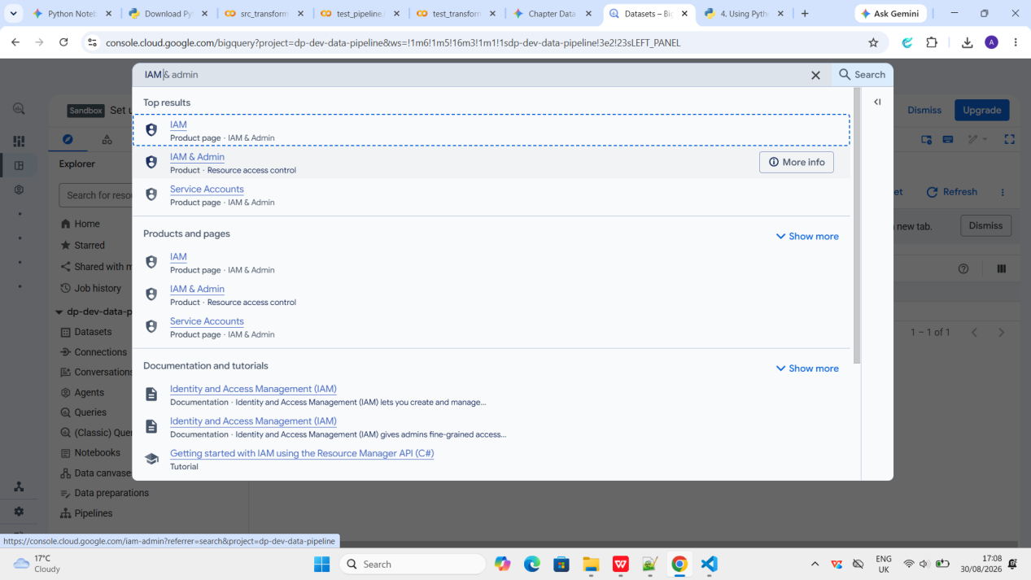

Step 2:- Go to Service Accounts

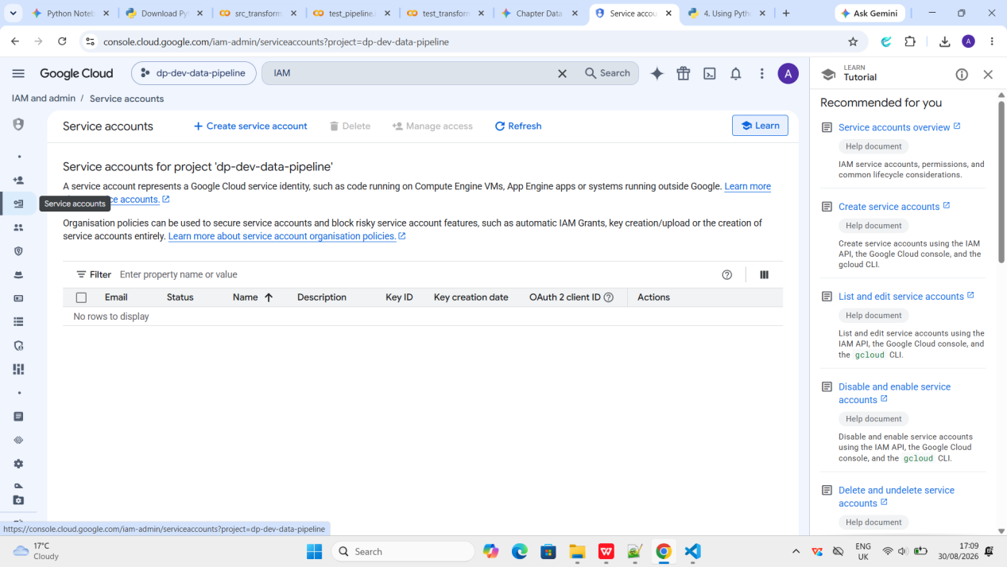

Step 3:- Click on Create Service account at the top

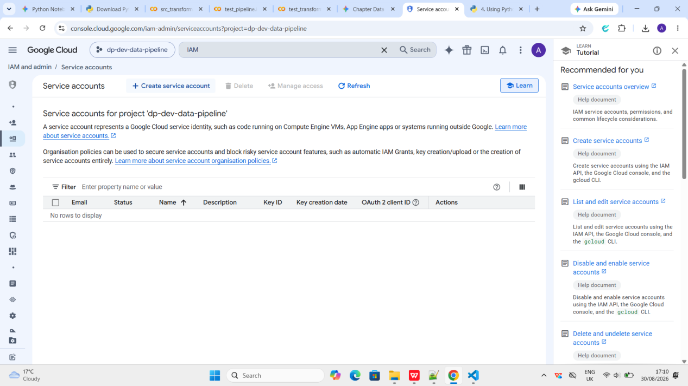

Step 4:- Give name of service account as: etl_pipeline-sa

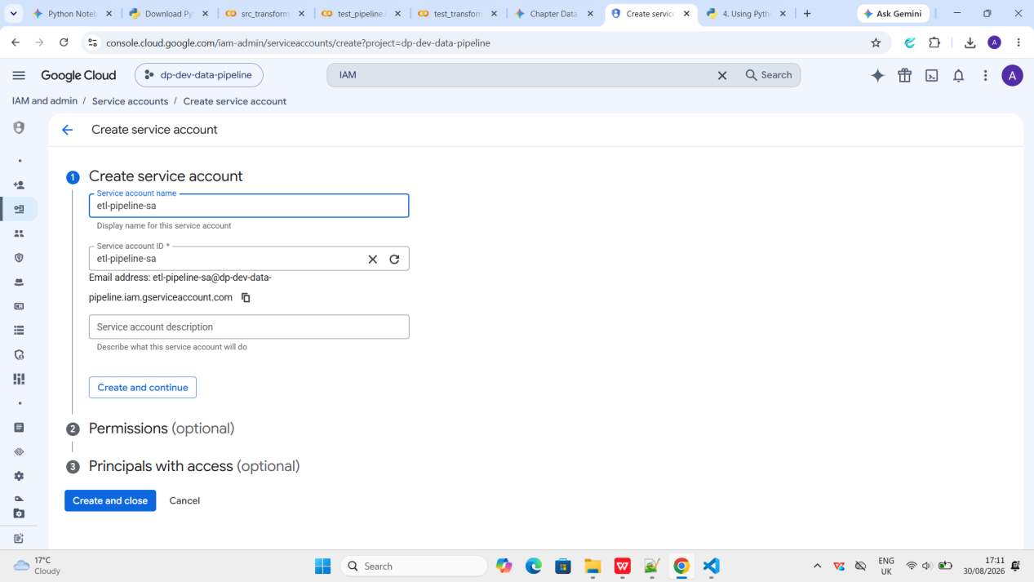

Step 5:- After that select the roles as BigQuery Admin, BigQuery Data Editor and BigQuery Job User.

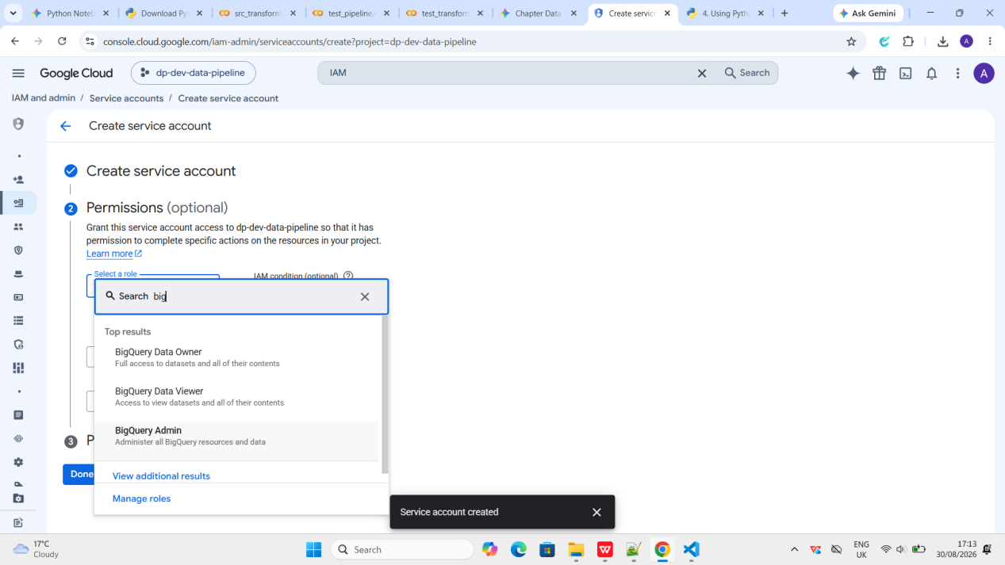

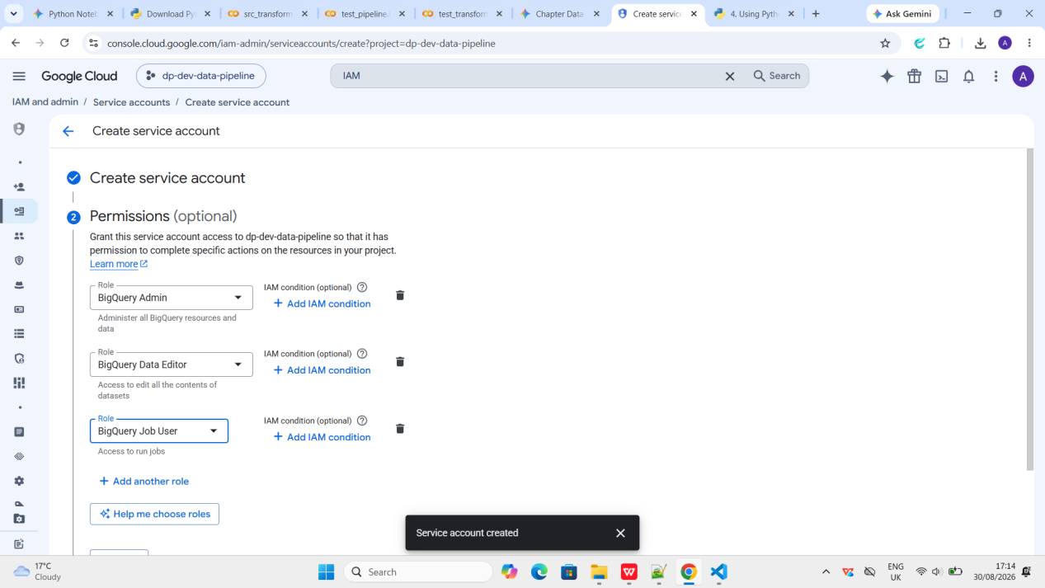

Step 6:- Click continue and then Done

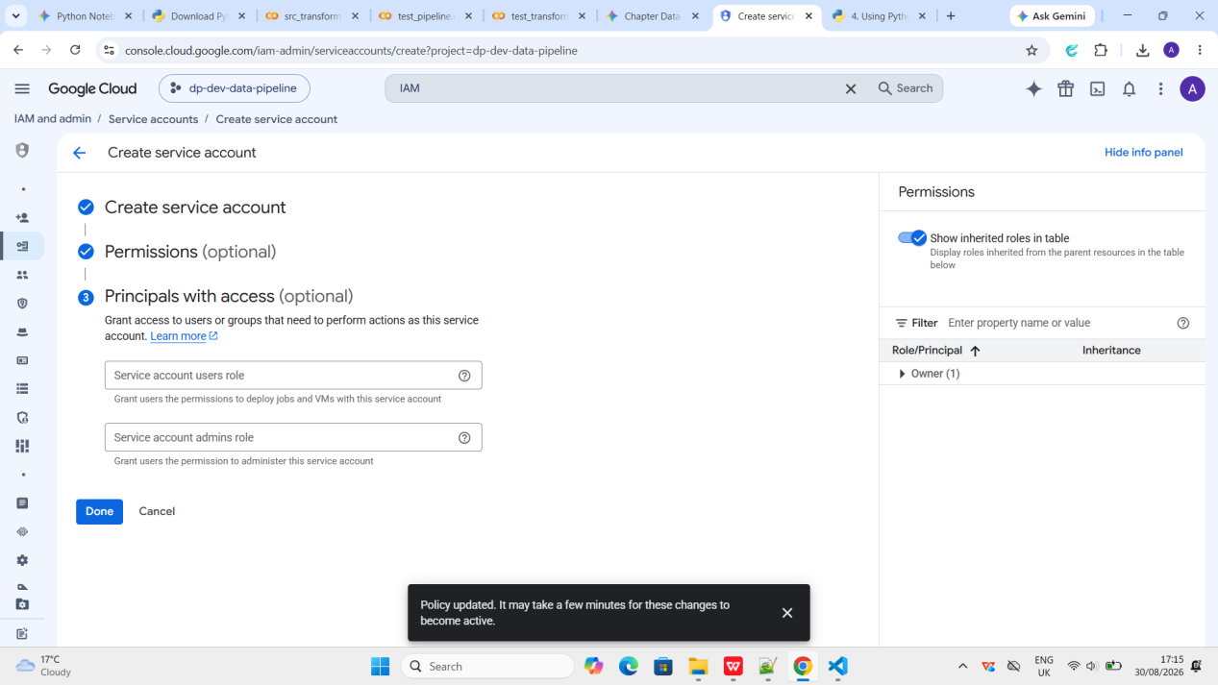

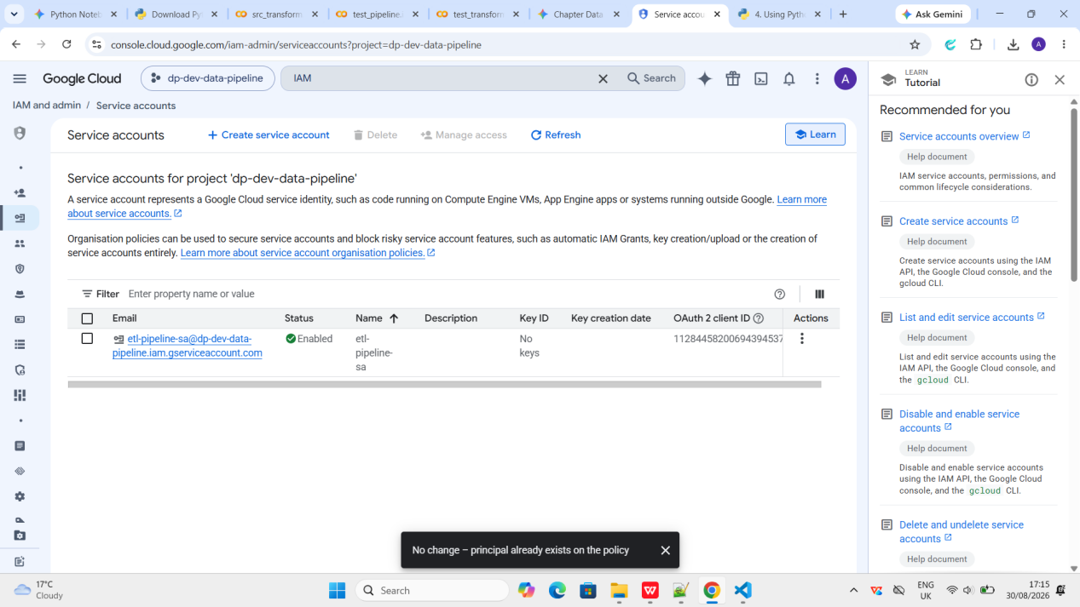

Step 7:- Select three dots under the action option and select Manage Keys

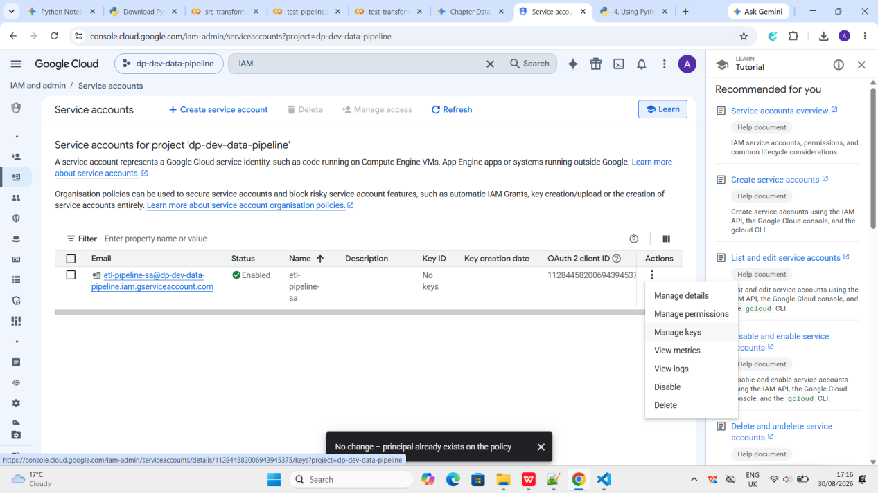

Step 8:- Click on Add Key and Create new key

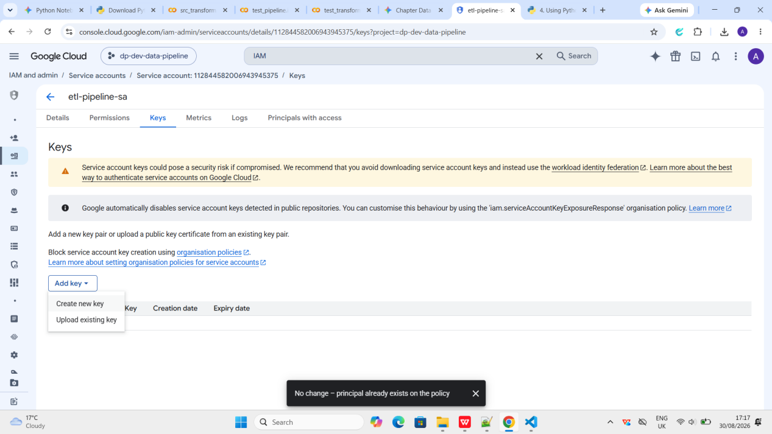

Step 9:- Select JSON as the new key

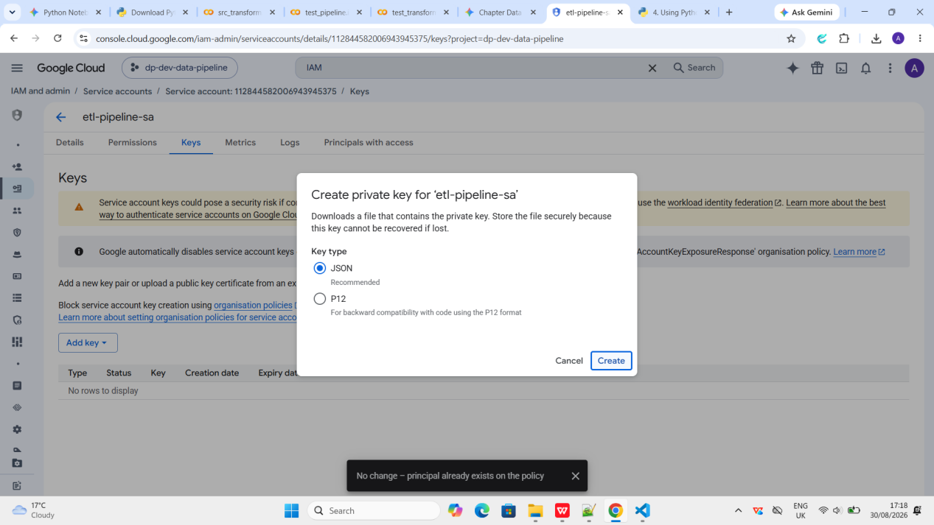

Step 10:- Move that downloaded JSON file into your project folder (for example, inside a dedicated folder or right in your root directory, but make sure it stays private and is never pushed to public repositories like GitHub).

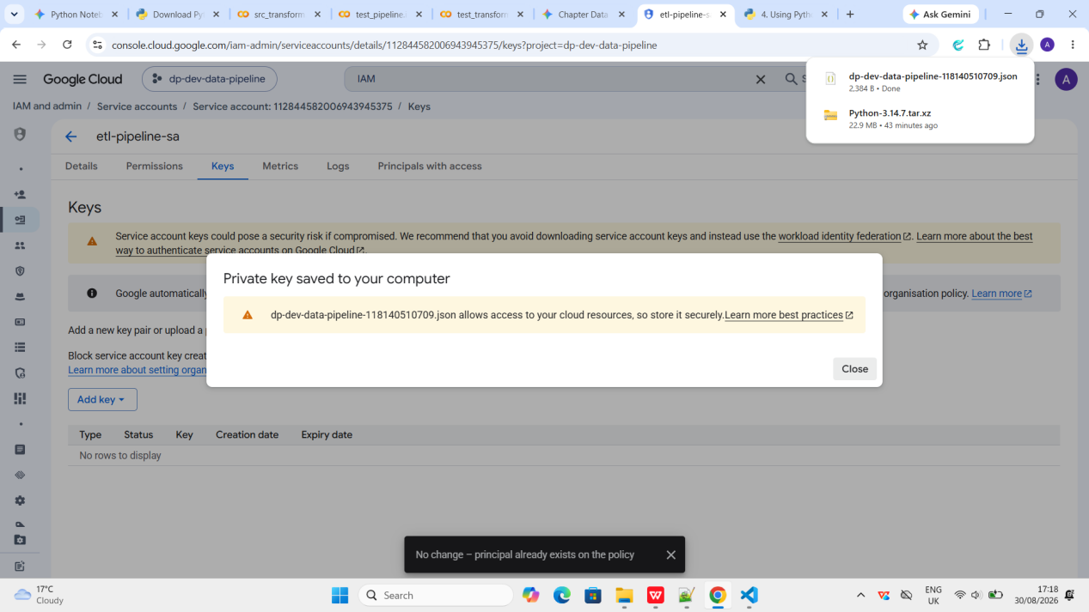

Step 11:- Set the Environment Variable: In your PowerShell terminal, point the environment variable to the exact file path of that downloaded JSON file:

$env:GOOGLE_APPLICATION_CREDENTIALS="C:\Users\asipr\Desktop\du-chapters-etl\your-service-account-file.json"

Step 12:- Once completed I can run my pipeline:

python -m src.src_pipeline

