Ducks Unlimited University Chapters ETL Pipeline

AIM: The aim of this project is to build an end-to-end automated ETL (Extract, Transform, Load) pipeline that extracts university chapter data for Ducks Unlimited from a public ArcGIS API endpoint, validates and transforms the records into a clean schema, and securely loads them downstream into Google BigQuery.

Key objectives include:

1.) Automated Data Integration: Programmatically fetching university chapter records using Python instead of manual data collection.
2.) Data Quality & Transformation: Parsing nested JSON structures and spatial attributes to ensure uniform data formats, accurate coordinates, and explicit schema constraints.
3.) Cloud Storage: Persisting structured data reliably inside Google BigQuery for reporting and analysis.
4.) Software Engineering Best Practices: Incorporating modular script design, automated unit testing with `pytest`, and continuous integration/continuous deployment (CI/CD) workflows via GitHub Actions.

Below are the source file names and target table which I used to migrate the data:

Component Type | Name / Identifier
Source File | src/src_extract.py
Source File | src/src_transform.py
Source File | src/src_bigquery_load.py
Source File | src/src_pipeline.py
Testing File | tests/test_pipeline.py
Testing File | tests/test_transform.py
CI/CD Config | .github/workflows/CI-CD.yml
Cloud Target | Google BigQuery Project (dp-dev-data-pipeline)
Cloud Target | BigQuery Dataset (etl_pipeline)
Cloud Target | BigQuery Table (university_chapters)

Step 1:- This YAML file configures a GitHub Actions workflow named "ETL CI/CD Pipeline" that automates testing for myrepository.

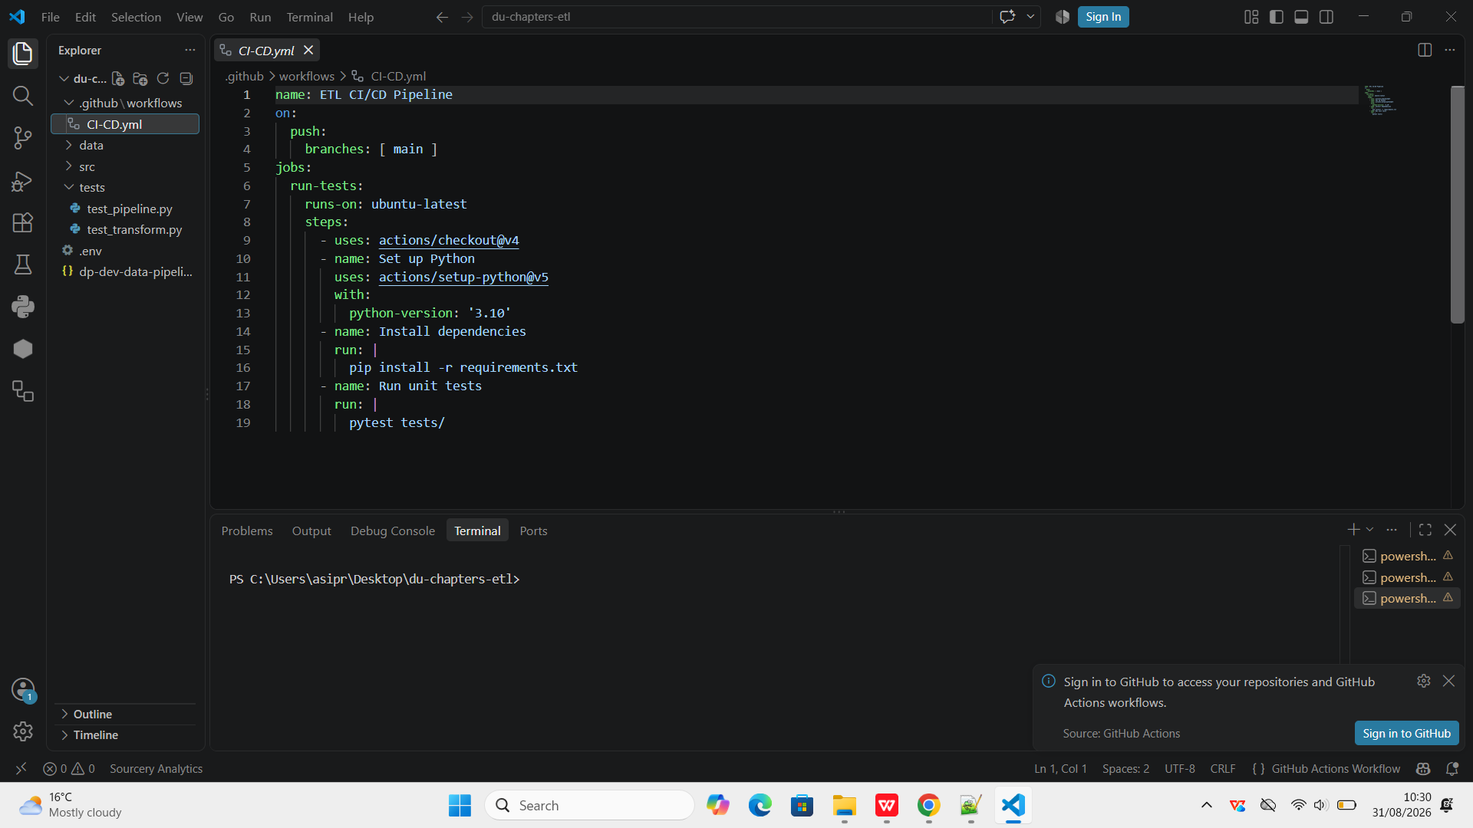

Step 2:- Inside the data folders I have real time data in CSV and other formats

CSV:-

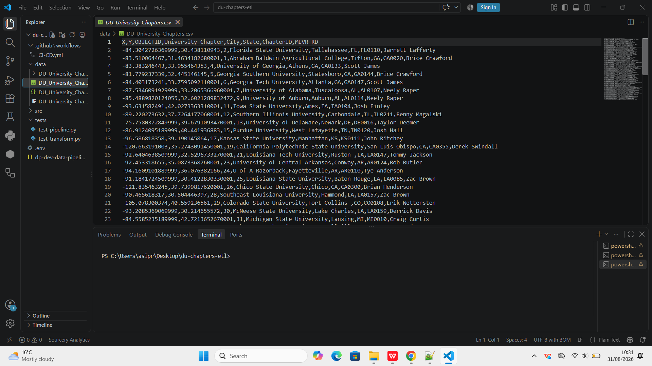

JSON:-

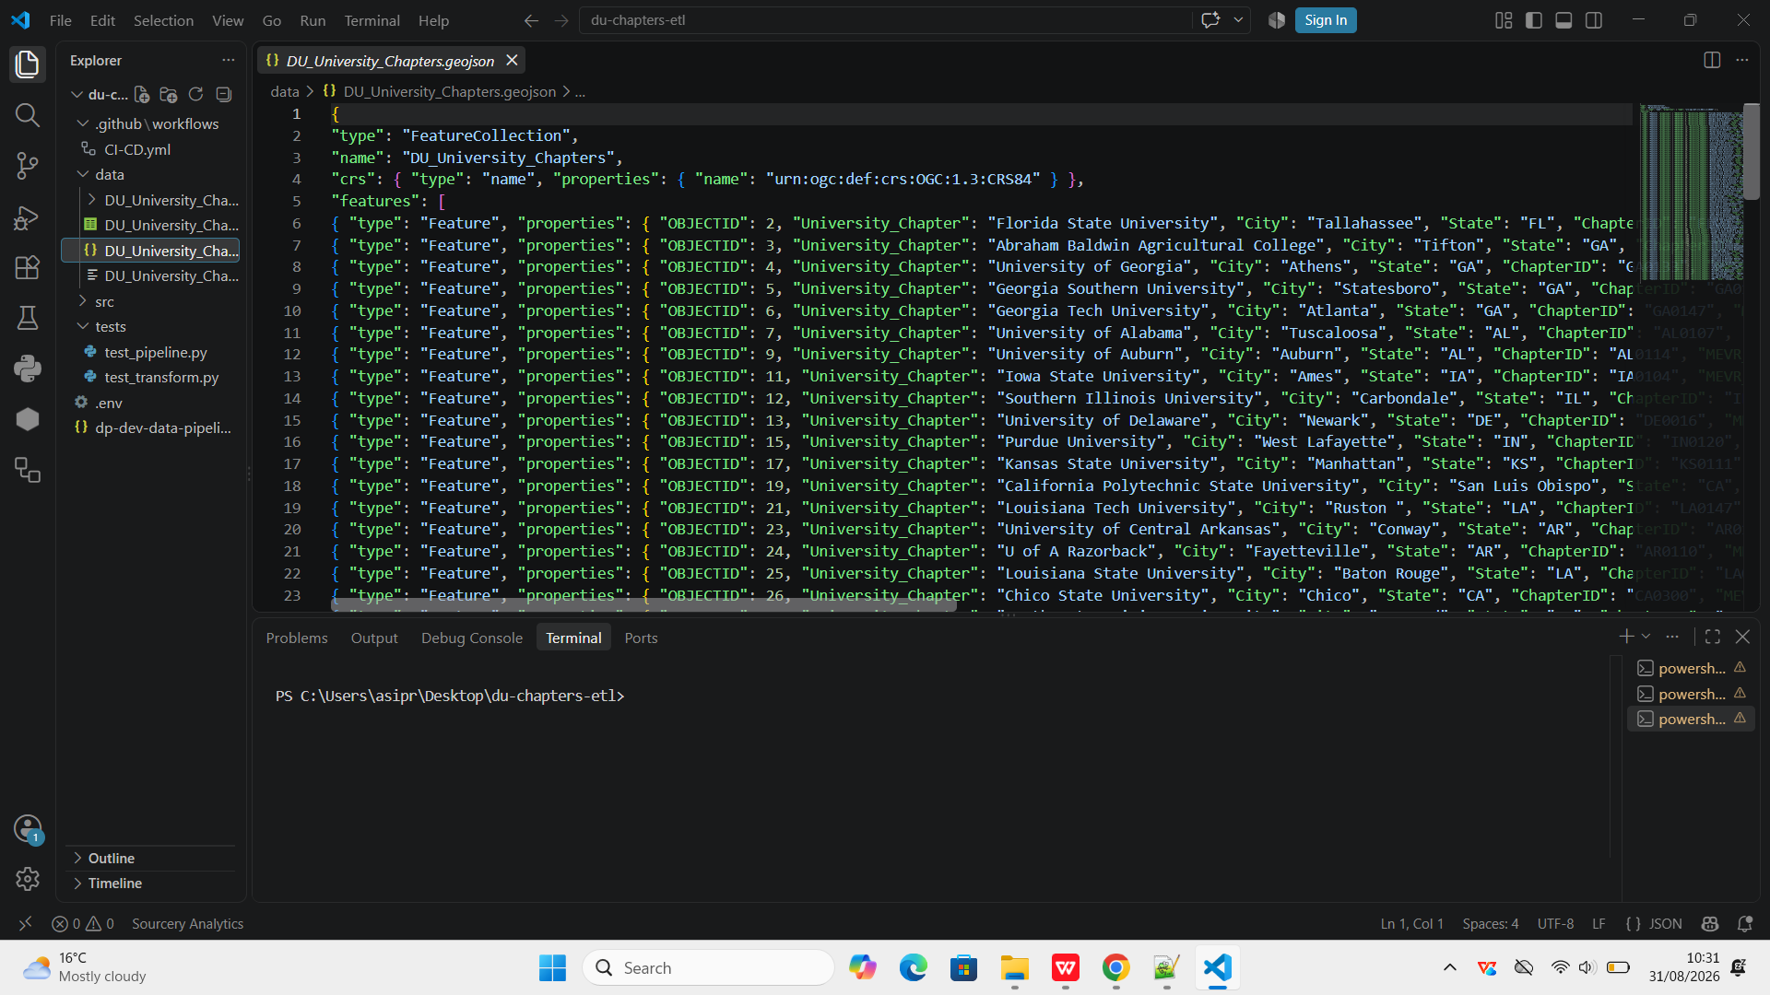

KML:-

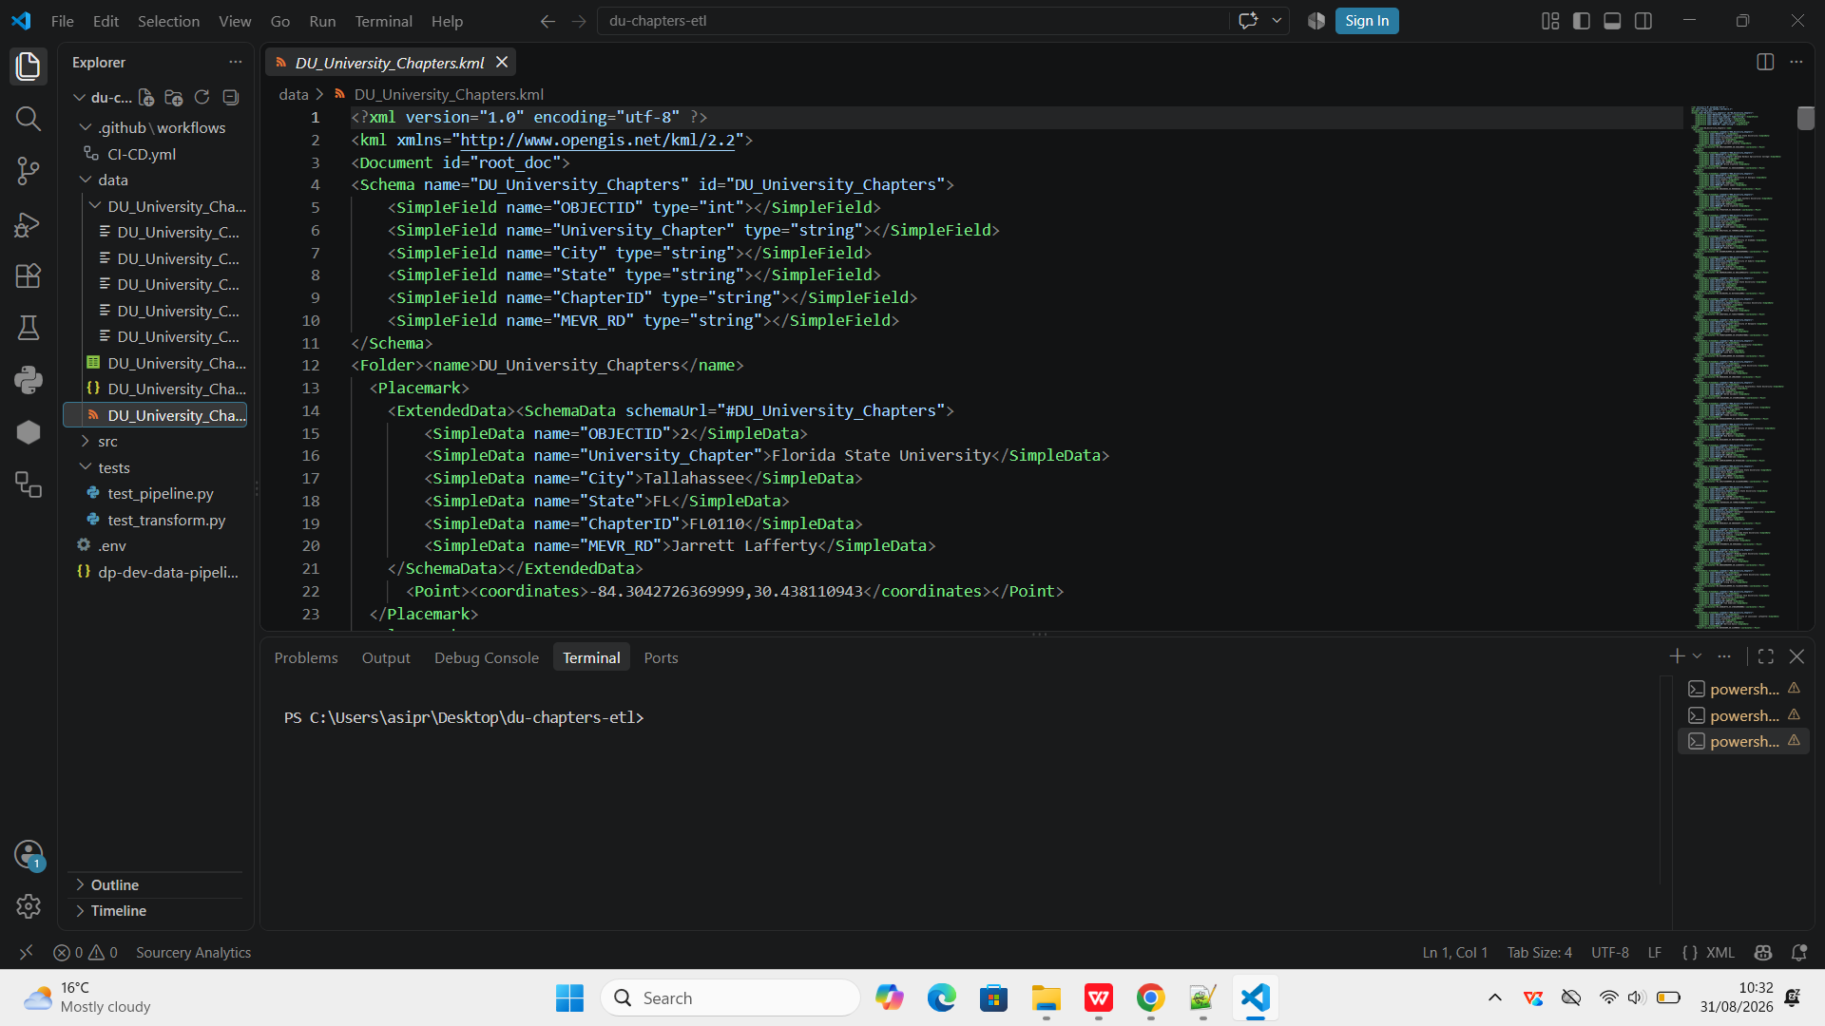

Step 3:- Below code reads raw chapter records from a local file as a fallback or testing option. Connects to the external ArcGIS REST API using `requests` with parameters to fetch raw JSON feature data.

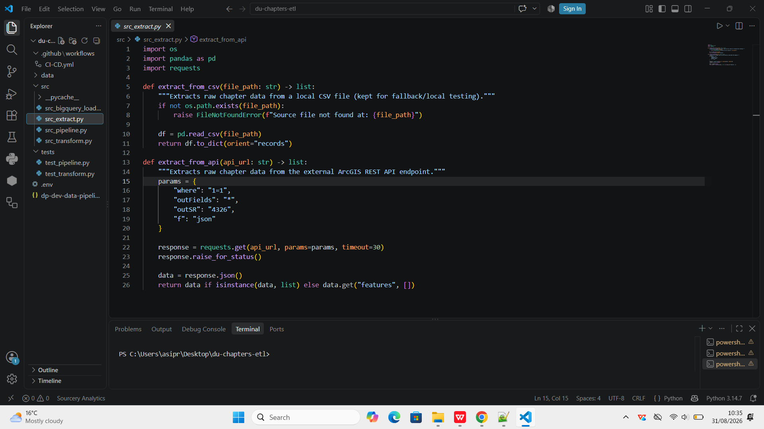

Step 4:- Normalizes raw API payloads by separating or parsing nested `attributes` and spatial `geometry` fields. Extracts longitude (`x`) and latitude (`y`) coordinates to map structural requirements for downstream storage. Outputs a clean Pandas DataFrame mapping core fields like Chapter ID, Name, City, and State.

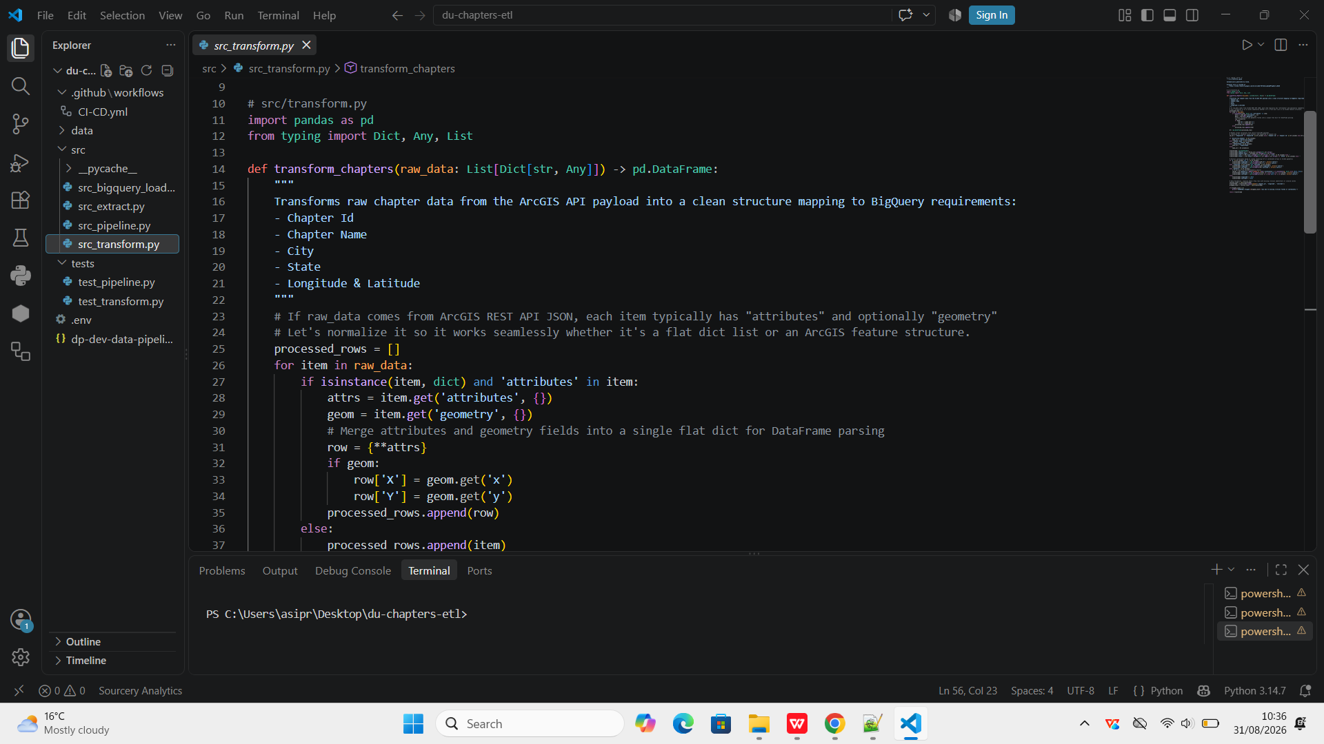

Step 5:- In the below code:

- Client Connection: Initializes a Google Cloud BigQuery client to connect to your project.
- Schema Enforcement: Defines strict data types and constraints (`STRING`, `FLOAT`, `REQUIRED`, `NULLABLE`) for all chapter attributes.
- Table Overwrite: Loads the Pandas DataFrame into BigQuery using `WRITE_TRUNCATE` to refresh the target table.

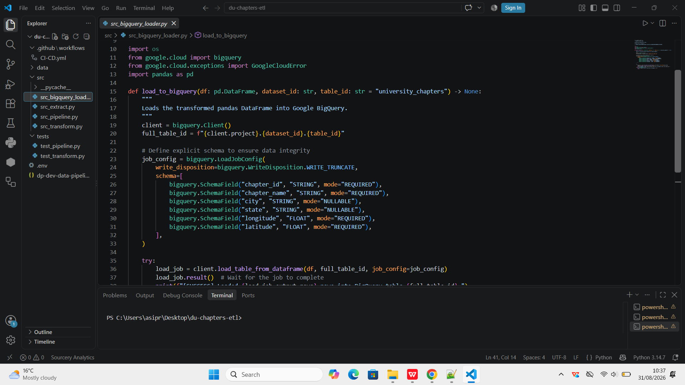

Step 6:- In below pipeline file:-

- Environment Configuration: Loads environment variables using `load_dot_env()` and sets configurations like data source type (`api` or `csv`), dataset ID, and table ID.
- Orchestration Execution: Acts as the master control script that sequentially coordinates the workflow by calling the extraction, transformation, and loading functions.

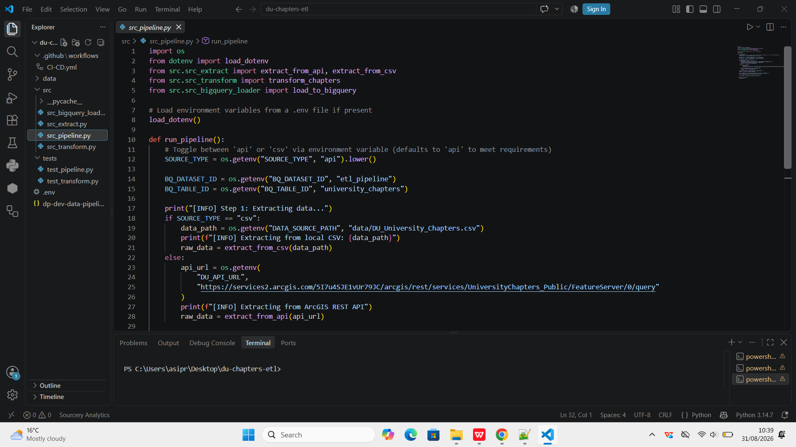
Step 7:- In testing

- Pipeline Mocking: Uses `unittest.mock` (`patch`) to isolate the orchestration test by mocking external dependencies like extraction and loading functions.
- Execution & Assertion: Simulates a successful run by passing mock chapter data, executing `run_pipeline()`, and asserting that both extract and load steps were called sequentially.

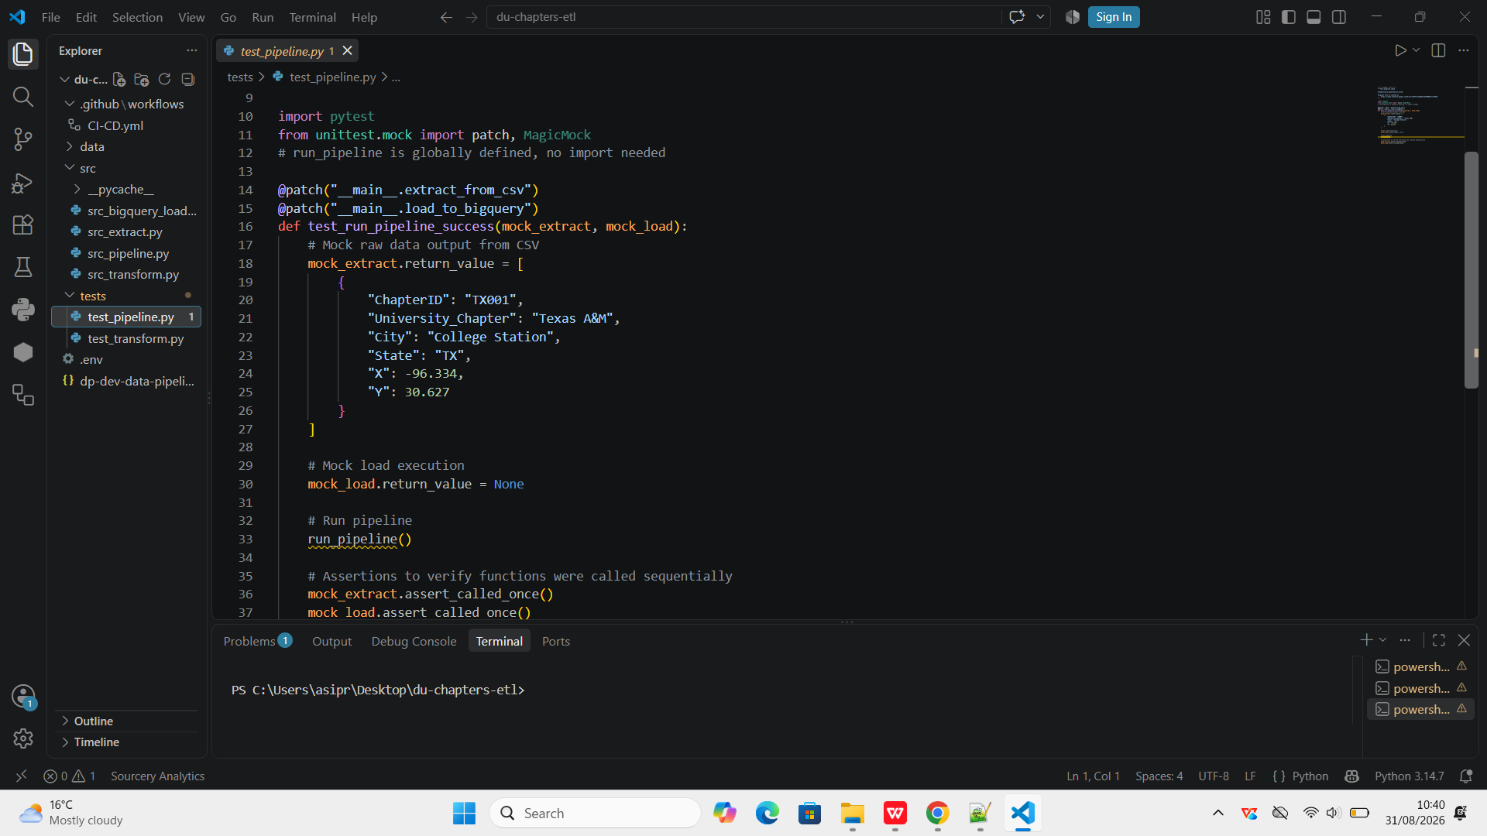

Step 8:-

- Transformation Testing**: Tests the `transform_chapters` function using sample raw chapter data to verify proper parsing.
- Assertion Checks**: Validates that the resulting DataFrame has the correct row count (`len(df) == 1`) and accurately maps specific fields like chapter ID and chapter name.

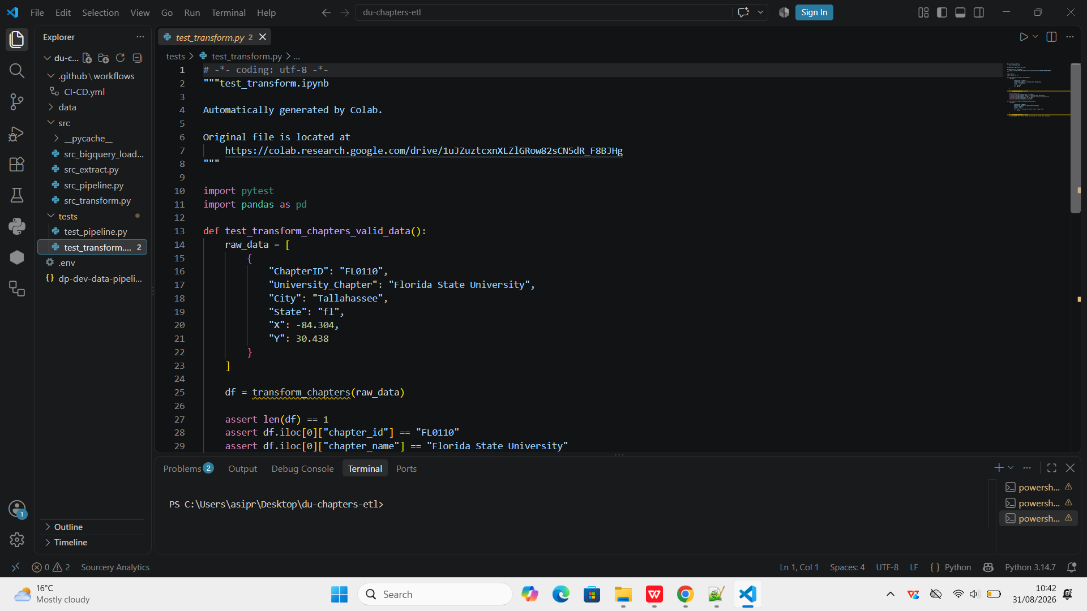

Step 9:- When I run command in terminal:-

Python -m src.src_pipeline it will load 136 records in my BigQuery table(university_chapters) after processing

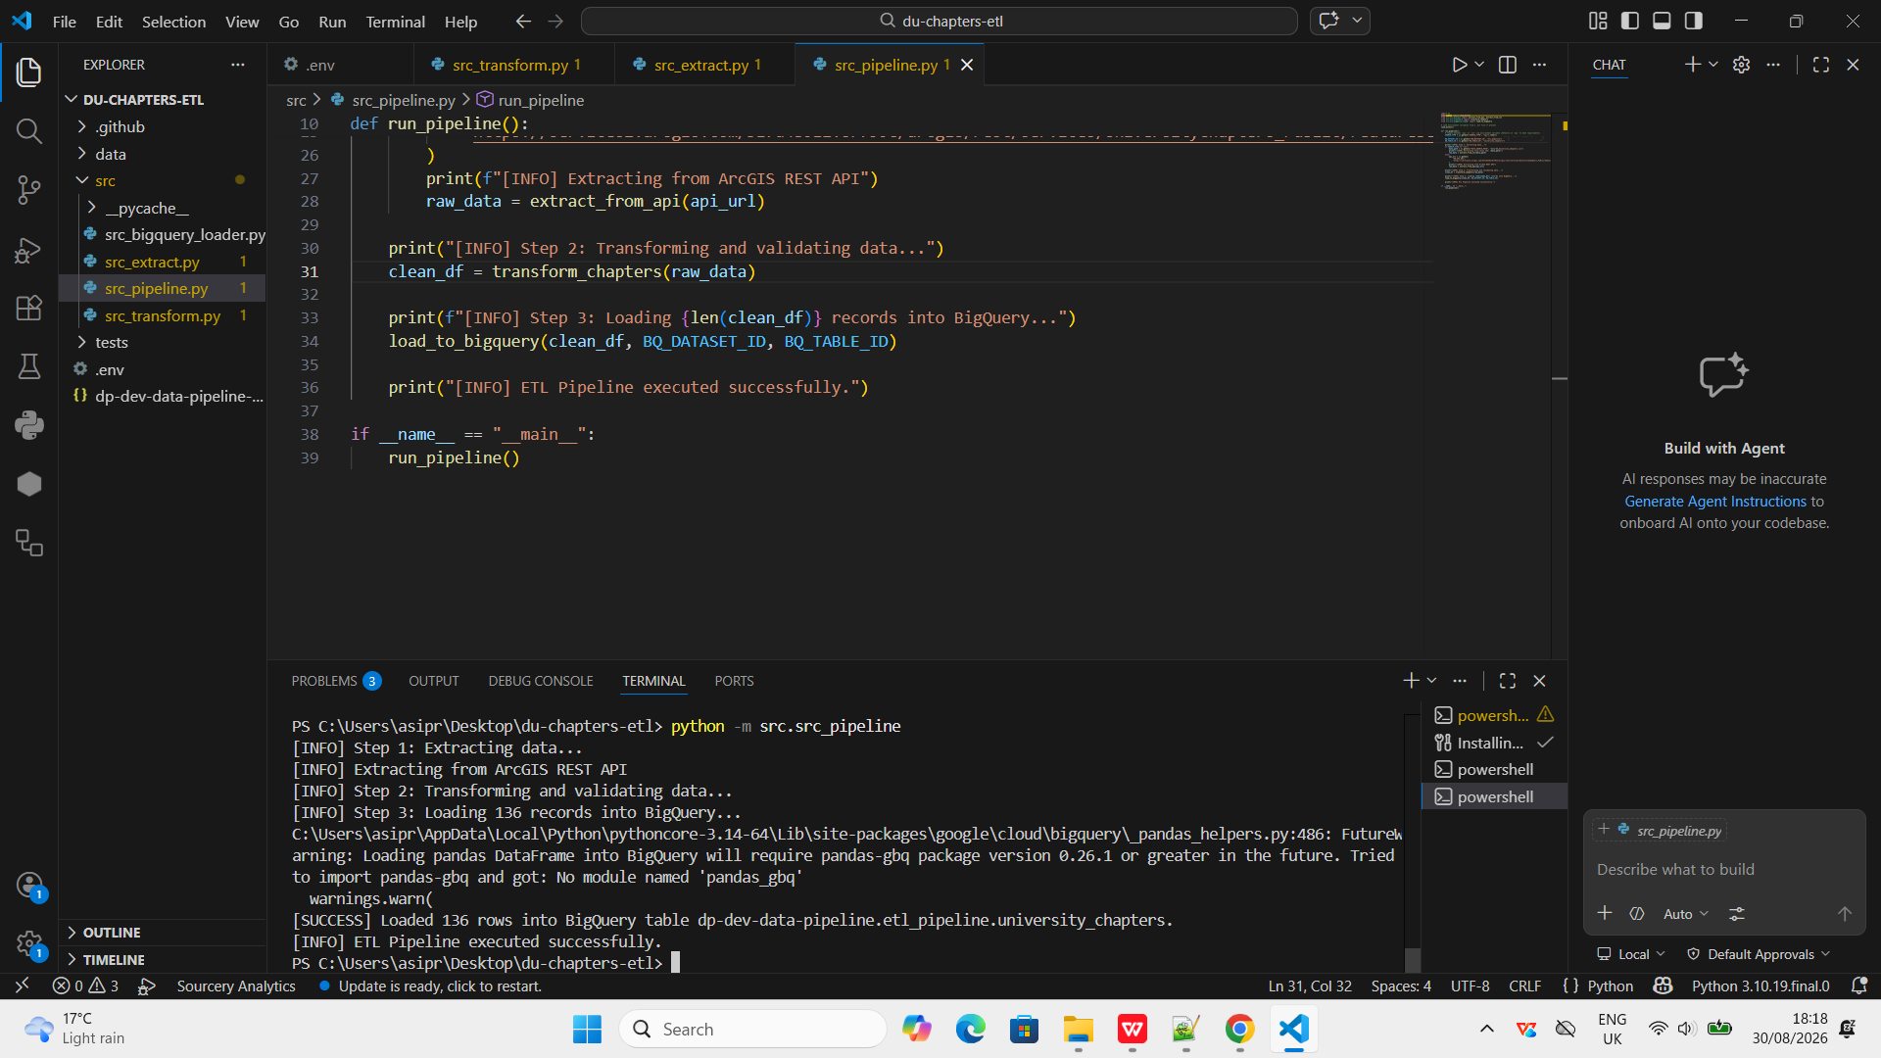

Step 10:- Total 136 records were loaded in BigQuery table

