Q1)  Read a CSV file with data in multiple columns and compute mean, median mode of each of the columns.

**m=k['c1'].median()**

**n=k['c2'].median()**

**o=k['c3'].median()**

**print(f"The median of the first colum is {m}")**

**print(f"The median of the second colum is {n}")**

**print(f"The median of the thir colum is {o}")**

**m=k['c1'].mode()**

**n=k['c2'].mode()**

**o=k['c3'].mode()**

**print(f"The mode of the first colum is {m}")**

**print(f"The mode of the second colum is {n}")**

**print(f"The mode of the thir colum is {o}")**

**m=k['c1'].mean()**

**n=k['c2'].mean()**

**o=k['c3'].mean()**

**print(f"The mean of the first colum is {m}")**

**print(f"The mean of the second colum is {n}")**

**print(f"The mean of the thir colum is {o}")**

**RESULTS**

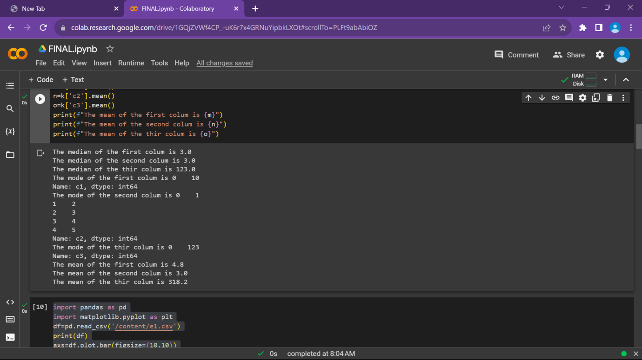

Q2) Plot each of the columns with different colors (check what kind of graph is suitable )

**import pandas as pd**

**import matplotlib.pyplot as plt**

**df=pd.read_csv('/content/e1.csv')**

**print(df)**

**axs=df.plot.bar(figsize=(10,10))**

**plt.show()**

**RESULTS**

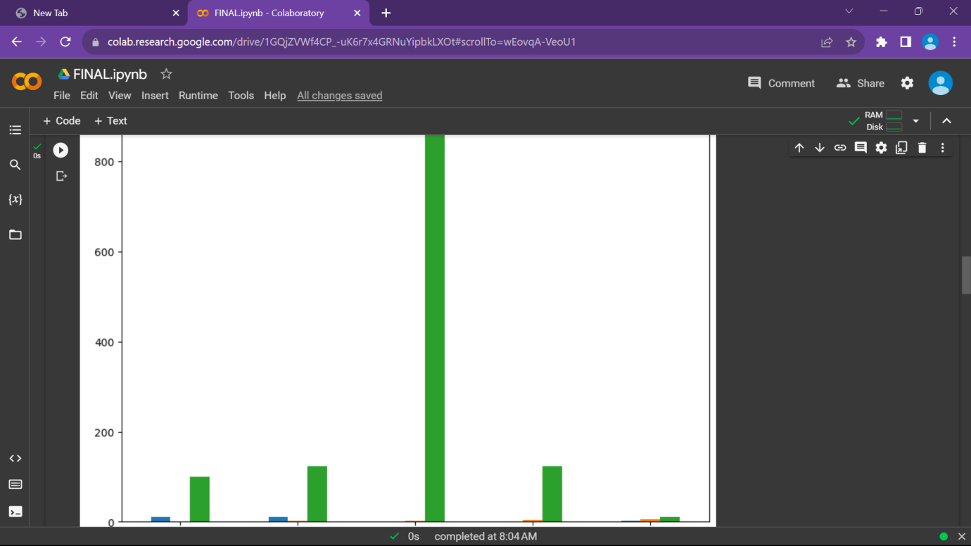

**Q3)** Create a game (like lottery/ rock paper/scissors) and write a python code to record how many times the computer won and the user won in an excel file. Plot the graph showing the success rate of user and computer with different colors

**import random**

**import pandas as pd**

**import matplotlib.pyplot as plt**

**def winner(a,b):**

**if(a=='s'):**

**if(b=='w'):**

**return 1**

**elif(b=='s'):**

**return 0**

**else:**

**return 2**

**elif(a=='w'):**

**if(b=='g'):**

**return 1**

**elif(b=='w'):**

**return 0**

**else:**

**return 2**

**elif(a=='g'):**

**if(b=='s'):**

**return 1**

**elif(b=='g'):**

**return 0**

**else:**

**return 2**

**user_wins = 0**

**computer_wins = 0**

**total_games = 0**

**results = []**

**for i in range(10):**

**a = input("Enter your choice Gun(g) Water(w) Snake(s) ")**

**randno = random.randint(1, 3)**

**if randno == 1:**

**b = 'g'**

**elif randno == 2:**

**b = 'w'**

**else:**

**b = 's'**

**print(f"The choice of the player 1 was {a}")**

**print(f"The choice of the computer was {b}")**

**if a in ('w', 'g', 's'):**

**if b in ('w', 'g', 's'):**

**result = winner(a, b)**

**if result == 1:**

**print("Player 1 won the game")**

**user_wins += 1**

**elif result == 2:**

**print("Computer won the game")**

**computer_wins += 1**

**else:**

**print("Draw")**

**results.append(result)**

**total_games += 1**

**else:**

**print("Invalid choice entered")**

**else:**

**print("Invalid choice entered")**

**user_success_rate = user_wins / total_games**

**computer_success_rate = computer_wins / total_games**

**labels = ['User', 'Computer']**

**success_rates = [user_success_rate, computer_success_rate]**

**colors = ['blue', 'red']**

**plt.bar(labels, success_rates, color=colors)**

**plt.xlabel('Player')**

**plt.ylabel('Success Rate')**

**plt.title('Game Success Rates')**

**plt.show()**

**RESULTS**

