**Sifting**

1. **Purpose:** Active Pharmaceutical Ingredients (API) and excipients are sifted through different sieves to avoid oversized contamination and are mixed.
2. **Login;**

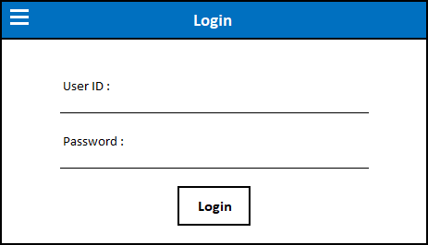

Upon selecting  ‘Drawer menu’, the drawer will display following options;

1. **System Information:** The module contains information of the system version, its serial no., MAC Address and respective IP address of HMI in Read Only format.

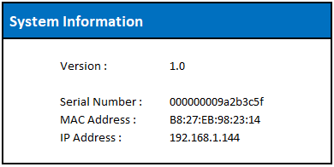

1. **Server IP Configuration:** The module displays API Server Address and Interface Server Address which are editable and accepts numeric values in set format.

* ‘Submit’ button will be disabled till user clicks on ‘Edit’ button. Click on ‘Edit’ button to make changes in API or Interface address and ‘Edit’ button will be replaced with ‘Clear’ button.
* Make required changes and click on ‘Submit’ button and updated data will be saved.

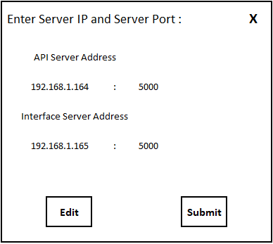

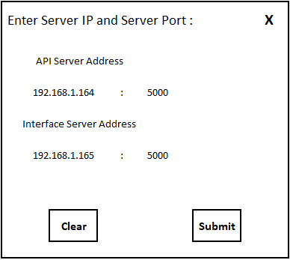

1. **Contact Us:** This module contains contact information of TantraSoft Solutions (India) Private Limited.

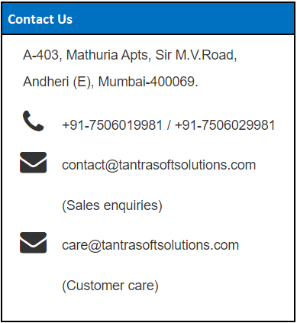

1. **About Us:** This module contains information about TantraSoft Solutions (India) Private Limited.

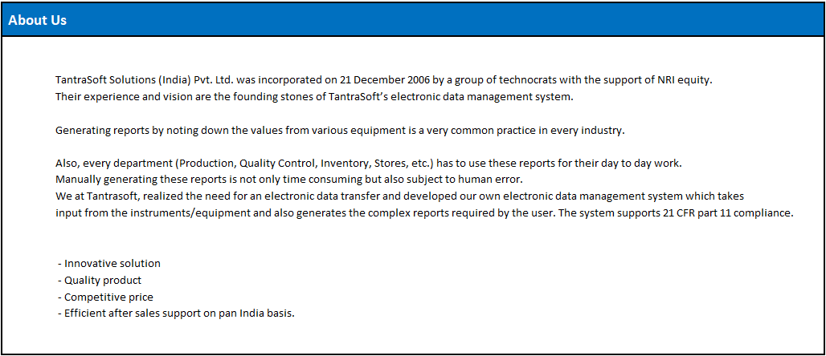

1. **Field Validations;**

|  |  |  |  |
| --- | --- | --- | --- |
| **Field** | **Data Type** | **Character limit** | **Source** |
| User ID | Alpha-numeric and special characters. | Minimum 1 and Maximum 10. | User Master |
| Password | Alpha-numeric and special characters. | Minimum 1 and Maximum 16. | User Master and Password Policy |

1. **Validations Messages;**

|  |  |  |  |
| --- | --- | --- | --- |
| **Field** | **Scenario** | **Validation messages** | **Co-relation** |
| User ID | Enter **incorrect** User ID. | Incorrect Credentials. | * Audit Trail for Unauthorized Login * Activity Log |
| Enter **inactive** User ID.  (Temporary / Permanent disabled User ID) | User Disabled. Contact Authorized Person. | * Audit Trail for Unauthorized Login * Activity Log |
| Enter User ID with which, a user is already logged in on software. | User Already Active on Software. | * Activity Log |
| Enter User ID with which, a user is already logged in on another hardware. | User Already Active on Hardware / another terminal. | * Activity Log |
| Password | Enter **correct** User ID and **incorrect** Password. | Incorrect Credentials. | * Audit Trail for Unauthorized Login * Activity Log |
| Enter **correct** User ID and **correct** Password (password is about to expire in the system). | Password Expires in <no. of days> Days.   * Change Password * Continue | * Audit Trail for Change Password (if user choose to change their password) * Activity Log |
| Enter **correct** User ID and **correct** Password (password has expired in the system). | Password Expired. Change Password.  (User will be directed to Change Password window). | * Audit Trail for Change Password * Activity Log |
| * Attempt to login multiple times with **correct** User ID and incorrect Password. * Attempt to login with **correct** User ID and **incorrect** Password when a disabled user has got enabled in the system. | User Locked for <Lock Period>.  (User will get locked for ‘Lock Period’). | * Audit Trail for Unauthorized Login * Activity Log |
| * Attempt to login with **newly created** User ID and Password. * Attempt to login when user has got their password changed in the system by Admin / Authorized User. * Attempt to login with **correct** User ID and **correct** Password when a disabled user has got enabled in the system. * Attempt to login with **correct** User ID and **correct** Password after no. of days set in ‘Non Login Period’. | Change Password  (User will be directed to Change Password window). | * Audit Trail for Change Password * Activity Log |
| * Attempt to login multiple times with **correct** User ID and **incorrect** Password and exhaust ‘Auto Enable Chances’. * Attempt to login with **correct** User ID and **incorrect** Password after no. of days set in ‘Non Login Period’. | Auto Enable Chances Exhausted. Contact Authorized Person. | * Activity Log |

\***Auto Enable Chances -** If the password entered is incorrect for a set number of attempts, User ID will get locked for seconds set in lock period. The user will be allowed to login for no. of attempts set in auto enable chances in spite of keying in incorrect password.

\***Lock Period -** If the user enters incorrect passwords for set number of times, he is locked for number of seconds set in lock period. The user can still try logging in after lock period for no. of attempts set in auto enable chances.

\***Non-Login Period -** If the user is not logged into the system for a set number of days, he will get disabled and will be forced to change the password on his next login attempt.

1. **Screen Design upon Successful Login;**

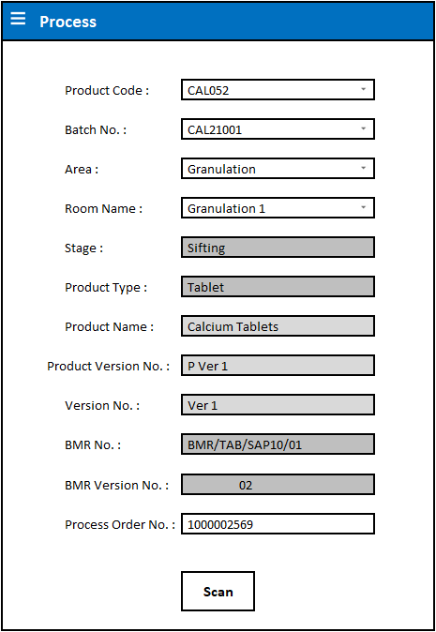

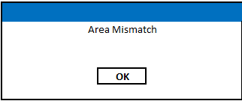

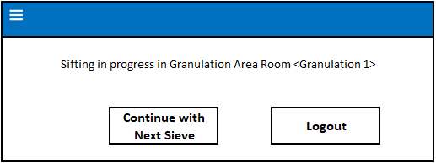

1. **Field Validations;**

|  |  |  |  |
| --- | --- | --- | --- |
| **Field Name** | **Field Validation** | **Character Limit** | **Source** |
| Product Code | Dropdown selection. | NA | Will display Product Codes for which Batch has been started in <Batch Setting>. |
| Batch No. | Dropdown selection. | NA | Material Batches fully Dispensed for Product.  **OR**  As set in <Batch Setting>. |
| Area | Dropdown selection. | NA | As set in <Area Master>. |
| Room Name | Dropdown selection. | NA | As set in <Area Master>. |
| Stage | Dropdown selection (applicable only when more than one stage assigned in <Area Master>; otherwise the field will be disabled and stage assigned in <Area Master> will be displayed). | NA | As set in <Area Master>. |
| Product Type | Field disabled. | NA | Product Name will be displayed as set in <Product Master>. |
| Product Name | Field disabled. | NA | Product Name will be displayed as set in <Product Master>. |
| Product Version No. | Field disabled. | NA | Product Version No. will be displayed as set in <Product Master>. |
| Version No. | Field disabled. | NA | Version No. will be displayed as set in <Product Master>. |
| BMR No. | Field disabled. | NA | BMR No. will be displayed as set in <Product Master>. |
| BMR Version No. | Field disabled. | NA | BMR Version No. will be displayed as set in <Product Master>. |
| Process Order No. | Alpha-numeric and special characters. | Minimum 1 and maximum 20. | Material Batches fully Dispensed for Product. |

*If Dispensing is linked with Granulation, Batch No. and Process Order No. will be displayed automatically as per dispensed Product data. Otherwise, provision to manually enter data.

1. **Validation Messages;**

|  |  |  |  |
| --- | --- | --- | --- |
| **Field** | **Scenario** | **Validation** | **Co-relation** |
| Batch No. | Enter an invalid batch no. | ‘Batch No. does not exist’ message will get displayed.  (Process Order No. will not be displayed for entered data). | Dispensing Table. |

*If Dispensing is linked with Granulation, Batch No. and Process Order No. will be displayed automatically as per dispensed Product data. Otherwise, provision to manually enter data.

1. **Workflow;**

* Login with valid User ID and Password.
* Upon successful login, ‘Process’ window will get displayed.
* Select ‘Product Code’ and ‘Batch No’ from dropdown list.
* Product details (Product Name, Product Version No. and Version No.), BMR No. and BMR Version No. will automatically get displayed in respective fields as set in <Batch Setting> upon Selection of ‘Product Code’ from dropdown list.
* Select ‘Area’ and ‘Room’ from dropdown list.
* Select appropriate ‘Stage’ name from dropdown list if available. (Stage will be automatically selected and disabled if only one stage is assigned in <Area Master>).
* Enter Process Order No. manually.
* Select ‘Scan’ button to scan the area barcode.
* If area details selected are matching with scanned information, process will be allowed to start. Otherwise message will be displayed.
* If sifting has already begun for selected product – batch and another user logs in through a different HMI, they will be notified of the same and will be given option to begin sifting with another sieve (option will only appear if sifting is ‘Simultaneous’).
* User can ‘Continue with Next Sieve’ to sift materials through other sieve set in <Product Master>.

1. Area Clearance form.

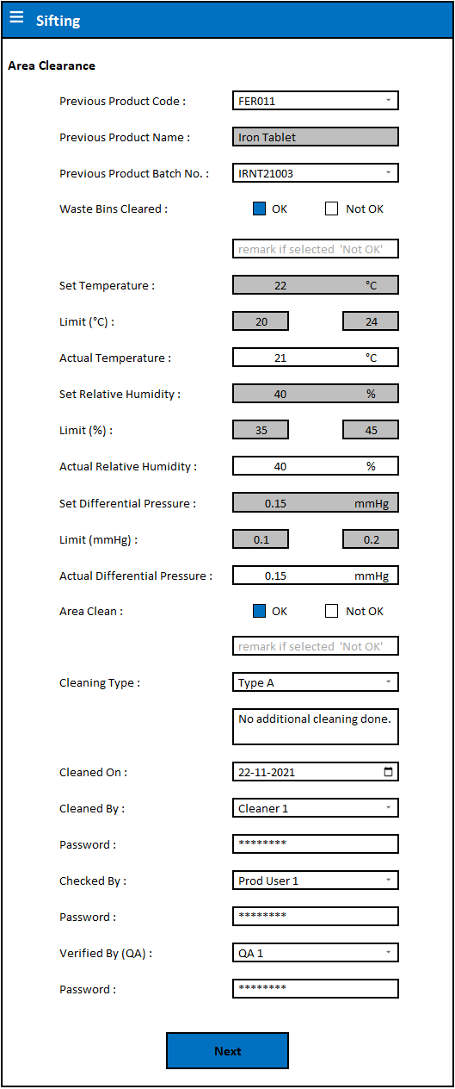

1. **Field Validations;**

|  |  |  |  |
| --- | --- | --- | --- |
| **Field Name** | **Field Validation** | **Character Limit** | **Source** |
| Previous Product Code | Dropdown selection. | NA | List of Product Code will be displayed for which, selected stage has been completed in selected area. |
| Previous Product Name | Auto Display. Field disabled. | NA | Product Name will be displayed according to Previous Product Code selected. |
| Previous Product Batch No. | Dropdown selection. | NA | List of Batches will be displayed for which, selected stage has been completed according to selected Product Code in selected area.  **\*NOTE:** Rejected Batch nos. will not be displayed in dropdown list. |
| Waste Bins Cleared (OK / Not OK) | Check box selection. | NA | NA. |
| Temperature | Numeric and decimal values. | * Range between 10 and 40 in case unit is selected as °C in <Area Setting>. * Range between 50 and 110 in case unit is selected as °F in <Area Setting>. | NA. |
| Set & Limits | Auto Display. Fields disabled. | NA | As set in <Area Master>. |
| Relative Humidity | Numeric and decimal values. | Range between 10 and 60. | NA. |
| Set & Limits | Auto Display. Fields disabled. | NA | As set in <Area Master>. |
| Differential Pressure | Numeric and decimal values. | * Range between 5 and 20 in case unit is selected as Pa (Pascal) in <Area Setting>. * Range between 0.001 and 5 in case unit is selected as mmHg in <Area Setting>. | NA. |
| Set & Limits | Auto Display. Fields disabled. | NA | As set in <Area Master>. |
| Area Clean (OK / Not OK) | Check box selection. | NA | NA |
| Cleaning Type | Dropdown selection (Type A or Type B).  Manual entry for remark (alpha-numeric and special characters). | Remark only in case of any additional cleaning done. | NA |
| Cleaned On | Date selection from calendar.  (User can select up to 7 days back date). | NA | Back dated entry can be selected from Calendar.  (Current Date will be selected by default). |
| Cleaned By | Dropdown selection. | NA | From <User Master>. |
| Password | Alpha-numeric and special characters. | Minimum 1 and maximum 16. | As per limits set in <Password Policy>. |
| Checked By | Dropdown selection. | NA | From <User Master>. |
| Password | Alpha-numeric and special characters. | Minimum 1 and maximum 16. | As per limits set in <Password Policy>. |
| Verified By (QA) | Dropdown selection. | NA | From <User Master>. |
| Password | Alpha-numeric and special characters. | Minimum 1 and maximum 16. | As per limits set in <Password Policy>. |

1. **Validation Messages;**

|  |  |  |  |
| --- | --- | --- | --- |
| **Field Name** | **Scenario** | **Validation** | **Co-relation** |
| Waste Bins Cleared (OK / Not OK) | Select ‘Not OK’. | ‘Exception Log’ form will get displayed where user will be asked to enter remark, file deviation record, enter QA credentials and QA decision will be selected as ‘Reject’ by default and ‘Accept’ and ‘Reject’ check boxes will be disabled. Upon ‘Save’, user will be directed to ‘Process’ window. | * Cleaning Log * Activity Log |
| Temperature | Enter Actual temperature beyond tolerance. | ‘Exception Log’ form will get displayed where user will be asked to enter remark, file deviation record, enter QA credentials and QA decision will be selected as ‘Reject’ by default and ‘Accept’ and ‘Reject’ check boxes will be disabled. Upon ‘Save’, user will be directed to ‘Process’ window. | * Cleaning Log * Activity Log |
| Relative Humidity | Enter Actual Relative Humidity beyond tolerance. | ‘Exception Log’ form will get displayed where user will be asked to enter remark, file deviation record, enter QA credentials and QA decision will be selected as ‘Reject’ by default and ‘Accept’ and ‘Reject’ check boxes will be disabled. Upon ‘Save’, user will be directed to ‘Process’ window. | * Cleaning Log * Activity Log |
| Differential Pressure | Enter Actual Relative Humidity beyond tolerance. | ‘Exception Log’ form will get displayed where user will be asked to enter remark, file deviation record, enter QA credentials and QA decision will be selected as ‘Reject’ by default and ‘Accept’ and ‘Reject’ check boxes will be disabled. Upon ‘Save’, user will be directed to ‘Process’ window. | * Cleaning Log * Activity Log |
| Area Clean (OK / Not OK) | Select ‘Not OK’. | ‘Exception Log’ form will get displayed where user will be asked to enter remark, file deviation record, enter QA credentials and QA decision will be selected as ‘Reject’ by default and ‘Accept’ and ‘Reject’ check boxes will be disabled. Upon ‘Save’, user will be directed to ‘Process’ window. | * Cleaning Log * Activity Log |
| Cleaned On | * Attempt to select future date from calendar. * Attempt to select back dated entry of more than 7 days. | * User will not be allowed to select future dates (all future dates will be disabled). * User will not be allowed to select entry of more than 7 back dates. | NA |
| Password | Attempt to feed in incorrect password for selected User ID. | User will not be allowed to proceed further until a correct password has been entered. | * Audit Trail for Unauthorized Login * Activity Log |

1. **Workflow;**

* Select ‘Previous Product Code’ from dropdown list and ‘Previous Product Name’ will be displayed automatically in the field.
* Select ‘Previous Product Batch No.’ from dropdown list.
* Check if ‘Waste Bins’ are clear and select relevant option.
* Check and enter Area Temperature, Relative Humidity and Differential Pressure to be as per limits set in ‘Area Master’.
* Check and select suitable checkbox if area is clean.
* Select appropriate ‘Cleaning Type’ from dropdown list and enter appropriate remark if any additional cleaning is done.
* Select ‘Cleaned On’ date from calendar.
* Select ‘Cleaned By’, ‘Checked By’ and ‘Verified By’ user details from dropdown list which will be available as per department from <User Master> and enter respective passwords.
* Click on ‘Next’ button to finish ‘Area Clearance’ save entered details and begin ‘Instrument Clearance’.
* Cleaning record of area will be generated in Reports module in software.

1. **Instrument Clearance;**

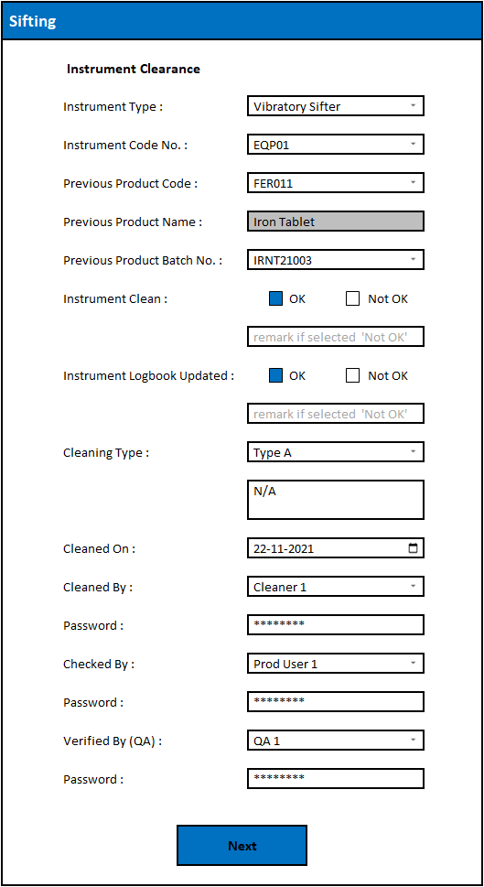

1. **Field Validations;**

|  |  |  |  |
| --- | --- | --- | --- |
| **Field Name** | **Field Validation** | **Character Limit** | **Source** |
| Instrument Type | Dropdown selection. | NA. | As per <Area Master>. |
| Instrument Code No. | Dropdown selection. | NA. | As per <Area Master>. |
| Previous Product Code | Dropdown selection. | NA. | List of Product Code will be displayed for which, selected stage has been completed in selected area. |
| Previous Product Name | Auto Display. Field disabled. | NA | Product Name will be displayed according to Previous Product Code selected. |
| Previous Product Batch No. | Dropdown selection. | NA. | List of Batches will be displayed for which, selected stage has been completed according to selected Product Code in selected area.  **\*NOTE:** Rejected Batch nos. will not be displayed in dropdown list. |
| Instrument Clean (OK / Not OK) | Check box selection. | NA | NA. |
| Instrument Logbook Updated (OK / Not OK) | Check box selection. | NA | NA. |
| Cleaning Type | Dropdown selection (Type A or Type B).  Manual entry for remark (alpha-numeric and special characters). | Remark only in case of any additional cleaning done. | NA |
| Cleaned On | Date selection from calendar.  (User can select up to 7 days back date). | NA | Back dated entry can be selected from Calendar.  (Current Date will be selected by default). |
| Cleaned By | Dropdown selection. | NA | From <User Master>. |
| Checked By | Dropdown selection. | NA | From <User Master>. |
| Verified By (QA) | Dropdown selection. | NA | From <User Master>. |
| Passwords | Alpha-numeric and special characters. | Minimum 1 and maximum 16. | As per limits set in <Password Policy>. |

1. **Validation Messages;**

|  |  |  |  |
| --- | --- | --- | --- |
| **Field Name** | **Scenario** | **Validation** | **Co-relation** |
| Instrument Clean (OK / Not OK) | Select ‘Not OK’ | ‘Exception Log’ form will get displayed where user will be asked to enter remark, file deviation record, enter QA credentials and QA decision will be selected as ‘Reject’ by default and ‘Accept’ and ‘Reject’ check boxes will be disabled. Upon ‘Save’, user will be directed to ‘Process’ window. | * Cleaning Log * Activity Log |
| Instrument Logbook Updated (OK / Not OK) | Select ‘Not OK’ | ‘Exception Log’ form will get displayed where user will be asked to enter remark, file deviation record, enter QA credentials and QA decision will be selected as ‘Reject’ by default and ‘Accept’ and ‘Reject’ check boxes will be disabled. Upon ‘Save’, user will be directed to ‘Process’ window. | * Cleaning Log * Activity Log |
| Cleaned On | * Attempt to select future date from calendar. * Attempt to select back dated entry of more than 7 days. | * User will not be allowed to select future dates (all future dates will be disabled). * User will not be allowed to select entry of more than 7 back dates. | NA |
| Password | Attempt to feed in incorrect password for selected User ID. | User will not be allowed to proceed further until a correct password has been entered. | * Audit Trail for Unauthorized Login * Activity Log |

1. **Workflow;**

* Select ‘Instrument Type’ and appropriate ‘Instrument Code No.’ from dropdown list (which will be fetched from <Area Master>).
* Select ‘Previous Product Code’ from dropdown list and ‘Previous Product Name’ will be displayed automatically in the field.
* Select ‘Previous Product Batch No.’ from dropdown list.
* Check if Instrument is clean and select relevant option.
* Check if ‘Instrument Logbook’ is updated.
* Select appropriate ‘Cleaning Type’ from dropdown list and enter appropriate remark if any additional cleaning is done.
* Select ‘Cleaned On’ date from calendar.
* Select ‘Cleaned By’, ‘Checked By’ and ‘Verified By’ user details from dropdown list which will be available as per department from <User Master> and enter respective passwords.
* Click on ‘Next’ button to finish clearance of selected Instrument and begin for next one.
* The process of ‘Instrument Clearance’ will repeat till all (Fixed and Portable) Instrument assigned in Area Master are cleaned.
* Cleaning record of Instrument will be generated in Reports module in software.

Set / Return IPCs for Stage;

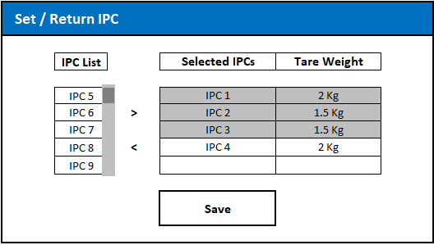

1. **Field Validations;**

|  |  |  |  |
| --- | --- | --- | --- |
| **Field Name** | **Field Validation** | **Character Limit** | **Source** |
| IPC List | Scroll selection. | NA | The list will be fetched from <IPC Master>.  *IPC IDs which are not assigned in any area / room will reflect in the IPC list. |
| “**<**” and “**>**” buttons | IPCs can be selected or deselected using these buttons (Multiple entries can be selected). | NA | NA |
| Tare Weight | Numeric and Decimal values. | Range from 0.001 to 99.999. | Tare Weight of IPCs will be captured automatically upon selection from <IPC Master>. |

1. **Workflow;**

* Upon successful completion of all Instrument assigned in Area Master, User will be asked to assign IPCs for stage.
* IPCs can be selected or deselected by using ‘**>**’ or ‘**<**’ buttons.
* Selected IPCs will get displayed in ‘Selected IPCs’ column and their ‘Tare Weight’ will get fetched from IPC master and will be displayed in next column.
* Assign required number of IPCs and ‘Save’ the details; post which user will be directed to stage.

1. **Process;**

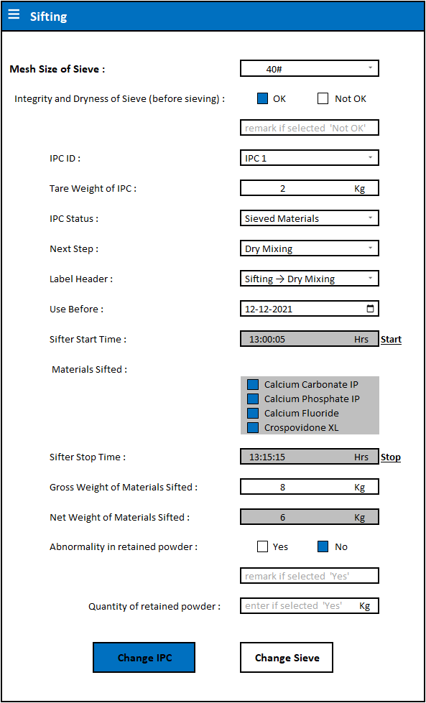

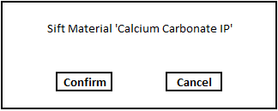 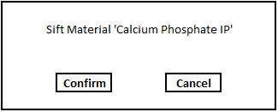

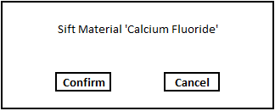 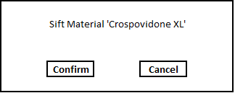

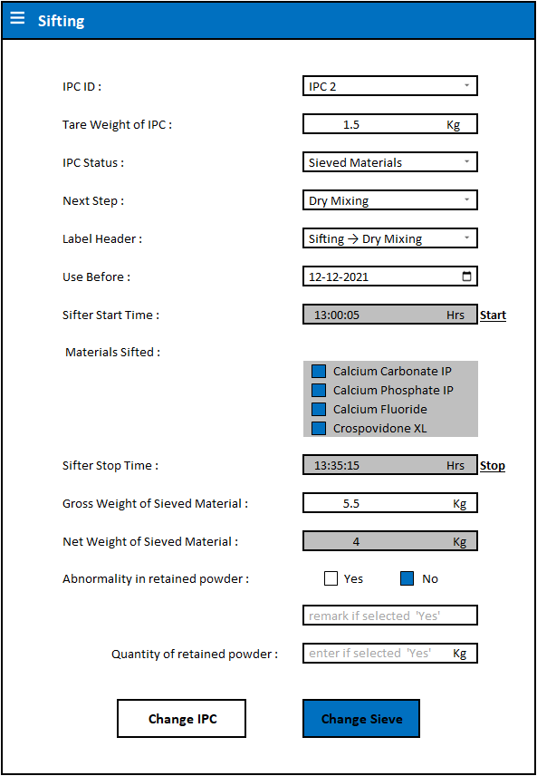

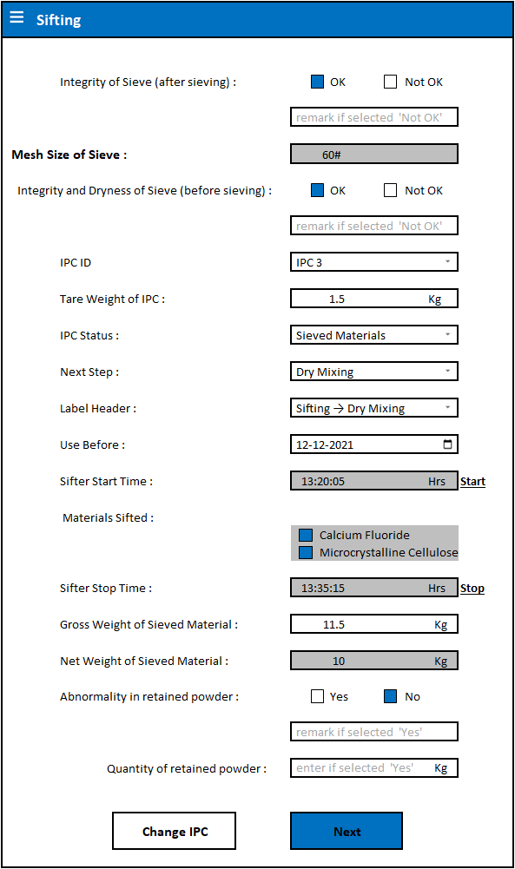

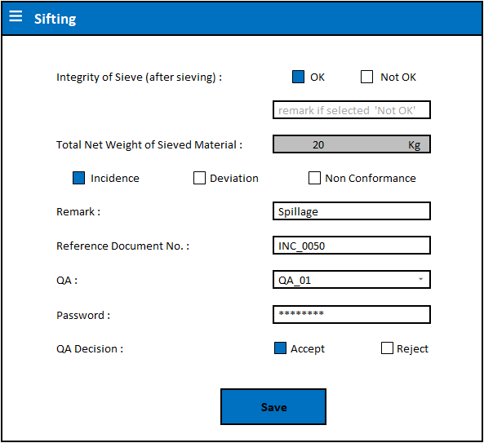

1. **Field Validations;**

|  |  |  |  |
| --- | --- | --- | --- |
| **Field Name** | **Field Validation** | **Character Limit** | **Source** |
| Mesh Size of Sieve | Dropdown selection from <Product Master>. (Mesh Size selection enabled in case of multiple sieves set in <Product Master>). | NA | As set in <Product Master>. |
| Integrity and Dryness of Sieve before sieving (OK / Not OK) | Check box selection. | NA | NA. |
| IPC ID | Dropdown selection as per IPCs assigned for stage. | NA | As set in ‘Set / Return IPC’. |
| Tare Weight of IPC | Fetched automatically when IPCs assigned for stage. | Range 0.001 to 99.999. | As set in ‘Set / Return IPC’. |
| IPC Status | Dropdown selection. | NA | From <Status Master>. |
| Next Step | Dropdown selection. | NA | From <Next Step Master>. |
| Label Header | Dropdown selection. | NA | From <Label Header Master>. |
| Use Before | Date selection from calendar.  (User can select up to 15 days future date). | NA | Future dated entry can be selected from Calendar.  (Current Date will be selected by default). |
| Sifter Start Time | Server time will be captured upon clicking ‘Start’ button.  *The field will not be editable. | Time will be captured of server upon click on ‘Start’ button in HH:MM:SS format and ‘Start’ button will be disabled. | Server. |
| Materials Sifted | Check box selection for respective material as sifting progresses.  Confirmation will be asked. Upon confirmation, material name will be disabled and check box will get selected. | NA | List of materials to be sifted will be fetched from <Product Master> (BOM). |
| Sifter Stop Time | Server time will be captured upon clicking ‘Stop’ button.  *The field will not be editable. | Time will be captured of server upon click on ‘Stop’ button in HH:MM:SS format. | Server. |
| Gross Weight of Materials Sifted | Manual entry consisting of numeric and decimal values. | Range 0.001 to 999.999. | Weighing / IPC Balance. |
| Net Weight of Materials Sifted | The field will be disabled. Net weight will be calculated automatically upon receiving Gross Weight. | NA | Tare and Gross Weights of IPC. |
| Abnormality in retained powder (Yes / No) | Check box selection. | NA | NA. |
| Quantity of retained powder | To be filled manually only if any abnormality found in sifted materials. It is expressed in numeric and decimal values. | Range 0.001 to 99.999. | NA. |
| Integrity of Sieve after sieving (OK / Not OK) | Check box selection. | NA | NA. |
| Total Net Weight of Sieved Materials | Will be calculated automatically and the field will be disabled. | NA | Tare and Gross Weights of IPCs. |
| Incidence/Deviation/Non Conformance | Check box selection. | NA | NA. |
| Reference Document No. | To be filled only if any incidence/deviation/non conformance. | Minimum 1 and maximum 50 alpha-numeric and special characters. | NA. |
| ‘Change IPC’ button. | Select ‘Change IPC’ to add new IPCs for sifting from assigned IPCs (refer note at the bottom of this table). | NA | NA. |
| ‘Change Sieve’ button. | Once required materials are passed through one sieve, ‘Change Sieve’ button can be selected to pass materials through another sieve. | NA | NA. |
| ‘Next’ button. | Button will be enabled only upon successful usage of all sieves set in <Product Master>. | NA | NA. |
| QA Login | Dropdown selection. | NA | <User Master>. |
| Password | Alpha-numeric and special characters. | Minimum 1 and maximum 16. | As per limits set in <Password Policy>. |
| QA Decision | Checkbox selection. | NA | NA. |

**\*NOTE:** Provision to keep a check box unchecked after IPC change if user has already sifted selected material in previous IPC.

**Eg.;** If 4 materials are set in BOM for Sifting (Calcium Carbonate IP, Calcium Phosphate, Calcium Fluoride and Crospovidone XL), and user has selected 3 materials (Calcium Carbonate IP, Calcium Phosphate and Calcium Fluoride) for sifting in one IPC and has opted for IPC change, they will get option to continue sifting the last material (Calcium Fluoride) along with remaining ones (Crospovidone XL). However, user can proceed to sift the remaining material (Crospovidone XL) and not select check box for the last material (Calcium Fluoride) as it has already been sifted in the previous IPC.

1. **Validation Messages;**

|  |  |  |  |
| --- | --- | --- | --- |
| **Field Name** | **Scenario** | **Validation** | **Co-relation** |
| Integrity and Dryness of Sieve before sieving (OK / Not OK) | Select ‘Not OK’ option. | ‘Exception Log’ form will get displayed where user will be asked to enter remark, file deviation record, enter QA credentials and QA decision will be selected as ‘Reject’ by default and ‘Accept’ and ‘Reject’ check boxes will be disabled. Upon ‘Save’, user will be directed to ‘Process’ window. | * Report * Activity Log |
| Abnormality in retained powder (Yes / No) | Select ‘Yes’ option. | ‘Exception Log’ form will get displayed where user will be asked to enter remark, file deviation record, enter QA credentials and enter QA decision.   * User will be directed to ‘Process’ window if QA decides to ‘Reject’. **OR** * User will be able to proceed further if QA decides to ‘Accept’ the incidence / deviation / non conformance. | * Report * Activity Log |
| Integrity of Sieve after sieving | Select ‘Not OK’ option. | ‘Exception Log’ form will get displayed where user will be asked to enter remark, file deviation record, enter QA credentials and QA decision will be selected as ‘Reject’ by default and ‘Accept’ and ‘Reject’ check boxes will be disabled. Upon ‘Save’, user will be directed to ‘Process’ window. | * Report * Activity Log |
| Incidence/Deviation/Non Conformance | Select any of the check box. | Enter remark, respective record no., enter QA credentials and QA decision. | * Incidence / Deviation / Non Conformance Record * Report * Activity Log |
| Reference Document No. | Select any of the check box. | User will be asked to enter remark, fill Reference document no. along with QA credentials and;   * User will be directed to ‘Process’ window if QA decides to ‘Reject’. **OR** * User will be able to proceed further if QA decides to ‘Accept’ the incidence / deviation / non conformance. | * Incidence / Deviation / Non Conformance Record * Report * Activity Log |

1. **Workflow;**

* Mesh Size selection for ‘Sifting’ stage will be enabled in case of multiple mesh sizes selected in <Product Master> to sift materials through more than one sieve (if only one mesh size set in <Product Master>, mesh size selection will be disabled).
* Check integrity and dryness of selected sieve before sieving. If ‘Not OK’, enter remark, file deviation record, enter QA credentials and begin from Instrument Clearance again.
* Select IPC ID from assigned IPCs, Tare Weight will be displayed from ‘Set / Return IPC’ (if any change in Tare Weight, enter the same), select ‘Status’, ‘Next Step’ and ‘Label Header’ for IPC and select ‘Use Before’ date for materials to be sifted from calendar.
* Start Vibratory Sifter and click on ‘Start’ button to note ‘Sifter Start Time’.
* Check respective check box and confirm to sift materials and material names will get disabled as sifting progresses.
* Stop the Sifter and click on ‘Stop’ button to note ‘Sifter Stop Time’.
* Weigh filled IPC, enter its Filled / Gross Weight in the field and its net weight will be calculated automatically, respective label will be generated and will be printed if ‘Auto’ Printing Mode selected in <Set All Parameters>.
* Check for any abnormality in sifted materials. If any found, enter remark and mention relevant quantity.
* Select ‘Change IPC’ option to select new IPC details (from list of assigned IPCs) to continue sifting of various other materials with same sieve. Or else, select ‘Change Sieve’ option to sieve materials through another sieve set in <Product Master>.
* Before changing sieve, check for integrity of the first sieve after sieving.
* If integrity of sieve after sieving found OK, change sieve, check its integrity and dryness before sieving.
* Repeat the same process from selecting IPC ID, Tare Weight, Status, etc. to check of abnormalities till all the materials are sifted.
* Upon successful completion sieving materials through all sieves set in <Product Master>, ‘Next’ option will be enabled. User will be asked to check integrity of sieve after sieving.
* Manually enter weights of all the containers filled with sifted materials. Net weight will be calculated automatically (Gross Weight of all IPCs – Tare Weight of all IPCs).
* File ‘Incidence/Deviation/Non Conformance’ if and as applicable. QA might ‘Accept’ or ‘Reject’ the incidence / deviation depending upon severity of issue. (User can proceed further if QA accepts or will be directed to ‘Process’ window if QA rejects the issue).
* Select ‘Save’ option to generate label.

1. **Reports;**

Area Clearance Report will be generated for all passed condition as follows;

**Area Clearance log.**

|  |  |  |  |  |
| --- | --- | --- | --- | --- |
| **Sr. No.** | **Checkpoint** | **Observation** | **Verified By** | |
| **Production** | **QA** |
| 1. | Previous Product Code. No. | FER011 |  |  |
| 2. | Previous Product Name | Iron Tablet |  |  |
| 3. | Previous Product Batch No. | IRNT21003 |  |  |
| 4. | Waste Bins Cleared | OK |  |  |
| 5. | Set Temperature | 22°C  20°C - 24°C |  |  |
| 6. | Actual Temperature | 21°C |  |  |
| 7. | Set Relative Humidity | 40%  35% - 45% |  |  |
| 8. | Actual Relative Humidity | 40% |  |  |
| 9. | Set Differential Pressure | 0.15 mmHg  0.1 mmHg - 0.2 mmHg |  |  |
| 10. | Actual Differential Pressure | 0.15 mmHg |  |  |
| 11. | Area Clean | OK |  |  |
| 12. | Cleaning Type | Type A |  |  |
| 13. | Cleaned On | 22/12/2021 |  |  |
| 14. | Cleaned By | Cleaner 1 |  |  |
| 15. | Checked By | Prod User 1 |  |  |
| 16. | Verified By (QA) | QA1 |  |  |

**Failed Area Clearance Log;**

|  |  |  |  |  |
| --- | --- | --- | --- | --- |
| **Sr. No.** | **Checkpoint** | **Observation** | **Verified By** | |
| **Production** | **QA** |
| 1. | Previous Product Code. No. | FER011 |  |  |
| 2. | Previous Product Name | Iron Tablet |  |  |
| 3. | Previous Product Batch No. | IRNT21003 |  |  |
| 4. | Waste Bins Cleared | Not OK |  |  |
| 5. | Deviation Reference Document No. | DEV_0102 |  |  |
| 6. | QA | QA01 |  |  |
| 7. | QA Decision | Reject |  |  |

**Instrument Clearance log.**

|  |  |  |  |  |
| --- | --- | --- | --- | --- |
| **Sr. No.** | **Checkpoint** | **Observation** | **Verified By** | |
| **Production** | **QA** |
| 1. | Instrument Type | Vibratory Sifter |  |  |
| 2. | Instrument Code No. | EQP01 |  |  |
| 3. | Previous Product Code. No. | FER011 |  |  |
| 4. | Previous Product Name | Iron Tablet |  |  |
| 5. | Previous Product Batch No. | IRNT21003 |  |  |
| 6. | Instrument Clean | OK |  |  |
| 7. | Instrument Logbook Updated | OK |  |  |
| 8. | Cleaning Type | Type B |  |  |
| 9. | Cleaned On | 22/12/2021 |  |  |
| 10. | Cleaned By | Cleaner 1 |  |  |
| 11. | Checked By | Prod User 1 |  |  |
| 12. | Verified By (QA) | QA1 |  |  |

**Failed Instrument Clearance Log;**

|  |  |  |  |  |
| --- | --- | --- | --- | --- |
| **Sr. No.** | **Checkpoint** | **Observation** | **Verified By** | |
| **Production** | **QA** |
| 1. | Instrument Type | Vibratory Sifter |  |  |
| 2. | Instrument Code No. | EQP01 |  |  |
| 3. | Previous Product Code. No. | FER011 |  |  |
| 4. | Previous Product Name | Iron Tablet |  |  |
| 5. | Previous Product Batch No. | IRNT21003 |  |  |
| 6. | Instrument Clean | OK |  |  |
| 7. | Instrument Logbook Updated | Not OK |  |  |
| 8. | Deviation Reference Document No. | DEV_0104 |  |  |
| 9. | QA | QA01 |  |  |
| 10. | QA Decision | Reject |  |  |

**Report Module;**

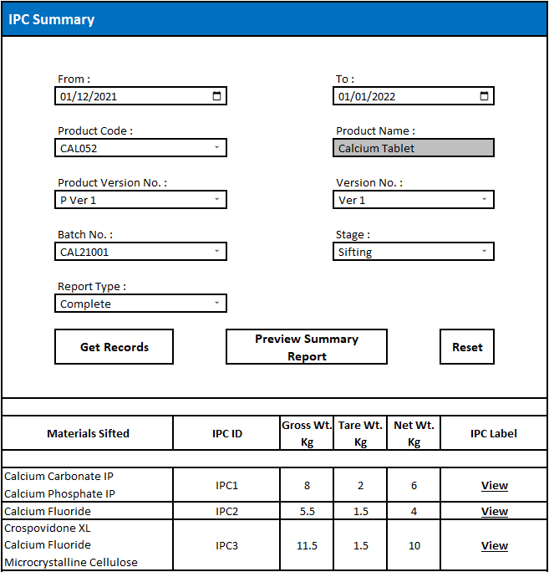

1. **Field Validations;**

|  |  |  |  |
| --- | --- | --- | --- |
| **Field Name** | **Field Validation** | **Character Limit** | **Source** |
| Date Range (From and To Date) | Date selection from calendar. | NA | Calendar. |
| Product Code | Dropdown selection.  *NOTE: Will display active and inactive product codes. | NA | Will display Product Codes for which, manufacturing stages have been initiated in selected date range. |
| Product Name | Auto Display. Disabled Field. | NA. | As per selected Product Code. |
| Product Version No. | Dropdown selection.  *NOTE: The field will be enabled only if more than one product version no. is present in the system. | NA. | As per selected Product Code. |
| Version No. | Dropdown selection.  *NOTE: The field will be enabled only if more than one product version no. is present in the system. | NA | As per selected Product Code. |
| Batch No. | Dropdown selection.  *NOTE: The field will display active, aborted and completed batch nos. | NA | Will display Batch Nos. for which, manufacturing stages have been initiated for selected Product. |
| Stage | Dropdown selection. | NA | Will display stages which have been performed for selected product-batch. |
| Report Type | Dropdown selection. | NA | Complete / Incomplete product-batch stages. |
| Get Records button | Enter data in the field and click on ‘Get Records’ button to generate record for selected input. | NA | NA. |
| Preview Summary Report button | A consolidated report will be generated for selected input upon click. | NA | NA. |

1. **Validation Messages;**

|  |  |  |  |
| --- | --- | --- | --- |
| **Field / Module Name** | **Scenario** | **Validation** | **Co-relation** |
| Get Records button | Select entries for which no record is generated. | ‘Record Not Found’ message will get displayed. | NA. |

1. **Workflow;**

* Go to Reports – Label Generation – IPC Summary.
* Select Date Range from Calendar, Product Code from dropdown list and relevant Product Name will be displayed in the field and it will be disabled (Product Version No. and Version No. fields will be disabled if only one of each available in the system; or else, the fields will display dropdown list for selection).
* Select Batch No. and Stage from dropdown list.
* Select Report Type (Complete or Incomplete) from dropdown list and click on ‘Get Records’ button; relevant records will get displayed in the grid below.
* Click on ‘Preview Summary Report’ button to generate a consolidated report of selected data.
* Click on ‘View’ button for a particular IPC to generate IPC label for selected entry.

**IPC Labels;**

**GRANULATION**

**SIFTING → DRY MIXING**

**PRODUCT NAME:** CALCIUM TABLET **PRODUCT CODE:** CAL052

**BATCH NO.:** 210045 **STATUS:** SIEVED MATERIALS

**NEXT STEP:** DRY MIXING

**IPC ID:** IPC 1 **GROSS WEIGHT:** 8 Kg

**IPC NO.:** 1 of 3 **TARE WEIGHT:** 2 Kg

**USE BEFORE:** 12/12/2021 **NET WEIGHT:** 6 Kg

**DATE:** 10/12/2021

**SIGNATURE:**

**GRANULATION**

**SIFTING → DRY MIXING**

**PRODUCT NAME:** CALCIUM TABLET **PRODUCT CODE:** CAL052

**BATCH NO.:** 210045 **STATUS:** SIEVED MATERIALS

**NEXT STEP:** DRY MIXING

**IPC ID:** IPC 1 **GROSS WEIGHT:** 5.5 Kg

**IPC NO.:** 2 of 3 **TARE WEIGHT:** 1.5 Kg

**USE BEFORE:** 12/12/2021 **NET WEIGHT:** 4 Kg

**DATE:** 10/12/2021

**SIGNATURE:**

**GRANULATION**

**SIFTING → DRY MIXING**

**PRODUCT NAME:** CALCIUM TABLET **PRODUCT CODE:** CAL052

**BATCH NO.:** 210045 **STATUS:** SIEVED MATERIALS

**NEXT STEP:** DRY MIXING

**IPC ID:** IPC 1 **GROSS WEIGHT:** 11.5 Kg

**IPC NO.:** 3 of 3 **TARE WEIGHT:** 1.5 Kg

**USE BEFORE:** 12/12/2021 **NET WEIGHT:** 10 Kg

**DATE:** 10/12/2021

**SIGNATURE:**

A consolidated IPC Summary report will also be generated upon saving the data;

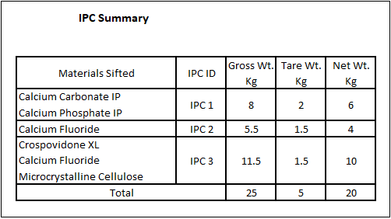

If an IPC has been assigned for stage and has not been used throughout, system will not allow user to proceed further and will ask user to return the IPC so that it can be assigned for next stage / process. The following window will be displayed;

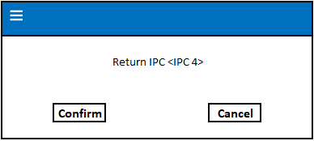

During an ongoing Sifting stage, new IPCs can be assigned and assigned but unused IPCs can be returned through ‘Drawer menu – Set / Return IPC’ module.



* To assign new IPC during an ongoing process, select IPC ID from IPC List and click on ‘>’ button.
* To return a particular IPC, select relevant IPC ID from Selected IPCs list and click on ‘<’ button.
* ‘Save’ details after assigning / returning the IPCs.

**\*NOTE:** ‘<’ button will be disabled for used IPCS. This means no action can be performed for used IPC IDs.

Option to ‘Switch User’ during an ongoing process is also provided in ‘Drawer menu’.

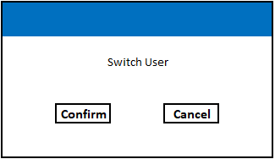

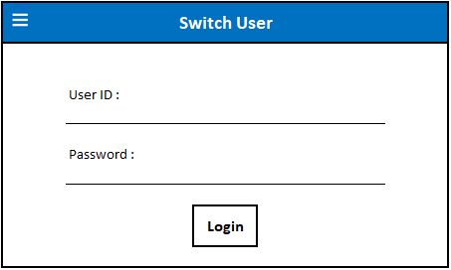

* Upon ‘Confirm’, new user credentials will be asked.
* Enter valid User ID and Password and click on ‘Login’ button to successfully login and continue process.
* Old user will be logged out.

File ‘Incidence / Deviation / Non Conformance’ details during ongoing process under ‘Exception Log’ through ‘Drawer menu – Exception Log’ module.

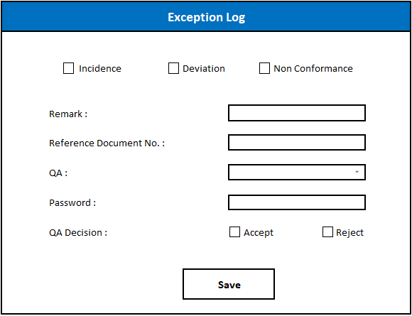

* Select relevant type of exception.
* Briefly mention its details in ‘Remark’ field, enter respective ‘Reference Document No.’ in the field.
* Provide QA User ID and Password and select QA Decision – ‘Accept’ or ‘Reject’ and ‘Save’ the details.
* Batch will be aborted and User will be directed to ‘Process’ window if QA has ‘Rejected’ the exception.
* User will be able to proceed if QA ‘Accepts’ the exception.

**\*NOTES:**

**1)** If ‘Exception Log’ accessed during ongoing process from Drawer menu, the batch will be aborted upon ‘Reject’ decision. This means the user will not be able to use the same batch no. for that product; however, same batch no. can be used for other product(s).

**2)** ‘Exception Log’ form which appears during ongoing process on selection of any negative remark will allow user to repeat stage with same Batch No. upon ‘Reject’ decision.

1. **Flowchart;**