# “AI Enhanced career guidance system for personalized career pathways”

The AI-Enhanced job Guidance System uses artificial intelligence to assess each person's distinct aptitudes, goals, abilities, and experiences in order to deliver tailored job recommendations.

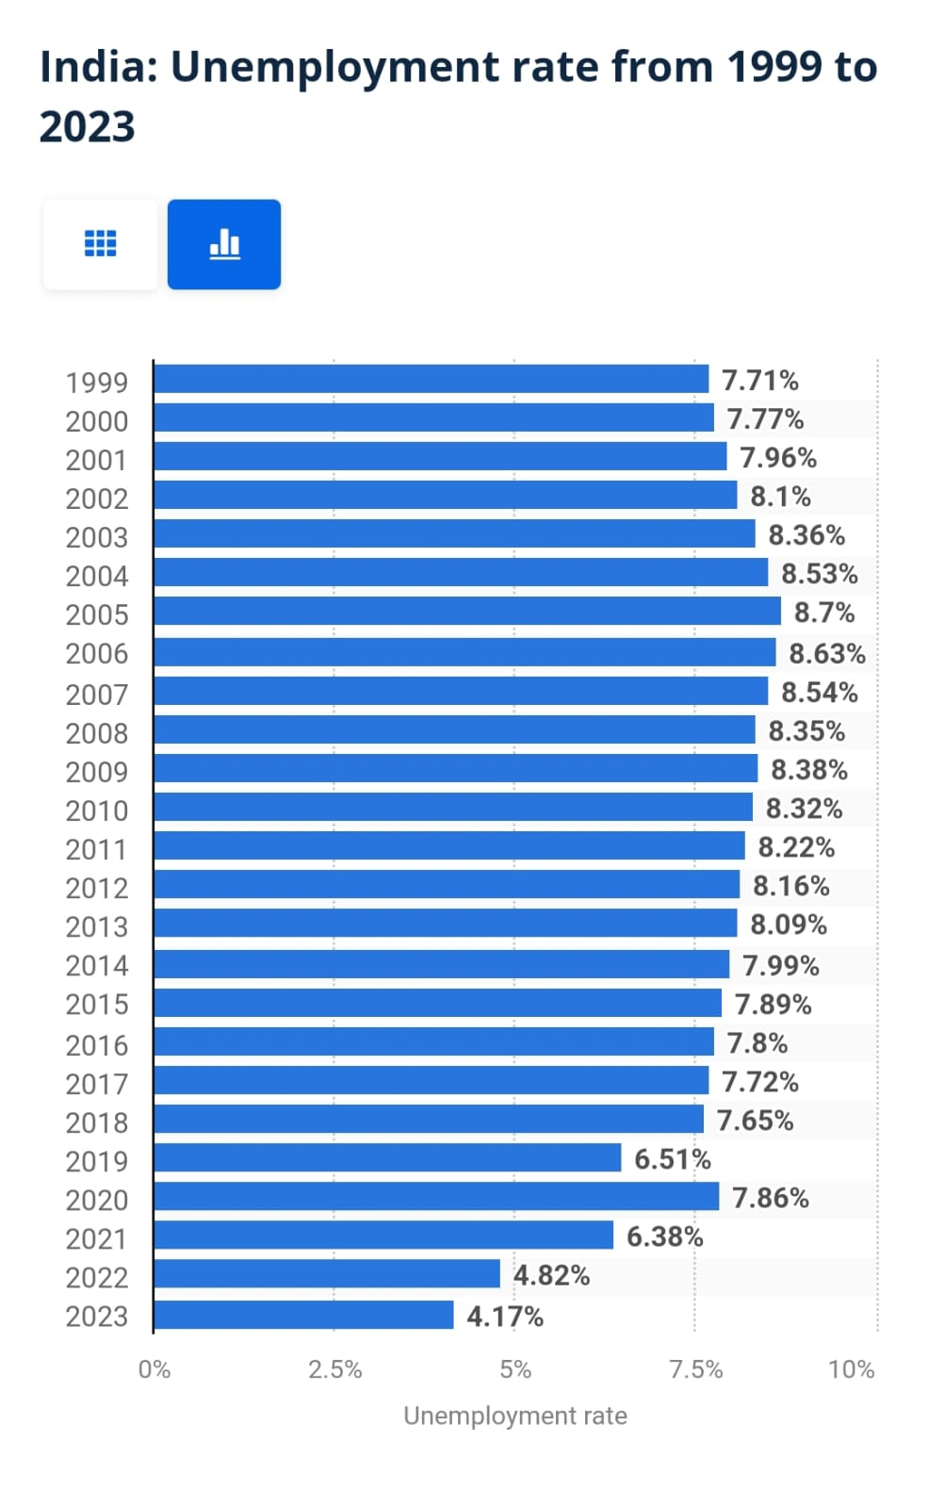

Fig: Unemployment rate from 1999 to 2023.

* Bar chart representing the unemployment rate in India from 1999 to 2023. The proportion of unemployment for each year is displayed in the chart; from 1999 to 2019, the unemployment rate typically ranged from 7.7% to 8.8%. After 2020, unemployment rates start to decline substantially, reaching 6.38% in 2021, 4.82% in 2022, and 4.17% in 2023.
* CS Branch has 12% of Unemployment Rate.
* Civil Branch has 70% of Unemployment Rate.

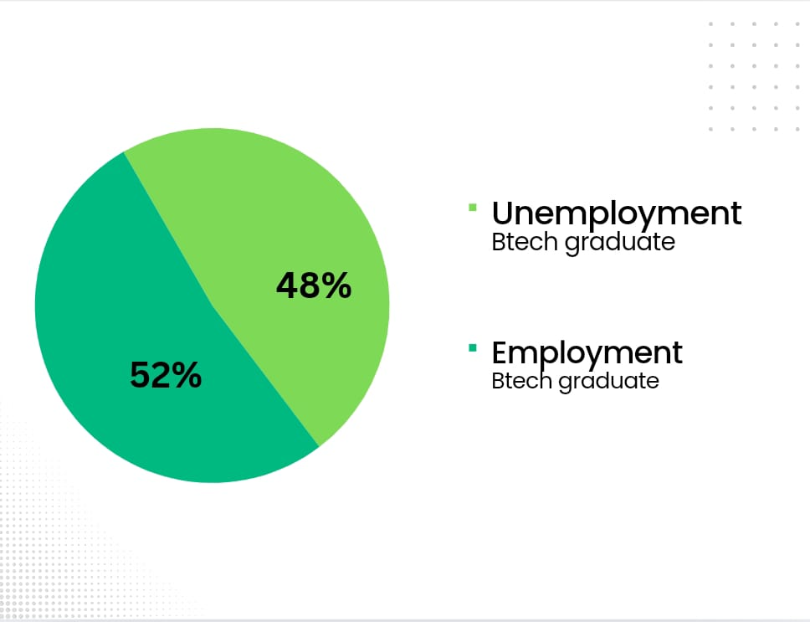 Description: Employment and Unemployment rate for B-tech graduate

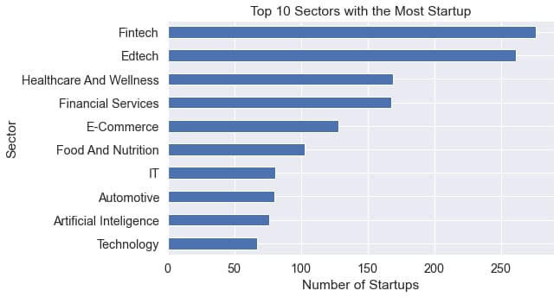

Fig: Number of startups according to different sectors

The Top 10 Industries for Startups. Based on the number of startups, the sectors are ranked in order of Fintech at the top, Edtech at the top, and Healthcare and Wellness at the bottom. There is also a lot of startup activity in other industries like Financial Services, E-Commerce, and Food and Nutrition.

Studies show how only 20% of startups survive for more than 5 year and only 8% five manage to survive beyond 10 years. As per a study conducted by the Institute of Business Value and Oxford Economics, 90% of Indian startups had failed within the first five years of operation.

**Flowchart:**

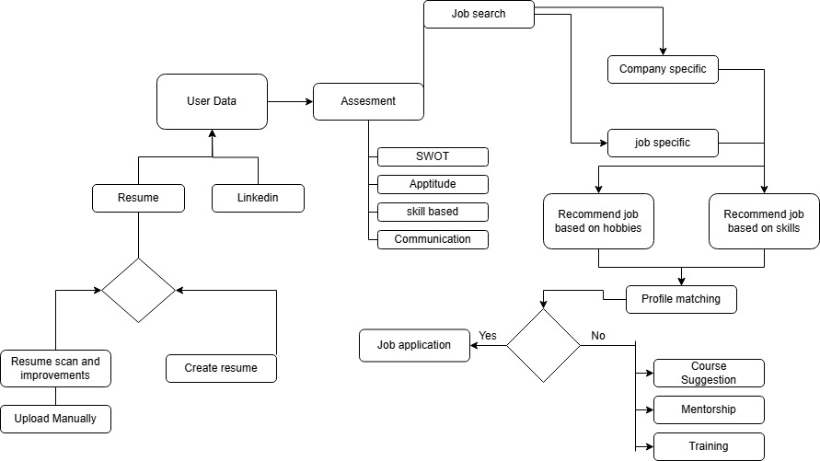

Fig: Flowchart

The process of a career guidance system, where user provides their data through a LinkedIn profile and résumé, as it is depicted in the flowchart. After that, the system conducts an assessment that includes communication, aptitude, skill-based, and SWOT analysis evaluations. It offers employment recommendations based on companies, job profiles, hobbies and talents to help the users with their career searches. The user can apply immediately if their profile fits the position. If not, the system recommends training, mentorship, or courses to strengthen their credentials and raise their prospects of success.