Python Practical Exam

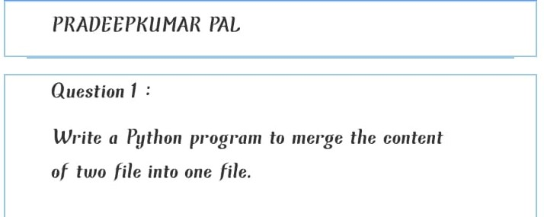

Code:

f1=open("abc.txt","w")

n=input("enter the text :")

f1.write(n)

f2=open("xyz.txt","w")

n=input("enter the text :")

f2.write(n)

f1.close()

f2.close()

f3=open("lmn.txt","w")

f1=open("abc.txt","r")

f3.write(f1.read())

f2=open("xyz.txt","r")

f3.write(f2.read())

f1.close()

f2.close()

f3.close()

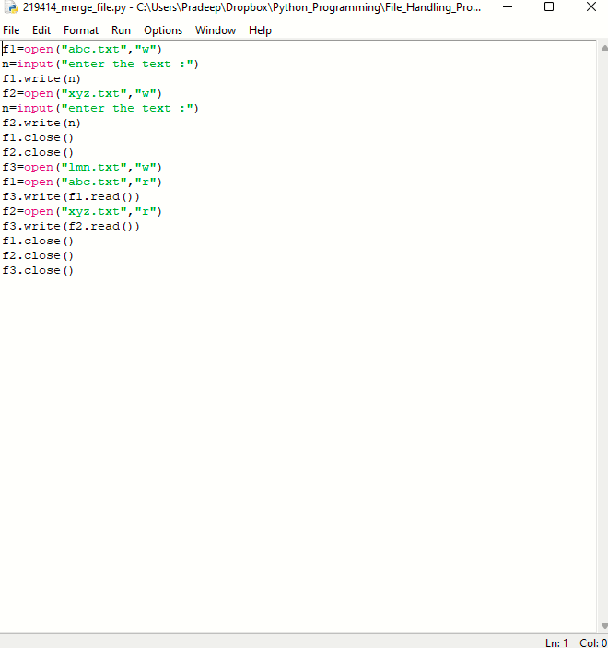

Output:

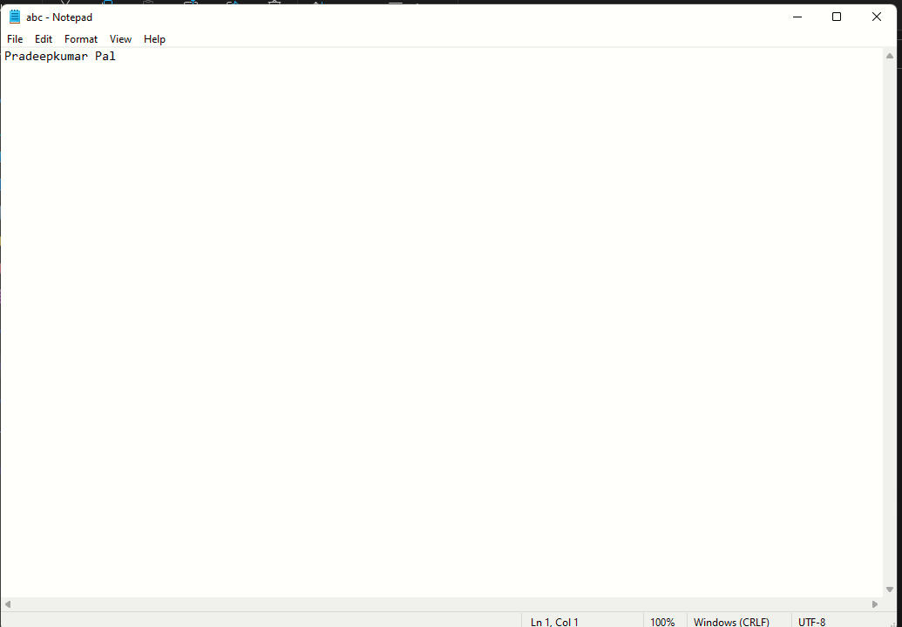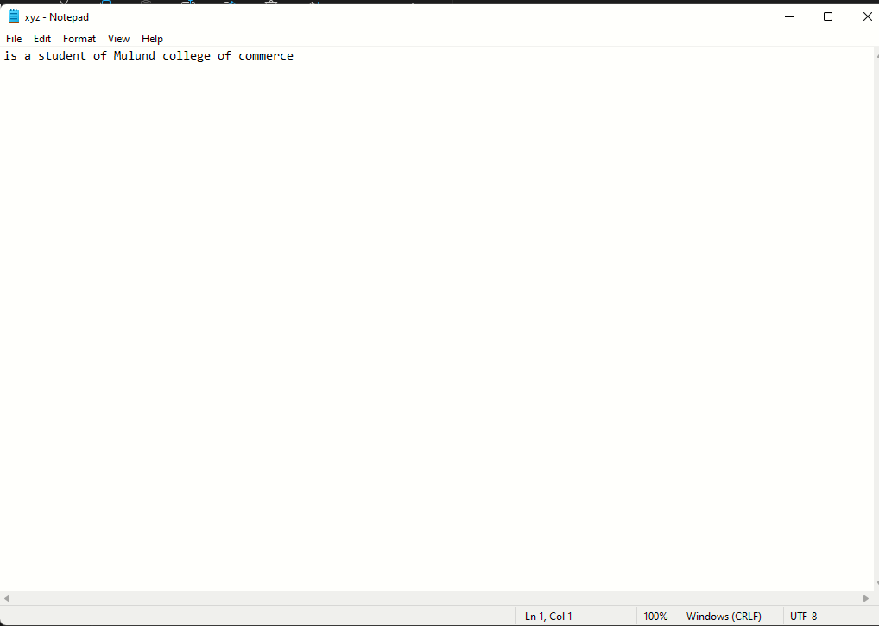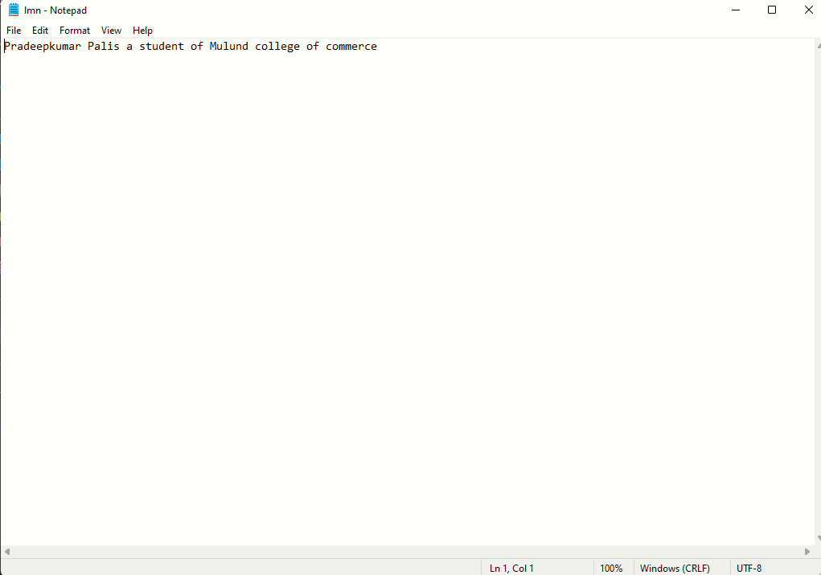

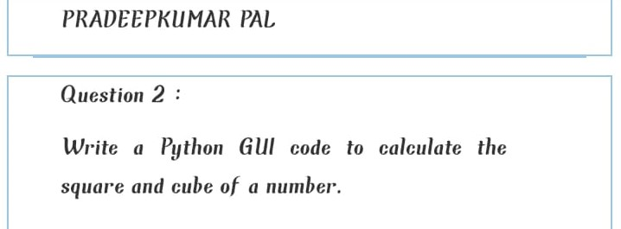

Code: