PROJECT REPORT
Threat Intelligence Aggregator
Aggregating live IoCs from VirusTotal and AlienVault OTX with Python
IBM SkillsBuild Cyber Security 2026
Conducted by BharatCares
Submitted by: [Your Full Name]
College / Organisation: [Your College Name]
Date: October 2026

Contents
Abstract
1. Introduction
2. Technologies Used
3. System Design
4. Implementation
5. Setup and Usage
6. Results
7. Security and Ethical Considerations
8. Limitations
9. Future Scope
10. Conclusion
References

Abstract
Security analysts must constantly judge whether an IP address, domain, URL or file hash is malicious. Doing this by hand across several websites is slow and error-prone. This project presents a Threat Intelligence Aggregator written in Python that automatically collects Indicators of Compromise (IoCs) from the AlienVault Open Threat Exchange (OTX) pulse feed, enriches each indicator with reputation data from VirusTotal and OTX, and merges the answers into a single normalised record with a 0–100 risk score and a verdict. Results are presented as a sorted table and charts and exported to CSV and JSON, together with a defanged list of high-risk indicators suitable for blocklists. The tool uses only passive, read-only API calls, handles API rate limits and errors, keeps API keys out of the source code, and includes an offline demo mode so it can be demonstrated without keys.

1. Introduction

1.1 Background
Cyber Threat Intelligence (CTI) is evidence-based knowledge about existing or emerging threats that helps defenders make decisions. An Indicator of Compromise (IoC) is a technical artefact – such as a malicious IP address, domain, URL or file hash – that suggests a system may have been attacked. Community and commercial platforms publish large volumes of IoCs every day, but each platform has its own data format and its own view of the same indicator.

1.2 Problem Statement
Analysts in a Security Operations Centre (SOC) typically open several websites to check a single indicator and then compare the answers manually. This does not scale, introduces inconsistency, and delays response. A tool is needed that gathers indicators automatically, queries multiple intelligence sources, and produces one consistent, prioritised result.

1.3 Objectives
- Pull recent IoCs automatically from the AlienVault OTX pulse feed.
- Identify the type of every indicator (IP, domain, URL, hash) and accept defanged input.
- Enrich each indicator with VirusTotal detection statistics and OTX pulse context.
- Normalise both sources into one record and compute a transparent risk score.
- Respect API rate limits, handle errors gracefully and protect API keys.
- Export results in analyst-friendly formats (table, charts, CSV, JSON, blocklist).

1.4 Scope
The project covers passive look-ups and reporting. It does not scan networks, execute malware, or automatically block anything. Final decisions remain with the human analyst.

2. Technologies Used
Technology | Purpose
Python 3.9+ | Core programming language
requests | HTTP/REST calls to the VirusTotal and OTX APIs, with retries and timeouts
pandas | Aggregation, sorting, summarising and exporting results
matplotlib | Bar chart of top risks and verdict distribution
python-dotenv | Optional loading of API keys from a local .env file
Jupyter Notebook | Interactive, documented delivery of the code
VirusTotal API v3 | Multi-engine malware / reputation analysis of IPs, domains, URLs and files
AlienVault OTX API | Community threat reports (pulses), tags and malware families

3. System Design

3.1 Architecture
The tool is a linear pipeline made of five stages. Each stage is implemented as small, independently testable functions or classes inside the notebook.
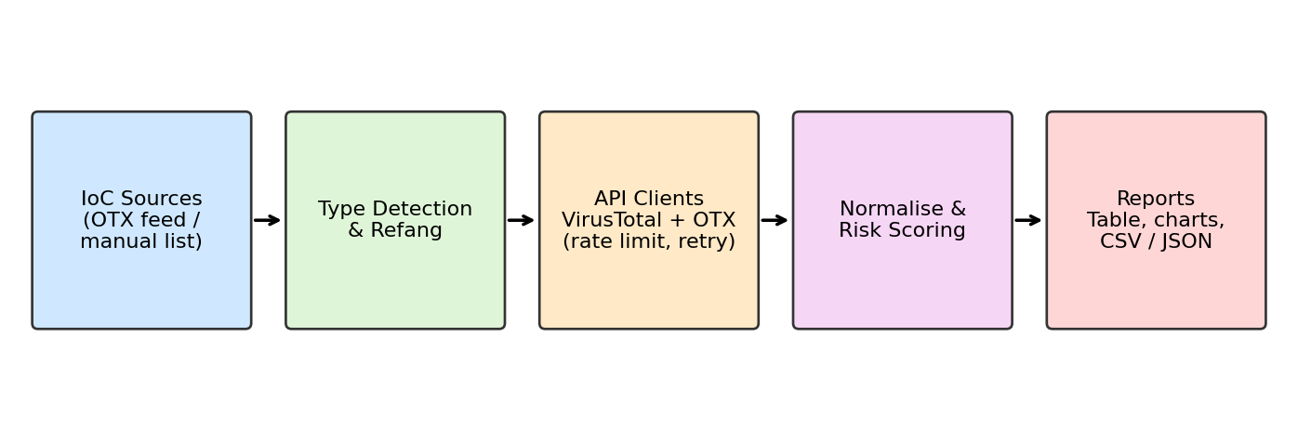
Figure 1: Pipeline architecture of the Threat Intelligence Aggregator

3.2 Data Sources
Source | Used for | Key endpoints
AlienVault OTX | Live IoC feed and community context | /pulses/subscribed ; /indicators/{type}/{ioc}/general
VirusTotal | Detection counts from many antivirus / scanning engines | /ip_addresses/{ip} ; /domains/{d} ; /files/{hash} ; /urls/{id}

VirusTotal returns last_analysis_stats (malicious, suspicious, harmless, undetected). OTX returns the number of pulses that mention an indicator, together with tags and malware families.

3.3 Risk Scoring Model
Each source is converted to a 0–100 component score and the components are combined with fixed weights:
- VirusTotal score = min(100, (malicious + 0.5 × suspicious) × 5). Twenty detections give the maximum score.
- OTX score = min(100, pulses × 10). Appearing in ten threat reports gives the maximum score.
- Combined risk = 0.7 × VT + 0.3 × OTX. If only one source returns data, that source's score is used on its own.

Risk score | Verdict | Suggested action
70 – 100 | High | Investigate immediately; candidate for blocklist
30 – 69 | Medium | Monitor and review in context
1 – 29 | Low | Log; low priority
0 | Clean / Unknown | No evidence of malicious activity found

VirusTotal is weighted higher because it reflects many independent detection engines, while OTX pulse counts measure community reporting and may include older or lower-confidence reports. The weights are heuristics and can be tuned.

4. Implementation

4.1 IoC Handling
detect_ioc_type() uses the ipaddress module and regular expressions to classify input as ip, domain, url or hash (MD5, SHA-1, SHA-256). refang() converts defanged indicators such as hxxp://evil[.]com into normal form for querying, and defang() makes indicators safe to display and share so that nobody clicks a malicious link by accident.

4.2 API Clients and Reliability
- VirusTotalClient builds the correct endpoint per indicator type; URLs are identified by their URL-safe base64 form without padding.
- OTXClient downloads recent pulses (pulses/subscribed with modified_since) and extracts supported indicator types, de-duplicating them.
- A RateLimiter enforces the VirusTotal free-tier limit of 4 requests per minute.
- http_get() applies timeouts, exponential back-off on network errors, waits on HTTP 429, treats 404 as 'unknown indicator' and reports 401/403 as authentication problems.

4.3 Aggregation and Reporting
aggregate() merges the VirusTotal and OTX dictionaries into one flat record containing detection counts, OTX pulse count, tags, malware families, country, risk score, verdict, contributing sources and a UTC timestamp. Records are placed in a pandas DataFrame sorted by risk score, visualised with matplotlib and exported to CSV and JSON. High-risk indicators are listed in defanged form as blocklist candidates.

4.4 Key Code Excerpt
def aggregate(ioc, ioc_type, vt=None, otx=None, feed_pulse=""):
row = {"ioc": defang(ioc), "type": ioc_type, "feed_pulse": feed_pulse}
scores = []
if vt: row.update(vt); scores.append((0.7, vt_score(vt)))
if otx: row.update(otx); scores.append((0.3, otx_score(otx)))
total_w = sum(w for w, _ in scores)
risk = round(sum(w * s for w, s in scores) / total_w, 1) if scores else 0.0
row.update({"risk_score": risk, "verdict": verdict_for(risk)})
return row
Listing 1: Core of the aggregation logic (simplified)

4.5 Demo Mode
When no API keys are configured the notebook switches automatically to a demo mode that uses simulated, deterministic responses for a fixed list of sample indicators (documentation address ranges, example domains and the EICAR test-file hash). This allows the whole pipeline to be demonstrated and tested offline.

5. Setup and Usage
- Install Python 3.9 or later and run: pip install -r requirements.txt
- Create free accounts at VirusTotal and AlienVault OTX and copy the API keys.
- Set the environment variables VT_API_KEY and OTX_API_KEY (or place them in a .env file).
- Open YourName_ThreatIntelAggregator.ipynb in Jupyter and choose Run All Cells.
- Review the table and charts, and collect the files saved in the output/ folder.
Optional parameters at the top of the notebook: MAX_IOCS (number of indicators), FEED_HOURS (how far back to pull the OTX feed) and MANUAL_IOCS (own indicators to analyse).

6. Results
IMPORTANT: The results below were produced in DEMO MODE with simulated data in order to illustrate the output format. They are not real threat intelligence. Replace this section with a screenshot and table from a live run using your own API keys before final submission.
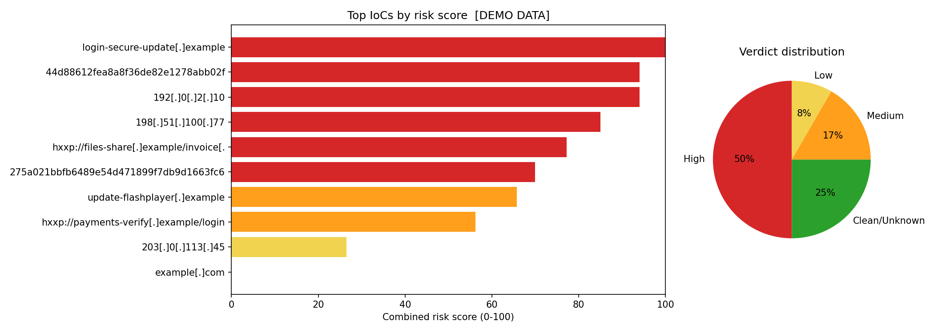
Figure 2: Risk-score chart and verdict distribution (demo data)
IoC (defanged) | Type | VT malicious | OTX pulses | Risk score | Verdict
login-secure-update[.]example | domain | 29 | 12 | 100 | High
44d88612fea8a8f36de82e1278abb02f | hash | 28 | 8 | 94 | High
192[.]0[.]2[.]10 | ip | 21 | 8 | 94 | High
198[.]51[.]100[.]77 | ip | 32 | 5 | 85 | High
hxxp://files-share[.]example/invoice[... | url | 11 | 14 | 77.2 | High
275a021bbfb6489e54d471899f7db9d1663fc... | hash | 25 | 0 | 70 | High
update-flashplayer[.]example | domain | 12 | 5 | 65.8 | Medium
hxxp://payments-verify[.]example/logi... | url | 7 | 15 | 56.2 | Medium
203[.]0[.]113[.]45 | ip | 5 | 3 | 26.5 | Low
example[.]com | domain | 0 | 0 | 0 | Clean/Unknown
8[.]8[.]8[.]8 | ip | 0 | 0 | 0 | Clean/Unknown
cdn[.]example[.]org | domain | 0 | 0 | 0 | Clean/Unknown
Table 1: Sample aggregated output (demo data)
The output shows how the model orders indicators: those flagged by many engines and mentioned in many pulses receive the highest scores, while known-good resources such as a public DNS resolver or example.com score zero and are marked Clean/Unknown.

7. Security and Ethical Considerations
- API keys are read from environment variables or a .env file and are never stored in the code or committed to version control.
- Only passive, read-only look-ups are performed; no scanning or interaction with the target indicators takes place.
- Indicators are defanged before display or export to prevent accidental clicks on malicious links.
- Use of the free API tiers follows each provider's terms: queries are rate-limited and data should not be redistributed commercially.
- Submitting an indicator to VirusTotal can make it visible to the community; do not look up internal or confidential data such as private file hashes or internal URLs.
- Scores are decision support only. False positives are possible, so analysts must verify before blocking.

8. Limitations
- The VirusTotal free tier (4 requests/minute, 500/day) limits throughput.
- The OTX feed depends on the pulses the account subscribes to; a new account may have an empty feed.
- Weights and thresholds are simple heuristics and are not statistically validated.
- Only two sources are combined, so coverage and confidence are limited.
- Results are not stored between runs, so there is no history or trend analysis.

9. Future Scope
- Add more feeds such as AbuseIPDB, URLhaus, Shodan and MISP.
- Store results in SQLite or Elasticsearch to track how indicators change over time.
- Schedule automatic runs and send alerts through e-mail, Slack or Microsoft Teams.
- Build a Streamlit dashboard and export STIX/TAXII for integration with a SIEM.
- Use machine learning to learn scoring weights from analyst feedback.

10. Conclusion
The Threat Intelligence Aggregator shows how a small Python program can replace repetitive manual look-ups with an automated, repeatable workflow. By combining VirusTotal detection data with AlienVault OTX community intelligence into a single risk score, it helps analysts prioritise indicators quickly while keeping the process transparent, rate-limit aware and secure. The project also gave practical experience with REST APIs, data normalisation, threat-intelligence concepts and secure handling of credentials, and it provides a base that can be extended into a fuller SOC automation tool.

References
- VirusTotal API v3 documentation – https://docs.virustotal.com/reference/overview
- AlienVault OTX – https://otx.alienvault.com and OTX DirectConnect API documentation – https://otx.alienvault.com/api
- Python requests library documentation – https://requests.readthedocs.io
- pandas documentation – https://pandas.pydata.org/docs/
- MITRE ATT&CK – https://attack.mitre.org
- IBM SkillsBuild – Cybersecurity learning resources – https://skillsbuild.org

