Step 1: Install Node.js and Nest.js CLI

Install Node.js:

First, check if Node.js is installed by running:

* node -v

If Node.js isn't installed, you can download and install it from the official Node.js website.

Install Nest.js CLI:

With Node.js installed, you can now install the Nest.js CLI globally:

* npm install -g @nestjs/cli

Step 2: Create a New Nest.js Project

Create the Project:

Open a terminal in VS Code and run the following command to create a new Nest.js project:

* nest new email-notification-service

Nest.js will prompt you to choose a package manager (either npm or yarn). Choose whichever you're comfortable with (let’s assume npm for simplicity).

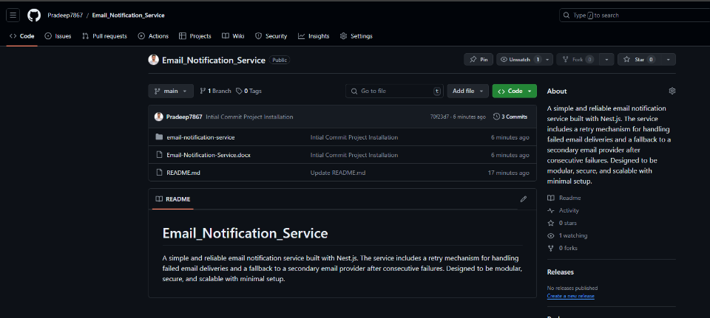Step 3: Initialize Git and Create a GitHub Repository

Step 4: Open the Project in VS Code

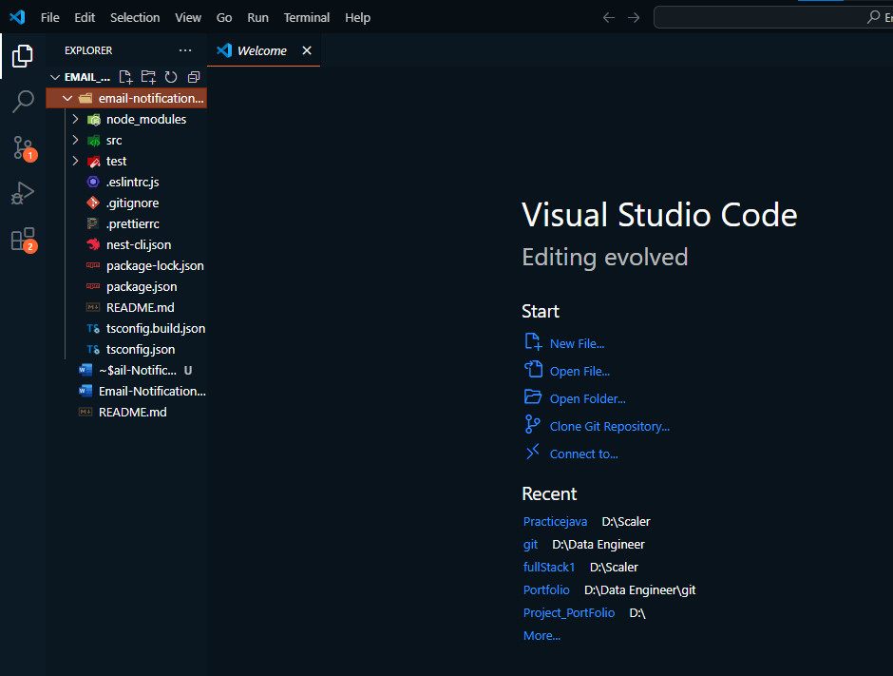

Step 5: Now Run the Application

Step 6: Key Takeaways from the Skeleton Code:

Project Structure:

The structure outlined in the skeleton code aligns with what we discussed earlier but adds more modularity with channels like email, SMS, and push notifications.

We’ll focus on the email channel and ensure it’s functioning with basic retry and fallback logic.

Notifme SDK:

The code suggests using the Notifme SDK for handling multiple notification channels. We'll start by setting this up for email notifications.

AWS SQS Integration:

There's mention of using AWS SQS for handling queued jobs, which is great for scalability. However, for simplicity, we can skip this initially and add it later if time permits.

Step 7: Simplify the Project Scope:

We'll focus on creating the notification service with basic email sending, retry logic, and a fallback mechanism.

Set Up Notifme SDK:

Implement the email sending service using Notifme SDK.

We’ll focus solely on the email channel to keep things simple.

NOW:

Step 8: Set Up the Notification Module

Step 9: Set up the Notification Service

Step 10: Set up the Notification Controller 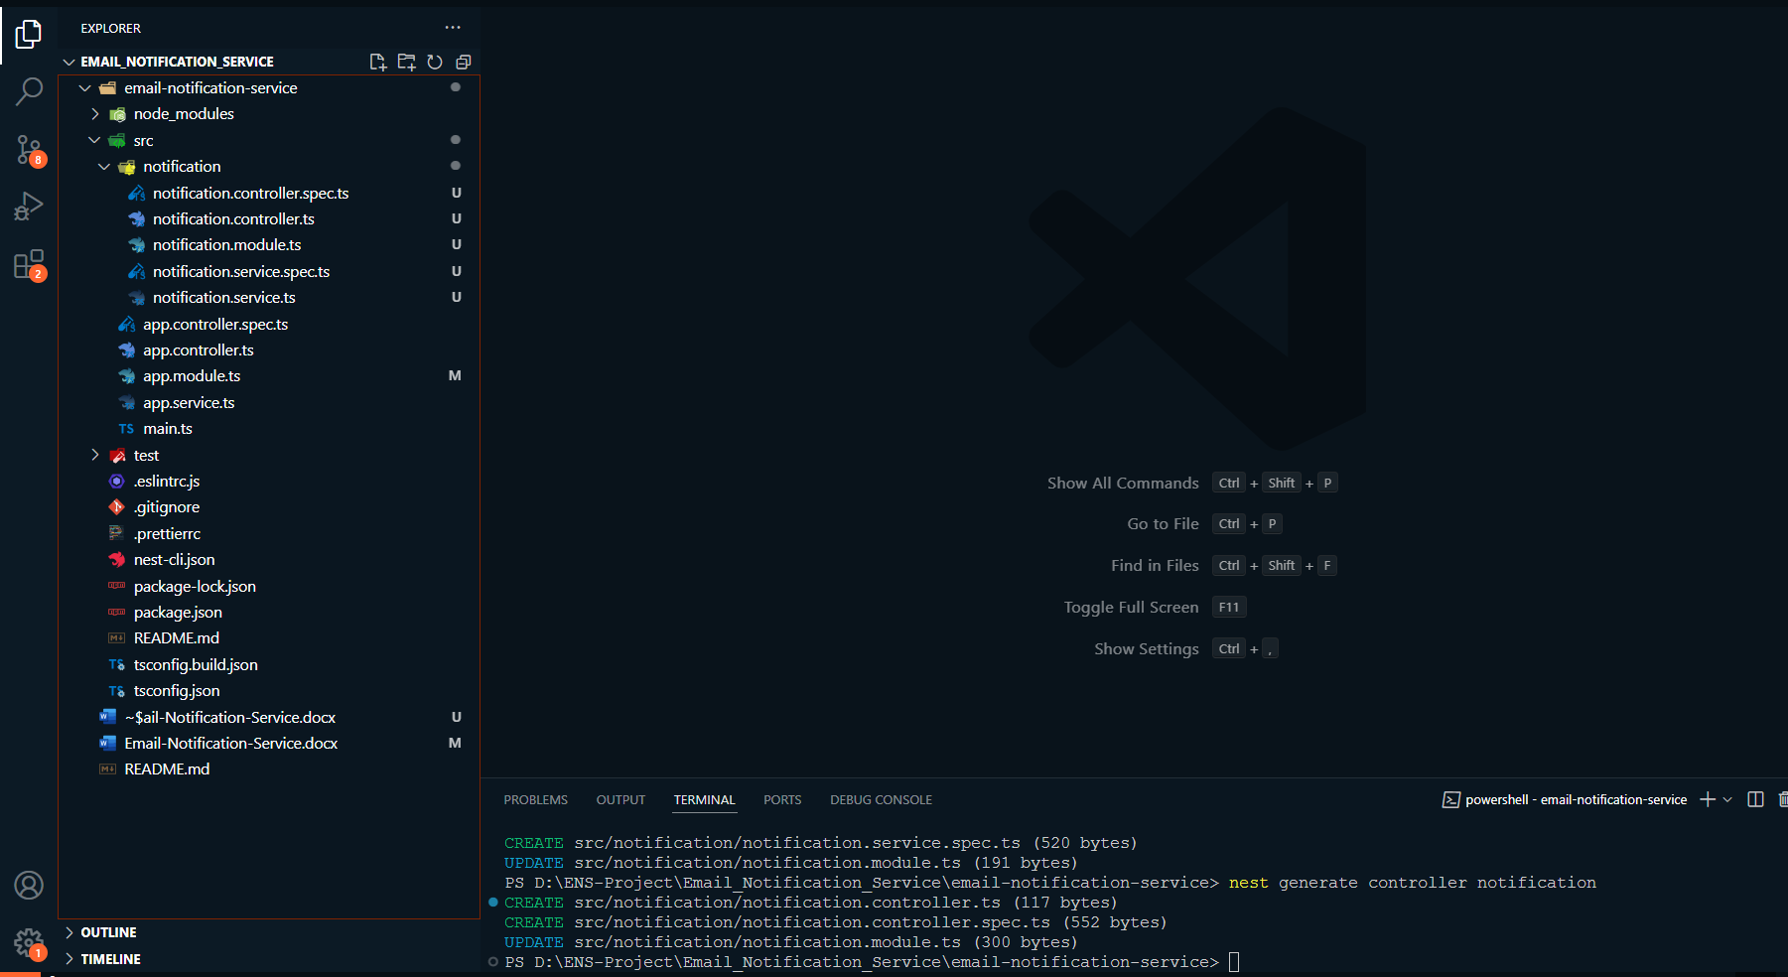

Step 11: Implement the NotificationController

Now, let's add some basic implementation in the notification.controller.ts to set up a route that handles the incoming notification requests.

Step 12: Implement the sendNotification Method in the ‘NotificationService’

Step 13: Update the AppModule

Finally, make sure the NotificationModule is imported and added to the AppModule:

