PROJECT REPORT
Genomic Alteration Prediction
using Histopathology Reports
An NLP + Machine Learning pipeline for predicting FDA-drug-targetable cancer
mutations directly from pathology report text — no genomic sequencing required.
8,796  Patients Analyzed | 3.5 GB  Mutation Data (MAF) | 25,000  TF-IDF Features | 0.86  Clinical AUC-ROC
Dataset: TCGA MC3 Pan-Cancer Mutation Data + TCGA Pathology Reports (GDC Data Portal)
Models: Logistic Regression · Random Forest · SGD · Bio_ClinicalBERT Ensemble

1. Executive Summary
Genomic sequencing is the gold-standard way to find cancer mutations that can be treated with an existing FDA-approved targeted drug — but it is slow and expensive. This project asks a simpler question: can we predict a patient's likely mutation status just from the pathology report a doctor already writes after every biopsy?
We built a full pipeline — from raw 3.5 GB genomic files down to a clinical decision report — that reads report text and predicts whether a patient likely carries a “Targetable” mutation (one with an approved drug), a “Non-Targetable” mutation, or no meaningful mutation at all. Two feature-extraction approaches were compared: classic TF-IDF word statistics, and Bio_ClinicalBERT, a deep learning model pre-trained on clinical text. Combining both in an ensemble gave the strongest result.
Headline Result | Value
Best held-out test AUC (TF-IDF, Logistic Regression) | 0.7329
Ensemble AUC (TF-IDF + BERT combined) | 0.7382
Full-cohort clinical AUC (final decision report) | 0.8576
Best single-gene AUC (IDH1 → Ivosidenib) | 0.9187
Patients with a targetable mutation | 5,880 / 8,796 (66.8%)
Table 1.1 — Key results at a glance

2. Dataset Overview
Two public datasets from the GDC Data Portal (The Cancer Genome Atlas) were combined:
File | Size | What it contains
mc3.v0.2.8.PUBLIC.maf | ~3.5 GB | Every mutated gene found via DNA sequencing, for every patient sample
TCGA_Reports.csv | ~30 MB | Pathology report text written by doctors after each biopsy, per patient
Table 2.1 — Raw input files

Patient Matching
Not every patient appears in both files. The pipeline keeps only patients present in both the mutation data and the reports — an inner join on Patient ID.
Metric | Count
Unique patients in mutation file | 10,224
Unique patients in reports file | 9,523
Final matched patients (used for ML) | 8,796
Present only in mutation data (dropped) | 1,428
Present only in reports (dropped) | 727
Distinct cancer cohorts represented | 76
Table 2.2 — Phase 1 patient-overlap results

3. Pipeline Architecture
The project runs as six sequential phases, each script reading the previous phase's saved checkpoint — so the large 3.5 GB file is only ever read once.
Phase | Script | What it does | Time
1. Data Alignment | data_alignment.py | Chunk-reads the 3.5GB MAF file (50K rows/chunk); joins mutations with reports by Patient ID | ~24s
2. Mutation Labeling | mutation_labeling.py | Filters biologically meaningful mutations; removes noise genes; labels each patient Targetable / Non-Targetable / None | ~1s
3. Feature Engineering | feature_engineering.py | Cleans report text; builds 25,000-dim TF-IDF vectors; encodes labels | ~25s
4. Model Training | model_training.py | Trains Logistic Regression, Random Forest, SGD on TF-IDF; picks best by AUC | ~44s
5. Clinical Analysis | clinical_analysis.py | Generates per-patient predictions, drug mapping, cancer-type breakdown, error analysis | ~5s
6. BERT + Ensemble | bert_embeddings.py / bert_training.py | Encodes reports with Bio_ClinicalBERT (GPU); retrains models; builds TF-IDF+BERT ensemble | ~3.5 min
Table 3.1 — Six-phase pipeline, run in order, ~5 minutes total end-to-end

4. What the Data Actually Looks Like
A real pathology report before and after the text-cleaning step (lowercasing, medical abbreviation expansion, boilerplate removal):
Patient ID | Label | Stage | Report Text (truncated)
TCGA-29-1775 | Targetable | Before | CLINICAL HISTORY: Malignant neoplasm of the ovary with. GROSS EXAMINATION: A. “Small nodule”…
TCGA-29-1775 | Targetable | After | clinical history malignant neoplasm of the ovary with. gross examination a. small nodule…
TCGA-BJ-A28V | Targetable | Before | PATIENT HISTORY: CHIEF COMPLAINT/PRE-OP/POST-OP DIAGNOSIS: Thyroid cancer. PROCEDURE…
TCGA-BJ-A28V | Targetable | After | patient history chief complaint pre-op post-op diagnosis thyroid cancer. procedure…
Table 4.1 — Sample text cleaning (feature_engineering.py, Phase 3)

Sample Mutation Labels (patient_mutation_labels.tsv)
Patient_ID | Mutation_Status | n_mutations | targetable_genes
TCGA-A5-A0G2 | Targetable_Mutation | 11,204 | PIK3CA, PTEN… (51 genes)
TCGA-IB-7651 | Targetable_Mutation | 8,377 | KRAS, BRAF… (44 genes)
TCGA-05-1234 | Non_Targetable_Mutation | 212 | —
TCGA-XX-YYYY | No_Mutation | 0 | —
Table 4.2 — Output of Phase 2 (illustrative rows from the pipeline)

Sample Final Predictions (final_patient_report.tsv)
Patient_ID | True Status | Predicted | Confidence
TCGA-S9-A6TX | Targetable_Mutation | Targetable_Mutation | 0.9477
TCGA-S9-A6TW | Targetable_Mutation | Targetable_Mutation | 0.9452
TCGA-HT-7695 | Targetable_Mutation | Targetable_Mutation | 0.9324
Table 4.3 — Output of Phase 5 (clinical_analysis.py)

5. Feature Engineering & Class Balance
Every cleaned report is converted into a 25,000-dimension TF-IDF vector (word/phrase importance scores, using 1-3 word combinations). The resulting feature matrix is 98.2% empty (sparse) — typical for text data, since each report only uses a small fraction of the full vocabulary.
Metric | Value
Patients in final dataset | 8,792
TF-IDF vocabulary size | 25,000
Feature matrix shape | 8,792 × 25,000
Sparsity | 98.16%
Binary class imbalance (Targetable vs Other) | 2.0 : 1 (acceptable)
3-class imbalance (incl. rare No_Mutation class) | 420 : 1 (severe)
Table 5.1 — Feature matrix statistics (Phase 3)
Because the 3-class split is severely imbalanced (only 14 patients with “No Mutation”), the project focuses on the binary task — Targetable vs. Everything Else — where class_weight='balanced' is sufficient without needing synthetic oversampling (SMOTE).

6. Baseline Models — TF-IDF Features
Three classic ML models were trained on an 80/20 stratified train/test split (7,033 train / 1,759 test patients) and compared with 5-fold cross-validation:
Model | Test AUC | CV AUC (5-fold) | F1 (Targetable) | Precision | Recall
Logistic Regression ★ best | 0.7329 | 0.7212 ± 0.018 | 0.7463 | 0.7939 | 0.7041
Random Forest | 0.7179 | 0.7108 ± 0.018 | 0.7696 | 0.7518 | 0.7883
SGD Classifier | 0.6928 | 0.6821 ± 0.012 | 0.7359 | 0.7628 | 0.7109
Table 6.1 — Model comparison on held-out test set (Phase 4)
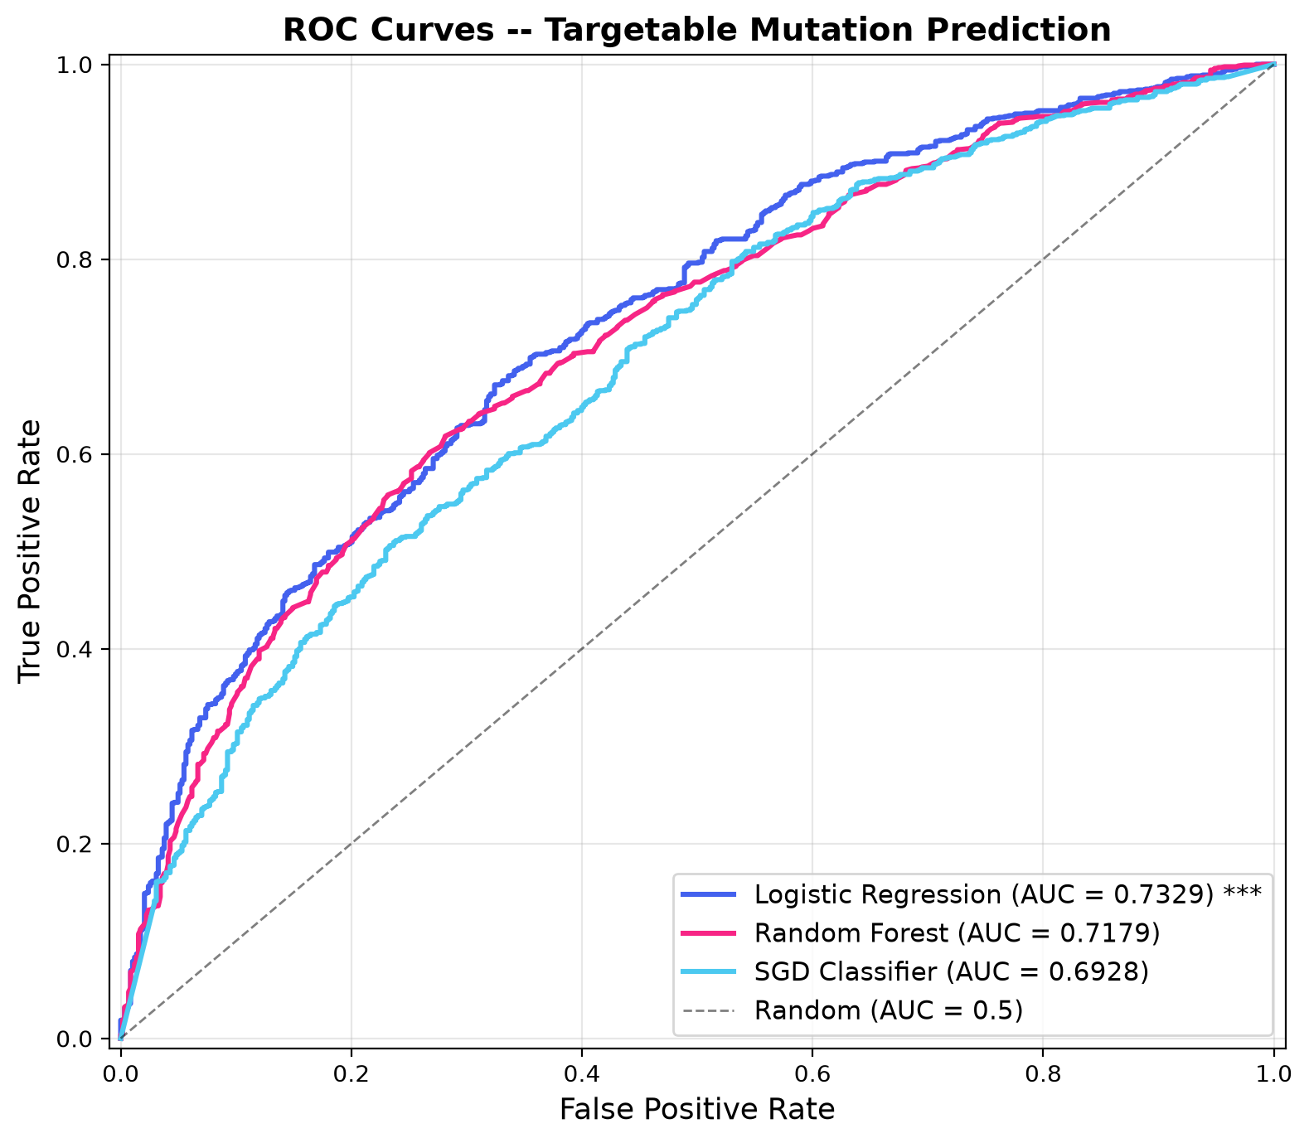
Figure 6.1 — ROC curves: Logistic Regression edges out Random Forest and SGD
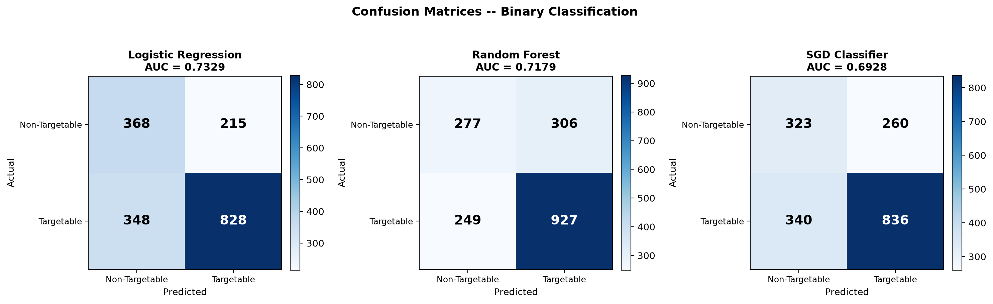
Figure 6.2 — Confusion matrices for all three TF-IDF models on the test set

What the Model Actually Learned
Looking at the strongest predictive words gives a sanity check that the model is picking up genuine clinical signal, not noise:
Predicts TARGETABLE mutation | Predicts NON-TARGETABLE
oligodendroglioma, melanoma, endometrioid, brain, urothelial | thymoma, sarcoma, gleason score, serous adenocarcinoma
adenocarcinoma, astrocytoma, clear cell, grade II | leiomyosarcoma, chromophobe, paraganglioma, prostate
Table 6.2 — Top TF-IDF terms driving each prediction (feature_importance.tsv)
A train-test AUC gap of 0.15 was observed for the best model, indicating mild overfitting typical of high-dimensional sparse text features — a known and expected trade-off with TF-IDF on a dataset of this size.

7. Deep Learning Upgrade — Bio_ClinicalBERT + Ensemble
TF-IDF only counts words — it has no sense of medical context or negation. Bio_ClinicalBERT is a transformer model pre-trained on clinical text, used here to turn each report into a 768-dimension embedding that captures meaning, not just word frequency. Encoding all 8,792 reports took 3.2 minutes on an RTX 4050 GPU.
Approach | Best Model | Test AUC
TF-IDF (word counts) | Logistic Regression | 0.7329
Bio_ClinicalBERT (contextual embeddings) | Logistic Regression | 0.7098
Ensemble — average of both | TF-IDF LR + BERT LR | 0.7382 ★ best overall
Table 7.1 — TF-IDF vs. BERT vs. Ensemble (Phase 6)
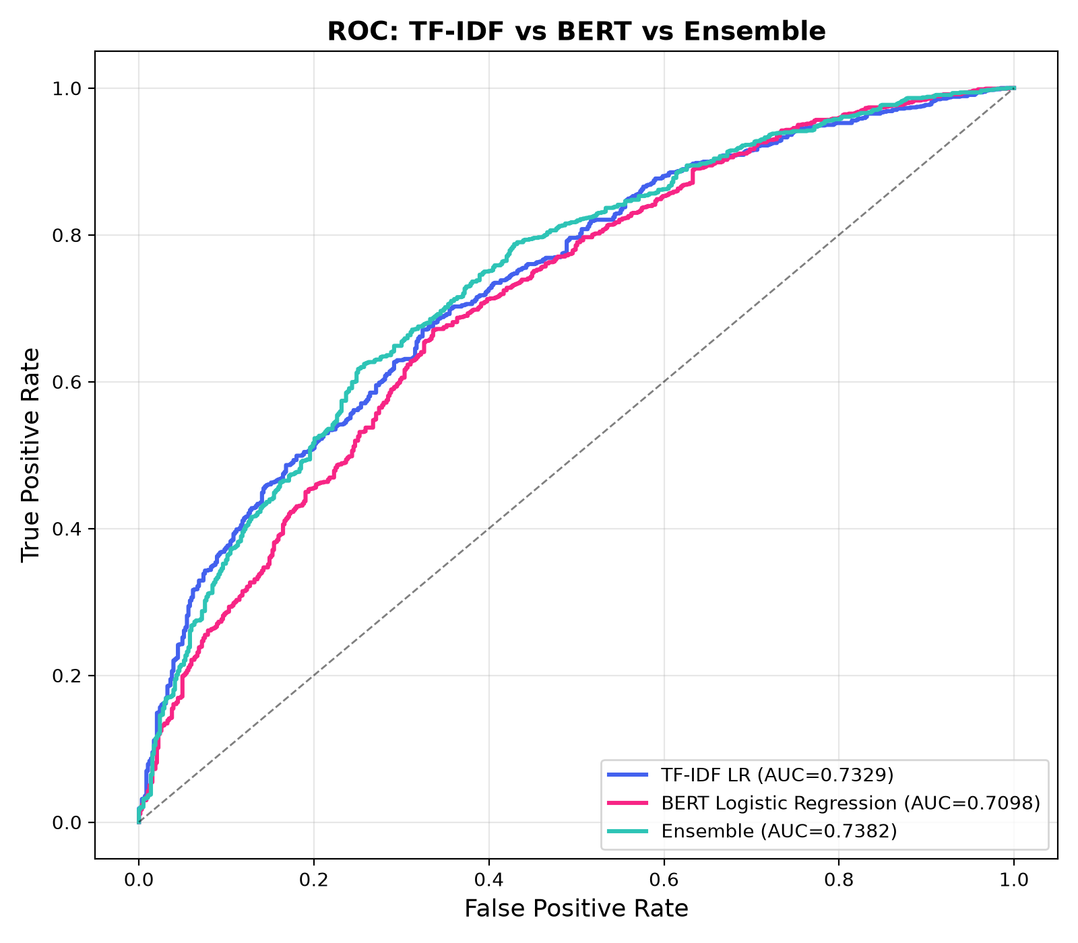
Figure 7.1 — Ensemble ROC curve edges out both individual approaches
Interestingly, TF-IDF alone slightly outperformed BERT alone on this dataset — likely because pathology reports rely heavily on precise, rare medical vocabulary (exact gene/diagnosis names) that TF-IDF is naturally suited to catch. BERT's strength is context and phrasing, which adds complementary — not superior — signal. Averaging both, however, beat either one individually, confirming they capture partially different information.

Per-Gene Prediction (Top 10 Genes)
Gene | Patients | AUC | FDA-Approved Drug
IDH1 | 462 | 0.9187 | Ivosidenib
KRAS | 703 | 0.8649 | Sotorasib
BRAF | 544 | 0.8353 | Vemurafenib
PIK3CA | 1,281 | 0.7686 | Alpelisib
PTEN | 782 | 0.7559 | Ipatasertib (investigational)
EGFR | 320 | 0.7128 | Osimertinib
ARID1A | 733 | 0.7189 | No FDA-approved therapy
ATM | 496 | 0.6723 | Olaparib (investigational)
NF1 | 515 | 0.6454 | No FDA-approved therapy
BRCA2 | 375 | 0.6310 | Olaparib
Table 7.2 — Some genes (IDH1, KRAS, BRAF) are far easier to predict than others — likely due to distinctive language in their associated pathology reports

Cancer-Type Specific Models
Cancer Type | Patients | % Targetable | AUC
LGG (Brain / Low-Grade Glioma) | 103 | 92.2% | 0.9474
COAD (Colon) | 131 | 80.2% | 0.7091
HNSC (Head & Neck) | 132 | 70.5% | 0.5395
BRCA (Breast) | 143 | 66.4% | 0.4316
Table 7.3 — Prediction difficulty varies substantially by cancer type

8. Clinical Decision Report
The final phase applies the trained model across the full 8,796-patient cohort and reframes the output as a clinical triage tool: which patients should be prioritized for confirmatory genomic testing and possible targeted therapy.
Metric | Value
Overall AUC-ROC (full cohort) | 0.8576
Sensitivity (catches true Targetable cases) | 78.7%
Specificity (correctly clears non-Targetable cases) | 77.1%
Patients correctly flagged for targeted therapy | 4,626 / 5,880 (78.7%)
Missed targetable patients (false negatives) | 1,252 — requires attention
Unnecessary referrals (false positives) | 668
Low-confidence predictions flagged for manual review | 3,158
Table 8.1 — Clinical performance summary (clinical_analysis.py)

Top Actionable Genes in the Cohort
Gene | Patients | % of Cohort | Targeted Drug
PIK3CA | 1,281 | 14.6% | Alpelisib
PTEN | 782 | 8.9% | Ipatasertib (investigational)
ARID1A | 733 | 8.3% | No FDA-approved therapy
KRAS | 703 | 8.0% | Sotorasib
BRAF | 544 | 6.2% | Vemurafenib
Table 8.2 — Most frequent targetable mutations and their approved therapies
Note: the 0.86 AUC above reflects the model's performance re-evaluated across the entire cohort (train + test combined) for the purpose of the clinical report, and is not directly comparable to the stricter 0.73 held-out test AUC from Phase 4 — that figure remains the honest measure of generalization to unseen patients.

9. Honest Takeaways & Limitations
- Overall AUC (~0.73–0.74 on held-out data) is moderate, not clinical-grade — this is a strong portfolio/research result, not a diagnostic tool ready for real deployment.
- Performance varies hugely by gene and cancer type: IDH1 (0.92 AUC) and KRAS (0.86 AUC) are predicted very well, likely because their associated cancers use distinctive language; other genes/cancer types (BRCA2, breast cancer) are much harder.
- TF-IDF slightly outperformed BERT alone in this dataset, showing that simple, interpretable models can be very competitive on specialized medical vocabulary — bigger/more powerful isn't always better.
- Mild overfitting was observed in the TF-IDF models (train-test AUC gap ~0.15), a known trade-off of high-dimensional sparse text features on a dataset of this size.
- The 3-class task (including the rare 'No Mutation' class, only 14 patients) is severely imbalanced (420:1) and was set aside in favor of the more reliable binary task.

10. Conclusion
This project demonstrates a complete, reproducible pipeline — from a 3.5GB raw genomic file to a clinical-style decision report — that shows pathology report text alone carries real, measurable signal about a patient's underlying mutation status. While not a replacement for genomic sequencing, a tool like this could serve as a fast, low-cost triage step: flagging patients most likely to benefit from confirmatory testing and targeted therapy, and helping prioritize limited sequencing resources toward the patients who need it most.

