# **Execution**

Before execution the required parameters like city name should be updated in the data provider in tests.java

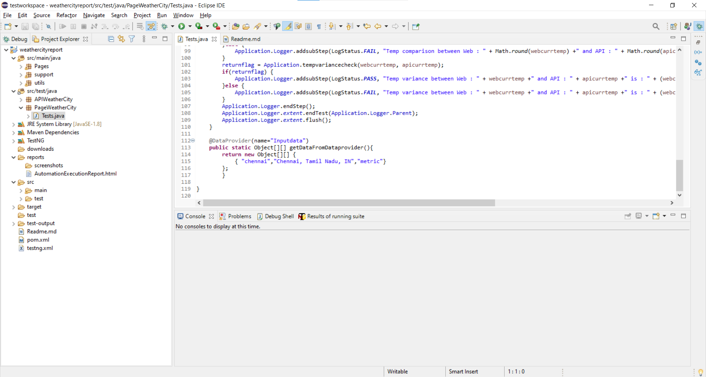

## **Maven Execution**

* Initial Maven Execution should be performed, and system should be able to connect to maven repository.
* Select the project -> Right click -> Run as “Maven test”

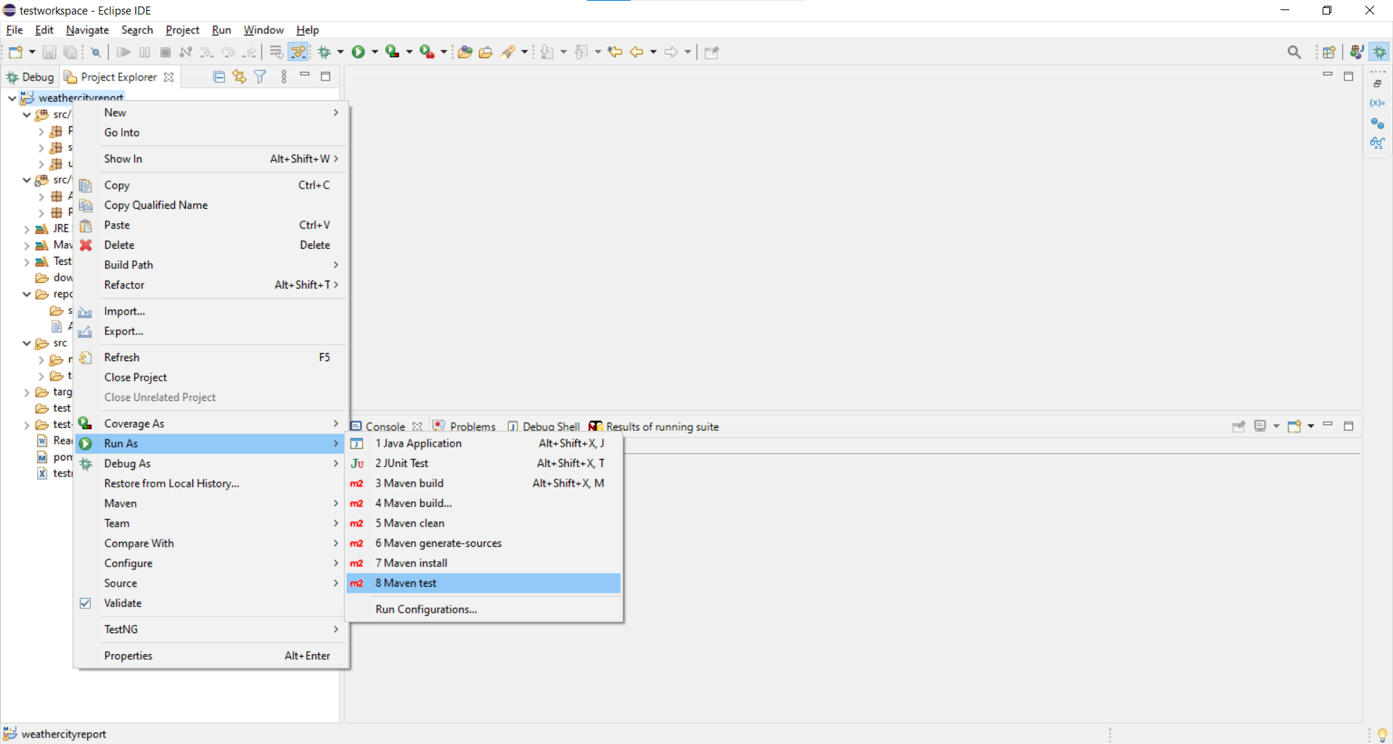

## **TestNG test Execution**

* Open testing.xml file or right click on testing.xml file in Eclipse and Run as “TestNG Suite”. Execution of the class files included in the testing.xml will execute.

