**Students Attendance Tracker**



Documentation

**Maintained By:**

Prayag Raj Acharya

Pradeep Bhattarai

Sardul Khanal

Vishal Pokharel

**Online Attendance Tracker**

**Project Description:**

The Online Attendance Tracker web app makes it simple for teachers to manage attendance. It’s easy to create classes, take attendance, and even download it as an Excel file. This web app offers different kinds of reports and graphs to show attendance. Only administrators are allowed to add or remove information about teachers, departments, and classes.

In this system the users are divided into two main roles: Admin and Teachers.

1. **Admin**

Administrator is the role having the highest privilege. They have to use Admin-Site. Administrator can do the following things:

* + Create accounts for teachers.
  + Create departments, program, subject or class.
  + Update and delete existing department, program, subject, class and teacher accounts

1. **Teachers**

Department assigns teachers for the certain subject and class. Teacher use Client-Site. Teachers can do the following things:

* + Take attendance of specific classes.
  + Download an excel file containing the attendance of the students.
  + View attendance history summary and visualization of specific classes.

**Project Setup:**

To run the project on your local machine, follow the instructions given below:

* Install node.js (V 12) as the first prerequisite of the project. (It can be installed from https://nodejs.org/en/download/ )
* For Node version 12 you can use NVM (node version manager) to switch between more node versions. It can be downloaded from (https://sourceforge.net/projects/nvm-for-windows.mirror/)
* Install MySQL or MariaDB or packages like Xampp, which ship with MariaDB by default.

**File Structure:**

There are three main folders.

* backend
* admin-site
* client-site

**Install Required Packages**

* Open the terminal and change the directory to the <project base directory>/backend
* Enter command “*npm install”*. This downloads and installs dependencies defined in a package.json file and generates a node_modules folder with the installed modules.
* Do above steps for each of the folders in the project.

**Creating Database using Xampp**

* Run Xampp Control Panel
* Start Apache and MySQL server
* Open Admin of MySQL or go to localhost/phpmyadmin in your browser
* For first time use, create a database named “schema_attendance”

**Initial Backend Setup**

Create a ***.env*** file on the root directory in folder “backend ” and add the following default credentials in the newly created file.

DB_HOST="localhost"

DB_USER="root"

DB_PASSWORD = ""

JWT_KEY = "HELLO"

ADMIN_KEY = "HELLO"

PORT_NO = "3082"

**Running the project**

* Enter command *“npm start”* inside the base directory “AttandanceManagementSystem/backend” to run the backend
* Now, enter command *“npm start”* inside the base directory “AttandanceManagementSystem/client-site” to run the client site or inside “AttandanceManagementSystem/admin-site” to run the admin site
* The instructions for using the admin site are given in the application itself, under the help section
* In case the application crashes, restart the respective application.
* Press CTRL + C to stop any of the servers.

**Tech Stacks Used**

**Front End**

The frontend part of the project is made using ReactJS. React is a free and open-source front-end JavaScript library for building user interfaces based on UI components. It is maintained by Meta and a community of individual developers and companies.

To learn React, check out the React documentation (<https://reactjs.org/>).

For some of the UI interface, Bootstrap is also used. Bootstrap is the most popular HTML, CSS, and JavaScript framework for developing responsive, mobile-first websites. It has numerous HTML and CSS templates for UI interface elements such as buttons and forms.

**BackEnd**

The backend or server-side is written in Express. Express is a minimal and flexible Node.js web application framework that provides a robust set of features for web and mobile applications.

**Database**

This application uses MySQL database infrastructure. MySQL is an open source relational database management system. Alternatively, XAMPP server can be used for this application which consists of MySQL database component. The data here is managed locally.

**Students Data And Subjects Related Data**

The data of students and subjects are fetched from the college database

through API of IOE PULCHOWK Campus database:

“http://assmnt.pcampus.edu.np/”

**User Manual**

There are two applications based on user:

1. Administrator (Admin Site)
2. Teacher (Client Site)

**Admin Site**

At first in the admin site you will get the following login page,

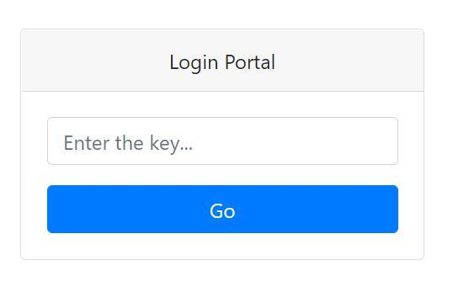

By default, the login key is ‘HELLO’. Enter the login key and you will be redirected to the following admin dashboard.

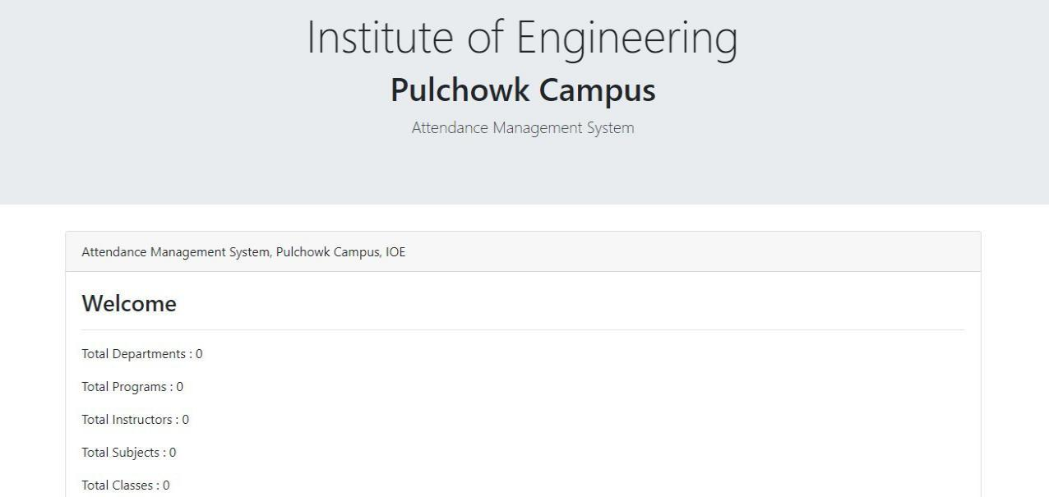

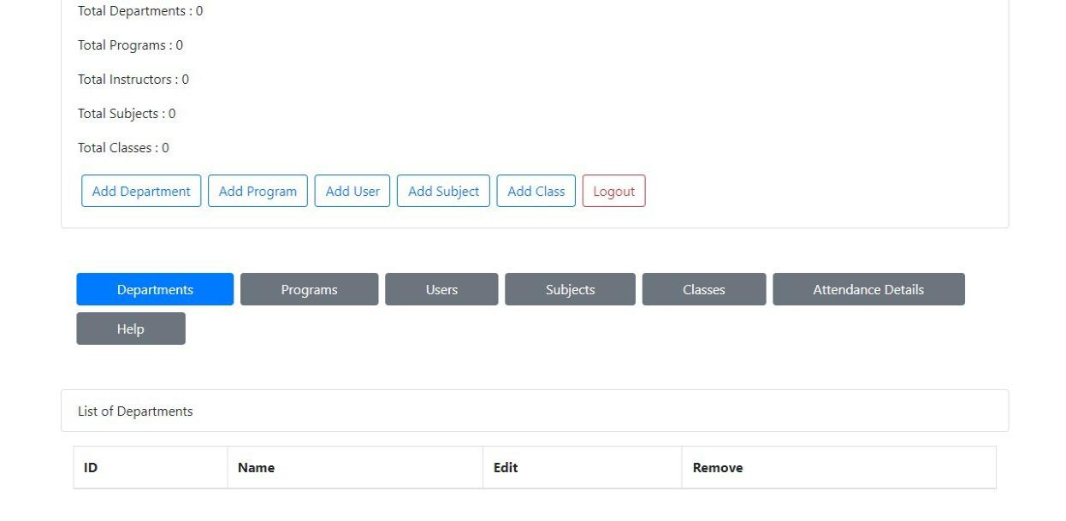

You are in the admin site of the Attendance Management System where you have almost all the control to the system. Be sure that you are the right person who is authorized to use the system. If you are here by mistake please Logout from the system.

First of all, add a department. We can also add multiple departments. We have to provide an id and a name to the department. Id can be DOECE, DOCE, etc. Name can be Department of Electronics and Computer Engineering, Department of Civil Engineering, etc.

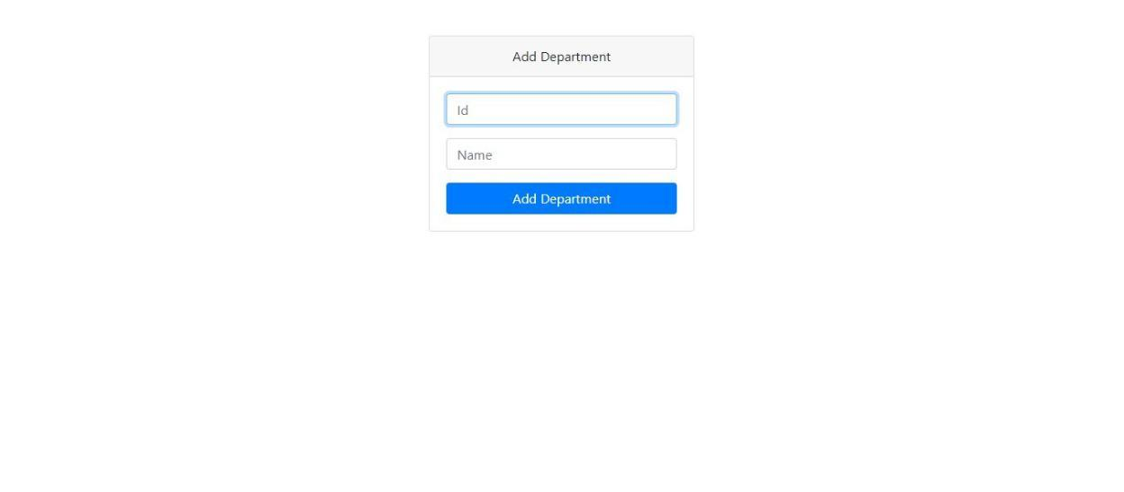

Now, add different programs which may be under different departments. The program consists of attributes like id, name, department and duration. Id can be

BCT, BCE, etc. Name can be Bachelor of Computer Engineering, Bachelor of Civil Engineering, etc. Department can be DOECE, DOCE, etc. Duration can be 4, 5, etc.

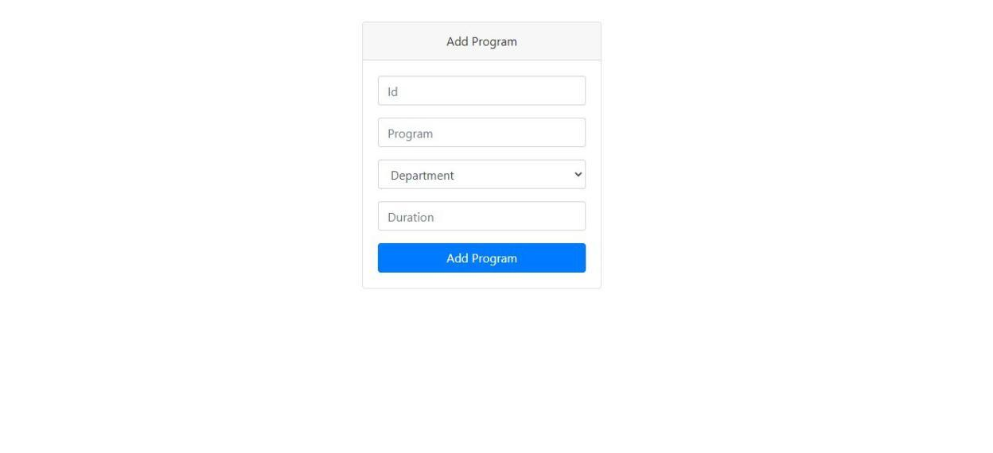

Now, users are added in order to access the client part of the system. One or more users can be added easily. User consists of attributes like name, username, password and department. We have to remember the username and password in order to login from the client site.

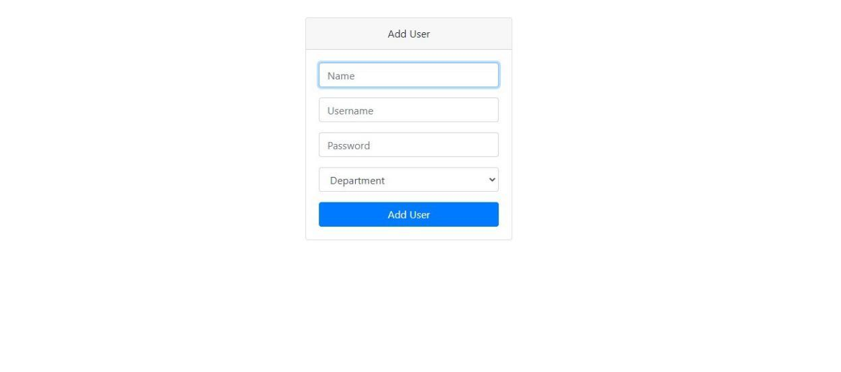

Now, subjects for the added program has to be added in order to take attendance by the teachers in the client site.

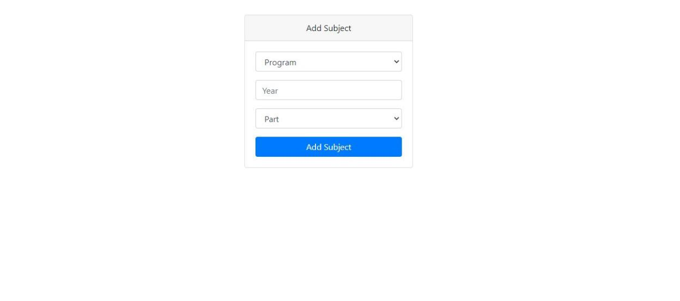

Finally, classes are to be added in order to take attendance of specific class. Note that attendance can be taken only in the client side of the system.

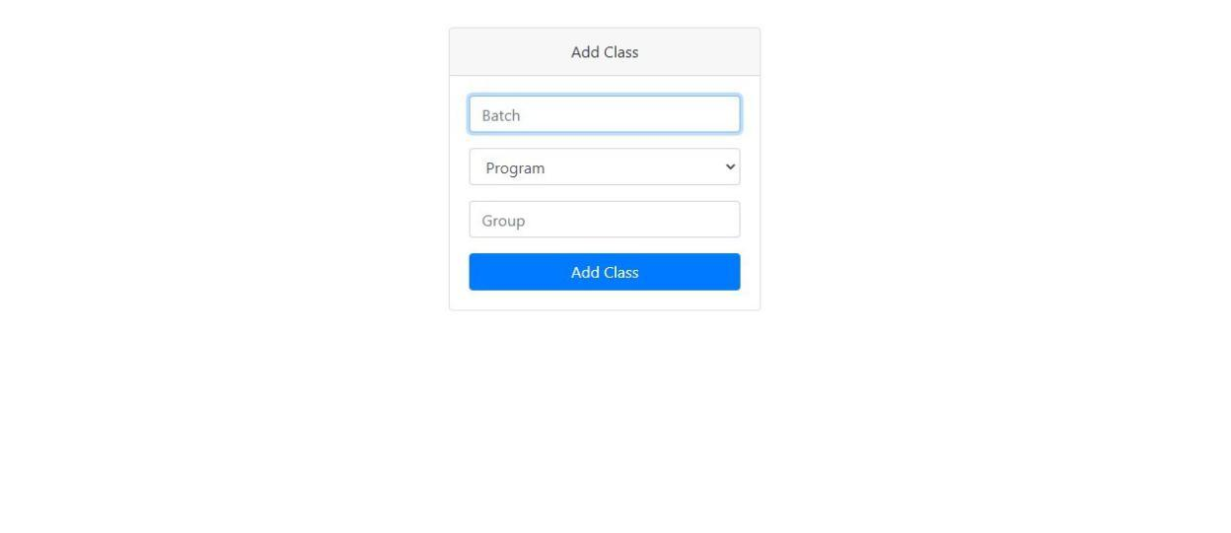

All the added items can be viewed in the main dashboard by clicking on the tabs of interest. You can see various buttons for editing the details and for removing the records. For viewing subjects, input might be given which is similar as instructed above in 'For Subject' section. For viewing classes also, similar thing has to be done as in the case of subjects. When you do all the necessary work, be sure to Logout from the system.

There also is a help tab that will navigate you through the admin site.

**2. Client Site**

**Login**

At first, teachers have to login with their username and password as provided by the administrator. Only the users whose account has been created by administrator from the admin site are authenticated.

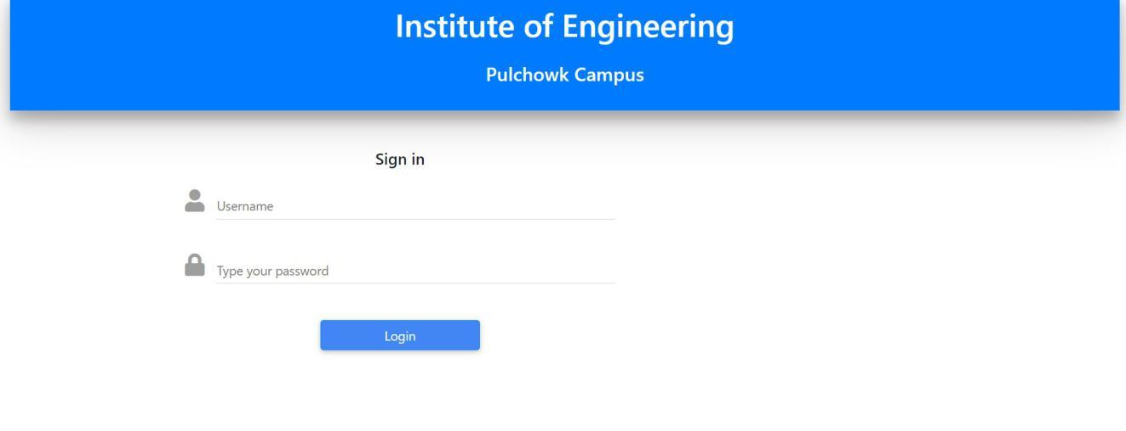

**Home**

Home shows “My Classes” which lists all the class whose attendance has been recorded. Here the classes are shown in simple cards listed with the programs, batch, section, class type.

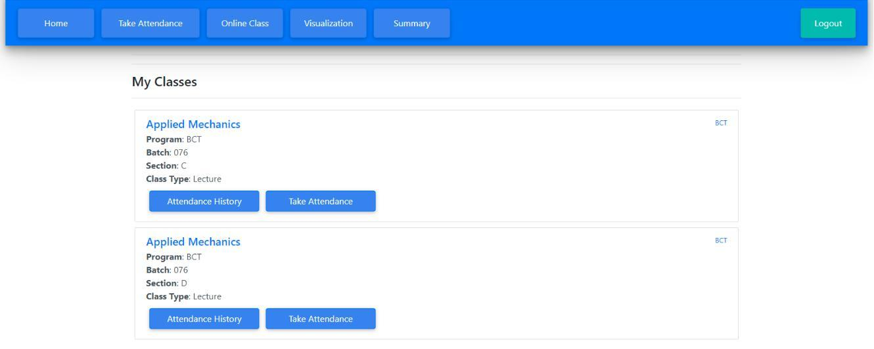

Along with all the general information the card also has buttons to easily access the “Attendance history” (this shows all the recorded attendance)

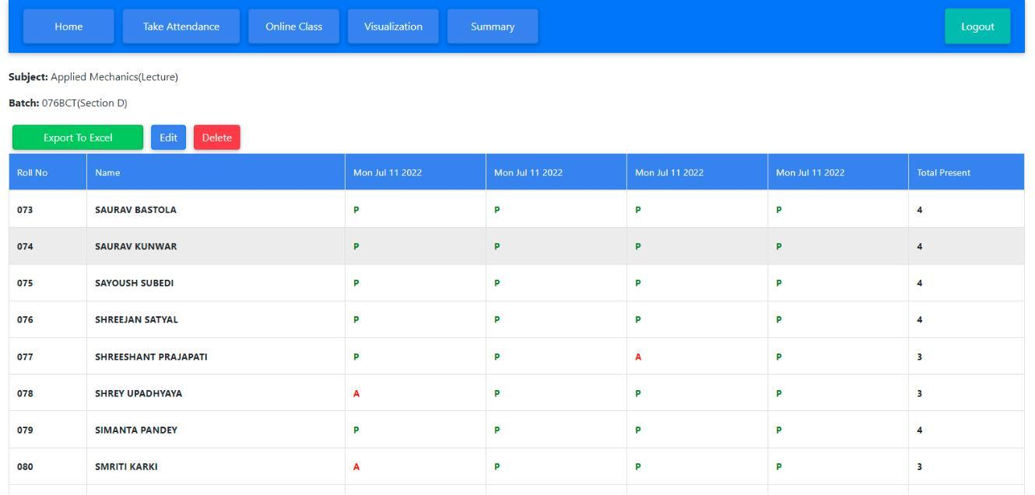

**Take Attendance**

This is the main section where the attendance record can be taken. To take the attendance first we are to select the right program, batch, section, year and then the subject and finally click on “Take Attendance” button.

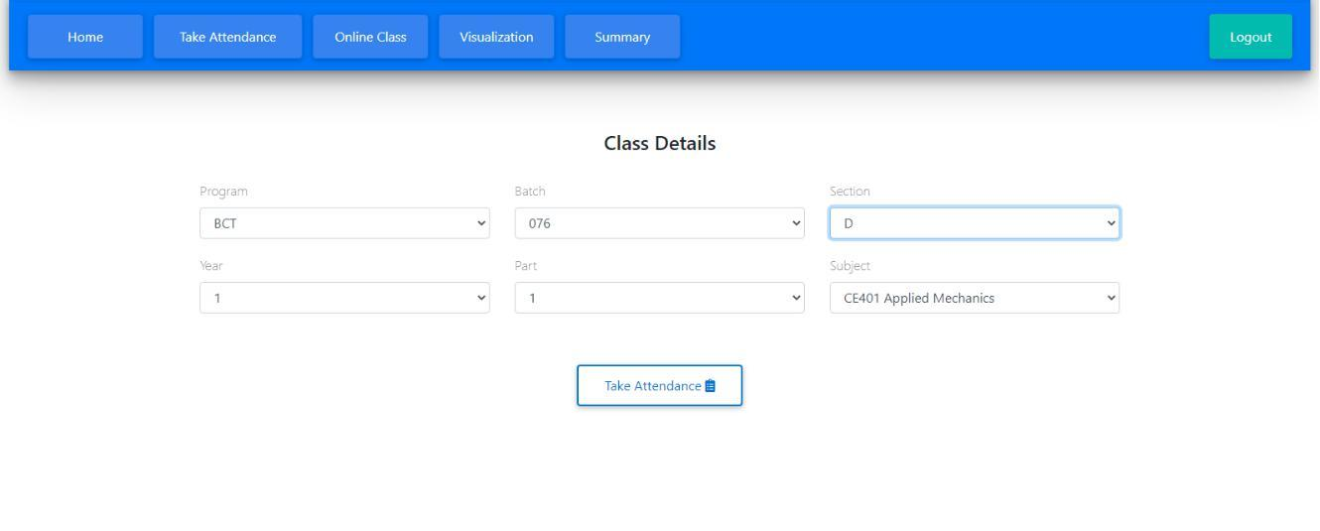

On clicking the button, the list of all the students in the class appears in a table with their roll no, name and present/absent column.

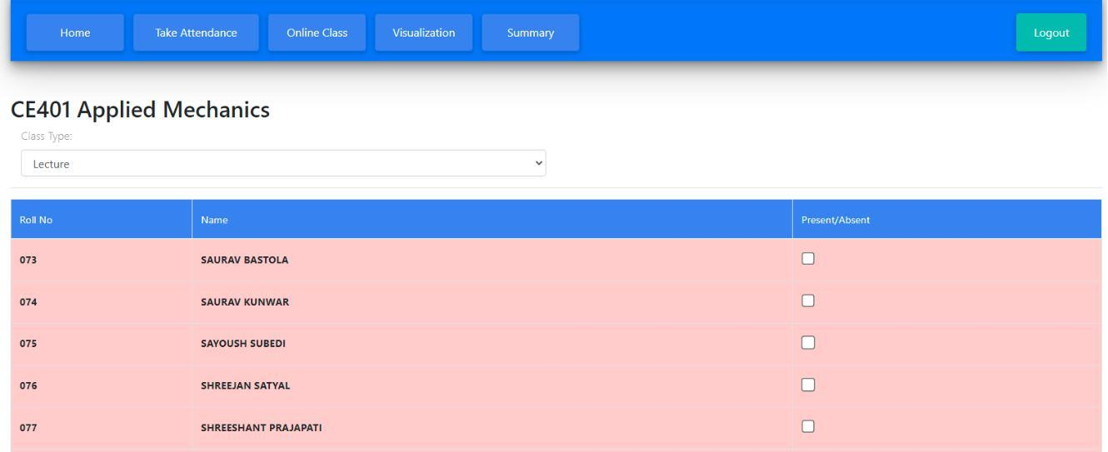

Now before taking the attendance user needs to specify the class type by selecting the drop down before the table by default, it is set to lecture class and for practical class it can be set by selecting from the drop-down.

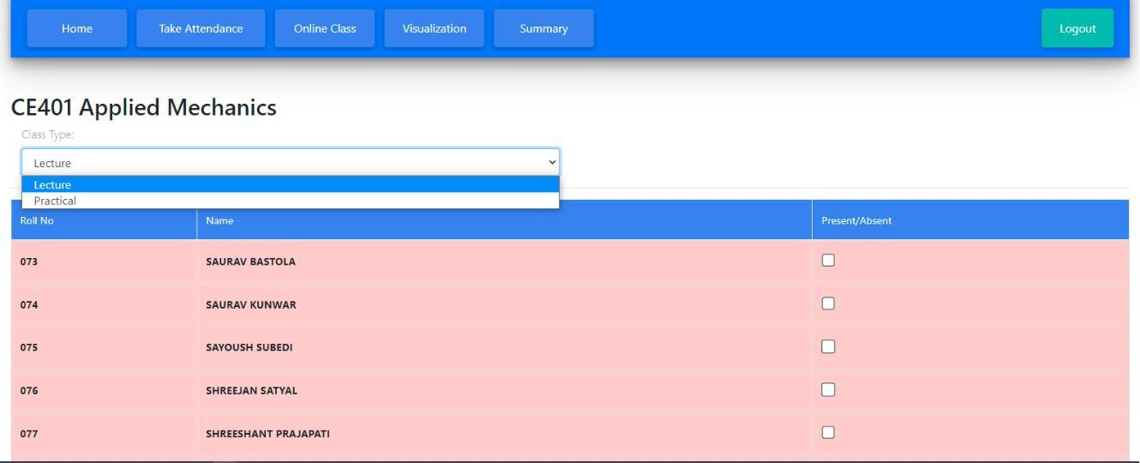

By default, all students are marked absent shown by red highlight; to mark any student present you go beside the name of the student in present/absent column and click on the checkbox, on clicking the checkbox the row with student name is highlighted by green color which signifies that student is marked present.

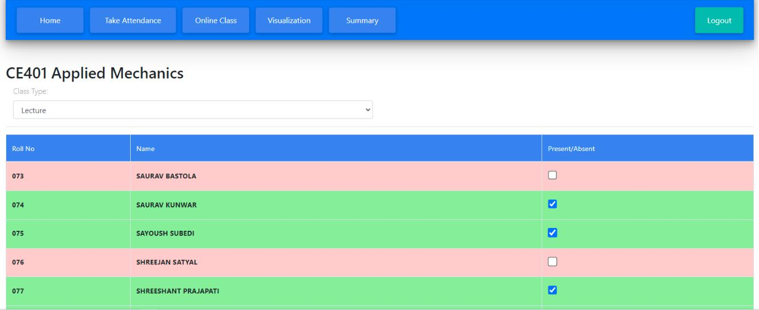

After taking the attendance (marking all the checkbox) user can submit the record by clicking “submit” button. This submits the record and stores it. After clicking the submit button the overview of the attendance record of the class appears and the user can edit (make changes to the recorded data), delete (delete entire record), or export it to excel.

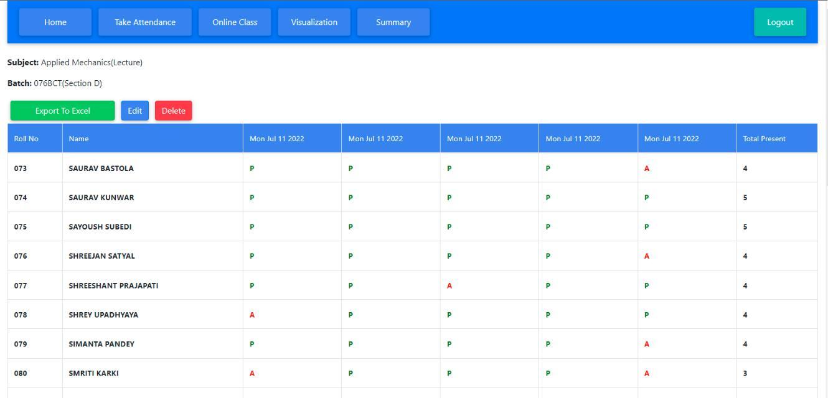

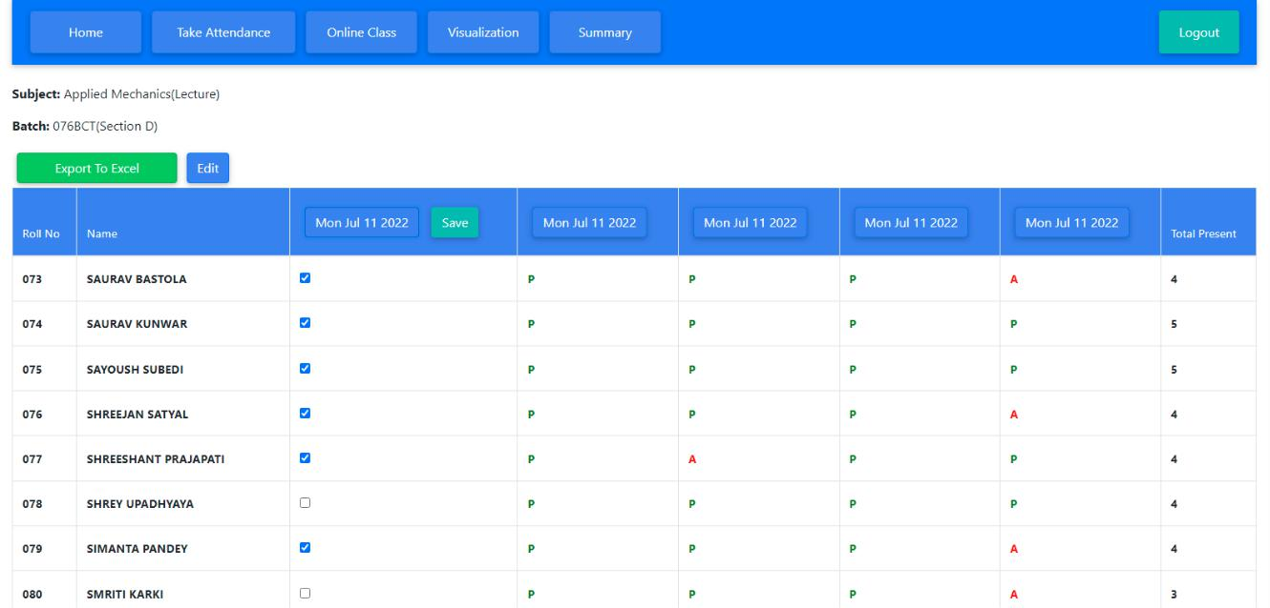

Above figure illustrated the editing record feature available to the user.

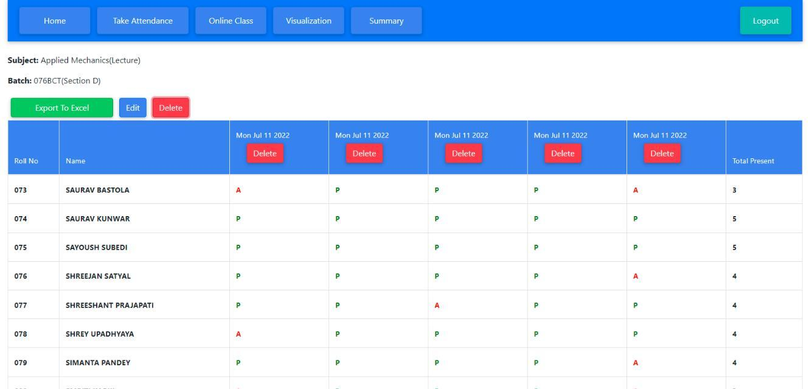

Above figure illustrates the delete record feature available to the user.

**Visualization**

Attendance records of specific class can be visualized. For this, click on Visualization tab. Then fill the class details (program, batch, section, year, part, subject, class type) and finally click on Visualize button to visualize the records.

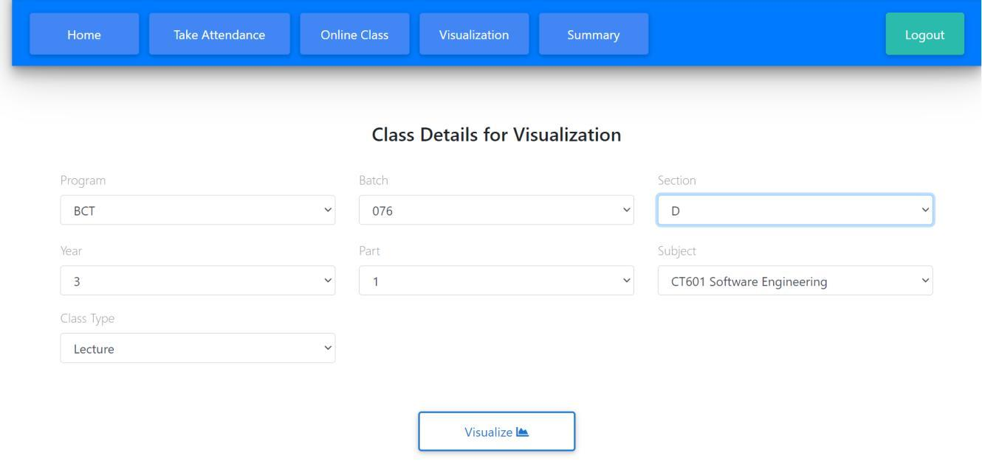

The date-wise attendance record plots the no of present students at respective dates.

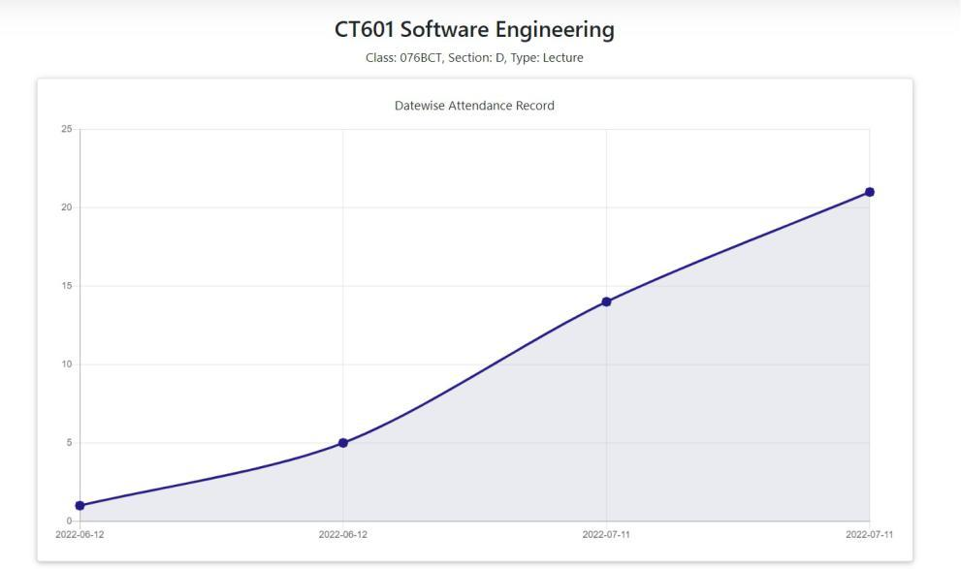

The student-wise attendance records shows the records in descending order of no. of present days from top to bottom.

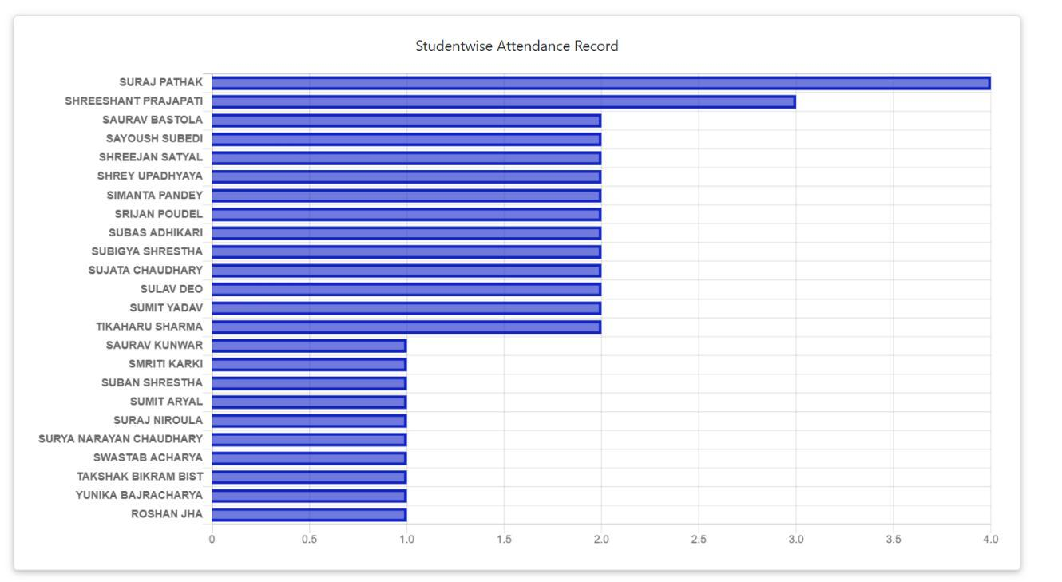

**Summary**

This section gives the summary of all attendance records taken for a specific section.

Select the required class details. The summary can also be downloaded in excel.

