Students Attendance Tracker

Documentation

Maintained By:

Suraj Pathak
Tikaharu Sharma
Subigya Shrestha
Shreeshant Prajapati

Online Attendance Tracker

Project Description

The Online Attendance Tracker application helps the teachers simplify the tedious task of keeping attendance. Setting up classes and taking attendance is very easy. The attendance can be downloaded in excel format. There is variety of reports available to the user. The user can visualize the attendance records in graphs. Only administrators have the rights to add and delete the details of the teachers, department, programs, classes, etc.

In this system the users are divided into two main roles: Admin and Teachers.

- Admin

Administrator is the role having the highest privilege. They have to use Admin-Site. Administrator can do the following things:
  - Create accounts for teachers.
  - Create departments, program, subject or class.
  - Update and delete existing department, program, subject, class and teacher accounts.

- Teachers

Department assigns teachers for the certain subject and class. Teacher use Client-Site. Teachers can do the following things:
  - Take attendance of specific classes.
  - Download an excel file containing the attendance of the students.
  - View attendance history summary and visualization of specific classes.

Project Setup

To run the project on your local machine, follow the instructions given below:
- Install node.js (at least V 12) as the first prerequisite of the project. (It can be installed from https://nodejs.org/en/download/ )
- Install MySQL or MariaDB or packages like Xampp, which ship with MariaDB by default.

File Structure

There are three main folders.
- Backend
- Admin-Site
- Client

Install Required Packages

- Open the terminal and change the directory to the <project base directory>/Attendance-Backend
- Enter command “npm install”. This downloads and installs dependencies defined in a package.json file and generates a node_modules folder with the installed modules.
- Do above steps for each of the folders in the project.

Creating Database using Xampp

- Run Xampp Control Panel
- Start Apache and MySQL server
- Open Admin of MySQL or go to localhost/phpmyadmin in your browser
- For first time use, create a database named “schema_attendance”

Initial Backend Setup

Create a .env file on the root directory in folder “Attendance/Backend ” and add the following default credentials in the newly created file. DB_HOST="localhost"

DB_USER="root"
DB_PASSWORD = ""
JWT_KEY = "HELLO"
ADMIN_KEY = "HELLO"
PORT_NO = "3082"

Running the project

- Enter command “npm start” inside the base directory “Attendance/Backend” to run the backend
- Now, enter command “npm start” inside the base directory “Attendance/Client” to run the client site or inside “Attendance/Admin-Site” to run the admin site
- The instructions for using the admin site are given in the application itself, under the help section
- In case the application crashes, restart the respective application.
- Press CTRL + C to stop any of the servers.
Tech Stacks Used

Front End

The frontend part of the project is made using ReactJS. React is a free and open-source front-end JavaScript library for building user interfaces based on UI components. It is maintained by Meta and a community of individual developers and companies.

To learn React, check out the React documentation (https://reactjs.org/).

For some of the UI interface, Bootstrap is also used. Bootstrap is the most popular HTML, CSS, and JavaScript framework for developing responsive, mobile-first websites. It has numerous HTML and CSS templates for UI interface elements such as buttons and forms.

BackEnd

The backend or server-side is written in Express. Express is a minimal and flexible Node.js web application framework that provides a robust set of features for web and mobile applications.

Database

This application uses MySQL database infrastructure. MySQL is an open source realtional database management system. Alternatively, XAMPP server can be used for this application which consists of MySQL database component.
User Manual

There are two applications based on user:

- Administrator (Admin Site)

- Teacher (Client Site)

Admin Site

At first in the admin site you will get the following login page,
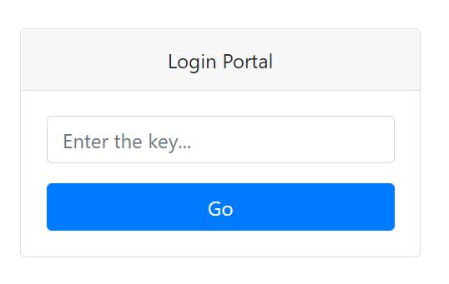

By default, the login key is ‘HELLO’. Enter the login key and you will be redirected to the following admin dashboard.
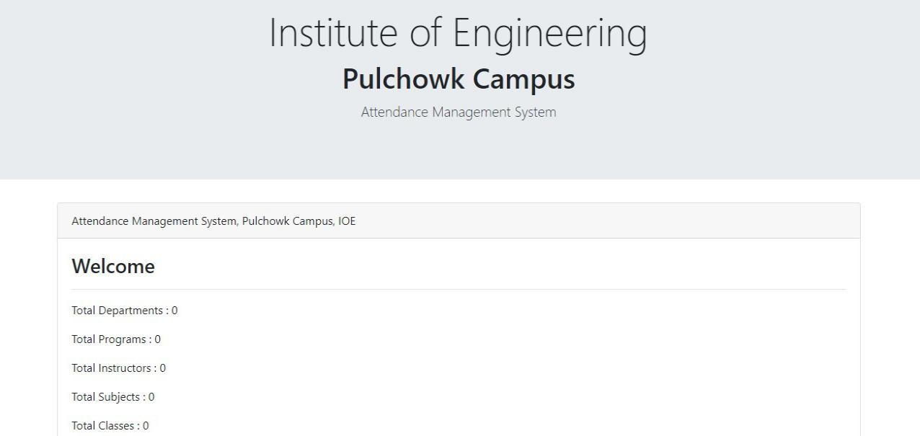
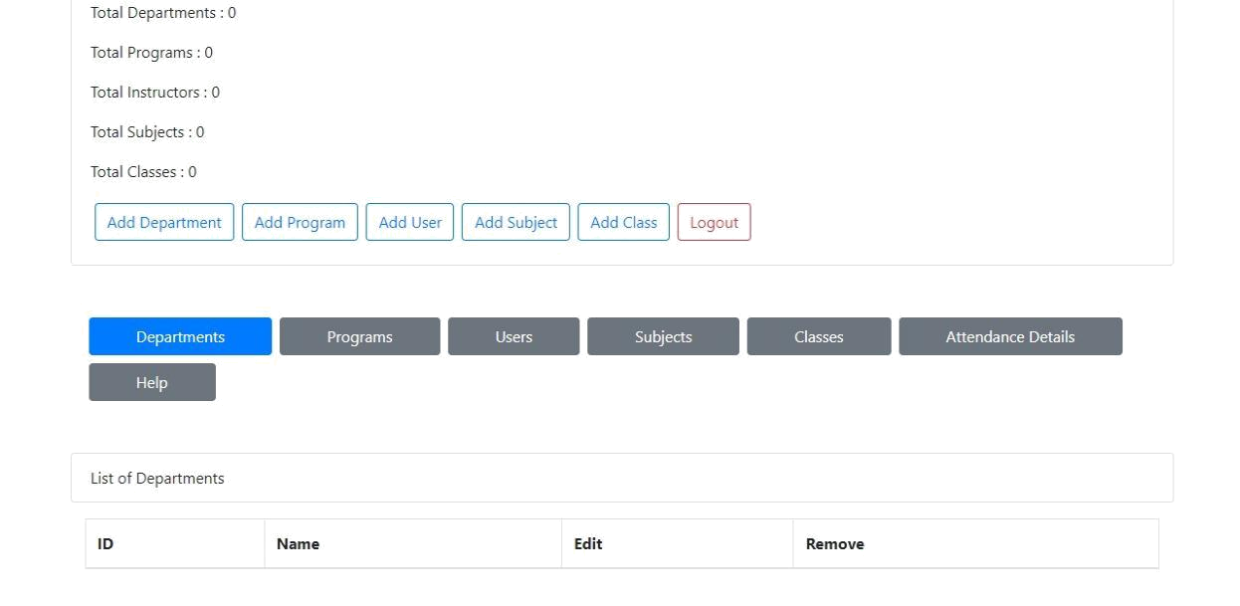

You are in the admin site of the Attendance Management System where you have almost all the control to the system. Be sure that you are the right person who is authorized to use the system. If you are here by mistake please Logout from the system.

First of all, add a department. We can also add multiple departments. We have to provide an id and a name to the department. Id can be DOECE, DOCE, etc. Name can be Department of Electronics and Computer Engineering, Department of Civil Engineering, etc.
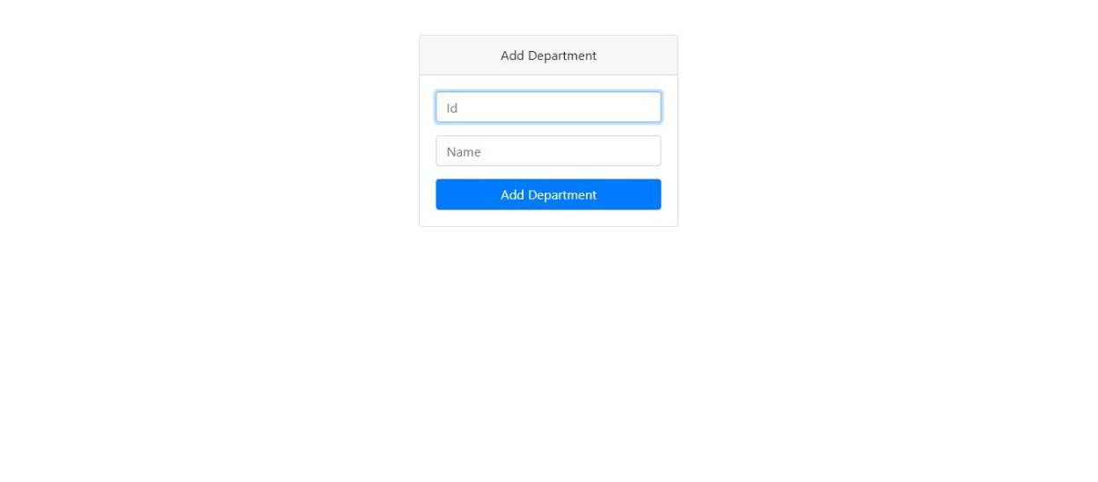

Now, add different programs which may be under different departments. The program consists of attributes like id, name, department and duration. Id can be

BCT, BCE, etc. Name can be Bachelor of Computer Engineering, Bachelor of Civil Engineering, etc. Department can be DOECE, DOCE, etc. Duration can be 4, 5, etc.
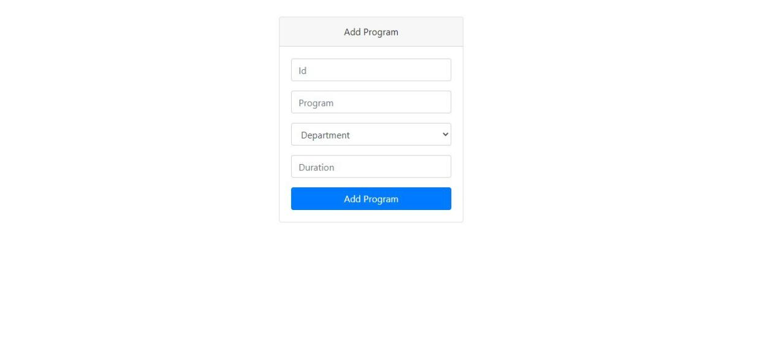

Now, users are added in order to access the client part of the system. One or more users can be added easily. User consists of attributes like name, username, password and department. We have to remember the username and password in order to login from the client site.
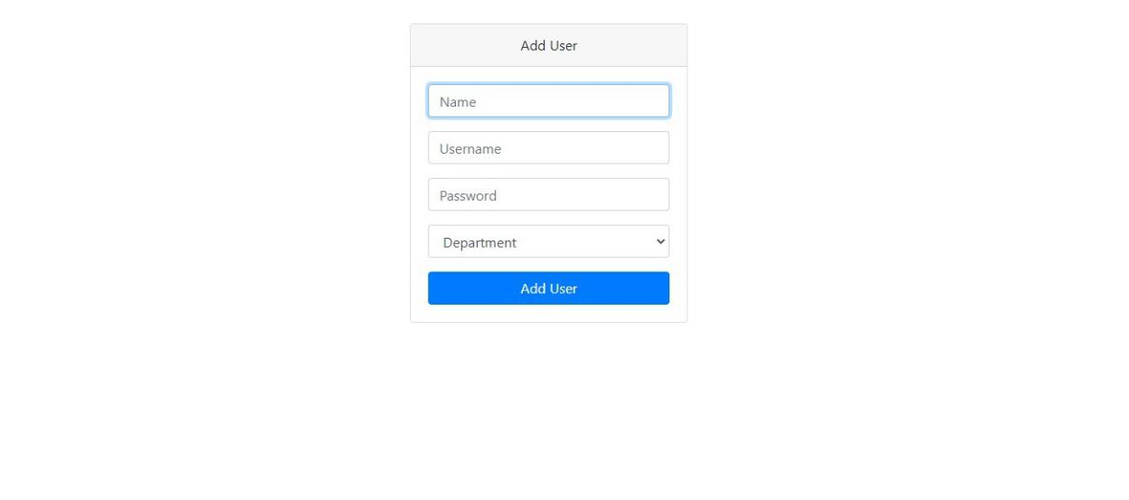

Now, subjects for the added program has to be added in order to take attendance by the teachers in the client site.

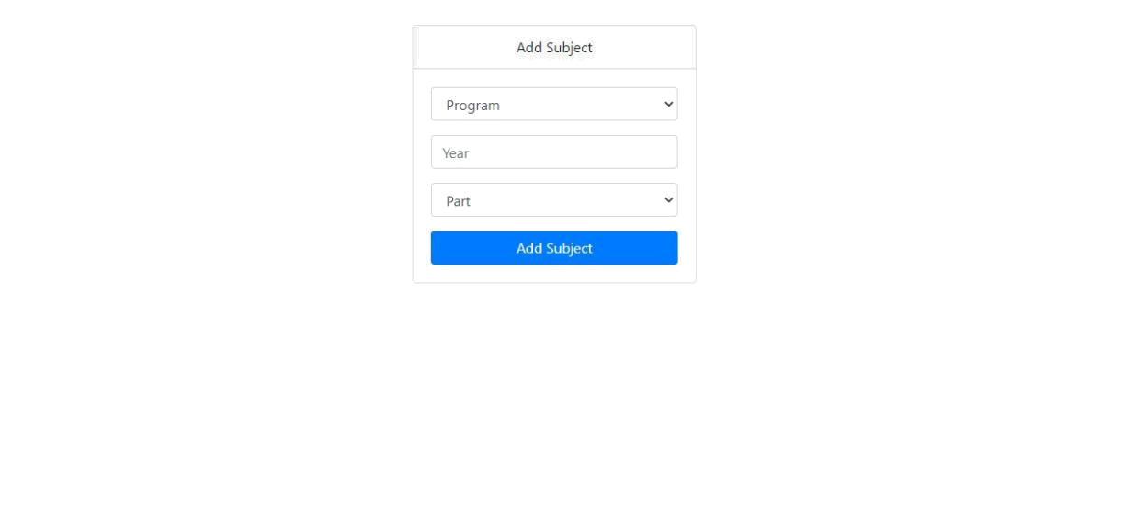

Finally, classes are to be added in order to take attendance of specific class. Note that attendance can be taken only in the client side of the system.
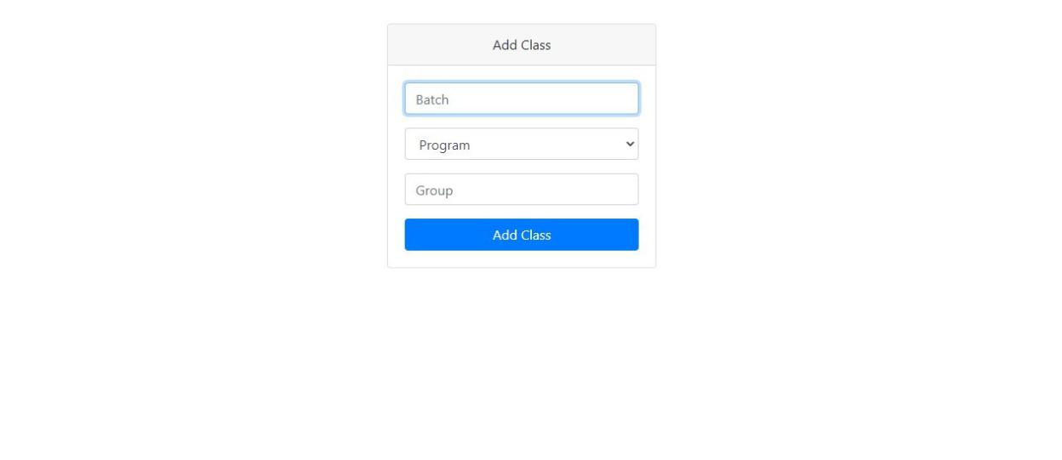

All the added items can be viewed in the main dashboard by clicking on the tabs of interest. You can see various buttons for editing the details and for removing the records. For viewing subjects, input might be given which is similar as instructed above in 'For Subject' section. For viewing classes also, similar thing has to be done as in the case of subjects. When you do all the necessary work, be sure to Logout from the system.

There also is a help tab that will navigate you through the admin site.
2. Client Site

Login

At first, teachers have to login with their username and password as provided by the administrator. Only the users whose account has been created by administrator from the admin site are authenticated.
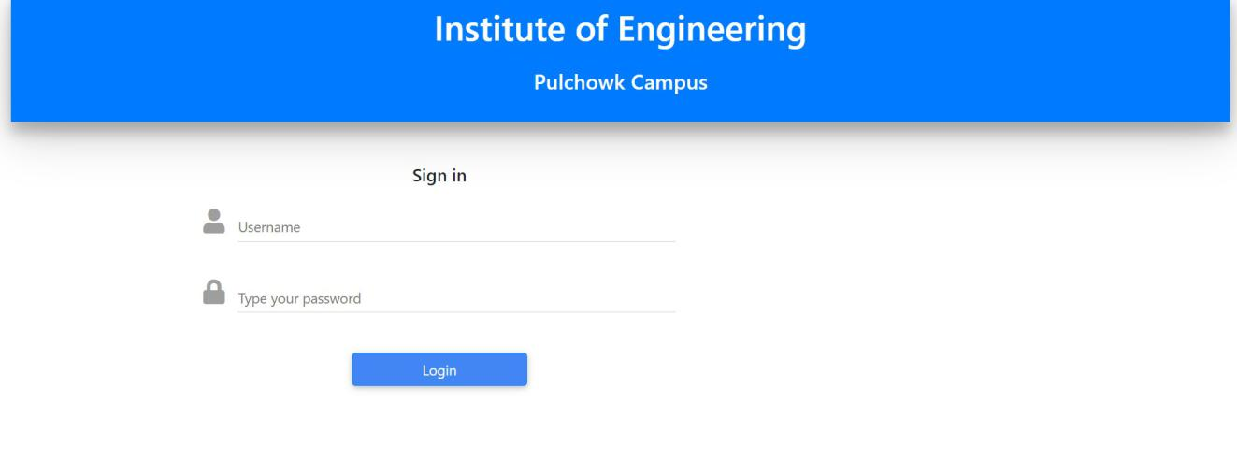

Home

Home shows “My Classes” which lists all the class whose attendance has been recorded. Here the classes are shown in simple cards listed with the programs, batch, section, class type.
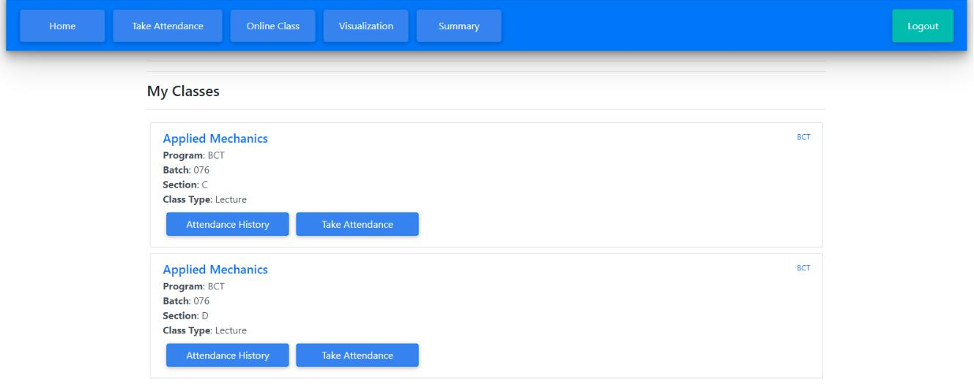
Along with all the general information the card also has buttons to easily access the “Attendance history” (this shows all the recorded attendance)
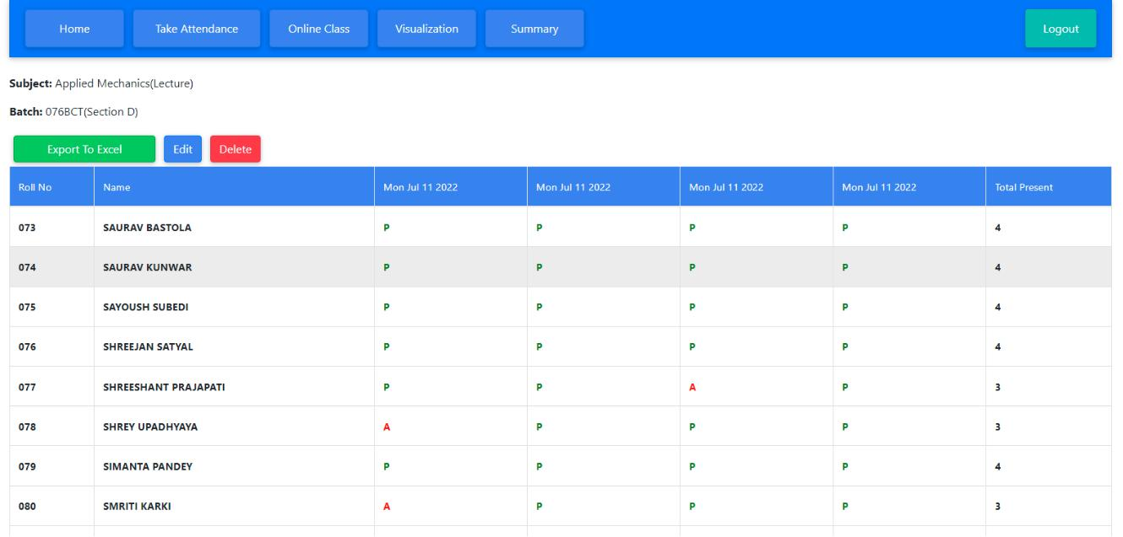

Take Attendance

This is the main section where the attendance record can be taken. To take the attendance first we are to select the right program, batch, section, year and then the subject and finally click on “Take Attendance” button.
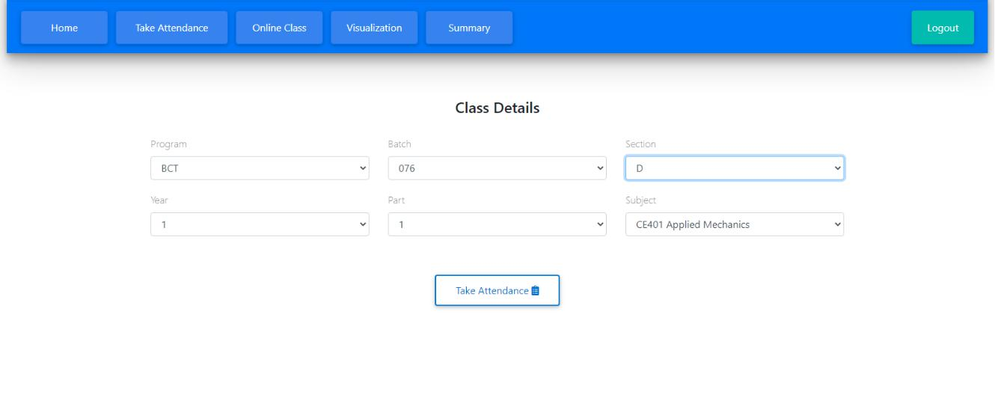
On clicking the button, the list of all the students in the class appears in a table with their roll no, name and present/absent column.
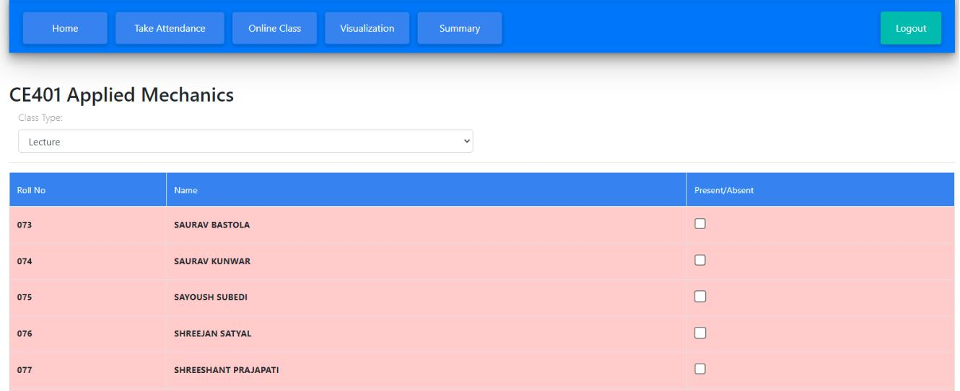

Now before taking the attendance user needs to specify the class type by selecting the drop down before the table by default, it is set to lecture class and for practical class it can be set by selecting from the drop-down.
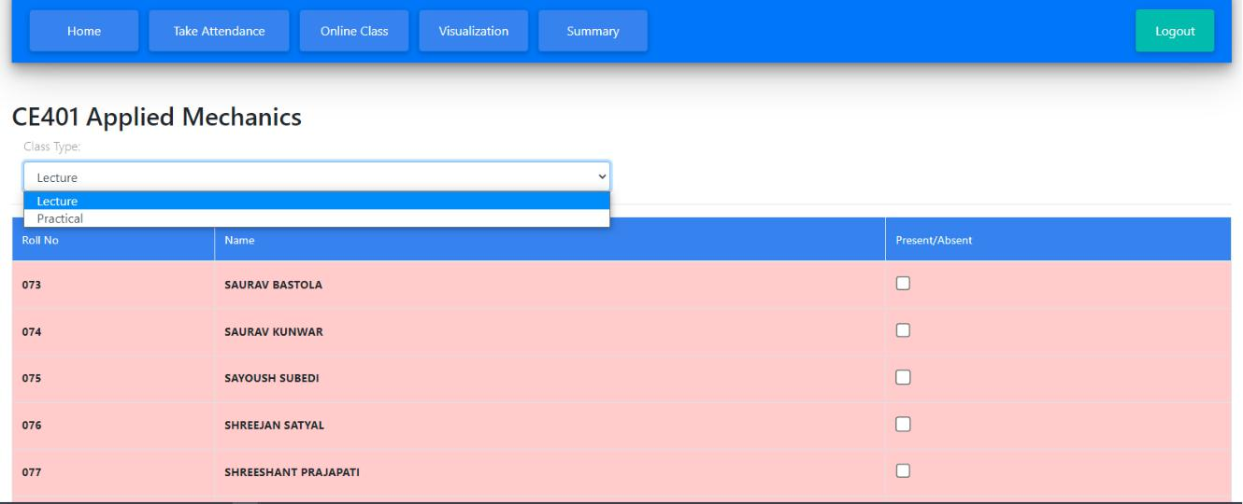

By default, all students are marked absent shown by red highlight; to mark any student present you go beside the name of the student in present/absent column and click on the checkbox, on clicking the checkbox the row with student name is highlighted by green color which signifies that student is marked present.

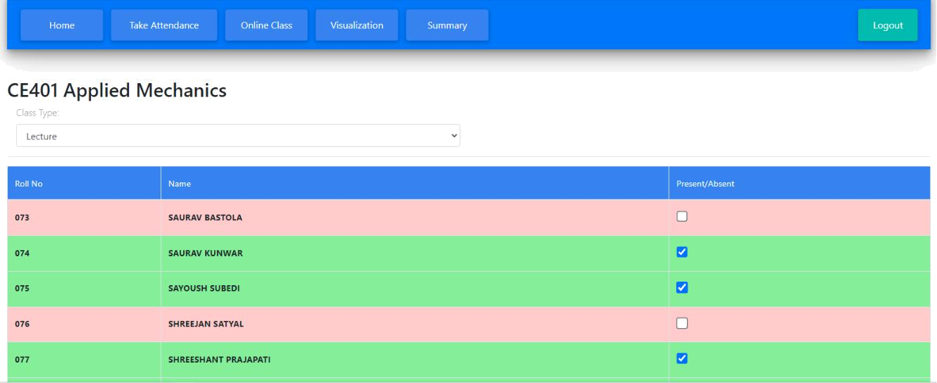

After taking the attendance (marking all the checkbox) user can submit the record by clicking “submit” button. This submits the record and stores it. After clicking the submit button the overview of the attendance record of the class appears and the user can edit (make changes to the recorded data), delete (delete entire record), or export it to excel.
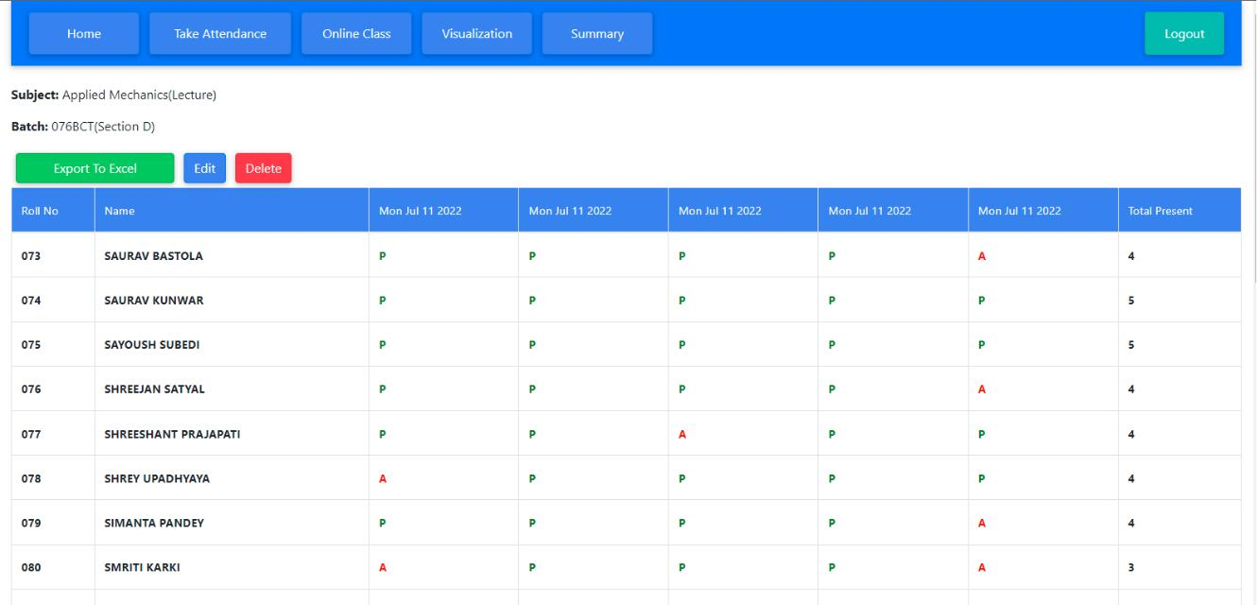
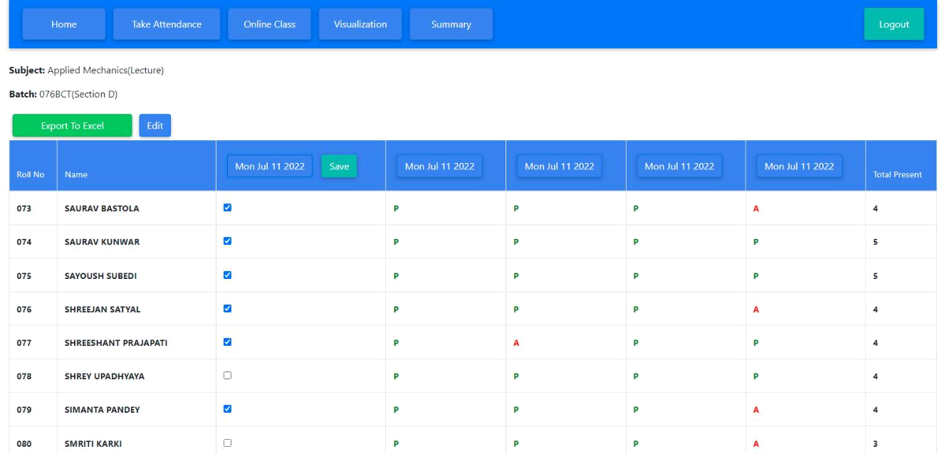

Above figure illustrated the editing record feature available to the user.
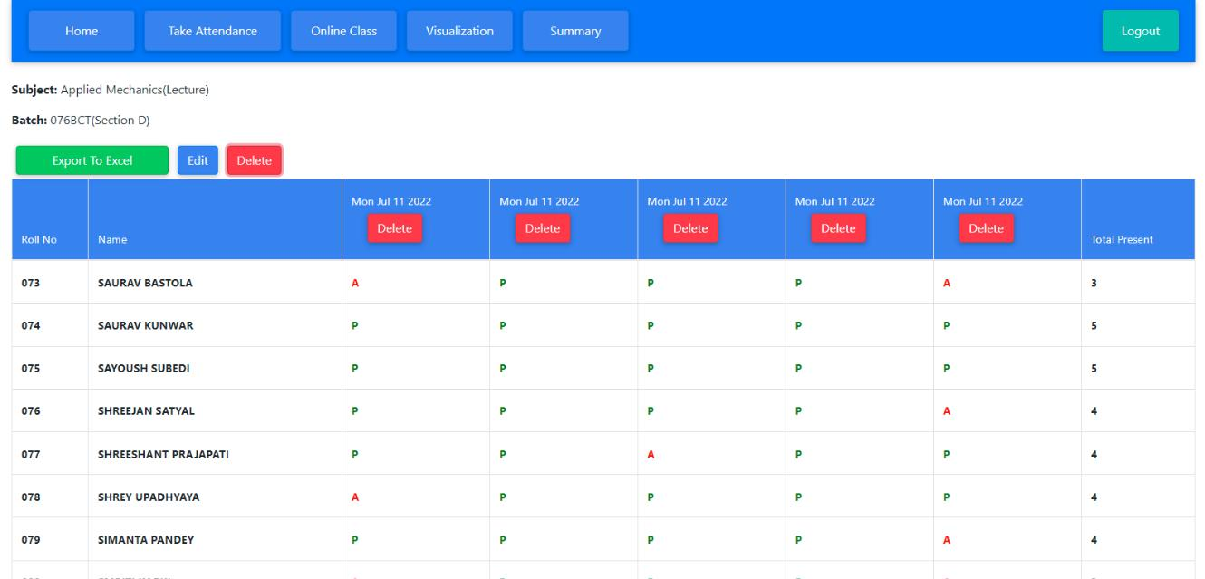

Above figure illustrates the delete record feature available to the user.
Visualization

Attendance records of specific class can be visualized. For this, click on Visualization tab. Then fill the class details (program, batch, section, year, part, subject, class type) and finally click on Visualize button to visualize the records.
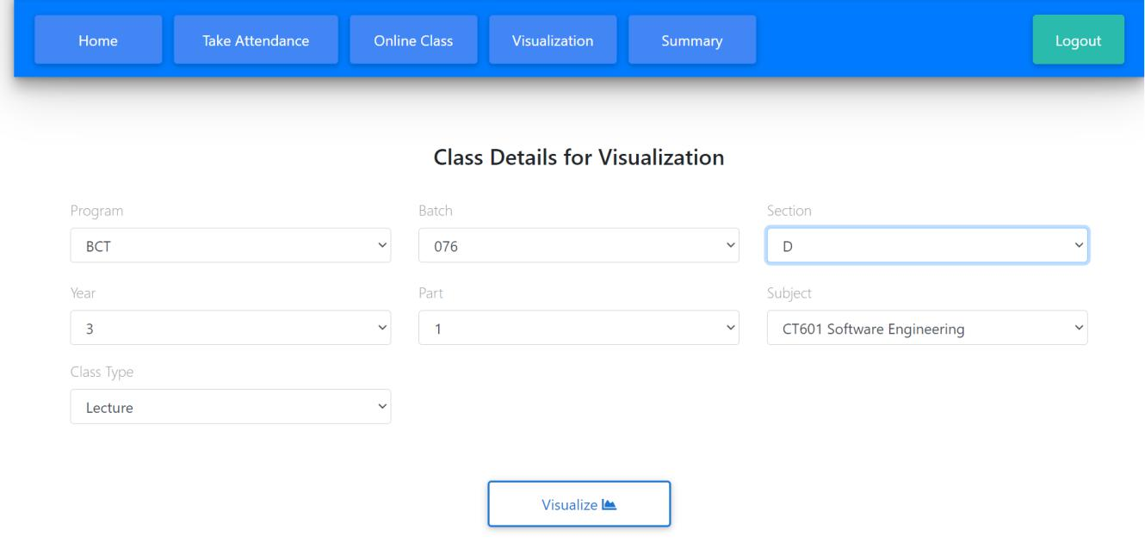

The date-wise attendance record plots the no of present students at respective dates.
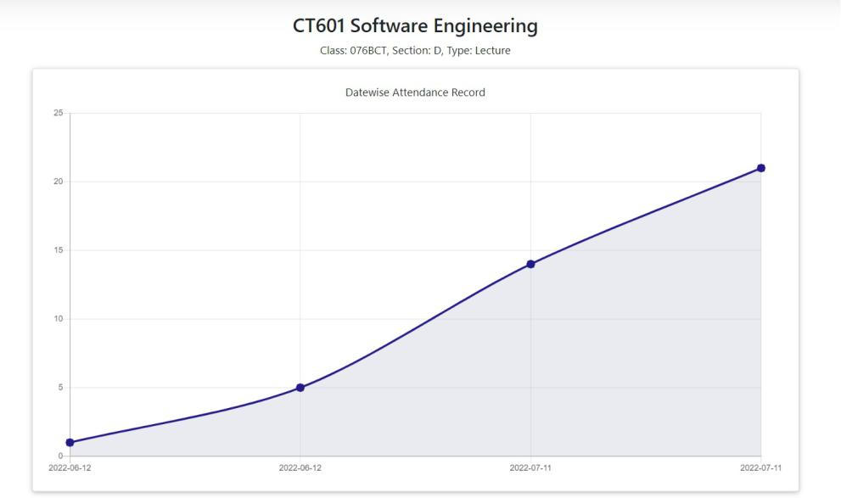
The student-wise attendance records shows the records in descending order of no. of present days from top to bottom.
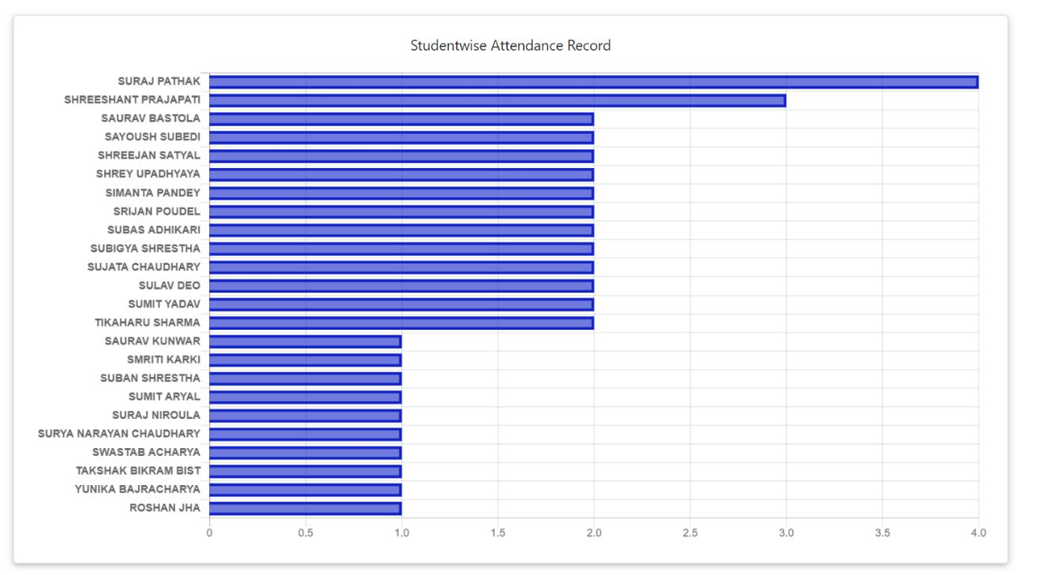

Summary

This section gives the summary of all attendance records taken for a specific section.
Select the required class details. The summary can also be downloaded in excel.
