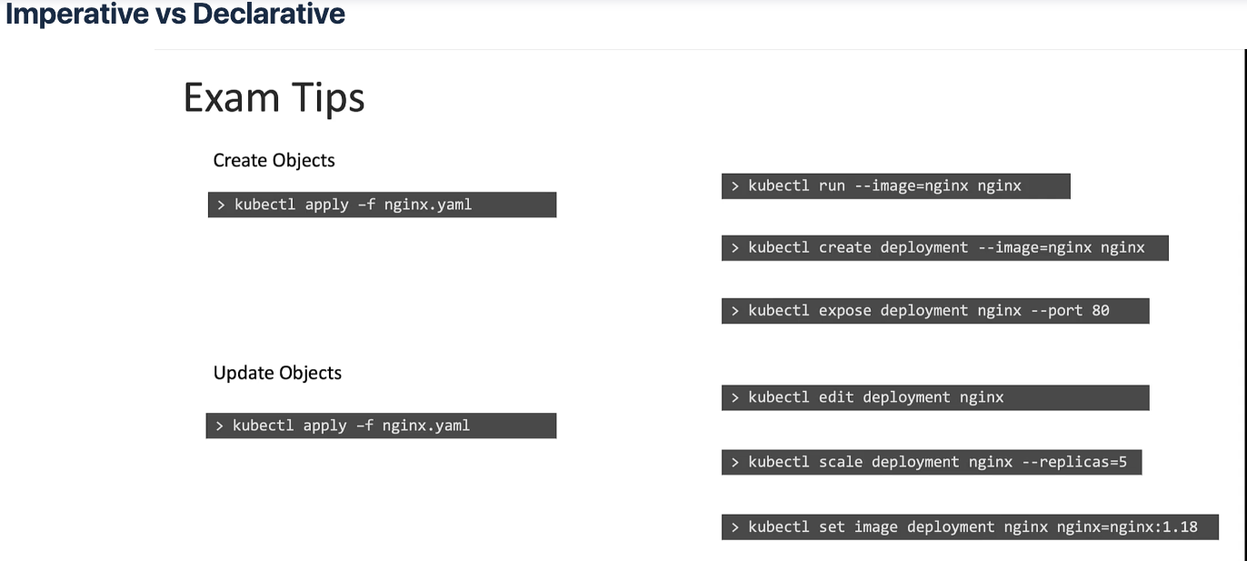

### POD

**Create an NGINX Pod**

kubectl run nginx --image=nginx

**Generate POD Manifest YAML file (-o yaml). Don’t create it(–dry-run)**

kubectl run nginx --image=nginx --dry-run=client -o yaml

### Deployment

**Create a deployment**

kubectl create deployment --image=nginx nginx

**Generate Deployment YAML file (-o yaml). Don’t create it(–dry-run)**

kubectl create deployment --image=nginx nginx --dry-run=client -o yaml

**Generate Deployment with 4 Replicas**

kubectl create deployment nginx --image=nginx --replicas=4

You can also scale a deployment using the kubectl scale command.

kubectl scale deployment nginx --replicas=4

**Another way to do this is to save the YAML definition to a file and modify**

kubectl create deployment nginx --image=nginx --dry-run=client -o yaml > nginx-deployment.yaml

You can then update the YAML file with the replicas or any other field before creating the deployment.

### Service

**Create a Service named redis-service of type ClusterIP to expose pod redis on port 6379**

kubectl expose pod redis --port=6379 --name redis-service --dry-run=client -o yaml

(This will automatically use the pod’s labels as selectors)

Or

kubectl create service clusterip redis --tcp=6379:6379 --dry-run=client -o yaml (This will not use the pods labels as selectors, instead it will assume selectors as **app=redis.**[You cannot pass in selectors as an option.](https://github.com/kubernetes/kubernetes/issues/46191) So it does not work very well if your pod has a different label set. So generate the file and modify the selectors before creating the service)

**Create a Service named nginx of type NodePort to expose pod nginx’s port 80 on port 30080 on the nodes:**

kubectl expose pod nginx --type=NodePort --port=80 --name=nginx-service --dry-run=client -o yaml

(This will automatically use the pod’s labels as selectors, [but you cannot specify the node port](https://github.com/kubernetes/kubernetes/issues/25478). You have to generate a definition file and then add the node port in manually before creating the service with the pod.)

Or

kubectl create service nodeport nginx --tcp=80:80 --node-port=30080 --dry-run=client -o yaml