Melissa Davies | melissa.davies@redburnatlantic.com
Michael Taylor | michael.taylor@redburnatlantic.com

30 April 2025
Economics
The Money Map April 2025
The stagflationary tariff and immigration-driven supply-side shock to the US economy means the Fed will have to sit on its hands until inflation expectations subside and job losses accumulate. Meanwhile, the Eurozone is benefitting from an accumulation of policy support and disinflationary trends relating to trade and energy prices.
An imminent tariff-driven inflationary shock to the US means the Fed will have to take care of price pressures before addressing future labour market weakness. Rates are set to remain on hold in the US to rein in inflation expectations and avoid ‘second-round’ effects in 2H25 as tariff uncertainty persists. Any debt ceiling-related bond market volatility in 3Q could be addressed via the Fed’s balance sheet, even as rates remain on hold.
The Eurozone, meanwhile, is experiencing the disinflationary consequences of the US trade shock and lower energy prices, providing plenty of scope for the European Central Bank (ECB) to lower rates further in 2025. Short-term monetary easing, accelerating corporate credit growth, forthcoming fiscal stimulus, lower energy prices and an improved bilateral relationship with China provide an encouraging set of macro tailwinds for the Eurozone.
In the UK, a short-term inflation acceleration means scope for rate cuts is more limited and fiscal policy needs to be tightened further. But supply-side improvements relating to planning reforms and trading relationships with both the US and Europe, along with resilient household sector balance sheets, provide some relief for the growth outlook.
In Japan, trade uncertainty is likely to keep the Bank of Japan on hold but the structural repositioning of global capital flows away from the US will continue to benefit the yen and undermine the carry trade. Domestic inflationary dynamics and a positive nominal interest rate environment are now well-entrenched.

The Fed
The tariff policy shock should lead to accelerating inflation from May onwards, followed by jobs market deterioration and a likely 2026 recession (defined as a sustained increase in the unemployment rate). We expect the Fed to ‘hold the line’ on rates this year to prevent second-round effects and manage inflation expectations. A debt ceiling crisis could lead to the resumption of asset purchases while rates remain on hold.

The next meeting: 6-7 May
We expect the Fed to keep policy rates on hold at the next meeting.

The next 12 months
We expect material upward pressure on US goods inflation to start appearing in the data from May. Our Y/E estimate of 5% CPI feels conservative, meaning there will be a notable squeeze on consumer real income growth by the end of 2025. Economic strains mean a 2026 recession is highly likely. Lower immigration means the labour market supply-side has tightened, so the runway is elongated for a labour market demand shock to turn into the rise in unemployment needed to define a US recession. We expect the Fed to remain on hold until jobs data starts to deteriorate in earnest in order to prevent further increases in inflation expectations. (Fig 1)
Fig 1: US CPI and inflation expectations (%)
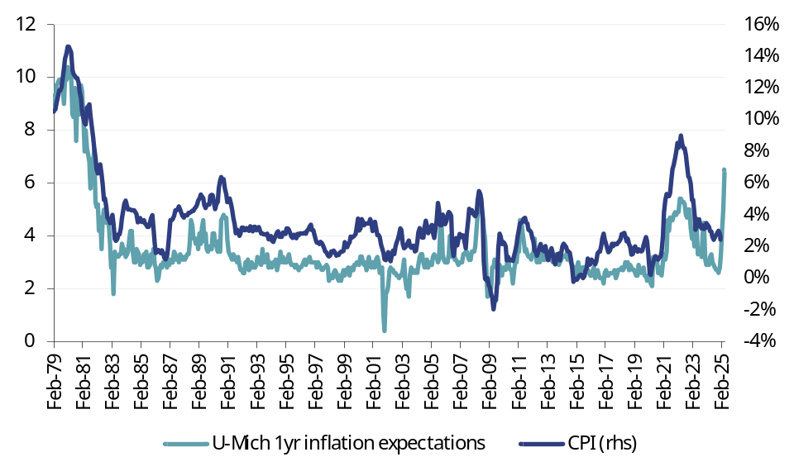
Source: Datastream
Debt ceiling negotiations will likely need to be carved out of the ‘one big bill’ currently working its way through Congress. The debt ceiling needs to be raised before the ‘X’ date, which is uncertain but likely falls in August. While the debt ceiling negotiations are ongoing, the government is spending cash in the Treasury General Account, which supports bank and money market fund liquidity at the Fed (Figs 2 and 3). But once a deal is agreed, the Treasury will start issuing new bonds as well as replenishing the Treasury General Account (Fig 4). In summer 2023, this new issuance was absorbed by excess liquidity sitting in the Overnight Reverse Repurchase Facility ($2trn).
This time around, there is only $200bn of cash held by Money Market Funds sitting in the ON RRP. This sets up the prospect of a repo market squeeze taking place after August (perhaps the end of 3Q), which could further stress bond markets and hedge fund trades at a time of rising inflation. The antidote to this would be Fed repo and asset purchase support, which could be deployed in the name of financial stability if bonds yields increase sharply (e.g. towards 5%) even as inflation rises.
Fig 2: Bank Reserves ($m) |  | Fig 3: ON RRP($m)
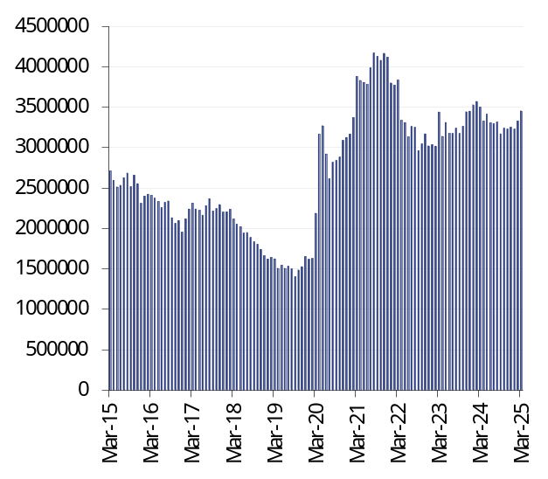 |  | 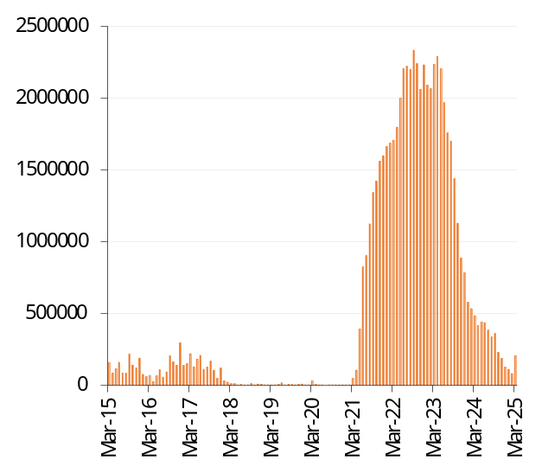
Source: Datastream
Fig 4: Treasury General Account ($m)
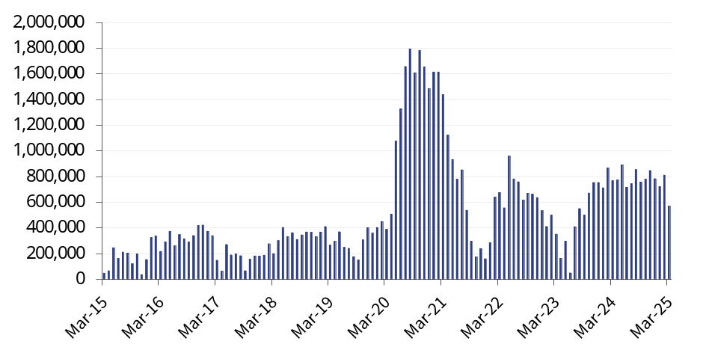
Source: Datastream

The longer term view
Our recent client roadshow to Washington DC hardened our 12-18 month bearish view on the US, but there are reasons for some constructive optimism over the longer term. The ideological regime shift represented by the Trump administration has quite a short runway – it should eventually be constrained by a weakening economy and deteriorating public opinion, via Congress, but this will take time.
Fig 6: US M1 and M2 YoY |  | Fig 7: Effective Fed funds rate (%)
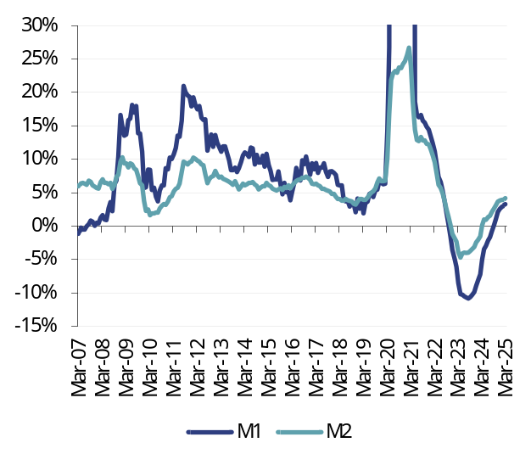 |  | 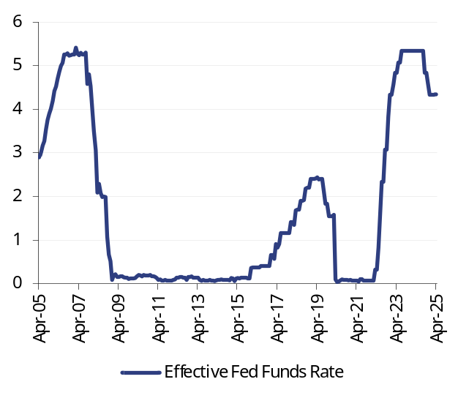
Source: Datastream |  | Source: Datastream

Fig 8: Corporate loans, YoY |  | Fig 9: Household loans, YoY
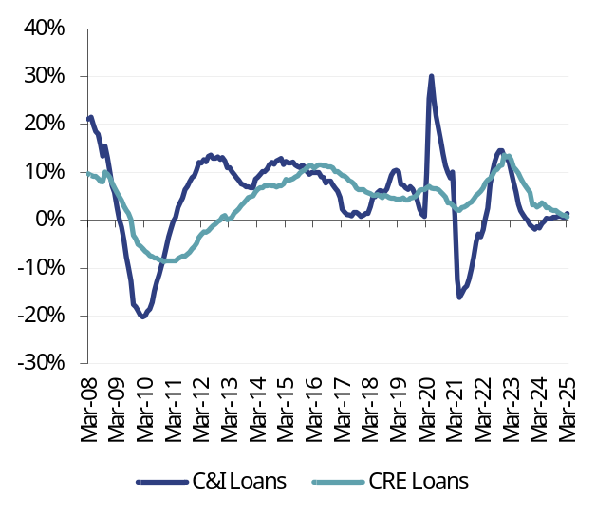 |  | 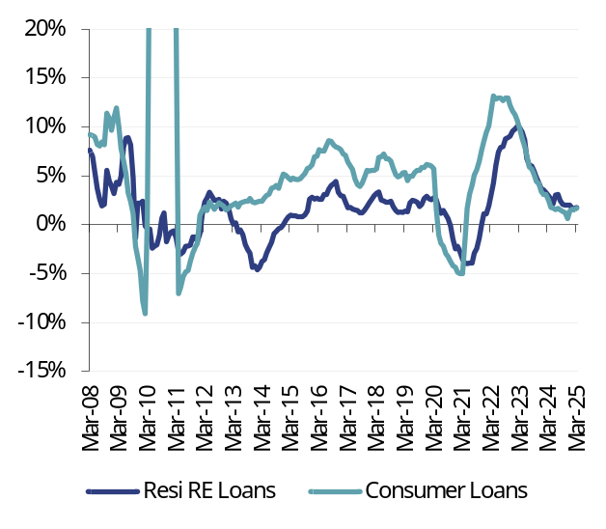
Note: C&I = commercial and industrial; CRE = commercial real estate  Source: Datastream |  | Note: RE = real estate  Source: Datastream

Fig 10: Fed Senior Loan Officer (SLO) survey – corporate credit (net balance) |  | Fig 11: Fed SLO Survey – credit cards (net balance)
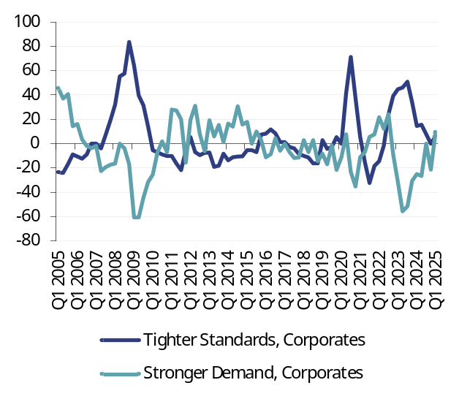 |  | 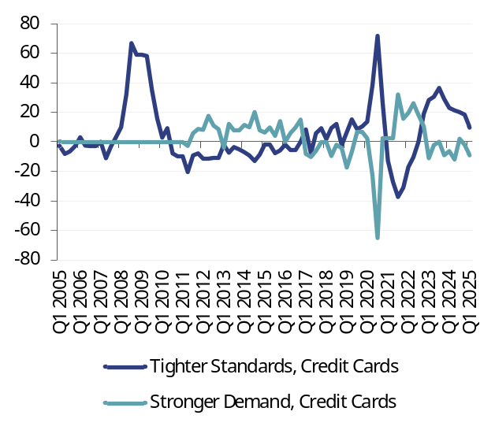
Source: Datastream, Fed Senior Loan Officer Survey |  | Source: Datastream, Fed Senior Loan Officer Survey
Fig 12: Fed SLO Survey – mortgages (net balance) |  | Fig 13: US sector financial balances (% GDP)
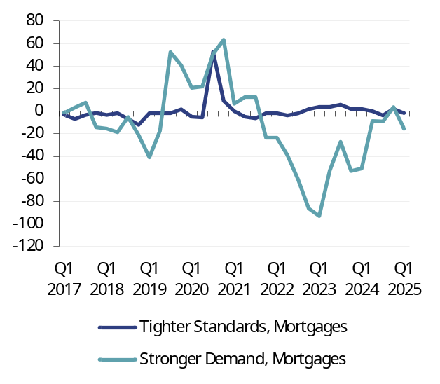 |  | 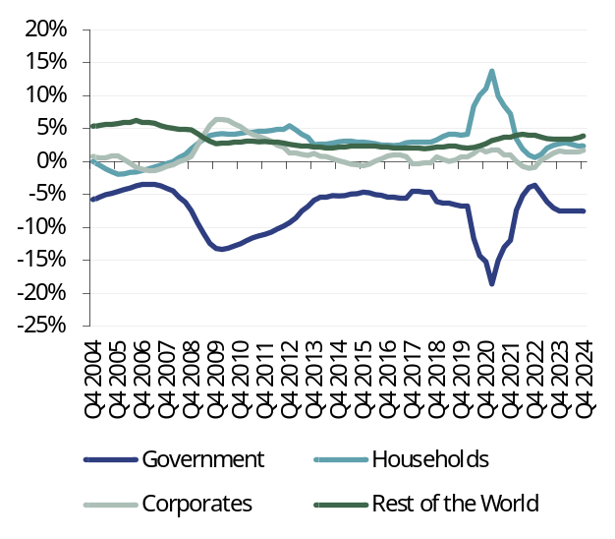
Source: Datastream, Fed Senior Loan Officer Survey |  | Source: Datastream

Fig 14: US CPI |  | Fig 15: US corporate profits
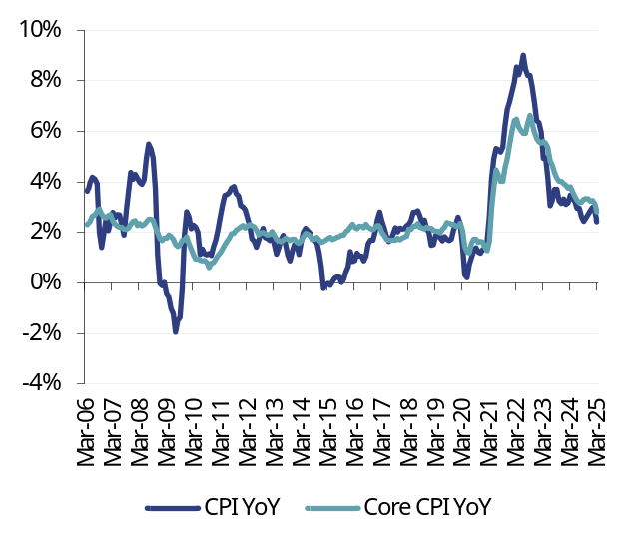 |  | 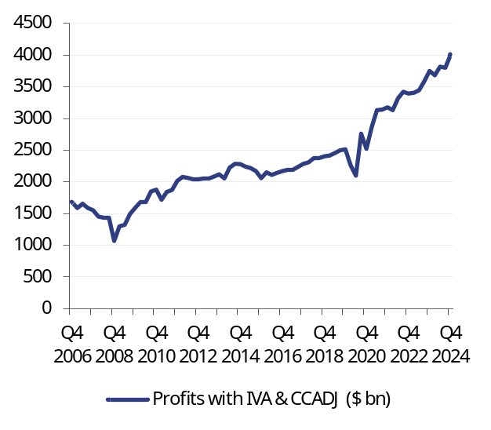
Source: Datastream |  | Note: IVA = Inventory Valuation Adjustment; CCADJ = Capital Consumption Adjustment  Source: Datastream

Fig 16: UMich five-year inflation expectations (%) |  | Fig 17: US ten-year inflation linked swap (%)
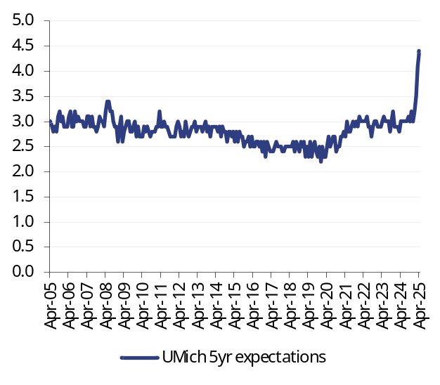 |  | 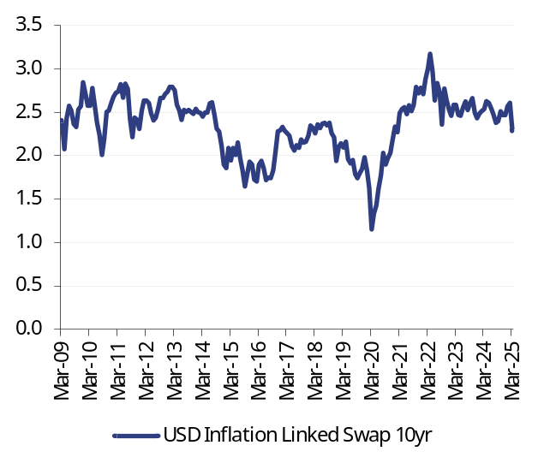
Source: Datastream |  | Source: Datastream

Fig 18: Atlanta Fed wage tracker (%) |  | Fig 19: US job openings and jobless claims (’000s)
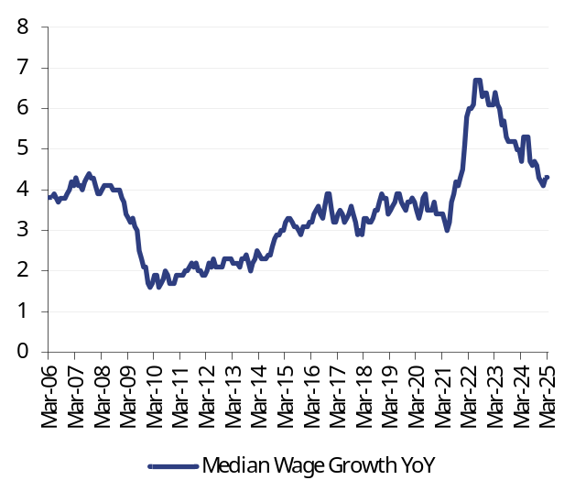 |  | 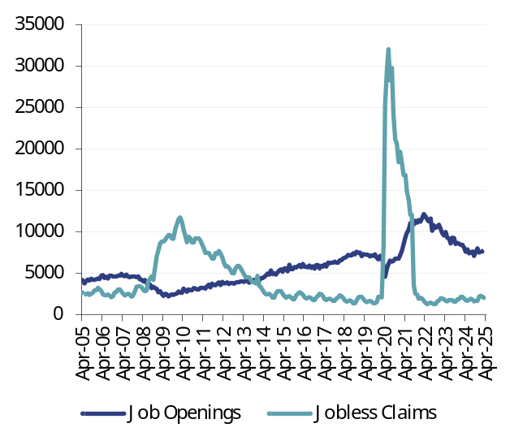
Source: Datastream |  | Source: Datastream

Fig 20: US ISM surveys |  | Fig 21: Nominal broad dollar exchange rate
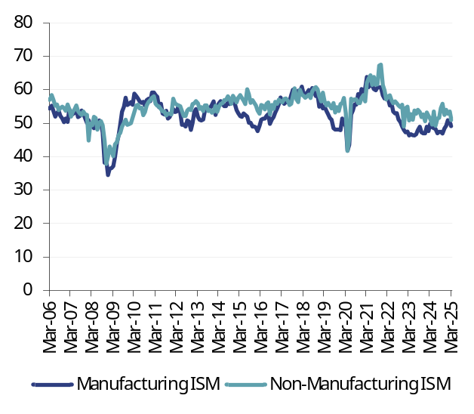 |  | 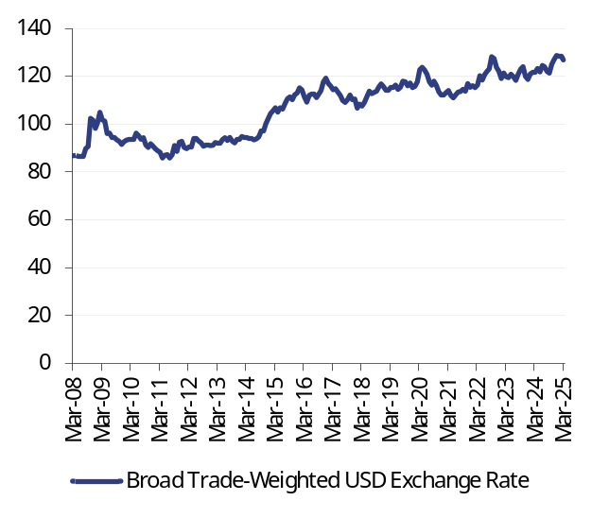
Source: Datastream |  | Source: Datastream, Federal Reserve

Fig 22: Fed assets ($m) |  | Fig 23: Fed reserves and ON RRP ($m)
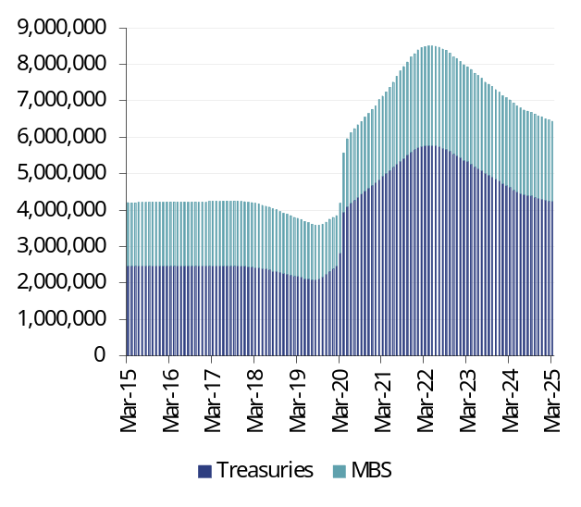 |  | 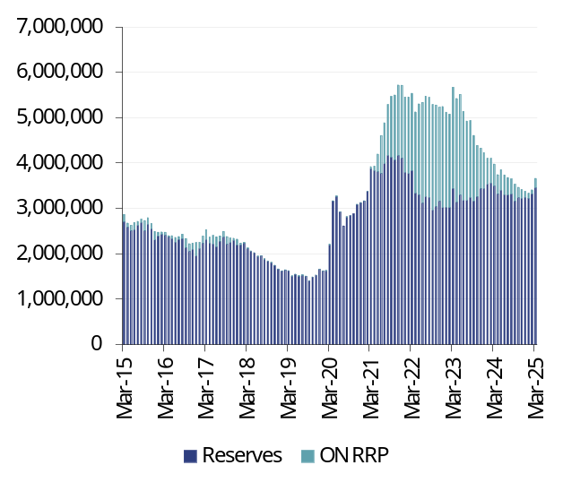
Source: Datastream |  | Source: Datastream

Fig 24: Overnight Index Swap (OIS) curve (%) |  | Fig 25: US yield curve (%)
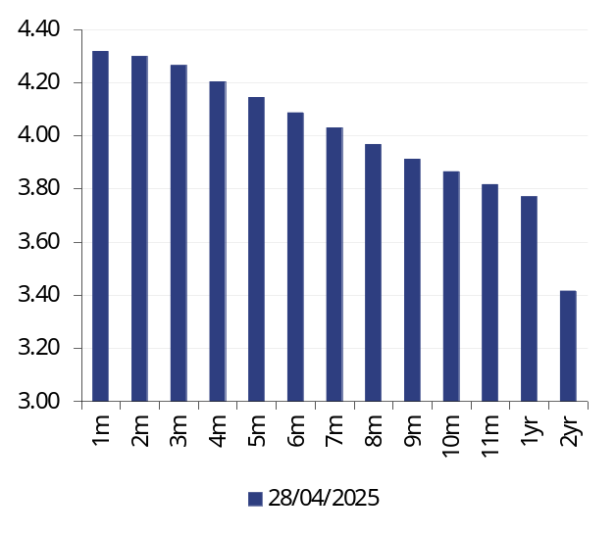 |  | 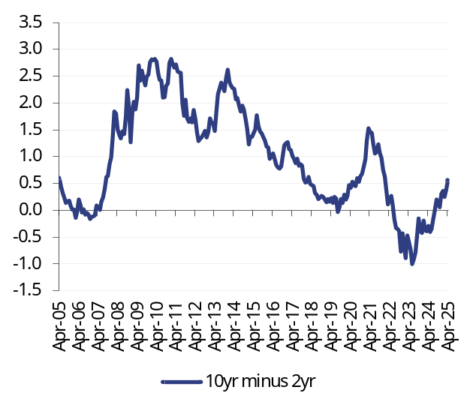
Source: Datastream |  | Source: Datastream, Federal Reserve

The European Central Bank
The ECB is well-placed to ease policy in response to the downside risks created by US trade policy. Growth risks include consumption and investment as well as exports. Inflation risks are also to the downside, assisted by the recent strength of the euro. A further 75bp of easing this year is likely, taking the Deposit rate to 1.5%. Further out, the ECB may face challenges as fiscal policy is eased in Germany and elsewhere, mainly to boost defence spending.

The next meeting: 5 June
We expect the ECB to cut the Deposit rate by 25bp to 2.0%.

The next 12 months
On 17 April, the ECB Governing Council voted unanimously to cut the Deposit rate by 25bp to 2.25%. At the subsequent press conference, ECB President Christine Lagarde emphasised the downside risks to growth arising from US trade policy. In addition to a negative effect on eurozone exports, ‘investment and consumption may be negatively affected by extreme uncertainty’. At the same time, Ms Lagarde said that the impact on inflation was ‘not clear’. But the near-term influences are downward, including from lower energy prices and the recent strength of the euro against the US dollar. So far this year, the euro has appreciated by c5% against the US dollar, with disruption to supply chains cited as a medium-term upside risk to inflation. We also note that the tariff outlook is uncertain: if a trade deal between the EU and US is not agreed and the US imposes a 20% tariff on EU exports, then the EU may respond by raising tariffs on the US, which would impact eurozone inflation, but at present the disinflationary process is well established.

Fig 26: Eurodollar exchange rate ($ per €)
Source: Datastream
The ECB is set to cut the Deposit rate by 25bp to 2.0% in June. Given the current downside risks to growth and a benign inflation outlook – lower gas prices may soon bring CPI inflation to the 2% target – further cuts are likely. We expect rates at 1.5% by year-end.

The longer term view
Policies of the US administration have strengthened the need for eurozone domestic resilience. A key element of this will be the transformation of fiscal policy in Germany. The incoming CDU/CSU SPD coalition is to create a €500bn (11% of GDP) infrastructure fund and release defence spending from the constraints of the so-called ‘debt brake’ which has constrained fiscal policy in recent years. New International Monetary Fund (IMF) forecasts of government structural balances illustrate how Germany is expected to have bigger, rather than smaller, deficits over the coming years compared with the whole eurozone.
Fig 27: General government cyclically adjusted government balance (% of GDP)
Source: IMF Fiscal Monitor April 2025
In addition to the German stimulus, there are plans to boost defence spending across the EU. The EU Commission has announced a €800bn defence plan out to 2030, giving member states fiscal flexibility to boost spending in this area. Despite high levels of public sector debt in some eurozone economies, the trend is likely to be increased overall debt and fiscal spend. The IMF forecasts a five-percentage point increase in the eurozone public sector debt to GDP ratio between 2024 and 2030, reaching 93% of GDP. Rising debt in some eurozone countries may cause the ECB concern and potentially involve ECB bond purchases.

Fig 26: Eurozone M1 and M3, YoY |  | Fig 27: ECB deposit facility rate (%)
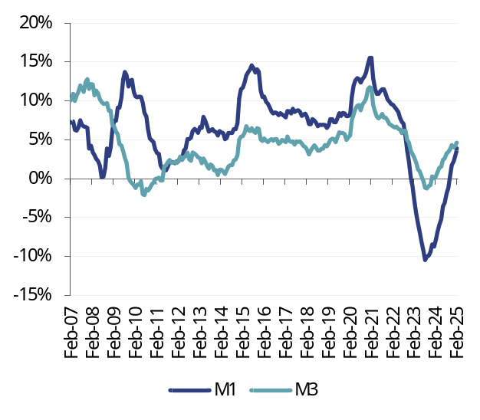 |  | 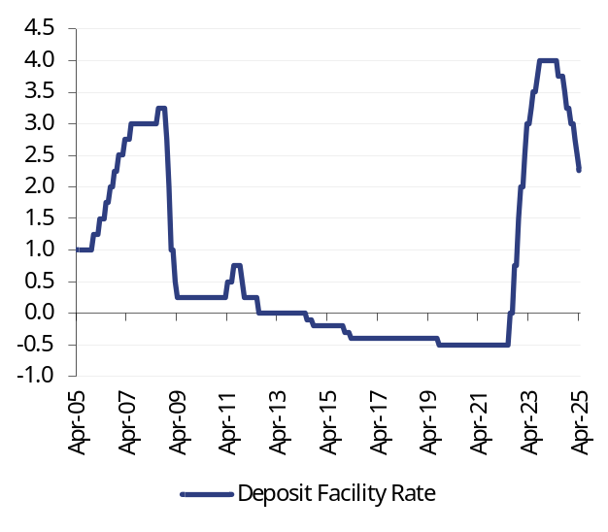
Source: Datastream |  | Source: Datastream

Fig 28: Corporate loans, YoY |  | Fig 29: Household loans, YoY
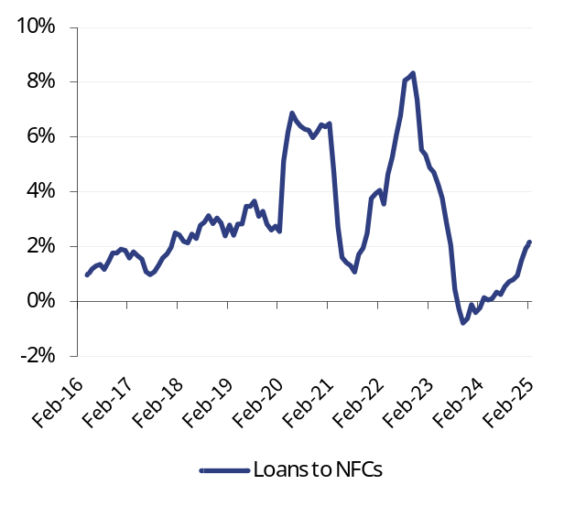 |  | 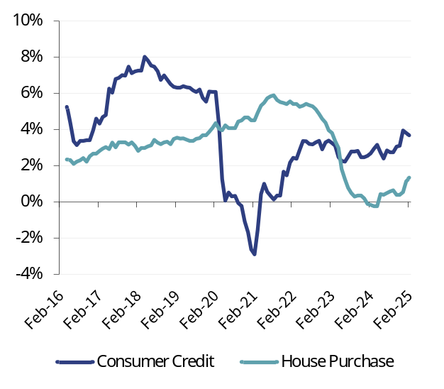
Note: NFCs = non-financial corporates  Source: Datastream |  | Source: Datastream

Fig 30: ECB Bank Lending survey – corporate credit (net balance) |  | Fig 31: ECB Bank Lending survey – consumer credit (net balance)
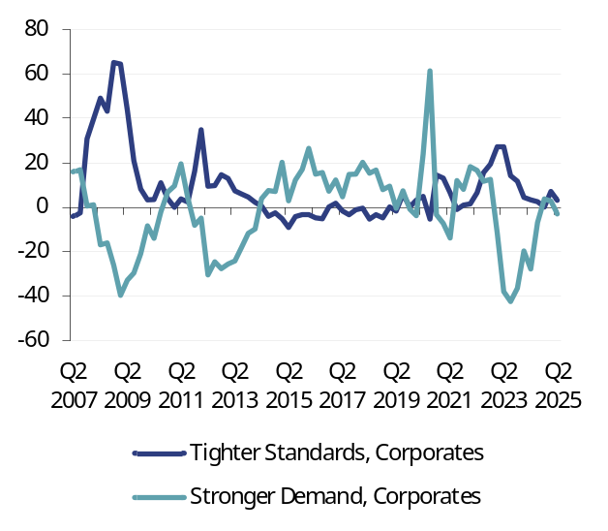 |  | 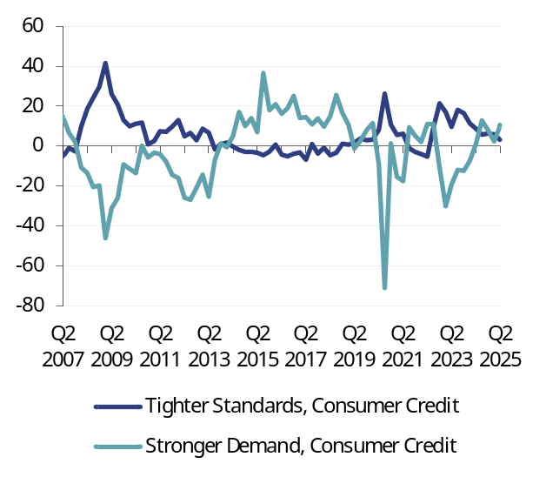
Source: Datastream, ECB Bank Lending Survey |  | Source: Datastream, ECB Bank Lending Survey
Fig 32: ECB Bank Lending survey – mortgages (net balance) |  | Fig 33: German sector financial balances (% GDP)
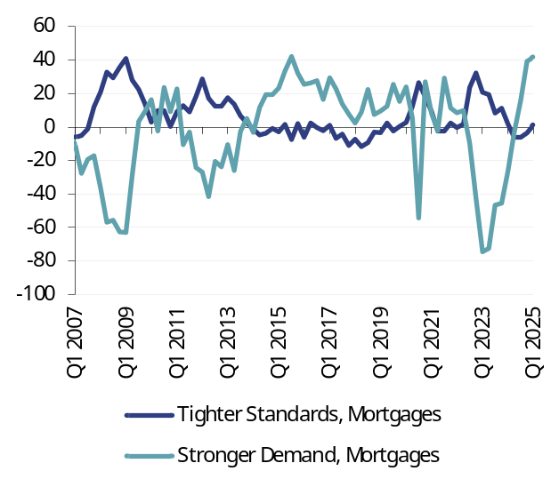 |  | 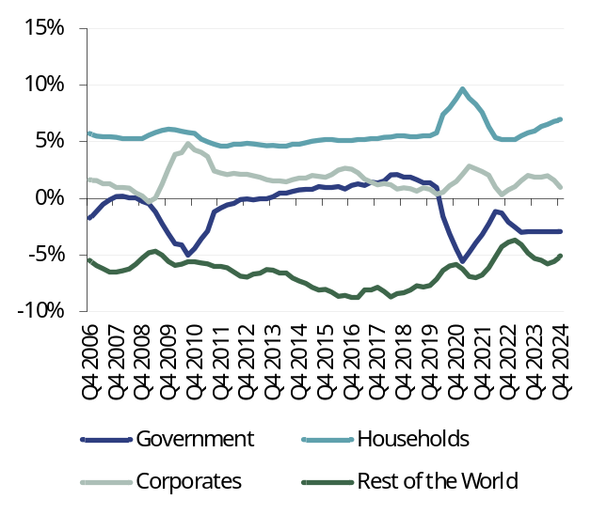
Source: Datastream, ECB Bank Lending Survey |  | Source: Datastream, Eurostat

Fig 34: Eurozone CPI |  | Fig 35: Eurozone non-financial corporate profits
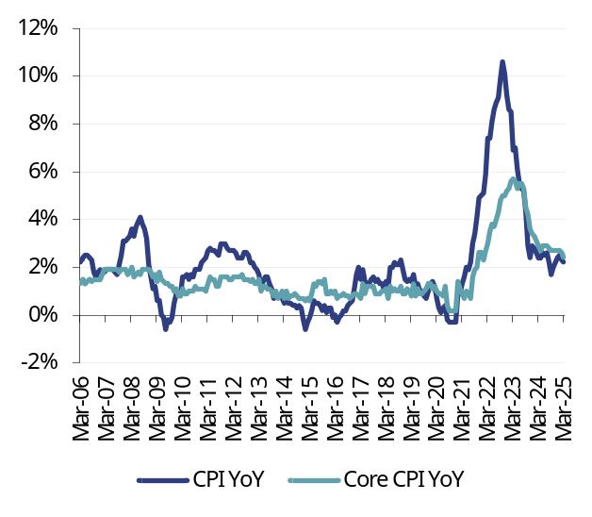 |  | 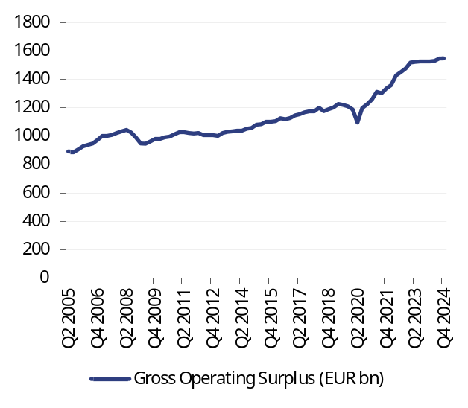
Source: Datastream |  | Source: Datastream

Fig 36: Eurozone consumer price expectations (%) |  | Fig 37: Euro ten-year inflation-linked swap rate (%)
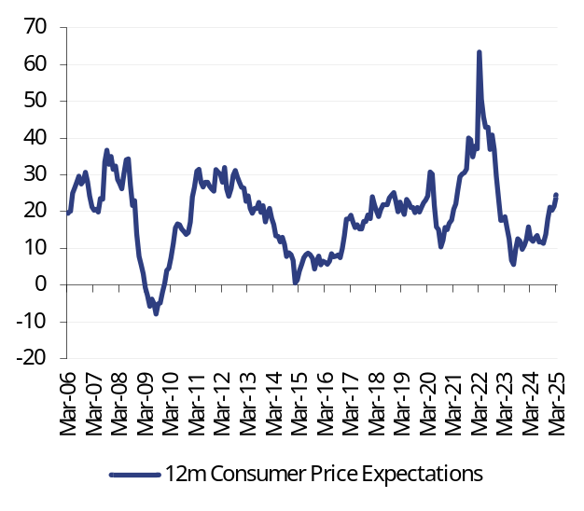 |  | 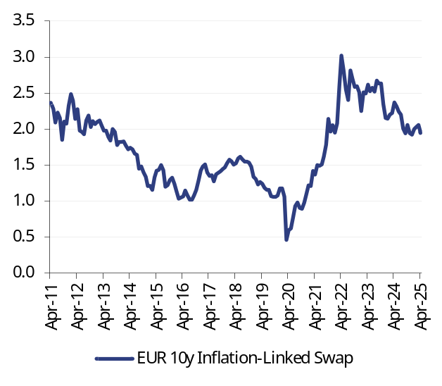
Source: Datastream, European Commission Surveys |  | Source: Datastream

Fig 38: Eurozone wage growth, YoY |  | Fig 39: Eurozone unemployment rate (%)
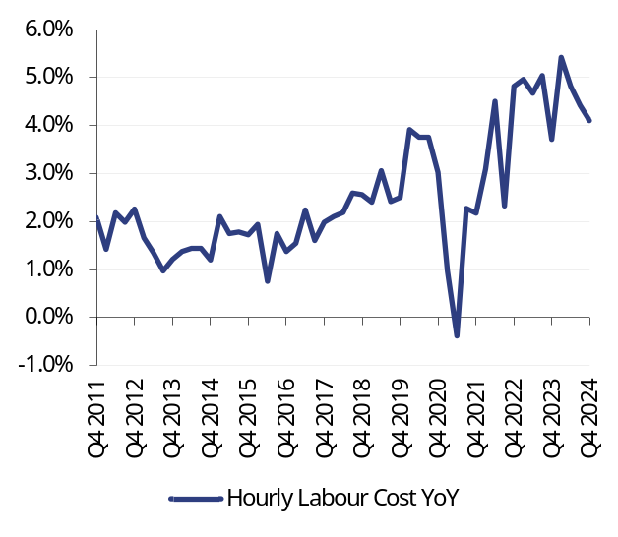 |  | 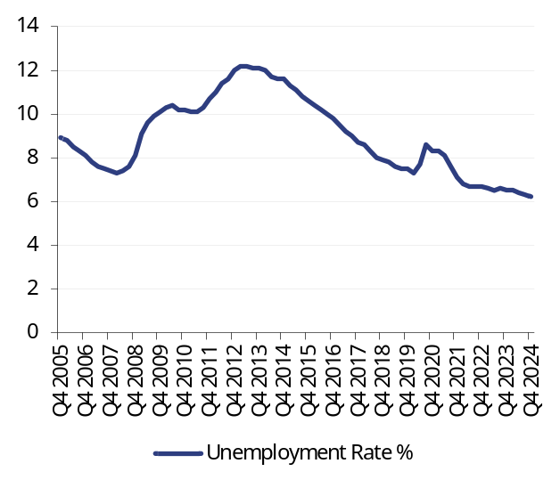
Source: Datastream, Eurostat |  | Source: Datastream, Eurostat

Fig 40: Eurozone PMI surveys (diffusion index) |  | Fig 41: Nominal broad euro exchange rate (index)
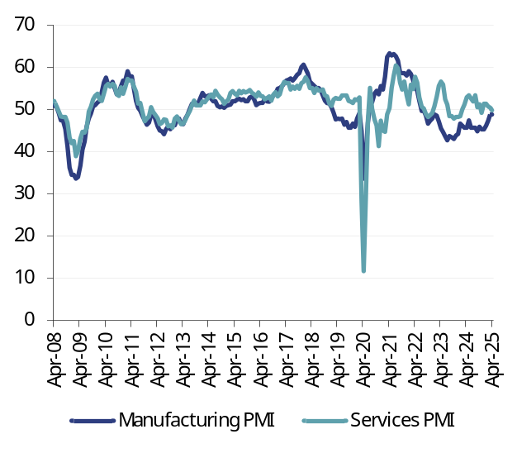 |  | 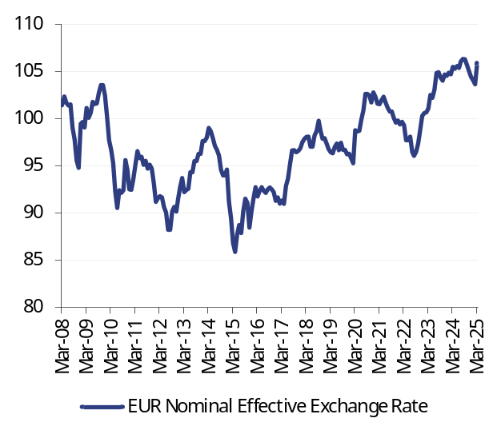
Source: Markit, Datastream |  | Source: Datastream

Fig 42: European Central Bank assets (€m) |  | Fig 43: European Central Bank reserves (€m)
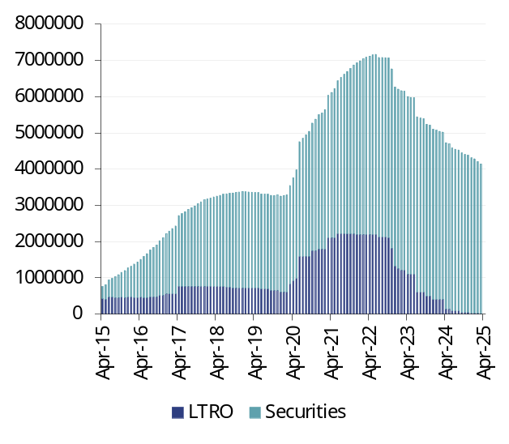 |  | 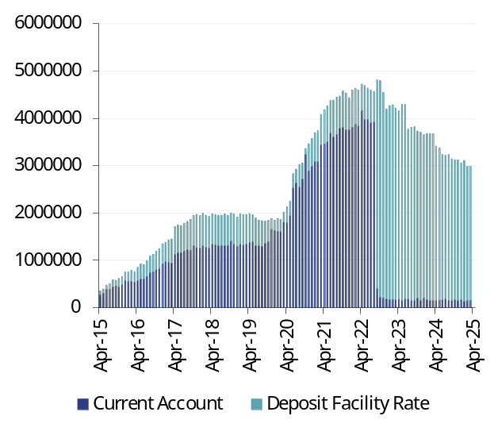
Source: Datastream |  | Source: Datastream

Fig 44: Overnight Index Swap (OIS) curve (%) |  | Fig 45: Eurozone yield curve (%)
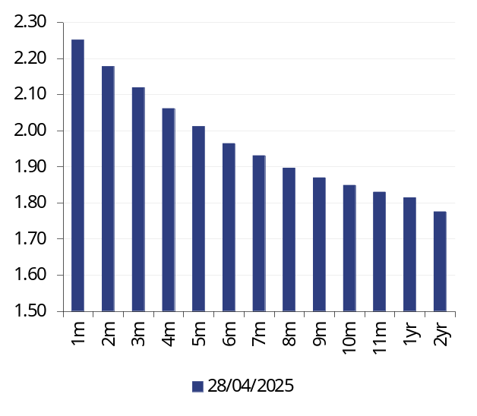 |  | 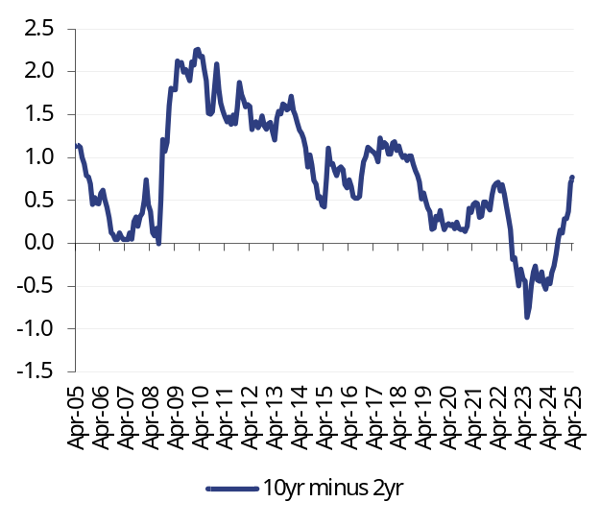
Source: Datastream |  | Source: Datastream

The Bank of England
Despite strong GDP growth and falling inflation early this year, the outlook for both is less positive. Inflation will soon be back above 3% mainly because of higher energy prices, while the growth outlook has deteriorated as US trade policy has created extreme uncertainty about the global economy. The Bank of England is likely to cut Bank Rate in May and at least one more time this year, to 4%. Easier monetary policy may offset tighter fiscal policy in the Autumn Budget.

The next meeting: 8 May
Bank Rate cut 25bp to 4.25% with an 8-1 vote

The next 12 months
The latest prints on GDP (up 0.5% in February) and CPI (2.6% in March) are likely to be the best for some time. From April CPI inflation will rise, lifted by higher energy and water prices. In addition, the rise in NICs and minimum wage, effective from April, may begin to be passed on in part to consumer prices. CPI inflation is likely to peak close to 4% later this year. Meanwhile GDP growth in 1Q will probably be at a quarterly rate of 0.6%, lifted by strong consumer spending (retail sales volumes were up 1.6% in the quarter). But the outlook has deteriorated, notably because of the extreme uncertainty created by US policy on trade and tariffs – the UK faces a 10% tariff on goods exports to the US. The April purchasing managers’ indices for the UK flagged a slowdown with the composite index falling to its lowest level in over two years. Consumer confidence also fell by four points in April to -23, the lowest since November 2023 (Fig 46).
Fig 46: UK composite PMI and consumer confidence
Source: Datastream
The Bank of England is almost certain to cut Bank Rate by 25bp at the May meeting and we expect one more cut later this year. The MPC view is that the imminent rise in inflation is temporary and the dominant medium-term influence on inflation will be below-trend GDP growth. Risks to growth have increased over the past month, suggesting more monetary ease this year. Depending on developments in US trade policy, the MPC may cut Bank Rate below 4%.
The longer term view
Prospects are for easier monetary policy but tighter fiscal policy. The Spring Statement last month included plans to cut welfare spending and reduce civil service costs to restore consistency with the key fiscal rule – that current spending is met out of taxation with only investment funded by borrowing. These measures restored a £9.9bn margin of safety for this so-called stability rule. The rise in gilt yields between last October’s Budget and March had wiped out the previous safety buffer.
In the month since the Spring Statement, the fiscal rule is once again in jeopardy. First the public finances data showed higher public sector borrowing for the 2024/25 financial year than forecast by the Office for Budget Responsibility (OBR) in the Spring Statement: total borrowing is put at £151.9bn, £14.6bn above the March OBR forecast. The data is subject to revision, but it is highly likely that a significant overshoot will persist. Moreover, the growth outlook has deteriorated in the wake of US tariff announcements. This may prove temporary, but there is the prospect of a permanent reduction in global trade that hurts innovation and productivity. The OBR projections included a modest rise in productivity growth, which, if it fails to materialise, would undermine the Chancellor’s fiscal rules. The Budget later this year – and subsequent ones –may tighten fiscal policy through squeezed public spending and/or tax rises.

Fig 47: UK M1 and M4, YoY |  | Fig 48: Bank Rate (%)
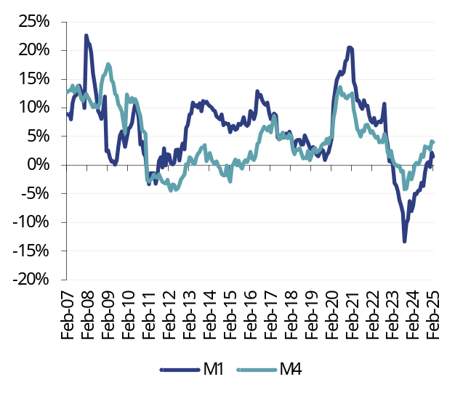 |  | 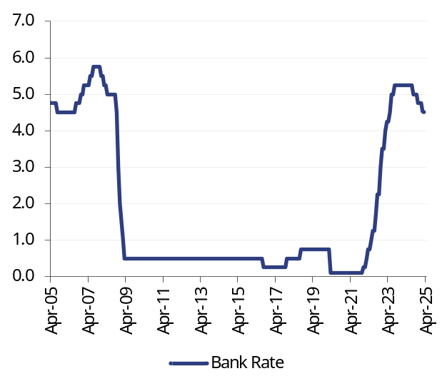
Source: Datastream, Bank of England |  | Source: Datastream, Bank of England

Fig 49: Corporate loans, YoY |  | Fig 50: Household loans, YoY
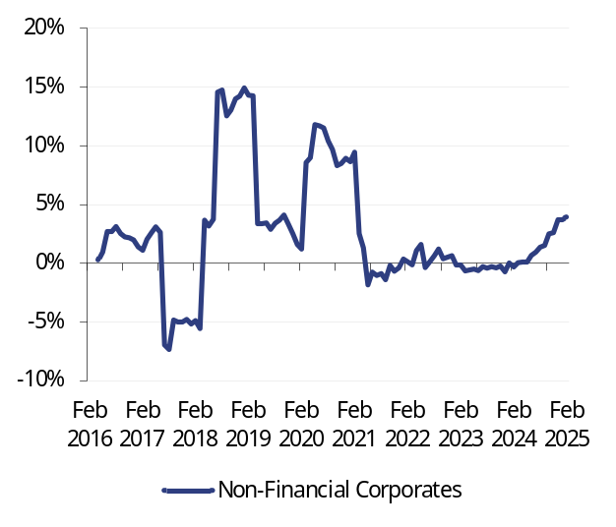 |  | 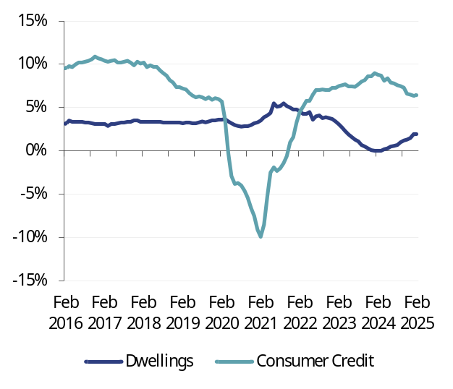
Source: Datastream, Bank of England |  | Source: Datastream, Bank of England

Fig 51: Credit Conditions survey – corporate credit (net balance) |  | Fig 52: Credit Conditions survey – consumer credit (net balance)
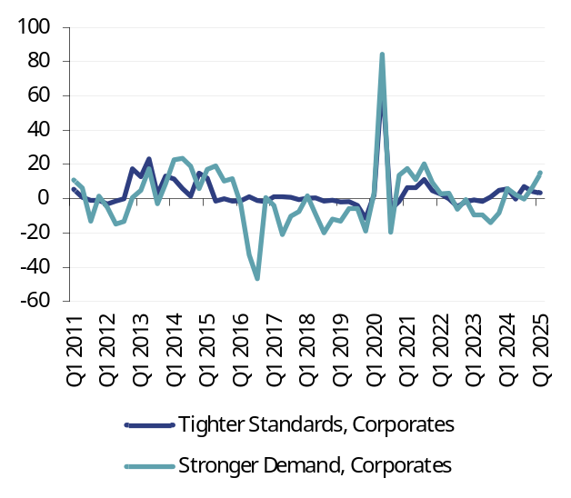 |  | 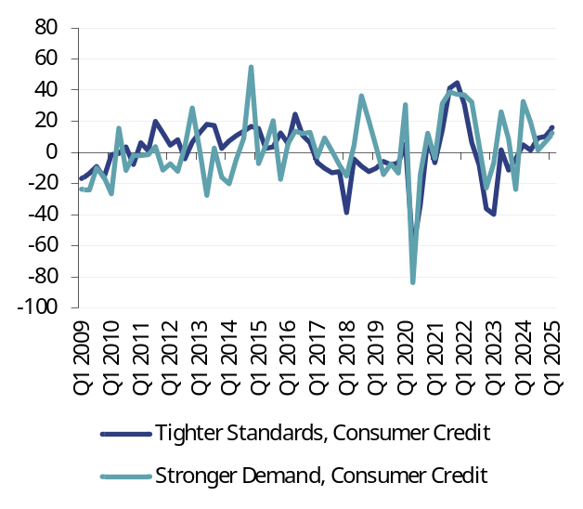
Source: Datastream, Bank of England Credit Conditions Survey |  | Source: Datastream, Bank of England Credit Conditions Survey
Fig 53: Credit Conditions survey – mortgages (net balance) |  | Fig 54: UK sector financial balances (% GDP)
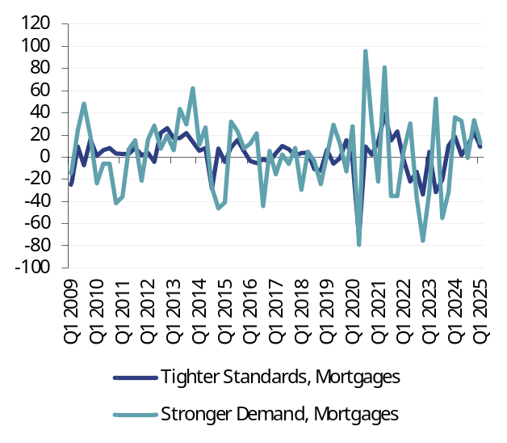 |  | 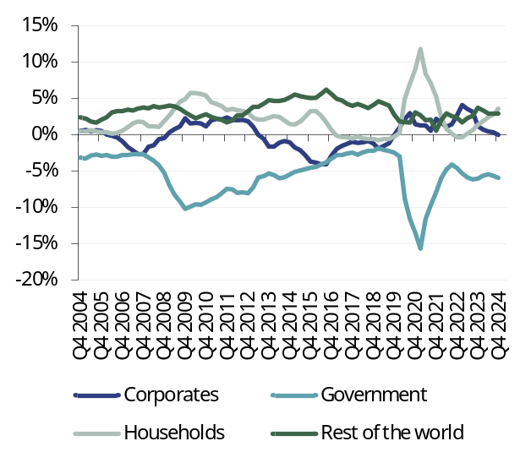
Source: Datastream, Bank of England Credit Conditions Survey |  | Source: Datastream

Fig 55: UK CPI |  | Fig 56: UK non-financial corporate profits
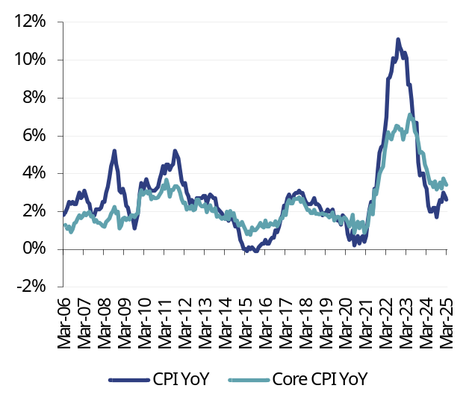 |  | 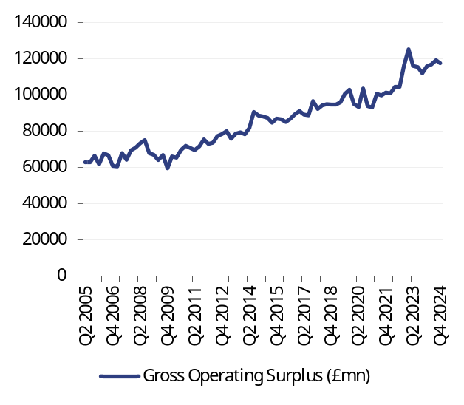
Source: Datastream |  | Source: Datastream

Fig 57: UK consumer price expectations |  | Fig 58: GBP ten-year inflation-linked swap rate (%)
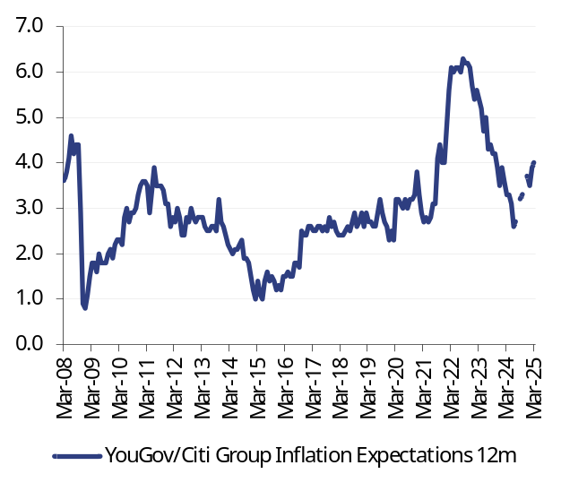 |  | 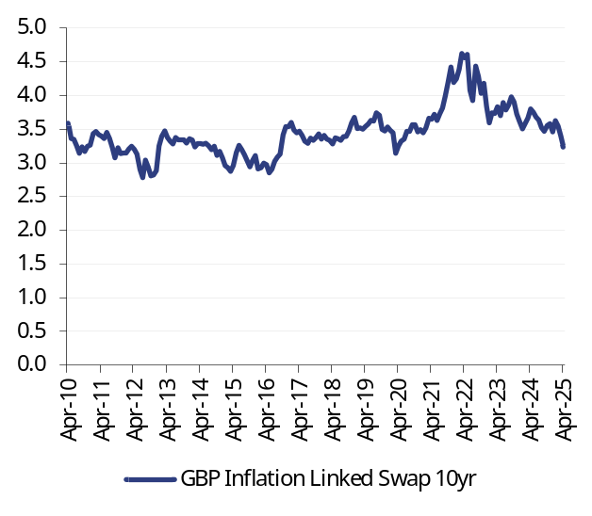
Source: Datastream, YouGov/Citi |  | Source: Datastream

Fig 59: UK wage growth, YoY |  | Fig 60: UK unemployment rate (%)
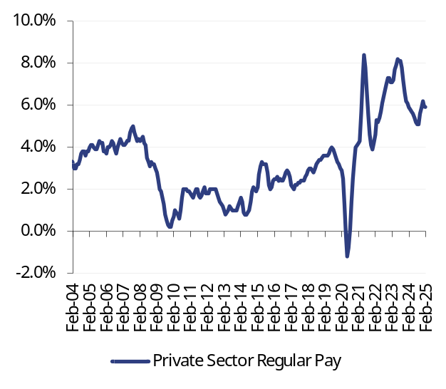 |  | 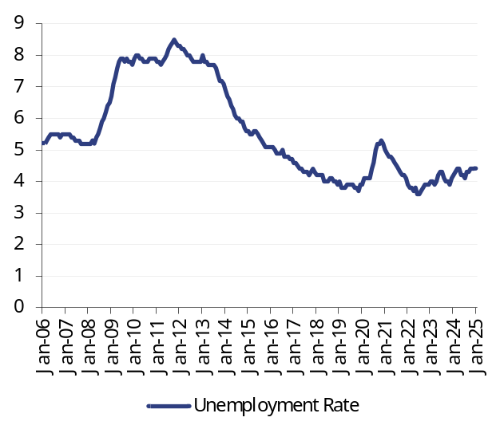
Source: Datastream, Office for National Statistics |  | Source: Datastream, Office for National Statistics

Fig 61: UK PMI surveys (diffusion index) |  | Fig 62: Nominal broad euro exchange rate (index)
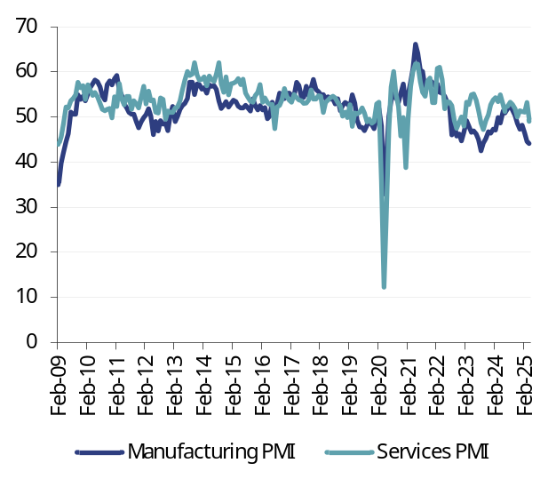 |  | 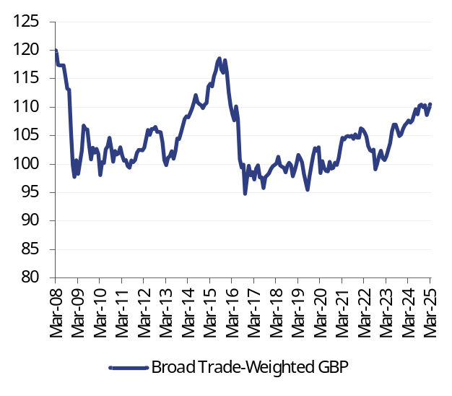
Source: Markit, Datastream |  | Source: Datastream

Fig 63: Bank of England assets (£m) |  | Fig 64: UK reserves (£m)
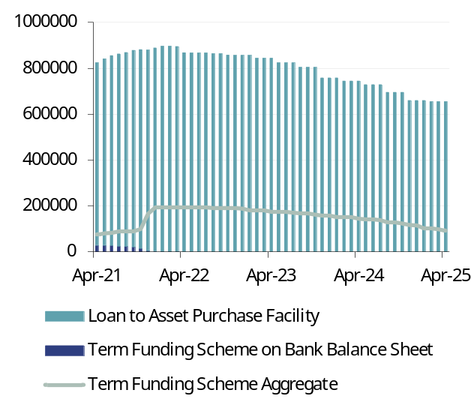 |  | 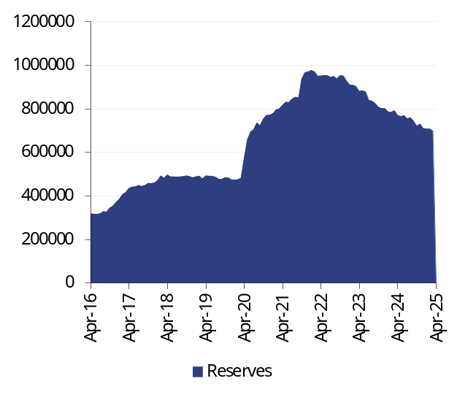
Source: Datastream, Bank of England |  | Source: Datastream, Bank of England

Fig 65: Overnight Index Swap (OIS) curve (%) |  | Fig 66: UK yield curve (%)
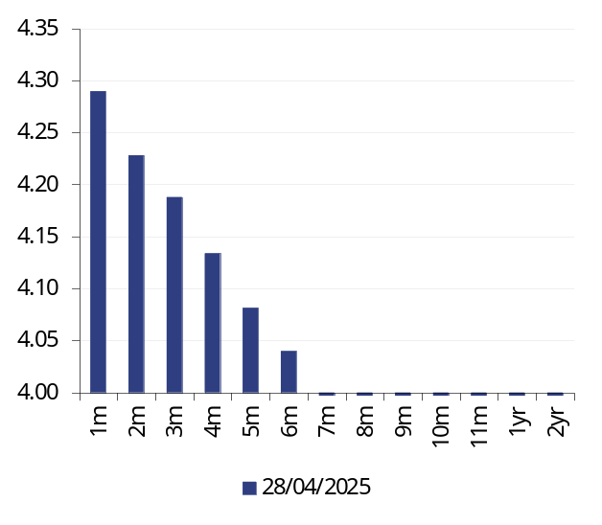 |  | 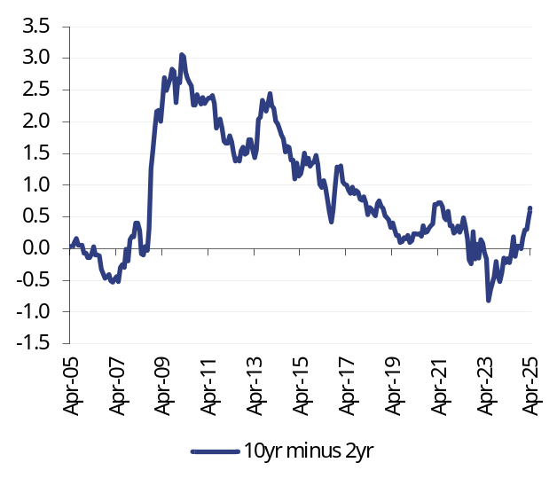
Source: Datastream |  | Source: Datastream

The Bank of Japan
Extreme uncertainty about US trade policy and the wider global economy mean that the BoJ is likely to refrain from further policy rate increases for the time being. Even a trade deal with the US that avoids the 24% reciprocal tariffs is not likely to change the outlook. The transformed global picture outweighs domestic considerations where strong wage settlements would otherwise have pointed to another 25bp increase over the summer.

The next meeting: 30 April-1 May
Policy interest rate on hold at 0.5%.

The next 12 months
At the last Monetary Policy meeting in mid-March, the BoJ was balancing what then appeared to be equal but opposing risks from the domestic and international side. Domestically the BoJ was – and probably still is – encouraged by wage developments, suggesting a strong round of pay settlements in the Spring negotiations. The virtuous wage-price spiral, that would deliver 2% inflation in a stable and sustainable manner looked on the way to becoming well established. But the minutes to the March meeting already revealed concerns about the potential impact of US tariffs.
“Downside risks stemming from the US have rapidly heightened recently and, depending on how tariff-related issues develop, it is quite possible that these risks will even have a negative impact on Japan's real economy. In that case, the Bank will need to be particularly cautious when considering the timing for raising the policy interest rate.” (Bank of Japan Minutes, 25 March)
Subsequently, the 2 April announcements by President Trump initially imposed a 24% reciprocal tariff on most Japanese goods exports to the US. This is in addition to the 25% tariff on cars, steel and aluminium. Until July, the reciprocal rate is 10% to allow for negotiations on a trade deal. Japan is reportedly ‘first in the queue’ for such a deal, although nothing has yet been agreed. Tariff developments look set to dominate monetary policy in the coming months. Markets are no longer anticipating further policy rate increases this year, having previously discounted at least one more 25bp hike. Unless there is a dramatic shift in US policy to reduce tariffs on Japan and other economies, then policy is indeed likely to be on hold into next year.

The longer term view
The divergence between rising US Treasury yields and a weakening US dollar underlines the new risk premium associated with US assets. In previous periods of heightened global economic uncertainty, such as the Global Financial Crisis, the dollar appreciated as US assets were perceived as a safe haven. Since 2 April, the US dollar has weakened against most developed market currencies. Against the Japanese yen, it has fallen by c5% and has moved closer to the low point reached last summer (¥140.6).
The yen may come under sustained upward pressure. First because the Japanese yen retains its safe haven status, enhanced even as the US dollar falls out of favour. In addition, the rise in JGB yields, ten-year yield now at 1.3%, may herald the end of the ‘carry trade’, where Japanese investors sought higher returns overseas, including in US Treasuries, where the Japanese are the biggest overseas owners. The reversal of this trade would add to upward pressure on the yen as funds were relocated to domestic investments. A significant appreciation of the yen, as well as refuting allegations of currency manipulation in the other direction, would be disinflationary and potentially allow an extension of the period over which monetary policy is normalised.
Fig 67: Japanese yen per US dollar
Source: Datastream

Fig 68: Japanese M1 and M4, YoY |  | Fig 69: Policy rate (%)
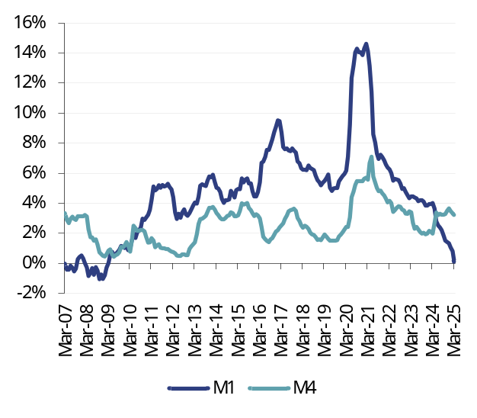 |  | 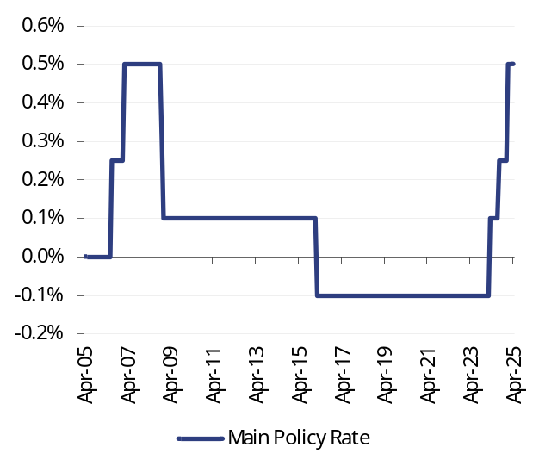
Source: Datastream, Bank of Japan |  | Source: Datastream, Bank of Japan

Fig 70: Corporate loans, YoY |  | Fig 71: Household loans, YoY
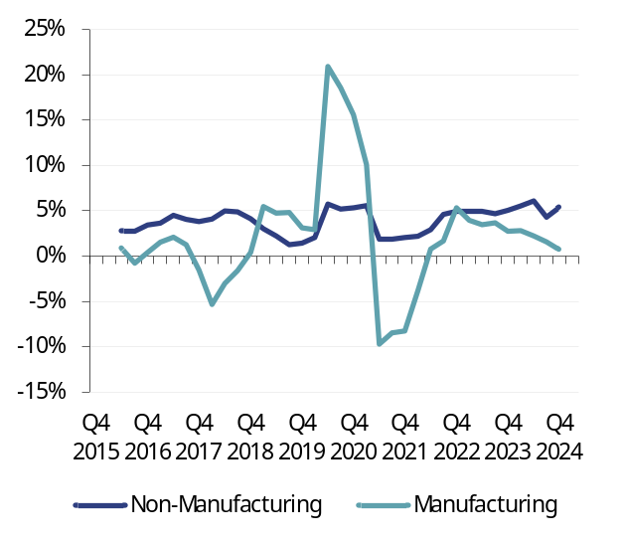 |  | 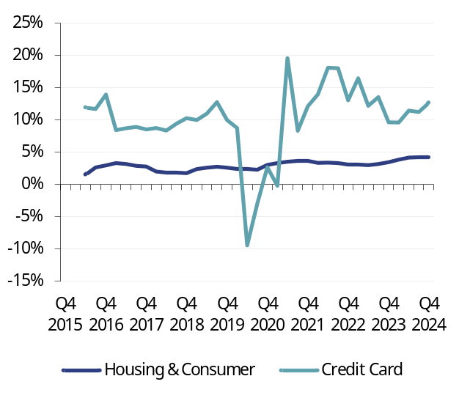
Source: Datastream, Bank of Japan |  | Source: Datastream, Bank of Japan

Fig 72: Loan survey – corporate credit (net balance) |  | Fig 73: Loan survey – consumer credit (net balance)
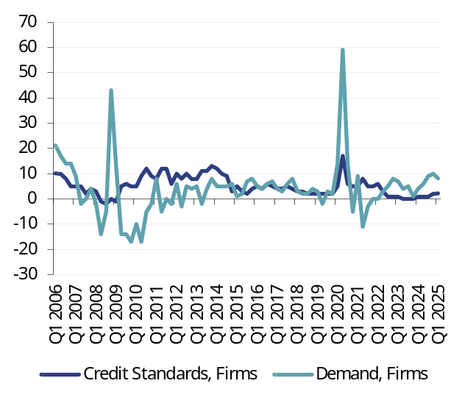 |  | 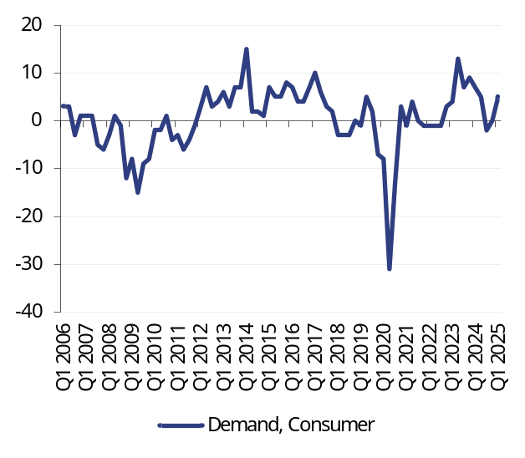
Source: Datastream, Bank of Japan |  | Source: Datastream, Bank of Japan
Fig 74: Loan survey – mortgages (net balance) |  | Fig 75: Japanese sector financial balances (% GDP)
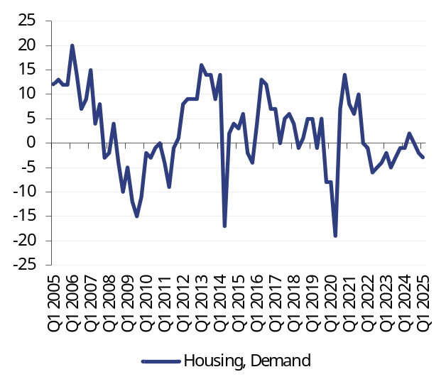 |  | 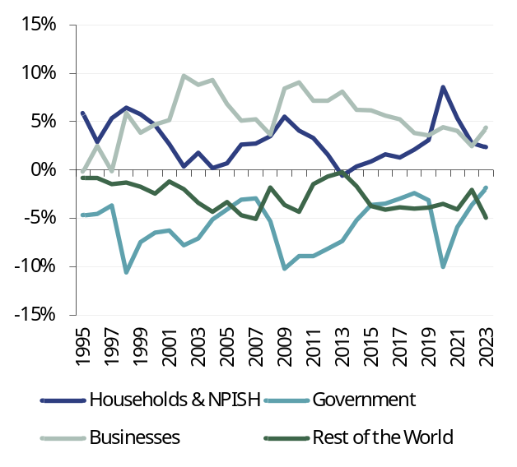
Source: Datastream, Bank of Japan |  | Note: NPISH = Non-Profit Institutions Serving Households  Source: Datastream

Fig 76: Japan CPI |  | Fig 77: Japanese non-financial corporate profits
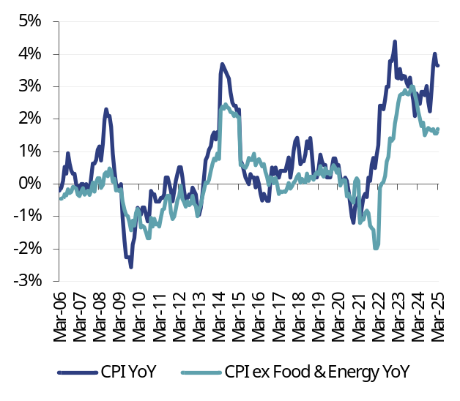 |  | 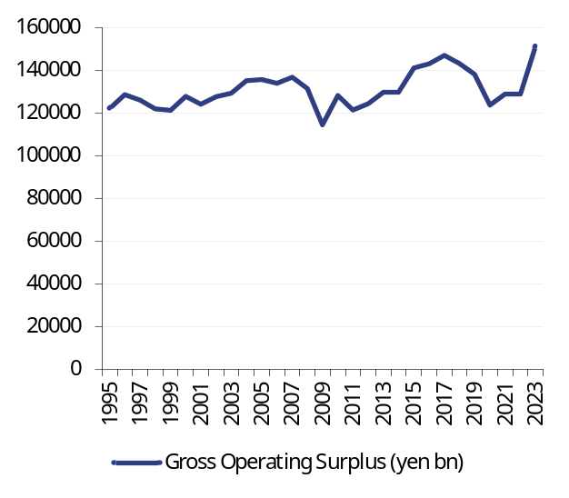
Source: Datastream |  | Source: Datastream

Fig 78: Japanese consumer price expectations (net balance) |  | Fig 79: JPY ten-year inflation-linked swap rate (%)
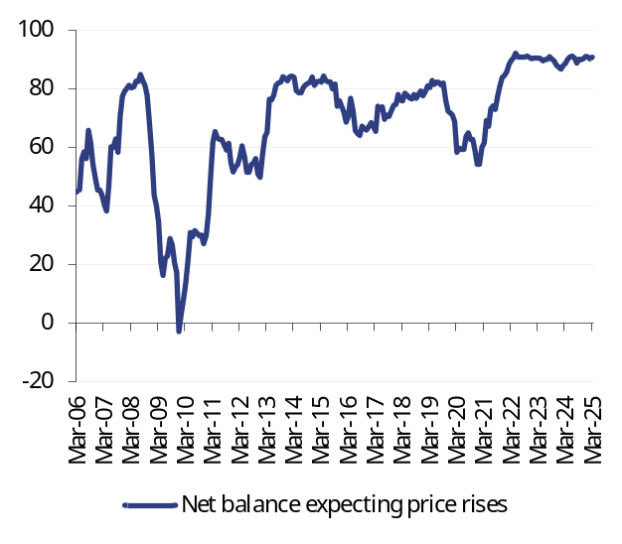 |  | 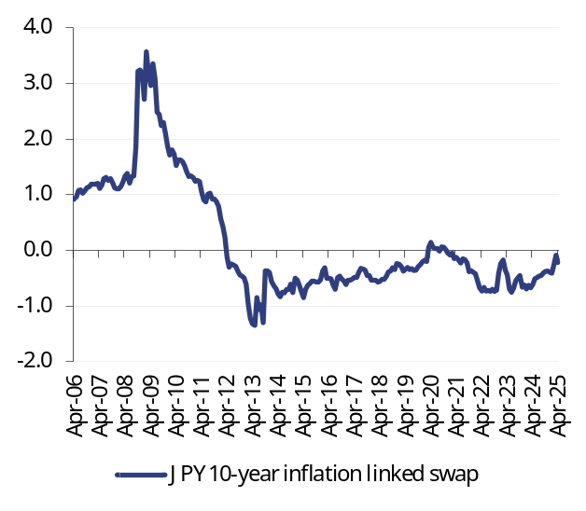
Source: Datastream |  | Source: Datastream

Fig 80: Japanese wage growth, YoY |  | Fig 81: Japanese unemployment rate (%)
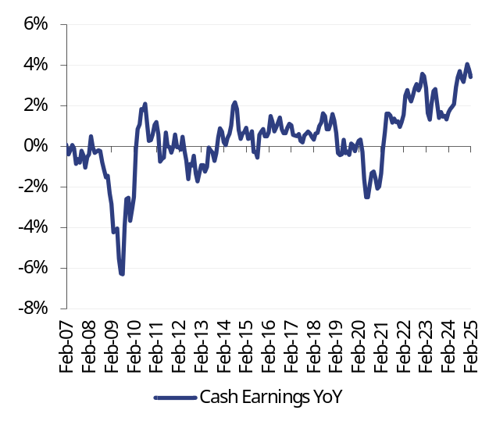 |  | 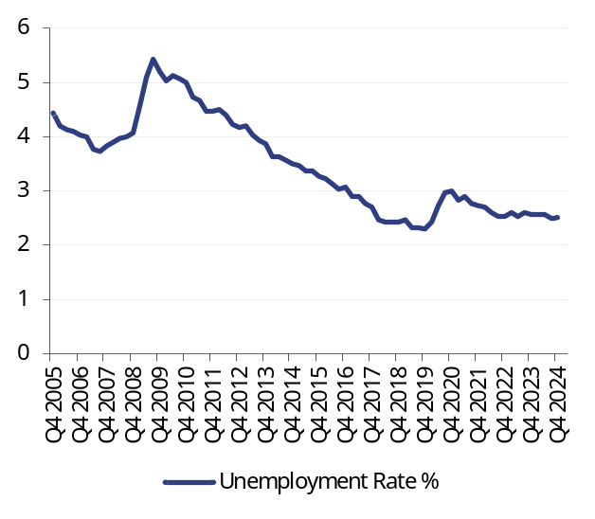
Source: Datastream |  | Source: Datastream

Fig 82: Japanese PMI surveys (diffusion Index) |  | Fig 83: Nominal broad JPY exchange rate (index)
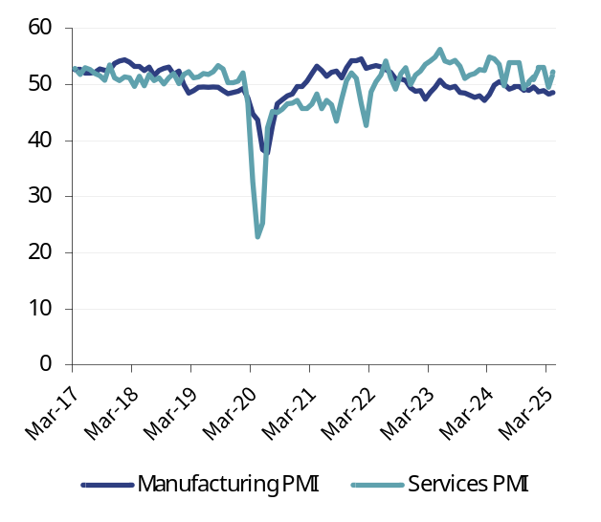 |  | 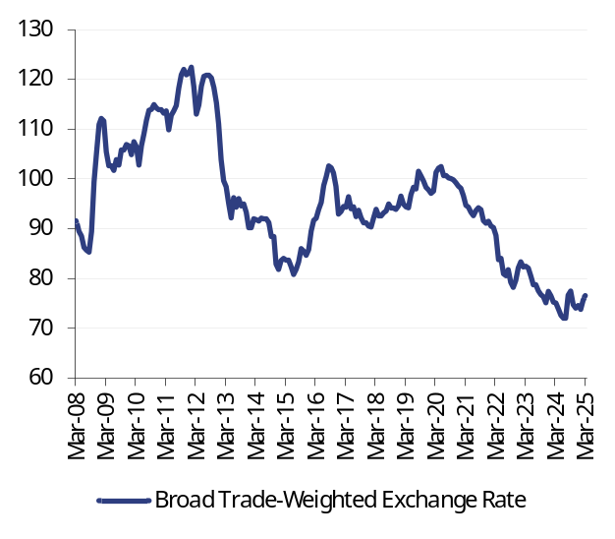
Source: Datastream |  | Source: Datastream

Fig 84: Bank of Japan assets (¥100m) |  | Fig 85: Japanese reserves (¥100m)
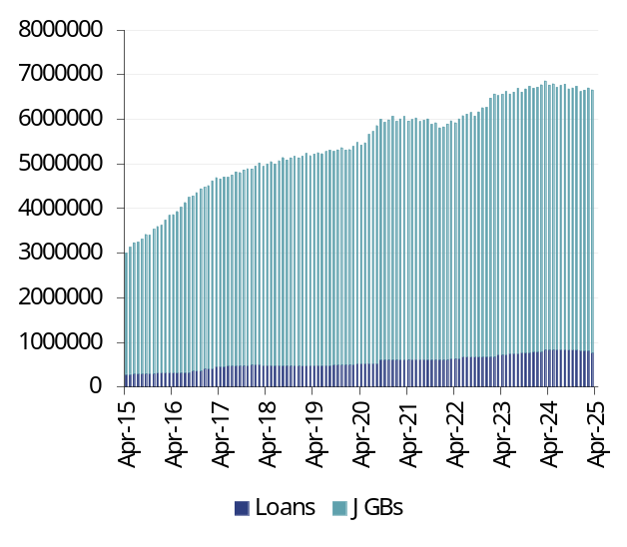 |  | 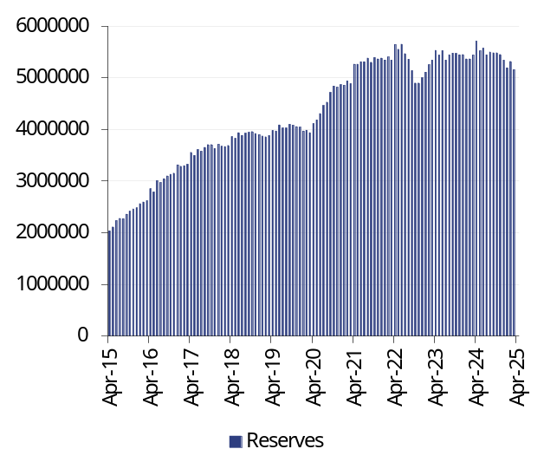
Source: Datastream, Bank of Japan |  | Source: Datastream, Bank of Japan

Fig 86: Overnight Index Swap (OIS) curve (%) |  | Fig 87: Japanese yield curve (%)
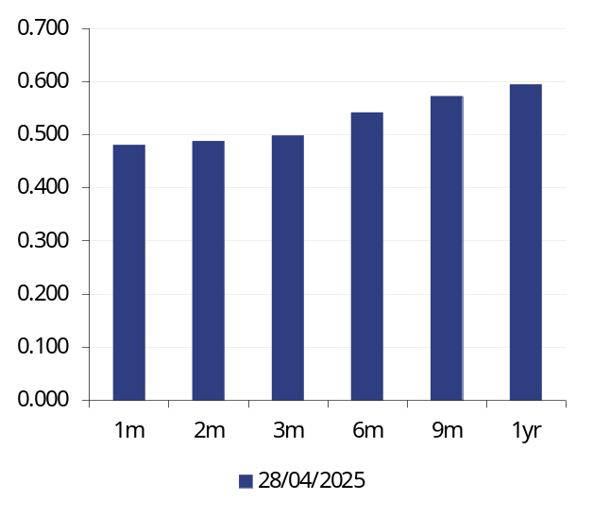 |  | 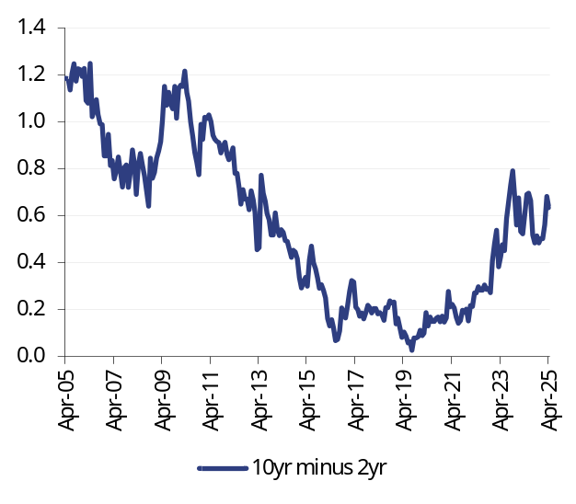
Source: Datastream |  | Source: Datastream

Melissa Davies  Economics  Redburn Atlantic  Capital House  85 King William Street  London EC4N 7BL  D +44 20 7000 2064  T +44 (0)20 7000 2020  E melissa.davies@redburnatlantic.com |  | Michael Taylor  Economics  Redburn Atlantic  Capital House  85 King William Street  London EC4N 7BL  D +44 20 7000 2066  T +44 (0)20 7000 2020  E michael.taylor@redburnatlantic.com
https://research.redburnatlantic.com/

Research Disclosures
This report has been issued by Redburn (Europe) Limited (‘Redburn Atlantic’), authorised and regulated by the Financial Conduct Authority (“FCA”) and registered as an investment adviser with the Securities and Exchange Commission (“SEC”). This report is intended for use by Professional Clients and Eligible Counterparties only. Redburn Atlantic is a member of the Rothschild & Co group (“R&Co”). Redburn (Europe) Limited is registered in England (company number: 4710622). Our registered office is New Court, St. Swithin’s Lane, London, EC4N 8AL. The FCA's registered office is 12 Endeavour Square, London E20 1JN.

All of Redburn Atlantic’s investment research is written by employees whose job title is “Analyst”.

This research was completed at 2025-04-29 15:50.
This research was published at 2025-04-30 06:30.

Unless specified, all dates and times in the document are UK standard time.

Where this report reaches conclusions or recommendations, the basis of valuation, methodology and/or the underlying assumptions on which those conclusions are based appear in the relevant commentary.

A redacted version of the full model in which certain worksheets have been removed and any links to the removed worksheets have been hardcoded is available at https://research.redburnatlantic.com/. Information in the model (including share prices, forex rates, consensus etc.) is not live as any links are hardcoded on the date of upload. Our intention in providing this model service is to give our clients access to a comprehensive, working model, which is entirely consistent with our published forecasts for the subject issuer. If you experience any technical difficulties with the spreadsheet, please contact numbers@redburnatlantic.com. If you have questions regarding the logic of, or assumptions made in the model, please contact the Analyst directly.

Buy: Redburn Atlantic argues that the stock price will rise by at least 15% over one year. For high beta stocks the hurdle rate may be commensurately higher.
Sell: Redburn Atlantic argues that the stock price will be lower over one year.
Neutral: Redburn Atlantic argues that the stock price will trade within the above ranges.

Redburn Atlantic has no timetable for the publication of research material. Material is published when an Analyst believes a report is warranted, and not to any timetable specified in advance.

Redburn Atlantic or another member of the R&Co group may offer investment banking services to issuers that are the subject of investment recommendations. Should this be the case, information about the nature of the service provided and the relationship between the issuer and Redburn Atlantic will be disclosed on Redburn Atlantic’s disclosure webpage https://disclosures.redburnatlantic.com/. In addition, employees that make or produce investment recommendations may receive a remuneration based upon various factors including overall firm revenues, which include investment banking revenues. Analyst remunerations are not linked to investment banking or capital markets transactions activities.

Each Analyst is primarily responsible for the content of their investment recommendations, and in whole or in part, certifies that all of the views expressed accurately reflect his or her personal views about any and all of the subject securities or issuers.

Redburn Atlantic’s Conflicts of Interest Policy is set out in Regulatory Information at www.redburnatlantic.com.

 | Coverage Universe |  | Investment Banking Client
 | Count | % | Count | % Total IB Client | % Rating Category
Buy | 276 | 48.94 % | 32 | 51.61 % | 11.59 %
Neutral | 225 | 39.89 % | 22 | 35.48 % | 9.78 %
Not Rated | 18 | 3.19 % | 7 | 11.29 % | 38.89 %
Sell | 45 | 7.98 % | 1 | 1.61 % | 2.22 %
Total | 564 | 100.00 % | 62 | 100.00 % | 10.99 %

Data relating to R&Co relates to the period (which is less than 12 months) since Redburn Atlantic has been a member of the R&Co group

Research reports are solely for the information of the addressee only and is not an offer, or solicitation of an offer, to sell, or buy, any securities or any derivative instruments or any other rights pertaining thereto. The information used to create or provide research reports are compiled from sources believed to be reliable, however, neither Redburn Atlantic nor any of its officers or employees, make any representations or warranties as to its accuracy or completeness. Any opinions, forecasts or estimates expressed constitute a judgement, as at the date of the research report, that is subject to change without notice. Redburn Atlantic has no obligation to update those opinions, forecasts or estimates. The recipient agrees that Redburn Atlantic shall have no liability for any misstatement or omission or fact or any opinion expressed, nor for the consequences of any reliance upon any statement, conclusion or opinion. Redburn Atlantic may have disseminated information contained in research reports prior to their publication. Research reports do not have regard to the specific investment objectives, financial situation and the particular needs of any specific person who may receive them. Nothing in our research reports should be construed as investment, tax, legal, accounting, regulatory or other advice or as creating a fiduciary relationship.

Redburn Atlantic’s products and services are intended distribution in the United States only to Major U.S. Institutional Investors as that term is defined for purposes of SEC Rule 15a-6.

Redburn (Europe) Limited is not a member of the Financial Industry Regulatory Authority (“FINRA”), and as such its Analysts are not subject to FINRA’s rules on research analysts and research reports, including FINRA restrictions on communications with a subject issuer, public appearances, and trading securities held by a research analyst account. Redburn (Europe) Limited is a correspondent of Redburn (USA) LLC, a SEC-registered broker-dealer. All US persons receiving research reports and wishing to buy or sell the securities discussed herein should do so through a representative of Redburn (USA) LLC.

©2025 – Redburn (Europe) Limited.

